SOLAR ENERGY
MBA Industry Primer | Energy & Infrastructure
Columbia Business School | April 2026

INDUSTRY AT A GLANCE
Solar energy is one of the fastest-growing industries in the world — and, as of 2025, the single largest source of new electricity-generating capacity added to the U.S. grid for the fifth consecutive year. For MBA candidates, solar sits at the intersection of finance, policy, technology, and global trade. Understanding it means understanding how capital flows into infrastructure, how government policy shapes private markets, and how a technology that was once too expensive to scale became cheaper than coal in under two decades.

Key Metric | Data Point (2025)
Global Solar PV Market Size (2025) | ~$368B (GVR); growing to ~$750B+ by 2030 (CAGR ~10–12%)
Global Installed Capacity (2025) | ~2.35 Terawatts (TW); China surpassed 800 GW after adding 330 GW in 2024 alone
U.S. New Capacity Installed (2025) | 43.2 GWdc — #1 source of new U.S. power for 5th consecutive year; 54% of all new U.S. capacity
Solar + Storage Share of New U.S. Capacity | 79% combined in 2025 (SEIA / Wood Mackenzie Year in Review)
U.S. Module Manufacturing Capacity (2025) | 65.5 GW operational — up 54% from 42.5 GW end of 2024; driven by IRA Section 45X credits
Key Policy Change (July 4, 2025) | OBBBA: ended 25D residential credit Dec 31, 2025; accelerated 48E/45Y phase-out to Dec 31, 2027; tightened FEOC rules
Tariff Environment (2025) | 175% effective tariff on Chinese finished panels; IEEPA tariffs: Vietnam 46%, Cambodia 49%
U.S. Cumulative Solar (End 2025) | 279 GWdc installed; Wood Mackenzie projects 769 GWdc by 2036 (~44 GWdc avg annual additions)
Key Players (Manufacturing) | Jinko Solar, LONGi, Trina, JA Solar, First Solar (USA), Hanwha Qcells (Korea/USA)
Key Players (U.S. Dev/Install) | NextEra Energy, Invenergy, AES, Sunrun, Nexamp, Lightsource BP

HISTORY & ORIGINS
The photovoltaic (PV) effect was discovered at Bell Labs in 1954, producing the first practical solar cell at roughly 4% efficiency. For decades, solar was expensive and reserved for satellites and remote applications. The 1970s oil crisis spiked interest, but costs remained prohibitive for mass deployment. The modern commercial solar industry traces its origins to Germany and Japan in the late 1990s, where government policy — not market economics — created the first large-scale demand.
1990s–2010: Germany, Japan, and the Policy Foundation. Germany's Energiewende feed-in tariff (EEG, 2000) guaranteed above-market prices for solar electricity, triggering the world's first mass-market deployment. China began investing heavily in PV manufacturing infrastructure, driving down panel costs through state-backed financing, low labor costs, and massive production scale. The U.S. introduced the Investment Tax Credit (ITC) in 2006, which became the cornerstone federal incentive and anchor of U.S. project finance.
2010–2018: The Cost Revolution. Solar module prices dropped over 90% between 2010 and 2020 — one of the fastest cost declines of any energy technology in history. Chinese manufacturing scale, learning curve effects, and intense global competition drove this transformation. Utility-scale solar became cost-competitive with natural gas in many markets. The U.S. imposed Section 201 and Section 301 tariffs on Chinese panels starting in 2012 and 2018, creating a persistent tension between cheap imports and domestic manufacturing.
2022–2024: The IRA Era. The Inflation Reduction Act (IRA), signed in August 2022, was the most transformational clean energy policy in U.S. history. It extended the 30% ITC and Production Tax Credit through the 2030s, created the Section 45X Advanced Manufacturing Production Tax Credit (~$0.07/watt for modules), and introduced domestic content bonuses. The result: $100B+ in U.S. solar and storage manufacturing announcements, module capacity surging from 15 GW to 65.5 GW by end of 2025, and U.S. annual installations surging from 23 GW to 50 GW (2021–2024).
2025: Policy Reversal and Market Turbulence. The Trump administration's One Big Beautiful Bill Act (OBBBA), signed July 4, 2025, eliminated the residential 25D solar tax credit after December 31, 2025 and accelerated the commercial 48E ITC phase-out — projects must be placed in service by December 31, 2027 to qualify for the full credit. Sweeping IEEPA tariffs on Vietnam (46%), Cambodia (49%), and sustained 175% tariffs on Chinese panels reshaped supply chains. U.S. installations fell 14% to 43.2 GWdc in 2025. Despite these headwinds, solar remained the #1 source of new U.S. power, and domestic module manufacturing capacity hit 65.5 GW — making the U.S. capable of supply self-sufficiency in modules for the first time since 2016.

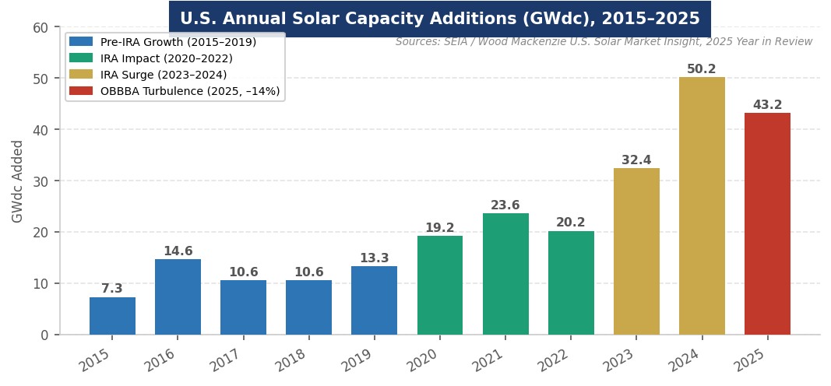
Figure 1. U.S. annual solar installations (GWdc), 2015–2025. Sources: SEIA / Wood Mackenzie U.S. Solar Market Insight, 2025 Year in Review.
MARKET STRUCTURE & VALUE CHAIN
The solar industry has a complex, globally integrated value chain. Understanding it is critical for any finance or infrastructure role, since cost, margin, and risk differ dramatically at each step.
The Solar Value Chain (Upstream → Downstream)
1. Polysilicon | Raw silicon feedstock; China controls ~95% of global supply. Highly capital-intensive. Tongwei controls >1/3 of global polysilicon and is deeply vertically integrated.
2. Ingots & Wafers | Purified silicon shaped into wafers. China dominant (~95%). Corning opened the first U.S. wafer plant (Michigan) in 2025 — completing the domestic solar supply chain for the first time since 2016.
3. Solar Cells | Wafers converted to PV cells via doping. China produces ~90%+. Key technology battleground: mono-Si (PERC → TOPCon → HJT) vs. thin film (First Solar CdTe). Technology battleground for efficiency leadership.
4. Modules (Panels) | Cells assembled into modules. Most U.S. assembly occurs here. 65.5 GW of U.S. module manufacturing capacity operational or ramping by end of 2025 — up 54% from 42.5 GW end of 2024.
5. Racking, Inverters & Trackers | Balance of system. More diversified; U.S., Spain, and Germany firms compete. NEXTracker (#1 global, 21.84 GW shipped). Tesla Powerwall 3 surged to 33.4% U.S. residential inverter share Q4 2025.
6. Project Development | Site acquisition, permitting, PPA negotiation, financing. High returns; U.S. developers lead. FERC interconnection queue: 1,500+ GW awaiting connection — primary structural bottleneck.
7. EPC (Engineering, Procurement & Construction) | Builds the project. Contracted or vertically integrated. Thin margins; execution risk material. Utility-scale: 34.7 GWdc installed in 2025 despite 16% decline year-over-year.
8. Asset Ownership & O&M | Utilities, IPPs, and infrastructure funds own operating assets long-term. Stable, bond-like cash flows. 25–35 year asset life. AI-powered O&M platforms increasingly deployed for yield optimization.

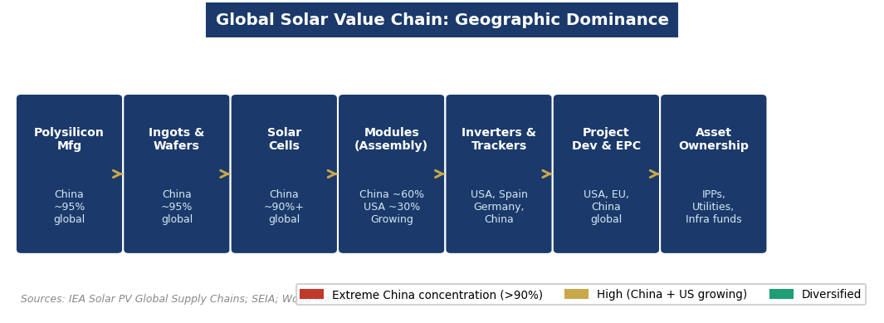
Figure 2. Geographic dominance across the solar value chain. Sources: IEA Solar PV Global Supply Chains; SEIA; Wood Mackenzie.
Three market segments define solar deployment:
- Utility-Scale (>1 MW): Largest segment; 34.7 GWdc installed in the U.S. in 2025. Projects sell power via long-term Power Purchase Agreements (PPAs). Major developers: AES, NextEra, Invenergy, Lightsource BP. FERC interconnection backlog (1,500+ GW) is the primary structural bottleneck.
- Commercial & Industrial (C&I): Mid-size rooftop and ground-mount for businesses, schools, and municipalities. Grew 6% in 2025 to 2,345 MWdc. California, New York, and Illinois lead. Third-party ownership (TPO) structures allow access to 48E credit through 2027 even after 25D expiration.
- Residential: Declined 2% in 2025 to 4,647 MWdc. The loss of 25D credit (December 31, 2025 deadline) and California's NEM 3.0 (75% reduction in net metering compensation) are primary headwinds. Sunrun, Tesla, and Qcells dominate installation.

KEY PLAYERS & COMPETITIVE LANDSCAPE
Global Module Manufacturers
Company | HQ | Notable Position
Jinko Solar | China | #1 globally for 4th+ consecutive year; ~130 GW annual capacity; factories in U.S. and SE Asia
LONGi Green Energy | China | Technology leader in monocrystalline silicon; R&D focus on HJT and TOPCon cells; world's most advanced cell efficiency roadmap
Trina Solar | China | Top 4 global position; diversifying into trackers and storage; combined Top 4 (Jinko, LONGi, Trina, JA) ~48.5% of global shipments
JA Solar | China | Rounds out dominant Chinese "Big 4"; broad manufacturing footprint across SE Asia; active in U.S. market despite tariff pressures
First Solar | USA | Only major U.S.-headquartered manufacturer; thin-film CdTe technology; no Chinese polysilicon or cells — strong FEOC positioning; ~14 GW U.S. capacity
Hanwha Qcells | South Korea/USA | Major U.S. manufacturing presence (Dalton, GA); 38.5% U.S. residential module market share in 2025; FEOC-compliant via Korean supply chain
Tongwei | China | Controls >1/3 of global polysilicon; deeply vertically integrated across supply chain from polysilicon through cells
Waaree Energies | India | Among first non-Chinese firms in global top 10; strong beneficiary of IEEPA tariffs on SE Asia; India's breakout global manufacturer

U.S. Developers, Installers & Utilities
Company | Role / Notes
NextEra Energy | Largest U.S. renewable developer and utility (Florida Power & Light); world's largest operator of wind and solar assets; NYSE: NEE
Invenergy | Private U.S. IPP; large utility-scale solar, wind, and storage developer; headquartered Chicago; active in corporate PPA market
AES Corporation | Global IPP; active in U.S. utility-scale solar and co-located storage; AES Clean Energy is primary solar vehicle
Sunrun | Largest U.S. residential installer; TPO (leases/PPAs) structure retains access to 48E credit through 2027; significant Powerwall reseller
Nexamp | Top U.S. community solar developer; 9.4% market share in 2025; subscription-based community solar in Northeast and Midwest
Lightsource BP | BP-backed developer; large U.S. and international utility-scale pipeline; aligned with BP's low-carbon transition strategy
Silicon Ranch | Nashville-based U.S. developer; attracted $500M from European investor AIP Management in 2025

Key Technology & Equipment Suppliers
Segment | Key Players
Inverters (Residential) | Tesla (33.4% U.S. share Q4 2025 via Powerwall 3), Enphase (declining), SolarEdge (restructuring)
Inverters (Commercial) | Chint Power Systems (30.2% U.S. share), SMA Solar Technology, Fronius
Trackers (Utility-Scale) | NEXTracker (global #1, 21.84 GW shipped), Array Technologies, PV Hardware (Spain)
Wafers (U.S.) | Corning (Michigan, opened 2025 — first U.S. wafer capacity since 2016; completes domestic supply chain)
Storage (BESS) | Tesla Megapack/Powerwall, LG Energy Solution, CATL (via U.S. partners), Fluence (AES/Siemens JV)

Financial Sponsors & Tax Equity
Project finance for utility-scale solar combines senior debt (50–60%), tax equity leveraging the ITC (~30% of project cost), and sponsor equity. Tax equity investors — JPMorgan, Bank of America, Citi, US Bancorp — provide upfront capital in exchange for the ITC benefit. The IRA's credit transferability (allowing PTCs to be sold directly without a partnership structure) significantly broadened the market to include insurance companies and corporates. Infrastructure funds (Brookfield, BlackRock, KKR, Macquarie) are active buyers of operating solar portfolios for their stable, long-duration cash flow profiles.

ANATOMY OF A SOLAR PANEL
A photovoltaic (PV) solar panel is a layered semiconductor device. Understanding its physical structure — from glass to silicon to backsheet — provides a foundation for understanding manufacturing complexity, quality differentiation, supply chain risk, and the strategic significance of each component.

Component / Layer | Key Specs | Strategic Significance
Anti-Reflection Coating | Nano-coating; reduces reflection, increases absorption | Proprietary formulations are a key efficiency differentiator. SiNx most common; perovskite-compatible coatings under development.
Tempered Glass (Front) | 3–4mm thick; ~94% transmittance | Protective front layer. Bifacial panels use transparent rear glass, capturing rear-side irradiance for 5–30% additional yield.
Encapsulant (EVA Film) | 0.4–0.5mm; Ethylene Vinyl Acetate | Seals cells from moisture and UV. Delamination is a primary long-term quality failure mode. POE gaining share for bifacial.
Solar Cells (Silicon Wafers) | 156–210mm; mono-Si or poly-Si | The core energy conversion layer. Technology roadmap: PERC → TOPCon → HJT. Standard: ~22–23%; HJT/TOPCon: 25–26%.
Busbars & Ribbons | Silver conductors; 0–20+ busbars per cell | Carry current to junction box. ~100mg silver per cell — key cost driver. Copper alternatives under development to reduce silver use.
Backsheet / Rear Glass | White polymer or glass; insulation | Weatherproof rear layer. Glass-glass bifacial: 30+ year life vs. polymer: 25 year standard. Higher cost, longer durability.
Aluminum Frame | 6063-T5 alloy; structural support | Enables racking and mounting. Subject to Section 232 aluminum tariffs in U.S. market. Weight and profile affect tracker compatibility.
Junction Box & Bypass Diodes | IP68 rated; 1–3 bypass diodes | Manages partial shading by bypassing shaded strings. Enphase and SolarEdge replace bypass diodes with module-level power electronics.

How it works: When photons from sunlight strike the silicon cell layer, they dislodge electrons and create an electric field — the photovoltaic effect. This generates direct current (DC) electricity, which an inverter converts to alternating current (AC) usable by homes and the grid. Cell efficiency — the percentage of incoming solar energy converted to electricity — is the key technology metric. Standard commercial panels achieve 22–24% efficiency; HJT and TOPCon designs push toward 25–26%, while perovskite-silicon tandems have exceeded 33% efficiency in laboratory conditions.
GLOBAL GEOGRAPHY & COUNTRY LEADERS
China: The dominant force in solar manufacturing at every stage of the value chain. Controls ~95% of global polysilicon, ingot, and wafer production; home to 7 of the world's 10 largest module manufacturers. Installed 330 GW of new solar in 2024 — more than the rest of the world combined — pushing cumulative capacity past 800 GW. State-backed investment, low labor costs, and massive scale create structural cost advantages ~30–40% below Western equivalents. Benchmark solar auction prices in China fell below $0.03/kWh in 2024, undercutting coal tariffs by 30%.
United States: The world's second-largest deployment market by annual installations and largest by project value. Solar installed 54% of all new U.S. electric capacity in 2025. The IRA triggered a manufacturing renaissance that pushed domestic module capacity from ~5 GW to 65.5 GW in three years — enabling domestic supply self-sufficiency for the first time since 2016. 77% of U.S. solar capacity is in Republican-leaning states — a structural political protection for the industry. The IEA revised the U.S. renewable growth forecast down 50% for 2025–2030 due to OBBBA and tariff disruption.
India: Rapidly ascending. India installed 18 GW in 2024, reaching ~90 GW cumulative. The Production Linked Incentive (PLI) scheme is driving 40 GW of new manufacturing commitments. Waaree Energies is India's breakout global manufacturer. The IEA forecasts India's annual additions to quadruple from 15 GW to 62 GW by 2030 — the fastest growth of any large economy globally.
Europe: Germany, Spain, the Netherlands, and Poland lead in deployment. The EU Solar Industry Alliance targeted 30 GW of European PV manufacturing by 2025 — largely unmet due to Chinese competition. REPowerEU targets 600 GW of solar by 2030. Spain pioneered innovative agrivoltaic programs in 2025. Germany's Energiewende continues to drive deployment despite permitting challenges.
Middle East & Southeast Asia: Saudi Arabia (NEOM, 4 GW), UAE (Al Dhafra, 2 GW), and Egypt (3.6 GW Suez pipeline) anchor Middle East growth. Vietnam and Cambodia were major panel-manufacturing export hubs for the U.S. — a routing strategy largely closed by 2025 IEEPA tariff expansions. Both countries are now pivoting manufacturing toward FEOC-compliant supply chains.
POLITICS, POLICY & REGULATION
Solar is perhaps the most politically sensitive sector in U.S. energy. Policy shapes financing structures, supply chains, project economics, and investor return profiles in ways that few other industries experience so directly. The OBBBA created the most significant policy disruption since the IRA.

Key Policy Levers MBA Candidates Must Know
Policy / Lever | What It Means for Solar
ITC / 48E (Commercial & Utility) | 30% investment tax credit. OBBBA: projects must be placed in service by Dec 31, 2027 for full credit; begin construction by July 4, 2026. After 2027: 60% in 2028, 20% in 2029, 0% from 2030.
Section 25D (Residential) | Ended December 31, 2025 under OBBBA. Third-party ownership (TPO leases/PPAs) still accesses 48E credit through 2027, preserving a residential pathway.
Section 45X (Advanced Mfg PTC) | IRA credit for U.S. manufacture of solar cells (~$0.04/W), modules (~$0.07/W), trackers, and inverters. Survived OBBBA largely intact. Primary driver of domestic factory investment.
FEOC Rules (OBBBA) | Bars 48E/45Y claims if >25% equity/debt from China, Russia, Iran, or North Korea; components from FEOC suppliers; or key IP from FEOC entities. Projects beginning construction before end of 2025 are fully exempt.
IEEPA Tariffs (2025) | Reciprocal tariffs on Vietnam (46%), Cambodia (49%), and other SE Asian panel manufacturers under IEEPA — closing prior routing workarounds. Chinese finished panels face ~175% effective tariff.
Net Metering (NEM) | State-level compensation for rooftop solar exports. California's NEM 3.0 (2023) cut compensation ~75%, sharply slowing residential growth. Other states watching California's model.
FERC Order 2023 | Reformed grid interconnection queue rules. 1,500+ GW backlog awaiting connection remains the industry's most significant structural constraint heading into 2027–2030.
Domestic Content Bonus | IRA bonus adds 10% ITC for U.S.-made components. Escalating threshold under OBBBA: 40% for 2026 construction starts, 45% for 2027, 55% for 2028+.

INDUSTRY TRENDS & TECHNOLOGY INNOVATION
Trend 1: Solar + Storage as the Default Solar + Storage as the Default
Battery energy storage systems (BESS) co-located with utility-scale solar reached 79% of all new U.S. power capacity in 2025 combined. Lithium-ion batteries dominate, with 4+ hour systems growing rapidly. BESS prices have fallen dramatically alongside solar. Under OBBBA, storage projects have more favorable tax credit timelines than solar (phase-out begins 2034 vs. 2027), creating a structural incentive to structure projects as solar-storage hybrids and capture the storage credit duration.
Trend 2: The AI & Data Center Demand Surge The AI & Data Center Demand Surge
Hyperscaler demand (Google, Microsoft, Amazon, Meta) is reshaping utility-scale solar procurement. Wood Mackenzie tracks ~160 GW of new large-load requests under construction or committed. Tech companies are executing large corporate PPAs directly with solar developers, often with 24/7 clean energy commitments. This corporate demand is structurally less sensitive to federal policy shifts than utility procurement — making it the most durable demand signal in U.S. utility solar for the next decade.
Trend 3: Domestic Supply Chain Build-Out Under FEOC Pressure Domestic Supply Chain Build-Out Under FEOC Pressure
The IRA's 45X manufacturing credit combined with OBBBA FEOC restrictions are incentivizing full vertical integration in the U.S. Corning's Michigan wafer plant (2025) completed the domestic PV supply chain for the first time since 2016. First Solar's thin-film technology (no Chinese polysilicon or cells) positions it as the premier FEOC-compliant manufacturer. A domestic module now costs ~$0.07/watt less than an imported equivalent after the 45X credit — meaningful at gigawatt scale.
Trend 4: Next-Generation Cell Technologies Next-Generation Cell Technologies
The dominant technology is shifting from PERC to TOPCon (Tunnel Oxide Passivated Contact) and HJT (Heterojunction) cells achieving efficiencies above 25%. Perovskite-silicon tandem cells have exceeded 33% efficiency in laboratory conditions and are on track for commercial deployment in the 2026–2028 timeframe (Oxford PV, LONGi). Perovskites could ultimately print like newspaper ink — potentially disrupting today's crystalline silicon supply chain in ways that no amount of FEOC compliance can protect against.
Trend 5: AI-Powered Operations & the Duck Curve AI-Powered Operations & the Duck Curve
AI is transforming solar asset management. AI-driven forecasting improves dispatch optimization. Predictive maintenance detects panel degradation before failure. NEXTracker's AI shadow avoidance increases yield at utility-scale plants. As solar penetration rises, grid operators face the "duck curve" — midday solar oversupply and sharp evening demand ramps — creating a premium for dispatchable rather than intermittent clean power and driving co-located storage adoption.
Trend 6: Agrivoltaics & Dual-Use Land Agrivoltaics & Dual-Use Land
Agrivoltaics — co-locating solar panels with agricultural land — solves land-use conflicts and reduces developer siting risk. Research shows certain crops (lettuces, berries, leafy greens) benefit from panel shading. Spain and Germany are leading deployment; the U.S. is piloting programs across the Midwest and Southeast. For infrastructure investors, agrivoltaics add a new layer of value creation and community buy-in — increasingly important as siting opposition blocks conventional utility-scale development.

CURRENT NEWS & MARKET DYNAMICS (2025–2026)
Headlines Every Candidate Should Know
- One Big Beautiful Bill Act (July 4, 2025): One Big Beautiful Bill Act (July 4, 2025): Eliminated residential 25D tax credit after December 31, 2025; accelerated commercial 48E ITC phase-out (placed in service by Dec 31, 2027 for full credit); tightened FEOC rules for projects beginning construction in 2026+. SEIA projects ~19% market contraction in 2026 before recovery driven by rising electricity rates and data center demand.
- IEEPA Tariff Escalation (April 2025): IEEPA Tariff Escalation (April 2025): Applied reciprocal tariffs on Vietnamese (46%) and Cambodian (49%) panels — closing prior Chinese module routing workarounds. 83% of U.S. solar imports in H1 2025 came from SE Asia. Chinese finished panels now face ~175% effective tariff, including layered AD/CVD, Section 301, and IEEPA duties.
- U.S. Manufacturing Milestone: U.S. Manufacturing Milestone: Module manufacturing capacity surged 54% to 65.5 GW in 2025, with wafer capacity coming online for the first time since 2016 (Corning, Michigan). The U.S. is now theoretically capable of meeting total domestic demand from domestic modules — a structural shift unimaginable three years ago.
- Tesla Inverter Surge: Tesla Inverter Surge: Tesla's Powerwall 3 drove its residential inverter market share from ~17% to 33.4% in Q4 2025, surpassing Enphase and SolarEdge. Powerwall's all-in-one battery-inverter design is reshaping residential solar economics as NEM 3.0 makes storage more valuable than export.
- Data Center Solar Procurement: Data Center Solar Procurement: Wood Mackenzie tracks 160 GW of new large-load requests from hyperscalers. Microsoft, Google, Amazon, and Meta have signed multi-GW solar PPAs. This corporate demand is less sensitive to OBBBA policy than utility procurement and represents the most durable growth signal for utility-scale solar through the 2030s.
- IEA Revises U.S. Forecast Down 50%: IEA Revises U.S. Forecast Down 50%: IEA's Renewables 2025 revised the U.S. renewable capacity growth forecast down almost 50% for 2025–2030 vs. prior-year projections, citing OBBBA policy changes, tariffs, and federal permitting restrictions on solar on federal lands. Global solar growth forecast revised down 5% overall but still expected to nearly double by 2030.
- China's 800 GW Milestone: China's 800 GW Milestone: China added 330 GW of solar in 2024 — more than the entire rest of the world combined — and surpassed 800 GW cumulative installed capacity. China is on track to meet its 2030 renewable targets five years early. Benchmark auction prices fell below $0.03/kWh in 2024, undercutting coal by up to 30%.
- Interconnection Bottleneck: Interconnection Bottleneck: 1,500+ GW of projects — solar, wind, and storage — await U.S. grid interconnection. Average wait times of 5+ years in PJM, MISO, and CAISO are the most significant structural constraint heading into 2027–2030. FERC Order 2023 reformed queue rules but implementation is slow.

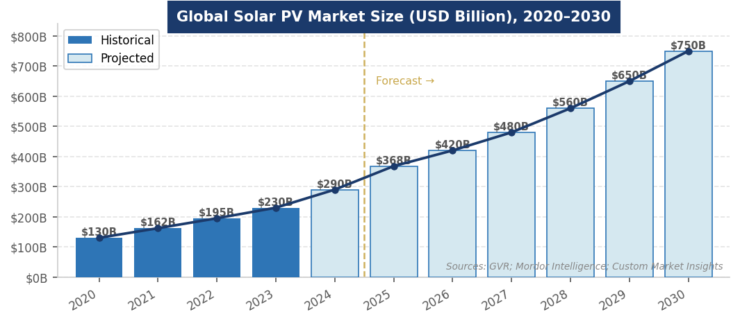
Figure 3. Global solar PV market size forecast, 2020–2030 (USD Billion). Sources: GVR; Mordor Intelligence; Custom Market Insights.
INVESTMENT, FINANCE & CAREER ANGLES
For MBA candidates pursuing energy and infrastructure roles, solar intersects with multiple finance functions:

- Project Finance: Project Finance: Utility-scale solar financed through non-recourse project finance structures with long-term PPAs providing revenue certainty. Capital stack: 50–60% senior debt, 25–35% tax equity (ITC), 10–20% sponsor equity. IRA credit transferability broadened the tax equity market significantly. OBBBA's compressed ITC timelines are accelerating developer pipelines and creating urgency around construction-start safe harbors.
- Infrastructure Investing: Infrastructure Investing: Solar assets exhibit bond-like profiles — long-duration PPA contracts (15–25 years), predictable generation, low OpEx. Brookfield, BlackRock, KKR, and Global Infrastructure Partners are active acquirers. Typical unlevered IRR targets: 7–9% for operating utility-scale solar; 12–18%+ for development-stage assets. OBBBA creates a vintage-year effect: pre-2026 construction starts command premium valuations.
- Venture Capital & Growth Equity: Venture Capital & Growth Equity: Early-stage opportunities in solar software (AI O&M, grid edge), next-gen cell technologies (perovskites, HJT tandems), agrivoltaics platforms, and BESS supply chain. Energy Impact Partners, Breakthrough Energy Ventures, and Lower Carbon Capital are the most active climate-focused VCs in adjacent technology.
- Corporate Strategy: Corporate Strategy: Apple, Google, Amazon, and Microsoft are signing multi-GW solar PPAs, creating corporate energy procurement and sustainability strategy roles. The 24/7 carbon-free energy commitment drives premium pricing for solar-plus-storage bundles in corporate PPA negotiations.
- Policy & Development Finance: Policy & Development Finance: DOE Loan Programs Office (LPO) has been a key capital provider for U.S. manufacturing and utility-scale projects. DFIs (IFC, ADB, EXIM) are major solar financiers in India, Africa, and Southeast Asia. Climate-focused investors (Breakthrough Energy Catalyst) back frontier solar technologies.

Key financial concepts to know: LCOE, capacity factor, PPA structure and tenor, tax equity, ITC/PTC transferability, domestic content bonus, DSCR, MACRS depreciation, safe harbor rules for construction start, and IRR thresholds (7–10% unlevered for operating U.S. utility-scale solar).
FUTURE OUTLOOK
Despite near-term headwinds, the long-term trajectory for solar is strong. Wood Mackenzie projects U.S. cumulative solar capacity to nearly triple from 279 GWdc to 769 GWdc by 2036, with average annual additions exceeding 44 GWdc. Solar's LCOE is below $25–40/MWh in most U.S. markets. The structural drivers — falling costs, AI-driven power demand, rising electricity rates, and global decarbonization commitments — are durable and independent of any single policy regime.

- Base Case: Base Case: U.S. installs ~35–40 GWdc annually from 2027–2030 with storage co-deployment rising. Solar remains the lowest-cost source of new power globally. Global market approaches $500–600B by 2030. IEA projects global solar capacity to more than double by 2030, with solar accounting for ~80% of all renewable capacity additions.
- Bull Case: Bull Case: FEOC rules spur rapid domestic supply chain integration; interconnection reform accelerates; AI demand pulls forward 20+ GW of additional utility-scale capacity annually. U.S. returns to 50+ GWdc by 2030. Perovskite-silicon tandems achieve commercial scale, resetting the LCOE floor below $20/MWh.
- Bear Case: Bear Case: Tariff disruption causes module supply shortages; FEOC compliance proves more complex than anticipated, delaying projects; interconnection failures prevent grid connection for hundreds of GW of queued projects. U.S. additions fall below 30 GWdc annually through 2028.

The one certainty: solar's cost curve has made it structurally competitive without subsidies in most markets. The question for the next decade is not whether solar grows, but at what pace, financed by whom, built from components sourced from where, and integrated into a grid designed for a different era of power generation.
INTERVIEW CONVERSATION STARTERS
- "Solar is now the cheapest source of new electricity in most markets globally — the question has shifted from 'can it compete?' to 'how fast can we build it and connect it to the grid?' The interconnection bottleneck — 1,500+ GW waiting years for grid connection — is the most important structural constraint that doesn't get enough airtime in most investment committee conversations."
- "The IRA created a manufacturing renaissance — module capacity went from 5 GW to 65 GW in three years — but the One Big Beautiful Bill injected real uncertainty into developer pipelines. The most valuable asset in U.S. solar right now isn't land or permits — it's a construction-start safe harbor before the ITC phase-out. Every developer is racing to lock in their vintage."
- "The AI and data center buildout is the most underappreciated tailwind for utility-scale solar. Wood Mackenzie tracks 160 GW of new large-load requests from hyperscalers, and this corporate demand is structurally less sensitive to federal policy than utility procurement. It's the demand signal that doesn't depend on who controls Congress."
- "China's dominance of the solar supply chain — 95% of polysilicon, 95% of wafers, 90%+ of cells — is both the solar industry's greatest competitive advantage and its greatest geopolitical risk. FEOC restrictions are the government's most serious attempt to break that dependency, but the honest answer is that full decoupling will take a decade and cost consumers more per watt in the near term."

REFERENCES
High-Quality Sources Used in This Primer
Government & Intergovernmental Organizations
[1] U.S. Energy Information Administration (EIA). "Electric Power Monthly." Washington, D.C.: U.S. DOE. https://www.eia.gov/electricity/monthly/
[2] International Energy Agency (IEA). "Renewables 2025: Analysis and Forecast to 2030." Paris: IEA, 2025. https://www.iea.org/reports/renewables-2025
[3] International Energy Agency (IEA). "Solar PV Global Supply Chains." Paris: IEA, 2022. https://www.iea.org/reports/solar-pv-global-supply-chains
[4] National Renewable Energy Laboratory (NREL). "Best Research-Cell Efficiency Chart." Golden, CO: NREL, 2025. https://www.nrel.gov/pv/cell-efficiency.html
[5] Federal Energy Regulatory Commission (FERC). "Order No. 2023: Improvements to Generator Interconnection Procedures." Washington, D.C.: FERC, 2023.
Industry Research & Trade Associations
[6] SEIA & Wood Mackenzie. "U.S. Solar Market Insight: 2025 Year in Review." SEIA, March 2026. https://seia.org/research-resources/us-solar-market-insight/
[7] SEIA. "Explained: The Clean Energy Provisions in the One Big Beautiful Bill." July 2025. https://seia.org/research-resources/clean-energy-provisions-big-beautiful-bill/
[8] Grand View Research. "Solar PV Market Size, Share & Trends | Industry Report, 2033." 2025. https://www.grandviewresearch.com/industry-analysis/solar-pv-industry
[9] Mordor Intelligence. "Solar Energy Market Size, Forecast, Share & Report Analysis 2031." January 2026. https://www.mordorintelligence.com/industry-reports/solar-energy-market
News & Policy Analysis
[10] Latham & Watkins. "One Big Beautiful Bill: New Law Disrupts Clean Energy Investment." July 2025. https://www.lw.com/en/insights/newsupdates/2025/07/the-one-big-beautiful-bill-act-navigating-the-new-energy-landscape
[11] Sidley Austin. "The One Big Beautiful Bill Act — Navigating the New Energy Landscape." November 2025. https://www.sidley.com/en/insights/newsupdates/2025/07/the-one-big-beautiful-bill-act-navigating-the-new-energy-landscape
[12] Novogradac. "Balancing Tariffs and Incentives: How Clean Energy Tax Credits Sustain U.S. Solar." August 2025. https://www.novoco.com/notes-from-novogradac/balancing-tariffs-and-incentives
[13] PV Magazine USA. "Navigating One Big Beautiful Bill and Tariffs in U.S. Solar PV and Storage." September 2025. https://pv-magazine-usa.com/2025/09/02/navigating-one-big-beautiful-bill-and-tariffs-in-u-s-solar-pv-and-storage/
[14] Lazard. "Levelized Cost of Energy Analysis — Version 17.0." New York: Lazard, 2024. https://www.lazard.com/research-insights/lazards-lcoe-plus/
Market Research & Legislation
[15] Custom Market Insights. "Global Solar Energy Market Size, Share 2025–2034." February 2026. https://www.custommarketinsights.com/report/solar-energy-market/
[16] Bloomberg New Energy Finance (BNEF). "New Energy Outlook 2025." New York: BloombergNEF, 2025.
[17] First Solar, Inc. "Annual Report 2025 (Form 10-K)." Tempe, AZ: First Solar, 2026. https://www.sec.gov/cgi-bin/browse-edgar?action=getcompany&CIK=fslr
[18] 117th U.S. Congress. "Inflation Reduction Act of 2022" (Pub. L. 117-169). Signed August 16, 2022. https://www.congress.gov/bill/117th-congress/house-bill/5376
[19] 119th U.S. Congress. "One Big Beautiful Bill Act" (H.R. 1). Signed July 4, 2025. Modifies 26 U.S.C. §§ 25D, 48E, and 45Y.
[20] Office of the U.S. Trade Representative (USTR). "Section 301 Tariff Actions and IEEPA Tariff Framework." USTR, 2024–2025. https://ustr.gov/issue-areas/enforcement/section-301-investigations

Disclaimer: This document is prepared for educational purposes as part of an MBA classroom exercise. Market data reflects conditions as of April 2026 and is sourced from publicly available materials. It does not constitute investment advice.

