Homework5

Chengming Li

1. Section 1 Basic operations in MongoDB
   1. Create a database

* 1. Drop a database

* 1. Creating a collection

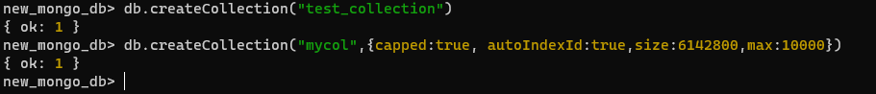

* 1. Dropping a collection

* 1. Insert a document

* 1. Query a document

* 1. Update a document

* 1. Delete a document



1. Use the New York City Restaurants data set to answer the seven questions below.
   1. How many restaurants are there in this collection?

**db.test_collection.count()**



* 1. List in alphabetical order each different (distinct) cuisine represented in this collection.

**db.test_collection.distinct('cuisine').sort()**

* 1. Return the name of all restaurants within the zipcode 10023 which serve Italian cuisine. Return only the names of the restaurants.

**db.test_collection.find(**

**{$and:[{"cuisine":"Italian"},**

**{"address.zipcode":"10023"}]},**

**{"name":1** **,"_id": 0})**

* 1. Which Borough has the most Greek restaurants? How many are there?

**db.test_collection.aggregate([**

**{$match:{cuisine:"Greek"}},**

**{$group: {_id:"$borough", count:{$sum:1}}},**

**{$sort:{count:-1}}**

**])**

**Answer:**

**{ _id: 'Queens', count: 58 }**

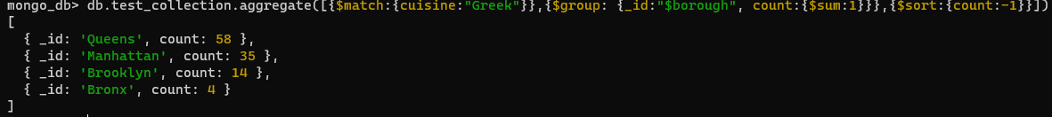

* 1. Return a list of restaurants (names) which have the string “Pho ” in their name. (“Pho” is a wonderful and delicious Vietnamese noodle soup.)

**db.test_collection.find({"name":{$regex: /Pho /}},{"name": 1, _id:0})**

* 1. Return a list of boroughs ranked by the number of Italian restaurants in the borough. That is, for each borough, find how many restaurants serve Italian cuisine and print the borough and the number of such restaurants sorted descending by this number. (HINT: use the aggregate method, and use a $group and a $sum.)

**db.test_collection.aggregate([{**

**$match:{cuisine:"Italian"}},**

**{$group: {_id:"$borough", count:{$sum:1}}},**

**{$sort:{count:-1}}**

**])**

* 1. Find the top 5 Greek restaurants in Brooklyn that have the highest total score. Return for each restaurant the restaurant’s name and the total score. (HINT: use the aggregate method with $unwind to parse out the scores array, followed by a $group and a $sum.)

**db.test_collection.aggregate([**

**{$match:{cuisine:"Greek",borough:"Brooklyn"}},**

**{$unwind:"$grades"},**

**{$group:{_id:"$name",total_score:{$sum:"$grades.score"}}},**

**{$sort:{total_score:-1}},**

**{$limit: 5}])**

