Lab1 Report_555 timer

Author: Chengming Li

1. **The scope trace of the output of the 555 timers**

Figure(1) Faster timer TLC555IDR

Frequency: 488.35Hz; Duty-Cycle: 52.552%; Maximum voltage: 4.82V

1. **Showing the rise or fall time of the faster timer**

Figure(2) rise edge:32ns

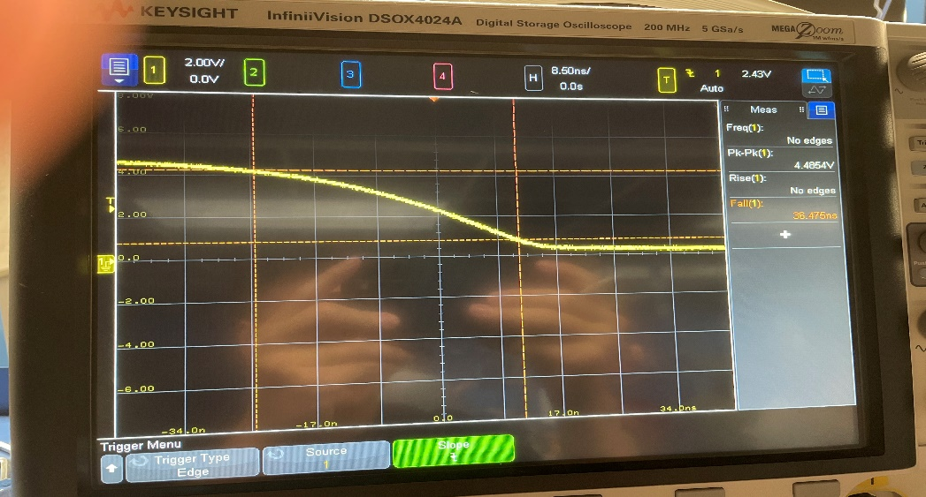Figure(3)fall edge: 36ns

1. **Timer Selection**

* For the screenshot, I use the faster timer TLC555IDR since it performs better in the output waveform features, like frequency and duty cycle.
* However, in the actual design, I use the slower timer, NE555, in the circuit implementation since it provides a greater current limit, and the 50-ohm resistor and one LED can connect to the circuit without affecting the output of the 555 timer.
* The disadvantage of using the slower timer is that the duty cycle and frequency of the output waveform are imprecise, with 66% as the duty cycle and 525Hz as the frequency.
* Based on the datasheet for TLC555IDR, TLC555IDR can sink 100mA and source 10mA typically. But, based on the datasheet for NE555, NE555 can both sink and source up to 200mA. Thus, the better current capability is the reason I choose a slower timer NE555 in my circuit design with a 50ohm resistor and LED.

1. **Description scope traces the meaning and my analysis**

* Based on figure(1), the vertical division is 0.63ms/div. For each cycle, the waveform takes roughly about 3 $\frac{1}{4}$ divs, which is about 2.1ms as the period and 488.4Hz as frequency. And duty cycle calculation is $\frac{ton}{t_total}=\frac{7}{13}=0.53=53\% .$ In my design, I was using 500Hz as the frequency and 50% as the duty cycle to do the resistance and capacitance analysis. So, the result is close to my expectations.
* Based on figure(2), the vertical division is 8.5ns/div. For this waveform, the rise time is roughly about 4 divs in total, which is 34ns in total as the rise time. So, it’s close to the measurement from oscilloscope.
* Based on figure(3), the vertical division is 8.5ns/div. For this waveform, the fall time is roughly about 4 divs in total, which is 34 ns in total as the fall time. So, it’s close to the measurement from oscilloscope.