Version 1 – Boiler plate code with no CSS.

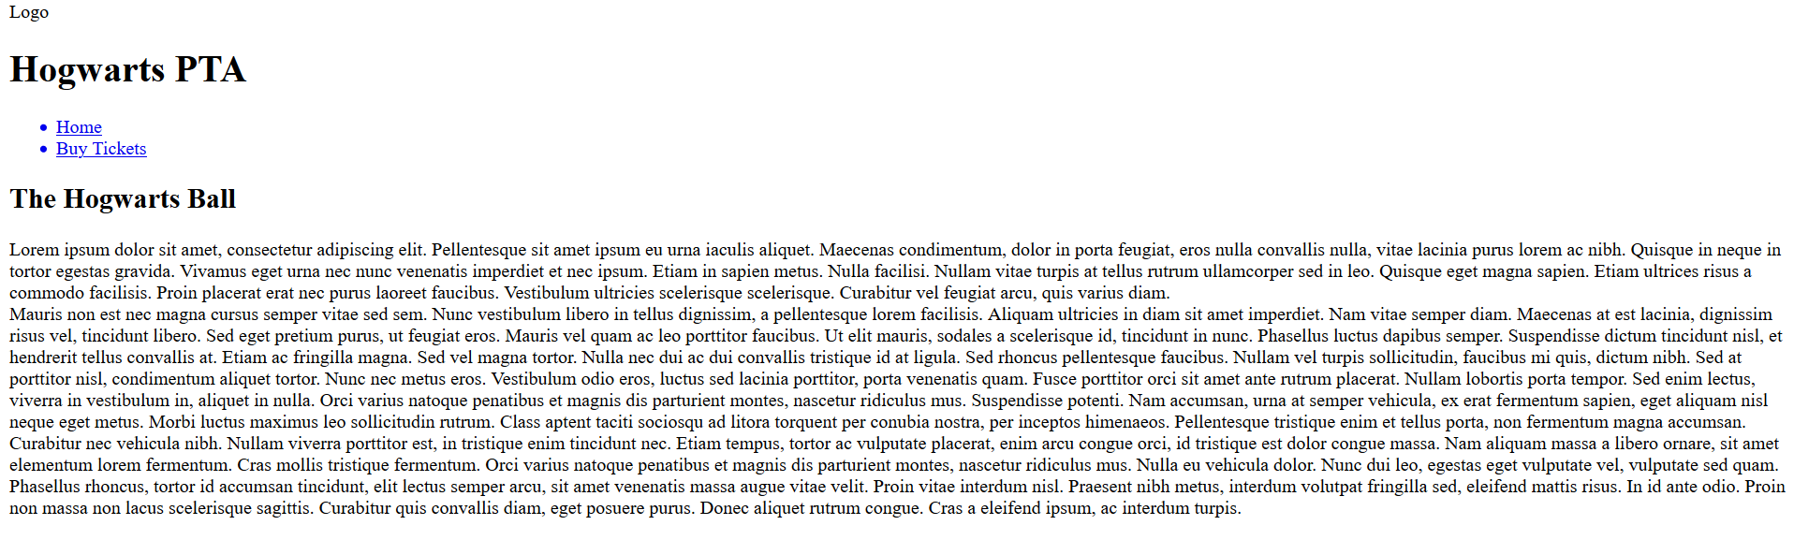

Implication – Cultural

My first consideration would be a color scheme in Hogwarts there are 4 houses Hufflepuff, Ravenclaw, Slytherin, and Gryffindor there is fierce competition between such houses. A website with the color of 1 house on it might be taken as prejudice to one house therefore I must avoid all colors of the houses or give each house’s color equal amounts of room. It is for this reason that I am choosing purple as the primary color for my web site.

Implication – Copyright

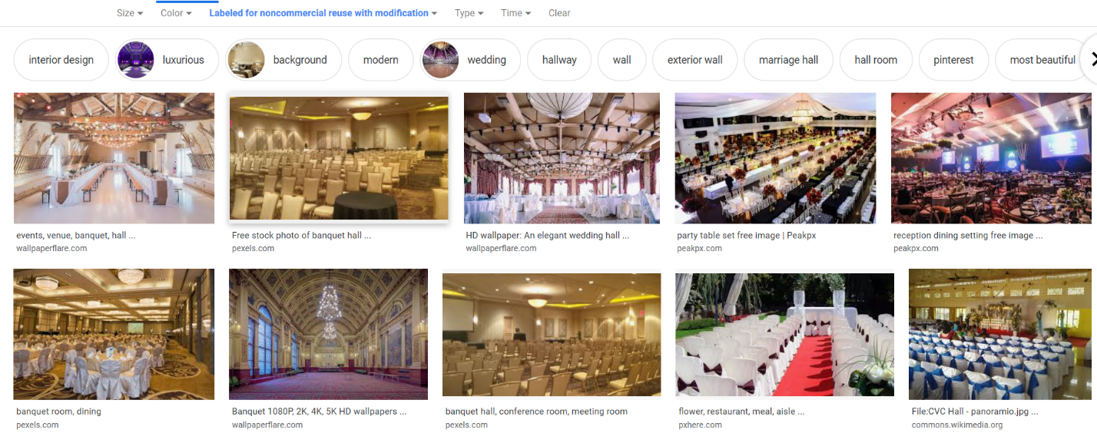I wanted to use an image of the Hogwarts Ball but this is protected by copyright, so I used Google’s license filter option.

Implication – Privacy

I want to protect my users data. I can do this by using prepared statements which should stop most forms of SQL injection.

Purchase Ticket Page

After some testing I noticed that if you did not select the checkbox you would receive this error.

