Edit inventory File:

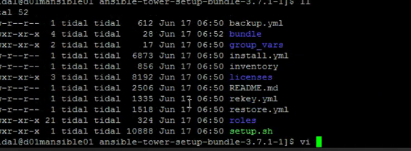

Edit admin_password and pg_password (which corresponds to Tower password and Posgres passwords respectively).

