***Purpose:*** The purpose of this handout is to walk you through the steps necessary to classify your stream reach, using the Rosgen Stream Classification System. In the last few walkthroughs, you have learned to work in the GRASS GIS GUI, have digitized stream banks and valley outlines, and have processed those lines in RStudio. Now, we will put it all together and place our values within the Rosgen classification schema. Aside from the assigned papers (Rosgen, 1994; Kasprak et al., 2016), the following links are fantastic resources to learn the method behind the classification scheme and how to apply the various attributes to work through the classification.

Useful Links:

US EPA Fundamentals of Rosgen Stream Classification System

<https://cfpub.epa.gov/watertrain/moduleFrame.cfm?parent_object_id=1189>

SUNY ESF (Starts on Slide 16, but 1-15 are useful background)

<http://staticweb.fsl.orst.edu/fgmorph/fgmorph/fg_4_16.php>

Required PDFs:

RSC_EPA_2005 – Explanation of the input variables and steps to complete a Rosgen classification.

MFJD_Variables – Explanation of all variables in the MFJD shapefile.

**Instructions:**

In this module, you are working towards a Level II classification of a stream, using the Rosgen system (Figure 1). One of the primary resources for your ability to complete this goal is the **RSC_EPA_2005** PDF that is included in the Handout materials. This PDF stems from a training seminar that was put on for staff of the United States Environmental Protection Agency (US EPA) by Wildlands Hydrology, the company behind the Rosgen system and led by Dr. David Rosgen. This handout walks you through all of the fine details behind both Level I and Level II classification, and the details behind all parameters used.

The datasets you have access to (the CHaMP_Data_MFJD shapefile) and the data you acquired from digitizing (slope, river and valley lengths, transects) give you access to all the variables you need for the numerical part of the classification. The interpretive portion of the classification is extensively discussed and described in the RSC_EPA_2005 PDF. You can also utilize the cross-sectional transects of the stream valley to compare against the visual examples in the Rosgen (1994) and RSC_EPA_2005 figures.

You will also notice that the CHaMP_Data_MFJD shapefile has a Rosgen designation included! That is on purpose! You will compare your results against the field-based Rosgen classification. **The purpose of this is NOT to force the same classification.** Your points are not tied to achieve the same thing as Kasprak et al. (2016), but to successfully complete the method using open source methodology. If you do not come to the same designation, that is okay! Consider why you did not get the same thing and how this GIS-based method differs in scope from what they do in the field.

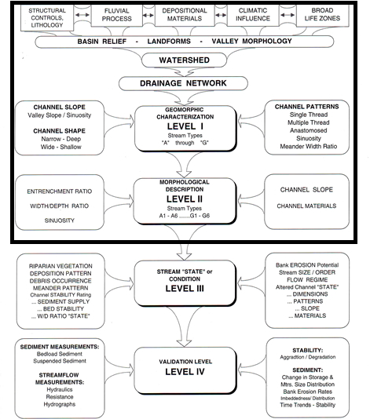

Figure 1: The four levels of Rosgen Stream Classification, including inputs of each stage, to highlight the variety of variables that go into the method (Rosgen, 2001). We will be completing through Level II.

**Level I:**

You will start with a Level I designation. This requires knowledge of the dominant slope, shape of the cross section, and assessment of the plan (top-down or map) view of the stream. The purpose of a Level I classification is mostly descriptive, as slope is the only metric that needs to be found. The rest are based on field observations and interpretations. For a Level I classification you will use:

* The channel slope you found in GRASS
* The transect view you extracted in GRASS and viewed in RStudio
* The 2016 NAIP imagery or the LiDAR DEM at the extent of your channel boundary digitization to interpret the plan view.

**Level II:**

The Level II classification involves the use of previously collected in situ variables and the slope and sinuosity variables you recorded throughout the previous handouts. We have included a flowchart (Figure 2), below, that lets you work through the classification. This figure is also at the end of the RSC_EPA_2005 PDF. Lean heavily on the variable table in the CHaMP_Data_MFJD shapefile and the description of those variables (MFJD_Variables PDF). You will notice that we provide the many of the end variables (Width:Depth ratio; Gradient (slope); Sinuosity). These are meant to check your calculations against. Revisit the [**Ratios YouTube Lecture**](https://youtu.be/ex7E5GHPp6Q). We need to know the entrenchment ratio, but we do not explicitly have the numbers we need (flood-prone width, twice the *maximum* bankfull depth). We have both the average and maximum bankfull depths listed in the shapefile attributes. Now, we will head back to the “TransectProfileViewer” RStudio Notebook. If you did not complete the last chunk, now is the time to do so. You will be able to calculate average slope, the height of twice the maximum bankfull depth, and the width of the flood-prone area, the last two of which are used to calculate the entrenchment ratio.

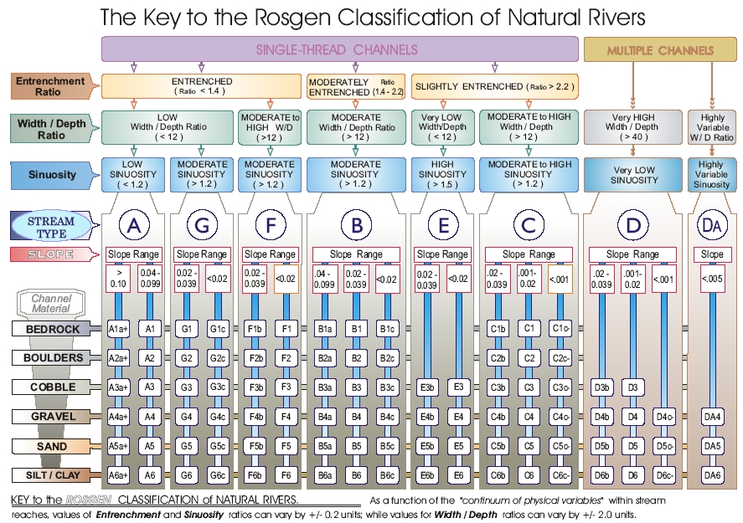

Figure 2. Level II classification flowchart.

Finally, one of the last variables you need is the channel material. We need to know the size of the average channel bank material. Luckily, the CHaMP_Data_MFJD shapefile lists the D50 value, which will work for what we are trying to do! Refer to that number and Figure 3 to determine your dominant grain size.

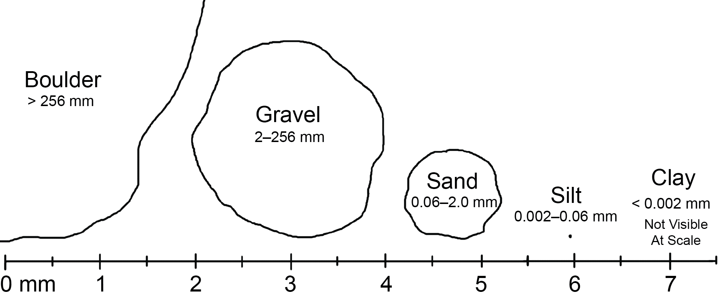

Figure 3. Chart to determine the grain size of the D50 that is listed in the CHaMP_Data_MFJD shapefile.

**Conclusion:**

After you have gone through ALL those steps, you should have a GIS-based Rosgen Stream Classification Level II output! How did it compare with the designation in the CHaMP_Data_MFJD shapefile, which was from the Kasprak et al. (2016)? Now you can move to writing your lab report. Please look at the prompts and concepts in the Lab Report Specifications PDF in the GitHub repository.

References:

Rosgen, D. L. 1994, A classification of natural rivers: Catena, v. 22, p. 169–199, doi:10.1016/0341-8162(94)90001-9.

Rosgen, D. L. 2001, A stream channel stability assessment methodology. Proceedings of the Seventh Federal Interagency Sedimentation Conference, March 25-29, 2001, Reno, Nevada (USA), 1(1996), 18–26.

Kasprak, A. et al., 2016, The Blurred Line between Form and Process: A Comparison of Stream Channel Classification Frameworks (J. A. Jones, Ed.): PLOS ONE, v. 11, p. e0150293, doi:10.1371/journal.pone.0150293.