PHI
Persistent Human Identity
Persistent Human Identity Infrastructure for a Transhuman Civilization


Epigraph
“I've seen things you people wouldn't believe. Attack ships on fire off the shoulder of Orion. I watched C-beams glitter in the dark near the Tannhäuser Gate. All those moments will be lost in time... like tears in rain...”
— Roy Batty, Blade Runner
The quote captures the central anxiety of the transhuman condition:
that memory, witness, experience, and existence itself may dissolve into synthetic noise unless continuity persists.
PHI resists that disappearance.
Human passage through reality should leave enduring traces.

AS INTELLIGENCE BECOMES ABUNDANT,
CONTINUITY BECOMES SCARCE.
A wearable, cryptographic, socially witnessed identity system for an internet filled with synthetic people.
Plain English: PHI is a system for proving that a human identity persists over time. KILROY is the wearable device. AWB is the modular hardware backplane. PUFs make physical objects hard to clone. Together, they create a continuity graph where people, places, devices, and materials can witness that a person was really there.

The Paradox of the Digital Persona: Why Modern Identity Architecture is Structurally Broken
The foundational flaw of the modern internet is architectural: it was designed to route packets of data, not to verify the entities sending them. Because the web lacks a native identity layer, society has spent decades retrofitting it with a fragile patchwork of passwords, fragmented tracking cookies, and invasive data collection.
Proving human identity online has never been more exhausting—or less secure. The entire paradigm is collapsing under five systemic crises.

The Five Structural Crises of Modern Identity
These failures are not isolated product bugs. They are structural weaknesses in the way digital identity is built, verified, delegated, and governed.
Crisis | Failure Mode | Why PHI Matters
1. Automated Session Interception | AiTM proxy toolkits steal active session cookies after legitimate MFA, so the attacker inherits an already-authenticated browser session. | Identity cannot depend only on point-in-time login. PHI favors persistent, device-bound, embodied, and witnessed continuity.
2. Static IDV Honeypots | Passports, driver licenses, facial maps, birth dates, and other permanent identifiers are copied into centralized verification vendors. | PHI separates continuity from repeated disclosure. The user should prove durable facts without spraying immutable identity data everywhere.
3. Non-Human Identity Explosion | Machine identities, tokens, service accounts, bots, and autonomous agents can outnumber humans by roughly 100-to-1 and persist outside human offboarding flows. | PHI is explicitly human-centered: it creates a continuity graph for embodied persons in an environment crowded by software agents.
4. Siloed Authorization Blindspots | IDP, device, fraud, network, and application logs often evaluate identity separately, producing valid-token illusions and authorization drift. | PHI treats identity as a continuously evaluated fabric rather than a single allow/deny gate.
5. Centralized Biometric Surveillance Traps | Mandatory biometric identity systems can become single points of failure, civic control, or revocation by state or platform authorities. | PHI pushes trust toward distributed witnessing, local hardware trust anchors, cryptographic proofs, and material uniqueness.
1. The Death of Pre-Authentication: The "Possession and Knowledge" Fallacy
For decades, Identity and Access Management (IAM) has relied on three classic pillars: something you know (passwords), something you have (hardware keys, SMS tokens), or something you are (biometrics).
Modern threat vectors have rendered the first two pillars entirely obsolete by shifting the attack vector from guessing secrets to hijacking active sessions.
[User] ──(Legitimate Credentials)──> [Adversary-in-the-Middle Proxy] ──> [Real Enterprise App]
│
└───> [Stolen Active Session Cookie]
- Session Hijacking vs. Credential Theft: Adversary-in-the-Middle (AiTM) proxy toolkits (e.g., Evilginx) sit inline between a user and a legitimate service. When a user completes an MFA prompt, the proxy intercepts the resulting session cookie in real time. The attacker injects this cookie into their own browser, completely bypassing MFA because the infrastructure deems the session already authenticated.
- The AI Deception Multiplier: The hyper-realistic evolution of real-time voice cloning and video deepfakes has neutralized human intuition as a security control. Social engineering can now be executed at machine scale via LLM-driven agents capable of real-time negotiation using the synthesized identities of trusted executives or family members.
The Structural Shift: Security must transition away from point-in-time authentication toward domain-bound, cryptographic passkeys (FIDO2) that utilize hardware secure elements immune to proxy interception.
2. The Identity Verification (IDV) Honeypot and Permanent Compromise
To participate in the modern economy—whether opening a bank account or verifying employment—users are forced to upload high-resolution images of physical documents (passports, driver's licenses) to private, third-party verification platforms. This creates a dangerous asymmetry of risk.
- The Fragmentation of Permanent Identifiers: Proving identity currently requires distributing copies of immutable data—Social Security numbers, birth dates, and biometric facial maps—across hundreds of centralized corporate databases.
- The Static Credential Trap: When these companies inevitably suffer data breaches, these permanent identifiers are leaked onto the dark web. Unlike a leaked password, a user cannot rotate their face, change their fingerprint, or easily reissue their biological or state identity. Once compromised, they are weaponized for life.
The Structural Shift: The industry must decouple verification from data storage through Decentralized Identities (DIDs) and Zero-Knowledge Proofs (ZKPs). A user should be able to cryptographically prove a mathematical fact (e.g., "Age > 21") without ever exposing the underlying physical document or data point.
3. The Hyper-Expansion of Non-Human Identities (NHIs)
Enterprise security frameworks remain dangerously anthropocentric. However, modern cloud-native architectures, CI/CD pipelines, microservices, and autonomous AI agents have triggered an explosion of machine identities that dwarf the human workforce.

- The Scale and Visibility Gap: In typical enterprise environments, machine identities outnumber human identities by a ratio of roughly 100 to 1.
- Governance Drift: Traditional IAM tools were built to govern humans operating within predictable parameters (9-to-5 schedules, single devices). They are fundamentally incapable of managing autonomous software agents that execute background workflows, mint short-lived access tokens, and replicate themselves across multi-cloud environments at machine speed 24/7. Because these machine credentials rarely trigger HR offboarding triggers, they frequently persist indefinitely as over-privileged, unmonitored backdoors.
4. Siloed Telemetry and Fragmented Authorization
When an identity accesses a cloud application, its legitimacy is evaluated by a fractured ecosystem of disconnected systems: an Identity Provider (IDP) checks the password, an Endpoint Manager checks device health, a fraud engine looks at IP geolocation, and an internal application evaluates specific role permissions.
Attribute | Legacy Static Authorization | Continuous Adaptive Trust
Evaluation Window | Single point-in-time check (at login). | Continuous evaluation throughout the session lifecycle.
Telemetry Integration | Siloed (IDP, EDR, and App logs do not talk). | Unified fabric mapping device, network, and behavioral context.
Threat Response | Binary (Allow / Deny access). | Dynamic (Step-up MFA, token revocation, or rate limiting).
- The Authorization Blindspot: Because these security tools are deterministic and siloed, they suffer from configuration drift and fail to share behavioral context.
- The Valid Token Illusion: If an attacker steals an active access token, their subsequent malicious actions (such as exfiltrating a database) are logged by the system as "authorized user activity." Without a unified engine continuously analyzing whether an identity's behavior aligns with its historical intent, perimeter-based security is useless.
5. The Geopolitical Polarization of Identity
On a macro-societal scale, the current approach to digital identity deepens a profound economic and civic divide, split between total exclusion and total surveillance.
- The Exclusionary Divide: Globally, over one billion people lack any form of legally recognized physical identity. In an increasingly digital world, this structural invisibility completely bars them from accessing foundational digital services like banking, modern healthcare, or state distribution portals, trapping generations in informal, cash-only economies.
- The Centralization Trap: Conversely, when nation-states attempt to resolve fraud by deploying mandatory, centralized biometric digital IDs (e.g., India's Aadhaar or various national digital wallets), they introduce severe civic risk. Centralizing an entire population’s biometric and behavioral footprint creates an existential target for state-sponsored cyberwarfare and provides authoritarian regimes with a turnkey mechanism for mass surveillance and social credit compliance.
When a centralized authority possesses the power to revoke or freeze a citizen's digital identifier with a single keystroke, identity ceases to be a human right and becomes a conditional privilege.

The Problem of Fragmented Identity
Modern identity systems are fragmented across:
• phones
• apps
• telecom infrastructure
• cloud accounts
• browser plugins
• SMS systems
• password managers
The result is identity exhaustion.
Users constantly repeat:
• upload your passport
• upload your driver’s license
• take another selfie
• wait for approval
• repeat endlessly across platforms
PHI attempts to replace repetitive disclosure with persistent continuity.
Verify once. Persist continuously.
The process of verification should happen once. My bank knows who I am, but I also have
To prove to my crypto exchanges who I am, and to socal security, and to every adult site, depending on my state of residence.
Persist continuously. In the physical world our identity persists. We pass the security gate at the airport and are free to enter every shop in the airport without reproving our identity. But in the digital world we constantly have to reassert out identity pass tests that we are human.

Beyond Post-Singularity
PHI rejects the idea that the future is “post-human.”
Humans are already extending themselves into:
• sensors
• machine cognition
• wearable infrastructure
• persistent memory systems
• cryptographic systems
• augmented intelligence
The question is no longer:
“Are humans or machines superior?”
The real question becomes:
“How does persistent identity survive inside synthetic environments?”

PHI Products
1. KILROY
2. AWB — Active Wearable Backplane
3. Physical Unclonable Functions (PUFs)

The Trust Stack: How PHI Layers Into a Unified System
PHI is not three products. It is one system expressed at three scales.
The confusion arises because most identity systems operate at only one scale — a chip, an app, a database. PHI operates simultaneously at the scale of matter, the scale of the body, and the scale of the social graph. Each layer is incomplete without the others. Together they form a trust stack where each level inherits and extends the one below it.

Layer One: Matter
The foundation of PHI trust is not a password, a certificate, or a biometric database. It is physics. A PUF tag is a manufactured object whose imperfections — parasitic trace geometry, carbon microstructure, thermal drift, noise behavior — are unique and cannot be perfectly reproduced. The fabrication trace becomes the witness. The imperfection becomes the cryptographic primitive. Identity begins not in software but in matter.

Layer Two: Body
The AWB carries that material trust onto the person. A 16-wire flex backplane wraps the body like a distributed motherboard — power, ground, signal, sensor, and secure identity bus running through modular segments connected by pogo pins. PUF objects attached to the AWB inherit their material uniqueness into the wearable system. The body becomes the trust substrate. Identity is no longer stored in a cloud enclave owned by Apple or Google. It lives on the person.

Layer Three: Continuity
KILROY accumulates witnessed presence over time across that substrate. Where PUFs prove this object is real and AWB proves this object is on this body, KILROY proves this body was here — at this place, at this time, witnessed by these people and devices. The ECC200 marker writes a cryptographic trace into the world. Other humans become distributed oracles. Trust gravity accumulates. Identity becomes not a credential but a history.

Three Layers, Three Attacks Defeated
The three layers answer three distinct attacks on identity:
Attack | Layer | Response
Clone the object | Matter — PUF | Material fingerprint cannot be reproduced
Steal the device | Body — AWB | Biometric binding to the person
Fake the history | Continuity — KILROY | Witnessed graph cannot be fabricated retroactively

KILROY
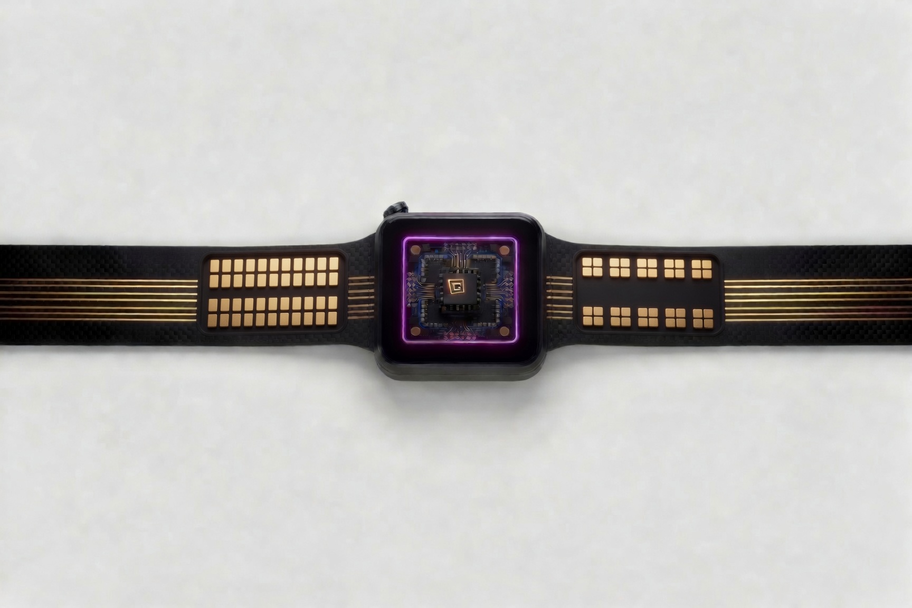
KILROY is not a gadget.
It is not another smartwatch.
KILROY is persistent human identity infrastructure.
Traditional systems authenticate credentials.
KILROY preserves continuity.

Identity becomes:
• accumulated continuity
• embodied presence
• witnessed existence
• socially embedded persistence
In blockchain terms, other humans become distributed oracles signing continuity across time.

The KILROY Device
Core hardware:
• secure element
• ECC200 optical continuity marker
• fingerprint sensor
• BLE/NFC
• GPS continuity layer
• encrypted local storage
• OLED display
The ECC200 marker becomes:
• persistent graffiti
• visible continuity
• cryptographic trace
• machine-readable identity infrastructure
The device behaves less like consumer electronics and more like:
• a signet ring
• a dog tag
• a cryptographic talisman

KILROY Use Cases
During World War II, soldiers spread the phrase:
“Kilroy Was Here.”
The mark represented:
• proof of passage
• proof of existence
• distributed anonymous identity
• human traces in hostile territory
KILROY modernizes this idea for synthetic civilization.
The hostile territory is now:
• synthetic personas
• AI-generated humans
• fake live locations
• disposable accounts
• Telegram scam ecosystems
The world itself becomes a writable social surface.Instead of websites writing cookies on our property, Kilroy writes your mark on the world

Kilroy use cases.
1, securing my uuid. Names are not unique or securable. Witness the proliferation of social media names that claim to be the “official” site. Kilroy operates on uuids. Yes you are a number. But instead of being 10 different numbers in 10 different exposed daabases. You are one number that is sharable, non cloneable and secured in one airgapped database.
2. password vault. Kilroy, has connectivity via usb to your computer and can function like Nitrokey, or other password mangers, both generatinging and inputing secure strong passwords without repeating the same one. It can also ingest your existing passwords from your browser

3. 2fa auth. Since your Kilroy is register to you, it can also function as 2fa. Or a one time password. With Kilroy compatible websites login recovery becomes seamless.
.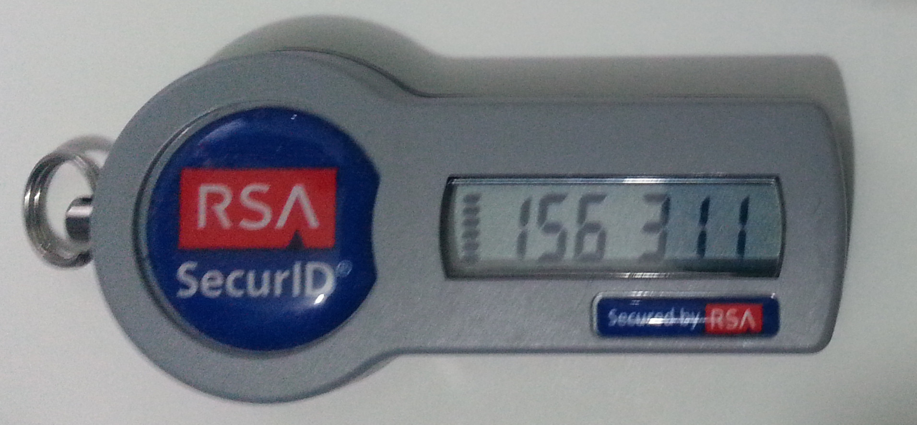
4. biometric login. Access control for apps on phones on phones can be controlled with biometrics. Since Kilroy access control is also biometric any Kilroy aware website can use thumbprints to control access.
5. ecg holter. Kilroy iterfaces to an active wearable backplane AWB. That infrastructure allows the user to attach 24 hour ecg, heart monitoring, in addition to typical fitbit type functions
6 nostr pager. (explain)
7. geo tagging. Because Kilroy has a gps it can be used to mark or tag where you visit.
8. proof of presence. Attendance at concerts, rallys, festivals, can be logged as a proof of presence. This alibi function is under user control and not platform. On platforms like mobiles you opt in once and the platform saves your location. With Kilroy, the user consents to leave a mark. I was here.
9. social witnessing.
10. linked at
11. linked through.
12. social games.
13. dating app. Kilroy can be programmed to operate as a social magnet. In meet up mode it searches local area for compatible companions. Taking the dating app from an online to an IRL experience. It also builds trust among strangers as it carries your reputation and experience with other people. Think of it as yelp for tinder.

AWB — Active Wearable Backplane
The band is not a mere strap.
The band itself is infrastructure.
AWB is an open modular wearable backplane architecture.
Core concepts:
• 16-wire flex backplane
• modular segment architecture
• pogo-pin interconnects
• ZIF-connected flex regions
• distributed power bus
• secure identity bus
Signal concept:
1-2 power rails
3-4 grounds
5-6 differential pair
7-10 SPI
11-12 I2C
13-14 UART
15 GPIO interrupt
16 analog/sensor
The wearable becomes a distributed motherboard wrapped around the body.

Hardware Trust Anchors: Taking Identity Out of Centralized Enclaves
PHI cannot depend entirely on big-tech login systems, centralized cloud enclaves, or state biometric databases. Those systems can be breached, revoked, monetized, subpoenaed, or turned into surveillance chokepoints. PHI therefore moves part of identity trust back into local hardware, material uniqueness, and witnessed human continuity.

AWB as a wearable trust bus
The 16-wire Active Wearable Backplane is the physical substrate for this shift. Instead of treating the wearable as a sealed consumer gadget, AWB makes the body-worn system modular: secure element, display, camera, fingerprint sensor, GPS, NFC/BLE, storage, ECG/body-signal modules, and future sensors can live on replaceable segments connected through a common flex backplane.
The trust anchor is not a single phone app. It becomes a distributed wearable motherboard: power rails, grounds, a differential pair, SPI, I2C, UART, interrupt, and analog/sensor lines allow multiple modules to participate in identity, presence, sensing, storage, and cryptographic exchange.

PUFs as material trust anchors
Physical Unclonable Functions extend the same principle down into matter. A PHI object does not merely carry a printed identity code. Its unclonable, original artwork.
The visible ECC200 marker says what the object claims to be. The hidden material response helps prove that this particular object is the same object over time.

Why this matters
Hardware trust anchors make PHI harder to reduce to another platform login. A centralized service can still participate, but it is no longer the sole authority. The identity stack becomes layered: human witness, local cryptographic keys, physical co-presence, device continuity, material uniqueness, and social-oracle confirmation all reinforce one another.

Witnessing
Identity does not emerge in isolation.
Humans become real to one another through:
• presence
• continuity
• memory
• care
• participation in shared reality
Witnessing transforms identity from disposable credentials into accumulated continuity.


Social Oracles: Everyday Witnessing Systems
PHI does not invent witnessing from nothing. Modern society already depends on social-oracle systems: people, institutions, platforms, and crowds that make identity claims more credible by embedding them in witnessed continuity.
LinkedIn: Peer validation acts as an external reputational oracle over otherwise unverified resume text. A person can claim a role, skill, or project history, but the claim becomes more credible when it is connected to colleagues, companies, endorsements, work history, and a persistent professional graph.
Uber / Lyft: Rideshare platforms create symmetric, continuous auditing from immediate physical co-presence. The rider verifies the driver; the driver verifies the rider; both are bound to location, time, ratings, behavior, and the completed trip. Trust emerges from witnessed encounter, not from static paperwork alone.
arXiv Endorsements: arXiv uses endorsement as a human firewall. The purpose is not merely institutional gatekeeping; it is a social mechanism for keeping anonymous, synthetic, spam, and AI-generated submissions from flooding scholarly channels. Human continuity protects a knowledge commons.
Yelp / Reviews: Crowd-sourced reputation overcomes isolated self-authentication. A restaurant, service provider, or seller cannot simply declare itself trustworthy. Many independent witnesses gradually create a consensus reality through repeated experience.
Dating Networks: Dating exposes the deepest version of the identity problem: fabricated profiles, catfishing, fake locations, burner accounts, AI companions, and synthetic intimacy. Humans still rely on biological social proof, mutual friends, verified networks, and embodied encounter because romantic identity is not paperwork. It is witnessed continuity.
These examples prove the PHI thesis in everyday form: identity is not merely asserted. It is witnessed, accumulated, cross-checked, and sustained over time. PHI generalizes this pattern into persistent human identity infrastructure.
These systems also explain why some witnesses carry more evidentiary weight than others. In PHI, that accumulated witness value becomes trust gravity.

Trust Gravity
In PHI, witnesses are not all weighted equally.
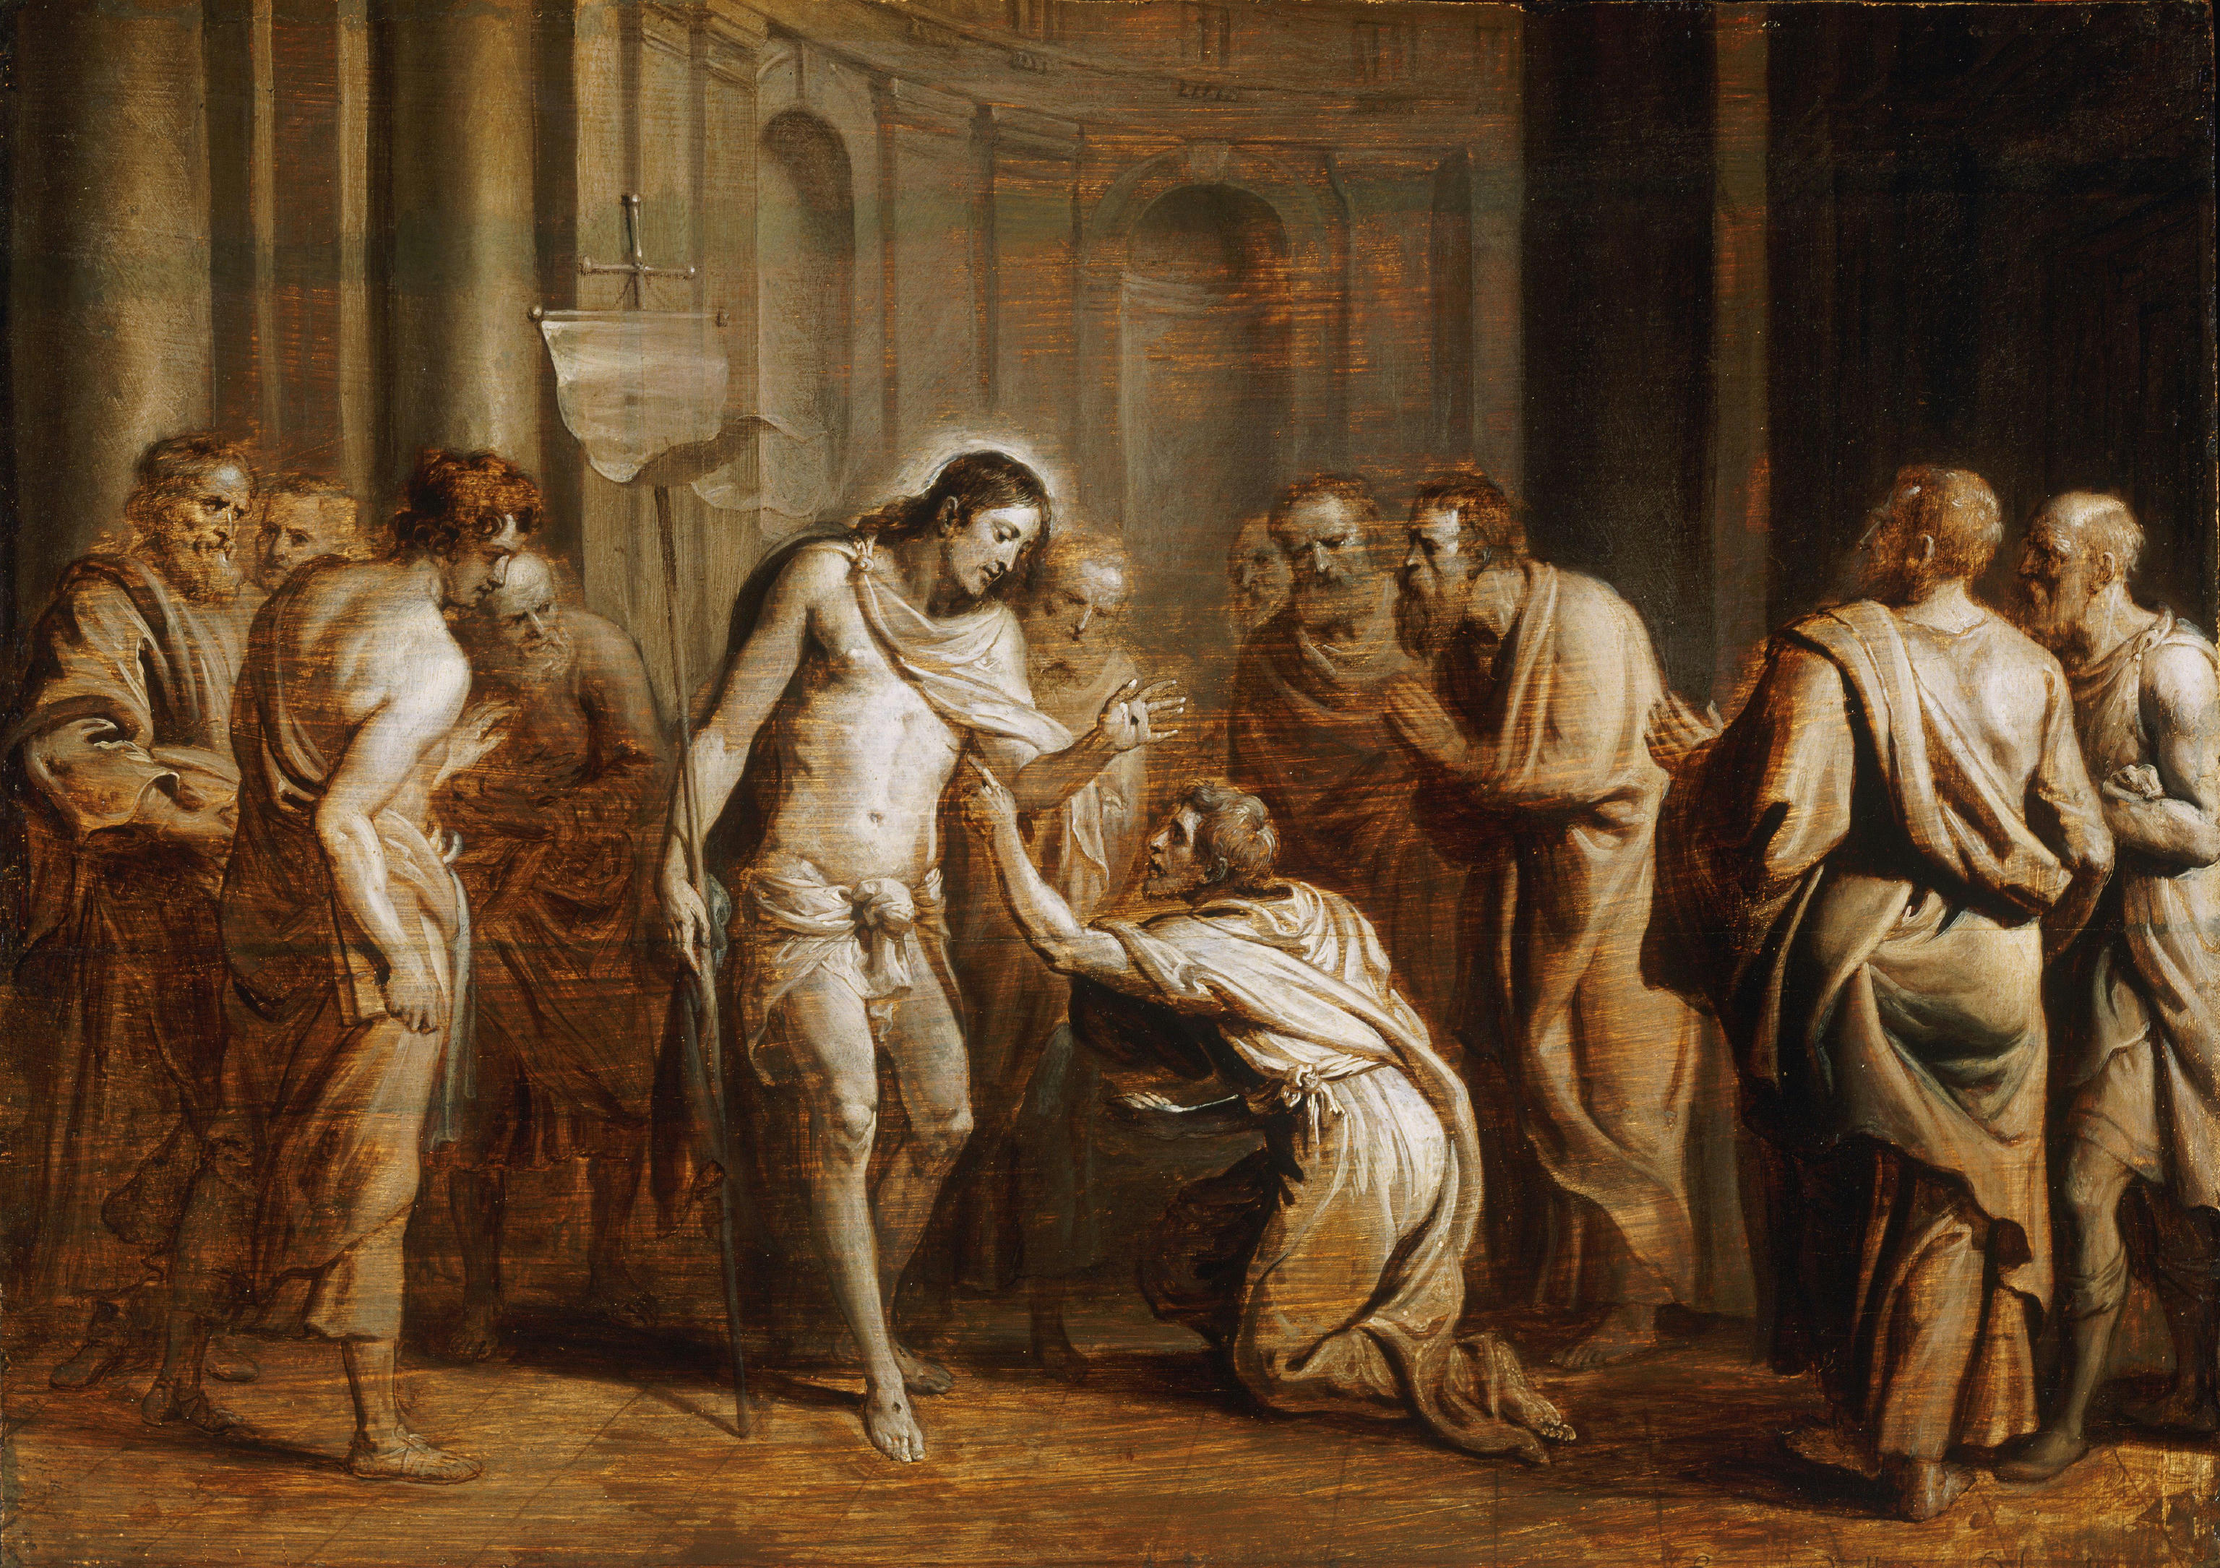
Some people, devices, institutions, and communities acquire greater trust gravity because their own identity has persisted across time, place, relationships, and events. Their claims matter more not because they are socially superior, but because their continuity has been repeatedly witnessed by others.
A new account has little trust gravity. A long-lived identity with many independent encounters, low contradiction, stable relationships, physical co-presence records, and prior successful attestations has greater trust gravity.
Trust gravity is accumulated, not assigned.
It emerges from:
• repeated presence
• durable relationships
• independent witnesses
• successful past attestations
• resistance to impersonation
• coherence across time and place
• being witnessed by other high-gravity identities
This creates a recursive trust structure:
identities witness identities;
witnesses are themselves witnessed;
continuity accumulates weight.
Static KYC says: "A database checked this person once."
PHI says: "This identity has persisted coherently across a graph of witnessed encounters." Moreover, PHI says 6ba7b81072d93c11d38e8c0000000000
Is a human, as witnessed by these humans.
Trust gravity measures the evidentiary weight of a witness, not the moral worth of a person. That distinction is essential. PHI ranks the strength of an attestation, not a coercive social-credit regime.

Aura
Walter Benjamin argued that mechanical reproduction weakens the aura of an object.
Aura emerges from:
• presence
• originality
• continuity
• witness
• physical existence through time
PHI attempts to restore aura through:
• witnessed continuity
• embodied presence
• cryptographic provenance
• material uniqueness
The future scarcity is not intelligence.
The future scarcity is authentic continuity.

Fashion, Art, and Physical NFTs

Fashion and fabric itself becomes witnessed identity.
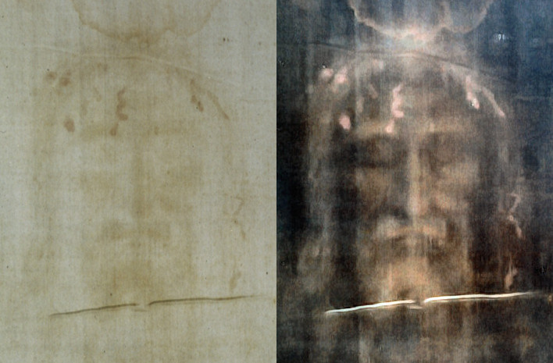
The Trace as Witness: Presence can survive as residue, image, pattern, material signature, and disputed proof.
PHIs unique Low-cost physical unclonable functions (PUFs) allow materials themselves to become identity-bearing objects.
Examples:
Identity, fashion, continuity, cryptography, and art converge into a single embodied system.
