CT331 – Assignment 4

Steven Noonan – 15517507

Github repo: https://github.com/stevennoonan/ct331_assignment4

Question 1:

Code:

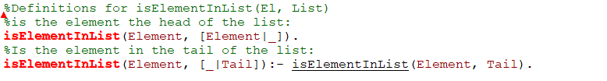

Output:

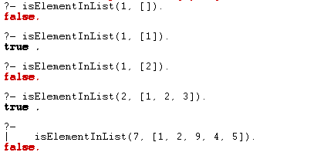

Question 2:

Code:

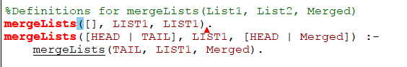

Output:

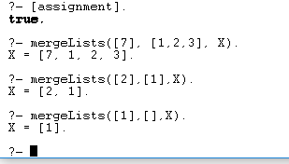

Question 3:

Code:

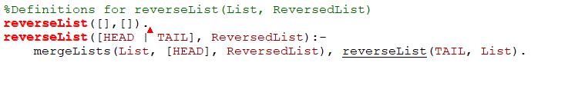

Output:

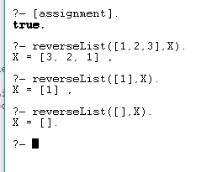

Question 4:

Code:



Output:

