ReqAgent
Application User Guide

A complete guide to what ReqAgent does and how to use each page of the application.

Author: Steven Saji Paul | Business Systems Analyst | June 2026

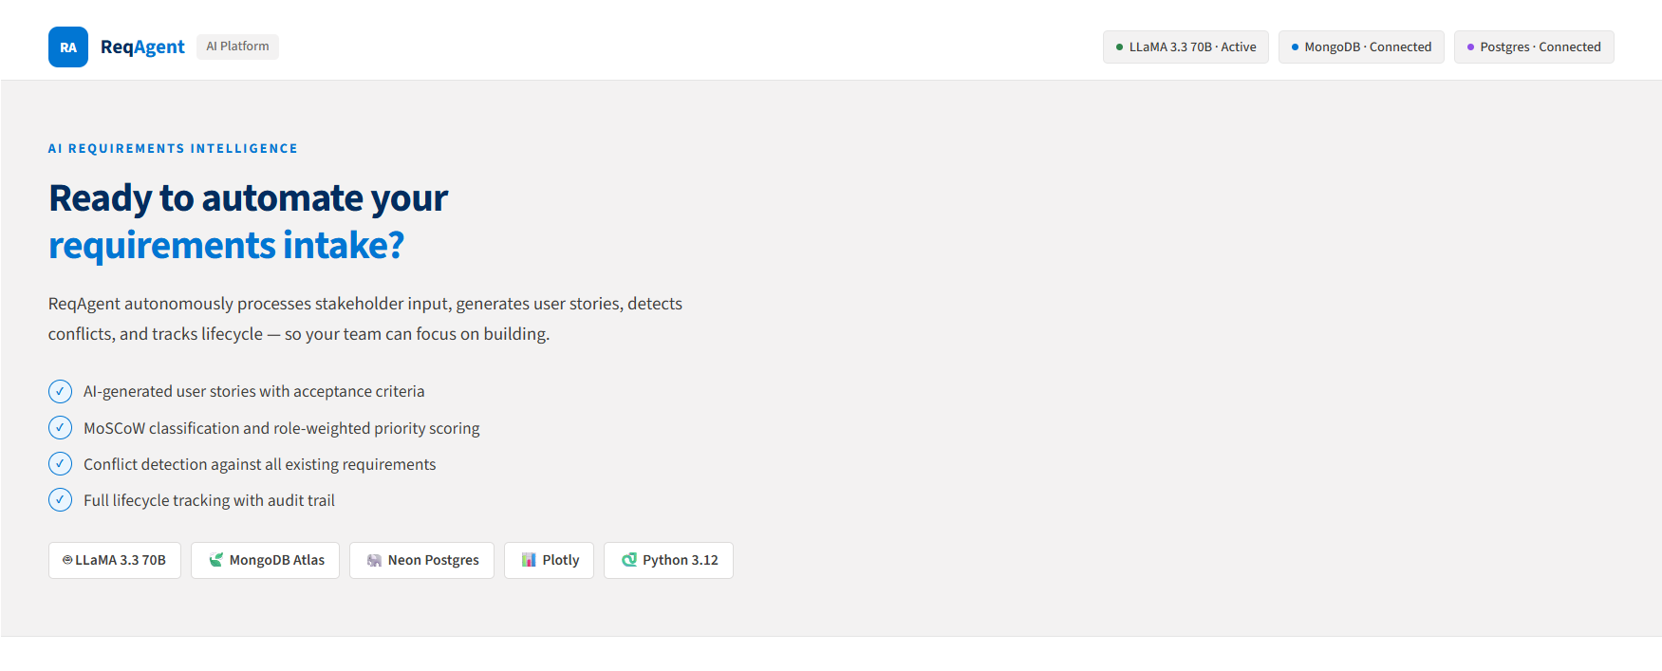
Figure 1 — ReqAgent homepage showing the navigation bar and hero section

Contents
- 1. What is ReqAgent?
- 2. How It Works — The End-to-End Flow
- 3. Page 1 — Submit Requirement
- 4. Page 2 — Requirements Tracker
- 5. Page 3 — Traceability Matrix
- 6. Page 4 — Analytics Dashboard
- 7. Quick Reference

1. What is ReqAgent?
ReqAgent is an AI-powered requirements intake and tracking platform. It eliminates the manual work that Business Analysts do every time a stakeholder submits a business requirement — writing user stories, classifying requirements by MoSCoW, assigning priorities, checking for conflicts, and maintaining traceability documentation.

In a traditional process, a single requirement can take a Business Analyst 6 to 8 hours to fully document. With ReqAgent, the same work is completed in under 30 minutes — with the AI handling all documentation automatically within 10 seconds of submission.

The platform has four sections:
- Submit Requirement — the intake form where stakeholders describe their business need
- Requirements Tracker — lifecycle management for every requirement from submission to completion
- Traceability Matrix — an always-current document linking requirements to user stories and acceptance criteria
- Analytics Dashboard — real-time metrics and charts showing the health of the requirements pipeline

Time Savings
Task | Manual Process | With ReqAgent
Write 3 user stories | 60–90 minutes | Under 10 seconds
Write acceptance criteria | 30–45 minutes | Under 10 seconds
MoSCoW classification | 15–30 minutes | Automatic
Conflict detection | 30–60 min (often missed) | 100% automated
Traceability matrix | 90–120 min to maintain | Always current, instant CSV
Total per requirement | 6–8 hours | 20–30 minutes

2. How It Works — The End-to-End Flow
Every requirement in ReqAgent follows the same automated pipeline from submission to structured output.

1 | Stakeholder submits form  A business user fills out the intake form with the requirement title, description, department, role, and business objective. Clicking Submit triggers the pipeline.

2 | Raw intake saved to MongoDB  The submission is stored in MongoDB Atlas exactly as written — no reformatting, no data loss. This is the permanent source of truth for what the stakeholder originally said.

3 | Existing requirements retrieved  The system pulls all existing requirement titles and descriptions from MongoDB to give the AI context for conflict detection.

4 | AI processes the requirement  Groq's LLaMA 3.3 70B model receives a structured prompt containing the new requirement and all existing ones. It generates user stories, acceptance criteria, MoSCoW classification, and a conflict report.

5 | Priority hardcoded by role  After AI processing, the priority score is set based on the submitter's role. C-Suite always gets High, End Users always get Low. This prevents the AI from inflating priorities based on urgent-sounding language.

6 | Structured output saved to Postgres  The user stories, acceptance criteria, MoSCoW, priority, and conflict data are saved to Neon Postgres for lifecycle tracking, traceability, and analytics.

7 | Results displayed to user  The full AI analysis appears on screen within 10 seconds. The requirement is now live in the Tracker and included in the Traceability Matrix and Analytics.

3. Page 1 — Submit Requirement
This is the starting point for every requirement. Any stakeholder fills out this form to submit a business need. The AI handles all documentation automatically.

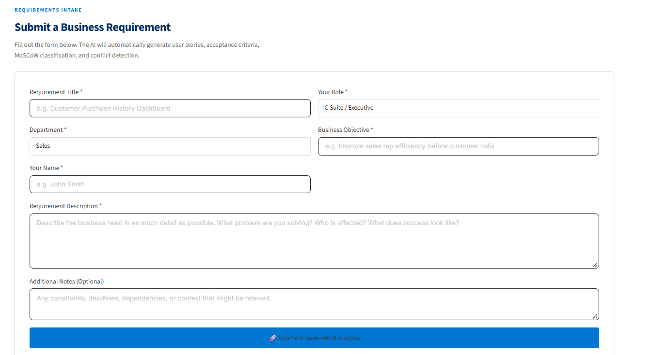
Figure 2 — The Submit Requirement form showing all required fields

Form Fields
Requirement Title * | A short, clear name for the requirement. Becomes the requirement's identifier throughout the system.

Your Role * | Determines the priority score. C-Suite and VP get High priority. Department Head and Team Lead get Medium. End User and External Stakeholder get Low. This cannot be overridden by the AI.

Department * | The department submitting the requirement. Used in the Analytics department breakdown chart.

Business Objective * | The business goal this requirement serves. Helps the AI write more relevant user stories.

Your Name * | The submitter's name. Appears in the Tracker and Traceability Matrix.

Requirement Description * | The most important field. The richer the description, the better the AI output. Describe the problem, who is affected, and what success looks like.

Additional Notes (Optional) | Constraints, deadlines, dependencies, or context. Not required but improves AI accuracy.

Priority Scoring by Role
Role | Priority | MoSCoW
C-Suite / Executive | High | Must Have
VP / Director | High | Must Have
Department Head / Manager | Medium | Should Have
Team Lead | Medium | Should Have
End User | Low | Could Have
External Stakeholder | Low | Could Have

Priority is determined by role, not by how urgent the requirement sounds. This ensures consistent, objective prioritization across all teams.

4. Page 2 — Requirements Tracker
The Requirements Tracker is where Business Analysts and Project Managers manage the full lifecycle of every requirement. All submitted requirements appear here as expandable cards.

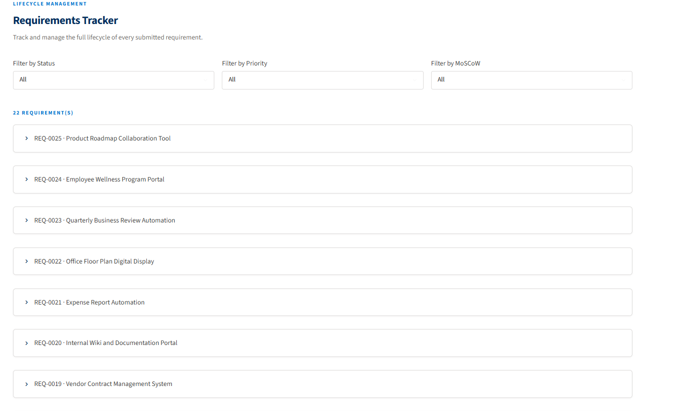
Figure 3 — The Requirements Tracker showing 22 requirements with filter controls

Filters
Filter by Status | Show only requirements at a specific stage: Submitted, Under Review, Approved, In Development, Done, or Rejected.

Filter by Priority | Show only High, Medium, or Low priority requirements.

Filter by MoSCoW | Show only Must Have, Should Have, Could Have, or Won't Have requirements.

Requirement Cards
Each requirement is displayed as a collapsible row. Clicking it expands a card showing:
- Status, Priority, and MoSCoW badges with color coding
- Story count showing how many user stories were generated
- Submitted By, Department, Role, and Created date
- Update Status dropdown with all 6 lifecycle options
- View Full Details button

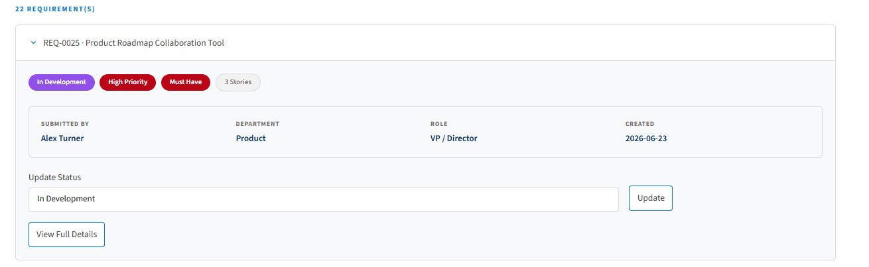
Figure 4 — An expanded requirement card showing badges, submitter info, and status controls

Lifecycle Stages
Status | Meaning
Submitted | Initial state. The requirement has been submitted and AI analysis is complete.
Under Review | A Business Analyst is reviewing the AI output and validating the business need.
Approved | The requirement is approved and ready to be added to the development backlog.
In Development | Engineering is actively building this requirement.
Done | The requirement has been implemented and delivered.
Rejected | The requirement was reviewed and will not be implemented in its current form.

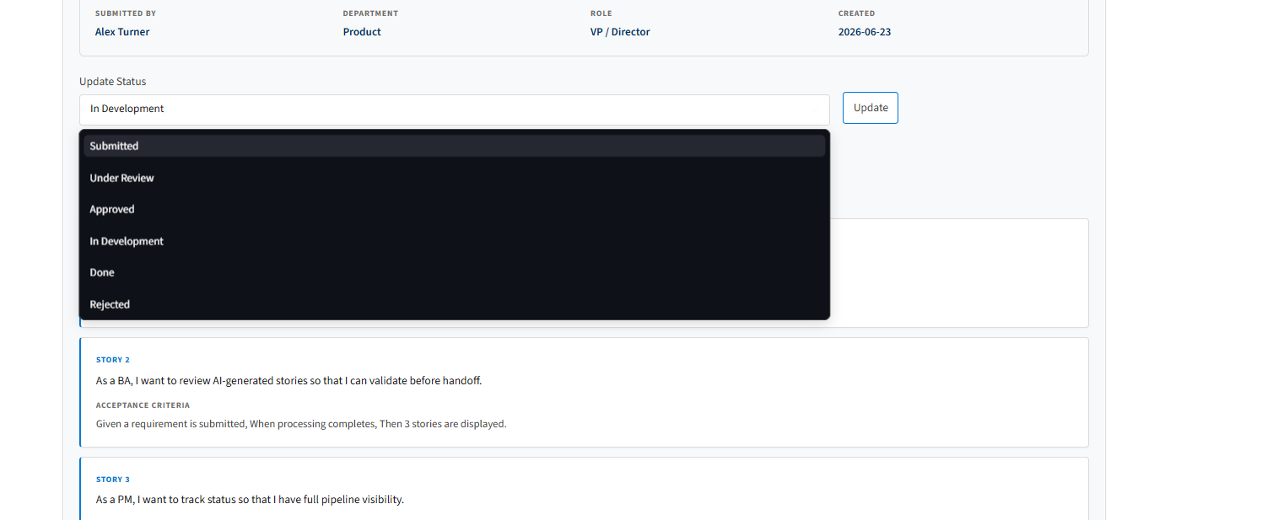
Figure 5 — The status dropdown showing all 6 lifecycle options

Full Details View
Clicking 'View Full Details' reveals three additional sections inside the card:
User Stories | All 3 AI-generated user stories with their full Given/When/Then acceptance criteria displayed in individual cards.

Audit Trail | Every status change logged with the old status, new status, and exact timestamp. Provides a complete history of who moved the requirement and when.

Original Intake (MongoDB) | The raw requirement description and business objective exactly as submitted — straight from MongoDB, unmodified.

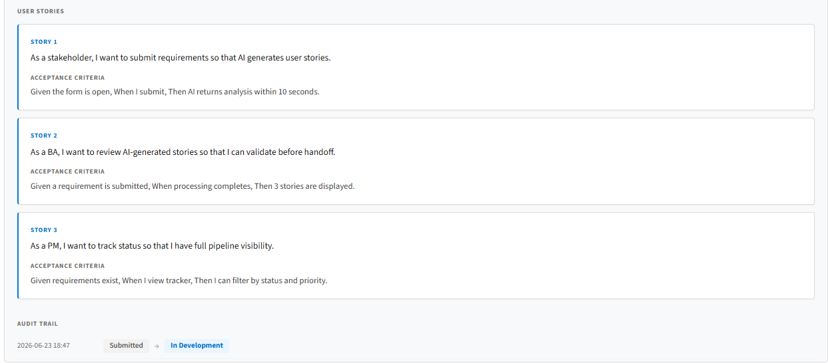
Figure 6 — User stories and acceptance criteria with audit trail below

5. Page 3 — Traceability Matrix
The Traceability Matrix is an automatically maintained document that links every requirement to its user stories and acceptance criteria. In a traditional BA workflow, this document is maintained manually in Excel and goes stale within days. In ReqAgent, it is always current and downloadable in one click.

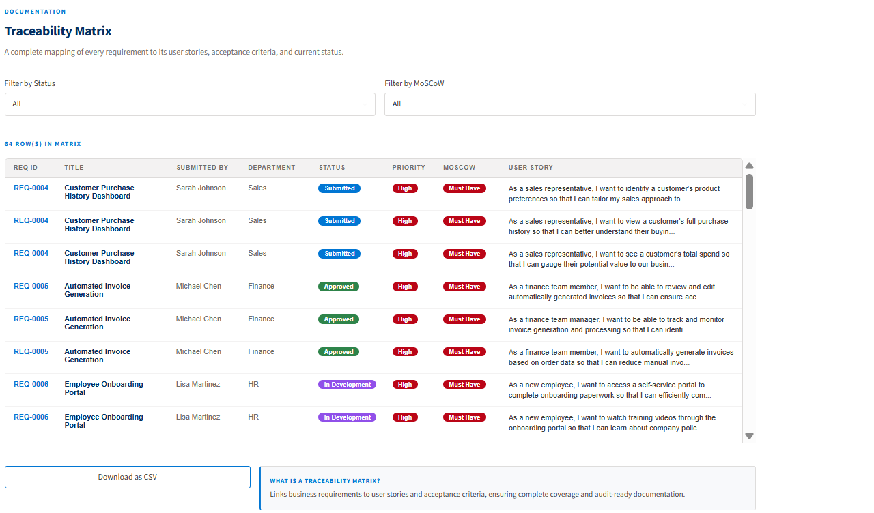
Figure 7 — The Traceability Matrix showing rows for all requirements

Understanding the Row Count
The matrix shows one row per user story, not one row per requirement. Since ReqAgent generates 3 user stories per requirement, a system with 22 requirements produces 66 rows (22 x 3). Each row is a direct traceable link between a business requirement and a specific user story.

Columns
REQ ID | Auto-generated identifier in REQ-XXXX format. Unique per requirement.

Title | The requirement title as submitted by the stakeholder.

Submitted By | Name of the person who submitted the requirement.

Department | The department the requirement came from.

Status | Current lifecycle status with color-coded badge.

Priority | High, Medium, or Low with color-coded badge.

MoSCoW | Must Have, Should Have, Could Have, or Won't Have with color-coded badge.

User Story | The AI-generated user story (first 120 characters shown in the table view).

Filters and Export
Filter by Status | Narrow the matrix to a specific lifecycle stage. Useful for reporting on approved requirements only.

Filter by MoSCoW | Narrow to a specific classification. Useful for sprint planning and release scoping.

Download as CSV | Exports the full matrix with all filters applied. The CSV includes complete user stories and acceptance criteria — not truncated. Can be imported into Excel, Jira, or any project management tool.

6. Page 4 — Analytics Dashboard
The Analytics Dashboard provides real-time visibility into the requirements pipeline. All metrics and charts update automatically as new requirements are submitted or statuses are changed. No manual reporting is needed.

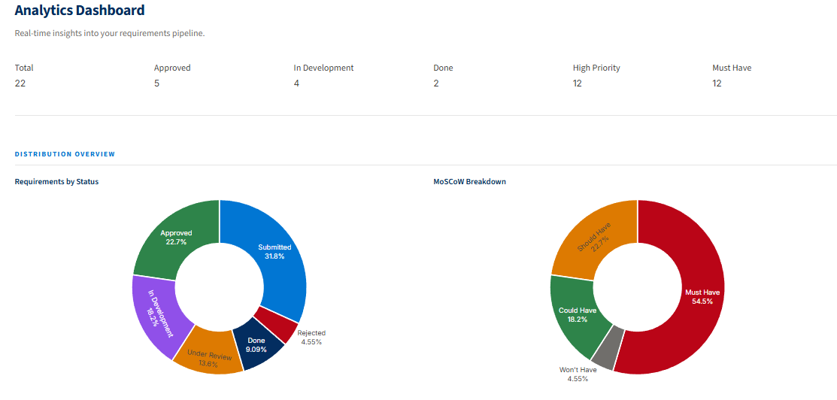
Figure 8 — KPI metrics and status/MoSCoW distribution charts

KPI Metrics
Total | Count of all requirements in the system across all statuses and departments.

Approved | Count of requirements in Approved status — reviewed, validated, and ready for development.

In Development | Count of requirements actively being built by engineering teams.

Done | Count of requirements fully implemented and delivered.

High Priority | Count of High priority requirements — submitted by C-Suite or VP roles.

Must Have | Count of Must Have requirements — the non-negotiable items for any release.

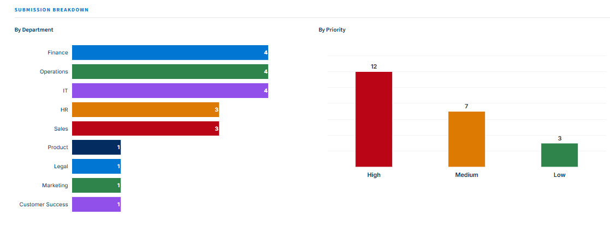
Figure 9 — Department and priority breakdown charts

Charts
Requirements by Status | Donut chart showing the percentage of requirements at each lifecycle stage. Gives an immediate read on how much work is still in flight versus completed.

MoSCoW Breakdown | Donut chart showing the distribution of Must Have, Should Have, Could Have, and Won't Have requirements. If Must Have dominates, the team has less flexibility in what can be deferred.

By Department | Horizontal bar chart showing how many requirements each department has submitted. Each department gets a distinct color. Shows which teams are driving the most demand.

By Priority | Bar chart showing the split of High, Medium, and Low priority requirements. Color-coded red, amber, and green.

Submission Timeline | Area chart showing requirements submitted over time. Useful for identifying periods of high intake and tracking velocity.

Submissions by Role | Bar chart showing how many requirements each submitter role has contributed. Helps identify whether demand is coming from leadership or end users.

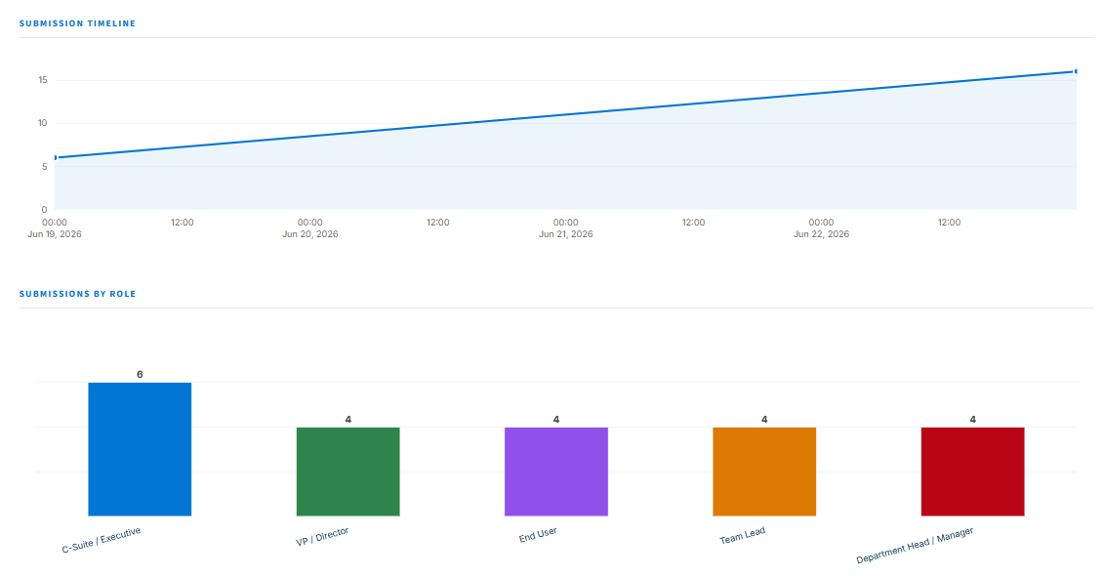
Figure 10 — Submission timeline and role breakdown charts

7. Quick Reference
I want to... | Go to | Action
Submit a requirement | Page 1 — Submit | Fill form, click Submit & Generate AI Analysis
See all requirements | Page 2 — Tracker | All requirements listed; use filters to narrow down
Update a status | Page 2 — Tracker | Expand card, select new status, click Update
Read user stories | Page 2 — Tracker | Expand card, click View Full Details
Check audit trail | Page 2 — Tracker | Expand card, View Full Details, scroll to Audit Trail
Download traceability report | Page 3 — Matrix | Apply filters if needed, click Download as CSV
Check pipeline health | Page 4 — Analytics | View KPI cards at top of the tab
See department demand | Page 4 — Analytics | Scroll to By Department chart
Check submission volume | Page 4 — Analytics | Scroll to Submission Timeline chart
See who is submitting | Page 4 — Analytics | Scroll to Submissions by Role chart

Steven Saji Paul | stevenspaul97@gmail.com | linkedin.com/in/stevensajipaul | stevensajipaul.github.io

