Progress, challenges and opportunities for Red Listing

# Abstract

Despite its recognition as an important global resource for conservation, the International Union for Conservation of Nature’s (IUCN) Red List of Threatened Species only provides assessments of extinction risk for a small and biased subset of known biodiversity. A more complete Red List can better support species-level conservation by indicating how quickly we need to act on species deemed to be priorities for conservation action.

Vascular plants represent one of the Red List knowledge gaps, with only ~6% of species currently on the Red List (including in the ‘Data Deficient’ and ‘Least Concern’ categories). Using vascular plants as a case study we highlight how recent developments, such as changes to rules, improvements to data management systems, better assessment tools and training, can support Red List assessment activity. We also identify ongoing challenges, such as the need to support regional and national assessment initiatives, the largely voluntary nature of the Red List community, as well as the core operating costs for the Red List. Finally, we highlight how new opportunities such as automation and batch uploading can fast-track assessments, and how better monitoring of assessment growth can help assess the impact of new developments. Most of our findings are also applicable to other speciose groups that are under-represented on the Red List.

We examine trends in plant Red Listing and conclude that the rate of new assessments has not increased in line with what would be required to reach goals like the Barometer of Life. This may result partly from a lag between recent changes and their effects, but further progress can be made by realising the opportunities outlined here and through ongoing and strengthening collaboration between IUCN and the Red List assessment community.

# 1. Introduction

The (IUCN) Red List of Threatened Species™ (hereafter the Red List) is an important global resource for conservation (Rodrigues et al., 2006). Faced with limited resources and ongoing threats (Symes et al., 2018), conservationists must prioritise their actions. Species prioritisation can be driven by different factors such as rarity (Ricketts et al., 2005), phylogenetic distinctness (Forest et al., 2018) or ‘keystone’ ecological roles (Marsh et al., 2007), but incorporating extinction risk, the likelihood of extinction under prevailing conditions (Mace et al., 2008), is crucial in order that priorities reflect the urgency with which we need to act. Currently, the Red List documents extinction risk of more than 95,922 taxa (IUCN, 2018a), but this represents a small proportion, and biased subset, of biodiversity (Stuart et al., 2010).

## 1.1 Gaps in Red List coverage – why the missing species matter

A major shortcoming of the Red List is its biased taxonomic coverage across the species-level diversity currently known to science. Comprehensive Red List assessments have been achieved for birds, mammals and amphibians, though assessment gaps for reptiles and fish reduce overall coverage for vertebrates to 67% of described species (IUCN, 2018a). Invertebrates, plants and fungi, on the other hand, are largely under-assessed, with average assessment <3% of known species (IUCN, 2018a). The lack of comprehensive Red List coverage for speciose groups has precluded their inclusion in large-scale analyses of threat status and conservation actions across the globe (Boyd et al., 2008; Grenyer et al., 2006; Venter et al., 2014). It is important that non-vertebrate groups are added to these analyses because more comprehensive coverage of biodiversity can provide new insights for conservation science (Clausnitzer et al., 2009; Larsen et al., 2012; Rodrigues and Brooks, 2007). Hence, there has been a call to extend the taxonomic coverage of the Red List and develop a more complete ‘Barometer of Life’ by assessing 160,000 species by 2020 (Stuart et al., 2010). However, with 93,577 species assessments published since the criteria were updated in 2001 (Result 1; IUCN, 2013), this will be challenging.

The gaps in coverage are also important because the Red List has become an increasingly vital tool to support conservation through its influence in the business sector (Bennun et al., 2018). For example, Performance Standard 6 of the International Finance Corporation (IFC) specifically incorporates species Red-Listed as Critically Endangered (CR) or Endangered (EN) in defining Critical Habitat. Development projects must offer protection for Critical Habitat or initiate remedial action (IFC, 2012). The Red List also influences the conservation funding sector, where a threatened species on the Red List can trigger funding through initiatives such as the Mohamed Bin Zayed Conservation Fund, IUCN’s own SOS fund or the Critical Ecosystem Partnership Fund. A perhaps unintended consequence of this influence is that less value is attached to species considered threatened, but not currently documented on the Red List. By omitting threatened species from the Red List we restrict our ability to influence conservation via these mechanisms.

There is also value in assessing species for the Red List even if there is insufficient information to assign a category of extinction risk: Data Deficient (DD) species are recognised as targets for research (Bland et al., 2015; Howard and Bickford, 2014) and their publication on the Red List has been shown to produce a listing effect that increases associated research output (Jarić et al., 2017).

## 1.2 Growing the Red List – vascular plants as a case study

The need for both taxonomic and temporal expansion (i.e. repeat assessments to detect trends) of the Red List has been recognised (IUCN Red List Committee, 2013; Rondinini et al., 2013; Stuart et al., 2010). In the following sections we first review recent developments in Red List assessment rules, guidelines and information management, and the tools and techniques available to support assessments. We consider what impact these changes have had on the Red List and the extent to which they are likely to contribute to filling existing gaps. Secondly, we consider ongoing challenges and issues influencing growth of the Red List. Finally, we explore opportunities for future work that may provide quick wins and can stimulate activity towards addressing knowledge gaps.

To better understand these developments, challenges and opportunities, we use vascular plants both as a case study and as a key species group. Vascular plants : i) are highly speciose, with 383,671 described species (Nic Lughadha et al., 2016) and are an important constituent of biodiversity (Bar-On et al., 2018); ii) are underassessed, thus representing a taxonomic gap for the Red List – assessments for only 6% of the species are currently published; iii) provide a historical perspective on Red Listing – they have been included since the earliest Red Data books (Lucas and Synge, 1978); and iv) a large plant Red Listing community already exists.

## 1.3 Overview of Red Listing process

To put the following sections into context, we outline a generalised Red List assessment workflow (Figure 1). There is no universally applied workflow, but Red Listing efforts often start with a species list, where species are either prioritised for assessment, or not (classified as ‘Not Evaluated’). This is followed by a pre-assessment stage where all available relevant data for each species are gathered. For plants this usually involves herbarium specimen data and observations (‘occurrence data’), or information derived from floras or monographs. The assessment stage is where data are analysed to produce metrics that allow the Red List criteria to be applied. If insufficient data are available, a species can be classed ‘Data Deficient’ (DD). If data are available to apply the criteria, and quantitative thresholds are met, a species can be assigned a threatened category: ‘Critically Endangered’ (CR), ‘Endangered’ (EN) or ‘Vulnerable’ (VU). If thresholds are not met, but are close, a species may be ‘Near Threatened’ (NT). If a species is far from the thresholds, it can be categorized ‘Least Concern’ (LC). The assessment can be a ‘desktop’ process, often carried out by an individual, or it can be part of a workshop where assessors, experts and facilitators process multiple assessments. Each assessment is then reviewed by an appropriate Red List Authority (RLA), often resulting in feedback to the assessor(s) in an iterative process until there is agreement. Finally, assessments are submitted to the Red List Unit where they undergo consistency and quality checks before publication on the Red List.

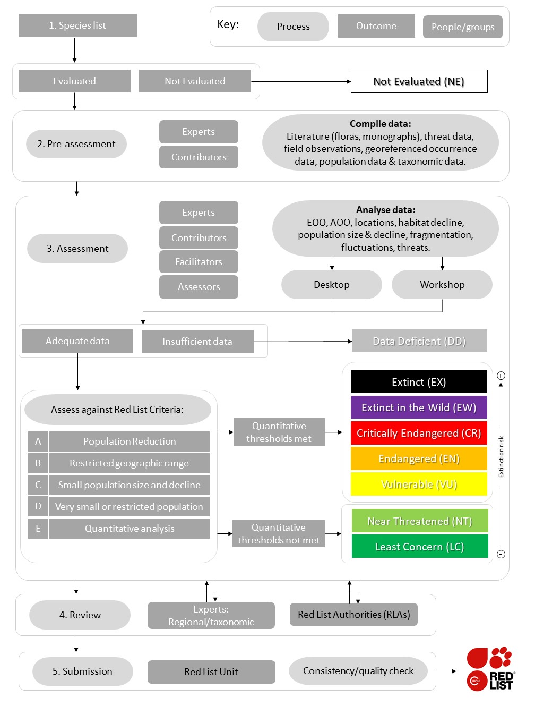

**Figure 1.** Generalised Red List assessment workflow from species list to publication on the Red List. Ovals represent processes, grey and coloured rectangles are outcomes and curved rectangles are people or groups. EOO = Extent of occurrence, AOO = Area of occupancy. Arrows indicate direction of flow through different stages, including feedback.

# 2. Recent developments

## 2.1 Automated criteria calculation and consistency checks

Red Listing is based on quantitative criteria that categorize species according to their likelihood of extinction under prevailing conditions (IUCN, 2001; Mace et al., 2008). The criteria are underpinned by metrics relating to extinction theory, such as small or declining populations (Mace and Lande, 1991). Thresholds set for these metrics determine to which category a species should be assigned (IUCN, 2001). Manual interpretation of the criteria, even by trained assessors, can sometimes result in errors that need to be resolved, either through assessment review or by IUCN Red List Unit staff, the team ultimately responsible for publication and upkeep of the Red List. Manual corrections absorb time that could be spent processing error-free assessments. To assist assessors, an automated *criteria calculator* has been built into the online Red List data management system, the Species Information Service (SIS). This automatically assigns the most appropriate category based on the data that have been entered (IUCN, 2018b).

Efficiency is also lost towards the end of the assessment process when time is spent checking assessments for consistency, such as ensuring the minimum requirements have been met. To reduce this wasted effort, an *integrity checker* has been added to SIS that checks that the appropriate level of supporting data has been provided – see section 2.2. The use of the *criteria calculator* and *integrity checker* will help assessors generate ‘technically’ correct assessments. Enforcing use of these tools is unlikely to result in a significant increase in the generation of new assessments; rather it will help to free capacity of the Red List Unit to process more assessments, and act as a training aid that can reduce assessor bias (Hayward et al., 2015).

## 2.2 Reduced data requirements

The comprehensive, quantitative nature of each Red List assessment both makes the Red List a valuable tool and slows its expansion. Assessors have been deterred by having to document species in much more detail than may be necessary to assign Red List Categories with reasonable confidence, resulting in potential contributors to the Red List either failing to finalise assessments or resorting to publishing them elsewhere.

Lobbying from the IUCN Plant Conservation Sub-Committee (PCSC) and the IUCN SSC South African Plant Specialist Group resulted in revised guidelines on supporting information requirements for Red List assessments (IUCN, 2016). The new guidelines identified that some data are not strictly required to support assessments and were therefore downgraded to optional. Further, data requirements were differentiated according to the final rating (e.g. minimal data are now required to support Least Concern assessments, while a threatened rating still requires all relevant data). The new guidelines also clarified IUCN’s justification for requesting these data, which included the need to analyse the Red List dataset and to allow basic functioning of the Red List website (searching and filtering). The new requirements split supporting data for Red List assessments into three categories:

1. **Required Supporting Information** – required for all Red List assessments or under specific conditions (e.g. plant growth form is only needed for plants).
2. **Recommended Supporting Information** – not mandatory, but assessors are encouraged to enter such data, especially for taxa included in the IUCN Species Strategic Plan, and for assessments generated by Red List Partner organisations.
3. **Discretionary (Optional) Supporting Information** – includes data not essential for the Red List, but which may be recorded for analytical purposes.

Reduced data requirements for Least Concern species open up the possibility of rapidly documenting many plant species – see section 4.2 – potentially leading to a future increase in Least Concern assessments published on the Red List.

This revision of data-requirements highlights several important points. First, pressure from IUCN plant Specialist Groups helped make positive changes to Red Listing procedures; the Red List Committee (incorporating Red List partners) was willing to respond. Second, the changes are also helpful for other highly speciose groups, such as fungi and invertebrates, that face similar challenges. Third, the Red List Committee should carefully consider which data are mandatory for Red Listing. New kinds of data will doubtless be required to support future Red List assessments, to document novel threats or support policy changes, but new data requirements should be clearly justified to the Red List community. The tools or techniques that may facilitate generation of the data should be considered.

## 2.3 Batch assessment upload with ‘SIS Connect’

The data management system underpinning the Red List (SIS) was developed to allow manual entry of supporting data for Red List assessments. However, supporting data needed for assessments, such as country-level distributions, taxonomic data or specimen data, often already exist in other databases. The need to manually transfer these data from one system to another limits the rate at which assessments can be added to SIS. To speed up the process, the Red List Unit developed a system to simultaneously transfer multiple assessments to SIS through a web service called ‘SIS Connect’ (<http://connect.iucnredlist.org/>). Data from a BRAHMS database at the Royal Botanic Gardens, Kew, were successfully transferred to SIS via SIS Connect in September 2016, and RBG Kew continues to use the system. Successful transfers have also been made by the New Caledonia Plant Red List Authority and South African National Biodiversity Institute.

To date, 509 assessments have been published on the Red List via the SIS Connect system and 915 more are in the pre-publication processing stage. Growth in SIS Connect use can be monitored to evaluate the benefit of this kind of technical development to the Red Listing process. If the rate of Red Listing does not increase, potential reasons should be investigated, such as insufficient capacity of the Red List Unit to process SIS Connect assessments, quality of documentation on the system or lack of awareness of its capabilities amongst the Red List community.

## 2.4 Inclusion of assessments in languages other than English

Until recently the Red List only published English-language assessments, contradicting IUCN’s position of supporting three official languages (English, French and Spanish). Because of this, regional Red Listing initiatives generating assessments in French (UICN France et al., 2013), Portuguese (Martinelli et al., 2013) and Spanish (Calderón Saenz Eduardo, 2005) have not published them on the global Red List, or have had to undertake expensive and time-consuming translations into English beforehand. This barrier constrained the potential connectivity between regional assessment initiatives and the global Red List, especially the submission of national endemics to the Red List, which are equivalent to global scale assessments (Rodríguez, 2008).

Recognising this issue, at the 20th meeting of the Red List Committee (May 2014), it was agreed that assessments could be submitted in French, Spanish and Portuguese. After modifications were made to SIS, 20 plant assessments from Brazil, in Portuguese, were successfully published on the Red List in 2016. The potential gain to the Red List in terms of growth in non-English language assessments has yet to be quantified, but with French, Spanish and Portuguese being the primary languages in seven of the top 17 megadiverse countries, each containing more than 5,000 endemic plant species (Mittermeier and Goettsch, 1997), the majority of which are currently ‘Not Evaluated’, there is clearly scope for a large increase in assessments. The most recent Red List update (2018-1) includes assessments of 38 trees from Haiti, written in French.

Language is now recorded as part of the assessment process, making it possible to track the uptake in assessments in each of the four recognised Red List languages. If further updates of the Red List still lack non-English assessments then other limiting factors should be explored, such as a lack of awareness of this decision across the Red List community, a lack of trained assessors or reviewers that are fluent in French, Portuguese and Spanish (but see section 2.7), or simply a lack of resources to carry out assessments.

## 2.5 Spatial tools support Red List automation

Spatial metrics used in the Red List criteria that were previously challenging to calculate have now become mainstream through the development of tools such as *ConR* (Dauby et al., 2017), *GeoCAT* (Bachman et al., 2011), *rCAT* (Moat and Bachman, 2017), and *Red* (Cardoso, 2017). These tools calculate spatial metrics such as extent of occurrence (EOO) and area of occupancy (AOO) using occurrence data, and *Red* also provides functionality to build species distribution models. The impact of these tools is reflected in the large number (~2,000) of species assessments in the Red List database (plants and others) that cite them (Craig Hilton-Taylor, pers. comm.). Advantages include rapid, consistent and auditable measurements, often via a user-friendly interface, although some require ability to use R. Disadvantages include potential uncritical user acceptance of results without considering other factors, such as sampling intensity (Sheth et al., 2012), although this can be addressed with training (see section 2.7). Different tools may also adopt slightly different methods for calculating key metrics, potentially leading to inconsistencies. A review of currently available tools, showing the strengths and limitations of each, would be useful to assessors and could be incorporated into training guidelines.

## 2.6 Linking new species and Red List assessment publications

New plant species are described at a fairly consistent rate, with a mean of 2,241 per year (1999–2017). Authors often include statements on the conservation status of newly-described species. Journals such as Kew Bulletin request descriptions of new taxa to include conservation statements specifically applying the IUCN Red List categories and criteria. However, these assessments rarely reach the global Red List. Of the 1,234 newly described taxa published in Kew Bulletin from 2003–2017, only 116 (9%) are currently on the Red List. A disincentive could be the extra effort required to transfer data to SIS and lack of perceived ‘reward’ for publication on the Red List if it is not considered equivalent to a scientific journal. The recent registration of the Red List with an international standard serial number (ISSN 2307-8235), development of a journal-like submission process and decision to publish Red List assessments as PDFs with digital object identifiers (DOI), and a more dynamic publication schedule, will all help to address this perception and incentivise publication on the Red List.

The connection between new species description and Red List assessment can also be improved with initiatives such as the ‘Species Conservation Profile’ (SCP) (Cardoso et al., 2016). The profile is equivalent to a Red List assessment, minus the final rating and rationale. It can be published through the *Biodiversity Data Journal* (BDJ) and subsequently submitted for publication on the Red List via SIS Connect. To date there have been 9 SCP papers published by BDJ, covering 195 taxa. Encouragingly, these included Red List knowledge gap groups such as Plantae, Aranae, Lepidoptera and Coleoptera. However, technical issues still need to be resolved and so far no SCPs have been transferred via the SIS Connect system (Craig Hilton-Taylor pers. comm.). If these issues can be overcome, other journals publishing new plant species descriptions can adopt similar strategies and utilise SIS Connect to help populate the Red List.

There may be valid reasons for a time-lag between description of new a species and its inclusion on the Red List. For example, species descriptions published towards the end of a calendar year are likely to miss the deadline for that year’s Red List update. To account for this, and monitor the rate at which newly-described plant taxa appear on the Red List, we looked at how much time had elapsed between formal description of a species and publication of an assessment for that species on the Red List. Species described and then assessed within 5 years were labelled as ‘New’, and species that were assessed more than 5 years since they were described were labelled ‘Old’ (Figure 2). Since 2003, the first year of significant plant assessments using Red List version 3.1 (IUCN, 2001), the number of ‘New’ species being converted to Red List assessments in a timely manner is low and falls well below the total number of newly described species each year.

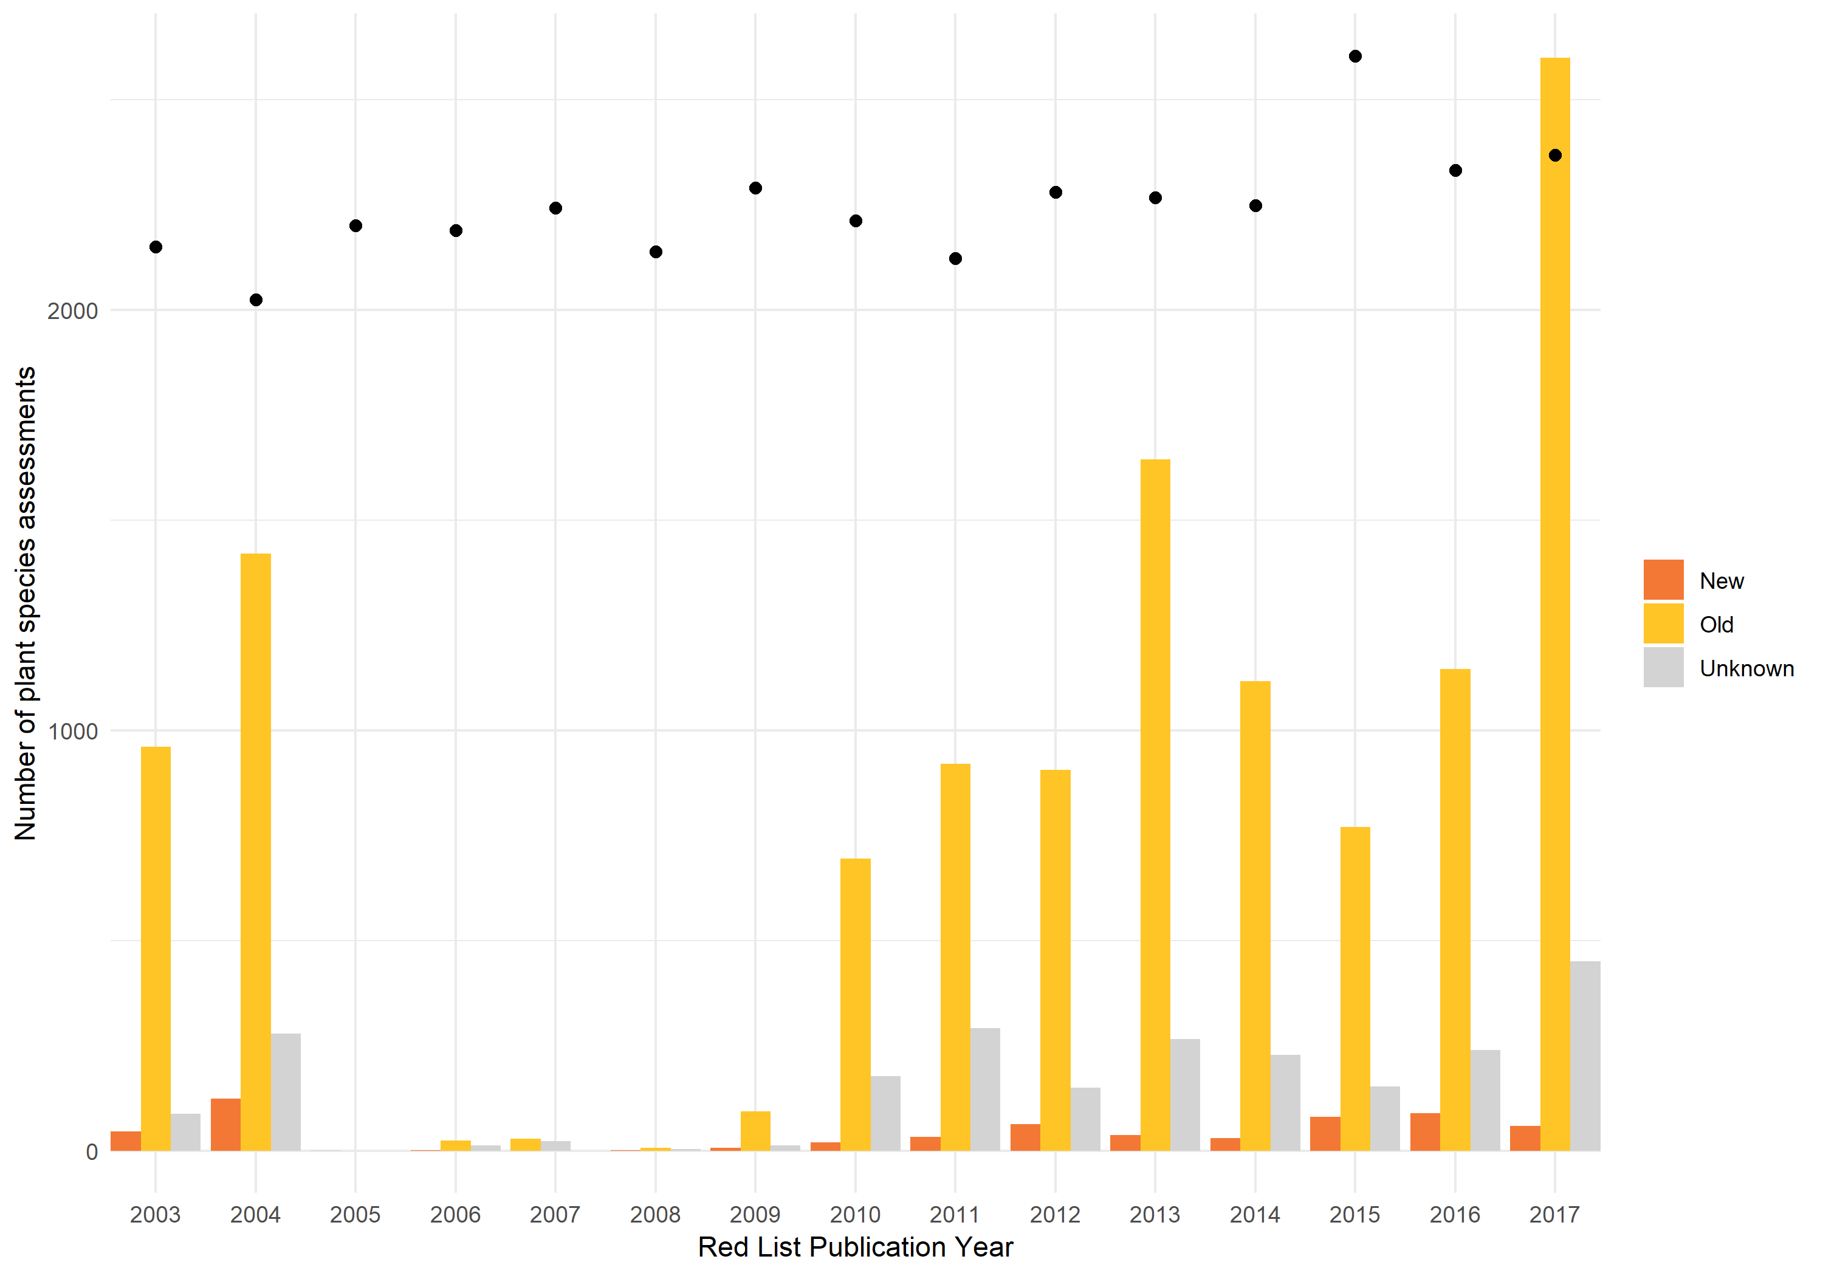

**Figure 2** Number of plant species assessments documented on the Red List for each year from 2003 – 2017, categorised by the time since the species was formerly described. Species that were documented on the Red List within 5 years of being published were labelled as ‘New’ and species where more than 5 years had elapsed before a Red List assessment was published were labelled as ‘Old’. When the year of species description could not be found or was ambiguous, it was marked as ‘Unknown’. As there are often multiple updates of the Red List in a year, the latest update was used to give the annual total for that year. The year 2018 was excluded as the true value is likely to be higher after another update, expected later in the year. There were no plant Red List assessments in 2005. Closed black circles show total number of newly described species for each year derived from IPNI ([www.ipni.org](http://www.ipni.org)). Date of species description was also derived from IPNI.

## 2.7 Consolidated training resources

Although submitting an assessment does not require formal training, many plant Red List contributors have been trained in applying the Red List Categories and Criteria and documenting an assessment. A shortage of plant experts trained in Red Listing could be a limiting factor for global Red Listing, and has been highlighted as a problem for regional Red Listing (Miller et al., 2007). Training is usually via formal instructor-led courses, often IUCN facilitated, or via self-study. Options for self-study have been greatly enhanced by the development and release of an online training course, providing the same curriculum as the instructor-led course. The “Assessing Species’ Extinction Risk using IUCN Red List Methodology” course, available from the ‘ConservationTraining’ portal <https://www.conservationtraining.org>, was launched in April 2014, and enrolled 2,513 people by October 2016 (Caroline Pollock pers. comm.).

Currently, it is difficult to analyse the impact of Red List training because trainees are not adequately tracked. This could be resolved with ORCID identifiers, unique 16-digit numbers that unambiguously identify researchers (Haak et al., 2012). If Red List trainees sign up for ORCID identifiers and document Red List training as a qualification, and if ORCID identifiers are linked to Red List assessments, it will be possible to link trainees with assessments, and quantify the impact of training on assessment activity.

The training material has been translated into Spanish and French, enhancing its reach. If a trainee’s language is documented through ORCID, along with keywords on geographic and taxonomic interests, then it will also be possible to query ORCID to identify potential recruits to fill Specialist Group gaps (see section 3.3).

Instructor-led training (as opposed to self-learning) is also likely to grow the number of plant specialists contributing Red List assessments, and training capacity is increasing as more trainers are trained. There are now 67 certified Red List trainers, including 24 with a plant specialism. Training should be targeted at areas of high plant diversity and offered in the most appropriate supported language. Training should also be followed up with a period of first-time assessment support as several sessions may be needed before assessment competency is attained (see section 4.3 for further support tools).

# 3. Challenges

## 3.1 Funding

Although the IUCN Red List is a critical conservation resource, its long-term stability could be compromised if core running costs are not met. This has already been recognised in the Red List Strategic Plan (Result 9: The IUCN Red List is sufficiently and sustainably financed) (IUCN Red List Committee, 2013). In 2013, growing and maintaining the Red List cost US$4.7 million, plus the equivalent of US$0.5 million in volunteer time (Juffe-Bignoli et al., 2016). For a flagship product, this is small relative to IUCN’s annual income of US$129 million (IUCN, 2017); Red List sustainability and growth may be at risk if funding is not prioritised to support vital infrastructure such as SIS, and to staff the Red List Unit sufficiently. Stabilising the core Red List operations, such as maintaining and developing SIS, quality control, standards development, training and support will ensure that additional funding can be wholly directed towards assessment and reassessment generation.

The only comprehensive evaluation to date (Juffe-Bignoli et al., 2016) revealed that philanthropy was the biggest source of Red List funding (42%), followed by governments (30%). The small (3%) contribution from the private sector can grow, and recent partnerships such as that with the Toyota Motor Company (https://www.iucn.org/content/new-iucn-toyota-partnership-expand-knowledge-threats-global-biodiversity) illustrate that large multi-nationals are willing to engage with the Red List. This commitment to tackle gaps in coverage such as plants ([http://www.kew.org/about/press-media/press-releases/toyota-supports-kew’s-vital-research-threatened-plant-species](http://www.kew.org/about/press-media/press-releases/toyota-supports-kew's-vital-research-threatened-plant-species)) is a model that other multi-nationals can follow.

## 3.2 National and regional assessments for the global Red List

Many regional or national scale plant assessments have not been included in the global Red List. However, if IUCN categories and criteria have been applied and species are endemic to the region of assessment, then they are equivalent to global assessments and could be published on the Red List. A recent review of all digitally available plant conservation assessments revealed that 241,919 have been published (Bachman et al., 2017), representing 111,824 species, most of which were assessed using IUCN Red List criteria (see *ThreatSearch* to access assessment data [http://www.bgci.org/threat_search.php]). Approximately 60% of plant species are endemic to a single region (Bachman et al., 2017), indicating that a large potential source of global Red List assessments already exists. Barriers such as the need to translate (section 2.4) and difficulties with batch transfer (section 2.3) have now been resolved, but a clear strategy is needed to engage the active community of regional assessors with the global Red List programme.

Global Red Listing of endemic plant species can be prioritised by cross-referencing regional or national assessments in *ThreatSearch* with checklists of plants in these areas. The establishment of a National Red List Working Group has also helped align national Red Listing initiatives with the IUCN Red List (Rodríguez, 2008) by focusing on training in the application of IUCN Regional Guidelines and building awareness of batch import options (section 3.4). Good communication between the IUCN Red List Programme and regional assessors is needed to ensure value is added to national/regional assessments by publishing them on the global Red List (Miller et al., 2007).

## 3.3 Supporting the Plant assessment champions –Specialist Groups and Authorities

IUCN SSC Specialist Groups (SGs) and Red List Authorities (RLAs) are the engines of the Red List programme, but lack of taxonomic and geographic coverage of these groups limits the rate at which assessments can be generated and validated for publication on the Red List. The SGs and RLAs are networks of volunteer experts providing vital roles for the Red List [<https://www.iucn.org/theme/species/about/species-survival-commission/governance-documents>]. The remit of SGs is promoting and delivering conservation – including producing Red List assessments – for a focal group of species. The RLAs, sometimes embedded within SGs, ensure all assessments of species within their jurisdiction have applied IUCN categories and criteria correctly, via an independent review process. There are 38 SGs or RLAs for plants, some with taxonomic focus (e.g. Orchid SG), some with geographic focus (e.g. Chinese Plant SG) and some with thematic focus (e.g. Medicinal Plant SG) (Table S1). Unsurprisingly, species within the remit of taxonomic SGs or RLAs are more likely to be assessed than expected by chance (P<0.001; Table S2).

Coverage of plants by the SGs/RLAs is taxonomically and geographically uneven. Several large, important plant families (e.g. Asteraceae, Fabaceae, Poaceae, Rubiaceae,) have no SG/RLA, and geographically there are gaps in known plant diversity hotspots such as Central America, north-western South America, West Africa, Australia, India and South-East Asia (Figure 3). Thus, many plant species fall outside the remit of any Specialist Group. The recent addition of the Indonesia RLA and Colombian SG and plans for a West African Plants RLA, a Sonoran Desert Plants SG and a Western Ghats Plant RLA, will all help address these gaps.

We call on the global community to work towards strategically establishing more groups, especially in diversity hotspots. The most effective investment would be to set up national RLAs in mega-diverse countries. Currently, only 9 mega-diverse countries are covered by plant SGs (Table S1). National Red Listing projects allow countries to monitor progress towards achieving Aichi Target 12 (UNEP/CBD, 2010).

SGs/RLAs are voluntary, built on goodwill. IUCN SSC should clearly specify incentives for experts to engage voluntarily with these groups, and should support those wishing to set up new groups through, for example, seed money, streamlining the application process, ensuring rapid decisions on proposals for new groups, and providing training on roles and responsibilities. Consolidating and supporting existing groups through training is also a priority.

Establishing more SGs and RLAs may mean greater jurisdiction overlap. Although validating an assessment only requires one RLA, each relevant RLA should be informed of the assessment, and according to present guidelines has up to three months to review it (IUCN, 2016). This is intended to ensure robust review of Red List assessments, but could also delay the review process. To avoid bottlenecks caused by sequential reviews, we encourage RLAs with overlapping remits to review assessments in parallel where possible (e.g. within one three-month period), or if they are happy to do so, to cede responsibility to the best-placed RLA. A review provided by one RLA, that has been fully addressed by assessors, should be, and typically is, sufficient for publication of an assessment.

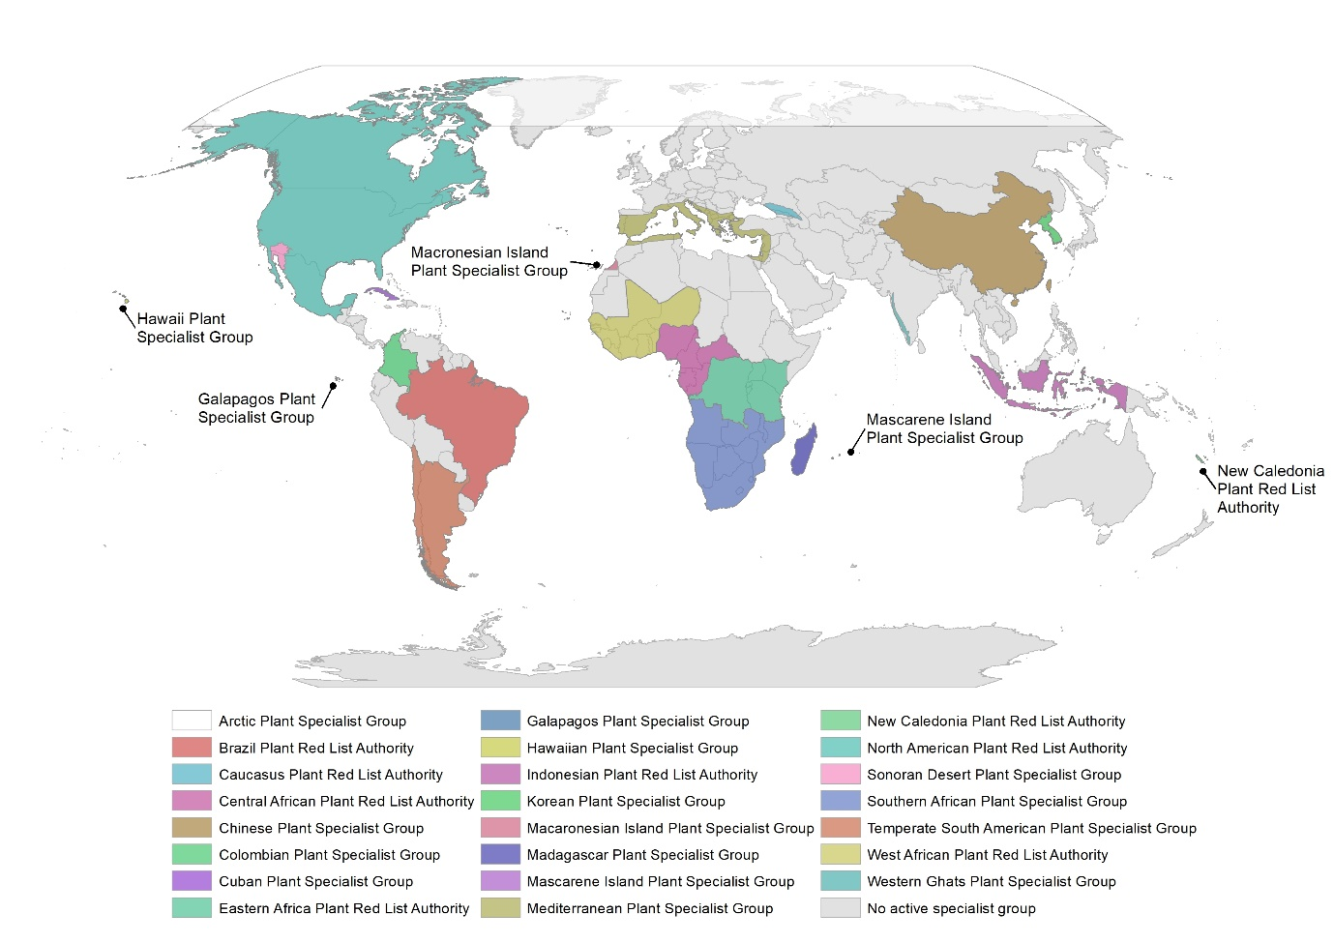

**Figure 3**. Coverage of the world by plant specialist groups (and Red List Authorities) with a geographic focus. The West African, Sonoran Desert and Western Ghats Plant Specialist Groups are in preparation.

# 4. Opportunities

## 4.1 Automated documentation of Least Concern species

The manual nature of species assessment is a major factor limiting growth of the Red List, but automation is possible. Reduced data requirements (section 2.2) and batch assessment transfer options (section 2.3) have opened the possibility of scaling-up documentation of Least Concern assessments. Many required fields for Least Concern assessments, such as taxonomy, countries of occurrence and plant growth form, already exist in databases such as Tree Search [http://www.bgci.org/global_tree_search.php] or Plants of the World Online [http://www.plantsoftheworldonline.org/]. Batch generation of Least Concern assessments that meet minimum requirements is quicker than a manual approach. We developed a tool using freely accessible data to generate required data for LC assessments, including spatial points, at a rate of one assessment every 1–2 seconds (https://github.com/stevenpbachman/XXXX), compared to a rate of up to 5 LC assessments per day for a trained assessor. Assessments still need to be transferred through SIS connect and reviewed by a relevant RLA, and crucially the assessor needs to determine which species should be assigned the LC category.

## 4.2 Prioritisation

Rapid, automatically generated assessments can save time and reduce costs for future assessments, but only if the species likely to be Least Concern are known. From a representative sample, we can infer that ~60% of plant species (~242,000) are likely to be Least Concern (Brummitt et al., 2015), but we don’t know which. Species can be assigned a likely category using predictive models based on coarse geographic data (Darrah et al., 2017), occurrence data from herbarium specimens (Krupnick et al., 2009), climate data (Moat et al., 2018) and traits (Saatkamp et al 2018). These approaches can reach high levels of accuracy (>92%) in predicting non-threatened species (Nic Lughadha, 2018).

## 4.3 Advancing techniques to assess threatened species

Threatened and Near Threatened plants also need to be rapidly and robustly assessed to fill Red List knowledge gaps, but have greater data requirements than LC assessments. Using remotely sensed (or Earth Observation) data can speed up the process. Such data may currently be underutilised (Turner et al., 2015), and insufficiently complete, available, up-to-date, repeated or accurate for use in threat assessments (Joppa et al., 2016), but Earth Observation data on forest loss have been used successfully to infer population declines for Red List assessment (Buchanan et al., 2008; Tracewski et al., 2016). Inference of population declines for use in Red List assessment can also be achieved by applying statistical techniques to opportunistic occurrence data (Maes et al., 2015), provided that appropriate methods are used (Isaac et al., 2014).

The Red Listing process can also be improved with existing tools (Table S3). Online consultation via web-based *fora* has proven a more cost-effective approach to Red List assessments than in-person workshops (Rondinini et al., 2013). A web-based community approach could also help transfer Red List assessment knowledge from experienced to less-experienced assessors via social Q&A platforms, such as those hosted by Stack Exchange [https://stackexchange.com]. New techniques such as chatbots could provide automated support. Sharing knowledge in a way that is open to all should yield higher quality assessments and more efficient transfer to the Red List, as well as alleviating pressure on the Red List Unit as the main information resource for assessors.

## 4.4. Monitoring progress

What is the evidence that the actions already undertaken, or proposed in this review, can benefit the plant Red List? It is hard to tease apart the overlapping impact of different interventions. We expect to see the overall trend in numbers of plant assessments increase, with marked growth in assessments of: Least Concern species, newly described species, non-English language and national or regional endemics. New Specialist Groups or Red List Authorities should increase assessments for taxa under their remit. To monitor the envisaged growth, we developed a data dashboard that will be updated as the Red List is updated: https://spbachman.shinyapps.io/plantdash. With this tool we can easily monitor growth and allow the broader Red List community to observe the progress made. Progress is likely to result from a combination of factors that collectively will have impact, rather like the stabilization ‘wedges’ proposed for moving from business-as-usual to a stable emissions scenario in response to climate change (Pacala and Socolow, 2004).

# 5. Conclusion

We have demonstrated that although positive steps have been taken to grow the Red List of vascular plants, the rate of new assessments has yet to achieve levels that would be needed to reach goals like the Barometer of Life, such as a 10-fold increase in annual assessment output. This may be due to a lag after new opportunities have been recognised, such as extending assessment language options, and as new methods are adopted, such as batch assessment upload.

In the drive to grow the Red List further, we have highlighted how several possible quick wins could be achieved (e.g. automation of Least Concern assessments), as well as key investment needs for future growth of the Red List (e.g. training and capacity building and supporting core operating costs of the Red List). Most of our findings are also applicable to other speciose groups, that are under-represented on the Red List, although these will bring unique challenges (Cardoso et al., 2011).

We hope to stimulate further discussion on the challenge of expanding the Red List in a strategic and cost-effective way that remains scientifically robust. In an era of intensifying threats, it is urgent that we work towards as complete a Red List as possible, to support species conservation. Success in this endeavour will be a product of the ongoing and strengthening collaboration between IUCN and the Red List assessment community.

# 6. Acknowledgements

Alan Paton provided useful comments on an earlier version of this paper. Craig Hilton-Taylor provided summary statistics from the Red List Unit and commented on an earlier version of this manuscript. Caroline Pollock provided data on online training from Conservation Training. Lauren Gardiner, Serene Hargreaves, Justin Moat, Malin Rivers and Matthew Smith provided useful discussion on the Red List process. Stephen Davis, Chris Leon and Hugh Synge provided input on an earlier version of this manuscript. We are grateful to members of the IUCN Plant Conservation Sub-Committee for providing the backdrop and inspiration for many of the issues discussed in this manuscript.

# References

Bachman, S.P., Moat, J., Hill, A., De La Torre, J., Scott, B., 2011. Supporting Red List threat assessments with GeoCAT: geospatial conservation assessment tool. Zookeys 150, 117. https://doi.org/10.3897/zookeys.150.2109

Bachman, S.P., Nic Lughadha, E.M., Rivers, M.C., 2017. Quantifying progress toward a conservation assessment for all plants. Conserv. Biol. https://doi.org/10.1111/cobi.13071

Bar-On, Y.M., Phillips, R., Milo, R., 2018. The biomass distribution on Earth. Proc. Natl. Acad. Sci. U. S. A. 201711842. https://doi.org/10.1073/pnas.1711842115

Bennun, L., Regan, E.C., Bird, J., van Bochove, J.-W., Katariya, V., Livingstone, S., Mitchell, R., Savy, C., Starkey, M., Temple, H., Pilgrim, J.D., 2018. The Value of the IUCN Red List for Business Decision-Making. Conserv. Lett. 11, e12353. https://doi.org/10.1111/conl.12353

Bland, L.M., Collen, B., Orme, C.D.L., Bielby, J., 2015. Predicting the conservation status of data-deficient species. Conserv. Biol. 29, 250–259. https://doi.org/10.1111/cobi.12372

Boyd, C., Brooks, T.M., Butchart, S.H.M., Edgar, G.J., Da Fonseca, G. a. B., Hawkins, F., Hoffmann, M., Sechrest, W., Stuart, S.N., Van Dijk, P.P., 2008. Spatial scale and the conservation of threatened species. Conserv. Lett. 1, 37–43. https://doi.org/10.1111/j.1755-263X.2008.00002.x

Brummitt, N.A., Bachman, S.P., Griffiths-Lee, J., Lutz, M., Moat, J.F., Farjon, A., Donaldson, J.S., Hilton-Taylor, C., Meagher, T.R., Albuquerque, S., Aletrari, E., Andrews, A.K., Atchison, G., Baloch, E., Barlozzini, B., Brunazzi, A., Carretero, J., Celesti, M., Chadburn, H., Cianfoni, E., Cockel, C., Coldwell, V., Concetti, B., Contu, S., Crook, V., Dyson, P., Gardiner, L., Ghanim, N., Greene, H., Groom, A., Harker, R., Hopkins, D., Khela, S., Lakeman-Fraser, P., Lindon, H., Lockwood, H., Loftus, C., Lombrici, D., Lopez-Poveda, L., Lyon, J., Malcolm-Tompkins, P., McGregor, K., Moreno, L., Murray, L., Nazar, K., Power, E., Quiton Tuijtelaars, M., Salter, R., Segrott, R., Thacker, H., Thomas, L.J., Tingvoll, S., Watkinson, G., Wojtaszekova, K., Nic Lughadha, E.M., 2015. Green Plants in the Red: A Baseline Global Assessment for the IUCN Sampled Red List Index for Plants. PLoS One 10, e0135152. https://doi.org/10.1371/journal.pone.0135152

Buchanan, G.M., Butchart, S.H.M., Dutson, G., Pilgrim, J.D., Steininger, M.K., Bishop, K.D., Mayaux, P., 2008. Using remote sensing to inform conservation status assessment: Estimates of recent deforestation rates on New Britain and the impacts upon endemic birds. Biol. Conserv. 141, 56–66. https://doi.org/10.1016/j.biocon.2007.08.023

Calderón Saenz Eduardo, 2005. Libro Rojo de plantas de Colombia, Libro rojo de plantas de Colombia. Volumen 2. Palmas, frailejones y zamias. Serie Libros Rojos de Especies Amenazadas de Colombia.

Cardoso, P., 2017. red - an R package to facilitate species red list assessments according to the IUCN criteria. Biodivers. Data J. 5, e20530. https://doi.org/10.3897/BDJ.5.e20530

Cardoso, P., Erwin, T.L., Borges, P.A.V., New, T.R., 2011. The seven impediments in invertebrate conservation and how to overcome them. Biol. Conserv. 144, 2647–2655. https://doi.org/10.1016/j.biocon.2011.07.024

Cardoso, P., Stoev, P., Georgiev, T., Senderov, V., Penev, L., 2016. Species Conservation Profiles compliant with the IUCN Red List of Threatened Species. Biodivers. Data J. 4, e10356. https://doi.org/10.3897/BDJ.4.e10356

Clausnitzer, V., Kalkman, V.J., Ram, M., Collen, B., Baillie, J.E.M., Bedjanič, M., Darwall, W.R.T., Dijkstra, K.-D.B., Dow, R., Hawking, J., Karube, H., Malikova, E., Paulson, D., Schütte, K., Suhling, F., Villanueva, R.J., von Ellenrieder, N., Wilson, K., 2009. Odonata enter the biodiversity crisis debate: The first global assessment of an insect group. Biol. Conserv. 142, 1864–1869. https://doi.org/10.1016/j.biocon.2009.03.028

Darrah, S.E., Bland, L.M., Bachman, S.P., Clubbe, C.P., Trias-Blasi, A., 2017. Using coarse-scale species distribution data to predict extinction risk in plants. Divers. Distrib. 23, 435–447. https://doi.org/10.1111/ddi.12532

Dauby, G., Stévart, T., Droissart, V., Cosiaux, A., Deblauwe, V., Simo-Droissart, M., Sosef, M.S.M., Lowry, P.P., Schatz, G.E., Gereau, R.E., Couvreur, T.L.P., 2017. ConR: An R package to assist large-scale multispecies preliminary conservation assessments using distribution data. Ecol. Evol. 7, 11292–11303. https://doi.org/10.1002/ece3.3704

Forest, F., Moat, J., Baloch, E., Brummitt, N.A., Bachman, S.P., Ickert-Bond, S., Hollingsworth, P.M., Liston, A., Little, D.P., Mathews, S., Rai, H., Rydin, C., Stevenson, D.W., Thomas, P., Buerki, S., 2018. Gymnosperms on the EDGE. Sci. Rep. 8. https://doi.org/10.1038/s41598-018-24365-4

Grenyer, R., Orme, C.D.L., Jackson, S.F., Thomas, G.H., Davies, R.G., Davies, T.J., Jones, K.E., Olson, V.A., Ridgely, R.S., Rasmussen, P.C., Ding, T.-S., Bennett, P.M., Blackburn, T.M., Gaston, K.J., Gittleman, J.L., Owens, I.P.F., 2006. Global distribution and conservation of rare and threatened vertebrates. Nature 444, 93–96.

Haak, L.L., Fenner, M., Paglione, L., Pentz, E., Ratner, H., 2012. ORCID: A system to uniquely identify researchers. Learn. Publ. 25, 259–264. https://doi.org/10.1087/20120404

Hayward, M.W., Child, M.F., Kerley, G.I.H., Lindsey, P.A., Somers, M.J., Burns, B., 2015. Ambiguity in guideline definitions introduces assessor bias and influences consistency in IUCN Red List status assessments. Front. Ecol. Evol. 3, 87. https://doi.org/10.3389/fevo.2015.00087

Howard, S.D., Bickford, D.P., 2014. Amphibians over the edge: silent extinction risk of Data Deficient species. Divers. Distrib. 20, 837–846. https://doi.org/10.1111/ddi.12218

IFC, 2012. Performance Standard 6 Biodiversity Conservation and Sustainable Management of Living Natural Resources [WWW Document]. URL http://www.ifc.org/wps/wcm/connect/bff0a28049a790d6b835faa8c6a8312a/PS6_English_2012.pdf?MOD=AJPERES

Isaac, N.J.B., van Strien, A.J., August, T.A., de Zeeuw, M.P., Roy, D.B., 2014. Statistics for citizen science: extracting signals of change from noisy ecological data. Methods Ecol. Evol. 5, 1052–1060. https://doi.org/10.1111/2041-210X.12254

IUCN, 2018a. Table 1: Numbers of threatened species by major groups of organisms (1996–2018) [WWW Document]. URL http://cmsdocs.s3.amazonaws.com/summarystats/2018-1_Summary_Stats_Page_Documents/2018_1_RL_Stats_Table_1.pdf

IUCN, 2018b. SIS Self-teach Tool [WWW Document]. URL http://www.iucnredlist.org/technical-documents/red-list-training/species-information-service

IUCN, 2017. IUCN 2016 Annual Report. Gland, Switzerland.

IUCN, 2016. Rules of Procedure for IUCN Red List Assessments 2017–2020.

IUCN, 2013. IUCN Species Strategic Plan 2013 - 2016.

IUCN, 2001. IUCN Red List Categories and Criteria: version 3.1. Prep. by IUCN Species Surviv. Comm.

IUCN Red List Committee, 2013. The IUCN Red List of Threatened Species: Strategic Plan 2013 - 2020.

Jarić, I., Roberts, D.L., Gessner, J., Solow, A.R., Courchamp, F., 2017. Science responses to IUCN Red Listing. PeerJ 5, e4025. https://doi.org/10.7717/peerj.4025

Joppa, L.N., O’Connor, B., Visconti, P., Smith, C., Geldmann, J., Hoffmann, M., Watson, J.E.M., Butchart, S.H.M., Virah-Sawmy, M., Halpern, B.S., Ahmed, S.E., Balmford, A., Sutherland, W.J., Harfoot, M., Hilton-Taylor, C., Foden, W., Minin, E.D., Pagad, S., Genovesi, P., Hutton, J., Burgess, N.D., 2016. Filling in biodiversity threat gaps. Science (80-. ). 352, 416–418. https://doi.org/10.1126/science.aaf3565

Juffe-Bignoli, D., Brooks, T.M., Butchart, S.H.M., Jenkins, R.B., Boe, K., Hoffmann, M., Angulo, A., Bachman, S., Böhm, M., Brummitt, N., Carpenter, K.E., Comer, P.J., Cox, N., Cuttelod, A., Darwall, W.R.T., Di Marco, M., Fishpool, L.D.C., Goettsch, B., Heath, M., Hilton-Taylor, C., Hutton, J., Johnson, T., Joolia, A., Keith, D.A., Langhammer, P.F., Luedtke, J., Nic Lughadha, E., Lutz, M., May, I., Miller, R.M., Oliveira-Miranda, M.A., Parr, M., Pollock, C.M., Ralph, G., Rodríguez, J.P., Rondinini, C., Smart, J., Stuart, S., Symes, A., Tordoff, A.W., Woodley, S., Young, B., Kingston, N., 2016. Assessing the Cost of Global Biodiversity and Conservation Knowledge. PLoS One 11, e0160640. https://doi.org/10.1371/journal.pone.0160640

Krupnick, G.A., Kress, W.J., Wagner, W.L., 2009. Achieving Target 2 of the Global Strategy for Plant Conservation: Building a preliminary assessment of vascular plant species using data from herbarium specimens. Biodivers. Conserv. 18, 1459–1474. https://doi.org/10.1007/s10531-008-9494-1

Larsen, F.W., Bladt, J., Balmford, A., Rahbek, C., 2012. Birds as biodiversity surrogates: will supplementing birds with other taxa improve effectiveness? J. Appl. Ecol. 49, 349–356. https://doi.org/10.1111/j.1365-2664.2011.02094.x

Lucas, G., Synge, H., 1978. The IUCN Plant Red Data Book. The Gresham Press, Old Woking, Surrey.

Mace, G., Collar, N.J., Gaston, K.J., Hilton-Taylor, C., Akakaya, H.R., Leader-Williams, N., Milner-Gulland, E.J., Stuart, S.N., 2008. Quantification of extinction risk: IUCN’s system for classifying threatened species. Conserv. Biol.

Mace, G.M., Lande, R., 1991. Assessing Extinction Threats : Toward a Reevaluation of IUCN Treatened Species Categories. Conserv. Biol. 5, 148–157.

Maes, D., Isaac, N.J.B., Harrower, C.A., Collen, B., van Strien, A.J., Roy, D.B., 2015. The use of opportunistic data for IUCN Red List assessments. Biol. J. Linn. Soc. n/a-n/a. https://doi.org/10.1111/bij.12530

Marsh, H., Dennis, A., Hines, H., Kutt, A., McDonald, K., Weber, E., Williams, S., Winter, J., 2007. Optimizing allocation of management resources for wildlife. Conserv. Biol. 21, 387–399. https://doi.org/10.1111/j.1523-1739.2006.00589.x

Martinelli, G., Moraes, M., Botânico, J., Janeiro, R. de, 2013. Livro vermelho da flora do Brasil.

Miller, R.M., Rodríguez, J.P., Aniskowicz-Fowler, T., Bambaradeniya, C., Boles, R., Eaton, M.A., Gärdenfors, U., Keller, V., Molur, S., Walker, S., Pollock, C., 2007. National threatened species listing based on IUCN criteria and regional guidelines: current status and future perspectives. Conserv. Biol. 21, 684–96. https://doi.org/10.1111/j.1523-1739.2007.00656.x

Mittermeier, R.A., Goettsch, C.M., 1997. Megadiversity: Earth’s Biologically Wealthiest Nations, CEMEX Conservation Book Series. https://doi.org/10.1111/j.1744-7429.2007.00368.x

Moat, J.F., Bachman, S.P., 2017. rCAT: Conservation Assessment Tools.

Moat, J.F., Gole, Tadesse, W., Davis, Aaron, P., 2018. Least concern to endangered: Applying climate change projections profoundly influences the extinction risk assessment for wild Arabica coffee. Glob. Chang. Biol. https://doi.org/10.1111/gcb.14341

Nic Lughadha, E., 2018. The use and misuse of herbarium specimens in evaluating plant extinction risks. Phil. Trans. R. Soc. R. Soc. B. https://doi.org/10.1098/rstb.2017.0402.

Nic Lughadha, E.M., Govaerts, R., Belayaeva, I., Black, N., Lindon, H., Allkin, R., Magill, R.E., Nicholson, N., 2016. Counting counts: revised estimates of numbers of accepted species of flowering plants, seed plants, vascular plants and land plants with a review of other recent estimates. Phytotaxa 272, 82–88.

Pacala, S., Socolow, R., 2004. Stabilization wedges: solving the climate problem for the next 50 years with current technologies. Science 305, 968–72. https://doi.org/10.1126/science.1100103

Ricketts, T.H., Dinerstein, E., Boucher, T., Brooks, T.M., Butchart, S.H.M., Hoffmann, M., Lamoreux, J.F., Morrison, J., Parr, M., Pilgrim, J.D., Rodrigues, A.S.L., Sechrest, W., Wallace, G.E., Berlin, K., Bielby, J., Burgess, N.D., Church, D.R., Cox, N., Knox, D., Loucks, C., Luck, G.W., Master, L.L., Moore, R., Naidoo, R., Ridgely, R., Schatz, G.E., Shire, G., Strand, H., Wettengel, W., Wikramanayake, E., 2005. Pinpointing and preventing imminent extinctions. PNAS 102, 18497–18501. https://doi.org/www.pnas.org_cgi_doi_10.1073_pnas.0509060102

Rodrigues, A.S.L., Brooks, T.M., 2007. Shortcuts for Biodiversity Conservation Planning: The Effectiveness of Surrogates. Annu. Rev. Ecol. Evol. Syst. https://doi.org/10.1146/annurev.ecolsys.38.091206.095737

Rodrigues, A.S.L., Pilgrim, J.D., Lamoreux, J.F., Hoffmann, M., Brooks, T.M., 2006. The value of the IUCN Red List for conservation. Trends Ecol. Evol. 21, 71–6. https://doi.org/10.1016/j.tree.2005.10.010

Rodríguez, J.P., 2008. National Red Lists: The largest global market for IUCN Red List Categories and Criteria. Endanger. Species Res. 6, 193–198. https://doi.org/10.3354/esr00129

Rondinini, C., Di Marco, M., Visconti, P., Butchart, S.H.M., Boitani, L., 2013. Update or outdate: long-term viability of the IUCN Red List. Conserv. Lett. 7, n/a-n/a. https://doi.org/10.1111/conl.12040

Sheth, S.N., Lohmann, L.G., Distler, T., Jiménez, I., Sheth, S.N., 2012. Understanding bias in geographic range size estimates. Glob. Ecol. Biogeogr. 21, 732–742. https://doi.org/10.1111/j.1466-8238.2011.00716.x

Stuart, S.N., Wilson, E.O., McNeely, J.A., Mittermeier, R.A., Rodríguez, J.P., 2010. Ecology. The barometer of life. Science 328, 177.

Symes, W.S., Edwards, D.P., Miettinen, J., Rheindt, F.E., Carrasco, L.R., 2018. Combined impacts of deforestation and wildlife trade on tropical biodiversity are severely underestimated. Nat. Commun. In press, 4052. https://doi.org/10.1038/s41467-018-06579-2

Tracewski, Ł., Butchart, S.H.M., Marco, M. Di, Ficetola, G.F., Rondinini, C., Symes, A., Wheatley, H., Beresford, A.E., Buchanan, G.M., 2016. Toward quantification of the impact of 21(st) -century deforestation on the extinction risk of terrestrial vertebrates. Conserv. Biol. https://doi.org/10.1111/cobi.12715

Turner, W., Rondinini, C., Pettorelli, N., Mora, B., Leidner, A.K., Szantoi, Z., Buchanan, G., Dech, S., Dwyer, J., Herold, M., Koh, L.P., Leimgruber, P., Taubenboeck, H., Wegmann, M., Wikelski, M., Woodcock, C., 2015. Free and open-access satellite data are key to biodiversity conservation. Biol. Conserv. 182, 173–176. https://doi.org/10.1016/j.biocon.2014.11.048

UICN France, CBNM, FCBN, MNHN, 2013. La Liste rouge des espèces menacées en France - Chapitre Flore vasculaire de La Réunion. Paris.

UNEP/CBD, 2010. The Strategic Plan for Biodiversity 2011-2020 and the Aichi Biodiversity Targets [WWW Document]. UNEP/CBD/COP/DEC/X/2. URL https://www.cbd.int/decision/cop/?id=12268

Venter, O., Fuller, R. a, Segan, D.B., Carwardine, J., Brooks, T., Butchart, S.H.M., Di Marco, M., Iwamura, T., Joseph, L., O’Grady, D., Possingham, H.P., Rondinini, C., Smith, R.J., Venter, M., Watson, J.E.M., 2014. Targeting global protected area expansion for imperiled biodiversity. PLoS Biol. 12, e1001891. https://doi.org/10.1371/journal.pbio.1001891