**WATCH**

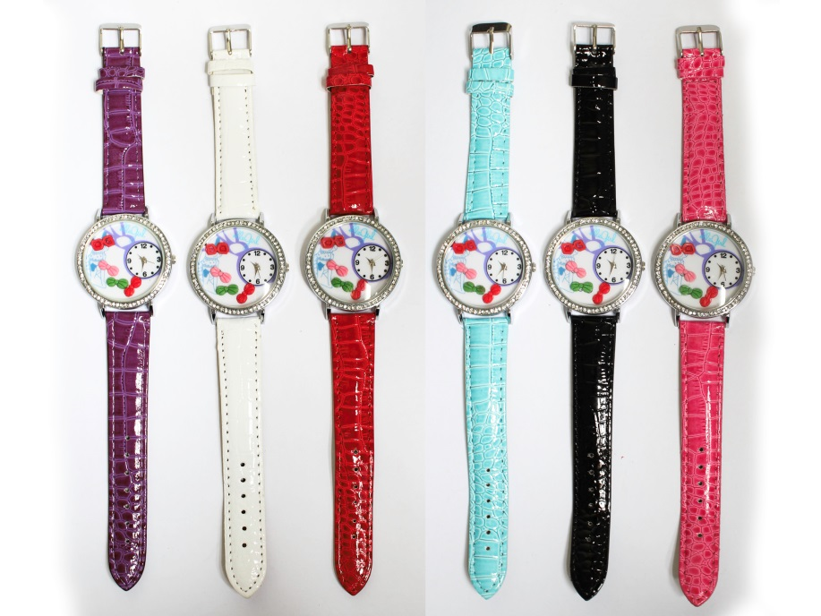

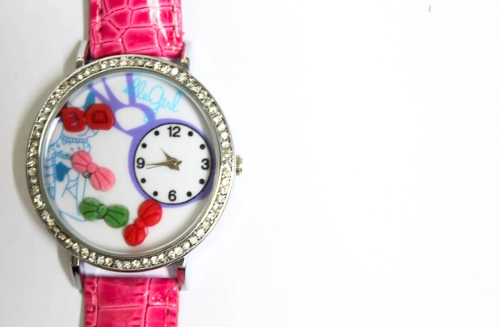

**Product:** Ribbon Studded Miniature Watch

**Item Code:** Watch037

**Retail Price:** PHP 350

All colors are available

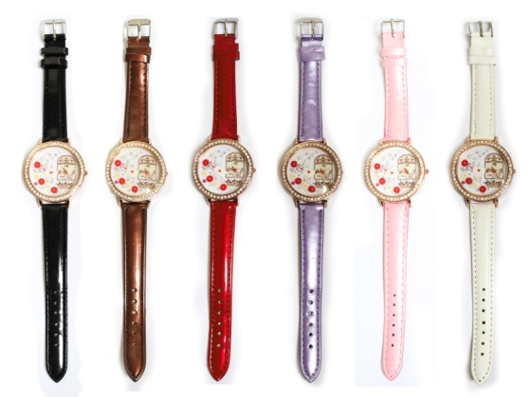

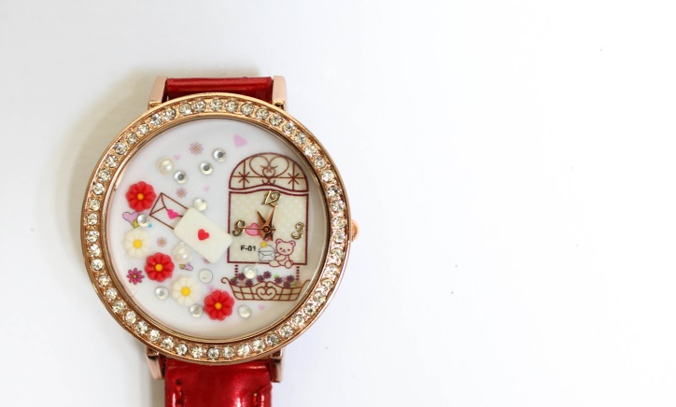

**Product:**Flowers Studded Miniature Watch

**Item Code:**Watch036

**Retail Price:**PHP 350

All colors are available

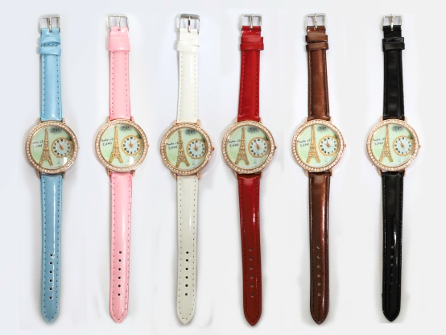

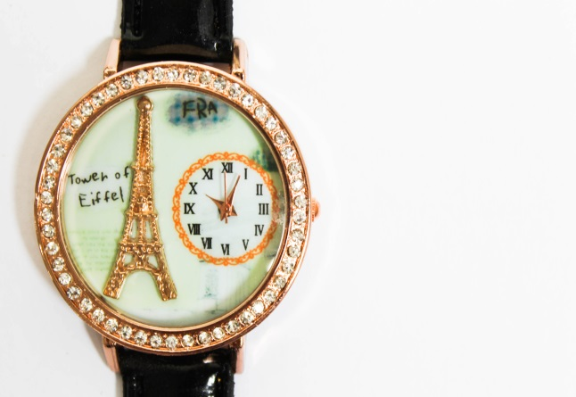

**Product:**Eiffel Tower Studded Miniature Watch

**Item Code:**Watch035

**Retail Price:**PHP 350

All colors are available

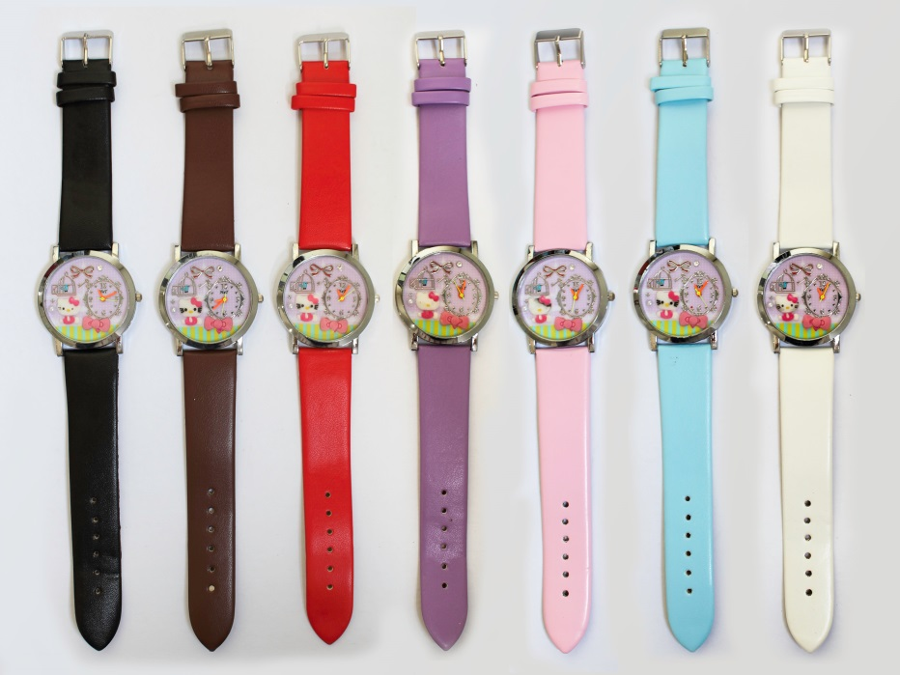

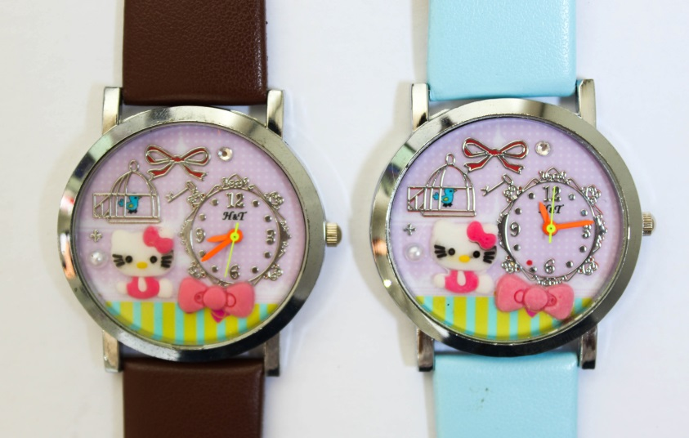

**Product:**Lovable Hello Kitty Miniature Watch

**Item Code:**Watch034

**Retail Price:**PHP 299

All colors are available