Angler Satisfaction Survey Results as Indicators of

Fisheries Changes: A Case Study

Steven H. Ranney*

596 North Laurel Parkway

Bozeman, Montana 59718 USA

Suggested running head:

Angler Satisfaction Survey Results May Portend Fishery Health Changes

*Email: [Steven.Ranney@gmail.com](mailto:Steven.Ranney@gmail.com)

<A>Abstract

**Objective**: I used long-term datasets to determine if angler complaints about fish size were evident in biological data and how complaints about angler crowding could serve as early indicators of fishery health.

**Methods**: I used standardized sampling data from 2004 through 2022 and evaluated fish weight-at-length with quantile regression compared to the reference year 2003. I also estimated population sizes for Brown Trout *Salmo trutta* and Rainbow Trout *Onchorhynchus mykiss* with maximum likelihood estimation, and use extant data related to angler demographics, catch-and-release mortality, catch rate, and summer season-length to predict changes to the Brown and Rainbow Trout populations with concomitant changes to the angler population.

**Result**: For all years except 2004, Brown and Rainbow Trout weight-at-length was significantly lower when compared to the reference population showing that angler complaints were reflected in the biological data. A significant linear model of estimated population size as a function of time predicts that Brown and Rainbow Trout populations could reach 0 at long-term sampling locations by 2025. Angler population size predictions and expected catch rates suggest that during summer season 2023, each Brown Trout was caught an estimated 1.8-4.7 times and Rainbow Trout an average of 2.4-7.4 times. As angler populations increase and fish populations decrease, the average number of times a fish is caught each summer will continue to increase and could lead to reduced spawning success through repeated handling stress.

**Conclusion**: Angler satisfaction survey results could provide early insight into fisheries management questions that may have otherwise been overlooked. When paired with analysis of long-term data sets, angler satisfaction surveys may provide fisheries scientists and managers the ability to validate or repudiate angler concerns.

**Keywords**: creel survey, angler satisfaction, quantile regression, maximum likelihood, population estimation

<A>Impact statement

Results from creel surveys that include questions related to angler satisfaction could provide anecdotal evidence related to fishery health. This anecdotal evidence, in conjunction with analysis of standardized long-term data sets, could provide insight into the health of a fishery before analyzing standardized sampling data alone would show.

<A>Introduction

Creel surveys of angler populations are the primary means through which fisheries managers collect information on angler effort and catch rates (Malvestuto 1996; Pollock et al. 1994). Surveys of recreational anglers provide crucial information related to fishing effort, harvest, and released catch to fisheries managers (McCormick and Meyer 2017). These estimates are important for providing data upon which fisheries management decisions can be based. Angler effort and catch rates, for example, can be used to estimate the number of fish harvested and released in sport fisheries (Malvestuto 1996; Pollock et al. 1994). Creel surveys are often labor intensive and expensive to conduct (Jones and Pollock 2012; McCormick and Meyer 2017) and many rely on angler-reported data to estimate the metrics used as the basis for fisheries management (McCormick et al. 2013).

In addition to effort, harvest, and released-catch information, recreational angler creel surveys may also be used to obtain biological fisheries data. Length and weight data, some of the most important information for fisheries management (Anderson and Neumann 1996; Neumann et al. 2012), can be collected on a subsample of the harvest (Jones and Pollock 2012). Disease status, fishing mortality, and other biological indicators (e.g., structures used for aging) may be collected simultaneously. Data on angler demographics, social, and economic variables may also be collected (Jones and Pollock 2012). Angler satisfaction data may also be collected from creel surveys, whether or not they are conducted in-person or through angler self-reporting via mail or online surveys. For cases where fisheries management agencies are beholden to–either directly or indirectly–their constituents (i.e., commercial or recreational anglers), if angler satisfaction drops, anglers may voice their opinions to their elected representatives or directly to fisheries managers. In either case, hearing from unsatisfied anglers, if a frequent occurrence, could be an indicator that something has gone awry in a fishery. Fisheries managers should take these complaints seriously and investigate, if there are data available.

Analysis of long-term datasets related to angler satisfaction may provide early insight into potential problem areas in a fishery. For example, decreases in angler-reported catch rates may be an indication of negative population-level issues in the fishery population. Similarly, decreases in angler satisfaction related to the size of fish caught may also imply a survival or growth issue in the fishery. Additionally, decreases in angler satisfaction related to angler crowding could lead to questions related to increased harvest or catch-and-release mortality, given more anglers would logically lead to increased total catch. The Madison River in Montana serves as a good case study for using angler satisfaction as insight into fisheries changes given the frequency with which anglers are surveyed, the river’s global popularity, and the availability of long-term datasets.

The Madison River in Montana is one of the most popular fisheries in the state [Montana Fish, Wildlife & Parks (MTFWP) 2017; Horton et al. 2018; MTFWP 2019; Skaar 2022; Lohrenz et al. 2023] and hosted over 300,000 angler days in 2020 (Lohrenz et al. 2023), the last year for which estimated effort is available. From its source in Yellowstone National Park (National Park Service 2023) through its confluence with the Gallatin and Jefferson Rivers at Missouri Headwaters State Park near Three Forks, Montana, the river is important to local economies to support tourism and agriculture as well as jobs in the commercial angling outfitting industry (Horton et al. 2018; Lohrenz et al. 2023). Because the river is a destination for trout anglers worldwide (Skaar 2022), a number of management strategies have been implemented since the 1950s to mitigate angler conflicts and crowding (Horton et al. 2018). The most numerous and frequently-targeted fish species on the Madison River include Brown Trout *Salmo trutta*, Rainbow Trout *Onchorhynchus mykiss*, and Mountain Whitefish *Prosopium williamsoni* (Lohrenz et al. 2023). Anglers on the upper Madison River (Figure 1) are responsible for approximately 58% of all angler trips on the Madison River (MTFWP 2017, 2019; League and Caball 2022).

The upper Madison River is managed with catch-and-release regulations for trout and use of artificial lures only (MTFWP 2023). Anglers ≤ 14 years old may take 1 trout daily, any size (MTFWP 2023). Additional regulations related to fishing from boats and vessels are in place for two sections of the upper Madison River. Although not a regulation, most anglers on the upper Madison River use fly-fishing gear (Roulson 2002; Horton et al. 2018). Of upper-river anglers, 73.2% are not residents of Montana and nearly 90% are male (Skaar 2022). Angling is the most popular activity by far on the upper Madison River; >90% of respondents of river-use recreational surveys at 11 of 13 public river access sites upstream of Ennis, Montana, were angling (Skaar 2022).

Angler-survey results from the Madison River indicate that angler satisfaction of the size of fish caught has been declining steadily over the last five decades (Horton et al. 2018). In the 1970s, 41.1% of anglers reported the size of fish caught on the Madison River as “excellent” and only 0.2% reported the size of fish caught as “poor” (Horton et al. 2018). By the 2010s, only 14.4% of respondents reported the size of trout caught as “excellent” while 5.3% reported the same metric as “poor” (Horton et al. 2018). Additionally, recent decreases in angler satisfaction related to angler crowding have been noted with several potential mitigation strategies having gone through internal and public review; Horton et al. (2018) provides a list of past actions undertaken to reduce angler conflicts and crowding since 1959 including float fishing closures, moratoriums on new outfitters, and different restrictions on fishing from vessels. Horton et al. (2018) noted that increased angler crowding may be suggestive of a concomitant increase in catch-and-release angling mortality and that the increased mortality from extant levels of angling pressure may be more than the fish populations can withstand.

The goal of this paper is twofold: (1) determine if the decreases in the reported angler satisfaction related to the sizes of Brown and Rainbow Trout caught on the upper Madison River, Montana, are reflected in the long-term fisheries population monitoring data and (2) evaluate the trends in population size estimates of Brown and Rainbow Trout the upper Madison River, Montana in recent years and to estimate what may happen to those populations if there are no changes in management strategies to reduce angler crowding, a complaint of anglers on the upper Madison River. I use long-term standardized sampling data to compare fish weight-at-length through quantile regression, estimate fisheries population sizes and evaluate population over time, and use extant data related to angling pressure, summer-season length, fishing day length, angler trip length, and catch rates to simulate how the angling population may change over time, estimate the average number of times individual fish are caught in a summer season, and how estimated angler population changes could impact the Brown and Rainbow Trout populations over time.

<A>Methods

<B>Quantile Regression of Weight at Length

I used 20 years’ worth of fisheries data collected by MTFWP at two upper Madison River long-term fisheries index sites, Varney and Pine Butte (Figure 1; MTFWP 2023). These locations were established as long-term monitoring locations on the upper Madison River in 1981 (Pine Butte) and 1967 (Varney). The Pine Butte location is 5.3 river km (rkm) long and the Varney location is 7.8 rkm long (MTFWP 2023). All sampling was completed during the months of September and October from 2003 through 2022. All sampling events were completed by electrofishing from drift boats with mobile anodes or rafts with boom-type anodes (MTFWP 2023). Although I retrieved 21 years’ worth of population data from the FishMT portal (MTFWP 2023), for allometric growth parameter comparison, I used data from every third year, beginning with 2004, to reduce the complexity of the results while still providing long-term inferences and allowing the breadth of the data set to be used. As a result, I used 8 years’ worth of data: 2003 (the “reference” population), 2004, 2007, 2010, 2013, 2016, 2019, 2022. Within species, I pooled data from the Varney and Pine Butte sampling areas and assigned equal weights to both populations regardless of contributed sample size (Cade et al. 2008; Ranney 2018b).

Angler-survey results indicate that anglers claim that the size of fish caught in the upper Madison River has been declining steadily since the 1970s (Horton et al. 2018). To evaluate how allometric growth patterns have changed since 2003, I evaluated changes in 75th quantile (𝜏 = 0.75) intercepts (β0) and slopes (β1) for both Brown and Rainbow Trout in the upper Madison River. I used methods described in Ranney (2018b) to compare yearly β0 and β1 values by regressing log10*W* as a function of log10*TL*. I used the linear quantile regression function rq() in the quantile regression package “quantreg” (Koenker 2021) in R version 4.3.2 (R Development Core Team 2023). Similar to Ranney (2018b), I used 𝜏 = 0.75 because this is a fish with “above average” body weight at a given length. I used a single linear model (Cade et al. 2008, 2011; Ranney 2018b; Cade and Gilham 2024) to provide estimates for separate population-level β0 and β1 values when compared to a reference population based on the methods described by Ranney (2018b). I used the 2003 sampling event as my “reference” population for two reasons: (1) it was a reasonably long time ago; and (2) the Brown and Rainbow Trout populations had recovered from the whirling disease impacts from the 1990s (M. Duncan, MTFWP, personal communication). I estimated the standard error (SE) of β0*j* and β1*j*, where *j* represented the individual yearly population intercept and slope values, respectively, by resampling, with replacement, 5,000 log10*W*-log10*TL* pairs 1000 times. I calculated 95% confidence intervals (CI) around each β0j and β1j with the *t* statistic = 1.960.

I compared individual yearly population β0j and β1j to the 2003 reference population β0 and β1 by setting the reference population as the base level then setting the contrasts between the rest of the categorical factors (i.e., yearly population identifier and its interaction with the continuous predictor variable; Ranney 2018b). Similar to calculating the SE of the β0 and β1 for each population-level model, I estimated the SE of the differences in β0*j* and β1*j* from the reference population β0 and β1 with resampling. I resampled 5,000 log10*W*-log10*TL* pairs 1000 times and calculated the 95% CIs around the differences in β0 and β1 with the *t* statistic = 1.960. I compared quantiles of weight at specific length values for both Brown and Rainbow Trout by regressing log10*W* as a function of log10*TL* for both species. I then estimated the weight and 95% CIs of weight for the midpoints of the length categories (Gabelhouse 1984) for Brown Trout [midpoints: substock (SS) = 75mm; stock-quality (S-Q) = 190mm; quality-preferred (Q-P) = 265mm; preferred-memorable (P-M) = 340mm; memorable-trophy (M-T) = 420mm; Milewski and Brown 1994] and Rainbow Trout [midpoints: substock (SS) = 125mm; stock-quality (S-Q) = 325mm; quality-preferred (Q-P) = 450mm; preferred-memorable (P-M) = 575mm; memorable-trophy (M-T) = 725mm; Simpkins and Hubert 1996]

<B>Population Estimates

I used annual sampling data from 2003 through 2022 to make population estimates. From 2003 through 2022, Montana FWP conducted annual mark-recapture sampling in the upper Madison River by capturing, marking, and releasing individuals during at least 3 sampling events at each location each year. During mark-recapture sampling events, marked fish were released unharmed and allowed to redistribute among unmarked fish. Mortalities that occurred from either a mark or recapture event were subtracted from the total number of fish. After redistribution of marked fish, MTFWP conducted 2-4 recapture runs at each sampling location an average of 10 d (SD = 2.5 d) later.

I estimated yearly population size () and 95% CI per rkm of Brown and Rainbow Trout at the Pine Butte and Varney sampling locations by 10 mm length class in the upper Madison River. I used a maximum likelihood estimator (MLE) to estimate population size. I calculated the likelihood function as

where *N* is the population size, *n* is the total number of fish captured in the recapture sampling event, *q* is the probability of capture of fish in that 10 mm length class, and *L* is the likelihood of *N* given *n* and *q* (Hayes et al. 2007). I allowed *N* to vary and estimated from the value of *N* for which the likelihood was maximized. I modeled *q* from observed values by fitting a smoothing spline to each species:year:location combination as a function of the observed proportion of fish recaptured to the total number of fish captured in the recapture event (Anderson 1995) by 10 mm length class because capture probability can change continuously with size. I constructed 95% CI around by determining values for the parameters that gave a log-likelihood value that was less than the maximum value of the log-likelihood by 3.841 (Hayes et al. 2007). I used a critical value of 3.841 because this is the 5% critical value for the distribution with 1 degree of freedom (Hayes et al. 2007).

I evaluated 20-year population trends in Brown and Rainbow Trout at Pine Butte and Varney long-term monitoring locations by summing the from each 10 mm length class for each year:species:location combination. I removed values where < 0.01 from these final estimates because poor capture efficiency overestimates the for these length classes. I calculated /km by dividing the total for each monitoring location and dividing by the total length of each monitoring location and regressed as a function of year with ordinary least squares regression.

<B>Angler Population Simulations

I used data on *n* anglers/year data from Horton et al. (2018) for 2011, 2013, 2015, and 2016 to create a linear model to predict anglers/year on the upper Madison River through 2030. I validated this limited model with observed anglers/year for 2017, 2019, and 2020 (MTFWP 2017, 2019; League and Caball 2022). From the linear model, I extrapolated the number of annual anglers/year through 2030 (± 95% prediction intervals) that would fish the upper Madison River. From the linear fit and prediction intervals, I simulated 7 years’ worth of summer-season anglers, trips, effort, and catch with the AnglerCreelSurveySimulation package (Ranney 2018a) in R version 4.3.2 (R Development Core Team 2023). The AnglerCreelSurveySimulation package allows fisheries managers to simulate a creel survey to better understand how a single access-point survey or bus route-type survey may best represent their fishery, including estimates of effort () and catch (including catch rate, ; Jones and Robson 1991, Jones and Pollock 2012). I used predicted output from the linear model of anglers/year and data from Horton et al. (2018) and Skaar (2022) to seed the angler population simulation with data related to *n* anglers, summer-season length (June 1 through August 30; 91 days), fishing day length (11 hours), catch rate (Brown trout = 0.38 fish/hr; Rainbow trout = 0.62 fish/hr), and average trip length (5.6 h). The AnglerCreelSurveySimulation package assigns angler start times with the uniform distribution and catch rates with the gamma distribution with the shape parameter (*k*) equal to the mean catch rate and the rate parameter equal to 1 (Ranney 2018a) .

Although AnglerCreelSurveySimulation (Ranney 2018a) is designed to allow fisheries managers to estimate effort and catch of an angler population with varying sampling probabilities (i.e., 0 *≤ p ≤* 1), if the sampling probability is set to 1 and there is a single “access point” (e.g., the entirety of the upper Madison River), then all anglers can be “sampled” by the simulated “surveyor” upon completion of their trip. As a result, and would equal the “true” effort and catch by each angler. In using a simulated angler population, I can observe all of the simulated trips and calculate “true” catch and effort for multiple summer seasons.

I estimated future catch-and-release related mortality on the upper Madison River from these reasonable predictions of *n* anglers/year. I used mortality rates from Horton et al. (2018) to calculate the number of Brown and Rainbow Trout that would succumb to catch-and-release mortality each summer from 2023 through 2030. Mortality rates used by MTFWP are 0.02 for Brown Trout and 0.08 for Rainbow Trout (Horton et al. 2018). I estimated the number of times that a fish will be caught in the summer season by dividing by from all summer-season anglers. All analyses were conducted in R version 4.3.2 (R Development Core Team 2023) and for all analyses, alpha was set to 0.05.

<A>Results

Long-term fall electrofishing samples from 2003 through 2022 yielded observations from 57,865 Brown Trout and 41,676 Rainbow Trout. Brown Trout captures averaged 2,893 (SD = 853) and Rainbow Trout captures averaged 2,084 (SD = 543) per year. Although Rainbow Trout X Westslope Cutthroat Trout *O. clarkii lewisi* hybrids and Westslope Cutthroat Trout observations existed in the dataset, together they represented < 0.001% of the total data and were removed from consideration.

<B>Quantile Regression of Weight at Length

The 𝜏 = 0.75 quantile regression model for β0 and β1 estimates from the reference data set (year = 2023) for Brown Trout were -4.6404 and 2.8818, respectively, and for Rainbow Trout were -4.4300 and 2.7955, respectively (Table 1). The 95% CIs from the reference data set for Brown Trout were β0 = -4.6859 to -4.595 and β1 = 2.864 to 2.9002 and for Rainbow Trout were β0 = -4.4890 to -4.3710 and β1 = 2.7717 to 2.8193. The lowest β0 for Brown Trout (-5.212) and Rainbow Trout (-5.1083) was during 2013 (Table 1). The lowest β1 for Brown Trout (2.8305) and Rainbow Trout (2.6933) was during 2004 (Table 1). For both Brown and Rainbow Trout, 2004 was the only year in which the intercept was higher and the slope was shallower than the reference population (Table 1). For all other years investigated, intercepts were lower and slopes were steeper than the reference population for both species (Table 1). There were no instances for either species in any year in which bootstrapped 95% CIs of 75th quantile β0 and β1 overlapped with the reference data set (Table 2).

Estimates and 95% CIs of weight at TL equal to the midpoints of length categories across all quantiles from from 𝜏 = 0.05 up to 0.95 by increments of 0.05 overlapped for both species for all years, especially at the upper length ranges for Brown Trout (TL = 420mm; Figure 2A) and for length ranges ≥ 450mm for Rainbow Trout (Figure 2B). For Brown Trout, the 2004 population was heavier than the reference population at all quantiles (except for the lowest extremes; (Figure 2A). In the substock (SS) and stock-quality (S-Q) length categories, individuals in all years after 2004 weighed less than the reference population at all quantiles 0.05 through 0.95 (Figure 2A). Overlap in predictions of weight-at-length for years after 2004 in the lower quantiles (𝜏 < 0.35) for quality-preferred (Q-P) and preferred-memorable (P-M) length categories became more pronounced. Similar to Brown Trout, prediction of weight-at-length for Rainbow Trout in 2004 at all quantiles for SS and S-Q length categories were higher than the reference populations except at the extreme lowest quantiles (i.e., < 0.20) for SS (Figure 2B). For SS and S-Q length categories, predictions of weight-at-length for years > 2004 are all lower than the reference population. In Q-P, P-M, and M-T length categories, the overlap of all quantiles and years ≥ 2004 was challenging to distinguish and, in many cases, predictions of weight-at-length did not follow any specific trend. Notably, the 95% CIs at TL = 575 and 725 were much broader than those in lower length categories (Figure 2B).

<B>Population Estimates

Annual fall sampling from established, long-term monitoring locations indicated that Brown Trout populations are declining while Rainbow Trout populations appear stable or are increasing (Figure 3). A linear model describing the Brown Trout decreases in the upper Madison River was significant at the Pine Butte (R2 = 0.1572; β0 = 73596.74; β1 = -35.84; *p* = 0.047) and Varney long-term monitoring locations (R2 = 0.2969; β0 = 65417.88; β1 = -31.87; *p* = 0.0013). Slopes for linear models fit to long-term sampling suggest that Rainbow Trout populations are stable or increasing at both Pine Butte and Varney, but the models fit to yearly data were not significant at ɑ = 0.05 (Pine Butte: R2 = 0.06165; β0 = 65654.24; β1 = -31.80; *p* = 0.15; Varney: R2 = 0.1619; β0 = -66330.16; β1 = 33.43; *p* = 0.055; Figure 3).

<B>Angler Population Simulations

Angling pressure (i.e., anglers/year) from 2011 through 2016 appeared linear in Horton et al. (2018), and the linear model fit to observed (2011, 2013, 2015) and estimated (2016) data was significant (adjusted R2 = 0.96; β0 = -33991356; β1 = 16949; *p* = 0.013; Figure 4). Although “hold-out” data did not fall on the predicted line, these data did fall within the 95% prediction interval of the linear model (Figure 4). If the linear model of angler pressure growth continues to hold into the future, angling pressure would be expected to increase year-over-year by roughly 5% (Figure 4; Table 3).

Similar to the expected linear increase in angling pressure, Brown and Rainbow Trout catch rates were also predicted to increase year-over-year by roughly 5% (Table 3) with a concomitant increase in hooking mortality from catch-and-release fishing (Table 3). Simulations of predicted angling pressure for 2023 on the upper Madison River during the summer season predicted a total catch of Brown Trout of 235,195 individuals (±95% prediction interval of ~69000; Table 3) and 395,059 Rainbow Trout (±95% prediction interval of ~114000; Table 3). At assumed levels of catch-and-release mortality (0.02 for Brown Trout, 0.08 for Rainbow Trout; Horton et al. 2018), catch and release mortality for Brown Trout in 2023 was predicted to be 4,704 individuals and 31,605 individuals for Rainbow Trout (Table 3). By 2030, if there is no change in the expected catch rates of Brown or Rainbow Trout, summer-season catch of Brown and Rainbow Trout would be predicted to increase to 328,666 and 552,697 individuals, respectively (Table 3). If 2023 predicted catch were distributed evenly across the 86.4 rkms of the upper Madison River, Brown Trout were estimated to have been caught an average of 1.8-4.7 times at Pine Butte and Varney and Rainbow Trout were estimated to have been caught an average of 2.4-7.4 times at Pine Butte and Varney. During the predicted summer season of 2030, at and with predicted growth in the angler population, Brown Trout were estimated to have been caught an average of 2.9-9.8 times at Pine Butte and Varney. During a predicted 2030 summer season, Rainbow Trout at Pine Butte and Varney were estimated to have been caught 3.8-7.7 times.

<A>Discussion

Anglers on heavily-pressured fisheries often have anecdotal evidence about the health of the fishery before fisheries managers may have the time or funding to investigate anglers’ concerns. Here, angler survey responses related to their opinions about fish size are reflected in long-term fisheries monitoring data. Similarly, evidence suggests that as angler overcrowding continues, Brown and Rainbow Trout populations may continue to drop. Because Brown Trout populations have been declining on the upper Madison River at Pine Butte and Varney since at least 2003 and declines in Brown Trout populations are outpacing limited increases from Rainbow Trout, angler survey results from Madison River anglers could “tip off” managers to a potential upcoming problem with the health of the fishery. Using declines in angler satisfaction as a potential early-warning system to system health may be a useful tool for fisheries managers.

The deviation between the actual weights of fish in a population and an expected length-specifc weight can indicate if biotic or abiotic conditions are beneficial or detrimental to that population (Ranney et al. 2008). The changes seen here in Brown and Rainbow Trout weight-at-length growth patterns are challenging to explain without a broader study related to additional system factors (e.g., prey availability, habitat availability, temperature regimes). Increased water temperatures unrelated to management of Hebgen Dam (i.e., from climate change) may be impacting growth and weight at length of Brown and Rainbow Trout (Vincent 1978; Jobling 1995; Wootton 1996; Réalis-Doyelle et al. 2018) and in the early 2000s, the Madison River basin had been going through several years of continuous drought (MTFWP 2005) which may have been driving the negative changes in Brown and Rainbow Trout weight at length seen here as early as 2007. I chose to use quantile regression to analyze weight at length in this analysis because it is particularly helpful when evaluating populations that are regularly monitored (Cade et al. 2008, 2011; Crane et al. 2015; Crane and Farrell 2017; Ranney 2018b; Cade and Gilham 2024), especially those that are trophy fisheries or may be valuable to local economies or as a source of recreation. Further, quantile regression estimates from linear models that contain relevant grouping factors is a comprehensive and rigorous analysis of changes in weight at length (Cade et al. 2008, 2011; Ranney 2018b; Neely et al. 2021; Cade and Gilham 2024).

I estimated population sizes at two specific long-term monitoring locations with a maximum likelihood estimator. Although these came from standardized sampling, estimating the population size of an open population without an encounter history matrix can be challenging (Hayes et al. 2007; Link and Barker 2010). Open populations include immigration, emmigration, mortality, and recruitment (Hayes et al. 2007; Link and Barker 2010). Assuming that anyone could estimate the abundance of an open population with precision without having an encounter history matrix of uniquely marked fish would be challenging. Tagging fish with unique identifiers and encouraging anglers to report catching tagged fish may help MTFWP make better estimates of the population of Brown and Rainbow Trout in the upper Madison River. Similarly, with uniquely-marked fish and reports of catch of these uniquely marked fish, managers could better estimate the recycling rate [i.e., total catch in a fishing season divided by the number of individuals caught at least once (Schill et al. 1986; Jones et al. 2022)] of their fishery (Jones et al. 2022). Without unique tagging, it’s impossible to know how much catch increased because of multiple recaptures. Indeed, beginning in Autumn 2023, MTFWP Began implementing a tagging study on the upper Madison River, including uniquely-identified tags. Calculating the recycling rates of a fishery may help managers better understand how catch is distributed across the fish population. For example, for a fisheries wide recycling rate of 2.0, each fish may have been caught twice or half of the fish were caught four times (Jones et al. 2022). For the case of Brown and Rainbow Trout in the upper Madison River, estimating with accuracy for the entire river is challenging, given the nature of open populations. However, if the estimated angling pressure in the upper Madison River during the 2023 summer season were evenly distributed across the entire 86.4 km of the river, each Brown Trout in the Pine Butte and Varney sampling areas would have been caught 1.8-4.7 and 2.6-4.8 times, respectively. These values increase as drops and the angler population increases if catch rate stays the same, an unlikely prospect.

The catch-and-release hooking mortality rates used herein are based on work from Boyd et al. (2010) in which cumulative stressors (including the number of times a fish was caught over the summer) and temperature regimes similar to the upper Madison River were not taken into account (Horton et al. 2018). “Fight time” [i.e.,time to landing (Boyd et al. 2010)] and the handling stress of increased recycling rate should be considered a cumulative stressor that should be taken into account in catch-and-release hooking-mortality estimates (Schill et al. 1986). Further, handling stress increases cortisol levels in salmonids (Donaldson 1981; Barton and Iwama 1991) and may affect the timing (Schreck et al. 2001) and success of reproduction (Campbell et al. 1992). As a result, understanding how the cumulative stress associated with multiple capture and handling events over the few months immediately preceding expected Brown Trout spawning affects reproduction success is important in comprehending the population-level consequences of those stressors (Schreck et al. 2001). Although acute stressors were shown to not affect spawning success of semelparous salmon on their spawning grounds, more chronic events (e.g., elevated water temperatures, multiple catch-and-release events in a season) demonstrate sustained elevation of stress hormones (McConnachie et al. 2012) which carries significant reproductive costs. Including estimates of these chronic stressors into future estimates of catch-and-release hooking mortality on the Madison River would likely increase the expected estimated mortality rate and may provide additional explanations for the decline in Brown Trout observed in these data.

Anecdotal evidence from local fishing guides on the upper Madison River suggests that the growth in the angler population is slowing (J. Seckinger, personal communication). While the trajectory of the increases may change (i.e., shallower slope or leveling off asymptotically in the model), the popularity of the Madison River as a global fishing destination is clear (Skaar 2022). Although temporary reductions in angling pressure have been observed in recent years (i.e., the 2020 COVID-19 global pandemic and poor air quality from drifting smoke from regional wildfires in 2021), the upward trajectory in angling pressure on the upper Madison River is likely to continue (Skaar 2022). Creel surveys focused on angler demographics and opinions reflect an increasing proportion of anglers expressing concern about the unacceptability of the numbers of people and boats on the Madison River (Skaar 2022). Regardless, the upper Madison River continues to draw global tourists (Skaar 2022) and as the population of cities in and surrounding SW Montana continues to grow, likely so will the population of anglers on the upper Madison River. Continued increases in angling pressure will lead to increases in catch-and-release mortality. If predictions of Brown and Rainbow Trout from MLE and subsequent models hold, the lower boundary of the 95% prediction interval of reaches 0 in 2025 at Pine Butte and Varney for Brown Trout and 2025 for Rainbow Trout at Pine Butte. Given that each long-term sampling site is an open population, Brown and Rainbow Trout are not likely to be locally extirpated. However, the negative feedback loop of decreasing coupled with increased angling pressure is expected to lead to increased recycling rates which will lead to increased stress in Brown and Rainbow Trout in the upper Madison River which may lead to additional declines in reproductive success, leading to a continued decrease in . One notable caveat in the predictions of angler pressure and catch I have made is that I have assumed that the seed metrics I used (i.e., season length, fishing day length, mean trip length, and mean catch rate) were not likely to change over the course of the predictions. It is possible that one or more of these metrics could change in the future. One potential scenario is to assume that as Brown Trout populations decline while angler pressure increases, catch rate will decline concomitantly. Similarly, MTFWP may enact changes to fishing day length that limit the amount of time anglers can spend on the water. For example, MTFWP already limits fishing on temperature and drought-impacted streams with periodic closures (colloquially known as “hoot owl” restrictions, prohibiting angling between the hours of 1400 and 0000 the following morning).

Fisheries managers have several tools at their disposal to manage fisheries, including supplemental stocking to increase recruitment to the recreationally-angled population, supplemental feeding of exogenous resources to improve growth, and requiring “hookless fishing” in which anglers are required to use hookless flies, simulating the “thrill of the catch” while hooking mortality becomes effectively zero. In a large, economically-important river like the upper Madison River, developing options that are easier to implement is warranted, ideally implementing those that are simple and may impact one or more of the fisheries dynamic rate functions. Fisheries managers cannot control much related to water temperature and volume (only the latter of which can be influenced by managers on impounded rivers and even then, only to a certain extent), but changes to the angling population could be applied that may improve the fishery. Because the deleterious impacts of increased angling pressure on Brown and Rainbow Trout appear to be predominantly associated with handling stress (and subsequent hooking mortality), reducing fisheries mortality by limiting the number of anglers on the river is one simple option because reduction in the number of anglers on the river would reduce catch-and-release mortality. However, this option is likely to receive significant negative feedback from the angling public and outfitter/fishing guide community reliant on the river for income. Requiring the use of barbless hooks is an implementable solution that may reduce hooking mortality but also allow the angler population to grow. Whether or not the use of barbless hooks directly affects mortality is debatable (i.e., Thompson 1946; Hunsaker et al. 1970; Titus and Vanicek 1988; Turek and Brett 1997). More likely, barbless hooks reduce the average time from landing to release (Schaeffer and Hoffman 2002) thus reducing fish stressors. Coupled with using barbless hooks, requiring all anglers to use a landing net while fishing the upper Madison River would eliminate the need for anglers to be handling fish at all and may reduce immunosuppression in landed fish.

Identifying the exact cause of the changes in weight at length of Brown and Rainbow Trout is beyond the scope of this analysis as is identifying the cause of declines of Brown Trout and Rainbow Trout and Pine Butte; however, given the increased angling pressure on the upper Madison River, it stands to reason that changes in water temperature regimes, increased recycling rate, and handling stress could be a starting point for future investigations. Indeed, environmental (e.g., water temperature) and mechanical (e.g., capture) stressors may lead to individuals making trade-offs between reproductive efforts, somatic growth, and survival (Schreck et al. 2001) and decreased weights at nearly all fish lengths in all quantiles when compared to the reference population for Brown Trout may be reflective of these tradeoffs. Potential areas to evaluate include changes in river thermal regimes, anglers targeting larger-sized fish, and fishing during spawning season that potentially contribute to additional increased mortality of larger fish.

Managing fisheries that are recreationally and economically important can be challenging. Balancing the desires of anglers, fishing guides and outfitters with the need to manage the natural resource requires walking a fine line. I encourage fisheries managers to review angler satisfaction survey results related to their fisheries. If a recreational or commercially-important fishery has no data related to angler satisfaction, I encourage managers to establish regular, valid creel surveys to sample angler demographics, satisfaction, and other key metrics. A global destination for trout anglers, fisheries managers on the upper Madison River have been in “uncharted waters” since 2018 with regards to catch and expected mortality (Horton et al. 2018). If there is evidence that a globally-recognized recreationally and economically-important fishery may be suffering a quality decline, including decreases in angler satisfaction in the size of fish they have caught over time (Horton et al. 2018), evidence of declines in estimates of weight-at-length and abundance (this paper), complaints of angler overcrowding (Horton et al. 2018; Skaar 2022), and evidence of angling mortality that exceeds the estimates of what a fishery can sustain (Horton et al. 2018), fishery managers should leverage the angler feedback they receive and look for supporting evidence in extant data sets. If evidence exists to support angler claims, identifying the fewest number of new regulations that have the largest positive impact on the fishery may be challenging but software exists for simulating management changes [e.g., Fisheries Analysis and Modeling Simulator (available through the American Fisheries Society), the R packages Fisheries Library in R (FLR), the fishmethods: Fishery Science Methods and Models package, etc.]. Still more challenging may be educating the angling public on why new regulations are required. Managing angler expectations will be important.

<A>Acknowledgements

Thanks to M. Duncan and D. Schmetterling (MTFWP) for answering a number of my early questions about FWP reports and for help retrieving data related to long-term sampling on the upper Madison River, M. Wuellner (University of Nebraska - Kearney) whose review of an early draft of this manuscript provided significant improvement, and X anonymous reviewers whose comments improved this manuscript. There is no conflict of interest declared in this article.

<A>Data Availability Statement

A repository that includes supplementary data and R code used in this manuscript is available at https://github.com/stevenranney/madison_river_fisheries.

<A>Ethics Statement

There were no ethical guidelines applicable to this study.

<A>References

Anderson, C. S. (1995). Measuring and correcting for size selection in electrofishing mark-recapture experiments. *Transactions of the American Fisheries Society, 124*, 663-676. <https://doi.org/10.1577/1548-8659(1995)124%3C0663:MACFSS%3E2.3.CO;2>

Anderson, R. O., & Neumann, R. M. (1996). Length, weight, and associated structural indices. In B. R. Murphy and D. W. Willis (Eds.), *Fisheries Techniques* (2nd ed., pp 447–482). American Fisheries Society.

Barton, B. A., & Iwama, G. K.. (1991). Physiological changes in fish from stress in aquaculture with emphasis on the response and effects of corticosteroids. *Annual Review of Fish Diseases, 1*, 3-26. https://doi.org/10.1016/0959-8030(91)90019-G

Boyd, J. W., Guy, C. S., Horton, T. B., & Leathe, S. A. (2010). Effects of catch-and-release angling on salmonids at elevated water temperatures. *North American Journal of Fisheries Management, 30*, 898-907. https://doi.org/10.1577/M09-107.1

Cade, B. S., & Gilham, A. T. (2024). Summarizing quantile estimates of weight at length to compare condition: Geographic and temporal variation in Arctic Grayling. *Transactions of the American Fisheries Society, 00*, 1-21. https://doi.org/10.1002/tafs.10466

Cade, B. S., Terrell, J. W., & Neely, B. C. (2011). Estimating geographic variation in allometric growth and body condition of Blue Suckers with quantile regression. *Transactions of the American Fisheries Society,* *140*, 1657-1669. https://doi.org/10.1080/00028487.2011.641885

Cade, B. S., Terrell, J. W., & Porath, M. T. (2008). Estimating fish body condition with quantile regression. *North American Journal of Fisheries Management, 28*, 349-359. http://dx.doi.org/10.1577/M07-048.1

Campbell, P. M., Pottinger, T. G., & Sumpter, J. P. (1992). Stress reduces the quality of gametes produced by Rainbow Trout. *Biology of Reproduction, 47*, 1140-1150. https://doi.org/10.1095/biolreprod47.6.1140

Crane, D. P., & Farrell, J. M. (2017). Trends in body condition of Smallmouth Bass and Northern Pike (1982–2013) following multiple ecological perturbations in the St. Lawrence River. *Canadian Journal of Fisheries and Aquatic Sciences, 74*, 1158–1172. https://doi.org/10.1139/cjfas-2016-0160

Crane, D. P., Farrell, J. M., Einhouse, D. W., Lantry, J. R., & Markham, J. L. (2015). Trends in body condition of native piscivores following invasion of Lakes Erie and Ontario by the Round Goby. *Freshwater Biology, 60*, 111–124. https://doi.org/10.1111/fwb.12473

Donaldson, E. M. (1981). The pituitary-interrenal axis as an indicator of stress in fish. In A. D. Pickering (Eds.), *Stress in Fish* (pp. 11-47). Academic Press, London.

Gabelhouse, D. W. Jr. (1984). A length-categorization system to assess fish stocks. *North American Journal of Fisheries Management, 4*, 273-285. https://doi.org/10.1577/1548-8659(1984)4%3C273:ALSTAF%3E2.0.CO;2

Hayes, D. B., Bence, J. R., Kwak, T. J., & Thompson, B. E. (2007). Abundance, biomass, and production. In C. S. Guy and M. L. Brown (Eds), *Analysis and Interpretation of Freshwater Fisheries Data* (pp. 327-374). American Fisheries Society. https://doi.org/10.47886/9781888569773

Horton, T., Moser, D., Morries, C., Puls, A., Lohrenz, T., & Lewis, M. (2018). *Angler satisfaction, demographic, and creel surveys–Upper Madison River, 2015-2017. Report to Northwestern Energy, Helena.* Montana Fish, Wildlife & Parks.

Hunsaker, J., Marnell, L. F., & Sharpe, F. P. (1970). Hooking mortality of Yellowstone cutthroat trout. *Progressive Fish-Culturist, 32*, 231-235. https://doi.org/10.1577/1548-8640(1970)32[231:HMOYCT]2.0.CO;2

Jobling, M. (1995). Environmental Biology of Fishes. Chapman & Hall, London.

Jones, C. M., & Pollock, K. H. (2012). Recreational survey methods: estimation of effort, harvest, and released catch. In A. V. Zale, D. L. Parrish, and T. M. Sutton (Eds.), *Fisheries Techniques (3rd ed.,* pp 883-919). American Fisheries Society. https://doi.org/10.47886/9781934874295

Jones, C. M., & Robson, D. (1991). Improving precision in angler surveys: traditional access design versus bus route design. American Fisheries Society Symposium 12:177-188.

Jones, T. S., Jones, M. I., Treml, M., & Heinrich, T. (2022). Estimating recycling of fish in catch-and-release fisheries. *Fisheries, 47,* 529-536. https://doi.org/10.1002/fsh.10824

Koenker, R. (2021). quantreg: Quantile Regression. R package version 5.85. [https://CRAN.R-project.org/package=quantreg](https://cran.r-project.org/package=quantreg)

League, C., & Caball, B. (2022). *Montana statewide angling pressure 2020, Helena*. Montana Fish, Wildlife & Parks.

Link, W. A., & Barker, R. J. (2010). Bayesian Inference with Ecological Applications. Elsevier. London.

Lohrenz, T., Duncan, M., Dukovcic, J., McCormak, M., & Jaeger, M. (2023). *Madison River Drainage 2188 Project Monitoring Report 2022, Helena.* Northwestern Energy, Environmental Division.

Malvestuto, S. P. (1996). Sampling the Recreational Creel. In B. R. Murphy and D. W. Willis (Eds.), *Fisheries Techniques* (2nd ed., pp. 591-623). American Fisheries Society.

McConnachie, S. H., Cook, K. V., Patterson, D. A., Gilmour, K. M., Hinch, S. G., Farrell, A. P., & Cooke, S. J. (2012). Consequences of acute stress and cortisol manipulation on the physiology, behavior, and reproductive outcome of female Pacific salmon on spawning grounds. *Hormones and Behavior, 62*, 67-76.

McCormick, J. L., & Meyer, K. A. (2017). Sample size estimation for on-site creel surveys. *North American Journal of Fisheries Management, 37*, 970-980. https://doi.org/10.1080/02755947.2017.1342723

McCormick, J. L., Quist, M. C., & Schill, D. J. (2013). Self-reporting bias in chinook salmon sport fisheries in Idaho: implications for roving creel surveys. *North American Journal of Fisheries Management, 33*, 723-731. https://doi.org/10.1080/02755947.2013.808293

Milewski, C. L., & Brown, M. L. (1994). Proposed standard weight (*Ws*) equation and length category standards for stream-dwelling brown trout. J*ournal of Freshwater Ecology, 9*, 111-116. https://doi.org/10.1080/02705060.1994.9664437

Montana Fish, Wildlife & Parks. (2005). *Annual FWP drought summary, Helena*. Montana Fish, Wildlife & Parks.

Montana Fish, Wildlife & Parks. (2017). *Montana statewide angling pressure 2017 summary report, Helena*. Montana Fish, Wildlife & Parks.

Montana Fish, Wildlife & Parks. (2019). *Montana statewide angling pressure 2019 summary report, Helena*. Montana Fish, Wildlife & Parks.

Montana Fish, Wildlife & Parks. (2023). *FishMT survey and inventory data, Madison River, Helena.* Accessed 18 October 2023. Available: [myfwp.mt.gov/fishMT/reports/surveyreport](https://myfwp.mt.gov/fishMT/reports/surveyreport)

Montana Fish, Wildlife & Parks. (2023). *2023 Fishing: Montana Fishing Regulations, Helena.* Montana Fish, Wildlife & Parks.

National Park Service. (2023). *The Madison River near West Yellowstone, Montana.* National Park Service. Accessed 2023-11-05. Available <https://www.nps.gov/articles/000/madison-river-west-yellowstone.htm>

Neely, B. C., Lynott, S. T., & Koch, J. D. (2021). Comparison of growth, body weight, and contribution to recreational cree of Channel Catfish and Channel Catfish x Blue Catfish hybrids in two public put-grow-take fisheries in Kansas. *North American Journal of Fisheries management, 41*(S1), S314-S322. https://doi.org/10.1002/nafm.10469

Neumann, R.M., Guy, C. S., & Willis, D. W. (2012). Length, weight, and associated indices. In A. V. Zale, D. L. Parrish, and T. M. Sutton (Eds.), *Fisheries techniques* (3rd ed., pp 637–669). American Fisheries Society. https://doi.org/10.47886/9781934874295

Pollock, K. H., Jones, C. M., & Brown, T. L. (1994). Angler survey methods and their applications in fisheries management. American Fisheries Society, Special Publication 25, Bethesda, Maryland. https://doi.org/10.1007/BF00043009

R Core Team. 2023. R: A language and environment for statistical computing. R Foundation for Statistical Computing, Vienna, Austria. [https://www.R-project.org/](https://www.r-project.org/).

Ranney, S. H., Fincel, M. J., Wuellner, M. R., VanDeHey, J. A., & Brown, M. L. (2008). Assessing length-related bias and the need for data standardization in the development of standard weight equations. *North American Journal of Fisheries Management, 30*, 655-664. https://doi.org/10.1577/M08-097.1

Ranney, S. H. (2018a). AnglerCreelSurveySimulation: Simulate an angler creel survey. Version 1.0.0. https://CRAN.R-project.org/package=AnglerCreelSurveySimulation

Ranney, S. H. (2018b). Quantile regression estimates of body weight at length in Walleye. *North American Journal of Fisheries Management, 38*, 769-776. https://doi.org/10.1002/nafm.10070

Réalis-Doyelle, E., Gisbert, E., Alcaraz, C., Teletchea, F., & Pasquet, A. (2018. Temperature affects growth allometry and development patterns in brown trout (*Salmo trutta*) fry: a multitrait approach. *Canadian Journal of Fisheries and Aquatic Sciences, 75*, 714-722. https://doi.org/10.1139/cjfas-2017-0037

Roulson, L. H. (2002). *An examination of 1995 and 1996 creel survey data for the Madison River, Montana and evidence of possible effects due to whirling disease, Helena.* Montana Fish, Wildlife & Parks.

Schaeffer, J. S., & Hoffman, E. M. (2002). Performance of barbed and barbless hooks in a marine recreational fishery. *North American Journal of Fisheries Management, 22*, 229-235. https://doi.org/10.1577/1548-8675(2002)022%3C0229:POBABH%3E2.0.CO;2

Schill, D. J., Griffith, J. S., & Gresswell, R. E. (1986). Hooking mortality of cutthroat trout in a catch-and-release segment of the Yellowstone River, Yellowstone National Park. *North American Journal of Fisheries Management, 6*, 226-232. https://doi.org/10.1577/1548-8659(1986)6%3C226:HMOCTI%3E2.0.CO;2

Schreck, C. B., Contreras-Sanchz, W., & Fitzpatrick, M. S. (2001). Effects of stress on fish reproduction, gamete quality, and progeny. *Aquaculture, 197*, 3-24. https://doi.org/10.1016/S0044-8486(01)00580-4

Simpkins, D. G., & Hubert, W. A. (1996). Proposed revision of the standard weight equation for rainbow trout. *Journal of Freshwater Ecology, 11*, 319-326. https://doi.org/10.1080/02705060.1996.9664454

Skaar, D. (2022). *Summary of the 2021 recreational use survey for the Madison River, Helena.* Montana Fish, Wildlife & Parks.

Thompson, F. (1946). Experiment proves small fish are worth saving. New Mexico Department of Game and Fish, Technical report 11-F.

Titus, R. G., & Vanicek, C. D. (1988) Comparative hooking mortality of lure-caught Lahontan Cutthroat Trout at Heenan Lake, California. *California Fish and Game, 74*, 218-255.

Turek, S. M., & Brett, M. T. (1997). Comment: Trout mortality from baited barbed and barbless hooks. *North American Journal of Fisheries Management, 17*, 807. https://doi.org/10.1577/1548-8675-17.3.807

Vincent, E. R. (1978). *Southwestern Montana Fisheries Investigations: Madison River temperature study, Helena*. Montana Department of Fish and Game.

Wootton, R. J. (1996). Ecology of Teleost Fishes. Chapman & Hall, London.

<A>Tables

Table 1. Estimates of intercept and slope from bootstrapped replicates of quantile regression with 𝜏 = 0.75 for 20 years’ worth of data–every third year–from long-term standardized sampling of Brown and Rainbow Trout from the upper Madison River. Bootstrapped replicates were estimated by resampling with replacement 5,000 log10*W* and log10*TL* pairs 1,000 times within each year:species combination.

|  |  |  |  |  |  |  |  |  |
| --- | --- | --- | --- | --- | --- | --- | --- | --- |
|  |  | Intercept (β0) | | |  | Slope (β1) | | |
| Species | Year | 2.50% | Estimate | 97.50% |  | 2.50% | Estimate | 97.50% |
| Brown Trout | Reference | -4.6859 | -4.6404 | -4.595 |  | 2.8634 | 2.8818 | 2.9002 |
| 2004 | -4.5496 | -4.4818 | -4.4139 |  | 2.8038 | 2.8305 | 2.8572 |
| 2007 | -4.9495 | -4.9021 | -4.8547 |  | 2.9661 | 2.9851 | 3.0041 |
| 2010 | -5.0628 | -5.0185 | -4.9742 |  | 3.0076 | 3.0254 | 3.0431 |
| 2013 | -5.2533 | -5.212 | -5.1708 |  | 3.0790 | 3.0955 | 3.1119 |
| 2016 | -4.8858 | -4.7794 | -4.6729 |  | 2.8905 | 2.9319 | 2.9732 |
| 2019 | -4.9808 | -4.9355 | -4.8902 |  | 2.9765 | 2.9946 | 3.0127 |
| 2022 | -5.1674 | -5.1231 | -5.0787 |  | 3.0459 | 3.0638 | 3.0817 |
| Rainbow Trout | Reference | -4.489 | -4.43 | -4.371 |  | 2.7717 | 2.7955 | 2.8193 |
| 2004 | -4.2363 | -4.1444 | -4.0525 |  | 2.6568 | 2.6933 | 2.7299 |
| 2007 | -4.7254 | -4.6689 | -4.6124 |  | 2.8662 | 2.8893 | 2.9124 |
| 2010 | -4.7478 | -4.701 | -4.6543 |  | 2.8714 | 2.8908 | 2.9102 |
| 2013 | -5.1614 | -5.1083 | -5.0552 |  | 3.0329 | 3.0545 | 3.076 |
| 2016 | -4.9109 | -4.8093 | -4.7076 |  | 2.8974 | 2.9373 | 2.9771 |
| 2019 | -4.7391 | -4.688 | -4.6368 |  | 2.8666 | 2.8876 | 2.9085 |
| 2022 | -4.8855 | -4.8223 | -4.7591 |  | 2.9173 | 2.9427 | 2.9681 |

Table 2. Differences and 95% CIs around the differences in intercepts and slope for each species:year population from the reference (2003) population. The *P*-value is from a test of the null hypothesis that the intercept and slope from the quantile regression, where 𝜏 = 0.75 for each species:year population, is equal to the reference population intercept and slope. The intercepts for all years for both species are significantly lower than each species’ reference (2003) population intercept, except for 2004 in which the intercept is significantly higher than 2003. Slopes for both species for all years were higher than 2003, except for 2004, in which the slope was significantly lower for 2004.

|  |  |  |  |  |  |  |  |  |  |  |
| --- | --- | --- | --- | --- | --- | --- | --- | --- | --- | --- |
|  |  | Intercept (β0) | | | |  | Slope (β1) | | | |
| Species | Year | 2.50% | Estimate | 97.50% | p-value |  | 2.50% | Estimate | 97.50% | p-value |
| Brown Trout | 2004 | 0.0796 | 0.1587 | 0.2378 | <0.0001 |  | -0.0828 | -0.0513 | -0.0199 | 0.0014 |
| 2007 | -0.3265 | -0.2617 | -0.1969 | <0.0001 |  | 0.0772 | 0.1033 | 0.1295 | <0.0001 |
| 2010 | -0.4381 | -0.3781 | -0.3181 | <0.0001 |  | 0.1193 | 0.1435 | 0.1677 | <0.0001 |
| 2013 | -0.6315 | -0.5716 | -0.5116 | <0.0001 |  | 0.1895 | 0.2136 | 0.2377 | <0.0001 |
| 2016 | -0.2518 | -0.1389 | -0.026 | 0.0159 |  | 0.0058 | 0.0500 | 0.0943 | 0.0267 |
| 2019 | -0.3558 | -0.2950 | -0.2342 | <0.0001 |  | 0.0883 | 0.1127 | 0.1372 | <0.0001 |
| 2022 | -0.5432 | -0.4826 | -0.422 | <0.0001 |  | 0.1574 | 0.182 | 0.2065 | <0.0001 |
| Rainbow Trout | 2004 | 0.1762 | 0.2856 | 0.3951 | <0.0001 |  | -0.1458 | -0.1022 | -0.0585 | <0.0001 |
| 2007 | -0.3217 | -0.2389 | -0.156 | <0.0001 |  | 0.0603 | 0.0938 | 0.1274 | <0.0001 |
| 2010 | -0.3419 | -0.2710 | -0.2002 | <0.0001 |  | 0.0664 | 0.0953 | 0.1242 | <0.0001 |
| 2013 | -0.7568 | -0.6783 | -0.5997 | <0.0001 |  | 0.2272 | 0.2590 | 0.2907 | <0.0001 |
| 2016 | -0.4968 | -0.3792 | -0.2616 | <0.0001 |  | 0.0952 | 0.1418 | 0.1883 | <0.0001 |
| 2019 | -0.3338 | -0.2579 | -0.182 | <0.0001 |  | 0.0612 | 0.0921 | 0.1229 | <0.0001 |
| 2022 | -0.4786 | -0.3922 | -0.3059 | <0.0001 |  | 0.1124 | 0.1472 | 0.182 | <0.0001 |

Table 3. Annual predictions and 95% prediction interval estimates of catch and mortality of Brown and Rainbow Trout from a linear model fit to observed data from 2011, 2013, 2015, and 2016. The model was validated with “hold out” data from 2017, 2019, and 2020.

|  |  |  |  |  |  |  |  |  |
| --- | --- | --- | --- | --- | --- | --- | --- | --- |
|  |  | Predicted catch | | |  | Predicted mortality | | |
| Species | Year | 2.50% | Fit | 97.50% |  | 2.50% | Fit | 97.50% |
| Brown  Trout | 2023 | 166,991 | 235,195 | 304,670 |  | 3,340 | 4,704 | 6,093 |
| 2024 | 174,470 | 249,459 | 320,142 |  | 3,489 | 4,989 | 6,403 |
| 2025 | 181,405 | 260,334 | 342,976 |  | 3,628 | 5,207 | 6,860 |
| 2026 | 189,290 | 275,611 | 359,286 |  | 3,786 | 5,512 | 7,186 |
| 2027 | 194,709 | 289,967 | 380,429 |  | 3,894 | 5,799 | 7,609 |
| 2028 | 203,201 | 300,709 | 401,463 |  | 4,064 | 6,014 | 8,029 |
| 2029 | 208,487 | 314,453 | 421,155 |  | 4,170 | 6,289 | 8,423 |
| 2030 | 216,089 | 328,666 | 441,977 |  | 4,322 | 6,573 | 8,840 |
| Rainbow Trout | 2023 | 282,098 | 395,059 | 510,461 |  | 22,568 | 31,605 | 40,837 |
| 2024 | 292,742 | 415,778 | 541,699 |  | 23,419 | 33,262 | 43,336 |
| 2025 | 304,842 | 438,442 | 575,719 |  | 24,387 | 35,075 | 46,058 |
| 2026 | 315,674 | 463,034 | 609,820 |  | 25,254 | 37,043 | 48,786 |
| 2027 | 328,031 | 485,093 | 641,658 |  | 26,242 | 38,807 | 51,333 |
| 2028 | 342,188 | 507,683 | 676,942 |  | 27,375 | 40,615 | 54,155 |
| 2029 | 352,244 | 527,682 | 709,354 |  | 28,179 | 42,215 | 56,748 |
| 2030 | 364,356 | 552,697 | 740,324 |  | 29,149 | 44,216 | 59,226 |

<A>Figures

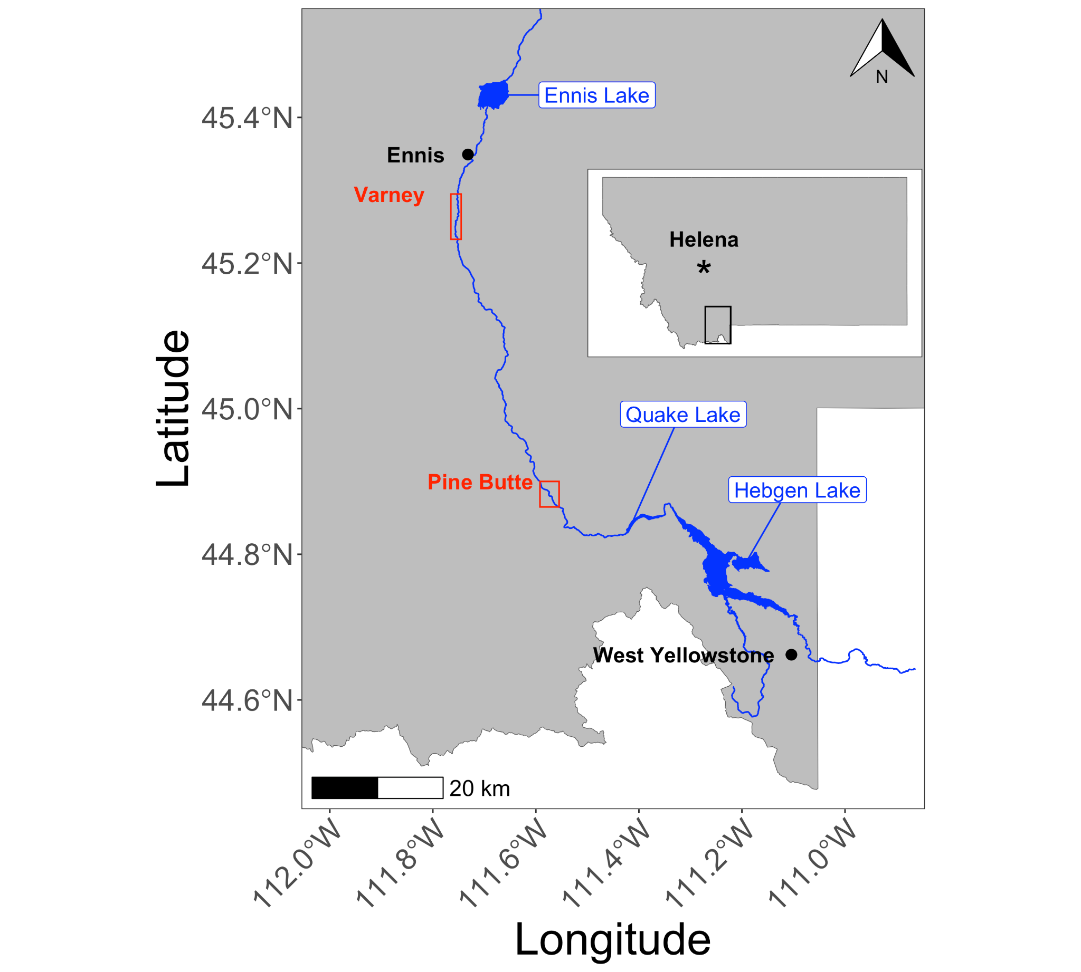

Figure 1. The Madison River from the dam at Hebgen Lake downstream through Ennis Lake is considered the upper Madison River. Long-term monitoring locations at Varney and Pine Butte are marked and bounded in red (MTFWP 2023).

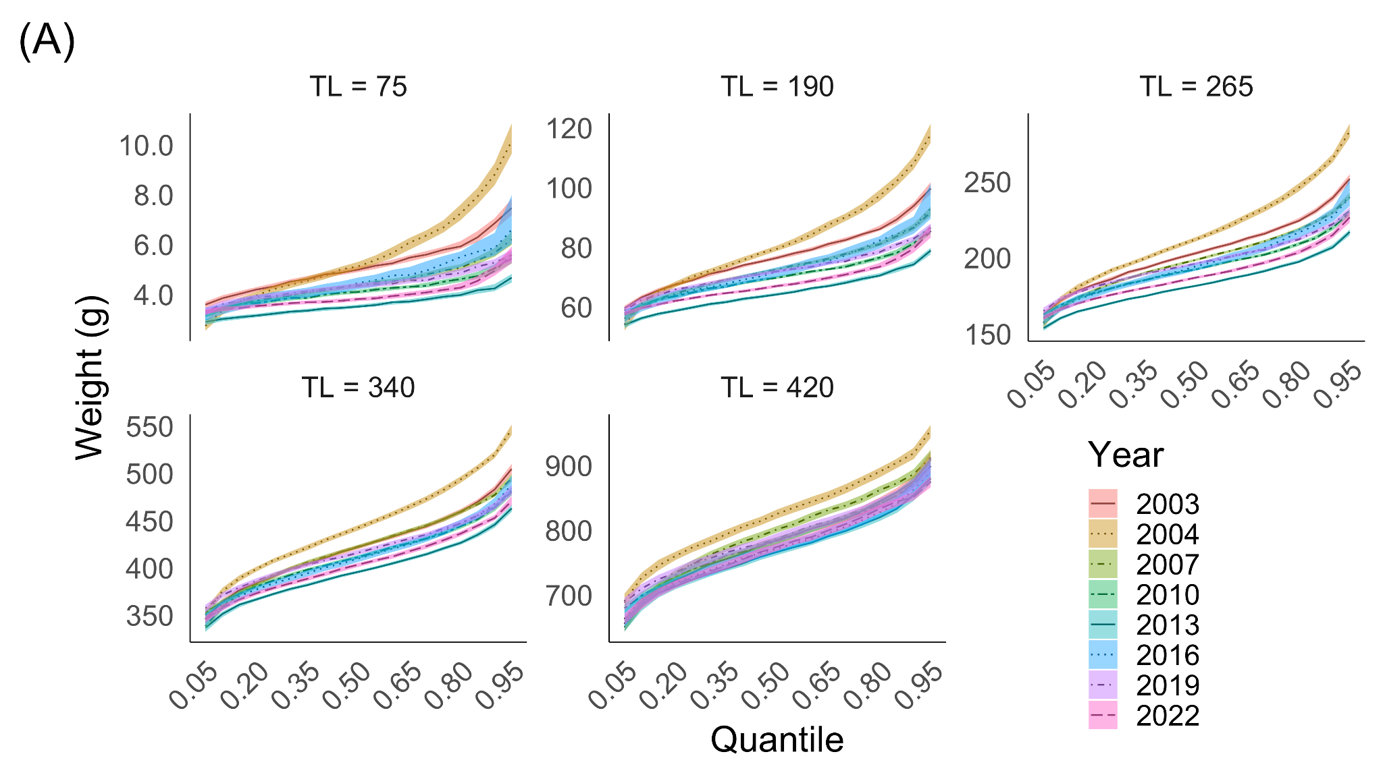

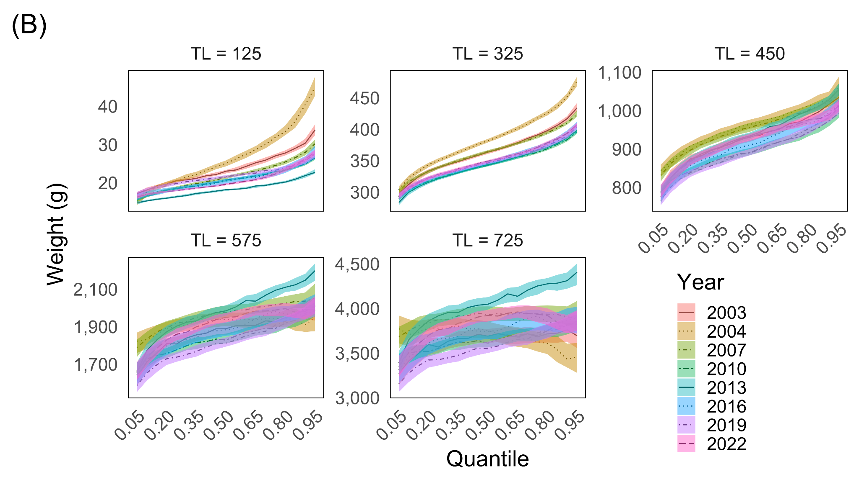

Figure 2. Quantile regression (𝜏 = 0.05 up to 0.95 by increments of 0.05) prediction and 95% CIs of weight for the midpoint (mm) of each length category [substock (SS), stock-quality (S-Q), quality-preferred (Q-P), preferred-memorable (P-M), memorable-trophy (M-T); Gabelhouse 1984] for the reference data set (Year = 2003) and seven subsequent years for Brown Trout (A) and Rainbow Trout (B) populations in the upper Madison River, Montana.

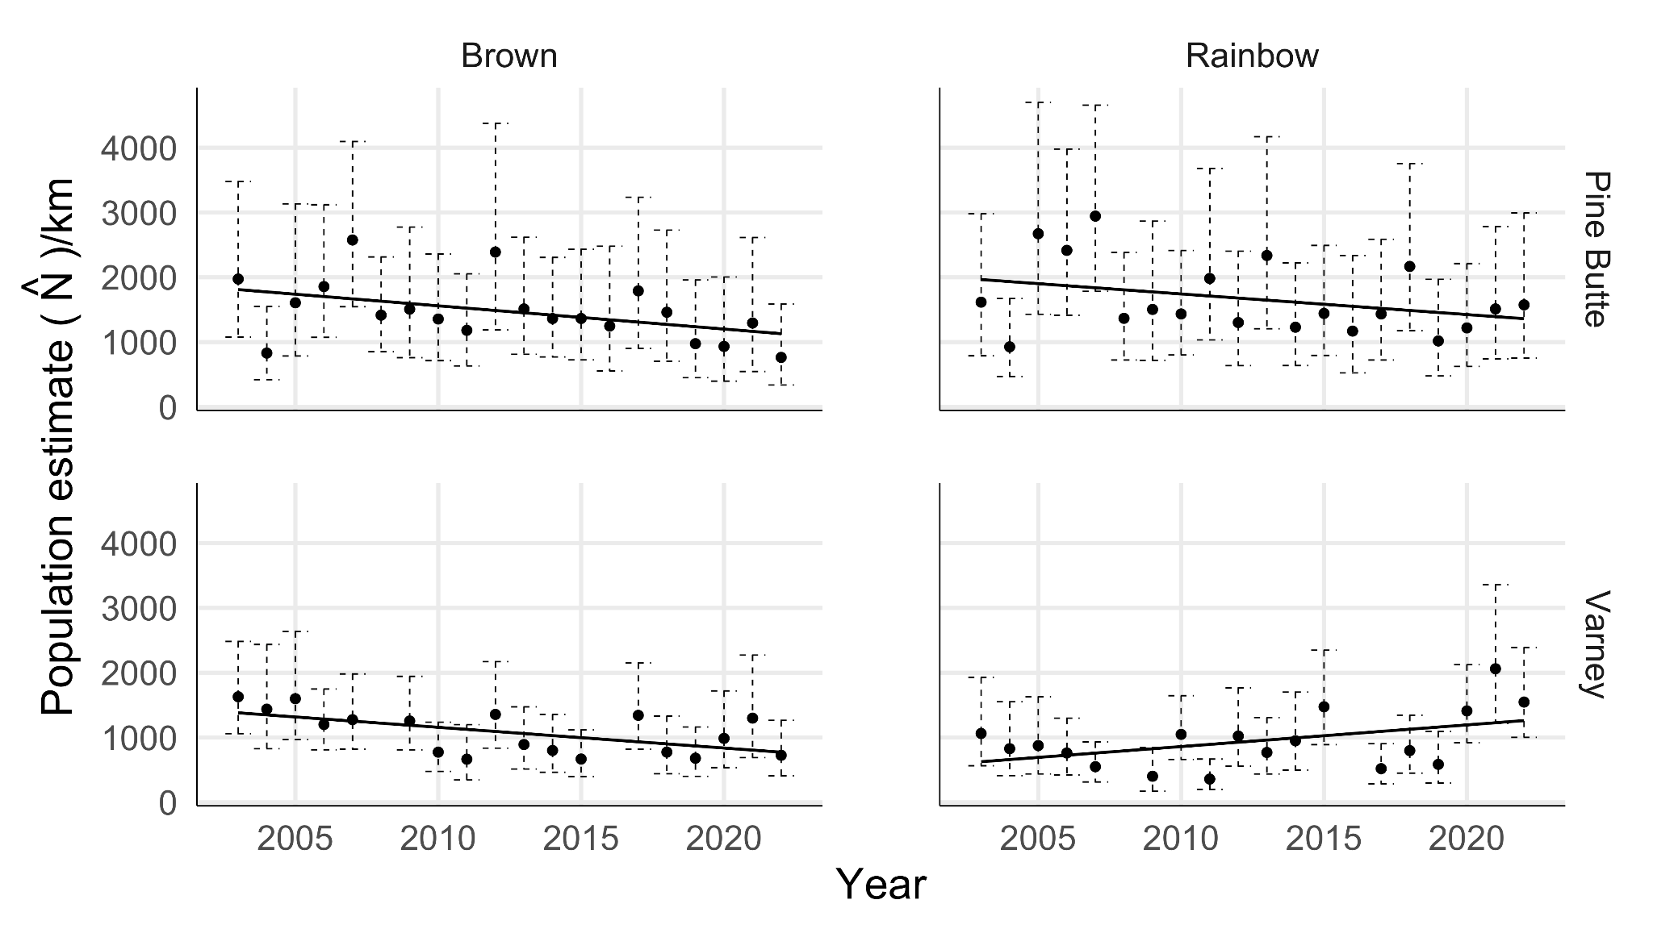Figure 3. Linear regression (solid line) of population estimates of Brown Trout (left column) and Rainbow Trout (right column) and constructed 95% confidence intervals (dashed lines) per river kilometer at two long-term monitoring locations in the upper Madison River, Pine Butte (top row) and Varney (bottom row). The overall model fit for Brown Trout at Pine Butte and Varney is significant (*p* = 0.047 and *p* = 0.014, respectively) suggesting that over time, there have been fewer Brown Trout in the upper Madison River. The overall model fits for Rainbow Trout at both sampling locations are not significant at ɑ = 0.05 (Pine Butte: *p* = 0.15; Varney: *p* = 0.055) and Rainbow Trout populations appear to be increasing at Varney.

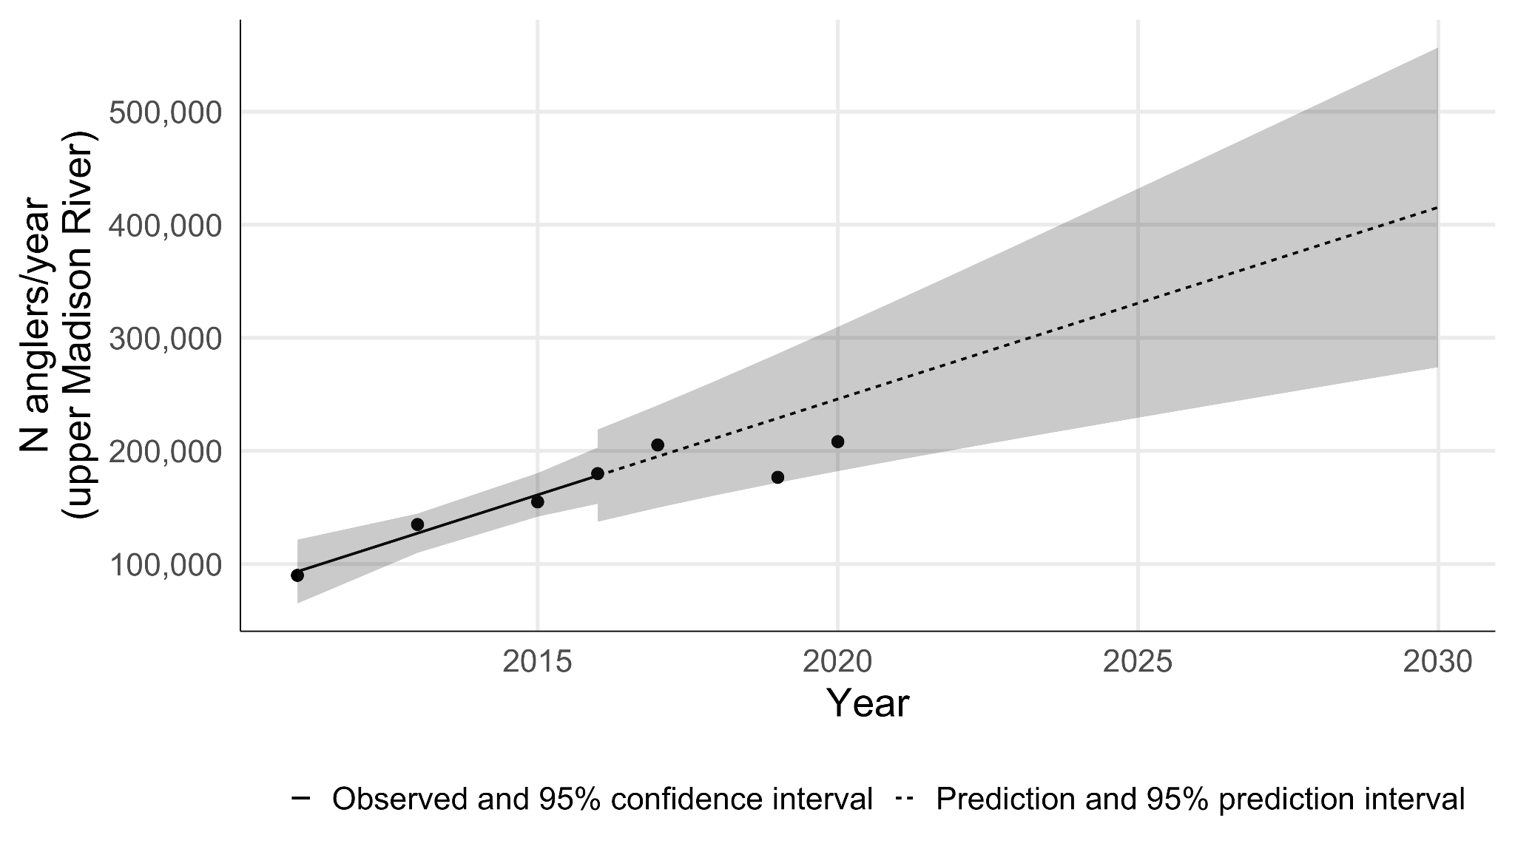

Figure 4. The observed (filled circles) number of anglers/year on the upper Madison River, Montana. A linear model and 95% CI (solid line and surrounding shaded area) was fitted to the number of anglers/year for years ≤ 2016 which was subsequently used to predict (dashed line) the number of anglers/year for 2017 through 2030. Observed data for years 2017, 2019, and 2020 (filled circles) were used to validate the prediction and 95% prediction interval (shaded area around dashed line). The linear model for the number of anglers was significant (adjusted R2 = 0.96; β0 = -33991356; β1 = 16949; *p* = 0.0134). Data point for 2016 is an estimate from a correlation analysis between reported outfitted trips and total angling pressure (Horton et al. 2018).