The Effect of Stomach Contents on the

Relative Weight (*Wr*) of Smallmouth Bass and Walleye

Steven H. Ranney*

1546 Tempest Court

#105

Bozeman, Montana 59718, USA

John M. Syslo

Montana Cooperative Fishery Research Unit and

Department of Ecology

Montana State University

Post Office Box 173460

Bozeman, Montana 59717, USA

Al Zale

U.S. Geological Survey, Montana Cooperative Fishery Research Unit,

and Department of Ecology, Montana State University

Post Office Box 173460

Bozeman, Montana 59717, USA

* Corresponding author: Steven.Ranney@gmail.com

<A>Abstract

Relative weight (*Wr*) is commonly used to characterize fish condition. As a short-term indicator of fish condition, *Wr* could be biased high by the mass of recently ingested prey items. We estimated the maximum stomach volume of smallmouth bass *Micropterus dolomieu* and walleye *Sander vitreus* from the Midwestern United States with quantile regression at τ = 0.99 and calculated the *Wr* of fish with empty stomachs (*Wr*E), stomachs filled to estimated maximum (*Wr*MAX), and with observed stomach contents (*Wr*) for four populations of smallmouth bass from South Dakota and six populations of walleye from Kansas (*n* = 1), Montana (*n* = 1), Nebraska (*n* = 1), and South Dakota (*n* = 3). We made comparisons between *Wr*E × *Wr*, *Wr*E × *Wr*Max, and *Wr* × *Wr*Max for all length categories (i.e., substock, Stock-Quality, Quality-Preferred, Preferred-Memorable, Memorable-Trophy) for both species. We found no significant differences in any length category for either species in the *Wr*E × *Wr* comparison. In the *Wr*E × *Wr*Max and *Wr* × *Wr*Max comparisons, we found statistically significant differences in all length categories except for the Memorable-Trophy category for both species. Significant differences in the substock length categories for both species translated to differences in relative weight of up to 20 *Wr* units. Significant differences in the larger length categories translated to changes in relative weight to a maximum of 10 *Wr* units. Because substock fishes are considered to not be recruited to the gear normally used to sample a given species, we consider these differences in relative weight to have little management-related significance. Further, because the largest predicted change in relative weight in higher length categories is only 10 *Wr* units and the minimum *Wr* resolution at which a population can be managed is 10 units, we do not believe that fisheries managers should consider the stomach contents of the fishes in their populations when setting *Wr* target ranges.

<A>Introduction

Length and weight data are important for fisheries management (Neumann et al. 2012) and are often used in combination (i.e., relative weight, *Wr*) to evaluate fish condition and the success of management actions (Blackwell et al. 2000). Further, *Wr* is a concept that is easily communicated by fisheries managers to anglers. Relative weight is simple to calculate provided a species has a standard weight (*Ws*) equation (Anderson and Neumann 1996; Pope and Kruse 2007). The simplicity of calculating and interpreting *Wr* is likely one reason *Wr* is a popular management tool. Relative weight is calculated by

where W is the weight of an individual fish at a given length and *Ws* is a length-specific standard weight predicted by a weight-length regression that represents the species (Wege and Anderson 1978; Neumann et al. 2009). Although *Wr* is represented as a percentage, *Wr* is unitless (Neumann et al. 2009). The *Ws* is calculated by a weight-as-a-function-of-length model, common to fisheries applications

where *a* is the intercept value, *b* is the slope of the log10(weight)-log10(length) regression equation, and L is the length of the fish. The optimal *Wr* target was established as 100 *Wr* units, indicating a fish in “above average” condition (Wege and Anderson 1978; Pope and Kruse 2007). When *Wr* values are below 100 for an individual, size group, or population, there could be issues with competition or food supply; for values of *Wr* well above 100, there could be excess prey (Neumann et al. 2009).

Estimates of *Wr* are widely used in fisheries management but are often used to evaluate physiological measures beyond just relative body size (Blackwell et al. 2000). Several studies have shown that *Wr* is positively correlated with environmental and physiological measures, suggesting that *Wr* could be a good non-invasive tool to estimate system wide drivers of fish populations or bioenergetic flow (see Neumann et al. 2009). However, the evidence for the utility of *Wr* is variable (Neumann et al. 2009). Fisheries managers that use *Wr* as an index to any of the dynamic rate functions (i.e., recruitment, growth, and mortality) or to estimate other population metrics should do so with caution and use additional data sources to validate assumed relationships (Neumann et al. 2009). Because *Wr* is generally considered to be a short-term indicator of fish condition, recently ingested prey could have a significant effect on the *Wr* of an individual.

Walleye *Sander vitreus* and smallmouth bass *Micropterus dolomieu* have similar feeding patterns and prey resources (Frey et al. 2003). In diet studies of both species, fishes, insects, and crustaceans routinely appear in the stomachs of both (Winemiller and Taylor 1987; Poe et al. 1991; Einfalt and Wahl 1997; Campbell 1998; Wuellner et al. 2010). Smallmouth have been shown to ingest prey with lengths 20-50% of their total length (TL; Winemiller and Taylor 1987) and walleye have been observed in the laboratory ingesting prey 18% - >60% of their TL (Einfalt and Wahl 1997; Campbell 1998). In Lake Sharpe, South Dakota, Wuellner et al. (2010) found that smallmouth can ingest deep-bodied prey gizzard shad *Dorosoma cepedianum* from 5% - 13% of their TL and walleye can consume gizzard shad 5%-15% of their TL. Given the information that smallmouth bass and walleye can ingest prey items that are comparatively large, this begs the question of whether large meals can affect *Wr* values. Recently ingested food may affect *Wr*, inflating the estimated condition of individual fish and affecting management decisions in the absence of supporting data. We evaluated the effect of stomach contents on *Wr* values of smallmouth bass and walleye from the Midwestern United States by comparing *Wr* values of fish without stomach contents, with stomach contents, and with estimated maximum stomach volumes.

<A>Methods

We solicited length (mm), weight (g), and stomach contents weight (g; weighed to a minimum accuracy of 0.01 g) data of individual smallmouth and walleye from fisheries scientists and managers across the Midwestern and Western United States. We calculated relative weight of each fish (Murphy et al. 1990; Kolander et al. 1993) with three different values of body weight: including stomach contents (*Wr*), excluding stomach contents (*Wr*E), and including the estimated maximum stomach capacity (*Wr*Max).

To calculate *Wr*Max, we first estimated the maximum stomach capacity of smallmouth bass and walleye. We based our estimates of maximum stomach capacity (*W*StMax) on a filtered data set. For both species, we selected the individuals with the highest observed stomach contents weight in each length category [substock (SS), stock – quality (S-Q), quality – preferred (Q-P), preferred – memorable (P-M), memorable – trophy (M-T), and greater than trophy (>T); Gabelhouse 1984] by population. This resulted in four individuals in all length categories for smallmouth bass and six individuals in each of the SS, S-Q, Q-P, and P-M categories and five individuals in the M-T category for walleye. One South Dakota population did not have any walleye in the M-T length category. With species-specific populations reduced to the individuals with the maximum observed stomach contents in each length category by population, we modeled observed stomach contents weight (*W*­St) as a function total weight minus observed stomach contents weight (*W*E) for each species. We used linear regression because visual examination of the relationship of *W*St to *W*E appeared linear.

We fit a linear model

,

where *W*St is the observed maximum stomach contents (g) of a fish at a given empty weight (*W*E; g) and *a* and *b* are derived from the linear model. We used linear quantile regression at the 99th quantile (τ = 0.99) to model *W*St because the ordinary least squares “best fit” line was lower than the actual values in many cases, thus returning estimated maximum stomach contents values that were less than the observed values. Quantile regression can estimate the functional relationships between variables for any portions of a distribution (Koenker and Basset 1978; Cade and Noon 2003). We used the rq() function in the “quantreg” package (Koenker 2017) in R 3.3.3 (R Development Core Team 2017) to model of *W*St as a function of *W*E at τ = 0.99. To evaluate goodness of fit, we used R1 for quantile regressions (Koenker and Machado 1999). R1 is a local measure of goodness of fit at a given quantile and can be interpreted similar to R2 from ordinary least squares regression (Koenker and Machado 1999). We estimated *W*StMax of each individual with the quantile regression lines for both species. We then calculated *Wr*Max by adding the estimated maximum stomach contents weight (g) to the total empty weight of each individual (*W*E) and calculating *Wr* with the species’ *Ws* equation.

We tested for normality of our *Wr*E, *Wr*, and *WrMax* data by each species × population × length category with a Shapiro-Wilk test because *Wr* dataare often non-normally distributed (Brendan et al. 2003; Pope and Kruse 2007). When data were distributed non-normally, we compared differences in the median values of *Wr*E, *Wr*, and *Wr*Max by length category and population with Wilcoxon two-sample tests (Pope and Kruse 2007). We removed species × lake × length category groups that had n < 3 individuals from consideration for this portion of the analysis. To evaluate potential biological significance of differences among *Wr*E, *Wr*, and *Wr*Max values within a length category, we calculated the percent difference between calculated values of relative weight using the equation

,

where *z* = the experimental value (i.e., *Wr*E, *Wr, Wr*Max) and *z*1 = the observed value (*Wr, Wr*E*, WrMax*), depending on the comparison made. Alpha for all statistical tests was set equal to 0.05. All statistical analyses were conducted using R version 3.3.3 (R Development Core Team 2017).

<A>Results

We collected total length, total weight, and stomach-contents weight data from 1,133 smallmouth bass individuals from four impoundments in eastern South Dakota (Clear, *n* = 294; Enemy Swim, *n* = 252; Pickerel, *n* = 296; Roy, *n* = 289). For walleye, we collected length, total weight, and stomach-contents weight data from 953 individuals from six populations including impoundments in eastern South Dakota (Bitter, *n* = 346; Pelican, *n* = 62; Twin, *n* = 23), Nebraska (Harlan Reservoir, *n* = 140), Kansas (lake unknown, *n* = 283), and the Missouri River upstream of Ft. Peck Reservoir in Montana (*n* = 99). Because these data were donated, the details of their collection method and time of year of collection are unknown.

Quantile regression of *W*St as a function of *W*E at the 99th quantile provided good fits for smallmouth bass (n = 22; R1 = 0.78; Figure 1) and walleye (n = 29; R1 = 0.74; Figure 1). Ordinary least squares linear regression of *W*St as a function of *W*E provided a good fit for smallmouth bass (n = 22; R2 = 0.76; Figure 1) and an adequate fit for walleye (n = 29; R2 = 0.56; Figure 1).

Eliminating species × lake × length category groups that had n < 3 individuals led to removal of 10 walleye: 1 >T from Harlan Reservoir, 2 SS from Kansas, 2 SS from MO River, 2 M-T from MO River, 1 SS from Twin, and 2 P-M from Twin. Shapiro-Wilk tests on *Wr*, *Wr*E, and *Wr*MAX data indicated departures from normality for both smallmouth bass and walleye. Wilcoxon two-sample comparison tests of *Wr*E and *Wr* by length category indicated that there was no statistical difference in fish condition between *Wr*E and *Wr* for smallmouth bass or walleye in either the SS, S-Q, Q-P, P-M, or M-T length categories (Table 1). For smallmouth bass, Wilcoxon two-sample test comparisons of *Wr*E and *Wr*MAX indicated that there were statistically significant differences between *Wr*E and *Wr*MAX in all five length categories (Table 1). For those comparisons that were significantly different, the smallest percent difference was -3.42% (M-T category for Roy; Table 1) representing an increase in relative weight from *Wr*E to *Wr*Max of 3 *Wr* units (Figure 1, panel A). The largest percent difference was -20.9% (SS category for Roy; Table 1) representing an increase in relative weight from *Wr*E to *Wr*Max of 25 *Wr* units (Figure 1, panel A). Significant differences between *Wr* and *Wr*Max existed in every length category except the M-T category (Table 1). For those comparisons that were significantly different, the smallest percent differences in relative weight ranged from -2.8% for the P-M category for Pickerel (Table 1) translating to an increase from Wr to *Wr*Max of 2 *Wr* units (Figure 1, panel A). The largest percent difference of -18.7% was in the SS category for Roy (Table 1), which represented an increase from *Wr* to *Wr*Max of 23 *Wr* units (Figure 1, panel A).

For walleye, Wilcoxon two-sample comparison tests indicated that there were statistically significant differences between *Wr*E and *Wr*Max in every length category except the M-T length category (Table 1). For those comparisons that were significantly different, the smallest percent difference between *Wr*E and *Wr*Max was -4.68% (P-M category for Harlan Reservoir; Table 1) representing an increase in relative weight from *Wr*E to *Wr*Max of 4 *Wr* units (Figure 1, panel B). The largest percent difference between *Wr*E and *Wr*Max was -11.7% (SS category for Pelican; Table 1), representing an increase relative weight from *Wr*E to *Wr*Max of 12 *Wr* units (Figure 1, panel B). Significant difference between *Wr* and *Wr*Max existed in every length category except the M-T category (Table 1). For those comparisons that were significantly different, the smallest percent difference between *Wr* and *Wr*Max was -3.31% (S-Q category for Kansas; Table 1) representing an increase in relative weight from *Wr* to *Wr*Max of 3 *Wr* units (Figure 1, panel B) while the largest percent difference was -15.6% (SS category for Bitter; Table 1) representing an increase in relative weight from *Wr* to *Wr*Max of 18 *Wr* units (Figure 1, panel B).

<A>Discussion

The most common method of calculating *Wr* includes the stomach contents of fish. For our smallmouth bass datasets, the differences among predictions of condition were smallest in the longer length categories and highest in the SS length category. Similarly, for our walleye datasets, differences among predictions of condition were smallest in the longer length categories and highest in the SS category. Statistically significant differences exist when comparing *Wr*E to *Wr*Max and *Wr* to *Wr*Max across all length categories except the M-T category for both species. Given that the impact of maximum stomach contents weight on calculated relative weight is reduced to differences of only 6 *Wr* units in the Q-P length category and above, we believe that only in the SS length categories would there be any management-related significant differences that would affect fisheries management actions.

Relative weight is a widely used tool to manage fish populations (Blackwell et al. 2000). Standard weight equations have been developed for over 60 species, many of which are recreationally and economically important. Additionally, some *Ws* equations have also been developed for rare and nongame fishes (Bister et al. 2000; Richter, T. J. 2007; Rypel and Richter 2008; Ogle and Winfield 2009). Fisheries managers rely on condition factors in monitoring and managing fish populations and the results herein suggest that although maximum stomach contents increase estimates of *Wr* across length categories, the increase among individuals most important to anglers (i.e., Q-P, P-M, and M-T length categories) is insignificant for management-related purposes. Though estimates of *Wr*MAX were significantly larger than estimates of *Wr*E in smallmouth bass and walleye in the SS length category by as many as 20 *Wr* units, fish of such small sizes are more likely to have inflated *Wr* values from a maximum-sized meal than a fish of larger sizes. Further, fish in the SS length category have generally not recruited to gear traditionally used by biologists to sample the species (Gabelhouse 1984) and the length bias inherent in Ws equations for fish at the lower length ranges of a species may cause condition values to be artificially inflated (Ranney et al. 2010 and 2011). Becuase the significant differences between *Wr*E × *Wr*Max and *Wr* × *Wr*Max in the Q-P, P-M, and M-T length categories translate to only moderate differences in calculated relative weight, even at maximum stomach capacity, the stomach contents of fishes would have little impact on management-related decisions when *Wr* is used as a management tool.

The details of the method of fish collection used in this study are unknown to us. Standard methods exist for freshwater fisheries collections (see Bonar et al. 2009) but given the nature of the donated datasets used herein, it is impossible for us to know how varied the collection methods were for each species and population. Given that we were focused on the maximum stomach contents of smallmouth bass and walleye and that fish must eat to survive, data collected during any time of year by any method would have fulfilled our needs. It is possible, however, that all of these datasets were collected during mid-winter when fish metabolism is lowest (Karås 1990) and their rate of ingestion is low. If this were the case, our quantile regression model would be biased low and thus predictions of *Wr*Max could be lower than actuals values.

Stomach fullness is limited by rates of digestion or prey encounter (Breck 1993). Thus, stomach fullness for an individual fish at a given time will range from empty to full (Gosch et al. 2009). Predicting the likelihood at which an individual fish will be at maximum stomach capacity would be almost impossible because prey are patchily distributed (Gosch et al. 2009). The difference in the slope coefficients, *b*, for smallmouth (*b* = 0.0381) and walleye (*b* = 0.0467) indicate that walleye have a higher rate of change in stomach capacity than smallmouth (Gosch et al. 2009). Thus, walleye experience a greater rate of change in stomach capacity with increasing length. This difference is likely a result of feeding strategies for these species. Walleye are considered specialist piscivores from hatch (Graeb et al. 2005) whereas smallmouth experience greater ontogenetic shifts in prey items: zooplankton to insects and small fish, culminating in crayfish and larger fish (Coble 1967). Another possible explanation for the differences in slope coefficients are the potential morphological differences in digestive systems between smallmouth and walleye. Though we did not investigate stomach morphology, walleye and smallmouth may have a dissimilar number of pyloric caeca, which could affect digestion rates and stomach fullness.

Developers of *Ws* equations have not accounted for the influence of stomach-contents on total fish mass (i.e., Murphy et al. 1990; Gerow et al. 2005). Wege and Anderson (1978) discuss several factors that could influence *Wr* in largemouth bass *Micropterus salmoides* (e.g., population density, prey abundance, etc.) but do not discuss how stomach contents could affect *Wr*. Though the stomach contents of fishes is a measurement error and population density and prey abundance are physiological mechanisms, measurement error should be taken into account when collecting data that will be used in management-related decisions. However, our analyses suggest that there are relatively small management-related differences among *Wr*E, *Wr*, and *Wr*MAX for individuals in length categories most frequently targeted by management actions.

Our choice of using quantile regression τ = 0.99 was motivated by the fact that ordinary least squares (OLS) regression will estimate the mean response of some variable *y* to some variable *x*. Here, we are trying to estimate the maximum response of *W*St as a function of *W*E. By using quantile regression at τ = 0.99, we can truly estimate the maximum response of *W*St to *W*E with observed values. The rationale for our argument for using quantile regression at τ = 0.99 rather than OLS regression is evident in Figure 1. Clearly, predictions from the linear model would underestimate maximum stomach contents weight as a function of the empty body weight of smallmouth and walleye while the quantile model at τ = 0.99 truly is an estimator of maximum stomach contents for both species (Figure 1).

To our knowledge, there has been no investigation into the lowest resolution of *Wr* at which fisheries managers can manage a population. Fish with *Wr* “close to” 100 are considered to be “in balance” with their food supply while fish with *Wr* less than 85 are underweight and fish with *Wr* greater than 105 are “more plump than necessary” (Flickinger et al. 1999). Most fisheries managers consider fish with a *Wr* value between 95 and 105 to be in good condition because *Wr* is a model of the 75th percentile of fish population weight as a function of length (Wege and Anderson 1978). When *Wr* target ranges are given for a species, the range encompasses 10 *Wr* units, suggesting that the lowest *Wr* resolution at which a fish population can be managed is 10 (see Blackwell et al. 2000). At higher length categories (i.e., S-Q, Q-P, P-M, and M-T) for both smallmouth and walleye, the largest differences we saw in relative weight between *Wr*E and *Wr*Max was 10 *Wr* units. Using 10 *Wr* units as the lowest resolution size at which a population can be managed, for these populations of smallmouth bass and walleye in the upper length categories, it is unlikely that stomach contents will affect management decisions. As a result, we do not believe that fisheries managers should consider the stomach contents of the fishes in their populations when setting *Wr* target ranges.

<A>Acknowledgments

We thank the contributors of the data used in this paper: T. Bacula, N. Olson, M. Quist, and T. Selch. Christopher Guy provided significant direction early in the development of this manuscript. We also thank X anonymous reviewers whose comments improved the quality of this manuscript.

<A>References

Anderson, R. O., and R. M. Neumann. 1996. Length, weight, and associated structural indices. Pages 447-482 *in* B. R. Murphy and D. W. Willis, editors. Fisheries techniques, 2nd edition. American Fisheries Society, Bethesda, Maryland.

Bister, T. J., D. W. Willis, M. L. Brown, S. M. Jordan, R. M. Neumann, M. C. Quist, and C. S. Guy. 2000. Proposed standard weight (*Ws*) equations and standard length categories for 18 warmwater nongame and riverine fish species. North American Journal of Fisheries Management 20:570-574.

Blackwell, B. G., M. L. Brown, and D. W. Willis. 2000. Relative weight (*Wr*) status and current use in fisheries assessment and management. Reviews in Fisheries Science 8:1-44.

Bonar, S. A., W. A. Hubert, and D. W. Willis, editors. 2009. Standard methods for sampling North American freshwater fishes. American Fisheries Society, Bethesda, Maryland.

Breck, J. E. 1993. Foraging theory and piscivorous fish: are forage fish just big zooplankton? Transactions of the American Fisheries Society 122:902:911.

Brendan, T. O., B. R. Murphy, and J. B. Birch. 2003. Statistical properties of the relative weight (*Wr*) index and an alternative procedure for testing *Wr* differences between groups. North American Journal of Fisheries Management 23:1136-1151.

Cade, B. S., and B. R. Noon. 2003. A gentle introduction to quantile regression for ecologists. Frontiers in Ecology and the Environment 1:412-420.

Campbell, E. A. 1998. Predation by small walleyes on yellow perch: effects of prey size distribution. Transactions of the American Fisheries Society 127:588-597.

Coble, D. W. 1967. Relationship of temperature to total annual growth in adult smallmouth bass. Journal of the Fisheries Research Board Canada 24:87-99.

Einfatl, L. M., D. H. Wahl. 1997. Prey selection by juvenile walleye as influence by prey morphology and behavior. Canadian Journal of Fisheries and Aquatic Sciences 54:2618-2626.

Flickinger, S. A., F. J. Bulow, and D. W. Willis. 1999. Small impoundments. Pages561 – 587 *in* C. C. Kohler and W. A. Hubert, editors. Inland fisheries management in North America, 2nd edition. American Fisheries Society, Bethesda, Maryland.

Frey, A. P., M. A. Bozek, C. J. Edwards, and S. P. Newman. 2003. Diet overlap and predation between smallmouth bass and walleye in a north temperate lake. Journal of Freshwater Ecology 18:43-54.

Gabelhouse, D. W., Jr. 1984. A length-categorization system to assess fish stocks. North American Journal of Fisheries Management 4:273-285.

Gerow, K. G., R. C. Anderson-Sprecher, and W. A. Hubert. 2005. A new method to compute standard-weight equations that reduces length-related bias. North American Journal of Fisheries Management 25:1288-1300.

Gosch, N. J. C., K. L. Pope, P. H. Michaletz. 2009. Stomach capacities of six freshwater fishes. Journal of Freshwater Ecology 24:645-649.

Graeb, B. D. S., T. Galarowicz, D. H. Wahl, J. M. Dettmers, and M. J. Simpson. 2005. Foraging behavior, morphology, and life history variation determine the ontogeny of piscivory in two closely related predators. Canadian Journal of Fisheries and Aquatic Sciences 62:2010-2020.

Karås, P. 1990. Seasonal changes in growth and standard metabolic rate of juvenile perch, *Perca fluviatilis* L. Journal of Fish Biology 37:913-920.

Koenker, R, and G. Basset. 1978. Regression quantiles. Econometrica 46:33-50.

Koenker, R. and J. A. F. Machado. Goodness of fit and related inference processes for quantile regression. Journal of the American Statistical Association 94:1296-1310.

Koenker, R. 2017. quantreg: Quantile Regression. R package version 5.34. http://CRAN.R-project.org/package=quantreg.

Kohler, C. C., and A. M. Kelly. 1991. Assessing predator-prey balance in impoundments. Pages 257-260 *in* J. L. Cooper and R. H. Hamre, editors. Warmwater fisheries symposium I. U.S. Forest Service General Technical Report RM-207, Fort Collins, Colorado.

Kolander, T. D. D. W. Wilis, and B. R. Murphy. 1993. Proposed revision of the standard weight (*Ws*) equation for smallmouth bass. North American Journal of Fisheries Management 13:398-400.

Murphy, B. R., M. L. Brown, and T. A. Springer. 1990. Evaluation of the relative weight (*Wr*) index, with new applications to walleye. North American Journal of Fisheries Management 10:85-97.

Neumann, R. M., C. S. Guy, and D. W. Willis. 2012. Length, weight, and associated indices. Pages 637-376 *in* A. V. Zale, D. L. Parris, and T. M. Sutton, editors. Fisheries techniques, 3rd edition. American Fisheries Society, Bethesda, Maryland.

Ogle, D. H., and I. J. Winfield. 2009. Ruffe length-weight relationships with a proposed standard weight equation. North American Journal of Fisheries Management 29:850-858.

Poe, T. P., H. C. Hansel, S. Vigg, D. E. Palmer, L. A. Prendergast. 1991. Feeding of predaceous fishes on out-migrating juvenile salmonids in John Day Reservoir, Columbia River. Transactions of the American Fisheries Society 120: 405-420.

Pope, K. L., and C. G. Kruse. 2007. Condition. Pages 423-471 *in* C. S. Guy and M. L. Brown, editors. Analysis and interpretation of freshwater fisheries data. American Fisheries Society, Bethesda, Maryland.

R Development Core Team. 2017. R: A language and environment for statistical computing. R Foundation for Statistical Computing, Vienna, Austria. ISBN 3-900051-07-0, URL http://www.R-project.org.

Richter, T. J. 2007. Development and evaluation of standard weight equations for bridgelip suckers and largescale suckers. North American Journal of Fisheries Management 27:936-939.

Rypel, A. L., and T. J. Richter. 2008. Empirical percentile standard weight equation for the blacktail redhorse. North American Journal of Fisheries Management 28:1843-1846.

Wege, G. J., and R. O. Anderson. 1978. Relative weight (*Wr*): a new index of condition for largemouth bass. Pages 79-91 *in* G. D. Novinger and J. G. Dillard, editors. New approaches to the management of small impoundments. American Fisheries Society, North Central Division, Special Publication 5, Bethesda, Maryland.

Wickham, H. 2009. ggplot2: Elegant Graphics for Data Analysis. Springer-Verlag New York.

Winemiller, K. O., and D. H. Taylor. 1987. Predatory behavior and competition among laboratory-housed largemouth and smallmouth bass. American Midland Naturalist 117:148-166.

Wuellner, M. R., S. R. Chipps, D. W. Willis, and W. E. Adams, Jr. 2010. Interactions between walleyes and smallmouth bass in a Missouri River reservoir with consideration of the influence of temperature and prey. North American Journal of Fisheries Management 30:445-463.

<A>Supplements

A repository that includes the R code and data used in this manuscript is available at <https://github.com/stevenranney/fishStomachContents>.

Table 1. Sample size, *p* value from Wilcoxon two-sample comparison test (e.g., *Wr*E X *Wr*), and % difference in *Wr* calculated from whole smallmouth bass (*Micropterus dolomieu*) and walleye (*Sander vitreous*) individuals (*Wr*), individuals minus stomach contents (*Wr*E), and individuals at estimated maximum stomach capacity (*Wr*MAX) by population and five-cell length category. Asterisks (*) indicate comparisons that were significantly different.

|  |  |  |  |  |  |  |  |  |  |
| --- | --- | --- | --- | --- | --- | --- | --- | --- | --- |
| Species | Length Category | Population | *n* | *Wr*E *×* *Wr* | % difference | *Wr*E *×* *Wr*Max | % difference | *Wr* *×* *Wr*Max | % difference |
| Smallmouth bass | SS | Clear | 53 | 0.596 | -1.07 | 5.07e-09* | -15.7 | 2.24e-08* | -14.8 |
| Enemy Swim | 83 | 0.46 | -2.41 | 5.27e-14* | -20.1 | 7.51e-13* | -18.1 |
| Pickerel | 61 | 0.556 | -0.799 | 6.28e-13* | -17.1 | 4.59e-12* | -16.4 |
| Roy | 77 | 0.566 | -2.61 | 4.36e-10* | -20.9 | 2.9e-09* | -18.7 |
| S-Q | Clear | 101 | 0.359 | -1.33 | 2.89e-10* | -7.76 | 1.38e-08* | -6.52 |
| Enemy Swim | 106 | 0.372 | -2.13 | 2.3e-09* | -9.38 | 1.18e-07* | -7.4 |
| Pickerel | 95 | 0.521 | -1.43 | 1.36e-08* | -7.8 | 2.99e-07* | -6.45 |
| Roy | 108 | 0.369 | -0.649 | 8.07e-10* | -7.8 | 3.21e-08* | -7.2 |
| Q-P | Clear | 61 | 0.467 | -1.54 | 0.000223* | -4.68 | 0.00167* | -3.19 |
| Enemy Swim | 30 | 0.398 | -1.17 | 0.00116* | -4.66 | 0.0055* | -3.53 |
| Pickerel | 69 | 0.334 | -0.496 | 1.03e-05* | -4.62 | 2e-04* | -4.14 |
| Roy | 44 | 0.341 | -1.67 | 0.00111* | -5 | 0.0119* | -3.39 |
| P-M | Clear | 40 | 0.569 | -0.592 | 0.0317* | -3.61 | 0.0914 | -3.03 |
| Enemy Swim | 29 | 0.677 | -0.221 | 0.0872 | -3.63 | 0.132 | -3.42 |
| Pickerel | 64 | 0.337 | -1.2 | 0.00162* | -3.97 | 0.0197* | -2.8 |
| Roy | 17 | 0.658 | -0.755 | 0.131 | -3.55 | 0.218 | -2.82 |
| M-T | Clear | 39 | 0.576 | -0.815 | 0.142 | -3.44 | 0.223 | -2.65 |
| Enemy Swim | 4 | 0.686 | -0.848 | 0.686 | -3.41 | 0.686 | -2.58 |
| Pickerel | 7 | 0.62 | -1.31 | 0.535 | -3.58 | 0.535 | -2.3 |
| Roy | 43 | 0.399 | -0.979 | 0.0216* | -3.42 | 0.0999 | -2.47 |
| Walleye | SS | Bitter | 68 | 0.243 | -0.539 | 1.31e-20* | -16 | 9.15e-20* | -15.6 |
| Harlan Reservoir | 5 | 0.69 | -2.83 | 0.69 | -14.9 | 0.69 | -12.4 |
| Pelican | 8 | 0.645 | -0.318 | 0.00699* | -11.7 | 0.0104* | -11.4 |
| S-Q | Bitter | 81 | 0.544 | -0.522 | 1.86e-09* | -6.54 | 2.4e-08* | -6.05 |
| Harlan Reservoir | 50 | 0.537 | -1.12 | 0.00218* | -6.87 | 0.00803* | -5.81 |
| Kansas | 44 | 0.57 | -2.4 | 0.0122* | -5.64 | 0.0392* | -3.31 |
| MO River | 36 | 0.52 | -0.235 | 0.00151* | -6.01 | 0.00624* | -5.79 |
| Pelican | 14 | 0.352 | -1.77 | 0.00915* | -6.31 | 0.0308* | -4.62 |
| Twin | 9 | 0.73 | -0.688 | 0.0625 | -7.69 | 0.0939 | -7.06 |
| Q-P | Bitter | 186 | 0.459 | -0.563 | 2.02e-11* | -5.11 | 9.41e-10* | -4.57 |
| Harlan Reservoir | 61 | 0.542 | -0.472 | 0.000178* | -5.4 | 0.00101* | -4.95 |
| Kansas | 187 | 0.609 | -0.624 | 1.02e-06* | -5.18 | 1.28e-05* | -4.58 |
| MO River | 52 | 0.628 | -1.11 | 0.000785* | -5.2 | 0.00276* | -4.13 |
| Pelican | 28 | 0.655 | -0.949 | 0.0135* | -5 | 0.0375* | -4.09 |
| Twin | 8 | 0.721 | -0.401 | 0.382 | -4.91 | 0.382 | -4.53 |
| P-M | Bitter | 11 | 0.748 | -0.258 | 0.217 | -4.79 | 0.243 | -4.54 |
| Harlan Reservoir | 14 | 0.748 | -0.0245 | 0.0212* | -4.68 | 0.0212* | -4.66 |
| Kansas | 32 | 0.634 | -2.03 | 0.0845 | -4.6 | 0.17 | -2.62 |
| MO River | 7 | 0.71 | -0.121 | 0.456 | -4.77 | 0.535 | -4.66 |
| Pelican | 8 | 0.721 | -0.36 | 0.382 | -4.71 | 0.442 | -4.37 |
| M-T | Harlan Reservoir | 9 | 0.73 | -0.0645 | 0.34 | -4.48 | 0.34 | -4.42 |
| Kansas | 18 | 0.58 | -1.8 | 0.111 | -4.5 | 0.252 | -2.75 |
| Pelican | 4 | 0.686 | -2.1 | 0.686 | -4.51 | 0.686 | -2.47 |
| Twin | 3 | 0.4 | -3.37 | 0.4 | -4.51 | 0.507 | -1.18 |

<A>Figure Legends

Figure 1. Plots of observed stomach contents weight (*W*St; g) as a function of total weight minus stomach contents (*W*E; g) for smallmouth bass *Micropterus dolomieu* and walleye *Sander vitreus*. Each point represents the maximum total prey mass (g) observed in an individual stomach for each five-cell length category (Gabelhouse 1984) from each of four populations of smallmouth bass and six populations of walleye. The linear regression (solid line) does not truly estimate the maximum stomach contents for each species. Note different scales on both axes.

Figure 2. Box plot of relative weight with (*Wr*) and without stomach contents (*Wr*E) and at estimated maximum stomach capacity from quantile regression at the 99th quantile (*Wr*Max) by length category (Gabelhouse 1984) and population for smallmouth bass *Micropterus dolomieu* (Panel A) and walleye *Sander vitreus* (Panel B). The box describes the median value (heavy line) and the upper and lower edges of the box are the 25th and 75th percentiles. The whiskers of the box extend to 1.5 × the interquartile range (Wickham 2009). Outliers beyond the whiskers are not shown.

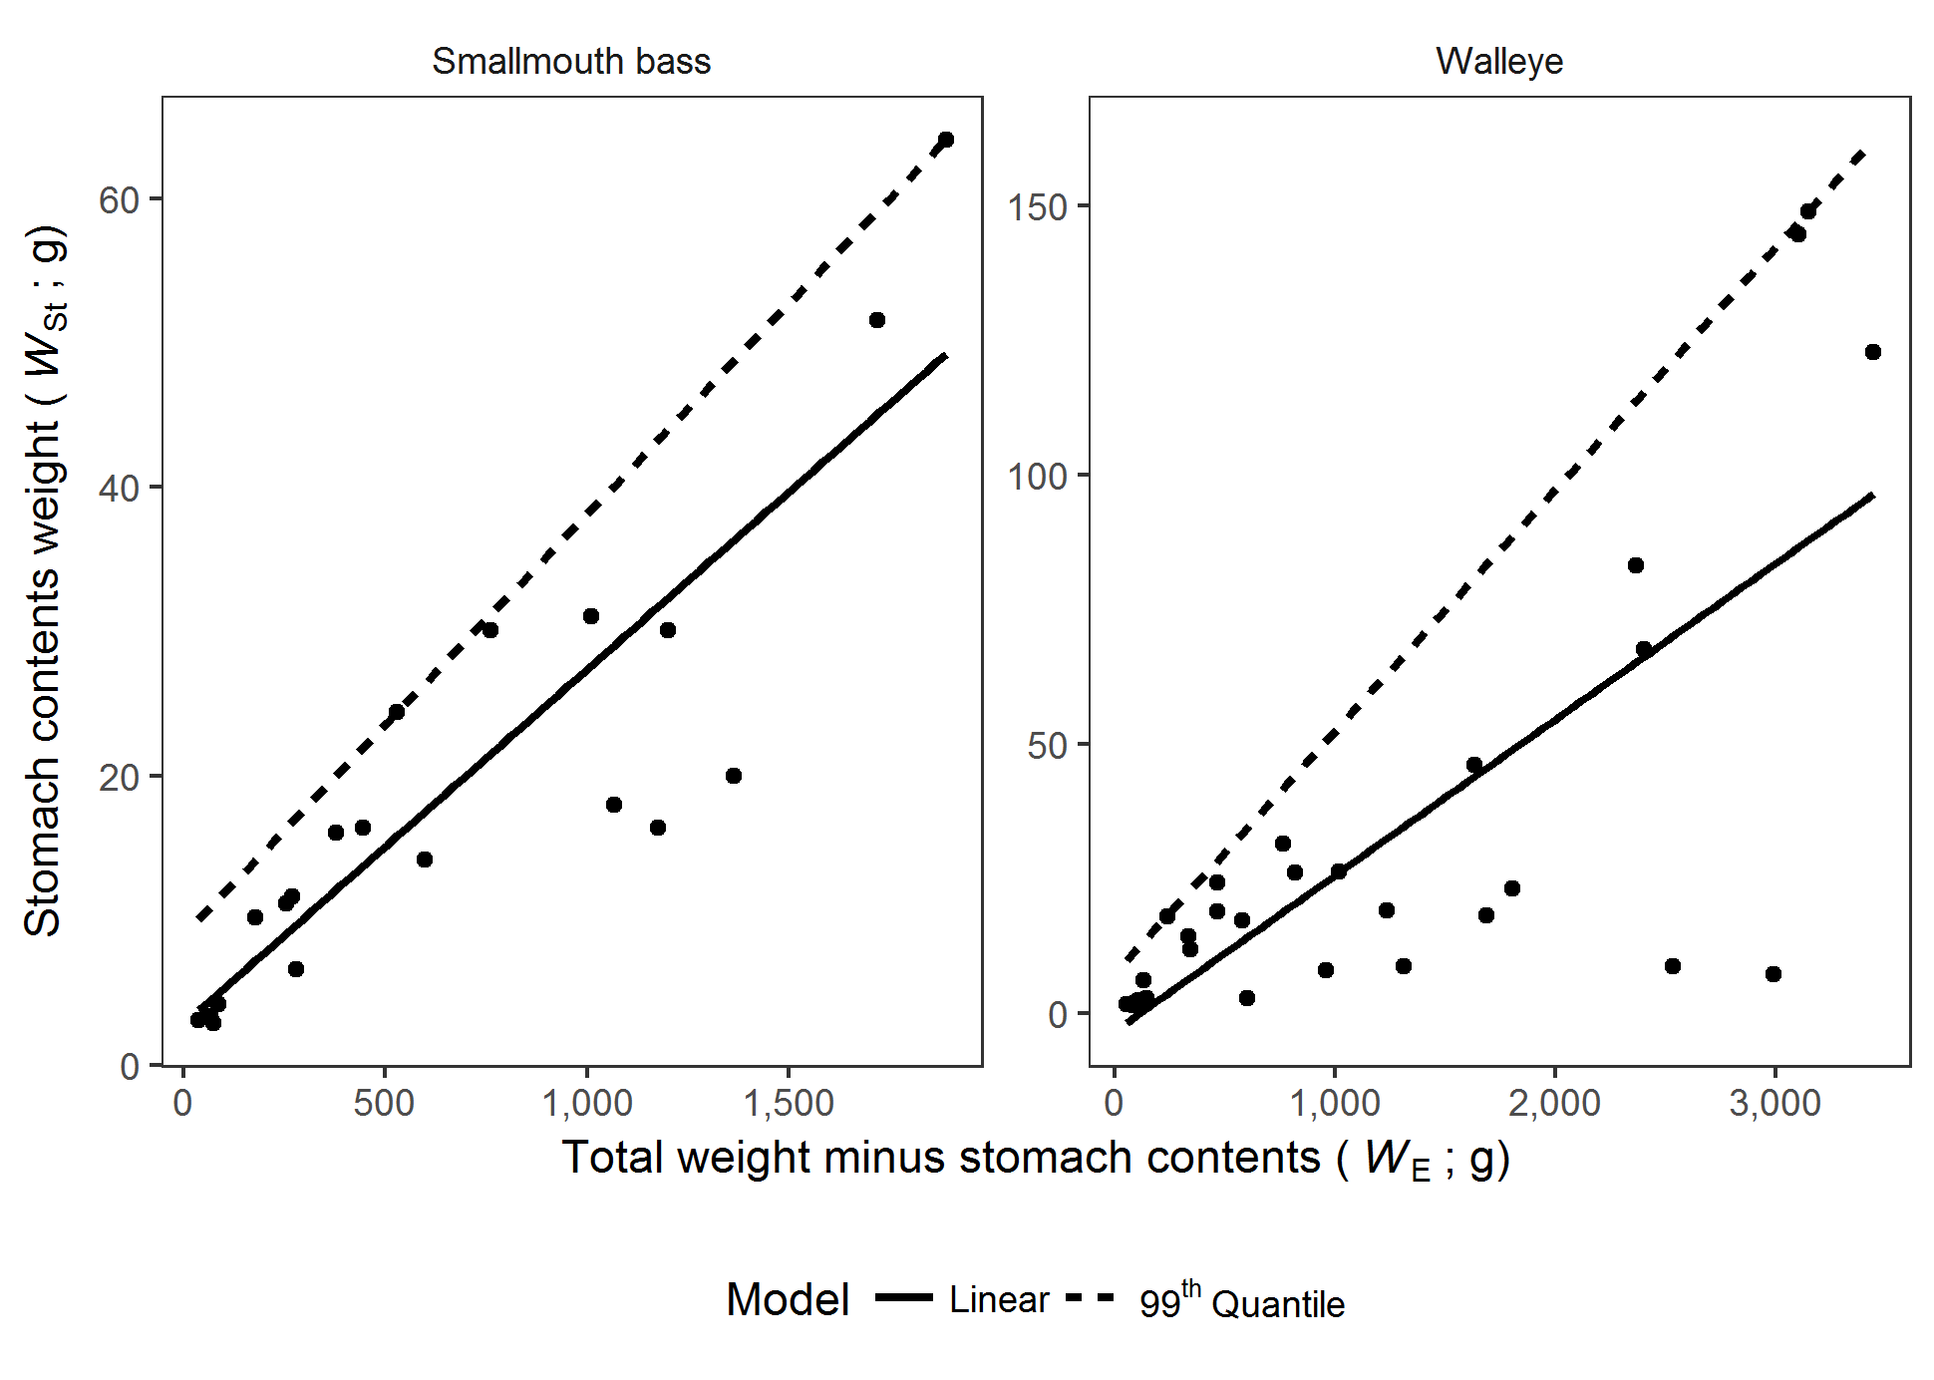

Figure 1.

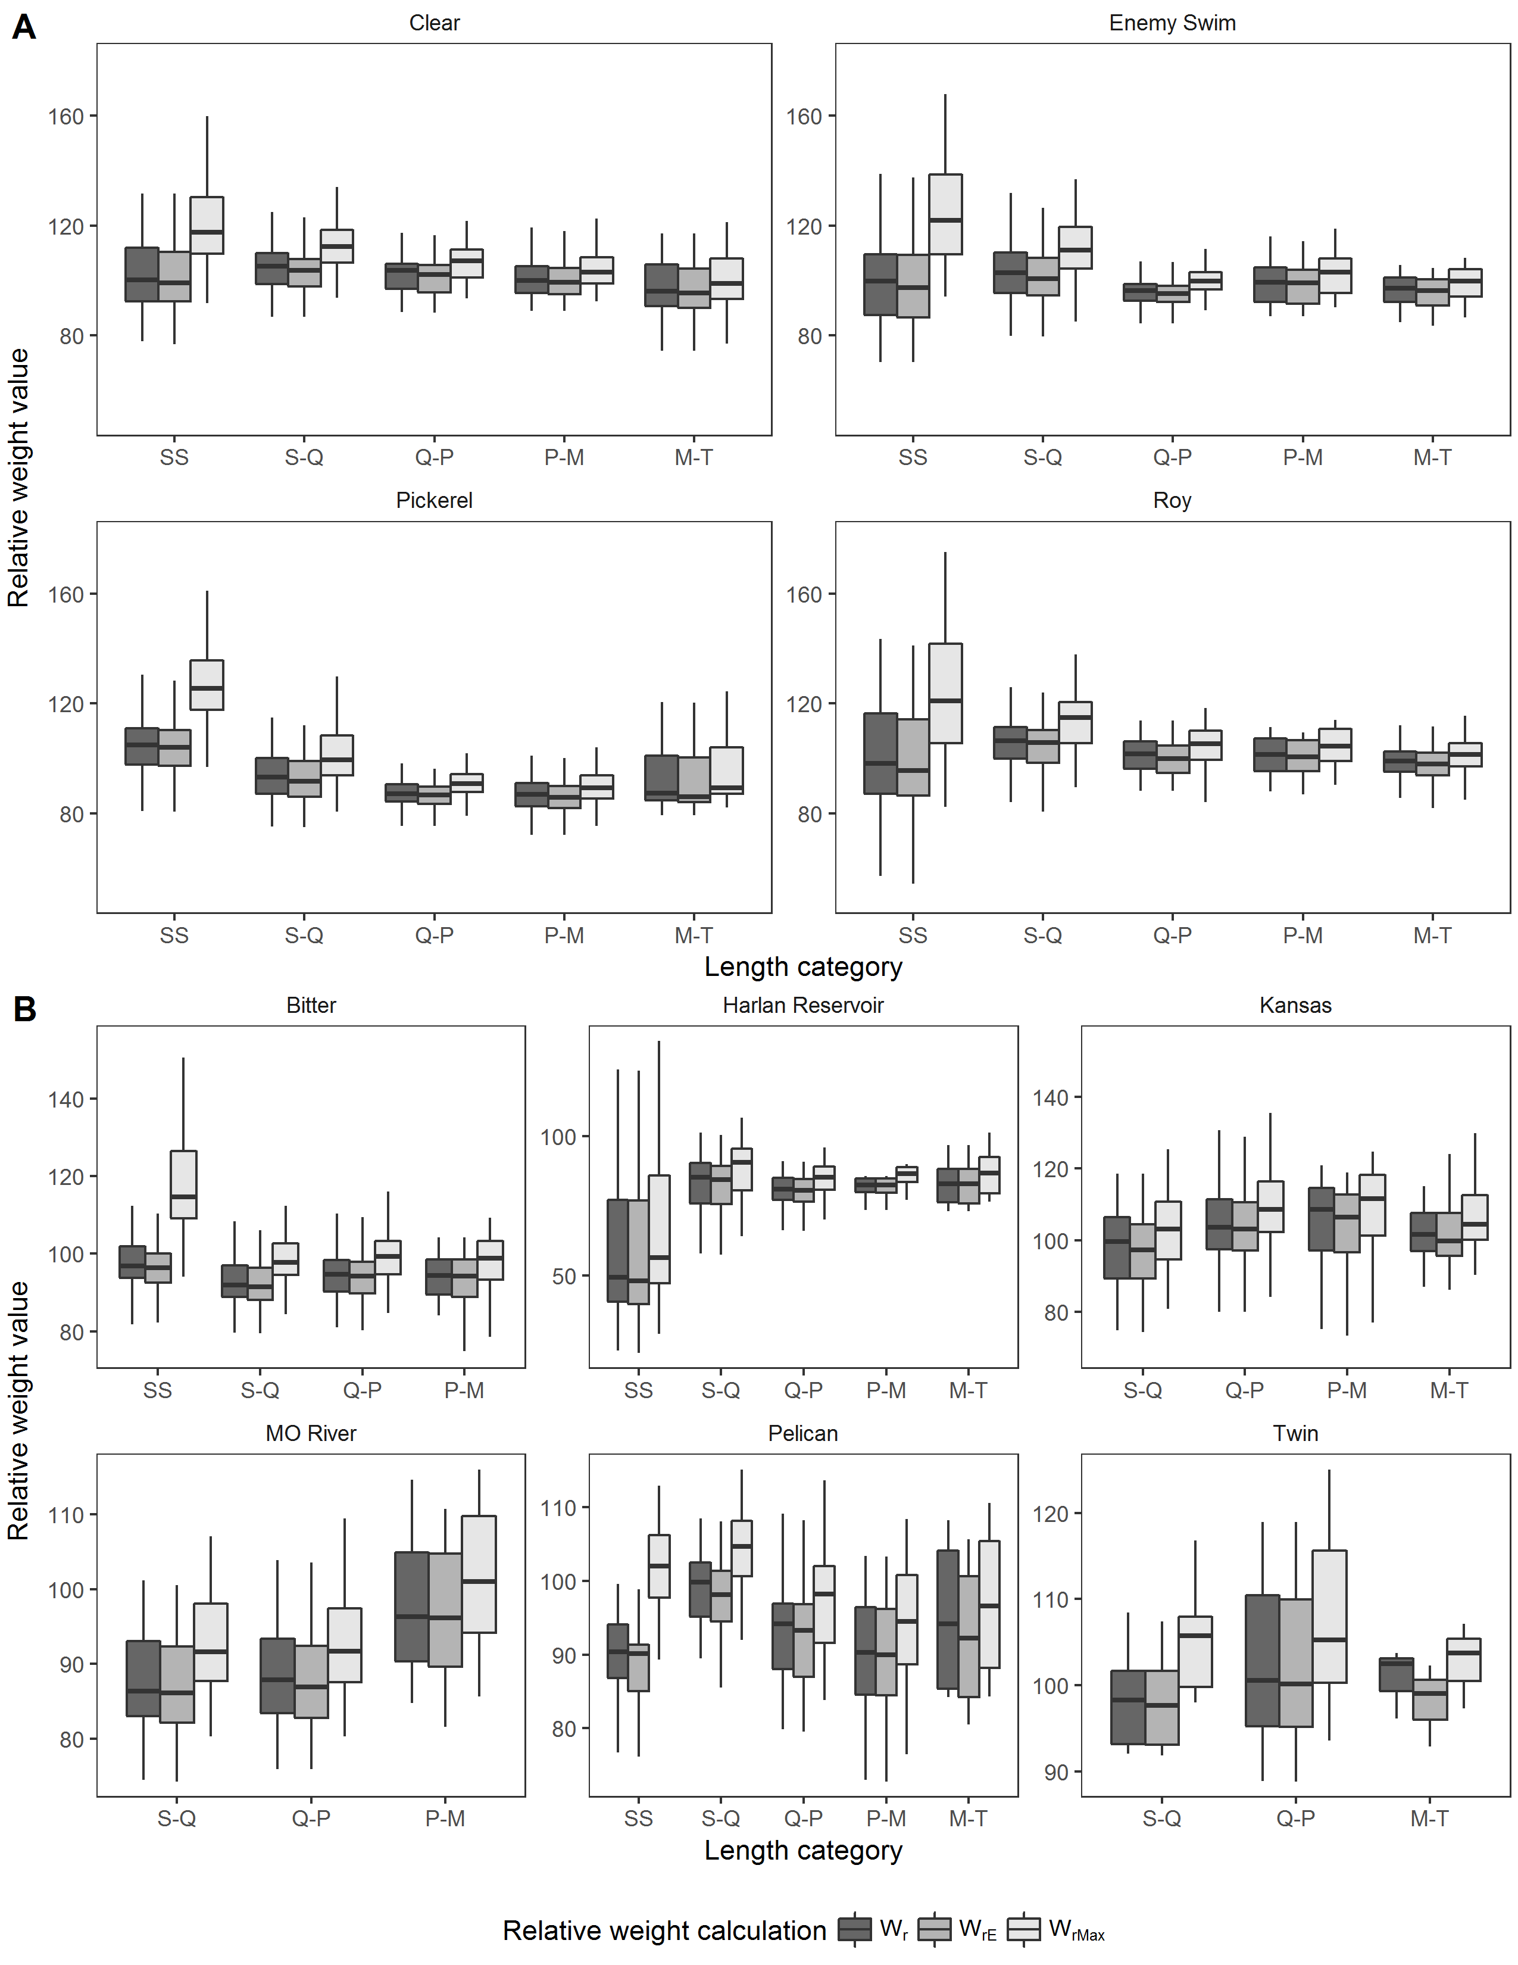

Figure 2.