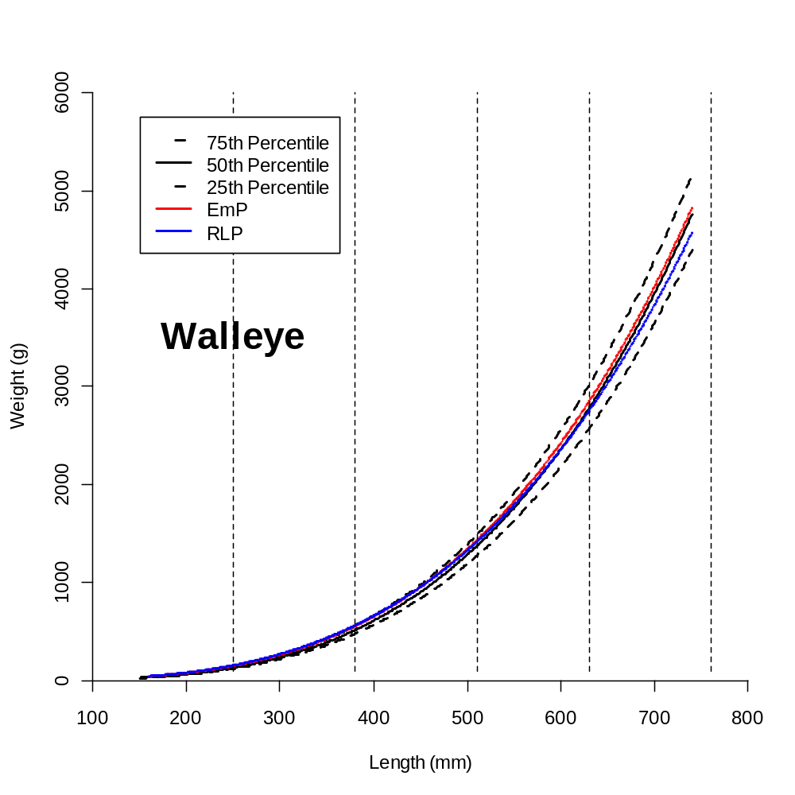

Figure X. Nonlinear regressions of the 25th, 50th, and 75th percentile (dashed, solid, dashed, respectively) of walleye weight as a function of length. The EmP and RLP lines represent standard weight (W_{s}) equations as calculated by the Empirical-Percentile (Gerow et al. 2005) and Regression-Line-Percentile methods (Murphy et al. 1990). The differences between the EmP and RLP lines and the 75th percentile line (upper dashed line) is the length bias detected when modeled third quartile weights (i.e., W_{s} equations) are compared to observed third quartile weights (i.e., percentile regressions). Length-weight data were filtered according to Ranney et al. (2010). Vertical dashed lines represent the divisions between substock, stock-quality, quality-preferred, preferred-memorable, memorable-trophy, and >trophy length categories (Gabelhouse 1984).
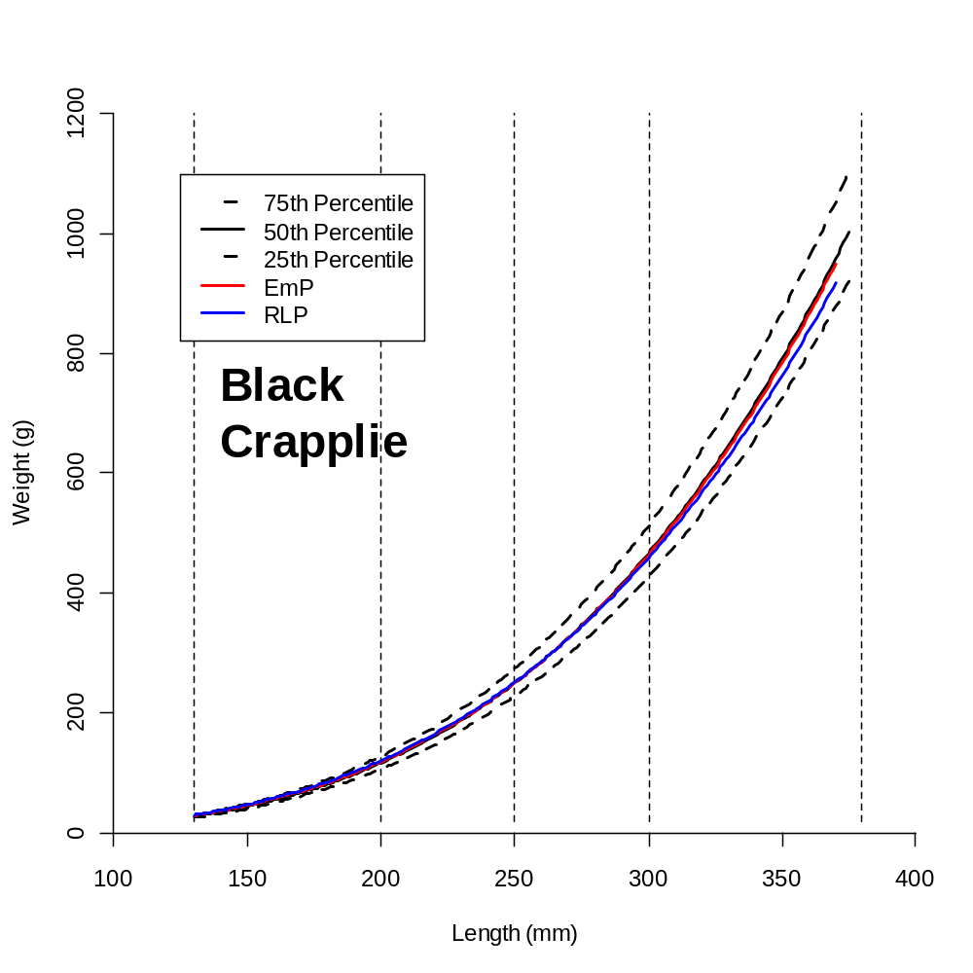
Figure X. Nonlinear regressions of the 25th, 50th, and 75th percentile (dashed, solid, dashed, respectively) of black crappie weight as a function of length. The EmP and RLP lines represent standard weight (W_{s}) equations as calculated by the Empirical-Percentile (Gerow et al. 2005) and Regression-Line-Percentile methods (Murphy et al. 1990). The differences between the EmP and RLP lines and the 75th percentile line (upper dashed line) is the length bias detected when modeled third quartile weights (i.e., W_{s} equations) are compared to observed third quartile weights (i.e., percentile regressions). Length-weight data were filtered according to Ranney et al. (2010). Vertical dashed lines represent the divisions between substock, stock-quality, quality-preferred, preferred-memorable, memorable-trophy, and >trophy length categories (Gabelhouse 1984).

