SOFTWARE REQUIREMENTS SPECIFICATION
  - Virtual Reality Mammalian Cell Culture Laboratory System

Document Identifier: SRS-VR-MCL-2026-V3.0
Target Release: Final Release (Version 3.0)
Submission Date: October 6, 2026
Project Governance & Team Authorization
Steven Rodriguez — Project Lead & Process Architecture Lead
Miguel Lopez — Interaction Modeler & UX/Prototype Lead
Nicholas Boeker — Quality Engineer, Biosafety Specialist & Documentation Lead

Academic Institution: University of Houston-Clear Lake
Course: Software Engineering Requirements Engineering

Document Control
Version | Release Date | Primary Author(s) | Summary of Changes
1.0 | September 26, 2026 | Steven Rodriguez  Miguel Lopez  Nicholas Boeker | Initial Working SRS Draft
2.0 | October 2, 2026 | Steven Rodriguez  Miguel Lopez  Nicholas Boeker | Presentation Release: Added Table 1.1 apparatus inventory, UC-00 setup to Figure 1.1, sequenced requirements [FR-001]–[FR-024], and populated Appendices A–C.
3.0 | October 6, 2026 | Steven Rodriguez  Miguel Lopez  Nicholas Boeker | Final Release: Added Section 2.3 Phase Gating State Machine, [FR-025], UC-05/UC-06 administrative use cases, and UC-00 sub-flow model; renumbered DFDs to Section 2.4 and Use Cases to Section 2.5.

Electronic Signatures & Approvals
By signing below, the project team certifies that all sections have been prepared, reviewed, and cross-audited in accordance with the course Requirements Engineering specification standards and rubric constraints.

Printed Name | Project Role | Digital Signature | Date Approved
Steven Rodriguez | Project Lead & Process Architecture Lead | Steven Rodriguez | October 06, 2026
Miguel Lopez | Interaction & Prototype Lead | Miguel Lopez | October 06, 2026
Nicholas Boeker | Quality & Documentation Lead | Nicholas Boeker | October 06, 2026

Table of Contents
1.0 Introduction 5
1.1 Purpose of the Document 5
1.2 Document Overview 5
1.3 Intended Readership and Relevance 6
1.4 Requirements Elicitation Techniques 6
1.5 Product Purpose and Mission Statement 6
1.6 Product Scope 7
2.0 Functional Requirements & Process Architecture 9
2.1 Section Introduction 9
2.2 System Functional Requirements 10
2.2.1 Phase 1: Aseptic Setup & Biosafety Cabinet Sanitization 10
2.2.2 Phase 2: Microscopic Inspection & Confluency Assessment 10
2.2.3 Phase 3: Enzymatic Cell Dissociation (Trypsinization) 11
2.2.4 Phase 4: Cell Viability Staining & Quantification 11
2.2.5 Phase 5: Secondary Inoculation, Labeling & Session Persistence 12
2.3 Laboratory Phase Execution & Gating State Machine 12
2.4 Data Flow Diagrams (DFDs) 15
2.4.1 Level 0 Context Data Flow Diagram 15
2.4.2 Level 1 Functional Decomposition DFD 15
2.4.3 Level 2 Child DFD 17
2.5 Use Case Specifications & Sub-Flows 17
2.5.0 UC-00: Initialize Workstation & Aseptic Setup 17
2.5.1 UC-01: Evaluate Monolayer Density 18
2.5.2 UC-02: Execute Enzymatic Cell Dissociation 19
2.5.3 UC-03: Determine Cell Count and Viability 19
2.5.4 UC-04: Subculture and Incubate Harvest 20
2.5.5 UC-05: Configure Experiment Scenario 20
2.5.6 UC-06: Review Session Logs 21
2.5.7 Sub-Use Case Decomposition Models: 22
3.0 Non-Functional Requirements & Safety Constraints 24
3.1 Section Introduction 24
3.2 Prioritized Quality Requirements 24
3.2.1 Software Performance & Frame Execution Budgets (Priority: High) 24
3.2.2 Input Telemetry Ingestion & Parsing Latency (Priority: High) 24
3.2.3 Spatial Interaction Tolerances & Ergonomic Accessibility (Priority: Medium) 25
3.2.4 Software Fault Handling & State Recovery (Priority: Medium) 25
3.2.5 Data Security & Local Persistence Integrity (Priority: Low) 25
3.3 Programmatic Safety Constraints & Forbidden Behaviors 25
4.0 Deliverables Matrix 25
4.1 Section Introduction 25
4.2 Project Deliverables Schedule Table 25
5.0 Open Issues 26
5.1 Section Introduction 26
5.2 Technical and Architectural Open Issues Table 26
6.0 References 27
Appendices 27
Appendix A: Data Dictionary & Process Specifications 27
A.1 Data Dictionary 27
A.1.1 Data Store Schemas 27
A.1.2 Data Flow Definitions 32
A.2 Process Specifications (Minispecs) 33
Process 3.4: Time Enzymatic Incubation 33
Process 4.0: Quantify Viable Density 34
Appendix B: Operational Interaction Scenarios 35
Scenario B.1: Nominal Passaging & Dilution Workflow (The Standard Path) 35
Scenario B.2: Aseptic Protocol Violation and Airflow Recovery (Error & Remediation) 36
Scenario B.3: Over-Trypsinization & Viability Discrepancy (Biological Edge Case) 37
Appendix C: Biological Ground Truth Standards & Formulations 37
C.1 Biological Domain Ground Truth & Regulatory Traceability 37
C.1.1 Total Viable Cell Concentration 38
C.1.2 Cell Viability Percentage 38
C.1.3 Target Inoculation Volume (Split Ratio Formula) 38
C.2 Biological Ground Truth Reference Table 39

1.0 Introduction
This section establishes the administrative and operational foundation for the Virtual Reality (VR) Mammalian Cell Culture Laboratory Software Requirements Specification (SRS), outlining document governance, intended audiences, requirements elicitation methods, product purpose, and system scope

1.1 Purpose of the Document
The purpose of this document is to provide a complete, verifiable, and contractual specification of the software requirements for the Virtual Cell Culture Laboratory system. It defines external interfaces, data flow architectures, functional behaviors, and software constraints necessary to simulate mammalian cell culture subculturing (passaging) within a Class II Biosafety Cabinet (BSC). This document serves as the formal baseline for development, testing, verification, and validation activities, excluding all physical compute and tracking hardware design from the software boundary.

1.2 Document Overview
This document is organized into five functional sections and three technical appendices conforming to course standards.

- Section 1.0 (Introduction): Outlines document purpose, intended readership, requirements elicitation methods, high-level product purpose, operational scope, the top-level use case model, and the apparatus inventory.
- Section 2.0 (Functional Requirements & Process Architecture): Details system functional requirements across five procedural phases, establishes the finite state machine governing procedural gating, presents Levels 0 through 2 Data Flow Diagrams, and details fully dressed use case specifications for both student trainees and laboratory instructors.
- Section 3.0 (Non-Functional Requirements & Safety Constraints): Specifies prioritized software execution budgets, telemetry parsing constraints, usability tolerances, data integrity controls, and programmatic safety hazard rules.
- Section 4.0 (Deliverables Matrix): Tabulates project delivery commitments, distribution media formats, and milestone deadlines.
- Section 5.0 (Open Issues): Documents active architectural investigations, technical trade-offs, and projected resolution dates.
- Section 6.0 (References): Provides formal bibliographic references for domain standards, software engineering guidelines, and protocols.
- Appendices (A through C): Contains the project Data Dictionary, operational interaction scenarios, and biological calculation ground-truth formulations.

1.3 Intended Readership and Relevance
This specification serves three primary stakeholder audiences.

- Biotechnology Students (Primary Trainees): Utilize this document to understand the operational rules of the virtual environment, the procedural boundaries of mammalian cell passaging, error-handling consequences, and performance evaluation metrics.
- Laboratory Instructors and Teaching Assistants (Supervisory Evaluators): Review this document to ensure that simulated workflows accurately reflect Biosafety Level 2 (BSL-2) aseptic discipline, that biological state changes follow standard cell biology principles, and that session logs provide sufficient auditing data.
- Software Engineering Evaluators and Developers (Technical Implementers): Use this document as a binding functional contract to verify architectural consistency, validate data flow balance across DFD levels, enforce software frame execution budgets, and map acceptance test suites.

1.4 Requirements Elicitation Techniques
Because physical access to specialized overseas cell biology cleanrooms was restricted, requirements were gathered using three formal elicitation techniques:

- Domain Analysis: Comprehensive examination of European and international standard operating procedures for Biosafety Level 2 (BSL-2) animal cell culture, cleanroom airflow principles, and chemical properties of key reagents (Dulbecco’s Modified Eagle Medium, 0.25% Trypsin-EDTA, and Trypan Blue vital stain).
- Scenario-Based Elicitation: Construction of operational scenarios depicting nominal user execution, procedural mistakes (such as thermal shock from unheated reagents or disrupted laminar airflow), and hazardous failure states to extract software error-handling logic.
- Protocol Analysis: Detailed cognitive decomposition of manual laboratory manipulations, including two-stop micropipette plunger operation, angled vessel wall dispensing, and hemocytometer grid counting logic, translating physical actions into discrete software states and algorithmic checks.

1.5 Product Purpose and Mission Statement
Specialized cell biology laboratory training is constrained by consumable costs, biosafety compliance overhead, cleanroom facility availability, and travel barriers associated with overseas study-abroad programs.

The Virtual Cell Culture Laboratory software system shall provide a standalone, immersive virtual environment that replicates the operational workflows, aseptic decision-making logic, biological state transitions, and contamination feedback loops of mammalian cell passaging, enabling measurable student procedural competency without laboratory resource dependency.

1.6 Product Scope
The software system manages the complete procedural workflow of passaging an adherent mammalian cell line within a simulated Class II Biosafety Cabinet workstation. As illustrated in the Top-Level Use Case Diagram (Figure 1.1), the software encompasses five core operational phases:
- The student accesses the simulation to verify personal protective equipment, position the biosafety cabinet sash to its certified operational height, activate the HEPA blower, and execute chemical surface decontamination using 70% ethanol.
- The student mounts a culture vessel onto an inverted phase-contrast microscope stage to inspect cell morphology and record a confluency assessment, determining whether monolayer density justifies chemical detachment.
- Within the cabinet workspace, the student aspirates acidic spent growth media into a biohazard vacuum trap, washes cell layers with phosphate-buffered saline, and dispenses trypsin enzyme to initiate chemical dissociation. The software manages background incubation countdown timers and detects mechanical vessel-tapping gestures to simulate cell detachment.
- The student quenches the enzymatic reaction using serum-supplemented medium, mixes a diagnostic aliquot with Trypan Blue exclusion dye, and transfers the mixture into a hemocytometer counting chamber. The software records student optical cell counts and evaluates calculation accuracy against internal ground truth.

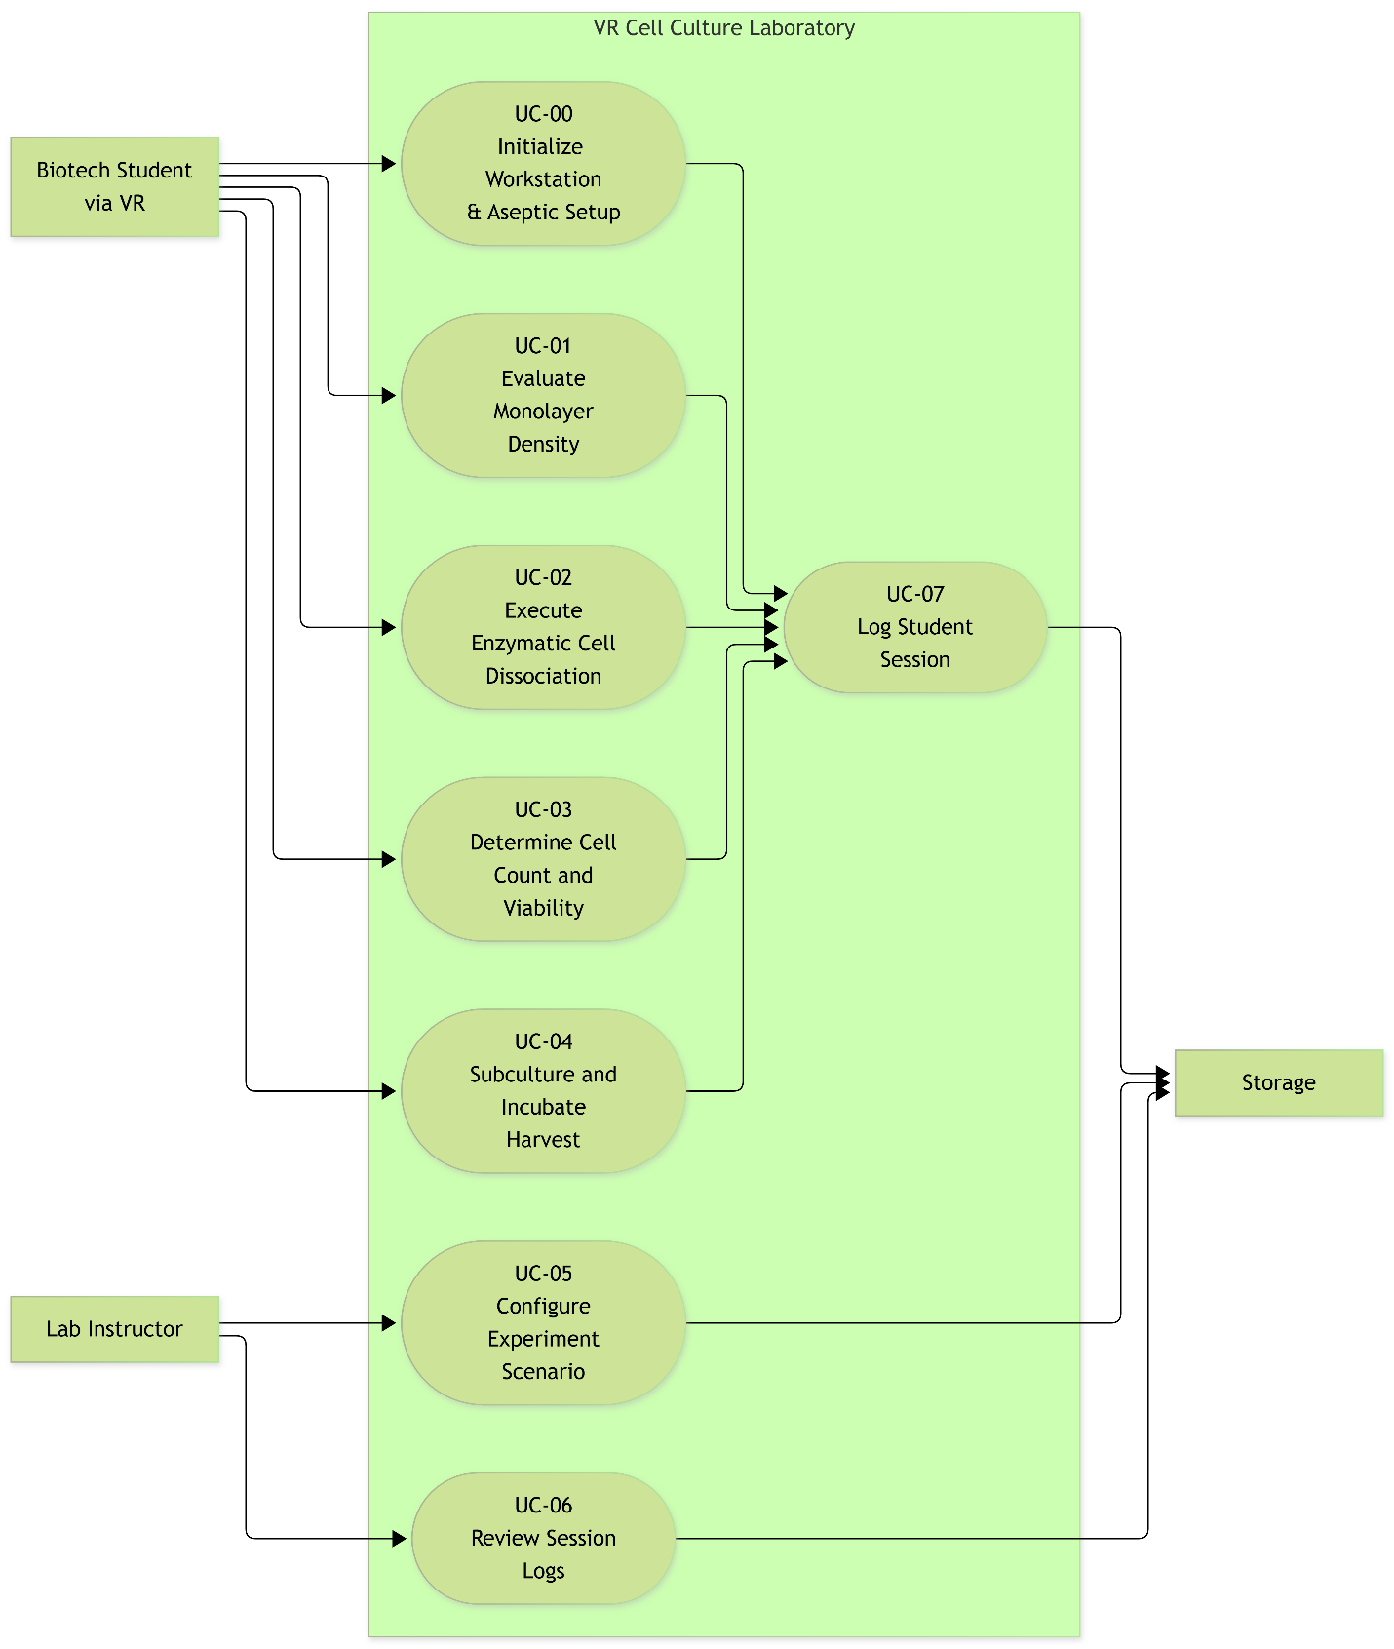
- The student calculates necessary split volumes, inoculates a labeled secondary culture vessel, and stores the culture within a simulated 37°C / 5% CO2 incubator. Throughout all operations, the software tracks safety violations, monitors airflow barrier integrity, and persists an encrypted performance audit log to local storage.
Figure 1.1: Top-Level Use Case Diagram

To support the simulated passaging workflow, the virtual environment requires a dedicated suite of interactive laboratory apparatus, optical instruments, and biological consumables. Table 1.1 details the complete inventory of virtual assets required by the software, including their interactive functional behaviors.

Table 1.1: Simulated Laboratory Apparatus & Equipment Inventory
Apparatus / Asset Name | Virtual Classification | Interactive Functional Behaviors Simulated | Procedural Phase(s)
Class II Type A2 Biosafety Cabinet (BSC) | Primary Workstation Equipment | Vertical motorized glass sash with 20 cm height sensor; operational HEPA intake/exhaust blower; germicidal UV interlock; stainless-steel work surface with keep-clear air grilles. | Phase 1, 3, 4, 5
Inverted Phase-Contrast Microscope | Optical Diagnostic Instrument | Dual-eyepiece viewport; revolving objective turret (4x, 10x, 40x); focus adjustment dials; mechanical stage clips to seat T-75 flasks. | Phase 2
Adjustable Micropipettes (P20, P200, P1000) | Precision Fluid Instruments | Digital volume selection micrometer dials; spring-loaded two-stop plungers; disposable tip ejector arm. | Phase 3, 4, 5
Vacuum Aspiration System | Liquid Evacuation Apparatus | Vacuum pump switch; dual-flask liquid collection trap; flexible vacuum hose; aspiration wand accepting glass/plastic Pasteur pipettes. | Phase 3
Hemocytometer & Counting Chamber | Quantification Apparatus | Dual-chamber Neubauer-improved etched optical glass grid; specialized glass coverslip; handheld 4-quadrant click counter interface. | Phase 4
Humidified CO2 Incubator | Environmental Storage Equipment | Sealed outer door and inner tempered glass gasket door; 37.0°C thermal controller; 5.0% CO2 gas regulator; interior perforated shelves. | Phase 5
Culture Labware & Consumables | Receptacles & Vessels | T-75 polystyrene adherent culture flasks with two-position vented filter caps; 15 mL conical centrifuge tubes; 1.5 mL microcentrifuge tubes; aerosol-barrier pipette tip boxes. | Phase 1–5
Reagents & Chemical Assets | Biological / Chemical Media | Dulbecco’s Modified Eagle Medium (DMEM) with phenol red indicator; 0.25% Trypsin-EDTA; Dulbecco's Phosphate-Buffered Saline (DPBS 1X); Trypan Blue 0.4% vital dye; 70% isopropanol/ethanol spray bottle. | Phase 1, 3, 4, 5

2.0 Functional Requirements & Process Architecture
This section details the functional requirements and process models governing the Virtual Cell Culture Laboratory software. Requirements are formally specified using singular identifiers ([FR-XXX]), followed by Level 0, Level 1, and Level 2 Data Flow Diagrams adhering to structured analysis principles.

2.1 Section Introduction
The functional requirements are partitioned into five sequential laboratory phases. Each requirement specifies software-verifiable behavior, mathematical tolerances, and discrete state triggers. Process models detail data transformations between external entities, internal software processes, and persistent data stores.

2.2 System Functional Requirements

2.2.1 Phase 1: Aseptic Setup & Biosafety Cabinet Sanitization
This phase establishes the operational cleanroom environment and prepares the physical workstation before any biological procedures commence. The software verifies that the user adheres to personal protective protocols, initializes the biosafety cabinet airflow systems, sanitizes the interior bench, and stages the necessary virtual apparatus within certified laminar airflow boundaries.
- [FR-001] PPE Verification: The system shall verify that the virtual operator has equipped virtual nitrile gloves, lab coat, and eye protection before unlocking interaction with sterile apparatus, chemical reagents, and biological vessels.
- [FR-002] Biosafety Cabinet Blower Startup & Purge: The system shall provide an interactive control interface to power on the Class II Biosafety Cabinet (BSC) HEPA blower and enforce a simulated 5-minute airflow stabilization purge cycle before permitting subsequent setup actions.
- [FR-003] Sash Height Sensor Tracking: The system shall continuously track virtual glass sash elevation and transition the cabinet operational status to "Ready" only when the sash is positioned at the 20 cm operating height line (tolerance: ±1 cm).
- [FR-004] Surface Decontamination Timer: The system shall register the application of simulated 70% ethanol spray across the interior stainless-steel work surface and enforce a mandatory 30-second evaporation delay before marking the work surface as sanitized.
- [FR-005] Apparatus & Consumable Staging: The system shall track the transfer and spatial placement of required sterile apparatus (micropipettes, pipette tip boxes, vacuum aspirator wand, and waste receptacles) into the cabinet interior, logging an airflow disruption penalty if items are placed within 10 cm of the front intake grille.
- [FR-006] Reagent Retrieval & Temperature Validation: The system shall evaluate the thermal state variable of retrieved media containers (DMEM and PBS) and log a procedural stress violation if the liquid temperature is below 37°C upon vessel introduction.

2.2.2 Phase 2: Microscopic Inspection & Confluency Assessment
- [FR-007] Phase-Contrast Field Rendering: The system shall render an inverted phase-contrast microscope viewport displaying adherent cell morphology that corresponds to current culture density data records.
- [FR-008] Optical Magnification Selection: The system shall toggle viewport magnification between 4x, 10x, and 40x objective states upon receiving optical selector inputs.
- [FR-009] Confluency Input Assessment: The system shall prompt the user to input an estimated monolayer confluency percentage and compare this value against simulated ground truth (nominal states: 40%, 80%, or 100%).
- [FR-010] Procedural Branching Verification: The system shall evaluate user confluency decisions and display an instructional confirmation dialog if the user attempts to initiate trypsinization on a culture evaluated below 70% confluency.

2.2.3 Phase 3: Enzymatic Cell Dissociation (Trypsinization)
- [FR-011] Vacuum Aspiration Dynamics: The system shall simulate liquid evacuation from the culture flask to the liquid waste trap at a rate of 2.0 mL/s whenever the aspirator wand collider contacts the liquid surface.
- [FR-012] Buffer Wash Angle Validation: The system shall verify that 5.0 mL (±0.5 mL) of Phosphate-Buffered Saline (PBS) is dispensed against the flask sidewall rather than directly onto the cell monolayer, recording an agitation penalty if dispensing normal exceeds 45 degrees relative to the wall.
- [FR-013] Trypsin Incubation Timing: The system shall initiate an internal countdown timer upon dispensing between 2.0 mL and 3.0 mL of 0.25% Trypsin-EDTA into the vessel.
- [FR-014] Mechanical Agitation Detection: The system shall register controller acceleration impulses representing manual vessel side-tapping and transition cell state from "Adherent" to "Suspension" when elapsed incubation time is between 3.0 and 5.0 minutes.
- [FR-015] Enzymatic Quenching: The system shall deactivate trypsin digestion logic and transition medium state to "Neutralized" immediately upon the addition of 6.0 mL or more of complete serum-containing DMEM.

2.2.4 Phase 4: Cell Viability Staining & Quantification
- [FR-016] Micropipette Volume Configuration: The system shall model volume adjustments across P20 (2–20 µL), P200 (20–200 µL), and P1000 (100–1000 µL) pipettes at a resolution of 1 µL.
- [FR-017] Dye Dilution Ratio Enforcement: The system shall verify a 1:1 volumetric ratio when mixing cell suspension with Trypan Blue dye in a microcentrifuge tube.
- [FR-018] Hemocytometer Optical Simulation: The system shall generate a 9-square hemocytometer grid overlay displaying viable cells as clear circular halos and non-viable cells as solid blue markers.
- [FR-019] Grid Tally Logging: The system shall record user click counts across the four corner grid squares and calculate viable cell density and viability percentage.
- [FR-020] Count Variance Calculation: The system shall compare user cell counts against simulated ground truth and write the absolute percentage variance to the session log.

2.2.5 Phase 5: Secondary Inoculation, Labeling & Session Persistence
- [FR-021] Seed Volume Verification: The system shall evaluate user calculations for target inoculation volume required to achieve 1.0 x 10^5 cells/mL in a new T-75 vessel.
- [FR-022] Vessel Metadata Validation: The system shall prompt for and attach metadata attributes (Cell Line ID, Passage Number P+1, Date, Operator Initials) to the destination vessel container record.
- [FR-023] Incubator Cap Venting Check: The system shall verify that the culture vessel filter cap is set to the vented position before permitting placement into the simulated 37°C / 5% CO2 incubator.
- [FR-024] Encrypted Session Record Generation: The system shall compile all error counts, timing records, and calculation accuracy metrics into a structured session report and persist the encrypted file to Local Storage upon session termination.

- [FR-025] Administrative Authentication: The system shall require password verification before granting access to instructor configuration menus (D1) and student session audit decryption tools (D2).

2.3 Laboratory Phase Execution & Gating State Machine
While the functional requirements in Section 2.2 define discrete system responsibilities and the subsequent Data Flow Diagrams (Section 2.4) model asynchronous data routing, the physical simulation requires deterministic procedural gating. The software runtime enforces order of operations through the finite state machine modeled in Figure 2.1. students cannot trigger downstream dissociation or quantification logic until all prerequisite environmental, physical, and biological guard conditions are met.

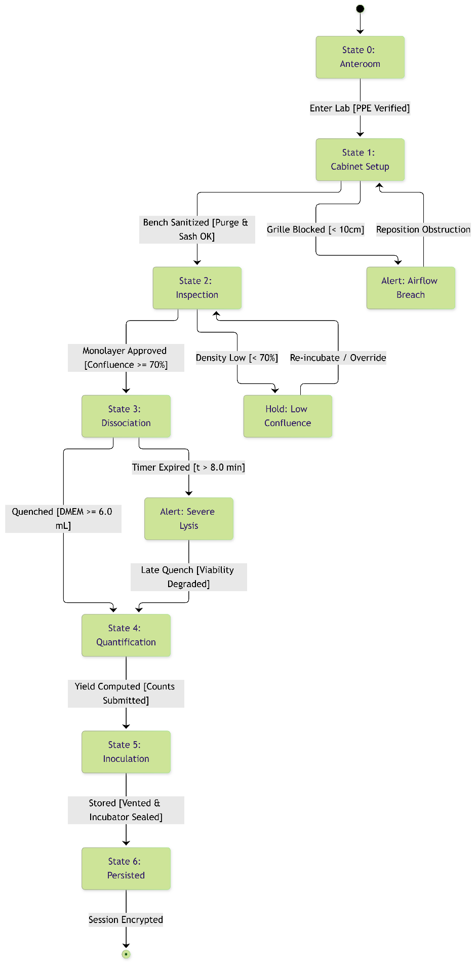
Figure 2.1: Simulation Lifecycle & Phase Gating State Machine Model
Table 2.1: State Transition Guards and Validation Criteria
Current State | Target State | Triggering Event | Programmatic Guard Conditions (Prerequisites) | Traceable Requirements
State 0: Anteroom | State 1: Cabinet Setup | Student opens cleanroom laboratory door. | Nitrile gloves, lab coat, and protective eyewear colliders equipped on avatar. | [FR-001]
State 1: Cabinet Setup | State 2: Inspection | Student retrieves culture vessel from transfer rack. | HEPA blower purge timer >= 300 s; sash sensor within 20 cm (±1 cm); ethanol surface evaporation >= 30 s; sterile tools staged >= 10 cm behind front intake grille. | [FR-002], [FR-003], [FR-004], [FR-005]
State 2: Inspection | State 3: Dissociation | Student transfers culture flask into BSC workspace. | Viewport inspection completed at 10x magnification; student confluency input recorded; confirmed confluency >= 70% threshold. | [FR-007], [FR-008], [FR-009], [FR-010]
State 3: Dissociation | State 4: Quantification | Student draws aliquot for hemocytometer loading. | Trypsin incubation >= 3.0 min; mechanical side-tap acceleration impulse >= 1.5g detected; complete serum DMEM addition >= 6.0 mL (medium state = "Neutralized"). | [FR-011], [FR-012], [FR-013], [FR-014], [FR-015]
State 4: Quantification | State 5: Inoculation | Student unboxes secondary destination culture flask. | 1:1 Trypan Blue dilution executed; 4 corner hemocytometer quadrants tallied; viability percentage and total cell density calculated and committed. | [FR-016], [FR-017], [FR-018], [FR-019], [FR-020]
State 5: Inoculation | State 6: Complete | Student closes CO2 incubator outer door. | Seed volume transferred matches C1V1 = C2V2 formula; destination vessel metadata label string attached; vessel cap toggle set to vented; incubator door sealed. | [FR-021], [FR-022], [FR-023]
State 6: Complete | Session Terminated | System initiates session teardown routine. | AES-256 encrypted session audit log successfully written to D2 Student Session Log and flushed to local storage. | [FR-024]

2.4 Data Flow Diagrams (DFDs)
The data flow models below specify system boundaries, data transformations, and internal storage mechanisms across the cell passaging lifecycle.

2.4.1 Level 0 Context Data Flow Diagram
The Level 0 Context Diagram establishes the software system boundary, identifying all external entities that communicate directly with the software runtime.
As shown in Figure 2.2, the software system interfaces with four external entities:
- External VR Hardware / Runtime API: Ingests spatial tracking coordinates, controller trigger states, and button presses from the physical user, forwarding pre-processed telemetry packets into the software. In return, the system dispatches rendered visual buffers and haptic trigger events back across the API.
- Biotech Student: The human trainee interacting through the external hardware boundary.
- Lab Instructor: Administrative user supplying scenario parameters (initial culture confluence, contamination probabilities) and receiving parsed evaluation reports.
- Local Storage: The local file storage providing baseline protocol records and receiving finalized encrypted session performance logs.

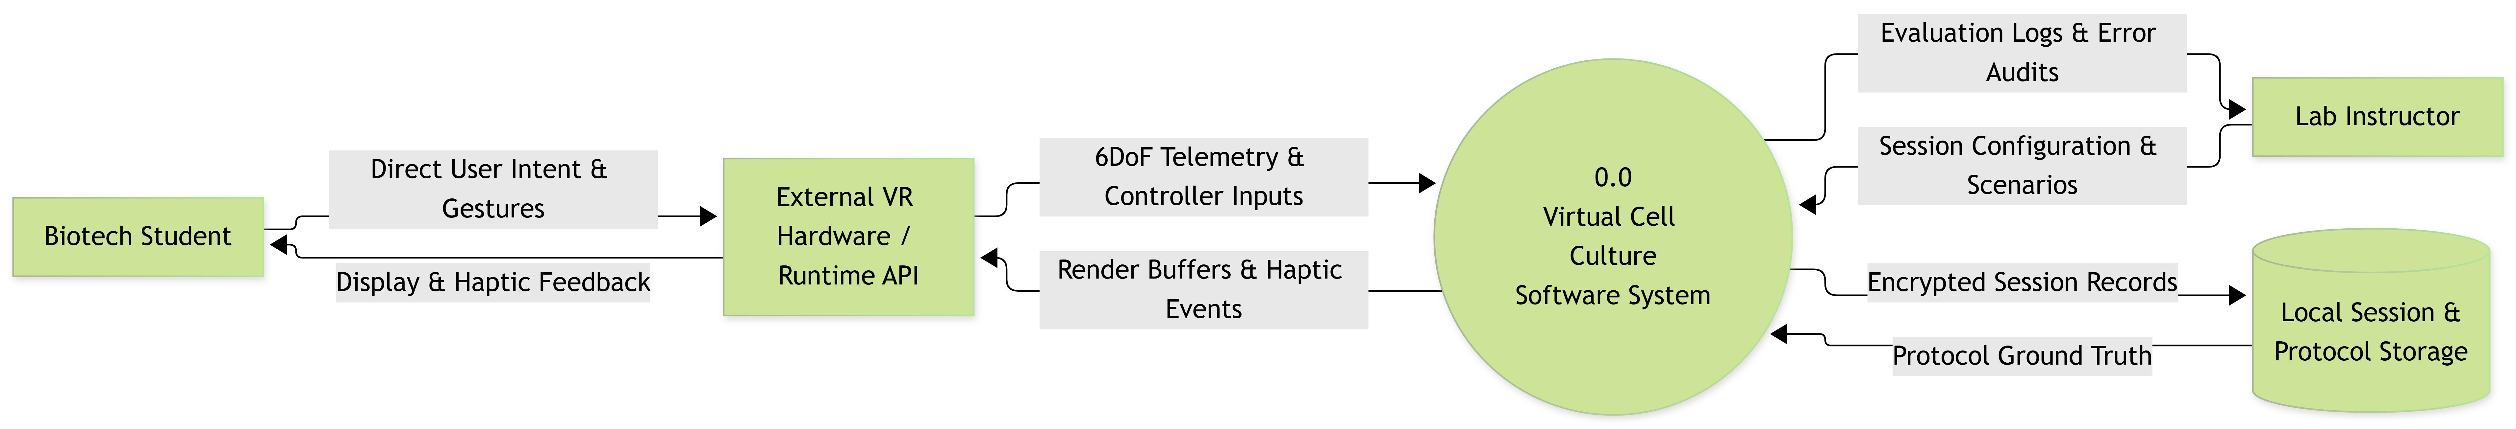
Figure 2.2: Level 0 Context Data Flow Diagram

2.4.2 Level 1 Functional Decomposition DFD
The Level 1 Data Flow Diagram explodes the central process into five core functional processes corresponding to the laboratory workflow, backed by three dedicated data stores.

As illustrated in Figure 2.3, data flows systematically across processes and data stores without illegal direct connections:
- Process 1.0 (Sanitize Station & Prepare Reagents): Processes setup and ethanol cleaning inputs from the runtime API, references protocol parameters in D1 Protocol Database, updates surface states in D3 Reagent State Database, and records setup milestones in D2 Student Session Log.
- Process 2.0 (Inspect Monolayer Confluence): Ingests optical magnification adjustments, compares current culture density against ground-truth images in D1, and records estimated confluence percentages to D2.
- Process 3.0 (Detach Adherent Cells): Manages fluid aspiration, buffer washes, and enzymatic digestion. It modifies chemical and volume attributes in D3 while streaming procedural logs and sterility infractions to D2.
- Process 4.0 (Quantify Viable Density): Ingests cell counting click coordinates, compares user tallies against biological ground truth in D1, and writes calculated viability rates to D2.
- Process 5.0 (Inoculate Secondary Culture): Ingests final dilution calculations and vessel metadata, reads viable yield data from D2, logs passage metrics, and outputs finalized session logs to Storage and the Lab Instructor.

Figure 2.3: Level 1 Functional Decomposition Data Flow Diagram

2.4.3 Level 2 Child DFD
Process 3.0 Detach Adherent Cells is decomposed into five detailed sub-processes to model enzymatic state transitions, countdown timer logic, and fluid interactions. As depicted in Figure 2.4, the child decomposition models functional data transformations, intermediate liquid tokens, and state record updates across the detachment lifecycle. Operational phase progression and execution gating are formally governed by the State Machine in Section 2.3.
- Sub-process 3.1 (Aspirate Spent Medium): Ingests aspiration wand spatial coordinates, updates fluid level records in D3, writes liquid waste transfer events to D2, and emits the Dry Monolayer State flag to Sub-process 3.2.
- Sub-process 3.2 (Wash Monolayer with Buffer): Ingests serological dispensing telemetry, updates PBS volume in D3, logs any perpendicular dispensing angle violations to D2, and passes the Clean Surface State token to Sub-process 3.3.
- Sub-process 3.3 (Apply Trypsin Enzyme): Processes enzyme pipetting inputs, stores active trypsin volume in D3, and emits a synchronous Timer Trigger Event to initiate Sub-process 3.4.
- Sub-process 3.4 (Time Enzymatic Incubation): Tracks elapsed incubation time, evaluates vessel tapping acceleration impulses, updates cell morphology states, logs overexposure events to D2 if incubation exceeds 8.0 minutes, and emits the Detached Suspension Token upon successful cell rounding.
- Sub-process 3.5 (Quench Dissociation Reaction): Ingests neutralizing media dispensing data, verifies that serum volume quenches enzymatic activity in D3, dispatches quench confirmation visual buffers to the runtime API, and records the detachment summary score to D2.

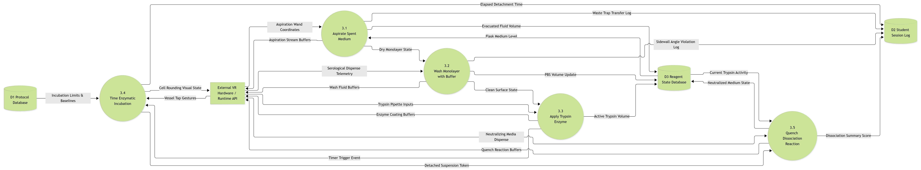
Figure 2.4: Level 2 Child Data Flow Diagram for Process 3.0

2.5 Use Case Specifications & Sub-Flows
Contains fully dressed use case specifications conforming to course templates (Actor, Preconditions, Basic Flow, Alternate Flows, Postconditions, Exception Handling) and supporting sub-diagrams:

2.5.0 UC-00: Initialize Workstation & Aseptic Setup
Actor
- Primary: Biotech Student

Preconditions
- Student has launched the virtual training module and spawned into the cleanroom anteroom.
- Biosafety Cabinet and required consumables are uninitialized.

Basic Flow
- Student equips nitrile gloves, lab coat, and safety glasses from the supply locker.
- System verifies PPE compliance and unlocks the cleanroom entry door.
- Student approaches the Class II Biosafety Cabinet and powers on the HEPA blower.
- System executes the 5-minute airflow purge cycle and illuminates the operational indicator.
- Student adjusts the glass sash to the 20 cm operating mark.
- Student sprays 70% ethanol across the work surface and waits 30 seconds for complete evaporation.
- Student stages sterile pipette tip boxes, tubes, and tools at least 10 cm behind the front air grille.
- System transitions cabinet status to "Ready for Culture Manipulation".

Alternate Flows
- Airflow Obstruction Detected
- Student places an item within 10 cm of the front intake grille.
- System displays an amber HUD warning banner: [HZ-001] Aseptic Flow Disrupted: Clear Intake Grille.
- Student repositions the item toward the center-rear work surface.
- System clears the warning and resumes nominal airflow tracking.

Postconditions
- Workstation clean state is updated to true in D3 Reagent State Database.
- Aseptic setup milestones and any grille violations are logged to D2 Student Session Log.

2.5.1 UC-01: Evaluate Monolayer Density
Actor
- Primary: Biotech Student

Preconditions
  - Biotech Student has entered the simulated laboratory
  - Microscope is available with cell culture loaded

Basic Flow
  - Biotech Student approaches microscope.
  - System displays the monolayer through viewport.
  - Student focuses the microscope.
  - System displays cell morphology and decision paths.
  - Student selects observed confluency level.
  - Student submits result.
  - System compares student’s result to expected result.

Alternate Flows
- Student wants to change selection before submitting.
    - Student requests to change selection.
    - System returns to 4 of basic flow.

Post Conditions
  - Student’s and expected results are saved.
  - System loads next scenario.

2.5.2 UC-02: Execute Enzymatic Cell Dissociation
(Includes sterile boundary check; extends to overexposure alert).

Actor
- Primary: Biotech Student

Preconditions
  - The student has completed confluency assessment.
  - Cell culture is available.
  - Reagents are available.

Basic Flow
  - System verifies the sterile boundary check.
  - Biotech Student applies the Trypsin.
  - System start exposure countdown timer.
  - Biotech student performs dissociation.
  - Biotech student neutralizes trypsin.
  - System records results.

Exception Handling
- Trypsin Overexposure
    - Student does not complete procedure before timer elapses.
    - System triggers overexposure alert.

Postconditions
- Results are saved.
- Trypsin is neutralized.

2.5.3 UC-03: Determine Cell Count and Viability
(Trypan Blue loading, hemocytometer counting, calculation check).

Actor
- Primary: Biotech Student

Preconditions
- Student has completed cell dissociation.
- Trypan Blue and hemocytometer are available.

Basic Flow
- Biotech Student loads the Trypan Blue-stained sample into hemocytometer
- System displays viable cells using clear circular haloes and non-viable cells as blue circles.
- Biotech Student counts the cells and records results.

Postconditions
- student’s counts and ground truth counts are saved.

2.5.4 UC-04: Subculture and Incubate Harvest
(Seed volume calculation, labeling, incubator placement).

Actor
- Primary: Biotech Student

Preconditions
  - Cell count and viability has been completed.
  - Growth medium and destination vessel are available.

Basic Flow
  - System displays the cell-count and viability data.
  - Biotech Student calculates the required seed volume.
  - Biotech transfers the cell suspension in the calculated volume to the destination vessel.
  - Biotech student labels vessel with metadata.
  - Biotech student places vessel in incubator.

Postconditions
1. Seed volume and label are saved.
2. Incubator state is saved.

2.5.5 UC-05: Configure Experiment Scenario

Actor
- Lab Instructor

Preconditions
- Instructor has authenticated into the administrative desktop interface.
- Protocol Database (D1) is accessible.

Basic Flow
- System prompts for instructor credentials (e.g., alphanumeric username/password or local administrative PIN).
- System authenticates credentials against local administrative hash before unlocking scenario editing
- Instructor selects target cell culture module (CHO-K1 Adherent Passaging).
- System displays configurable scenario parameters (starting confluency state: 40%, 80%, or 100%; trypsin sensitivity; contamination risk multipliers).
- Instructor adjusts initial confluency baseline and toggles airflow disturbance events.
- Instructor commits scenario configuration.
- System serializes scenario parameters to Protocol Database (D1) for subsequent student runtime sessions.

Alternate Flow
- Invalid Parameter Entry
- Instructor inputs an out-of-range baseline density (< 1.0 x 10^5 or > 5.0 x 10^6 cells/mL).
- System rejects input, displays a parameter boundary warning, and restores nominal baseline.
- Invalid password
1. Locks the terminal after 3 failed attempts.

Postconditions
- Custom simulation profile is saved to D1.
- Runtime environment initializes with instructor-defined starting states upon student launch.

2.5.6 UC-06: Review Session Logs

Actor
- Lab Instructor

Preconditions
- One or more student simulation sessions have completed and persisted to Local Storage (D2).
- Instructor is logged into the administrative evaluation dashboard.

Basic Flow
- System prompts for instructor credentials (e.g., alphanumeric username/password or local administrative PIN).
- System authenticates credentials against local administrative hash before unlocking student grade logs
- Instructor selects student ID or session timestamp from the roster log list.
- System decrypts and parses the student session performance record from D2.
- System renders an itemized evaluation report displaying technique compliance, confluency error delta, trypsinization duration, hemocytometer count accuracy, split ratio calculations, and safety hazard logs.
- Instructor exports report or flags session for remediation.

Alternate Flow
- Corrupted or Tampered Record Detected
  - System fails AES-256 integrity verification upon reading session file.
  - System flags session as "Integrity Compromised / Unverified" and logs an administrative audit error.
- Invalid password
1. Locks the terminal after 3 failed attempts.

Postconditions
- Session review status is marked as "Audited" in administrative metadata.

2.5.7 Sub-Use Case Decomposition Models:
diagrams showing <<include>> and <<extend>> associations for sub-flows.

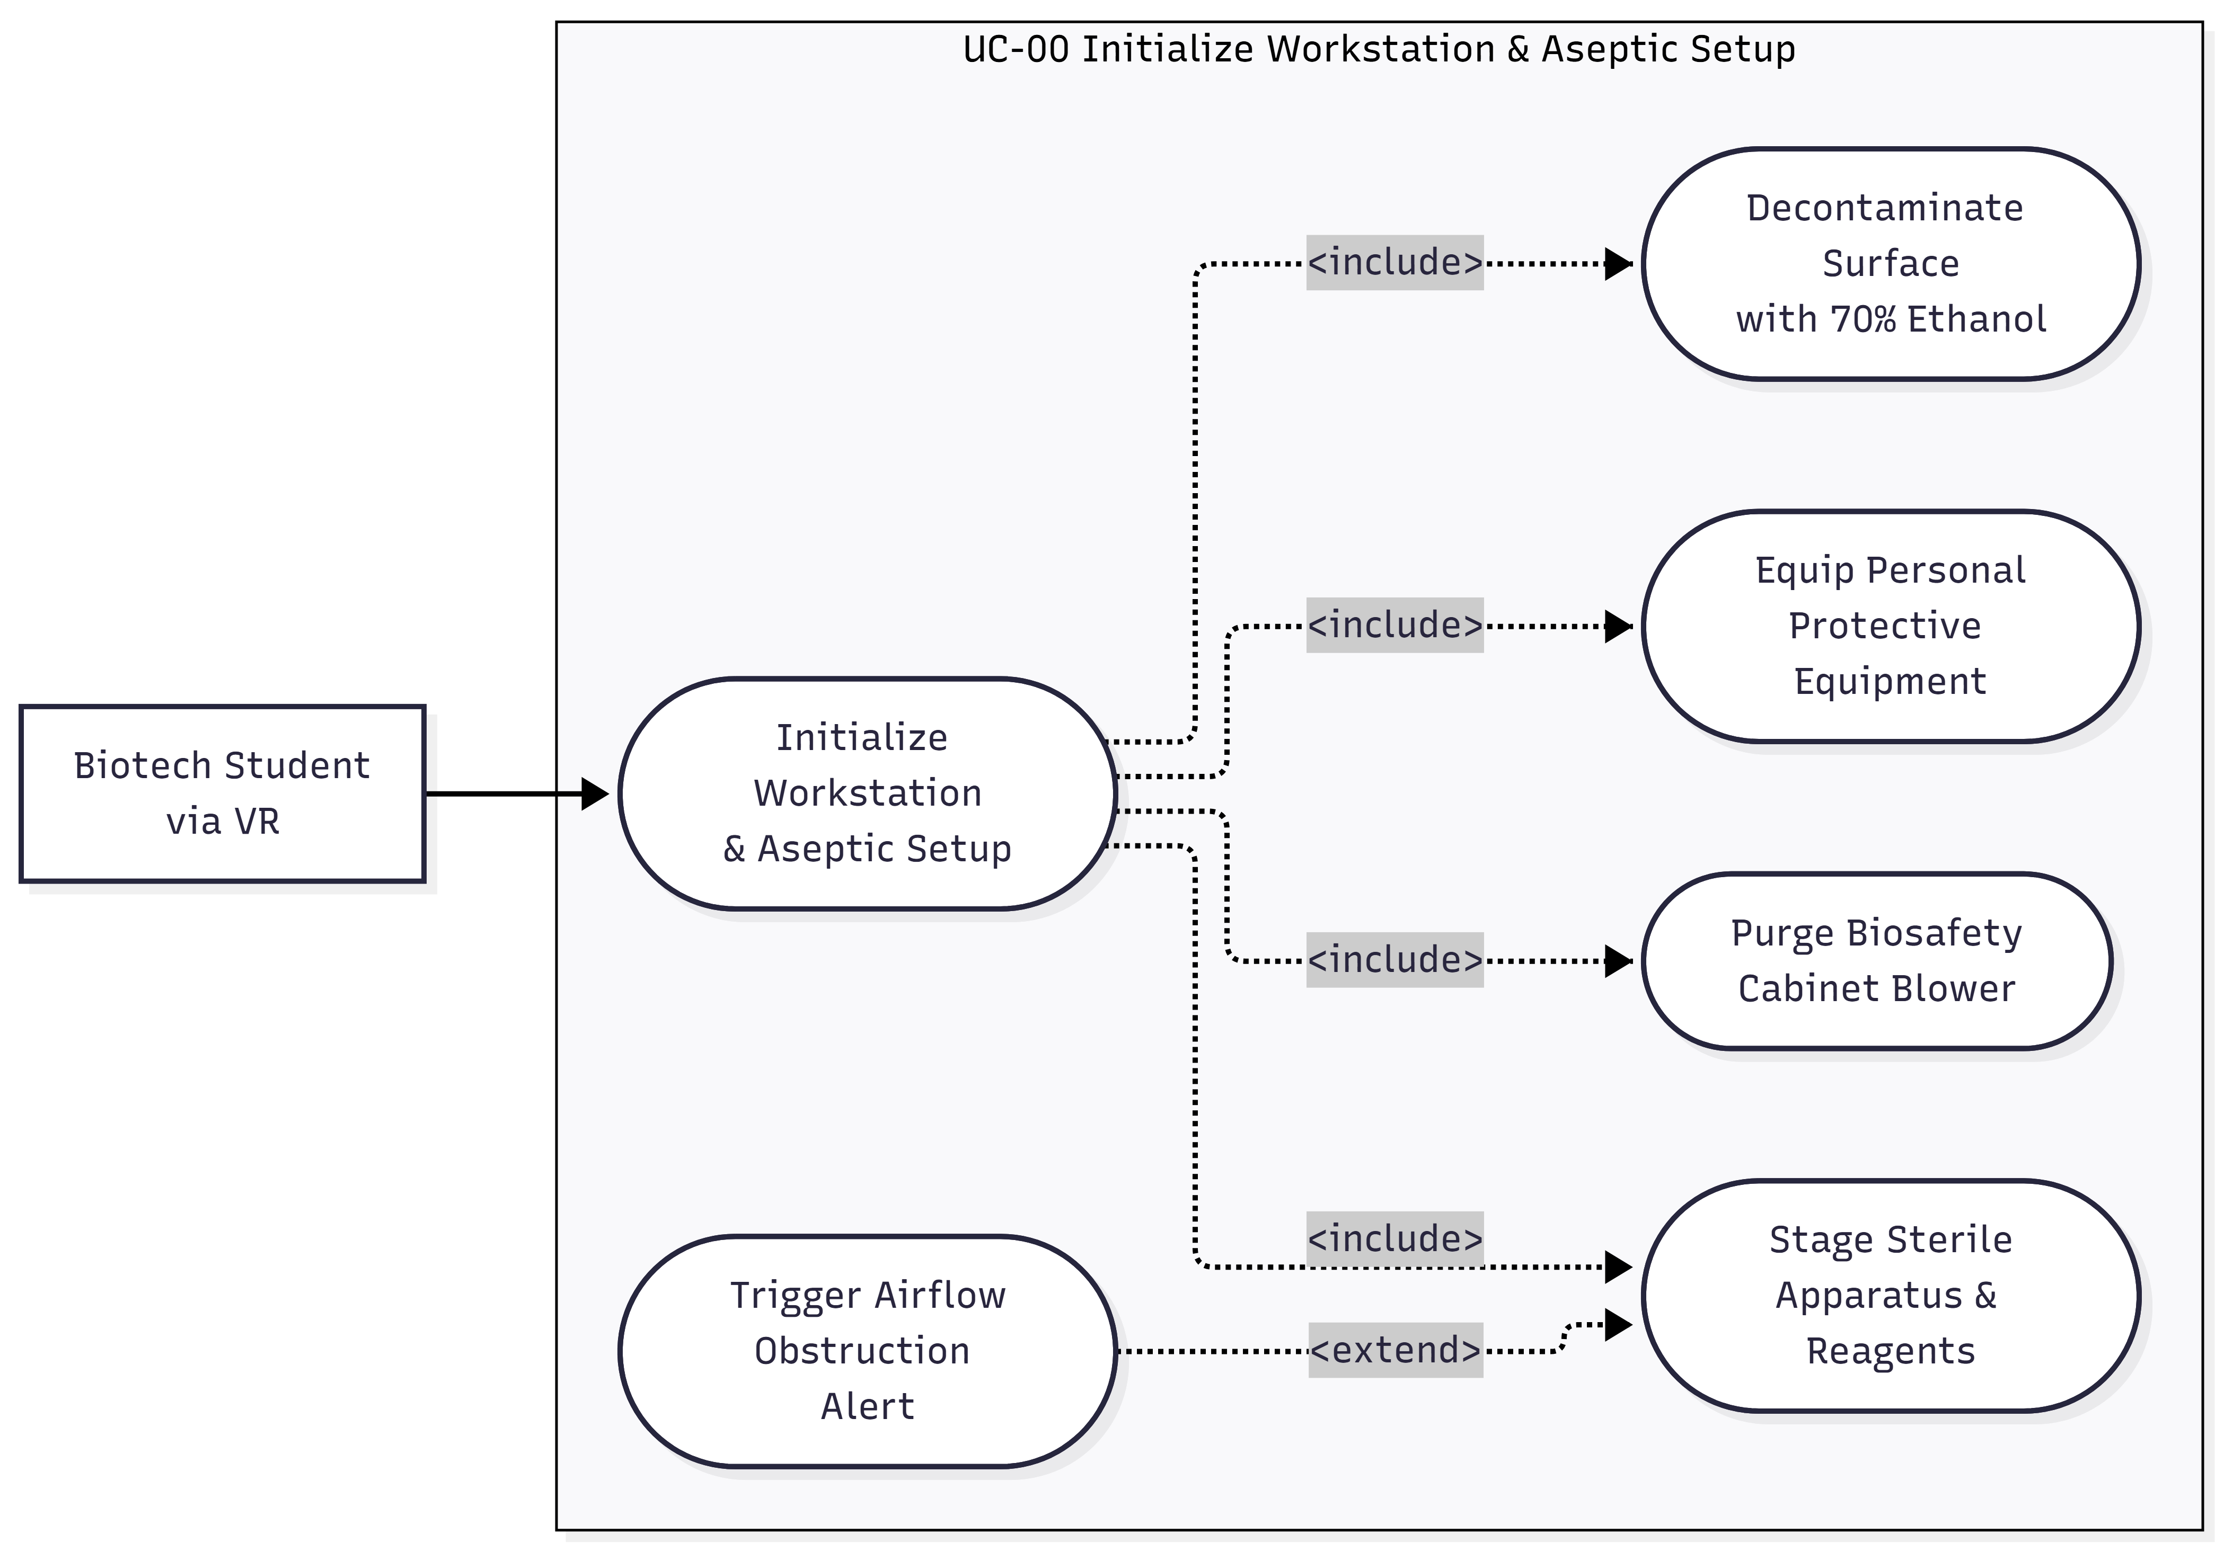

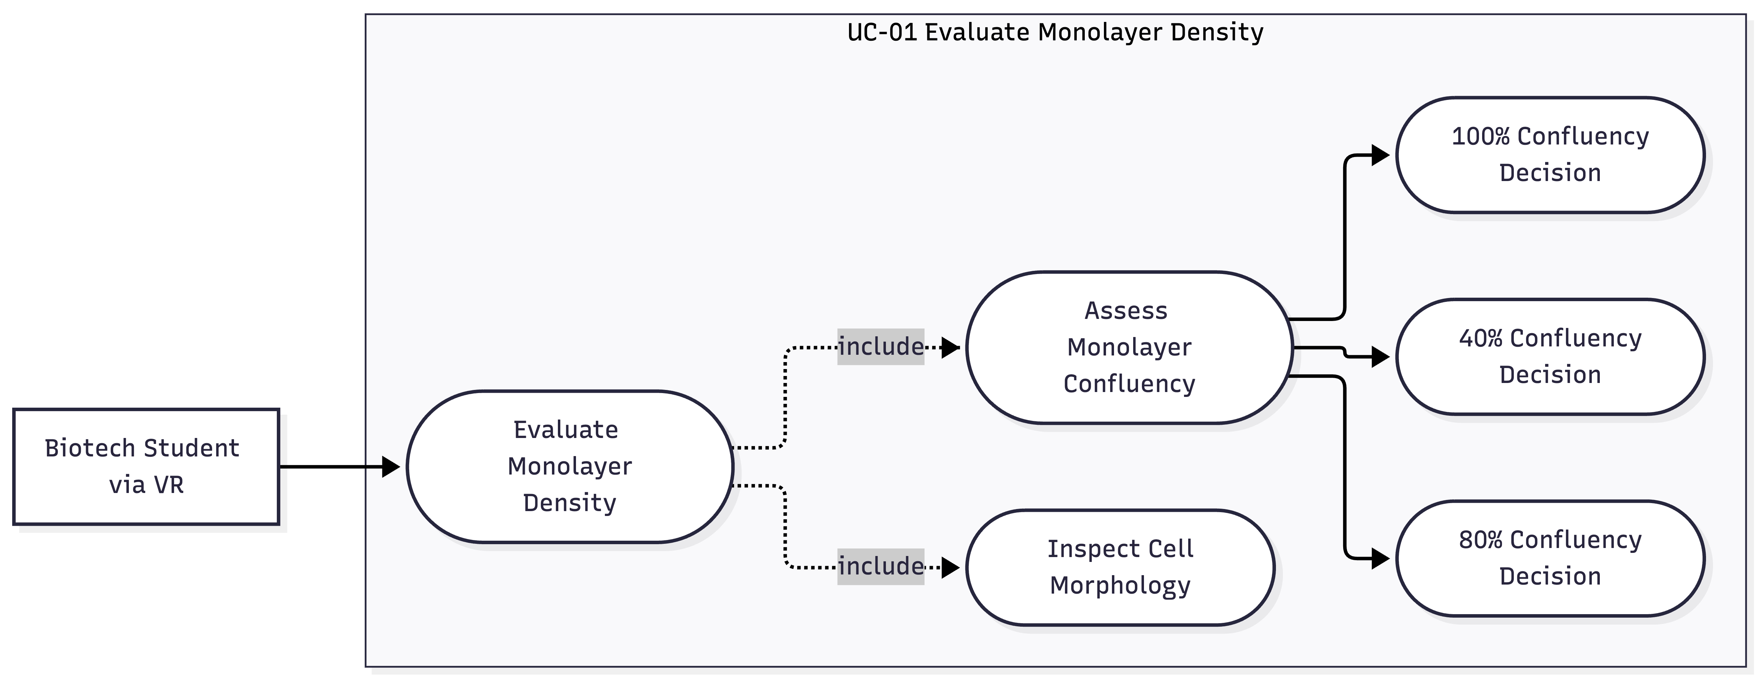

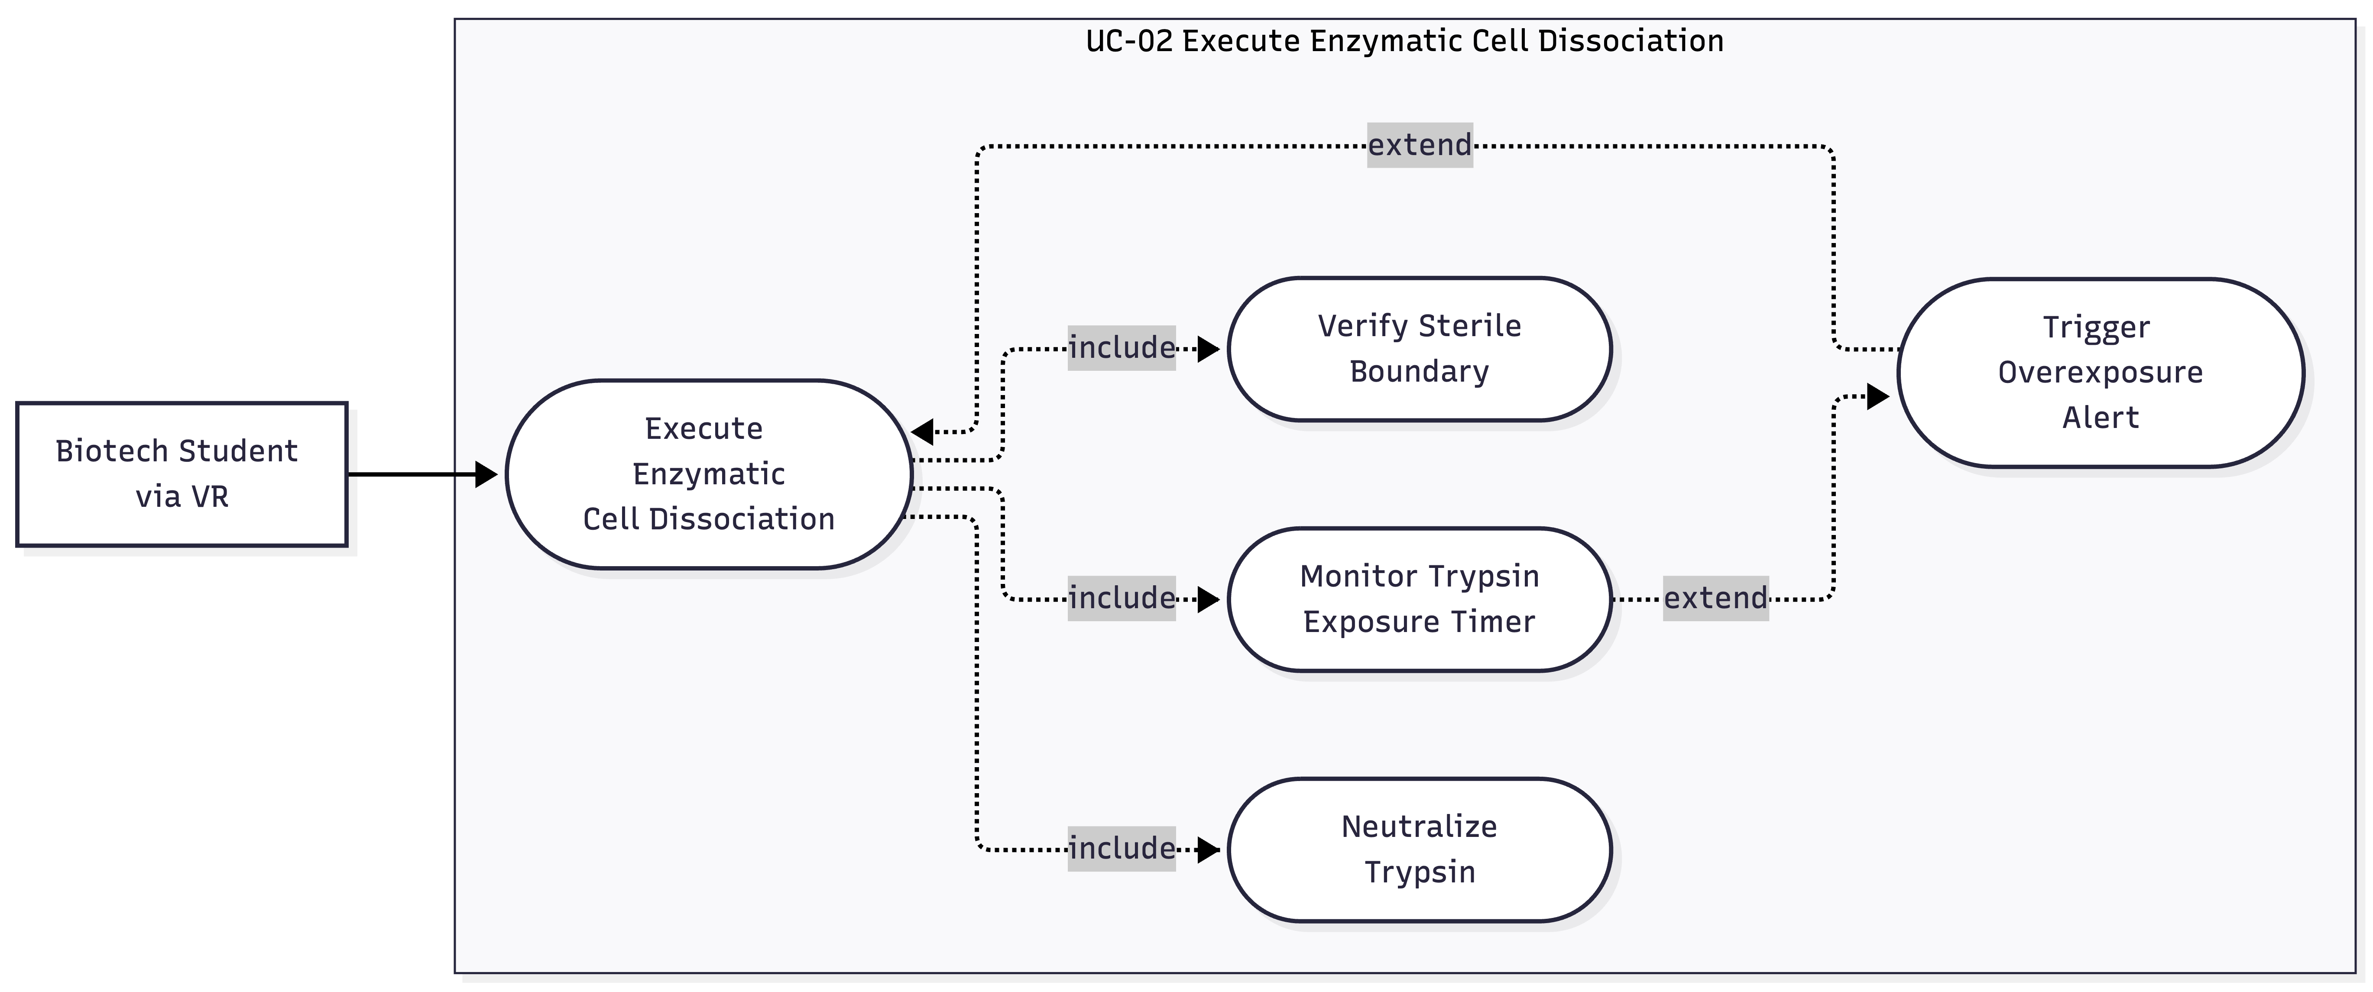

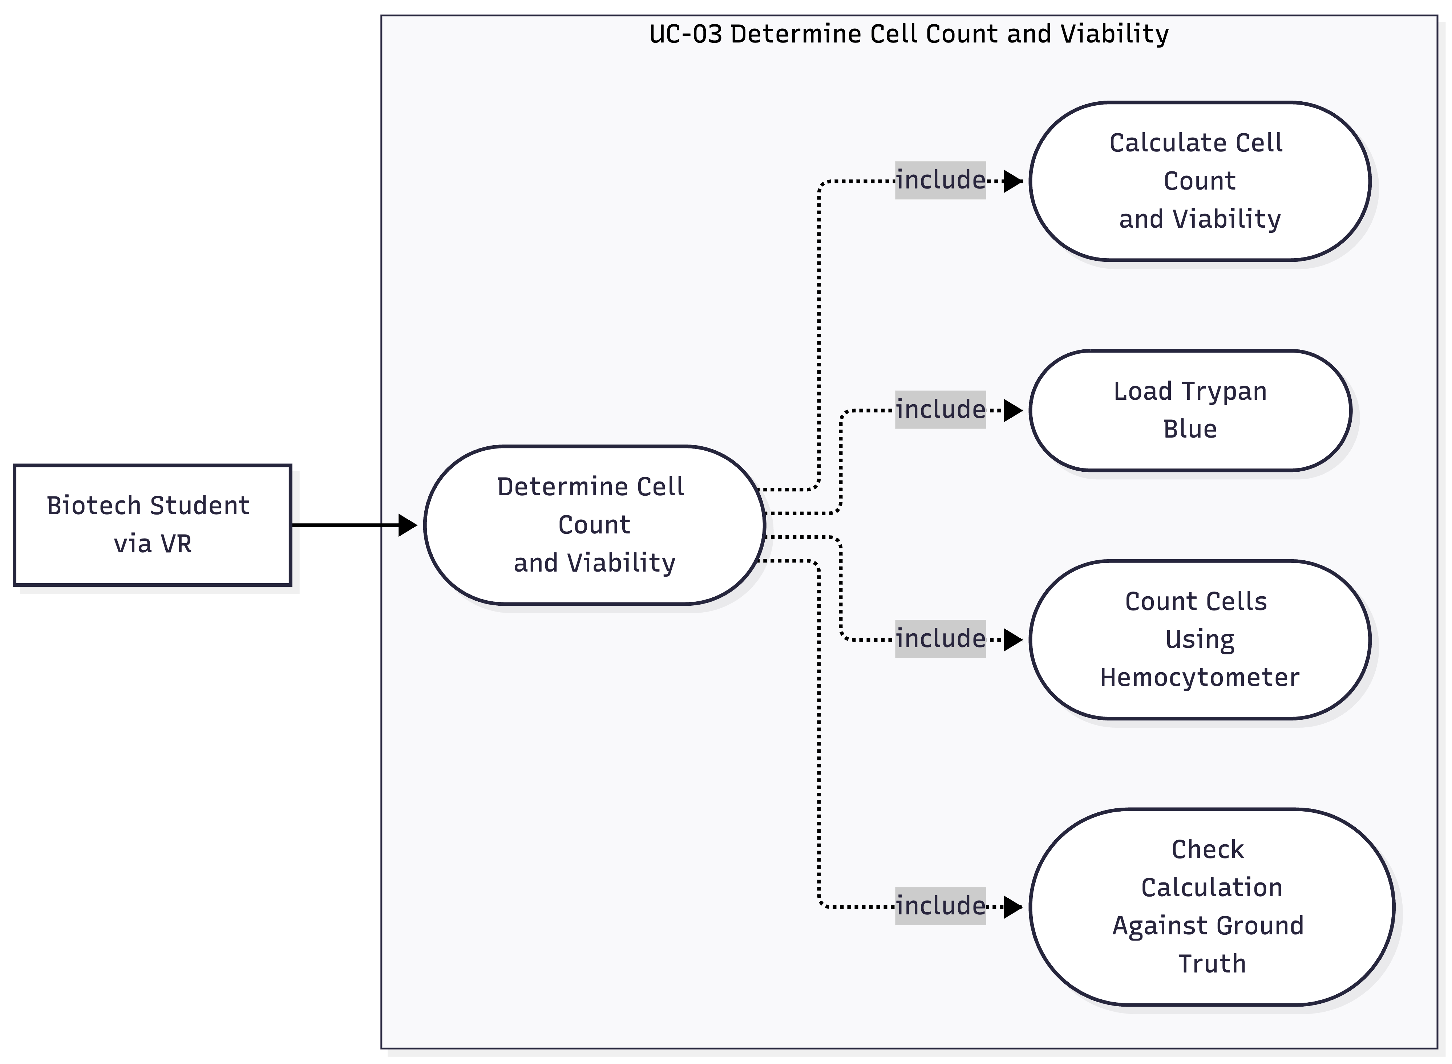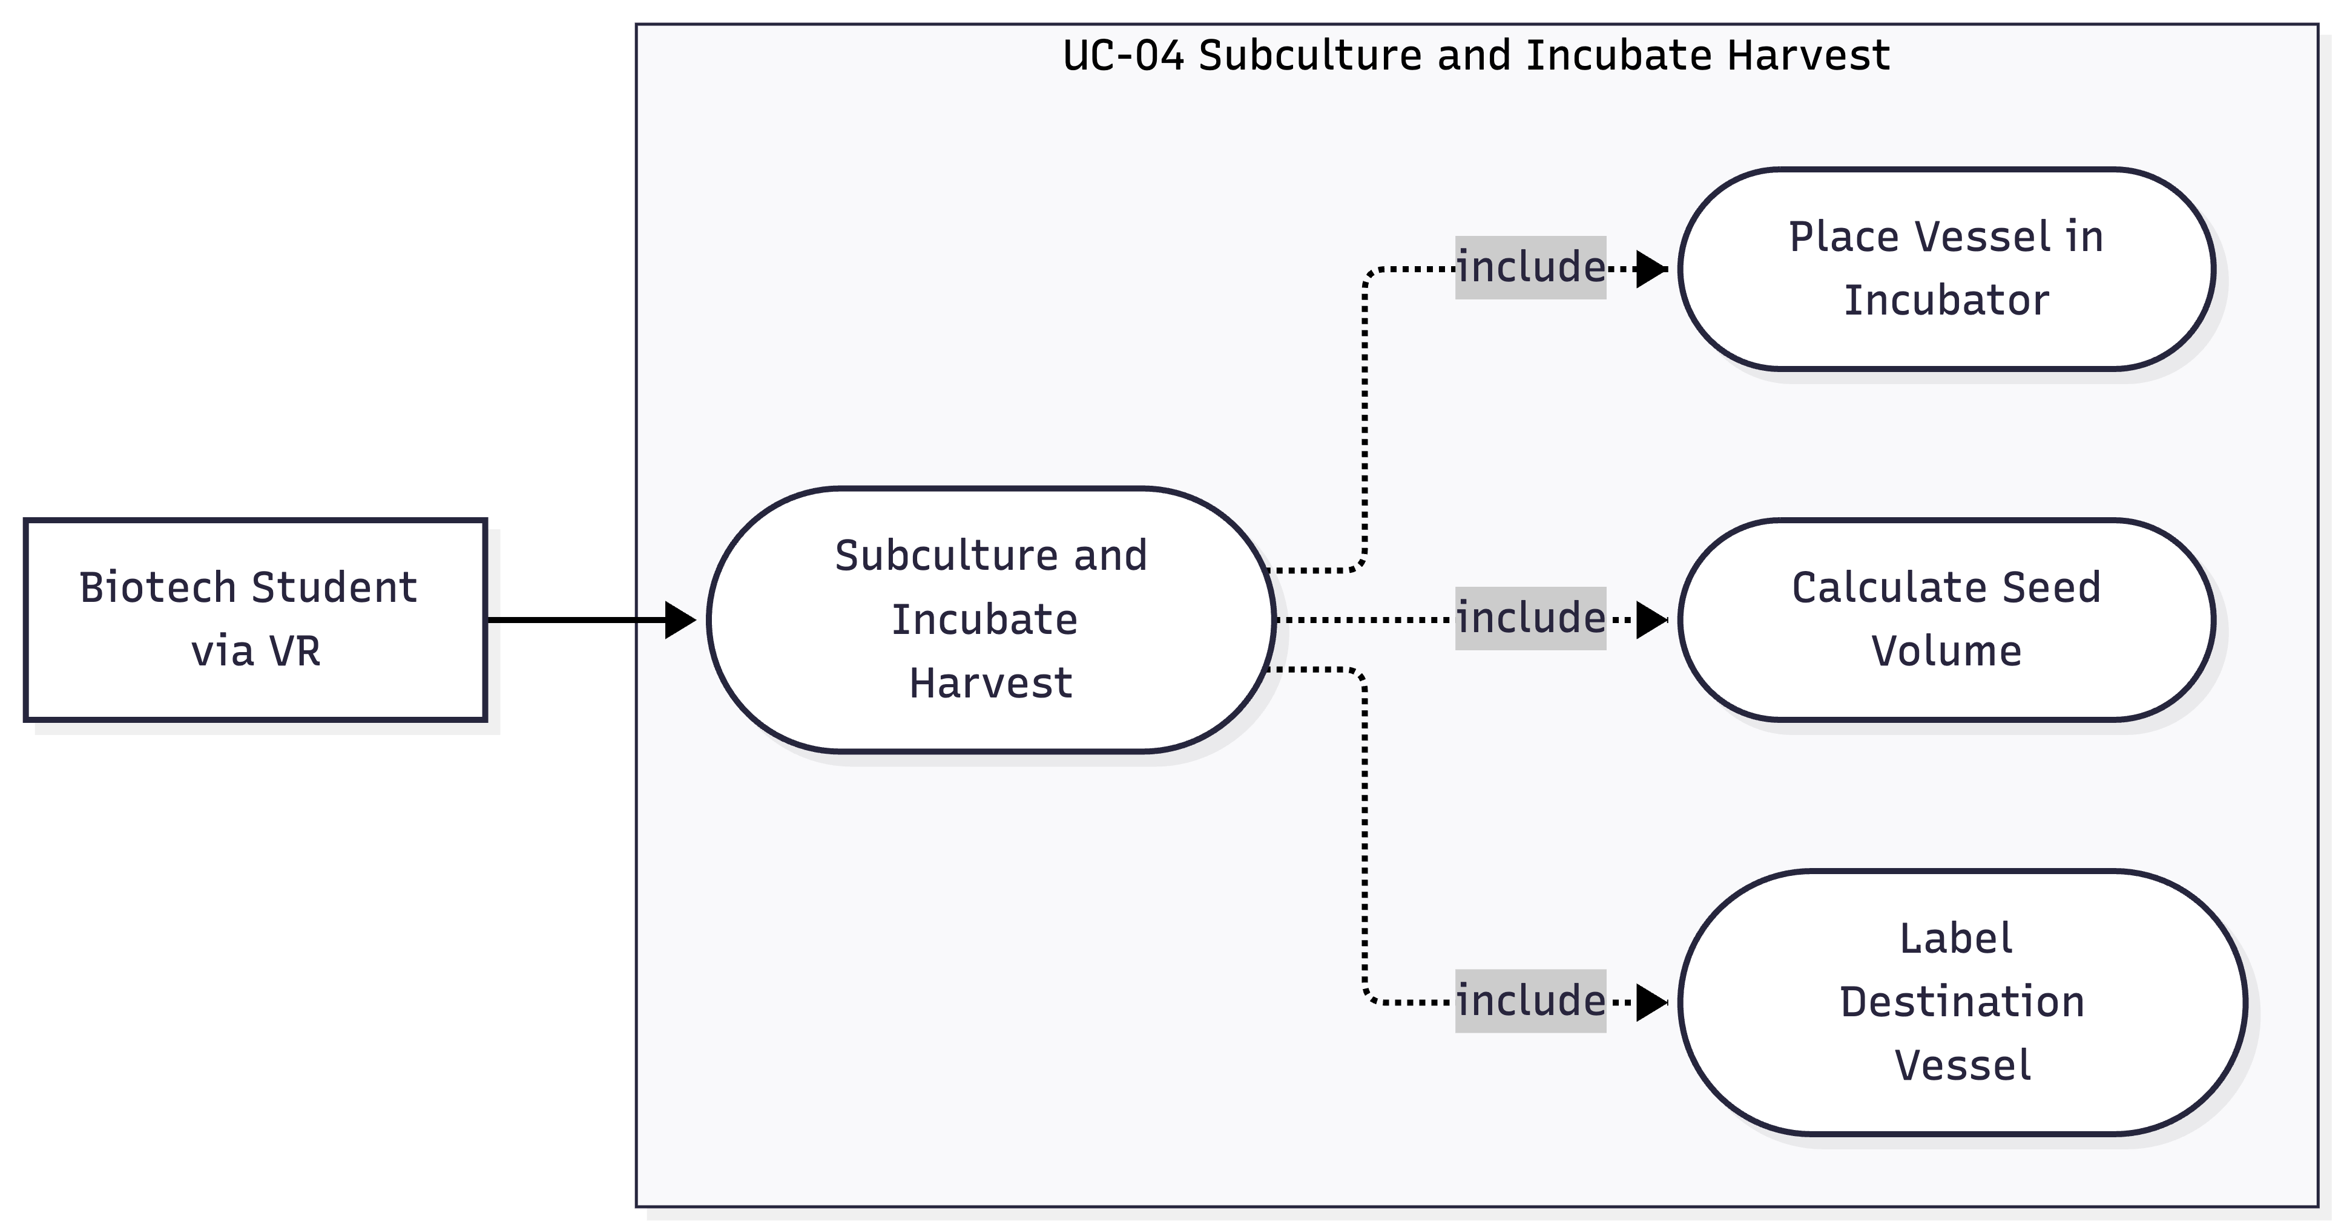

3.0 Non-Functional Requirements & Safety Constraints
While the functional requirements guide what the software must do, this section defines the qualities required for the software to be considered effective and safe as a training tool. Because errors in technique can compromise experimental integrity at best or pose a biohazard at worst, the fidelity of the software is of utmost importance. The users of this software could be taking poor habits into a real lab later on, so the performance, usability, and reliability of the software is paramount.

3.1 Section Introduction
This section introduces the criteria used to evaluate system performance, ergonomic safety, and computational efficiency within a VR simulation environment. Qualitative metrics such as frame rate, load time, and latency will be used to determine performance. Safety will be evaluated through user testing and evaluating how users feel after a session. Efficiency will be measured by determining the resource usage on the hardware running the system.

3.2 Prioritized Quality Requirements
Presents testable, prioritized (High, Medium, Low) software quality requirements specified using SEI Quality Attribute Scenarios (Source, Stimulus, Environment, Artifact, Response, Response Measure) and Planguage parameters:

3.2.1 Software Performance & Frame Execution Budgets (Priority: High)
- [NFR-001] Software scene graph evaluation, collision checks, and render buffer dispatches must complete within 11.1 ms per frame to sustain 90 FPS on external display hardware.

3.2.2 Input Telemetry Ingestion & Parsing Latency (Priority: High)
- [NFR-002] Processing latency between receiving 6DoF controller packets from the hardware API and resolving virtual collisions shall not exceed 5 ms.

3.2.3 Spatial Interaction Tolerances & Ergonomic Accessibility (Priority: Medium)
- [NFR-003] Virtual tool registration precision shall remain 2mm for fine micropipetting tasks; software must support both seated and standing calibration offsets.

3.2.4 Software Fault Handling & State Recovery (Priority: Medium)
- [NFR-004] In the event of an unexpected hardware disconnect, active session states shall be cached to memory within 500 ms without corrupting student progress data.

3.2.5 Data Security & Local Persistence Integrity (Priority: Low)
- [NFR-005] Student performance logs and assessment files saved to local storage must be encrypted using AES-256 routines to prevent unauthorized score tampering.

3.3 Programmatic Safety Constraints & Forbidden Behaviors
Specifies software-enforced hazard controls:
- [HZ-001] The software shall not permit virtual UV germicidal lamp activation while the simulated cabinet sash state is elevated.
- [HZ-002] The software shall not permit unsterilized tool objects to intersect sterile culture media colliders without executing an immediate contamination event.
- [HZ-003] The software shall not permit trypsin incubation timers to exceed 8.0 minutes without applying cell viability degradation penalties.
- [HZ-004] The software shall not permit liquid waste evacuation logic to complete into a non-biohazard data receptacle.

4.0 Deliverables Matrix
Section Owner: Miguel Lopez
Note: Section begins with an introductory paragraph defining the baseline schedule, distribution media, and stakeholder commitments.

4.1 Section Introduction
The project will produce four primary deliverables that document and demonstrate the proposed Virtual Cell Culture Laboratory software system.

4.2 Project Deliverables Schedule Table
Structured table specifying deliverable items, digital file formats, delivery dates, and recipient stakeholders.
Deliverable Item | Description & Contents | Distribution Format | Delivery Milestone
Initial Working SRS Draft | Complete baseline draft including Sections 1.0–5.0, DFDs Levels 0–2, use cases, and initial prototype wireframes. | Microsoft Word (.docx) | September 26, 2026
SRS Presentation | Visual overview covering the educational problem, software scope, process models, prototype demonstration, and requirement evolution. | Teams Meeting & Microsoft Word (.docx) | October 2, 2026
Final Software Requirements Specification | Revised, polished, and fully cross-audited SRS document incorporating draft feedback and finalized models. | Microsoft Word (.docx) | October 6, 2026
Visual Prototype |  |  | October 6, 2026

5.0 Open Issues
This section identifies the key risks associated with the development and deployment of the software system and establishes a process for documenting, monitoring, and resolving them and any other technical issues that occur during the development of the software.

5.1 Section Introduction
Ongoing risk and issue tracking ensures that issues that emerge partway through development such as hardware compatibility, fidelity shortfalls, or scope of work changes get addressed promptly.

5.2 Technical and Architectural Open Issues Table
Structured table detailing active project risks, performance considerations, and target resolution dates:
Issue ID | Technical Description & Scope | System Impact | Assigned Owner | Target Resolution Date
01 | Hardware Performance Risk – Low performance resulting in degraded user experience | Medium impact | Technical Team | TBD
02 | Simulation Fidelity Risk – Inaccurate replication of real-world lab environment or behaviors | High Impact | Technical Team | TBD

6.0 References
- P. A. Laplante, Requirements Engineering for Software and Systems, 4th ed. Boca Raton, FL, USA: CRC Press / Auerbach Publications, 2022.
- R. I. Freshney, Culture of Animal Cells: A Manual of Basic Technique and Specialized Applications, 7th ed. Hoboken, NJ, USA: John Wiley & Sons, 2016.
- H. J. Robin, J. M. Graham, and D. Rickwood, Cell Biology Protocols. Hoboken, NJ, USA: John Wiley & Sons, 2006.
- American Type Culture Collection (ATCC), Animal Cell Culture Guide: Tips and Techniques for Continuous Cell Lines. Manassas, VA, USA: ATCC Technical Manual, 2021.
- Centers for Disease Control and Prevention (CDC) and National Institutes of Health (NIH), Biosafety in Microbiological and Biomedical Laboratories (BMBL), 6th ed. Washington, DC, USA: U.S. Department of Health and Human Services, 2020.
- World Health Organization (WHO), Laboratory Biosafety Manual, 4th ed. Geneva, Switzerland: World Health Organization, 2020.

Appendices

Appendix A: Data Dictionary & Process Specifications
This appendix establishes the formal data definitions, attributes, and algorithmic mini specifications that support the Data Flow Diagrams presented in Section 2.3. Section A.1 defines the composition, types, units, and ranges for all data stores and flows in tabular format. Section A.2 defines the transformation logic for primary primitive processes using Structured English.

A.1 Data Dictionary

A.1.1 Data Store Schemas
Repository Type: Read-Only Reference Store
Description: Contains ground-truth standard operating procedures (SOPs), physical apparatus dimensions, biological tolerances, and validation baselines.

Table A.1: Data Store D1 — Protocol Database Schema
Field / Attribute Name | Data Type | Units | Valid Range / Permitted Values | Description & Operational Purpose
sop_id | String | N/A | "SOP-MCL-001" to "SOP-MCL-999" | Unique protocol identification code.
target_sash_height | Decimal | cm | 19.0 to 21.0 | Certified operational sash height (20.0 cm nominal).
blower_purge_delay | Integer | seconds | 300 | 5-minute HEPA stabilization purge requirement.
ethanol_evaporation_time | Integer | seconds | 30 | Minimum contact evaporation time for 70% ethanol.
intake_grille_keepout_dist | Decimal | cm | >= 10.0 | Minimum clearance distance from front intake grilles.
media_target_temp | Decimal | °C | 36.5 to 37.5 | Target pre-warmed media temperature (37.0°C nominal).
confluency_nominal_levels | Array[Int] | % | [40, 80, 100] | Pre-configured simulation visual confluency states.
aspiration_flow_rate | Decimal | mL/s | 1.8 to 2.2 | Simulated liquid extraction rate (2.0 mL/s nominal).
pbs_wash_volume | Decimal | mL | 4.5 to 5.5 | Required wash volume for T-75 vessel (5.0 mL nominal).
pbs_dispense_angle_limit | Decimal | degrees | <= 45.0 | Max allowable angle relative to vessel sidewall.
trypsin_volume_range | Range[Dec] | mL | 2.0 to 3.0 | Required volume of 0.25% Trypsin-EDTA.
trypsin_incubation_nominal | Range[Dec] | minutes | 3.0 to 5.0 | Safe enzymatic digestion window.
trypsin_overexposure_limit | Decimal | minutes | 8.0 | Threshold triggering irreversible cell lysis.
neutralization_min_media | Decimal | mL | >= 6.0 | Minimum serum medium to quench 2.5 mL trypsin.
trypan_dilution_ratio | Decimal | ratio | 1.0 (1:1 ratio) | Volumetric ratio of cell suspension to Trypan Blue dye.
hemocytometer_factor | Decimal | constant | 10000.0 (10^4) | Volumetric scalar from 0.1 mm^3 to 1.0 mL.
ground_truth_cell_density | Decimal | cells/mL | 1.0 x 10^5 to 5.0 x 10^6 | Algorithmic baseline concentration for evaluation.
target_seeding_density | Decimal | cells/mL | 1.0 x 10^5 | Standard target inoculation density for new T-75.

Repository Type: Append-Only Transactional Log
Description: Records student interactions, time-stamped telemetry milestones, infractions, calculation inputs, and final scoring.

Table A.2: Data Store D2 — Student Session Log Schema
Field / Attribute Name | Data Type | Units | Valid Range / Format | Description & Operational Purpose
session_id | UUID | N/A | 128-bit hex string | Unique global session identifier.
student_id | String | N/A | Alphanumeric (e.g., "STU-10842") | Enrolled student credential.
session_timestamp | DateTime | N/A | ISO 8601 UTC timestamp | Session initiation date and time.
ppe_status | Boolean | N/A | true, false | True when gloves, coat, and eye protection are equipped.
blower_purge_completed | Boolean | N/A | true, false | True if full 5-minute HEPA stabilization elapsed.
sash_compliance | Boolean | N/A | true, false | Maintained within 20 cm (+/- 1 cm) during procedure.
ethanol_wait_elapsed | Integer | seconds | >= 0 | Recorded surface contact delay prior to wiping.
grille_blockage_events | Integer | count | >= 0 | Number of front intake grille airflow violations.
assessed_confluence_val | Integer | % | 0 to 100 | Trainee estimated confluency input.
confluence_delta | Integer | % | >= 0 | Absolute percentage variance from ground truth.
aspiration_vol_removed | Decimal | mL | 0.0 to 15.0 | Total spent medium evacuated to waste trap.
pbs_wash_vol_actual | Decimal | mL | 0.0 to 10.0 | Actual volume of PBS wash buffer dispensed.
sidewall_violations | Integer | count | >= 0 | Count of perpendicular dispensing fluid shear events.
trypsin_vol_actual | Decimal | mL | 0.0 to 5.0 | Actual volume of 0.25% Trypsin-EDTA added.
trypsin_time_elapsed | Decimal | minutes | 0.0 to 15.0 | Total active enzyme incubation duration.
overexposure_flag | Boolean | N/A | true, false | True if incubation exceeded 8.0 minutes.
mechanical_tap_detected | Boolean | N/A | true, false | Valid controller side-tap acceleration impulse (>= 1.5g).
quench_media_vol_actual | Decimal | mL | 0.0 to 12.0 | Volume of complete DMEM added to quench reaction.
live_cells_counted | Integer | count | >= 0 | Cumulative user tally of unstained refractive cells.
dead_cells_counted | Integer | count | >= 0 | Cumulative user tally of blue-stained lysed cells.
calculated_viability_pct | Decimal | % | 0.0 to 100.0 | Trainee-submitted viability calculation.
calculated_density | Decimal | cells/mL | >= 0.0 | Trainee-submitted cell concentration calculation.
density_variance_pct | Decimal | % | >= 0.0 | Absolute percentage error vs. ground truth.
target_seed_vol_input | Decimal | mL | 0.0 to 10.0 | Trainee-submitted inoculum transfer volume.
seed_calc_delta | Decimal | mL | >= 0.0 | Delta between user seed volume and C1V1 = C2V2 truth.
vessel_label_record | String | N/A | Max 128 characters | Formatted string: Line_Passage_Date_Initials.
cap_vented_status | Boolean | N/A | true, false | True if vessel filter cap is set to vented position.
violation_log | Array[Str] | N/A | List of Hazard Codes | Logged codes (e.g., ["HZ-001", "HZ-002"]).

Repository Type: Runtime Transactional State Store
Description: Tracks the real-time physical, spatial, and chemical attributes of simulated liquids, vessels, and tools.

Table A.3: Data Store D3 — Reagent State Database Schema
Field / Attribute Name | Data Type | Units | Valid Range / Permitted Values | Description & Operational Purpose
workstation_clean_state | Boolean | N/A | true, false | True after successful ethanol evaporation cycle.
hepa_blower_active | Boolean | N/A | true, false | Power status of cabinet air filtration motor.
air_curtain_integrity | Boolean | N/A | true, false | False if items intersect intake grille keep-out zone.
flask_medium_level | Decimal | mL | 0.0 to 15.0 | Current fluid volume inside the culture flask.
medium_color_state | String | N/A | "Red-Orange", "Yellow", "Clear" | Phenol red pH indicator visual state.
medium_temperature | Decimal | °C | 20.0 to 37.0 | Thermal variable of culture medium in flask.
cell_adhesion_state | String | N/A | "Adherent", "Rounding", "Suspension", "Lysed" | Current biological attachment state of monolayer.
pbs_volume_in_flask | Decimal | mL | 0.0 to 10.0 | Volume of wash buffer currently in culture vessel.
active_trypsin_volume | Decimal | mL | 0.0 to 5.0 | Volume of unquenched enzyme active on cells.
trypsin_activity_state | String | N/A | "Inactive", "Active", "Neutralized" | Catalytic digestion status of dissociation reagent.
pipette_liquid_type | String | N/A | "None", "DMEM", "PBS", "Trypsin", "Suspension", "Dye" | Chemical identity of fluid inside pipette barrel.
pipette_aspirated_vol | Decimal | µL | 0.0 to 1000.0 | Exact volume currently loaded in micropipette.
waste_trap_fill_level | Decimal | mL | 0.0 to 1000.0 | Cumulative volume inside biohazard vacuum flask.

A.1.2 Data Flow Definitions

Table A.4: Inter-Process and Interface Data Flow Dictionary
Data Flow Name | Source Entity / Process | Destination Entity / Process | Data Structure & Elements Contained
6DoF Telemetry & Controller Inputs | External VR Hardware / Runtime API | Processes 1.0, 2.0, 3.0, 4.0, 5.0 | struct { float head_pos[3]; float head_rot[4]; float hand_pos[2][3]; float hand_rot[2][4]; float trigger[2]; bool grip[2]; bool btn_primary[2]; bool btn_secondary[2]; }
Render Buffers & Haptic Events | Software System (0.0) | External VR Hardware / Runtime API | struct { frame_buffer left_eye; frame_buffer right_eye; uint8_t motor_id; float frequency_hz; float amplitude; uint16_t duration_ms; }
Dry Monolayer State | Process 3.1 (Aspirate Spent Medium) | Process 3.2 (Wash Monolayer with Buffer) | struct { bool is_medium_evacuated; float residual_vol_ml; timestamp completion_time; }
Clean Surface State | Process 3.2 (Wash Monolayer with Buffer) | Process 3.3 (Apply Trypsin Enzyme) | struct { bool is_monolayer_washed; float pbs_residual_ml; bool wash_angle_valid; }
Timer Trigger Event | Process 3.3 (Apply Trypsin Enzyme) | Process 3.4 (Time Enzymatic Incubation) | struct { timestamp start_time; float trypsin_vol_dispensed; bool enzyme_contact_verified; }
Detached Suspension Token | Process 3.4 (Time Enzymatic Incubation) | Process 3.5 (Quench Dissociation Reaction) | struct { bool is_detached; float elapsed_minutes; bool tap_gesture_verified; bool overexposure_flag; }
Hemocytometer Grid Clicks | External VR Hardware / Runtime API | Process 4.0 (Quantify Viable Density) | struct { float raycast_hit[3]; uint8_t quadrant_index; string cell_type_classified; }
Passage Log & Dilution Scores | Process 5.0 (Inoculate Secondary Culture) | D2 Student Session Log | struct { float inoculum_vol_transferred; float media_added; string metadata_label; bool cap_vented; float accuracy_score; }

A.2 Process Specifications (Minispecs)

Process 3.4: Time Enzymatic Incubation
- Process ID: 3.4
- Process Name: Time Enzymatic Incubation
- Input Data Flows: Timer Trigger Event, Vessel Tap Gestures, Incubation Limits & Baselines (from D1)
- Output Data Flows: Elapsed Detachment Time (to D2), Cell Rounding Visual State (to Runtime API), Detached Suspension Token (to Process 3.5

BEGIN Process 3.4
RECEIVE Timer Trigger Event
SET elapsed_time = 0.0
SET tap_registered = FALSE
SET detachment_complete = FALSE
SET overexposure_flag = FALSE
READ incubation_nominal_min, incubation_nominal_max, overexposure_limit FROM D1 Protocol Database

WHILE Trypsin Activity State in D3 Reagent State Database is "Active" DO
WAIT for Clock Interval (100 ms tick)
INCREMENT elapsed_time BY 0.1 seconds

// Stage 1: Dynamic cell rounding transition
IF elapsed_time >= incubation_nominal_min AND elapsed_time < incubation_nominal_max THEN
UPDATE D3.cell_adhesion_state = "Rounding"
DISPATCH Cell Rounding Visual State TO External VR Runtime API

// Detect vessel mechanical agitation gesture
IF RECEIVE Vessel Tap Gestures (Acceleration Impulse >= 1.5g) THEN
SET tap_registered = TRUE
SET detachment_complete = TRUE
UPDATE D3.cell_adhesion_state = "Suspension"
BREAK
ENDIF
ENDIF

// Stage 2: Proteolytic overexposure threshold
IF elapsed_time >= overexposure_limit THEN
SET overexposure_flag = TRUE
UPDATE D3.cell_adhesion_state = "Lysed"
LOG Hazard "HZ-003: Trypsin Overexposure Exceeded 8.0 Minutes" TO D2 Student Session Log
DISPATCH Visual Overexposure Warning TO External VR Runtime API
SET detachment_complete = TRUE
BREAK
ENDIF
ENDWHILE

WRITE elapsed_time, tap_registered, overexposure_flag TO D2 Student Session Log
CREATE Detached Suspension Token (detachment_complete, elapsed_time, tap_registered, overexposure_flag)
EMIT Detached Suspension Token TO Process 3.5
END Process 3.4

Process 4.0: Quantify Viable Density
- Process ID: 4.0
- Process Name: Quantify Viable Density
- Input Data Flows: Hemocytometer Grid Clicks, Ground Truth Cell Densities (from D1)
- Output Data Flows: Calculated Viability & Counts (to D2), Grid Reticle Buffers (to Runtime API)

BEGIN Process 4.0
INITIALIZE live_counts[4] = {0, 0, 0, 0}
INITIALIZE dead_counts[4] = {0, 0, 0, 0}
READ ground_truth_density FROM D1 Protocol Database
READ hemocytometer_factor, trypan_dilution_ratio FROM D1 Protocol Database

WHILE Hemocytometer Counting Session is Active DO
RECEIVE Hemocytometer Grid Click (quadrant_index, raycast_hit_uv, cell_type)

IF quadrant_index IN [1, 2, 3, 4] THEN
IF cell_type == "Viable_Halo" THEN
INCREMENT live_counts[quadrant_index]
DISPATCH Render Marker (Green Halo Ring at raycast_hit_uv) TO External VR Runtime API
ELSE IF cell_type == "NonViable_Blue" THEN
INCREMENT dead_counts[quadrant_index]
DISPATCH Render Marker (Solid Blue Dot at raycast_hit_uv) TO External VR Runtime API
ENDIF
ENDIF
ENDWHILE

SET total_live = SUM(live_counts)
SET total_dead = SUM(dead_counts)
SET total_cells = total_live + total_dead

// Compute viability percentage
IF total_cells > 0 THEN
SET calculated_viability = (total_live / total_cells) * 100.0
ELSE
SET calculated_viability = 0.0
ENDIF

// Standard Neubauer Hemocytometer calculation
// Concentration = (Total Live Cells / 4 squares) * Dilution Factor (2.0) * 10^4
SET mean_cells_per_square = total_live / 4.0
SET dilution_factor = 2.0
SET calculated_density = mean_cells_per_square * dilution_factor * hemocytometer_factor

// Compute student percentage variance vs. simulation ground truth
SET density_variance_pct = (ABS(calculated_density - ground_truth_density) / ground_truth_density) * 100.0

WRITE total_live, total_dead, calculated_viability, calculated_density, density_variance_pct TO D2 Student Session Log
END Process 4.0

Appendix B: Operational Interaction Scenarios
This appendix presents descriptive operational scenarios documenting end-to-end user interactions, error feedback loops, and remediation flows. These scenarios substantiate the elicitation findings described in Section 1.4 and provide operational context for the formal use case specifications in Section 2.4.

Scenario B.1: Nominal Passaging & Dilution Workflow (The Standard Path)
User Persona: Alex, a third-year undergraduate biotechnology student completing a scheduled subculturing assignment.
Operational Context: The user executes an error-free passaging procedure on a standard adherent Chinese Hamster Ovary (CHO) culture.
Execution Sequence:
- Anteroom Preparation: Alex enters the virtual anteroom, navigates to the supply locker, and equips virtual nitrile gloves, a disposable lab coat, and protective eyewear. The system unlocks the cleanroom entry door.
- Workstation Setup: Alex approaches the Class II Type A2 Biosafety Cabinet, elevates the sash to the marked 20 cm operating height, and presses the blower power switch. The software enforces a simulated 5-minute HEPA purge cycle before activating the green "Operational" LED.
- Aseptic Sanitization: Alex sprays 70% ethanol across the interior stainless-steel surface. The system initiates a 30-second evaporation timer, displaying a translucent wet sheen that clears once sanitization completes.
- Apparatus Staging: Alex transfers sterile micropipette tip boxes, serological pipettes, and microcentrifuge tube racks into the cabinet, maintaining a distance of at least 10 cm from the front intake grille to avoid airflow disruption.
- Confluence Inspection: Alex retrieves the T-75 culture flask from the temporary transfer rack and seats it on the mechanical stage clips of the inverted phase-contrast microscope. Toggling the objective turret from 4x to 10x, Alex observes an evenly spread, adherent monolayer. Alex inputs "80%" on the keypad. The system records zero confluence error variance and approves continuation to dissociation.
- Aspiration & Buffer Wash: Alex places the flask inside the BSC, unfastens the cap, attaches a sterile glass pipette to the vacuum aspiration wand, and suctions the acidic, yellow spent medium into the liquid biohazard trap. Alex attaches a serological pipette, draws 5.0 mL of pre-warmed 37°C PBS, tilts the flask 45 degrees, and dispenses the fluid down the sidewall. Alex rocks the vessel gently and aspirates the wash buffer.
- Enzymatic Dissociation: Alex pipettes 2.5 mL of 0.25% Trypsin-EDTA into the vessel, coats the cell sheet, and starts the timer. At 3.5 minutes, visual rendering displays cells rounding up. Alex removes the flask and applies two firm palm taps to the side wall; the controller delivers a haptic click, and the visual engine transitions cells to a free-floating suspension.
- Quenching: Alex immediately adds 7.5 mL of serum-supplemented complete DMEM down the sidewall, neutralizing the trypsin.
- Viability Staining & Quantification: Using a P20 micropipette, Alex dispenses 20 µL of cell suspension and 20 µL of Trypan Blue into a 1.5 mL microcentrifuge tube (1:1 dilution). Alex loads 10 µL into the hemocytometer chamber and focuses the 10x grid reticle. Alex clicks the corner quadrant counters, tallying 182 clear viable cells and 8 solid blue non-viable cells.
- Inoculation & Storage: Alex calculates a 95.8% viability and computes the exact inoculum volume required to seed 1.0 × 10^5 cells/mL into a fresh T-75 flask containing 10.0 mL of fresh medium. Alex inoculates the secondary flask, enters the vessel metadata (CHO-K1, Passage P+1, Date, Initials), sets the filter cap to the vented position, and places the vessel onto the incubator shelf.

System Evaluation: The session concludes. The software logs a technique score of 100%, records zero contamination flags, and serializes an encrypted audit record to Local Storage.

Scenario B.2: Aseptic Protocol Violation and Airflow Recovery (Error & Remediation)
User Persona: Jordan, a novice trainee unfamiliar with cleanroom airflow dynamics.
Operational Context: The user commits procedural errors regarding airflow maintenance and fluid dispensing velocity.
Execution Sequence:
- Airflow Obstruction: Upon beginning work inside the Biosafety Cabinet, Jordan places a large 500 mL media bottle directly across the front perforated intake grille to keep it within arm's reach.
- System Intervention: The system registers blockage of the laminar air barrier. The peripheral HUD flashes amber, rendering visible turbulent vector smoke lines leaking outside the glass sash, accompanied by an alert banner: [HZ-001] Aseptic Barrier Compromised: Clear Front Intake Grille.
- Remediation: Jordan moves the media bottle to the center-rear work zone. The simulation runs a 10-second stabilization timer, the smoke vectors return to laminar downward laminar flow, and the warning banner clears.
- Fluid Shear Infraction: During the wash phase, Jordan positions a serological pipette vertically (90 degrees perpendicular) directly over the adherent cell monolayer and discharges 5.0 mL of PBS at maximum ejection velocity.
- System Intervention: The software calculates excessive hydrodynamic shear stress against the adherent surface. The controller emits a strong haptic vibration, and the session log records: Procedural Penalty: High Fluid Shear Damage to Monolayer (Perpendicular Dispense).
- Remediation: Jordan tilts the culture flask at a 45-degree angle, resting the pipette tip against the upper sidewall to allow subsequent fluid transfers to flow smoothly across the cells.

System Evaluation: Jordan completes the passaging run, but the final debrief tablet deducts 20 points from the overall score, providing an itemized breakdown of the airflow obstruction and mechanical shear infractions.

Scenario B.3: Over-Trypsinization & Viability Discrepancy (Biological Edge Case)
User Persona: Taylor, a student working through a distraction scenario.
Operational Context: The user mishandles enzymatic exposure timing and attempts to falsify viability calculation results.
Execution Sequence:
- Unmonitored Incubation: Taylor adds 2.5 mL of trypsin to the flask but fails to monitor the countdown timer while organizing the workspace.
- Enzymatic Degradation: At 5.0 minutes, the cell monolayer enters full suspension. Taylor remains distracted. As elapsed time reaches 8.0 minutes, the software triggers the overexposure limit: [HZ-003] Severe Enzymatic Overexposure: Cell Lysis Active. The simulation updates the biological state engine, rupturing cell membranes and transitioning 65% of the culture from viable to lysed/dead.
- Belated Quenching: Realizing the timer expired, Taylor rushes to add complete media, neutralizing the remaining enzyme.
- Hemocytometer Inspection: Taylor stains an aliquot with Trypan Blue and mounts the slide. Under the microscope reticle, extensive blue dye uptake is visible (dark blue dots dominating the grid fields).
- Data Falsification: Taylor counts 45 viable cells and 95 non-viable cells across the four corner squares (actual viability: 32.1%). Knowing standard protocols expect viability above 90%, Taylor inputs "92.0%" into the calculation terminal.
- System Intervention: The verification engine evaluates the student submission against internal ground truth. The interface locks the progression and displays an error modal: Data Calculation Mismatch: Submitted viability (92.0%) deviates by >50% from optical ground truth (32.1%). Overexposure lysis detected.

System Evaluation: The software marks the passage as a failure, generates an incident report in D2, and requires the student to restart the session from Phase 3.

Appendix C: Biological Ground Truth Standards & Formulations

C.1 Biological Domain Ground Truth & Regulatory Traceability
Because software developers and system analysts are not practicing cellular biologists, all simulated kinetics, chemical concentration ratios, incubation safety limits, and mathematical quantification formulas are directly derived from established international Biosafety Level 2 (BSL-2) operating procedures and peer-reviewed cell culture manuals
- Cell Culture Techniques & Splitting Kinetics: Derived from Freshney’s Culture of Animal Cells: A Manual of Basic Technique and Specialized Applications (7th Edition) and Robin et al., Cell Biology Protocols. These define the 80% confluency threshold, 0.25% Trypsin-EDTA detachment times (3.0 to 5.0 minutes), and complete media quenching ratios.

- Hemocytometer & Trypan Blue Quantification Standards: Derived from the ATCC Animal Cell Culture Guide and standard hemocytometer operating procedures. These provide the mathematical derivation for the 0.1 mm chamber depth factor (10^4), the 1:1 vital dye dilution ratio, and the C1V1 = C2V2 conservation of mass split volume equations.

- Cleanroom Aerodynamics & Workstation Safety Rules: Derived from the World Health Organization (WHO) Laboratory Biosafety Manual and the CDC/NIH Biosafety in Microbiological and Biomedical Laboratories (BMBL) 6th Edition. These establish the certified 20 cm sash height boundary, the 10 cm front intake grille keep-out zone, and the 70% ethanol surface contact kill times.

C.1.1 Total Viable Cell Concentration
The concentration of viable cells per milliliter of harvest suspension is determined using the standard Neubauer hemocytometer chamber formula.

Total Viable Cell Concentration (cells/mL) = (Total Viable Cells Counted / Number of Corner Squares Counted) × Dilution Factor × Chamber Conversion Factor
- Total Viable Cells Counted: The cumulative click tally of unstained cells displaying bright, refractive circular halos across the grid squares. Cells touching the top and left boundary lines are included; cells touching the bottom and right boundary lines are excluded.
- Number of Corner Squares Counted: Standard protocol mandates counting the 4 large corner quadrants (each containing 16 smaller tertiary squares). Value = 4.
- Dilution Factor: Accounts for pre-loading dilution with Trypan Blue vital dye. For a standard 1:1 volumetric ratio (e.g., 20 µL suspension + 20 µL dye), the Dilution Factor = 2.0.
- Chamber Conversion Factor: Each large corner quadrant has an area of 1.0 mm^2 and a chamber depth of 0.1 mm, yielding a volume of 0.1 mm^3 (10^-4 mL). The conversion factor to scale to 1.0 mL is 10^4 (10,000).

Calculation Example:
- Viable cells counted across 4 squares = 180 cells
- Cells/mL = (180 / 4) × 2.0 × 10,000 = 45 × 2.0 × 10,000 = 9.0 × 10^5 cells/mL

C.1.2 Cell Viability Percentage
The proportion of viable cells within the total harvested population is calculated via dye exclusion percentage.

Cell Viability (%) = [Total Number of Viable Cells / (Total Number of Viable Cells + Total Number of Non-Viable Cells)] × 100
- Total Viable Cells: Unstained cells with intact, impermeable cell membranes (clear refractive halos).
- Total Non-Viable Cells: Cells with compromised cell membranes that internalize Trypan Blue dye, staining dark blue.
- Operational Acceptance Thresholds:
- Optimal (Pass): Viability ≥ 90.0%. Monolayer suitable for subculturing.
- Marginal (Warning): Viability between 70.0% and 89.9%. Prompts an instructional review of pipetting shear stress and warm-up times.
- Failed (Abort): Viability < 70.0%. Prompts session termination due to cell lysis or severe protocol deviations.

C.1.3 Target Inoculation Volume (Split Ratio Formula)
The volume of cell suspension required to inoculate a new vessel at a designated target seeding density is derived using the standard conservation of mass dilution equation.
C1 × V1 = C2 × V2
Solving for the required inoculum volume (V1):
V1 = (C2 × V2) / C1
- C1 (Initial Concentration): Viable cell concentration of the harvested suspension (cells/mL), as determined by hemocytometer counting.
- V1 (Inoculum Volume): Volume of cell suspension to transfer into the destination vessel (mL).
- C2 (Target Seeding Density): Required cell density in the destination culture flask (nominal standard: 1.0 × 10^5 cells/mL).
- V2 (Final Culture Volume): Total volume of complete growth medium in the destination vessel (standard for T-75 flask = 10.0 mL).

Calculation Example:
- Initial harvested concentration (C1) = 1.0 × 10^6 cells/mL
- Target density (C2) = 1.0 × 10^5 cells/mL
- Final destination volume (V2) = 10.0 mL
- V1 = (1.0 × 10^5 cells/mL × 10.0 mL) / (1.0 × 10^6 cells/mL) = 1.0 mL
- Fresh media volume to add to new flask = V2 - V1 = 10.0 mL - 1.0 mL = 9.0 mL

C.2 Biological Ground Truth Reference Table
The software state machine references the physiological standards in Table C.1 to drive biological transitions, timer intervals, and error tolerances.
Table C.1: Biological Reference Baselines & Parameter Boundaries
Physiological Parameter | Standard Baseline Value | Operational Safe Range | Failure / Hazard Threshold
Culture Temperature | 37.0°C | 36.5°C to 37.5°C | < 35.0°C (Thermal Shock) / > 39.0°C (Protein Denaturation)
Incubator CO2 Level | 5.0% | 4.5% to 5.5% | < 4.0% / > 6.0% (Medium pH shift)
Medium pH Indicator Color | Red-Orange (pH 7.2–7.4) | Red-Orange | Yellow (Acidic, exhausted nutrients) / Purple (Basic, CO2 loss)
Monolayer Confluence for Passage | 80% | 70% to 85% | < 70% (Premature passage) / > 90% (Contact inhibition & senescence)
0.25% Trypsin Incubation Window | 3.5 minutes | 3.0 to 5.0 minutes | > 8.0 minutes (Proteolytic cell lysis)
Enzyme Quenching Volumetric Ratio | 3:1 Media-to-Trypsin (7.5 mL media : 2.5 mL trypsin) | Minimum 2:1 ratio (≥ 6.0 mL media) | < 2:1 ratio (Incomplete trypsin neutralization)
Trypan Blue Contact Window | 3.0 minutes | 1.0 to 5.0 minutes | > 10.0 minutes (Cytotoxic dye uptake in viable cells)
Target Seeding Density (T-75) | 1.0 × 10^6 total cells (1.0 × 10^5 cells/mL in 10 mL) | 0.8 × 10^6 to 1.2 × 10^6 total cells | < 0.5 × 10^6 (Growth lag) / > 2.0 × 10^6 (Overcrowding)

