**ENG 10: Design Proposal**

**Spring 2021**

**Team 1:**

Anika Bhattacharya

Fernando Rico

Tyler Stevens

**Team Name:**

T.A.F. Inc

**Mission Statement:**

Covid 19 has changed the landscape of public health and technology needs to change with it. To ensure one’s health, wearing a face mask and social distancing has proven to be the most effective step against the spread of covid. However, the problem is ensuring a distance of six feet can be a challenge whether it is at the grocery store, work, schools, etc. This is a problem worth solving because not only will it help reduce the spread of the virus, but it will also increase one’s sense of safety when venturing out of their homes.

**Design Requirements:**

* A device that can measure distance
* Easy to use mask housing that is comfortable.
* Alert the user when distance is too small using sound and LED indicators
* A reusable mask that reduces the spread of a virus.
* A way to put the mask on (mask strap)

**Proposed Solution:**

We propose a smart high-tech mask that senses when someone is within six feet of the user and alerts them. Able to have different functions based on the user’s needs. For example, if the user would like to audibly be alerted a sound can be outputted. The user will also have the option to use the LEDS as an alert source. Additionally, the mask will have a mic option so when they talk it will be amplified more clearly. This mask is also equipped with a servo motor that turns a fan on it and the housing passes a certain temperature.

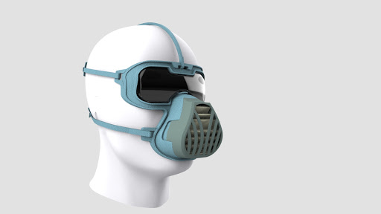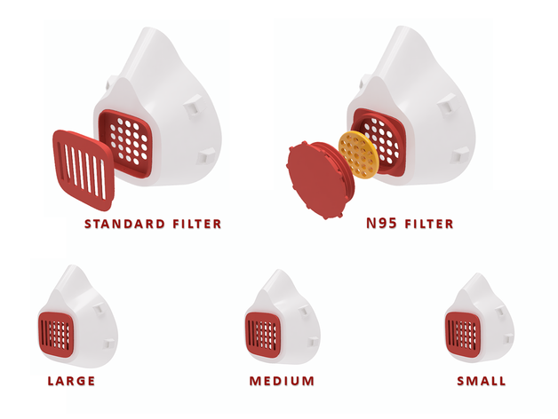

**Figure 1:** Possible ideas for mask housing

**Materials:**

* (1) Adafruit Circuit Playground Express
* (1) USB cable
* (1) Proximity Sensor
* (1) Mask Housing - PLA material
* (1) Mask Straps
* (1) Servo motor
* (1) Battery pack