Amdocs DTAG Cold Stand-by Server Integration and Restore procedure Document for DRA

Version 0.1 - March 11, 2012

table of contents

1. INTRODUCTION and assumptions 1

2. Pre-Build check list 2

3. Cold STANDBY - pcrf HS22 Blade 3

3.1 Turn on visual LED on defective blade 3

3.2 Power off defective blade via AMM 3

3.3 Check switch ports for new blade 4

3.4 Remote Terminal connect to Standby blade 5

3.5 Restart/start Standby blade 5

3.6 Raid setup for blade 6

3.7 Halt blade at Select boot device 6

3.8 Install Linux Operating System 7

3.8.1 MAC Address for Standby Server 7

3.8.2 Configure MAC Address’ for standby blade on BMS 7

3.8.3 KickStart HS22 Blade 8

3.9 Configure OAM access network on Server 9

3.10 Restart networking 11

3.11 Setup Server to access BMS server repository: 11

3.12 Import Linux GPG-KEY 12

3.13 Update Linux with latest BMS repository rpms 12

3.14 Update Linux with 02022012 security rpms 12

3.15 Transfer backup tar ball from BMS server 13

3.16 Restore system /etc configuration files 13

3.17 Reboot the server 14

3.18 DRA Server Restore 14

3.18.1 SLF DRA Server Restore 14

3.18.2 Transfer Required Packages to the Server 15

3.18.3 Install packages 16

3.18.4 Restore backed-up opt directory config files 16

3.18.5 Re-create TimesTen Instance and replication 17

3.18.6 Re-create the SNMP instance: 18

3.18.7 Re-create the SLF Instance 19

3.18.8 Re-create the DRASLF Instance 19

3.18.9 Verify SLF 19

3.18.10 Install Traffix sdc tar file 21

3.18.11 Restore Traffix sdc configs 22

3.18.12 Create Link to jdk 22

3.18.13 Create link to /etc/init.d 22

3.18.14 Startup Traffix sdc 23

3.18.15 Cluster install and configure - Corosync/Pacemaker 23

3.18.16 Restore system /etc/corosync configuration files 24

3.18.17 Verify config file are restored 24

3.18.18 Create corosync log file (defined in corosync.conf): 24

3.18.19 Enable Corosync and Pacemaker System startup: 24

3.18.20 Start Corosync and Pacemaker: 25

3.18.21 Check node are online with crm_mon : 25

3.18.22 Configure crm : 25

3.18.23 Remove directories used for restore 26

4. AppeNdix A 28

4.1 Setting up Linux kickstart server. 28

4.1.1 Assumptions 28

4.1.2 PXEboot and kickstart setup on BMS server 28

5. APPENDIX B 33

5.1 Setting up Linux DVD iso local repository. 33

5.1.1 For setup on BMS Server 33

6. APPENDIX C 35

6.1 LSI Raid setup Screen captures. 35

6.1.1 LSI Raid setup utility selection screen 35

6.1.2 Select SAS1064 Adaptor 35

6.1.3 Select RAID Properties 36

6.1.4 Create Integrated Mirror Volume 36

6.1.5 Select Overwrite exiting data “D” 37

6.1.6 Screen capture with both drives as part of RAID disk 37

6.2 Select boot device Screen captures 38

6.2.1 Select <F12> to select boot device 38

6.2.2 Select PXE Network 38

6.2.3 Select yes to initialize the Disk 39

6.2.4 Linux installed 39

7. APPENDIX D 40

7.1 Backup file manifest. 40

Document Release Notes

|  |  |  |  |
| --- | --- | --- | --- |
| **Version** | **Author** | **Date** | **Comments** |
| 0.1 | Bart Baas | March 11 2012 | Initial version stated from 0.3 of PCRF doc |
|  |  |  |  |
|  |  |  |  |
|  |  |  |  |
|  |  |  |  |
|  |  |  |  |
|  |  |  |  |

# INTRODUCTION and assumptions

* This section will describe the procedure for the activation of a Cold Stand-by Server for DRA application.
* These sections includes steps to install and update the RHL 5.7 Linux OS
* This procedure relies on a backup having being successfully carried out before hand and backup files transferred to the BMS server node.

NOTE: any modifications made since the previous backup will not be restored.

* Assumptions:
* Individual performing procedure is familiar with logging into AMM / BNT switches, the blades BIOS and able to navigate around all these interfaces /components.
* SB (standby Server) is integrated into the cabinet/rack ie: powered and cabled
* Backup files of DRA server is available (lists include in APPENDIX D)
* DRA server is part of cluster and will be replicated from other DRA server in the same cluster.
* ssh and web interface to the AMM / BNT, switches and blades are accessible.
* Servers are configured on the BMS to allow them to kick start from BMS sever as per Appendix A Setting up Linux kickstart server.

# Pre-Build check list

* Before starting, the following information should be known :

|  |  |
| --- | --- |
| Slot/Bay number of defective Blade |  |
| Slot/Bay number of Standby Blade |  |
| Backup location of configuration and instance for defective blade stored on BMS server |  |
| Administrative access to management of BNT switch ( login id /password ) |  |
| Administrative access to AMM (login id /password) |  |
| System IP plan including Vlan and network address’s |  |
| rhl_update_02022012.tar.gz is needed to update Linux |  |
| Access to the following packages is required:  the Traffix cdc tar file:  sdc-3.3.2.0-36.tar.gz  Corosync/Pacemaker required rpms:  From EPEL (Extra Packages for Enterprise Linux) Repository:  libesmtp-1.0.4-5.el5.x86_64.rpm  From Corosync/Pacemaker Repositories:  pacemaker-libs-1.1.5-1.1.el5.x86_64.rpm  pacemaker-1.1.5-1.1.el5.x86_64.rpm  cluster-glue-libs-1.0.6-1.6.el5.x86_64.rpm  corosync-1.2.7-1.1.el5.x86_64.rpmr  heartbeat-3.0.3-2.3.el5.x86_64.rpm  heartbeat-libs-3.0.3-2.3.el5.x86_64.rpm  cluster-glue-1.0.6-1.5.el5.x86_64.rpm  resource-agents-1.0.4-1.1.el5.x86_64.rpm  corosynclib-1.2.7-1.1.el5.x86_64.rpm  jdk-6u30-linux-x64.bin |  |
|  |  |
|  |  |
|  |  |
|  |  |
|  |  |

# Cold STANDBY - pcrf HS22 Blade

## Turn on visual LED on defective blade

|  |  |
| --- | --- |
|  | Login to AMM |
|  | Turn Blink on Location LED for defective card  Under **Monitors / LED’s**  Located bay number for defective card and click on Blink Location button  The location LED will go from “Off” to “Blue blinking”  Note: Depending on the issue with the defective blade, this may not function |

## Power off defective blade via AMM

|  |  |
| --- | --- |
|  |  |
|  | Login to AMM |
|  | Power off defective blade:  Under **Blade Tasks / Power/Restart**  Located bay # for defective blade and check the box for this blade  Under Available actions use pull down to select “**Power Off Blade**”  Click on “**Perform action**” button  Verify Power state of defective blade:  Under **Monitors / System Status**  Verify that the defective blade show “**Off**” under the Pwr column |

## Check switch ports for new blade

|  |  |
| --- | --- |
|  | Login to BNT switches as admin |
|  | Check on all BNT switches that INT ports are configure for new card . The INT port for the new blade need to be part of the correct vlan etc.. (configure as required )  Check switch configuration on all 4 BNT’s by displaying vlan information:  **Router >enable**  **Enable privilege granted.**  **Enable privilege granted.**  **BNT2#show vlan**  **VLAN Name Status MGT Ports**  **---- -------------------------------- ------ --- -------------------------**  **1 Default VLAN ena dis INT5-INT12 EXT1-EXT3**  **EXT6-EXT9**  **207 VLAN 207 ena dis INT1-INT4 INT13 INT14 EXT4**  **EXT5**  **804 VLAN 804 OAM Traffic ena dis INT1-INT4 INT13 INT14 EXT4**  **EXT5**  **4095 Mgmt VLAN ena ena INT1-INT14 MGT1 MGT2**  The INT port should be listed as part of the correct vlan etc.  Note: INT1 connects to bay 1, INT14 connects to bay 14 , so if the Standby blade is in bay 5 then INT5 needs to be included in same vlans as defective blade was configured for. |

## Remote Terminal connect to Standby blade

|  |  |
| --- | --- |
|  | Login to AMM |
|  | Connect to Standby Server:  Under **Blade Tasks / Remote Control**  Click on the “Start Remore Control button”  A new windows will open with Remote Console access to blades in Bladecenter: Video/blade /KVM/Media Tray/Remote Drive / Preference and Help  Select the bay for the “standby server bay” from the pull down box for blades  The Remote console output from the standby by blade will be displayed.  This screen will be used to select boot device and configure network in later steps |

## Restart/start Standby blade

|  |  |
| --- | --- |
|  | Login to AMM |
|  | Restart/ Start standby blade in original window:  Under **Blade Tasks / Power/Restart**  Located bay for standby blade and check the box for this blade  Under Available actions use pull down to select “Restart Blade”  Click on “Perform action” button  Then go back to Remote console window and catch “LSI Setup Utility” during Blade boot up |

## Raid setup for blade

|  |  |
| --- | --- |
|  | Setup Raid Mirroring for Drive 0 and 1  Select the LSI Setup Utility during Blade Boot up  Reference APPENDIX C for LSI Raid setup Screen captures. |
|  | Hold down <Ctrl> and press <c> key when the following appears on the screen:  **LSI Corporation MPT SAS BIOS**  **MPTBIOS-X.XX.XX.XX (XXXX.XX.XX)**  **Press Ctrl-C to start LSI Corp Configuration Utility…**  Press Enter to select **SAS1064 Adaptor**  Move over to **RAID Properties** and press enter  If disk are already part of Array and have been setup then it will display  ie: RAID Disk = **YES**  Otherwise  Select **Create IM Volume** ( Integrated Mirror Array of 2 disk)  Add both Drives by changing RAID DISK from **[No]** to **[Yes]** for Slot 0 and 1  Change this by moving to **[No]** and pressing **+** to select disk  (Overwrite exiting data if prompted )  Then Press **C** to Create array  Save changes / Exit utility and reboot |

.

## Halt blade at Select boot device

|  |  |
| --- | --- |
|  | Once blade reboots, halt blade at “select boot device” screen by selecting <F12>  Reference APPENDIX C for Select boot device Screen captures |

## Install Linux Operating System

|  |  |
| --- | --- |
|  | Linux is installed using BMS as kickstart server  see Appendix A Setting up Linux kickstart server. for PXE boot / kickstart setup for BMS server |

### MAC Address for Standby Server

|  |  |
| --- | --- |
|  | - Determine MAC address for eth0 and eth1 of Standby Server |
|  | Login to root on BMS server |
|  | Run the following command from BMS server to display standby server MAC address via AMM  Replace ip adddress below with ip address of AMM  Replace X in blade[X] with bay number for the standby blade  **# ssh -l USERID 192.168.155.30 "info -T system:blade[7]" | grep "MAC Address [12]"**  **password:**  **MAC Address 1: 34:40:B5:81:58:A8**  **MAC Address 2: 34:40:B5:81:58:AA** |

### Configure MAC Address’ for standby blade on BMS

|  |  |
| --- | --- |
|  | - Assumption is that defective blade was configured on the BMS for kickstart |
|  | Login to root on BMS server |
|  | - Replace defective blade MAC address with standby MAC address in /etc/dhcpd.conf  Update the defective blade entry with standby MAC adddress  **# vi /etc/dhcpd.conf**  **host kansparc5437_eth0 {**  **server-name "kansparc5445";**  **hardware ethernet 34:40:B5:81:5C:3C;**  **fixed-address 192.168.154.45;**  **}**  **host kansparc5437_eth1 {**  **server-name "kansparc5445";**  **hardware ethernet** 34:40:B5:81:5C:3E**;**  **fixed-address 192.168.154.45;**  **}**  Verify MAC address from standby blade  **# egrep 34:40:B5:81:58:A8 /etc/dhcpd.conf**  **hardware ethernet 34:40:B5:81:58:A8;**  - Restart the dhcpd service on the BMS  **# restart dhcpd service**  **Shutting down dhcpd: [ OK ]**  **Starting dhcpd: [ OK ]**  - Create tftpboot file for standby server using defective blade file:  The name of the file will consist of 01 followed by MAC address in lowercase separated with dashes ie:  **# cp /tftpboot/linux-install/pxelinux.cfg/01-34-40-b5-81-5c-3c /tftpboot/linux-install/pxelinux.cfg/01-34-40-b5-81-58-a8** |

### KickStart HS22 Blade

|  |  |
| --- | --- |
|  | - Select a “one time boot” alternate boot device during system startup  Reference APPENDIX C for Select boot device Screen captures |
|  | Login to AMM on server |
|  | Remote connect to the server which is to be booted and installed with RedHat.  During beginning of server boot enter <F12> was entered to select boot Device  Select: one time boot - select PXE network  Install process should be automatic except you may need to answer “Yes” to prompt to initialize the drive and Erasing All data.  Reference APPENDIX C for Select yes to initialize the Disk  Blade will reboot once completed and bring up Linux from Disk drive |

## Configure OAM access network on Server

|  |  |
| --- | --- |
|  | - Configure ip address, vlan, MAC address for blade OAM network  - configure the following files:  /etc/sysconfig/network  */etc/sysconfig/network-scripts/ifcfg-eth0*  */etc/sysconfig/network-scripts/ifcfg-eth1*  */etc/sysconfig/network-scripts/ifcfg-bond0*  /etc/sysconfig/network-scripts/ifcfg-bond0. <VLAN>  /etc/modprobe.conf |
|  | Login to AMM on server |
|  | Under: Blade Tasks / Remote Control         Start a remote control console session to the Server  Login into console and configure eth0 and eth1 and bonded pair and setup the OAM vlan.  Edit ifcfg-eth0 and ifcfg-eth0 and update as follows ( change HWADDR to MAC address of standby blade)  **# vi /etc/sysconfig/network-scripts/ifcfg-eth0**  **DEVICE=eth0**  **BOOTPROTO=none**  **ONBOOT=yes**  **TYPE=Ethernet**  **MASTER=bond0**  **SLAVE=yes**  **USERCTL=no**  **HWADDR=5C:F3:FC:B7:76:B0**  **# vi /etc/sysconfig/network-scripts/ifcfg-eth1**  **DEVICE=eth1**  **BOOTPROTO=none**  **ONBOOT=yes**  **TYPE=Ethernet**  **MASTER=bond0**  **SLAVE=yes**  **USERCTL=no**  **HWADDR=5C:F3:FC:B7:76:B2**  Edit ifcfg-bond0 and update as follows  **# vi /etc/sysconfig/network-scripts/ifcfg-bond0**  **DEVICE=bond0**  **BONDING_OPTS="mode=1 miimon=100"**  **BOOTPROTO=none**  **ONBOOT=yes**  **USERCTL=no**  **TYPE=BOND**  **IPV6INIT=no**  Edit ifcfg-bond0.<VLAN> and update as follows ( change VLAN and ipaddres specific for this server)  **# vi /etc/sysconfig/network-scripts/ifcfg-bond0.<VLAN>**  **DEVICE=bond0.<VLAN>**  **BOOTPROTO=none**  **ONBOOT=yes**  **IPADDR=10.94.49.240**  **NETWORK=10.94.49.0**  **NETMASK=255.255.255.0**  **USERCTL=no**  **VLAN=yes**  **TYPE=Ethernet**  Add the following line to /etc/modprobe.conf:  **# vi /etc/modprobe.conf**  alias bond0 bonding |

## Restart networking

|  |  |
| --- | --- |
|  | Restart networking with bond and vlan interface |
|  | # service network restart  Shutting down interface eth0:  ……  Verify network configure  # ifconfig bond0.<vlan>  ….  And verify ssh to the new blade. |

## Setup Server to access BMS server repository:

|  |  |
| --- | --- |
|  | - Setup to insstall/update packages on server from repository on BMS  - Assumption: httpd and repository has been setup on BMS server (see Appendix B to set this up) |
|  | Login to server as root |
|  | create a file called redhat_5.7_bms.repo in /etc/yum.repos.d and add the following:  Note: replace highlighted ip address with address of BMS sever  **# vi /etc/yum.repos.d/redhat_5.7_bms.repo**  **[RHEL5.7-BMS-Repository]**  **name=redhat_5.7_bms.repo**  **baseurl=http://192.168.154.27/cdrom/**  **enabled=1**  **gpgcheck=1**  **pgkey=http://192.168.154.27/cdrom/iso/RPM-GPG-KEY-redhat-release**  And verify it is part of repolist:  **# yum repolist RHEL5.7-BMS-Repository**  **Loaded plugins: downloadonly, security**  **repo id repo name status**  **RHEL5.7-BMS-Repository redhat_5.7_bms.repo 3,389**  **repolist: 3,389** |

## Import Linux GPG-KEY

|  |  |
| --- | --- |
|  | Copy BWS-V2-CGC-KEY from BMS server and Import it on Standby Blade  Normaly Located on BMS server at: /var/www/htmlcdrom/iso/RPM-GPG-KEY-redhat-release  **# mkdir -p /stage/Linux**  **# scp <BMS_SERVER>:/var/www/html/cdrom/iso/RPM-GPG-KEY-redhat-release /stage/Linux**  **# rpm --import /stage/Linux/RPM-GPG-KEY-redhat-release** |

## Update Linux with latest BMS repository rpms

|  |  |
| --- | --- |
|  |  |
|  | Login as root |
|  | Update linux:  **# yum update** |

## Update Linux with 02022012 security rpms

|  |  |
| --- | --- |
|  | - rhl_update_02022012.tar.gz is needed to update Linux |
|  | Login as root |
|  | Here steps  to upgrade the server:  Create directory:  **# mkdir -p /stage/Linux/update02022012**  Copy rhl_update_02022012.tar.gz to /stage/Linux/update0202201  Excute following steps:  **# cd /stage/Linux/update02022012**  **# tar -zxvf rhl_update_02022012.tar.gz**  **# yum update ./\*** |

## Transfer backup tar ball from BMS server

|  |  |
| --- | --- |
|  | Backup file is located on BMS server in following directory: /doxstore2/backstore_location  Create temporary directory called /var/tmp/backups and copy the backup archive into it  **# mkdir -p /var/tmp/backups**  **# scp <BMS_SERVER>:<BACKUP_FILE> /var/tmp/backups** |

## Restore system /etc configuration files

|  |  |
| --- | --- |
|  | - Restore the system /etc configuration files  - Backup archive files are located in /var/tmp/backups |
|  | The restore of these configuration will overwritten and need to be saved first  /etc/sysconfig/network-scripts/ifcfg-eth0  /etc/sysconfig/network-scripts/ifcfg-eth1  It will also overwrite these files and MAC address need to be saved so that they can be reapplied to the files  /etc/sysconfig/network-scripts/ifcfg-eth2  /etc/sysconfig/network-scripts/ifcfg-eth3  Save copy of eth0/1 files :  # cp /etc/sysconfig/network-scripts/ifcfg-eth0 /tmp/ifcfg-eth0  # cp /etc/sysconfig/network-scripts/ifcfg-eth1 /tmp/ifcfg-eth1  Determine HRWRD / MAC address from eth2 and eth3: ( this will used to update these files), only if applicable  # grep egrep 'DEVICE|HWADDR' /etc/sysconfig/network-scripts/ifcfg-eth[23]  DEVICE=eth2  HWADDR=34:40:B5:77:84:2A  DEVICE=eth3  HWADDR=34:40:B5:77:84:2C  Restore tar backup  # cd /  # tar zxvf /var/tmp/backups/<BACKUP_FILE> etc  Restore the saves eth0/1 files :  # mv /tmp/ifcfg-eth0 /etc/sysconfig/network-scripts/ifcfg-eth0  # mv /tmp/ifcfg-eth1 /etc/sysconfig/network-scripts/ifcfg-eth1  Edit, if applicable :  /etc/sysconfig/network-scripts/ifcfg-eth2  /etc/sysconfig/network-scripts/ifcfg-eth3  And restore the HWADDR address determined above  Ie:  DEVICE=eth2  HWADDR=34:40:B5:77:84:2A  DEVICE=eth3  HWADDR=34:40:B5:77:84:2C |

## Reboot the server

|  |  |
| --- | --- |
|  | # reboot |

## DRA Server Restore

### SLF DRA Server Restore

#### Determine PWS/BPC packages versions to install

|  |  |
| --- | --- |
|  | **\*\*Perform this step** (3.18.1.1) **ONLY if the node is an SLF node\*\***  Determine packages needed from /opt/bpc/backup/TARFILE/PackageVersions.<DATE>.txt  # cd /var/tmp/backups  # tar zxvf <BACKUP_FILE> opt/bpc/backup/TARFILE/PackageVersions*  # egrep 'BWS|BPC|BWC' /var/tmp/backups/opt/bpc/backup/TARFILE/PackageVersions.<DATE>.txt  BPCdraslf-44RELv1-hga00a00012277  BPCsnmp-44RELv1-hga00a00012277  BPCttdb-44RELv1-hga00a00012277  BWCcta-1.3.1-OAM00001396  BPCapps-44RELv1-hga00a00012277 |
|  |  |
|  |  |
|  |  |

### Transfer Required Packages to the Server

|  |  |
| --- | --- |
|  | Create /stage/Amdocs directory as user “**root**”on the server.  # mkdir -p /stage/Amdocs |
|  | Transfer the Required Packages and GPG-Key to the /stage/Amdocs directory  (these should be available on the BMS sever )    **Transfer the following packages ONLY if node is an SLF node**  BPCapps-44RELv1-hga00a00012277.x86_64.rpm  BPCdraslf-44RELv1-hga00a00012277.x86_64.rpm  BPCsnmp-44RELv1-hga00a00012277.x86_64.rpm  BPCttdb-44RELv1-hga00a00012277.x86_64.rpm  BWCcta-1.3.1-OAM00001396.noarch.rpm  **The following packages are required for ALL nodes**  The following rpms are also required:  net-snmp-5.3.2.2-14.el5_7.1.x86_64.rpm  net-snmp-utils-5.3.2.2-14.el5_7.1.x86_64.rpm  the Traffix cdc tar file:  sdc-3.3.2.0-36.tar.gz  Corosync/Pacemaker required rpms:  From EPEL (Extra Packages for Enterprise Linux) Repository:  libesmtp-1.0.4-5.el5.x86_64.rpm  From Corosync/Pacemaker Repositories:  pacemaker-libs-1.1.5-1.1.el5.x86_64.rpm  pacemaker-1.1.5-1.1.el5.x86_64.rpm  cluster-glue-libs-1.0.6-1.6.el5.x86_64.rpm  corosync-1.2.7-1.1.el5.x86_64.rpmr  heartbeat-3.0.3-2.3.el5.x86_64.rpm  heartbeat-libs-3.0.3-2.3.el5.x86_64.rpm  cluster-glue-1.0.6-1.5.el5.x86_64.rpm  resource-agents-1.0.4-1.1.el5.x86_64.rpm  corosynclib-1.2.7-1.1.el5.x86_64.rpm  **Transfer the following package ONLY if the node is NOT an SLF node**  jdk-6u30-linux-x64.bin |

### Install packages

|  |  |
| --- | --- |
|  | **\*\*Perform this step (3.18.3) ONLY if the node is an SLF node\*\***  Import BWS-V2-CGC-KEY    # rpm --import /stage/Amdocs/BWS-V2-GPG-KEY  Install:  net-snmp-5.3.2.2-14.el5_7.1.x86_64.rpm  net-snmp-utils-5.3.2.2-14.el5_7.1.x86_64.rpm  # yum install net-snmp-5.3.2.2-14.el5_7.1.x86_64.rpm net-snmp-utils-5.3.2.2-14.el5_7.1.x86_64.rpm  Use yum to install BWS/BPC/BWC packages:    # cd /stage/Amdocs  # yum install BPCttdb-44RELv1-hga00a00012277.x86_64.rpm  # yum install BPCsnmp-44RELv1-hga00a00012277.x86_64.rpm  # yum install BPCapps-44RELv1-hga00a00012277.x86_64.rpm  # yum install BPCdraslf-44RELv1-hga00a00012277.x86_64.rpm  # yum install BWCcta-1.3.1-OAM00001396.noarch.rpm |
|  |  |

### Restore backed-up opt directory config files

|  |  |
| --- | --- |
|  | Backup archive files are located in /var/tmp/backups |
|  | Change to / directory and restore opt files :  # cd /  # tar zxvf /var/tmp/backups/<BACKUP_FILE> opt  **\*\*Skip the following step if the node is NOT an SLF node\*\***  Remove the restores /opt/bpc/is/DRASLF/config/dra-slf-config.xml to allow recreation of DRASLF instance:  # \rm –r /opt/bpc/is/DRASLF |

### Re-create TimesTen Instance and replication

|  |  |
| --- | --- |
|  | **\*\*Perform this step (3.18.5) ONLY if the node is an SLF node\*\***  As bpc user: |
|  | Get size of datastore from backup tt parmdb file:  $ grep TT_PERM_SIZE /opt/bpc/backup/TARFILE/BPCttdb-44RELv1-hga00a00012277.TimesTen.parmdb  parmdb_publish TT_PERM_SIZE "10000"  Get blade dsn from backup tt parmdb file:  $ grep TT_INSTANCE_NAME /opt/bpc/backup/TARFILE/BPCttdb-44RELv1-hga00a00012277.TimesTen.parmdb  parmdb_publish TT_INSTANCE_NAME "bpckanlinux5445"  Re-create the TimesTen instance:  $ restorecnfg TimesTen BPCttdb_<REL_DATE> /opt/bpc/backup/TARFILE/BPCttdb-44RELv1-hga00a00012277.TimesTen.parmdb  During restore it will ask you for the datastore size select size to match from previous output command.  Please choose the size of this datastore (in megabytes)  1) 512  2) 1024  3) 2048  4) 4096  5) 10000  6) 20000  #? 5  Generating Configuration.  Installing the database; this may take a few minutes...  run /opt/bpc/rootbin/TimesTen_setup as root to complete the installation:  # /opt/bpc/rootbin/TimesTen_setup  Re-enable TimesTen replication:  $ vi /opt/bpc/is/TimesTen/bpckanlinux5445/info/sys.odbc.ini  $ vi /opt/bpc/is/TimesTen/<new blade dsn>/info/sys.odbc.ini  CHANGE AutoCreate=1 => AutoCreate=0 $ ttAdmin <new blade dsn> $ ttAdmin -ramPolicy inuse <new blade dsn> $ ttAdmin -repPolicy manual <new blade dsn> $ ttAdmin -repStop <new blade dsn> $ ttAdmin -ramUnload <new blade dsn> $ ttDestroy -wait <new blade dsn>  $ ttRepAdmin -dsn <new blade dsn> duplicate -from <existing blade dsn> -host <existing blade hostname> -localhost <new blade hostname>  $ ttAdmin -ramPolicy always <new blade dsn> $ ttAdmin -repPolicy always <new blade dsn> $ ttrepadmin -showStatus <new blade dsn> $ vi /opt/bpc/is/TimesTen/bpckanlinux5445/info/sys.odbc.ini  CHANGE AutoCreate=0 => AutoCreate=1  NOTE -  <new blade hostname> = Hostname of the new server  <new blade dsn> = The new TimesTen Instance DSN name  <existing blade hostname> = Hostname of the other server  <existing blade dsn> = TimesTen DSN name of other server |

### Re-create the SNMP instance:

|  |  |
| --- | --- |
|  | **\*\*Perform this step (3.18.6) ONLY if the node is an SLF node\*\***  As bpc user: |
|  | $ restorecnfg SNMP BPCsnmp-<REL_DATE> /opt/bpc/backup/TARFILE/BPCsnmp_<REL_DATE>.SNMP.parmdb    run /opt/bpc/rootbin/BPCsnmp/SNMP_sma_setup as root to complete the installation unless root password was supplied in previous command:  # /opt/bpc/rootbin/BPCsnmp/SNMP_sma_setup |

### Re-create the SLF Instance

|  |  |
| --- | --- |
|  | **\*\*Perform this step (3.18.7) ONLY if the node is an SLF node\*\***  As bpc user: |
|  | $ restorecnfg SLF BPCapps-44RELv1-hga00a00012277 /opt/bpc/backup/TARFILE/BPCapps-44RELv1-hga00a00012277.SLF.parmdb  run /opt/bpc/rootbin/PCRF_setup as root to complete the installation  # /opt/bpc/rootbin/PCRF_setup |

### Re-create the DRASLF Instance

|  |  |
| --- | --- |
|  | **\*\*Perform this step (3.18.8) ONLY if the node is an SLF node\*\***  As bpc user: |
|  | $ restorecnfg DRASLF BPCdraslf-44RELv1-hga00a00012277 /opt/bpc/backup/TARFILE/BPCdraslf-44RELv1-hga00a00012277.DRASLF.parmdb |

### Verify SLF

|  |  |
| --- | --- |
|  | **\*\*Perform this step (3.18.9) ONLY if the node is an SLF node\*\***  As bpcuser: |
|  | -sh-3.2$ ttrepadmin -showStatus bpckanlinux5437  Replication Agent Status as of: 2012-02-29 22:23:07  DSN : bpckanlinux5437  Process ID : 6668 (Started)  Replication Agent Policy : always  Host : KANLINUX5437  RepListener Port : 17015  Last write LSN : 0.20236928  Last LSN forced to disk : 0.20236928  Replication hold LSN : 0.20232440  Replication Peers:  Name : BPCKANLINUX5445  Host : KANLINUX5445  Port : 17015 (Connected)  Replication State : STARTED  Communication Protocol : 24  TRANSMITTER thread(s):  For : BPCKANLINUX5445  Start/Restart count : 3  Send LSN : 0.20235208  Transactions sent : 12  Total packets sent : 7034  Tick packets sent : 7010  MIN sent packet size : 64  MAX sent packet size : 1710  AVG sent packet size : 65  Last packet sent at : 22:23:01  Total Packets received: 7032  MIN rcvd packet size : 64  MAX rcvd packet size : 120  AVG rcvd packet size : 119  Last packet rcvd'd at : 22:23:01  Most recent errors (max 5):  TT16032 in transmitter.c (line 1412) at 21:50:34 on 02-29-2012  TT16032 in transmitter.c (line 1412) at 21:50:42 on 02-29-2012  TT16032 in transmitter.c (line 1412) at 21:50:50 on 02-29-2012  TT16032 in transmitter.c (line 1412) at 21:51:06 on 02-29-2012  TT16032 in transmitter.c (line 1412) at 21:54:10 on 02-29-2012  RECEIVER thread(s):  For : BPCKANLINUX5445  Start/Restart count : 1  Transactions received : 0  Total packets sent : 206  Tick packets sent : 0  MIN sent packet size : 64  MAX sent packet size : 120  AVG sent packet size : 118  Last packet sent at : 22:23:02  Total Packets received: 206  MIN rcvd packet size : 64  MAX rcvd packet size : 154  AVG rcvd packet size : 64  Last packet rcvd'd at : 22:23:02  -sh-3.2$ ttRepAdmin -dsn bpckanlinux5437 -receiver list  Peer name Host name Port State Proto  ---------------- ------------------------ ------ ------- -----  BPCKANLINUX5445 KANLINUX5445 17015 Start 24  Last Msg Sent Last Msg Recv Latency TPS RecordsPS Logs  ------------- ------------- ------- ------- --------- ----  00:00:07 00:00:06 -1.00 -1 -1 1  -sh-3.2$ /opt/bpc/is/SLF/bin/rgmgr list  Please enter the name and password of an account with provisioning privileges  Username: root  Password:  Name Status Creation Date Activation Date  test INACTIVE 2012-02-29 05:54:49  cpf-cluster-0 ACTIVE 2012-02-29 06:06:47 2012-02-29 06:10:00  rgmgr command ran successfully  -sh-3.2$  -sh-3.2$ ttIsql -connstr dsn=bpckanlinux5445  Command> select * from SLF.CLUSTER_PARTITION;  < 1, cpf-cluster-0, A, 0, W, 2012-02-29 03:12:45.087000, 2012-02-29 04:00:00.000000, 4F4DA2C0000016C2 >  < 2, test, U, 0, W, 2012-02-29 03:16:19.524000, <NULL>, 4F4DA22F0007C6B9 >  2 rows found.  Command> select * from SLF.CLUSTER_RANGE;  < 1, 302000000000000, 302999999999999, 0, 0, 4F4D97AD00018E1E >  < 1, 544000000000000, 544999999999999, 0, 0, 4F4D97AD00018EA2 >  < 2, 302000000000000, 302999999999999, 0, 0, 4F4D9883000804AD >  < 2, 544000000000000, 544999999999999, 0, 0, 4F4D9883000804F9 >  4 rows found.  Command> |

### Install Traffix sdc tar file

|  |  |
| --- | --- |
|  | As root user: |
|  | # mkdir -p /opt/traffix  copy sdc-3.3.2.0-36.tar.gz to /opt/traffix  # cd /opt/traffix  # tar zxvf sdc-3.3.2.0-36.tar.gz  # ln -s /opt/traffix/sdc-3.3.2.0-36 /opt/traffix/sdc  # ls -l /opt/traffix/sdc |

### Restore Traffix sdc configs

|  |  |
| --- | --- |
|  | As root user: |
|  | # cd /  # unzip /opt/backup/TARFILE/DRA_SDC.config.zip  Archive: /opt/backup/TARFILE/DRA_SDC.config.zip  replace opt/traffix/sdc/config/dictionaries/base.xml? [y]es, [n]o, [A]ll, [N]one, [r]ename: A |

### Create Link to jdk

|  |  |
| --- | --- |
|  | As root user: |
|  | **Perform the following section ONLY if the node is NOT an SLF node**  # mkdir /opt/java  copy jdk-6u30-linux-x64.bin to /opt/java  # cd /opt/java  # chmod 744 ./jdk-6u30-linux-x64.bin  ./jdk-6u30-linux-x64.bin  # mkdir -p /usr/jdk  # ln -s /opt/java/jdk1.6.0_30 /usr/jdk/latest  # ls -l /usr/jdk  total 0  lrwxrwxrwx 1 root root 21 Feb 24 09:26 latest -> /opt/java/jdk1.6.0_30  **Perform the following section ONLY if the node is an SLF node**  # # mkdir -p /usr/jdk  # ln -s /opt/bpc/util/java1.6.0_30 /usr/jdk/latest |

### Create link to /etc/init.d

|  |  |
| --- | --- |
|  | As root user: |
|  | add startup for sdc:  # cd /etc/init.d  # ln -s /opt/traffix/sdc/bin/traffix_config_mgr_init .  # ln -s /opt/traffix/sdc/bin/traffix_cpf_init .  # ln -s /opt/traffix/sdc/bin/traffix_common_init .  and only on one server incluster:  # ln -s /opt/traffix/sdc/bin/traffix_webui_init . |

### Startup Traffix sdc

|  |  |
| --- | --- |
|  | As root user: |
|  | startup for sdc:  # /opt/traffix/sdc/bin/traffix_config_mgr_init start  # /opt/traffix/sdc/bin/traffix_cpf_init start  start WebUI component (run only on one of the blades )  # /opt/traffix/sdc/bin/traffix_webui_init start |

### Cluster install and configure - Corosync/Pacemaker

|  |  |
| --- | --- |
|  | As root user: |
|  | Install the following rpms from rhd distribution repo:  # yum install libibverbs librdmacm openhpi-libs openib PyXML perl-TimeDate  Install the following From EPEL (Extra Packages for Enterprise Linux) Repository:  # cd /stage/Amdocs  # yum install libesmtp-1.0.4-5.el5.x86_64.rpm --nogpgcheck  Install the following From Corosync/Pacemaker Repositories:  # yum install cluster-glue-libs-1.0.6-1.6.el5.x86_64.rpm cluster-glue-1.0.6-1.6.el5.x86_64.rpm --nogpgcheck  # yum install corosync-1.2.7-1.1.el5.x86_64.rpm corosynclib-1.2.7-1.1.el5.x86_64.rpm --nogpgcheck  # yum install resource-agents-1.0.4-1.1.el5.x86_64.rpm --nogpgcheck  # yum install heartbeat-3.0.3-2.3.el5.x86_64.rpm heartbeat-libs-3.0.3-2.3.el5.x86_64.rpm --nogpgcheck  # yum install pacemaker-1.1.5-1.1.el5.x86_64.rpm pacemaker-libs-1.1.5-1.1.el5.x86_64.rpm --nogpgcheck |

|  |
| --- |
|  |

### Restore system /etc/corosync configuration files

|  |  |
| --- | --- |
|  | Backup archive files are located in /var/tmp/backups |
|  | Change to / directory and restore etc/corosync files :  # cd /  # tar zxvf /var/tmp/backups/<BACKUP_FILE> etc/corosync |

### Verify config file are restored

|  |  |
| --- | --- |
|  | As root user: |
|  | # ls -lia /etc/corosync/authkey /etc/corosync/corosync.conf /etc/corosync/service.d/pcmk  21987411 -r-------- 1 root root 128 Mar 3 01:54 /etc/corosync/authkey  21987412 -rw-r--r-- 1 root root 438 Mar 3 02:03 /etc/corosync/corosync.conf  21987413 -rw-r--r-- 1 root root 83 Mar 3 03:07 /etc/corosync/service.d/pcmk |

### Create corosync log file (defined in corosync.conf):

|  |  |
| --- | --- |
|  | As root user: |
|  | # mkdir -p /var/log/cluster  # touch /var/log/cluster/corosync.log |

### Enable Corosync and Pacemaker System startup:

|  |  |
| --- | --- |
|  | As root user: |
|  | # chkconfig corosync on  # chkconfig pacemaker on |

### Start Corosync and Pacemaker:

|  |  |
| --- | --- |
|  | As root user: |
|  | # service corosync start  # service pacemaker start |

### Check node are online with crm_mon :

|  |  |
| --- | --- |
|  | As root user: |
|  | # crm_mon ??????? status  ============  Last updated: Mon Mar 5 21:05:24 2012  Stack: openais  Current DC: kanlinux5437.bridgewatersys.com - partition with quorum  Version: 1.1.5-1.1.el5-01e86afaaa6d4a8c4836f68df80ababd6ca3902f  2 Nodes configured, 2 expected votes  0 Resources configured.  ============  Online: [ kanlinux5437.bridgewatersys.com kanlinux5445.bridgewatersys.com ] |

### Configure crm :

|  |  |
| --- | --- |
|  | As root user: |
|  | Pacemaker configuration (only on one node)  For >2 nodes in cluster :  crm configure property no-quorum-policy="freeze"  For 1 and 2 node clusters:  crm configure property no-quorum-policy="ignore"  Then (for both cluster type):  crm configure property stonith-enabled="false"  crm configure property start-failure-is-fatal="false"  crm configure property cluster-recheck-interval=5m  crm configure property pe-input-series-max=1000  crm configure property pe-warn-series-max=1000  crm configure property pe-error-series-max=1000  crm configure rsc_defaults resource-stickiness=100  crm configure rsc_defaults migration-threshold=3  crm configure rsc_defaults failure-timeout=10m  crm configure op_defaults timeout=30  crm configure op_defaults on-fail=restart  Note : Will need to also perform any specific configs specific to the cluster etc.. |

### Remove directories used for restore

|  |  |
| --- | --- |
|  | As root user: |
|  | # \rm -r /opt/bpc/backup  # \rm -r /var/tmp/backups |

# AppeNdix A

## Setting up Linux kickstart server.

### Assumptions

|  |  |
| --- | --- |
|  | - redhat distribution iso is mounted at /var/www/html/cdrom/iso  and  part of repo list (see Appendix B to set this up)  **# mount | grep iso**  **/stage/Linux/rhel-server-5.7-x86_64-dvd.iso on /var/www/html/cdrom/iso type iso9660 (ro,loop=/dev/loop0)**  **# yum repolist RHEL5.7-DVD-Repository**  **Loaded plugins: downloadonly, security**  **repo id repo name status**  **RHEL5.7-DVD-Repository redhat_5.7_dvd.repo 3,389**  **repolist: 3,389** |

### PXEboot and kickstart setup on BMS server

|  |  |
| --- | --- |
|  | - Setup server to allow other servers to PXE boot from it and kickstart: |
|  | Login to server as root |
|  | Install tftp-server, syslinux, dhcp, httpd  (some packages may already be installed )  **# yum install tftp-server**  **Package tftp-server-0.49-2.x86_64 already installed and latest version**  **Nothing to do**  **# yum install syslinux**  **Package syslinux-3.11-4.x86_64 already installed and latest version**  **Nothing to do**  **# yum install dhcp**  **Installed:**  **dhcp.x86_64 12:3.0.5-29.el5**  **# yum install httpd**  **Installed:**  **httpd.x86_64 0:2.2.3-53.el5**  Enable daemons startup during system boot up:  **# chkconfig dhcpd on**  **# chkconfig httpd on**  **# chkconfig tftp on**  Check  daemons startup during  system boot up:  **# chkconfig --list | egrep 'dhcp|tftp|http'**  **dhcpd           0:off   1:off   2:on    3:on    4:on    5:on    6:off**  **httpd           0:off   1:off   2:on    3:on    4:on    5:on    6:off**  **tftp:           on**  Create/configure /etc/dhcpd.conf ( example below:  will  need to have  2 entries for each server  ( eth0 and eth1 ):  Enter the MAC address’s for both eth0 an eth1 ports for each server.  The MAC address can be determined for each of the blades by running the following command on the BMS server: ( note replace blade[X] with bay number for blade)  **# ssh -l USERID <AMM_IP_ADRESS> "info -T system:blade[7]" | grep "MAC Address [12]"**  **# cat /etc/dhcpd.conf**  **allow booting;**  **allow bootp;**  **ddns-update-style none;**  **subnet 10.108.92.64 netmask 255.255.255.192 {**  **# PXE-specific configuration directives**  **next-server 10.108.92.68;**  **filename "linux-install/pxelinux.0";**  **host bonspr02a_eth0 {**  **server-name "bonspr02a";**  **hardware ethernet 5C:F3:FC:B6:3A:20;**  **fixed-address 10.108.92.69;**  **}**  **host bonspr02a_eth1 {**  **server-name "bonspr02a";**  **hardware ethernet 5C:F3:FC:B6:3A:22;**  **fixed-address 10.108.92.69;**  **}**  **host bonXXXX_eth0 {**  **server-name "bonXXXX";**  **hardware ethernet 5C:F3:FC:B6:3A:40;**  **fixed-address 10.108.92.XX;**  **}**  **host bonXXXX_eth1 {**  **server-name "bonXXXX";**  **hardware ethernet 5C:F3:FC:B6:3A:42;**  **fixed-address 10.108.92.XX;**  **}**  **}**  Start up services:  ( you may get message during http startup as below)  **# service xinetd restart**  **Stopping xinetd:                                           [  OK  ]**  **Starting xinetd:                                           [  OK  ]**  **# service dhcpd restart**  **Shutting down dhcpd:                                       [  OK  ]**  **Starting dhcpd:                                            [  OK  ]**  **# service httpd start**  **Starting httpd: httpd: Could not reliably determine the server's fully qualified domain name, using 10.108.92.68 for    ServerName [  OK  ]**    Create files in /tftpboot/linux-install/pxelinux.cfg/:  these should be named  the  MAC address of each server eth port preceded by 01 and octets separated with “-“  A default file is included for servers who’s MAC’s  that are not included in this directory ( the default one is interactive with prompts during install)  **# cat /tftpboot/linux-install/pxelinux.cfg/01-5c-f3-fc-b6-3a-20**  **default linux**  **timeout 100**  **label linux**  **kernel vmlinuz**  **append initrd=initrd.img ksdevice=eth0 noipv6 ks=http://10.108.92.68/ks_configs/ks_bonspr02a.cfg**  **# cat /tftpboot/linux-install/pxelinux.cfg/01-5c-f3-fc-b6-3a-22**  **default linux**  **timeout 100**  **label linux**  **kernel vmlinuz**  **append initrd=initrd.img ksdevice=eth1 noipv6 ks=http://10.108.92.68/ks_configs/ks_bonspr02a.cfg**  **# cat /tftpboot/linux-install/pxelinux.cfg/default**  **default linux**  **timeout 100**  **label linux**  **kernel vmlinuz**  **append initrd=initrd.img interactive ksdevice=eth0 noipv6 ks=http://10.108.92.68/ks_configs/ks_bonXXXXX.cfg**  Create anaconda style config  files in /var/www/html/ks_configs/ for each server.  Replace the ip and netmask for the eth0 device.  Drive setup can also be customized in this file.  Packages that are installed on server can be added/delete in this file.  Set correct BMS server ip address in file ie ([**http://10.108.92.68/cdrom/iso**](http://10.108.92.68/cdrom/iso))  **# cat /var/www/html/ks_configs/ks_bonspr02a.cfg**  **# Kickstart file for bonspr02a Feb 17 2012**  **install**  **url --url** [**http://10.108.92.68/cdrom/iso**](http://10.108.92.68/cdrom/iso)  **key --skip**  **lang en_US.UTF-8**  **keyboard us**  **xconfig --startxonboot**  **network --device eth0 --bootproto static --ip 10.108.92.69 --netmask 255.255.255.192**  **network --device eth1 --onboot no --bootproto dhcp**  **network --device eth2 --onboot no --bootproto dhcp**  **network --device eth3 --onboot no --bootproto dhcp**  **rootpw --iscrypted $1$qfX292pU$Nw6eQz7t0/x55cJA8anV40**  **firewall --disabled**  **authconfig --enableshadow --enablemd5**  **selinux --disabled**  **timezone --utc Etc/GMT**  **bootloader --location=mbr --driveorder=sda --append="rhgb quiet"**  **# The following is the partition information you requested**  **# Note that any partitions you deleted are not expressed**  **# here so unless you clear all partitions first, this is**  **# not guaranteed to work**  **clearpart --all --drives=sda**  **part / --fstype ext3 --size=100 --grow**  **part /var --fstype ext3 --size=51200**  **part swap --size=25600**  **reboot**  **%packages**  **@admin-tools**  **@base**  **@core**  **@dialup**  **@editors**  **@gnome-desktop**  **@games**  **@graphical-internet**  **@graphics**  **@java**  **@legacy-software-support**  **@office**  **@printing**  **@sound-and-video**  **@text-internet**  **@base-x**  **kexec-tools**  **fipscheck**  **device-mapper-multipath**  **sgpio**  **emacs**  **libsane-hpaio**  **xorg-x11-utils**  **xorg-x11-server-Xnest** |

# APPENDIX B

## Setting up Linux DVD iso local repository.

### For setup on BMS Server

|  |  |
| --- | --- |
|  | - local repository can be setup to install/update packages rpm on the server  - Assumption: you have a copy of the iso image. |
|  | Login to server as root |
|  | Create a directory called /stage/linux and copy Linux iso image to that directory  **# mkdir –p /stage/Linux**  Then you will need to put a copy of Linux iso image in the directory.  Add the following line to /etc/fstab to automount iso at boot time:  **/stage/Linux/rhel-server-5.7-x86_64-dvd.iso /var/www/html/cdrom/iso iso9660 loop,ro,auto 0 0**  Mount the iso image and verify it has been mounted:  **#** **mount –a**  **#** **mount | grep iso**  **/stage/Linux/rhel-server-5.7-x86_64-dvd.iso on /var/www/html/cdrom/iso type iso9660 (ro,loop=/dev/loop0)**  To manually mount the iso image, if fstab has not been setup to automount the iso, execute the following:  **# mount -o loop /rhel-server-5.7-x86_64-dvd.iso /var/www/html/cdrom/iso**  Check to see if createrepo is installed on server:  **# rpm -qa --last | grep create**  **createrepo-0.4.11-3.el5 Thu 02 Feb 2012 05:09:11 PM GMT**  If it is not installed, then install from iso image:  **# rpm -i /var/www/html/cdrom/iso/Server/createrepo*.rpm**  Change to the /var/www/html/cdrom directory and execute:  **# cd /var/www/html/cdrom**  **# createrepo .**  **createrepo-0.4.11-3.el5 Thu 02 Feb 2012 05:09:11 PM GMT**  create a file called redhat_5.7_dvd.repo in /etc/yum.repos.d and add the following:  **# vi /etc/yum.repos.d/redhat_5.7_dvd.repo**  **[RHEL5.7-DVD-Repository]**  **name=redhat_5.7_dvd.repo**  **baseurl=file:///var/www/html/cdrom**  **enabled=1**  **gpgcheck=1**  **pgkey= file:///var/www/html/cdrom/iso/RPM-GPG-KEY-redhat-release**  And verify it is part of repolist:  **# yum repolist RHEL5.7-DVD-Repository**  **Loaded plugins: downloadonly, security**  **repo id repo name status**  **RHEL5.7-DVD-Repository redhat_5.7_dvd.repo 3,389**  **repolist: 3,389** |

# APPENDIX C

## LSI Raid setup Screen captures.

### LSI Raid setup utility selection screen

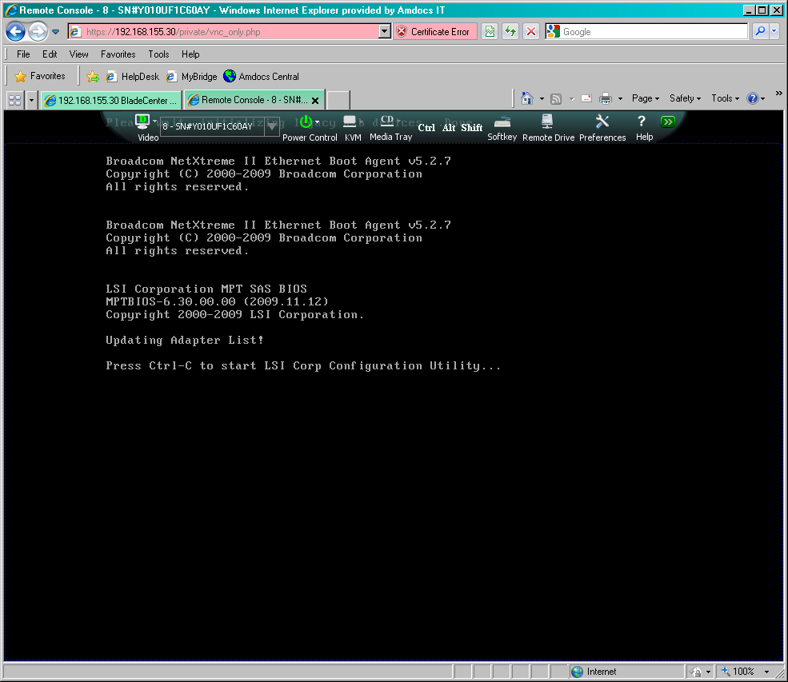

### Select SAS1064 Adaptor

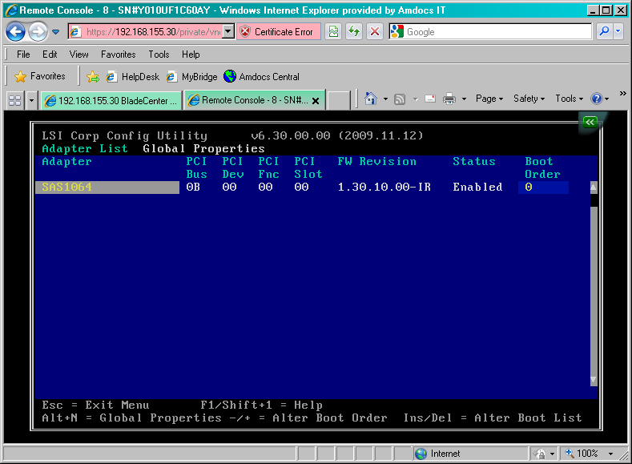

### Select RAID Properties

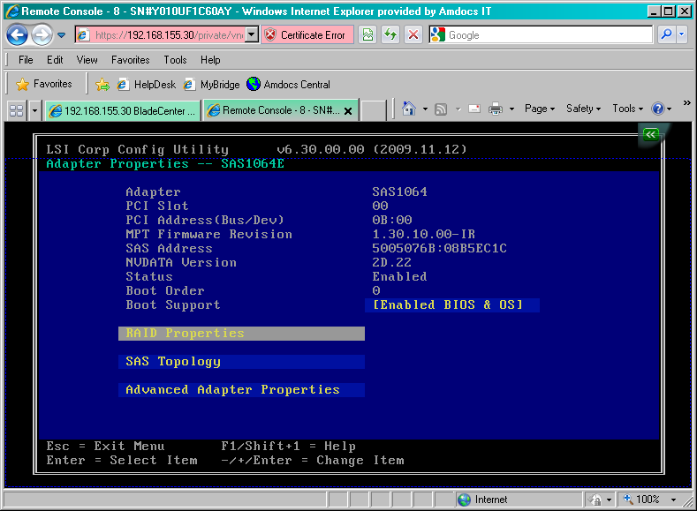

### Create Integrated Mirror Volume

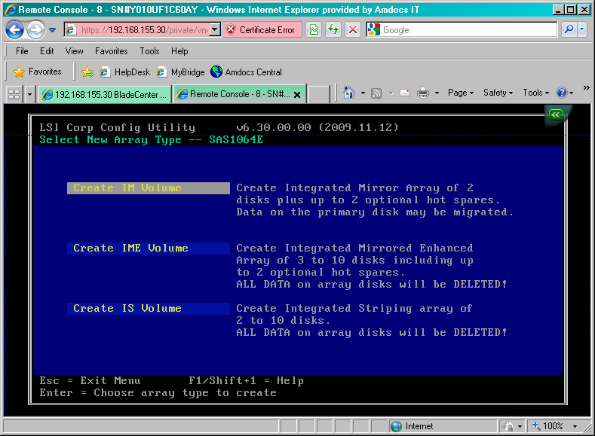

### Select Overwrite exiting data “D”

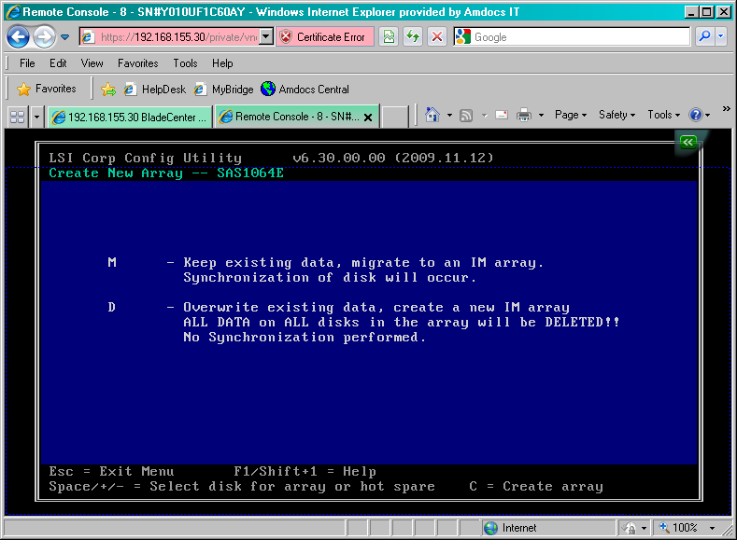

### Screen capture with both drives as part of RAID disk

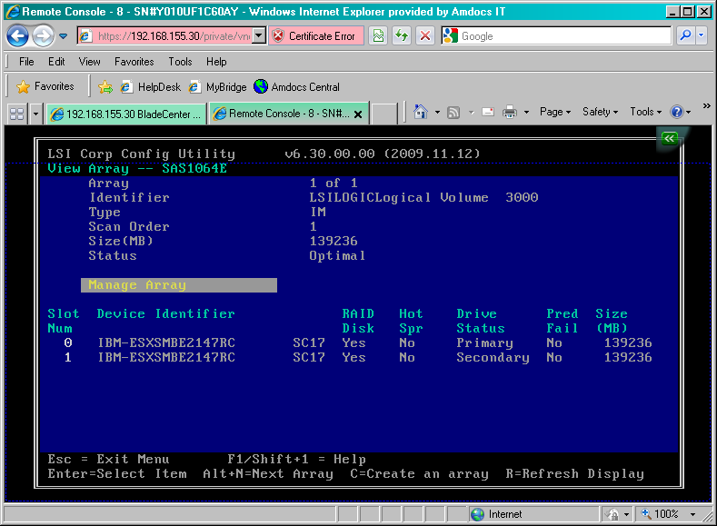

## Select boot device Screen captures

### Select <F12> to select boot device

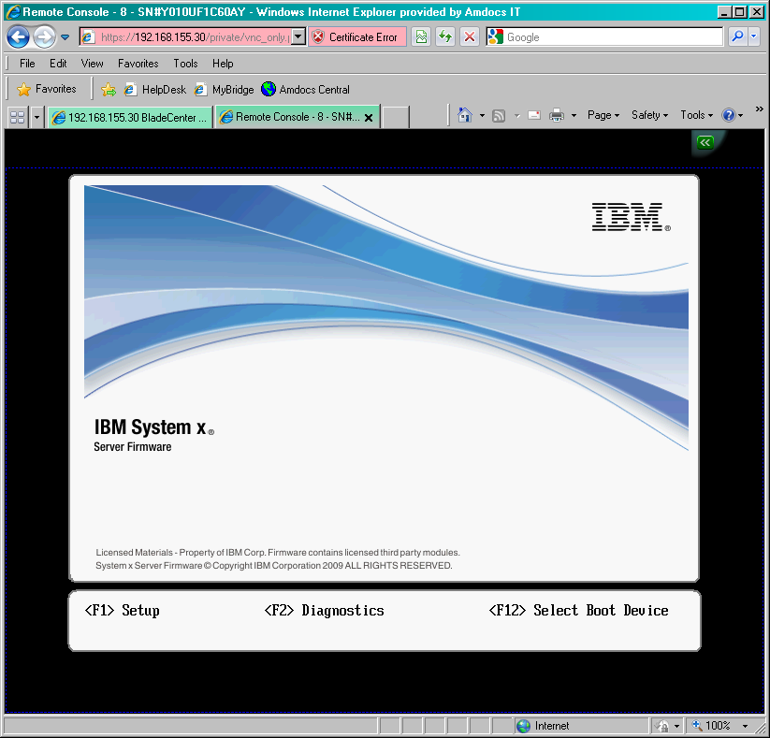

### Select PXE Network

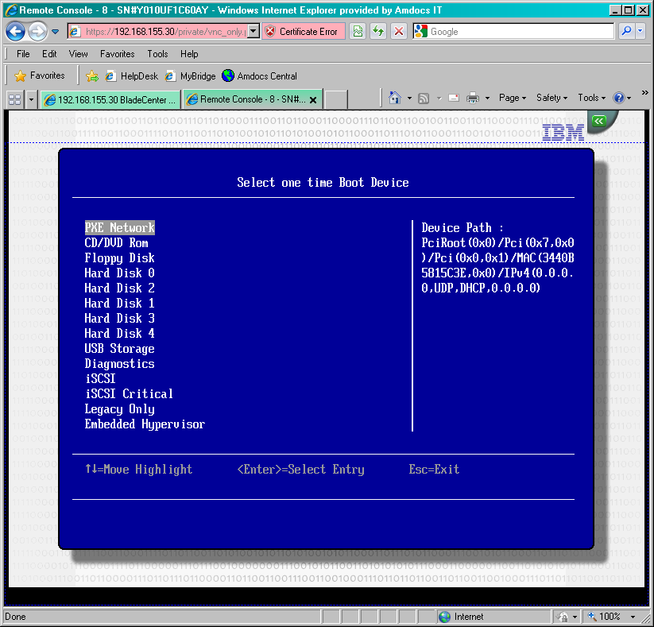

### Select yes to initialize the Disk

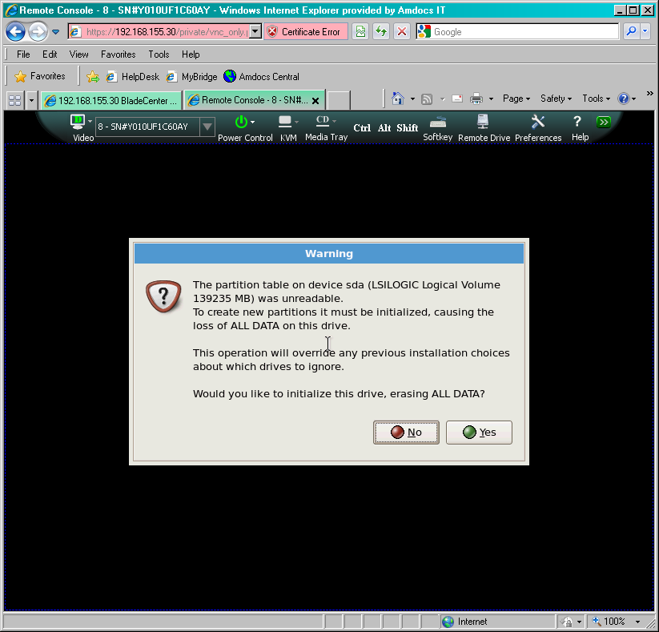

### Linux installed

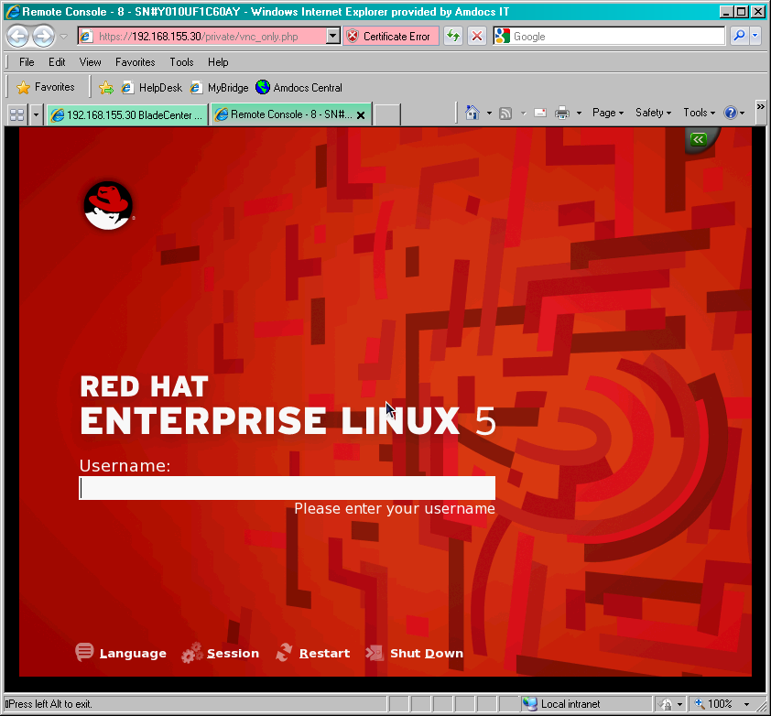

# APPENDIX D

## Backup file manifest.

*Table 1.0 PCRF backup manifest*

|  |
| --- |
| *Backup file manifest* |
| Parmdb files for all the the configured instances: |
| BPCapps-44RELv1_1-hga00a00013315.PCRF.parmdb  BPCsnmp-44RELv1-hga00a00012277.SNMP.parmdb  BPCttdb-44RELv1-hga00a00012277.TimesTen.parmdb |
| RMS rules for all configured projects |
| BPCapps-44RELv1_1-hga00a00013315.PCRF.RE.NetworkPolicy.zip  BPCapps-44RELv1_1-hga00a00013315.PCRF.RE.SessionRights.zip  BPCapps-44RELv1_1-hga00a00013315.PCRF.RE.TieredServices.zip |
| The BPC configuration directory /<ACTIVE_INSTANCE>/config/provserver/ |
| BPC.config.zip |
| Package versions for all the installed packages both at a system and application level |
| PackageVersions.010212.txt |
| Relevant system –level configs |
| /etc/sysconfig/network-scripts/ifcfg-eth0  /etc/sysconfig/network-scripts/ifcfg-eth1  /etc/sysconfig/network-scripts/ifcfg-eth2  /etc/sysconfig/network-scripts/ifcfg-eth3  /etc/network  /etc/modprobe.conf  /etc/hosts  /etc/syslog.conf  /etc/passwd  /etc/group  /etc/sysconfig/network-scripts/route- *  /etc/sysctl.conf  /etc/sysconfig/syslog  /etc/ntp.conf  /etc/sysconfig/selinux  /etc/yum.repos.d/*  NOTE to ADD:  log rotation stuff,  Timsezone / date stuff, |