**Title**

Recent fire severity is unprecedented compared to the previous four centuries in the Jemez Mountains, New Mexico

**Running Title**

*Running Title*

**Authors**

Jens T. Stevens 1*, Ellis Q. Margolis1, Jonathan D. Coop, Sean A. Parks, Calvin A. Farris, Craig D. Allen1

**Author Affiliations and Addresses**

1U.S. Geological Survey, New Mexico Landscapes Field Station, Santa Fe NM

**Keywords:** Keywords

**Acknowledgments**: Acknowledgments. This paper was written and prepared by US Government employees on official time, and therefore it is in the public domain and not subject to copyright. Any use of trade, firm, or product names is for descriptive purposes only and does not imply endorsement by the U.S. Government.

**Target Journal**: Landscape Ecology

**Abstract**

Abstract

**Introduction**

In North American forests where fire was frequent prior to the 20th century, contemporary fires are widely understood to have effects outside the range of historical variability (cite).

Here, we compared the observed pattern of **fire scar mortality** against a neutral landscape model of high-severity fire, simulated to reflect the observed distributions of stand-replacing patch sizes but not their observed locations on the landscape. We represented observed distributions of stand-replacing patch sizes using three high-severity fire models: A conservative **single-burn** estimate, an intermediate **multi-burn** estimate, and a cumulative **treeless** estimate, using different standardized remote sensing techniques. For a given high-severity fire model, we thus generated a null distribution of fire scar mortality by intersecting observed scar locations with simulated stand-replacing patches. We hypothesized that if the observed (nonrandom) sample of fire scars across the landscape represents **recurring fire refugia** compatible with observed contemporary fire severity, then the observed number of dead scarred trees (or dead tree clusters) should occur less than 5% of the time under a neutral landscape of high-severity fire, for a given true model of high-severity fire. If a neutral model failed to meet this criterion by killing fire scarred trees more than 5% of the time, then we adjusted the proportion of high-severity fire in the simulation downwards until the criterion was met. The proportion of high-severity fire that meets this criterion represents a putative upper boundary on historical high-severity fire, for the degree of patch aggregation represented by a given true model. Finally, we simulated recurring fire at a range of fire return intervals to generate a putative upper bound for proportion of high-severity fire on a 15-year return interval.

**Methods**

*Study site*

We integrated contemporary burn severity data with historical fire scar records within the eastern Jemez Mountains of northern New Mexico, USA (Figure 1). The eastern Jemez Mountains range in elevation from approximately 1600 m on their eastern boundary with the Rio Grande, to over 3000 m on the mountain peaks that comprise the rim of the Valles Caldera, created by a series of volcanic eruptions over 1 million years ago. Much of the eastern flank of the mountains is comprised of banded volcanic tuff formations deposited by these eruptions, sitting on top of basalt. Erosion of the tuff has created a series of deeply incised canyons and mesa tops, with topography generally sloping gradually except for canyon walls and fault scarps.

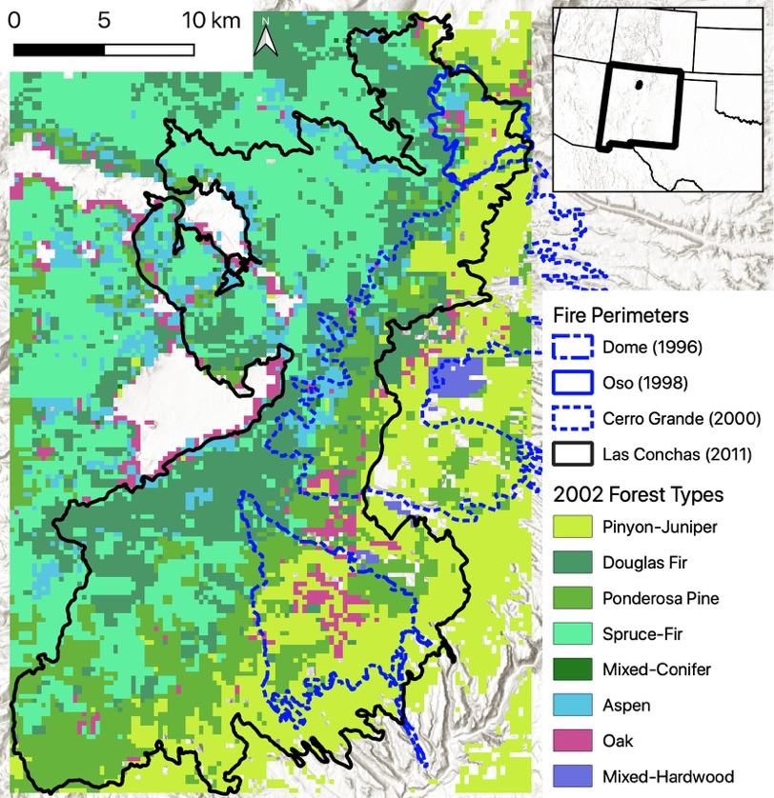

**Figure 1**: Map of the study area, with Las Conchas and treeless perimeter shown. Vegetation classification by USDA Forest Service (Ruefenacht et al. 2008) based on 2002 data.

The Las Conchas fire started on June ##, 2011, burning 61057 ha in total. The fire burned through different forest types, ranging from pinyon-juniper at lower elevations, to ponderosa pine and mixed-conifer (including Douglas-fir) at mid-elevations, to spruce-fir at the highest elevations (Figure 1). The Las Conchas fire burned partially or completely over the footprints of at least nine previous fires since 1977: La Mesa (1977), Dome (1996), Lummis (1997), Oso (1998), Unit 29 prescribed burn (1998), Unit 38 prescribed burn (1999), Cerro Grande (2000), San Miguel (2009) and South Fork (2010). The deforested landscape following Las Conchas therefore reflected the cumulative high-severity effects of these previous fires, even if the fire effects from Las Conchas itself did not register as high severity (see below). For our burn severity assessments (below), we examined satellite-derived burn severity metrics for the three prior fires that had substantial (> 10 ha) high-severity area: Dome, Oso, and Cerro Grande (Table 1). The La Mesa fire burned prior to standardized satellite mapping technology, and a reliable assessment of burn severity following this fire is not available, so we did not include this fire in the above list, although it is accounted for in the treeless model (below).

*Burn severity assessment*

There are a wide range of methods available for deriving contemporary vegetation burn severity. Rather than choose one a priori as the most accurate, we used three alternative models to represent the actual occurrence of stand-replacing patches (“high-severity models” or HSM). First, we calculated the predicted Composite Burn Index (CBIp) using a composite model of Relative Burn Ratio (RBR) and other satellite and topoclimatic variables following the methods of Parks et al. (2019), for the Las Conchas fire only (HSM1: single burn). Second, we calculated CBIp for the Dome, Oso and Cerro Grande fires, and used the cumulative high severity effects from these fires plus Las Conchas (HSM2: multi burn). High-severity fire was defined as CBIp >= 2.25 (Appendix 1). Third, we defined treeless areas from high-resolution (1m) postfire imagery (HSM3: treeless) following the methods of Walker et al. (2019). Each subsequent HSM predicts greater collective area of high-severity fire.

**Table 1**: Area of fire effects in the East Jemez, 1984-2011. High-severity area calculated for following the methods of Parks et al. 2019. Overlap refers to portions of three earlier fires that overlapped the Las Conchas fire perimeter.

|  |  |  |  |  |
| --- | --- | --- | --- | --- |
| fire | year | area | high severity area | proportion high severity |
| Las Conchas | 2011 | 61057 | 21834 | 0.36 |
| Cerro Grande | 2000 | 17919 | 6155 | 0.34 |
| Cerro overlap |  | 7799 | 2789 | 0.36 |
| Oso | 1998 | 2144 | 615 | 0.29 |
| Oso overlap |  | 1952 | 605 | 0.31 |
| Dome | 1996 | 6385 | 1249 | 0.2 |
| Dome overlap |  | 6320 | 1253 | 0.2 |

To compare contemporary fire patterns against historical fire evidence, we compiled a record of crossdated fire scars from within the footprint of the Las Conchas fire.

START HERE To simulate a range of possible historical (pree-1900) stand-replacing patch size distributions, we…

**Results**

Results

Table 2: Optimal parameters for neutral landscape models.

|  |  |  |  |
| --- | --- | --- | --- |
| High-severity fire model | Single burn | Multi burn | Treeless |
| Proportion high-severity (observed) |  |  |  |
| Proportion dead scarred trees |  |  |  |
| Number of dead scarred trees |  |  |  |
| False mortality |  |  |  |
| False survival |  |  |  |
| Classification error |  |  |  |
| Parameter 1 |  |  |  |
| Parameter 2 |  |  |  |
|  |  |  |  |
|  |  |  |  |
|  |  |  |  |
|  |  |  |  |

sdf

**Discussion**

Discussion

**References**:

**References**

Parks SA, Holsinger LM, Koontz MJ et al (2019) Giving ecological meaning to satellite-derived fire severity metrics across North American forests. Remote Sensing 11(14):1735

Ruefenacht B, Finco MV, Nelson MD et al (2008) Conterminous U.S. and Alaska forest type mapping using Forest Inventory and Analysis data. Photogrammetric Engineering & Remote Sensing 74(11):1379-1388

Walker RB, Coop JD, Downing WM, Krawchuk MA, Malone SL, Meigs GW (2019) How much forest persists through fire? High-resolution mapping of tree cover to characterize the abundance and spatial pattern of fire refugia across mosaics of burn severity. Forests 10(9):782