# Figure 1

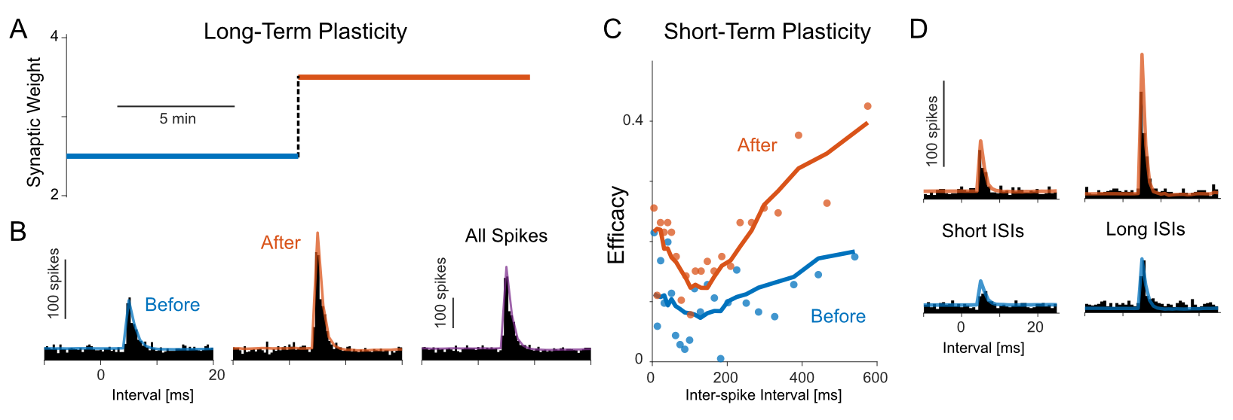

**Simulation Example of the generalized bilinear model (GBLM)**

**(A)** In this example the recording time is 20 min (T), and the simulated long-term plasticity (LTP) is step-changing at middle recording time (T/2). The change of LTP can be visualized by splitting the cross-correlogram, before and after T/2. **(B)** The cross-correlation between pre- and postsynaptic spiking is higher after T/2, which suggests a stronger coupling. **(C)** The simulated short-term plasticity (STP) can be viewed by plotting the efficacy of postsynaptic neuron against presynaptic inter-spike interval (ISI). Shorter presynaptic ISIs correspond to lower postsynaptic efficacies, which shows that the STP is depression here. The efficacy after T/2 consistently dominates the efficacy before T/2, and this shows abruptly increase of LTP after T/2. **(D)** By splitting cross-correlogram according to T and presynaptic ISI, we can show LTP and STP simultaneously. The cross-correlation is higher for later recording period (>T/2) and longer presynaptic ISIs (> median of simulated ISI).

# Figure 2

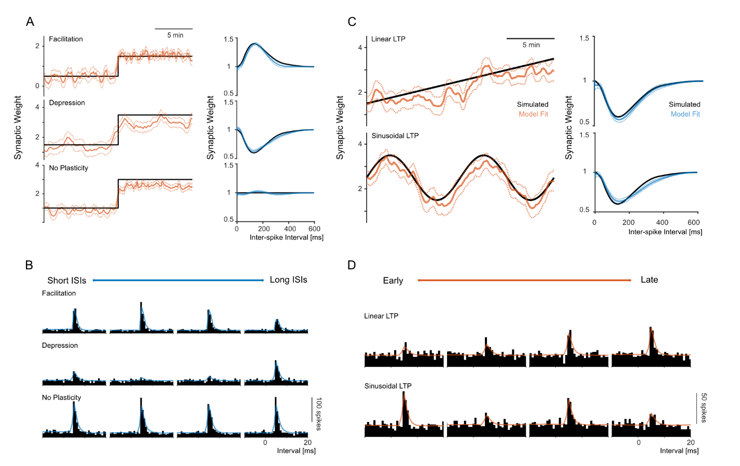

**Inference of different long- and short-term plasticity**

These plots show fitting results for different LTP (orange) and STP (blue). The STP is shown by modification function. The dashed lines show standard error from point estimations. The simulated recording time length is 20 min. **(A)** The fitting results under different types of STP, i.e. depression, facilitation and no STP. The postsynaptic baseline firing rates are constant and LTPs are step-changing at middle recording time. **(B)** Split cross-correlograms for quartiles of presynaptic ISIs show these STPs and fitted values. **(C)** The fitting results under different types of LTP, i.e. linear- and sinusoidal-changing. The postsynaptic baseline firing rates are constant and STPs are depression. **(D)** These two LTPs and fitted values can also be visualized by splitting cross-correlogram for quartiles of recording time.

# Figure 3

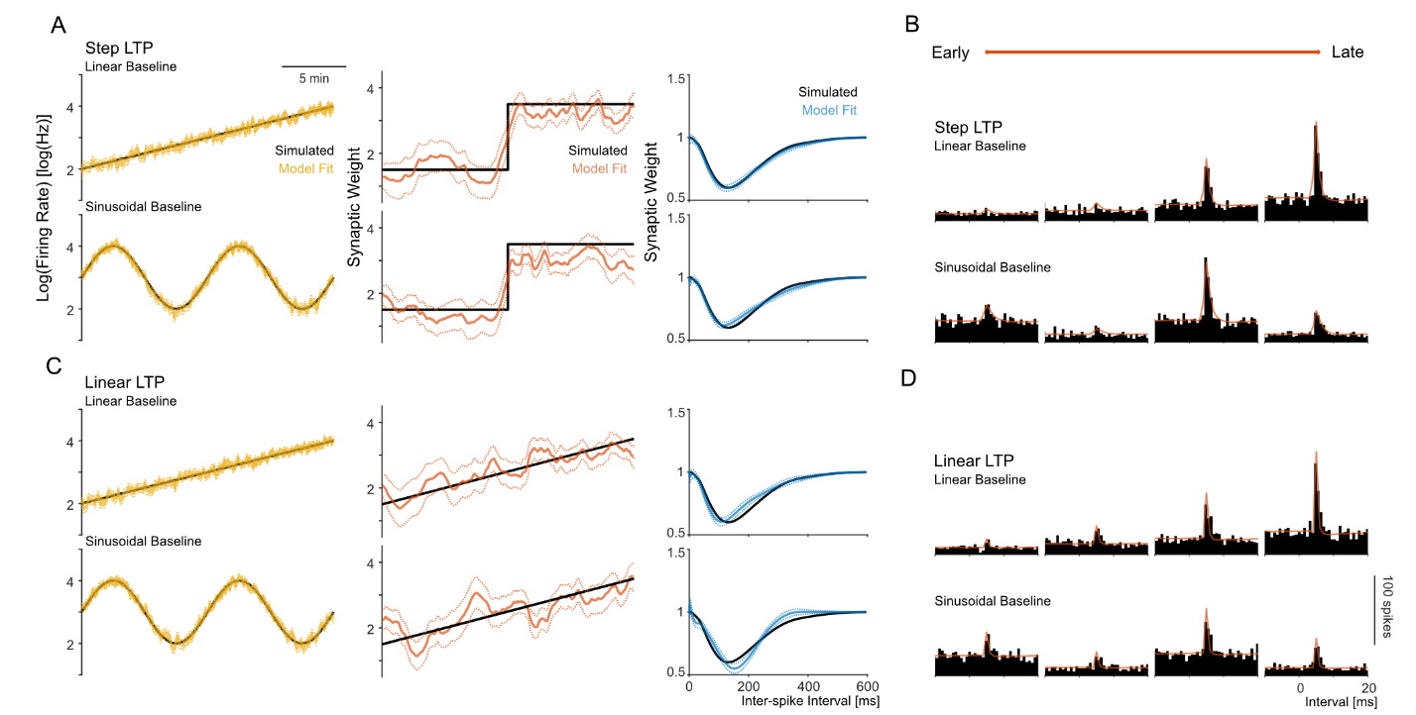

**Inference of different postsynaptic baseline firing rates**

These plots show fitting results of postsynaptic baseline firing rates (yellow). The STP is shown by modification function. The fitted values for LTP and STP are shown in orange and blue. The dashed lines show standard error from point estimations. The simulated recording time length is 20 min. **(A)** The fitting results under different types of baseline, i.e. linear- and sinusoidal-changing. The LTPs are step-changing at middle recording time and STPs are depression. **(C)** The same simulation settings as (A), except that the LTP changes linearly. **(B) and (D)** Split cross-correlograms for quartiles of recording time show dynamics of baseline and LTP.

# Figure 4

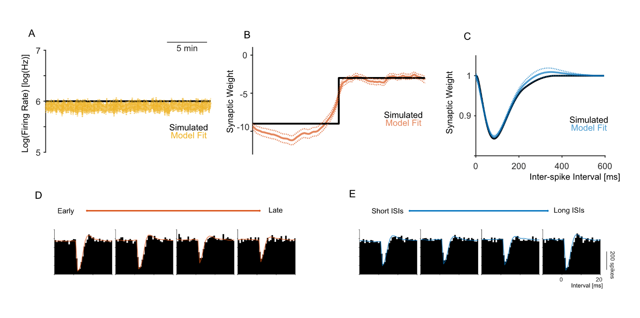

**Inference of inhibitory synapse**

These plots show one example for estimations on inhibitory synapse, and the STP is shown by modification function. In this example, the baseline firing rate is constant, the LTP jumps at mid-recording-time and STP is depression. The simulated values and data are plot in black, while the fitted values are plot in yellow for baseline, orange for LTP, and blue for STP. The dashed lines show standard error from point estimations. The simulated recording time length is 20 min. **(A), (B) and (C)** show fitted results for baseline, LTP and STP. By splitting cross-correlogram for quartiles of recording time **(D)** and presynaptic ISIs **(E)**, we can show corresponding LTP and STP.

# Figure 5

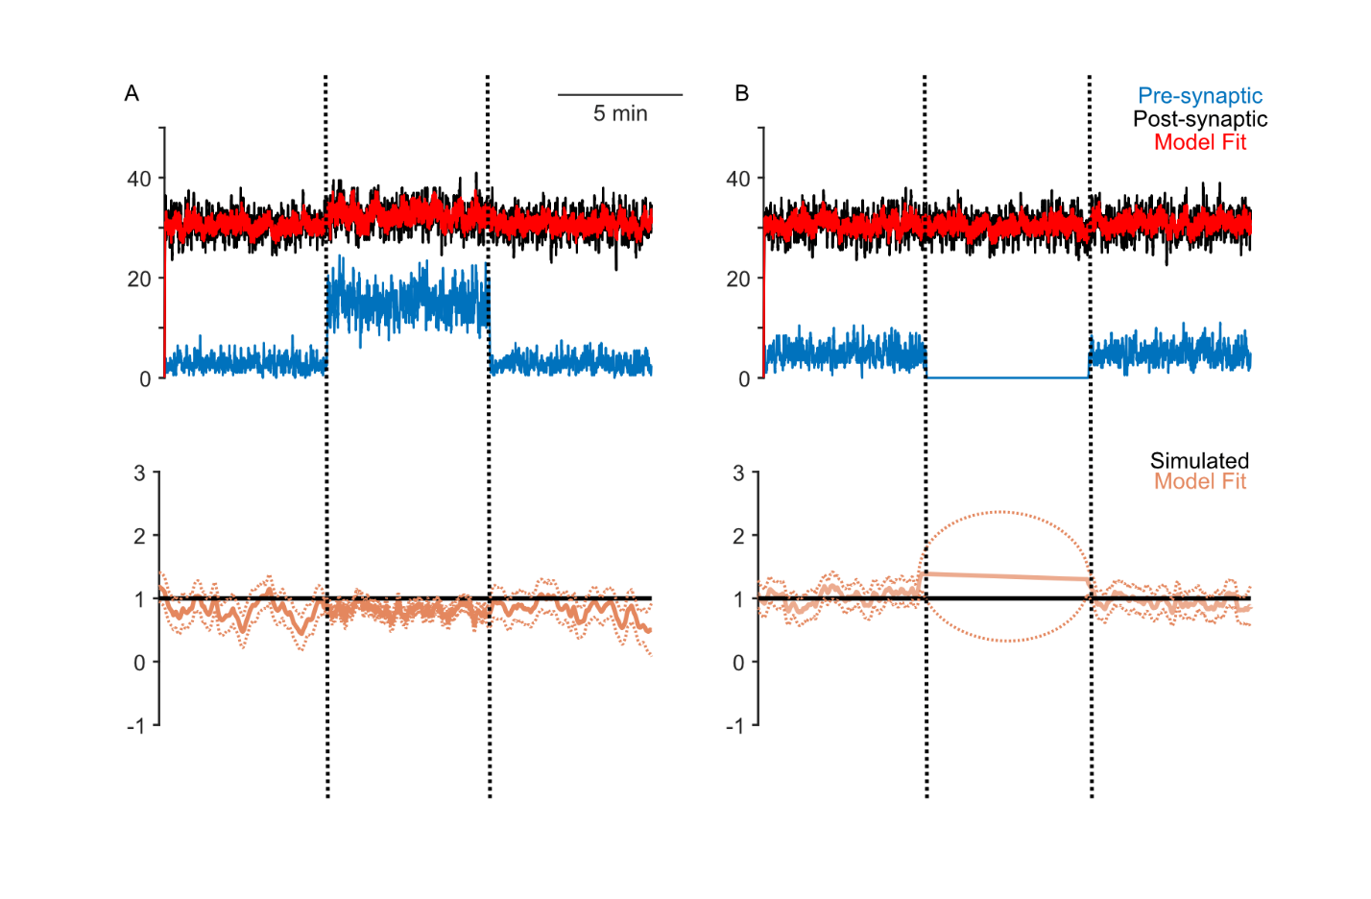

**Influence of presynaptic firing rates on LTP estimation**

In these two examples, the baseline firing rates and LTP are constant. The STP is facilitation to show more significant results. The simulated recording time length is 20 min. To show the influence of presynaptic firing rates, the recording time is divided into three parts evenly and different presynaptic firing rates are assigned to each part respectively. **(A)** In this simulation, the presynaptic firing rates are 3Hz in the first and third part, while it is set as 15Hz in the middle part. When the firing rate increase, the estimation of LTP is more accurate. **(B)** Now, the presynaptic firing rates are 5Hz in the first and third part, while there’s no presynaptic spikes in the middle. Lack of the presynaptic spikes leads to a variated LTP estimation. The variation in presynaptic firing rates will not influence estimation of baseline and STP a lot.

# Figure 6

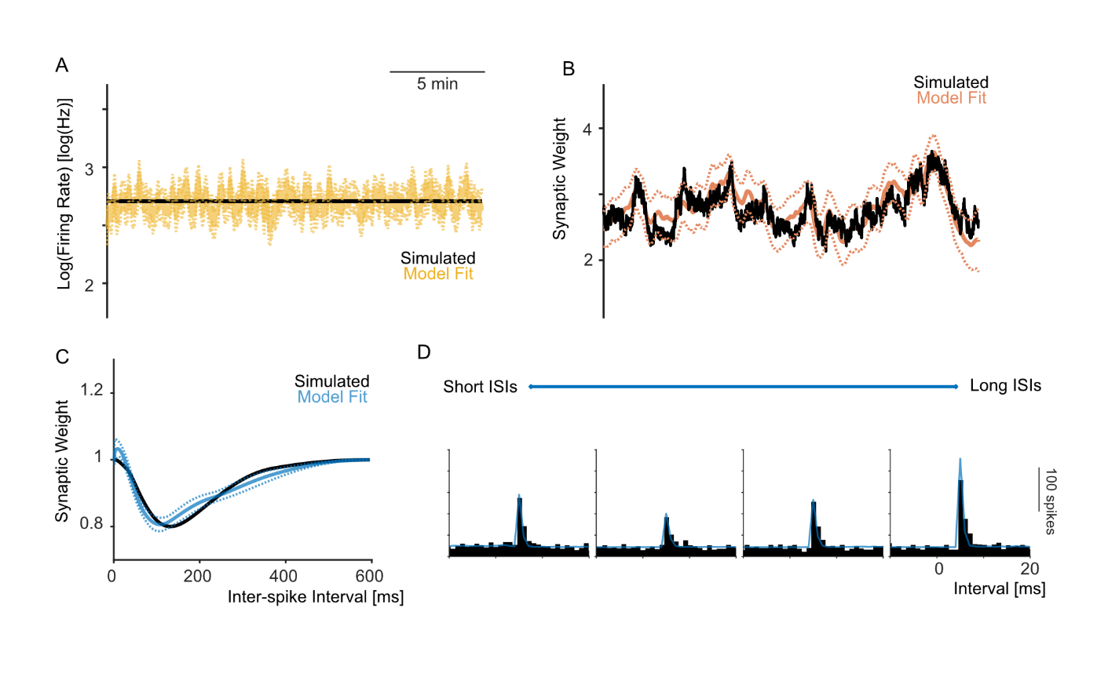

**Inference under STDP generated LTP**

These plots show one example with LTP generated by spike-timing dependent plasticity (STDP) model. The modification function for LTP in STDP model is a double-exponential function. The baseline is constant and STP is depression, and STP is shown by modification function. The simulated values and data are plot in black, while the fitted values are plot in yellow for baseline, orange for LTP, and blue for STP. The dashed lines show standard error from point estimations. The simulated recording time length is 20 min. **(A), (B) and (C)** show fitted results for baseline, LTP and STP. **(D)** The STP can be visualized by splitting cross-correlogram for quartiles of presynaptic ISIs.

# Figure 7

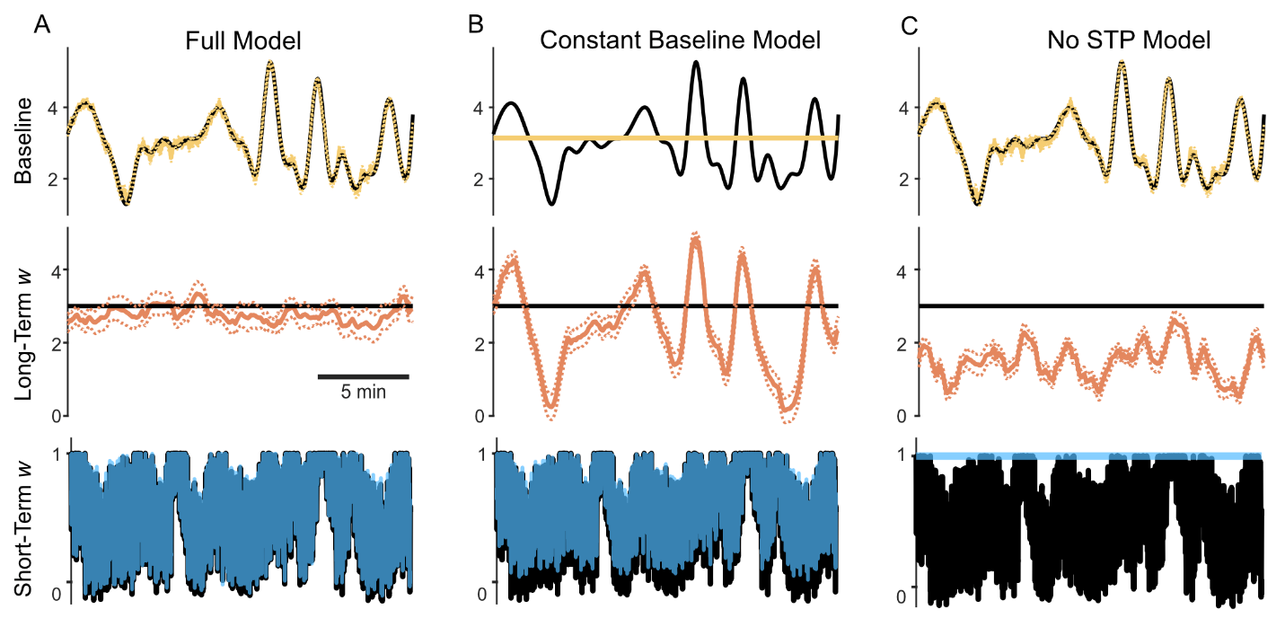

**Miss to estimate the baseline or STP causes spurious LTP estimations**

These plots show one example when missing estimations on baseline or STP. The postsynaptic baseline firing rate fluctuated around exp(3) = 20 Hz, and the presynaptic firing rate fluctuated around 8Hz. The simulated recording time length is 20 min, and STP is depression. The simulated values and data are plot in black, while the fitted values are plot in yellow for baseline, orange for LTP, and blue for STP. The dashed lines show standard error from point estimations. **(A)** Fitting results when all three effects (baseline, LTP and STP) are estimated simultaneously. **(B)** When we miss to estimate the baseline, the fluctuation in baseline will flow and enlarge in LTP estimation. **(C)** Similarly, the LTP estimation will capture STP fluctuation when we miss to estimate STP.

# Figure 8

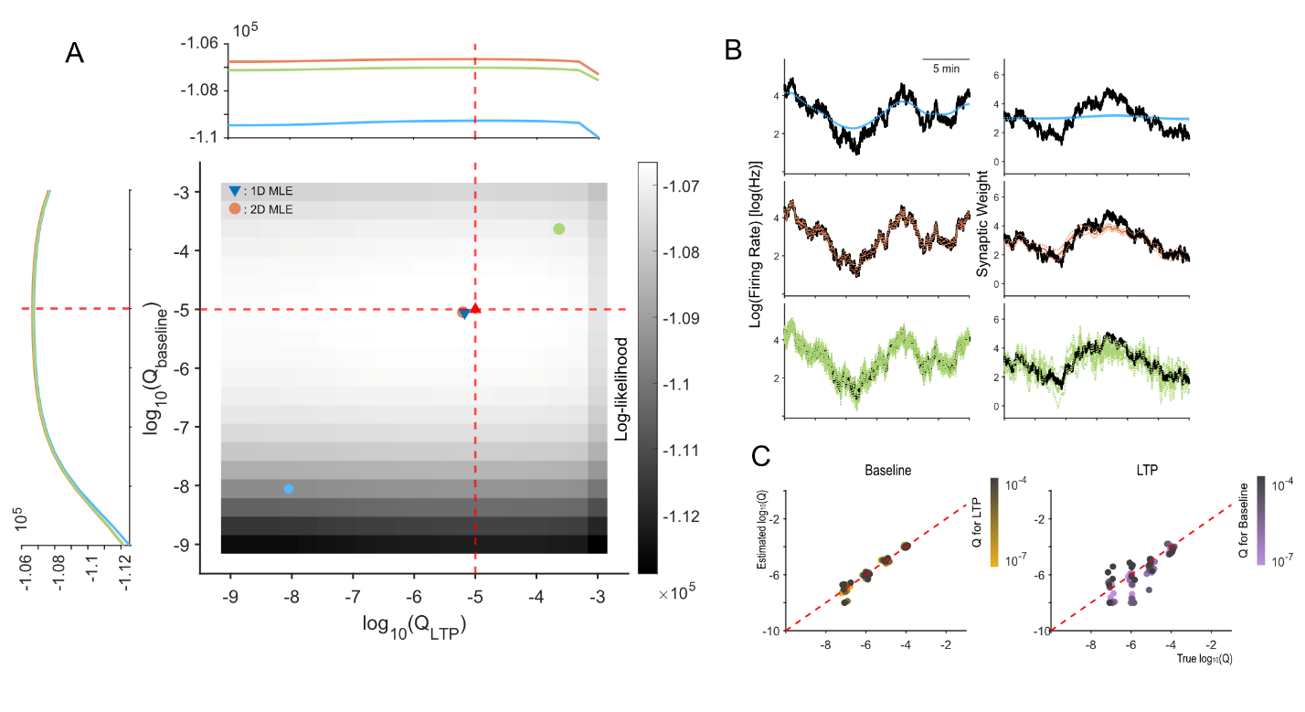

**Selection and influence of in point process adaptive smoothing**

**(A)** The heatmap shows prediction log-likelihood under different . The red upward-pointing triangle and dashed lines represent true . The orange dot represents the maximum prediction likelihood estimate (MLE) of . The blue dot is and the green dot is . The one-dimensional MLE is shown in blue downward-pointing triangle. The slices of prediction log-likelihood for LTP and baseline is shown around the heatmap. The simulated recording time length is 20 min. **(B)** Corresponding fitted baselines and LTPs, for , and . When is too small, the estimations are over-smoothed; when is too large, the estimations are too noisy. **(C)** The performance of MLE (2D) under different combinations of true , shown by plotting MLE values against true values. Each combination has 5 replicates. The simulated recording time length are all 10 min.