Tugas IMPAL 2019

Analisis White Box Testing

Create Event

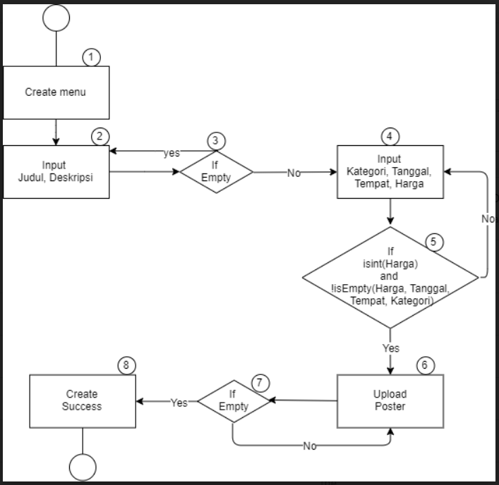

Create Event Cylomatic complexity:

1. 3+1 = 4
2. 1,2,3,4,5,6,7,8
3. 1,2,3,2,3,4,5,6,7,8
4. 1,2,3,4,5,4,5,6,7,8
5. 1,2,3,4,5,6,7,6,7,8
6. Test Case:

* X = ‘event1’, ‘Final Competition Programming Telkom 2020’, ‘Technology’, ‘24/06/2020’, ‘Telkom University Convention Hall’, “”, 540000, Post.img
* Path: 1,2,3,4,5,4,5,6,7,8

Edit Event

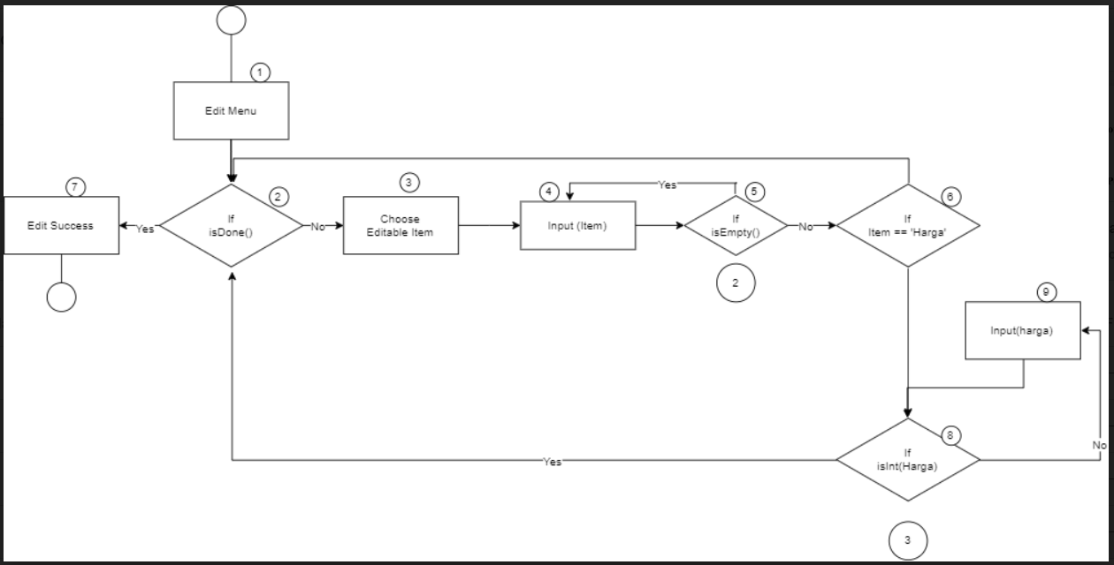

Create Event Cylomatic complexity:

1. 4+1 = 5
2. 1, 2,3, 4, 5, 6,2, 7
3. 1,2,3,4,5,4,5,6,2,7
4. 1,2,3,4,5,4,5,6,8,2,7
5. 1,2,3,4,5,6,8,9,8,2,7
6. 1,2,3,4,5,4,5,6,8,9,8,2,7
7. Test Case:

* X = Harga(), “”,Harga(), “Abjad”, 320000
* Path = 1,2,3,4,5,4,5,6,8,9,8,2,7

Delete event

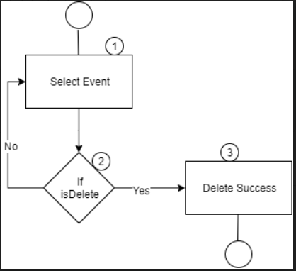

Delete Event Cylomatic complexity:

1. 1+1 = 2
2. 1,2,3
3. 1,2,1,2,3

b. Test Case:

* X = Event(‘event1’), Delete(), ‘No’, Event(event2), Delete(), ‘Yes’
* Path: 1,2,1,2,3