Linear mixed models for repeated measurements

Inhoud

0: data in long format 1

1: Spaghetti plots 2

2 Mixed model for repeated measures analysis 6

3 Model fit checking 6

# 0: data in long format

If data in wide format, set it to long format.

Look on the internet e.g.:

<https://www.youtube.com/watch?v=avInSDUTs_c>

<https://kb.iu.edu/d/bbqj>

For the rest we assume that we got the following variables:

* A subject identifier
* A time variable (can be continuous and not equally spaced)
* An observed outcome
* Possibly other variables used to model data (baseline covariates, treatment arm, ...)

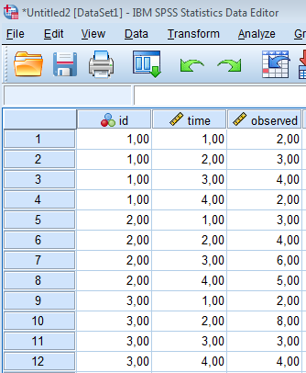

It helps if the measurement scale is set to nominal for “id”:

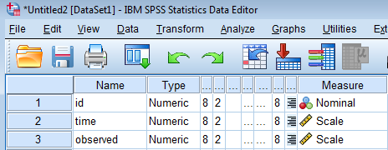

# 1: Spaghetti plots

To get to know the data, we make spaghetti plots

Graphs> Chart builder> OK

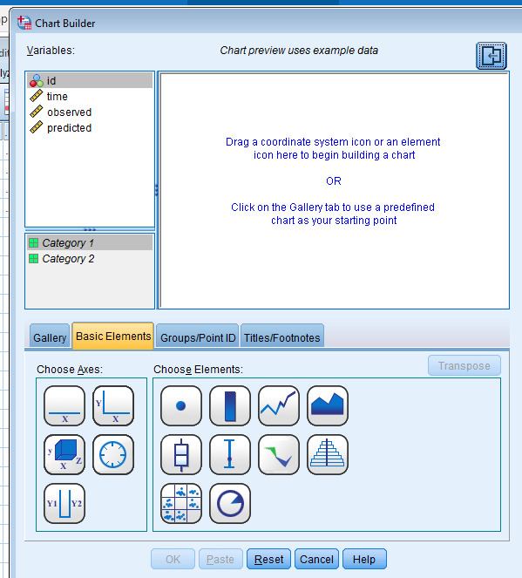

Choose axis: Y-X by drawing it into the empty field.

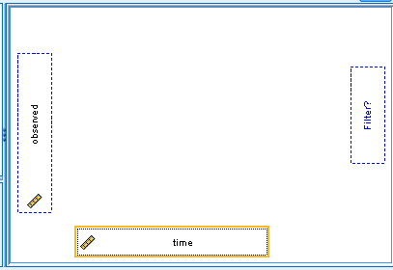

Choose the line element and draw it into the graph area

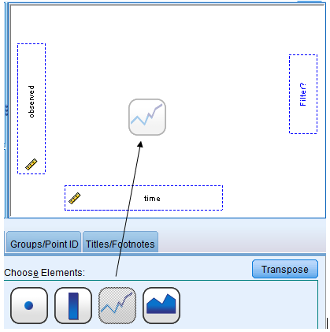

Choose the “value” as statistic to display.

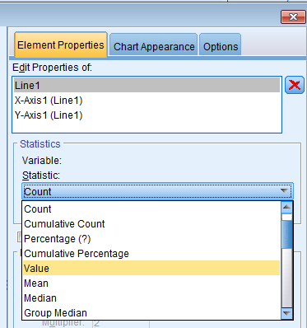

Choose Groups/Points ID > check “groupings/stacking variable” (or another option) and draw “id” into the graph area:

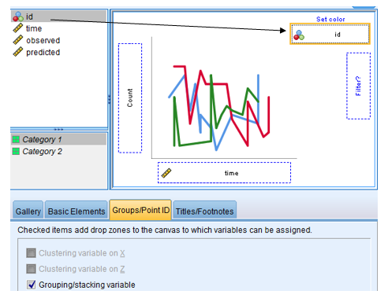

Also possible to set two arms next to each other: check the “colums panel variable” (for example):

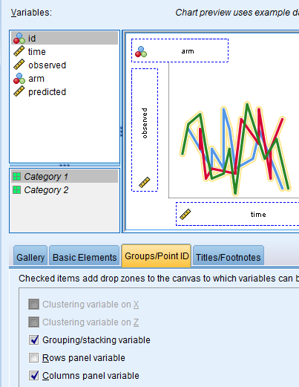

Axis options can be set as well.

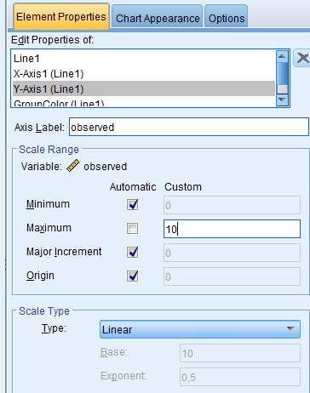

Final analysis code (paste the syntax)

* Chart Builder.

GGRAPH

/GRAPHDATASET NAME="graphdataset" VARIABLES=time observed id MISSING=LISTWISE REPORTMISSING=NO

/GRAPHSPEC SOURCE=INLINE.

BEGIN GPL

SOURCE: s=userSource(id("graphdataset"))

DATA: time=col(source(s), name("time"))

DATA: observed=col(source(s), name("observed"))

DATA: id=col(source(s), name("id"), unit.category())

GUIDE: axis(dim(2), label("observed"))

GUIDE: legend(aesthetic(aesthetic.color.interior), label("id"))

SCALE: linear(dim(2), max(10))

ELEMENT: line(position(time*observed), color.interior(id), missing.wings())

END GPL

Google or see also:

<http://www.floppybunny.org/robin/web/virtualclassroom/stats/statistics2/repeated_measures_1_spss_lmm_intro.pdf>

<http://www.floppybunny.org/robin/web/virtualclassroom/stats/statistics2/lmm_3_beatblues.pdf>

# 2 Mixed model for repeated measures analysis

Choose according to design and spaghetti plots a suitable model

Save also the residuals and the predicted values

# 3 Model fit checking

We assume that the residual and predicted values are stored in variables

## Residual plots:

scatter plot of residuals (y-axis) against predicted values (x-axis)

Choose axes: Y-X

Define the X-axis:

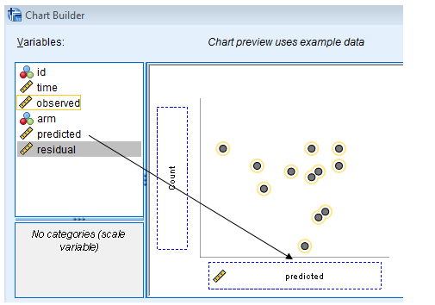

Choose elements, define the y-axis and set the statistic:

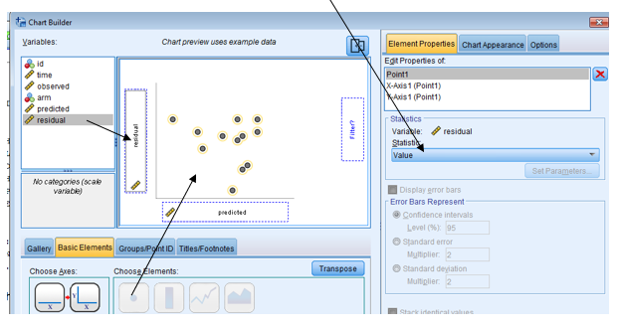

Look at all the residuals (no split file) but also in subgroups:

Data> split file

Can have a look at the residuals overall and per subgroups ( e.g. subject, or treatment arm, etc)

## Observed vs predicted plots

Data> Split file to split by subject.

Chartbuilder:

Choose axes: Y1-Y2 and define the x-axi

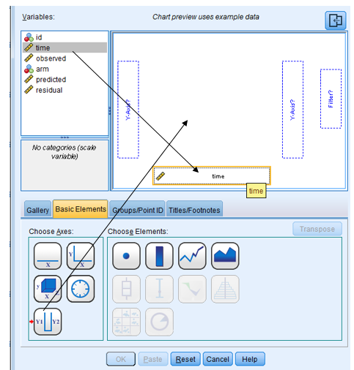

Choose elements for the left axis, set the statistic and define the axis

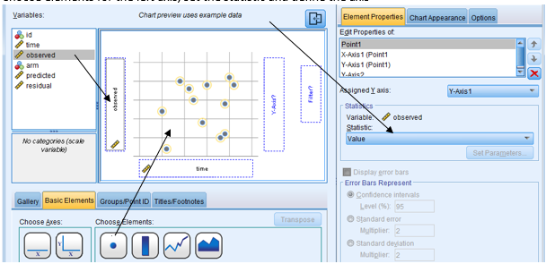

Choose element for the right axis, edit the properties and set the statistic to value, and define the axis

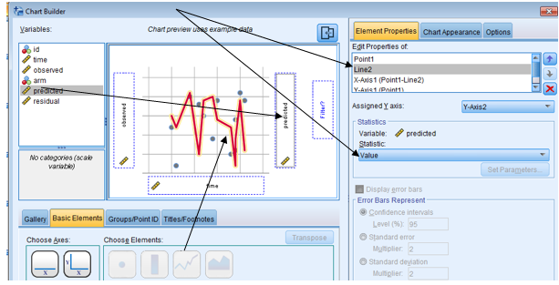

SORT CASES BY id.

SPLIT FILE SEPARATE BY id.

* Chart Builder.

GGRAPH

/GRAPHDATASET NAME="graphdataset" VARIABLES=time observed predicted MISSING=LISTWISE

REPORTMISSING=NO

/GRAPHSPEC SOURCE=INLINE.

BEGIN GPL

SOURCE: s=userSource(id("graphdataset"))

DATA: time=col(source(s), name("time"))

DATA: observed=col(source(s), name("observed"))

DATA: predicted=col(source(s), name("predicted"))

GUIDE: axis(scale(y1), label("observed"), color(color."5596E6"))

GUIDE: axis(scale(y2), label("predicted"), color(color."D70033"), opposite())

SCALE: y1 = linear(dim(2))

SCALE: y2 = linear(dim(2))

ELEMENT: point(position(time*observed), color.interior(color."5596E6"), scale(y1))

ELEMENT: line(position(time*predicted), missing.wings(), color.interior(color."D70033"),

scale(y2))

END GPL.