Interrupted time series analysis and N=1 trials in SPSS

This is adapted from: [https://www.researchgate.net/profile/Paul-Louangrath/post/Can_we_use_interrupted_time_series_design/attachment/59d63304c49f478072ea1eac/AS%3A273638895357952%401442252005126/download/21+Interrupted+time+series+analyses+2013+08+12.pdf](https://www.google.com/url?sa=i&rct=j&q=&esrc=s&source=web&cd=&cad=rja&uact=8&ved=0CAQQw7AJahcKEwjwtvbz3Lj9AhUAAAAAHQAAAAAQAg&url=https%3A%2F%2Fwww.researchgate.net%2Fprofile%2FPaul-Louangrath%2Fpost%2FCan_we_use_interrupted_time_series_design%2Fattachment%2F59d63304c49f478072ea1eac%2FAS%253A273638895357952%25401442252005126%2Fdownload%2F21%2BInterrupted%2Btime%2Bseries%2Banalyses%2B2013%2B08%2B12.pdf&psig=AOvVaw0Eh_gRj2-i-HN_DbFJclpn&ust=1677691127233319)

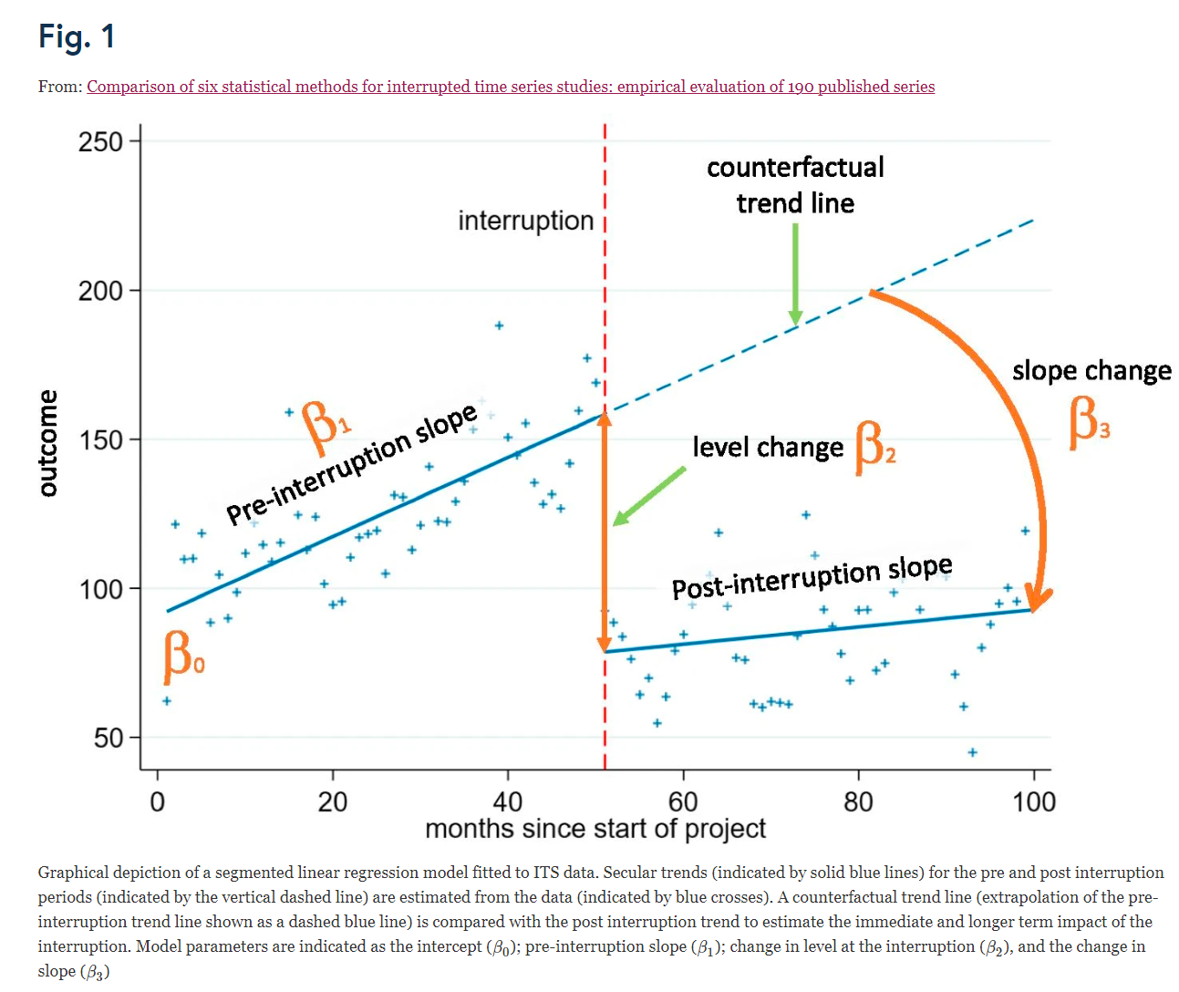

(source: https://bmcmedresmethodol.biomedcentral.com/articles/10.1186/s12874-021-01306-w/figures/1)

Limitations/assumptions:

* The below describes **linear autoregression without correction for seasonal effects but allows for a (linear) time trend.**

# ITS

## Data ITS

The following data gives easier interpretations later on::

|  |  |  |  |  |  |
| --- | --- | --- | --- | --- | --- |
| Outcome | period | Intervention1  _levelchange | Intervention1  _slopechange | Intervention2  _levelchange | Intervention2  _slopechange |
| 1742 | 1 | 0 | 0 | 0 | 0 |
| 1651 | 2 | 0 | 0 | 0 | 0 |
| 1543 | 3 | 0 | 0 | 0 | 0 |
| 1447 | 4 | 0 | 0 | 0 | 0 |
| 1306 | 5 | 0 | 0 | 0 | 0 |
| 1083 | 6 | 1 | 0 | 0 | 0 |
| 1092 | 7 | 1 | 1 | 0 | 0 |
| 970 | 8 | 1 | 2 | 0 | 0 |
| 839 | 9 | 1 | 3 | 0 | 0 |
| 724 | 10 | 1 | 4 | 0 | 0 |
| 678 | 11 | 1 | 5 | 0 | 0 |
| 694 | 12 | 1 | 6 | 0 | 0 |
| 509 | 13 | 1 | 7 | 0 | 0 |
| 433 | 14 | 1 | 8 | 1 | 0 |
| 390 | 15 | 1 | 9 | 1 | 1 |
| 356 | 16 | 1 | 10 | 1 | 2 |
| 310 | 17 | 1 | 11 | 1 | 3 |
| 280 | 18 | 1 | 12 | 1 | 4 |
| 270 | 19 | 1 | 13 | 1 | 5 |
| 250 | 20 | 1 | 14 | 1 | 6 |
| 230 | 21 | 1 | 15 | 1 | 7 |

that is:

* intervention1_levelchange indicates whether intervention 1 is “on” (here: starting from period 6).
* intervention1_slopechange= period - 6 is the time since start of intervention 1. In particular, it is 0 in the period when the intervention 1 starts.
* intervention2_levelchange indicates whether intervention 2 is “on” (here: starting from period 14).
* intervention1_slopechange= period -14 is the time since start of intervention 2. In particular, it is 0 in the period when the intervention 2 starts.

## Terms in the regression model

In terms of Figure 1 and additional terms for intervention 2, we have:

* the coefficient for period allows estimation of and correction for a linear time trend (if period is a continuous variable).

## Analysing data (using SPSS/PASW Statistics)

1. Click on ‘Analyse’ and chose ‘Forecasting’ from the first drop down menu and ‘Createmodels’ from the second.

2. Put ‘Outcome’, i.e. the raw data, as the dependent variable, and ‘period, ‘intervention1_levelchange’, ‘intervention1_slopechange’, ‘intervention2_levelchange’, ‘intervention2_slopechange’ as the independent variables in the analysis.

3. Choose ‘ARIMA’ from the methods drop down menu. Click on ‘Criteria’ and set the nonseasonal autoregressive (p) as 1. Click on ‘continue’.

4. Click on ‘Statistics’ and tick box under ‘Statistics for individual models’ to presentparameter estimates.

5. Click on ‘Save’ and tick box for ‘Predicted values’ to save predicted values to data file. Clickon ‘okay’

**What do your results tell you?**

Skip the first three tables (‘Model description’, ’Model Fit’ and ‘Model Statistics’), and go theone labelled ‘ARIMA Model Parameters

* The coefficient for ‘period’ is the slope in the time series before intervention 1 occurs (“pre interruption slope in Figure 1);
* the coefficient for intercept is the value in the first period ( in Figure 1).
* The coefficient for ‘intervention1_levelchange’ is the jump that occurs when intervention 1 kicks in (in Figure 1).
* The coefficient for ‘intervention1_slopechange’ is the change in slope, i.e., the slope during (only) intervention 1 minus the slope before intervention 1. ( in Figure 1).
* The coefficient for ‘intervention2_levelchange’ is the jump that occurs when intervention 2 kicks in. This is a level change between the time series during intervention 1 and the time series during intervention 2
* The coefficient for ‘intervention2_slopechange’ is the change in slope due to adding intervention 2 on top of intervention 1, i.e., the slope during intervention 2 (on top of intervention 1) minus the slope during only intervention 1.

Remarks

* the Forecasting module SPSS can handle more types of time series (e.g. with seasonal effects, more lags in the time series), but these are not treated here.

# N=1 trial

## Data N=1 trial

Special case:

* For one experimental vs a control condition.
* Difference in average level
* No estimation of and adjustment for carry-over effects, i.e. the difference between average outcome during intervention periods and control periods inclusive possible changes in those levels due to carry-over.

|  |  |  |
| --- | --- | --- |
| Outcome | period | Intervention1  _levelchange |
| 1742 | 1 | 0 |
| 1651 | 2 | 0 |
| 1543 | 3 | 0 |
| 1447 | 4 | 0 |
| 1306 | 5 | 0 |
| 1083 | 6 | 1 |
| 1092 | 7 | 1 |
| 970 | 8 | 1 |
| 839 | 9 | 1 |
| 724 | 10 | 1 |
| 678 | 11 | 1 |
| 694 | 12 | 0 |
| 509 | 13 | 0 |
| 433 | 14 | 0 |
| 390 | 15 | 0 |
| 356 | 16 | 0 |
| 310 | 17 | 1 |
| 280 | 18 | 1 |
| 270 | 19 | 1 |
| 250 | 20 | 1 |
| 230 | 21 | 1 |
| .. | .. | .. |

that is:

* intervention1_levelchange indicates whether intervention 1 is “on” (here: starting from period 6 and switching back in period 17).

## Terms in the regression model

## Analysing data (using SPSS/PASW Statistics)

Same as for the ITS.