Interrupted time series analysis in SPSS

One intervention in the interrupted time series

This is adapted from: https://www.researchgate.net/profile/Paul-Louangrath/post/Can_we_use_interrupted_time_series_design/attachment/59d63304c49f478072ea1eac/AS%3A273638895357952%401442252005126/download/21+Interrupted+time+series+analyses+2013+08+12.pdf

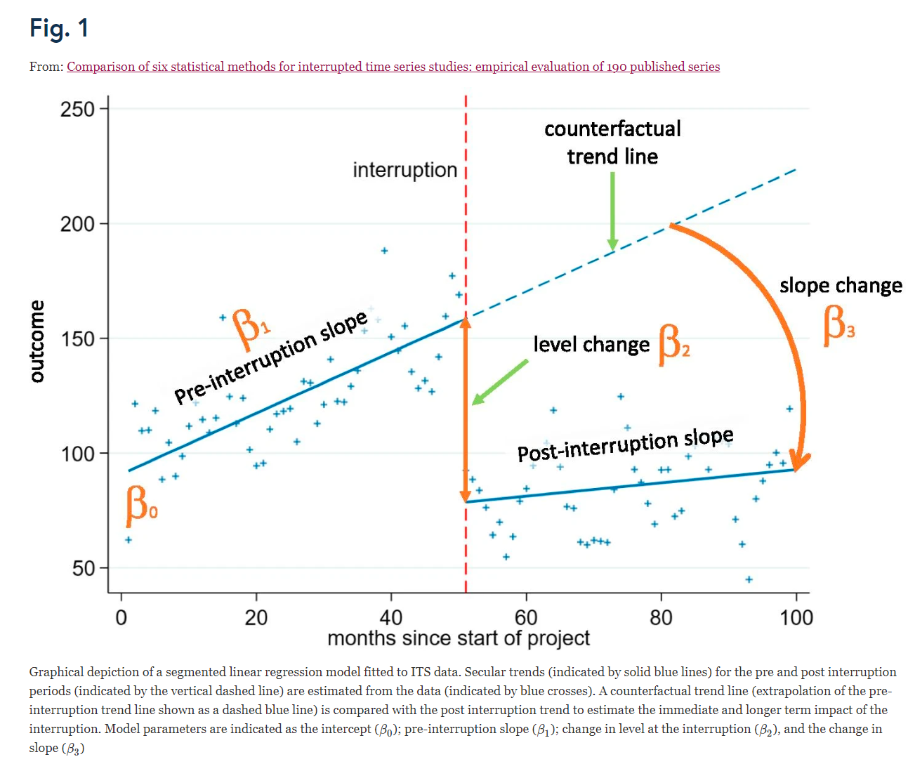
(source: https://bmcmedresmethodol.biomedcentral.com/articles/10.1186/s12874-021-01306-w/figures/1)

Below describes linear autoregression without correction for seasonal effects.

Data

The following data gives easier interpretations later on::

Outcome | period | Intervention1  _levelchange | Intervention1  _slopechange
1742 | 1 | 0 | 0
1651 | 2 | 0 | 0
1543 | 3 | 0 | 0
1447 | 4 | 0 | 0
1306 | 5 | 0 | 0
1083 | 6 | 1 | 0
1092 | 7 | 1 | 1
970 | 8 | 1 | 2
839 | 9 | 1 | 3
724 | 10 | 1 | 4
678 | 11 | 1 | 5
694 | 12 | 1 | 6
509 | 13 | 1 | 7
433 | 14 | 1 | 8
390 | 15 | 1 | 9
356 | 16 | 1 | 10
310 | 17 | 1 | 11
280 | 18 | 1 | 12
270 | 19 | 1 | 13
250 | 20 | 1 | 14
230 | 21 | 1 | 15

that is:
- intervention1_levelchange indicates whether intervention 1 is “on” (here: starting from period 6).
- intervention1_slopechange= period - 6 is the time since start of intervention 1. In particular, it is 0 in the period when the intervention 1 starts.

Suppose your data has at least a variable that gives the period where the transition took place (transition_intervention1=6). If this is not available, it can be made simply with
COMPUTE transition_intervention1=6.
EXECUTE.

Outcome | period | Transition_intervention1
1742 | 1 | 6
1651 | 2 | 6
1543 | 3 | 6
1447 | 4 | 6
1306 | 5 | 6
1083 | 6 | 6
1092 | 7 | 6
970 | 8 | 6
839 | 9 | 6
724 | 10 | 6
678 | 11 | 6
694 | 12 | 6
509 | 13 | 6
433 | 14 | 6
390 | 15 | 6
356 | 16 | 6
310 | 17 | 6
280 | 18 | 6
270 | 19 | 6
250 | 20 | 6
230 | 21 | 6

Then
- the variable intervention_levelchange can be made easily with:
COMPUTE intervention1_levelchange=0.
IF (period >= transition_intervention1) intervention1_levelchange=1.
EXECUTE.
- And the variable intervention1_levelchange can be made with
COMPUTE intervention1_slopechange=0.
IF (period >= transition_intervention1) intervention1_slope=period – transition_intervention1.
EXECUTE.

Terms in the regression model
In terms of Figure 1 and additional terms for intervention 2, we have:

$$outcome=β_{0}⋅1+β_{1}⋅period+β_{2}⋅Intervention1_{levelchange}+β_{3}⋅Intervention1_{slopechange}$$

Analysing data (using SPSS/PASW Statistics)
1. Click on ‘Analyse’ and chose ‘Forecasting’ from the first drop down menu and ‘Create (traditional)
models’ from the second. (Click OK if prompted for defining time periods etc).
2. Put ‘Outcome’, i.e. the raw data, as the dependent variable, and ‘period, ‘intervention1_levelchange’, ‘intervention1_slopechange’ as the independent variables in the analysis.
3. Choose ‘ARIMA’ from the “Method” drop down menu. Click on ‘Criteria’ and set the nonseasonal autoregressive (p) as 1. Click on ‘continue’.
4. Click on the ‘Statistics’ tab and check the box under ‘Statistics for individual models’ to present
parameter estimates.
5. Click on the ‘Save’ tab and tick box for ‘Predicted values’ to save predicted values to data file.
6. Click on the ‘Plots’ tab and check the box for ‘observed values’ and ‘fit values’.
7. Click on ‘okay’ (or ‘Paste’ if you want to keep the code).

What do your results tell you?
Skip the first three tables (‘Model description’, ’Model Fit’ and ‘Model Statistics’), and go the
one labelled ‘ARIMA Model Parameters

- The coefficient for ‘period’ is the slope in the time series before intervention 1 occurs (“pre interruption slope in Figure 1);
- the coefficient for intercept is the value in the first period ($β_{0}$ in Figure 1).
- The coefficient for ‘intervention1_levelchange’ is the jump that occurs when intervention 1 kicks in ($β_{2}$in Figure 1).
- The coefficient for ‘intervention1_slopechange’ is the change in slope, i.e., the slope during (only) intervention 1 minus the slope before intervention 1. ( $β_{3}$ in Figure 1).

Remarks
- the Forecasting module SPSS can handle more types of time series (e.g. with seasonal effects, more lags in the time series), but these are not treated here.

More than one intervention (cumulative) in the interrupted time series

Data

The following data gives easier interpretations later on::

Outcome | period | Intervention1  _levelchange | Intervention1  _slopechange | Intervention2  _levelchange | Intervention2  _slopechange
1742 | 1 | 0 | 0 | 0 | 0
1651 | 2 | 0 | 0 | 0 | 0
1543 | 3 | 0 | 0 | 0 | 0
1447 | 4 | 0 | 0 | 0 | 0
1306 | 5 | 0 | 0 | 0 | 0
1083 | 6 | 1 | 0 | 0 | 0
1092 | 7 | 1 | 1 | 0 | 0
970 | 8 | 1 | 2 | 0 | 0
839 | 9 | 1 | 3 | 0 | 0
724 | 10 | 1 | 4 | 0 | 0
678 | 11 | 1 | 5 | 0 | 0
694 | 12 | 1 | 6 | 0 | 0
509 | 13 | 1 | 7 | 0 | 0
433 | 14 | 1 | 8 | 1 | 0
390 | 15 | 1 | 9 | 1 | 1
356 | 16 | 1 | 10 | 1 | 2
310 | 17 | 1 | 11 | 1 | 3
280 | 18 | 1 | 12 | 1 | 4
270 | 19 | 1 | 13 | 1 | 5
250 | 20 | 1 | 14 | 1 | 6
230 | 21 | 1 | 15 | 1 | 7

that is:
- intervention1_levelchange indicates whether intervention 1 is “on” (here: starting from period 6).
- intervention1_slopechange= period - 6 is the time since start of intervention 1. In particular, it is 0 in the period when the intervention 1 starts.
- intervention2_levelchange indicates whether intervention 2 is “on” (here: starting from period 14).
- intervention1_slopechange= period -14 is the time since start of intervention 2. In particular, it is 0 in the period when the intervention 2 starts.

Terms in the regression model
In terms of Figure 1 and additional terms for intervention 2, we have:

$$outcome=β_{0}⋅1+β_{1}⋅period+β_{2}⋅Intervention1_{levelchange}+β_{3}⋅Intervention1_{slopechange}+β_{4}⋅Intervention2_{levelchange}+β_{5}⋅Intervention2_{slopechange}$$

Analysing data (using SPSS/PASW Statistics)
Same as for one intervention but

2. Put ‘Outcome’, i.e. the raw data, as the dependent variable, and ‘period, ‘intervention1_levelchange’, ‘intervention1_slopechange’, ‘intervention2_levelchange’, ‘intervention2_slopechange’ as the independent variables in the analysis.

What do your results tell you?
Skip the first three tables (‘Model description’, ’Model Fit’ and ‘Model Statistics’), and go the
one labelled ‘ARIMA Model Parameters

- The coefficient for ‘period’ is the slope in the time series before intervention 1 occurs (“pre interruption slope in Figure 1);
- the coefficient for intercept is the value in the first period ($β_{0}$ in Figure 1).
- The coefficient for ‘intervention1_levelchange’ is the jump that occurs when intervention 1 kicks in ($β_{2}$in Figure 1).
- The coefficient for ‘intervention1_slopechange’ is the change in slope, i.e., the slope during (only) intervention 1 minus the slope before intervention 1. ( $β_{3}$ in Figure 1).
- The coefficient for ‘intervention2_levelchange’ is the jump that occurs when intervention 2 kicks in. This is a level change between the time series during intervention 1 and the time series during intervention 2
- The coefficient for ‘intervention2_slopechange’ is the change in slope due to adding intervention 2 on top of intervention 1, i.e., the slope during intervention 2 (on top of intervention 1) minus the slope during only intervention 1.

Remarks
- the Forecasting module SPSS can handle more types of time series (e.g. with seasonal effects, more lags in the time series), but these are not treated here.

