* Download meta-xl at [MetaXL (epigear.com)](http://www.epigear.com/index_files/metaxl.html)
* Run installations with excel applications closed
* Launch excel, it should have a MetaXL menu button now

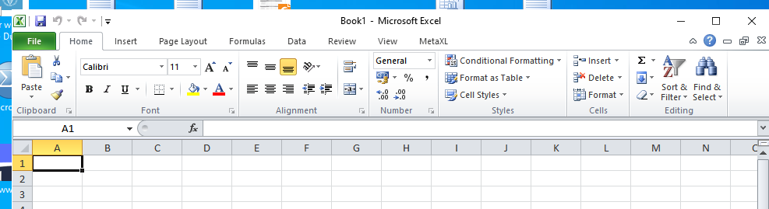

And clicking it open:

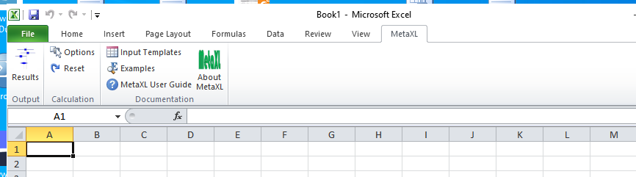

In an existing or new excel file, you can choose an input format (not per see needed but it shows how MetaXL needs the input):

Press “Input Templates” and choose from the option list (here we have hazard ratios),

then press “Copy”

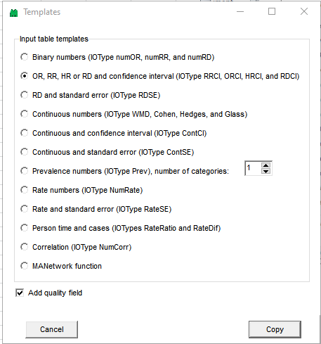

Set the cursor in one empty excel cell, and paste (control-V) or

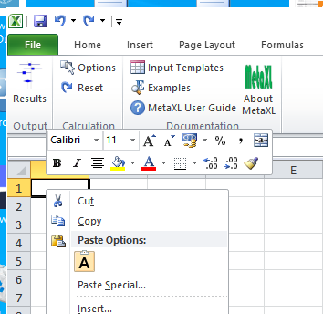

This gives, depending on your choice, columns in excel to fill in:

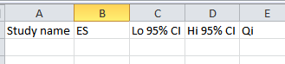

Fill these columns with the study names and their results,

Qi is a column for study quality, to additionally weight studies on quality (left blank here)

Note to use the right format for study name (character input), and ES, Lo 95% CI, Hi 95% CI

(so in this language settings a “ , “ denotes a decimal point)

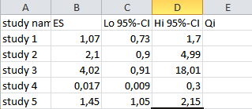

The meta-analysis and other calculations are now performed using excel formulas.

So select any empty cell in excel and put a relevant formula in that cell.

The easiest is to use the ‘insert function’ option

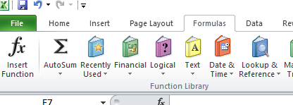

And then use the MetaXL menu and click “OK”

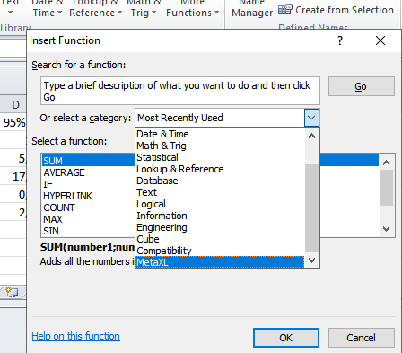

Then select the appropriate function. For data input we need MAInputTable,

Click “OK”

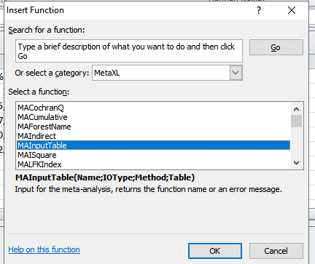

Then the menu helps to choose the right options

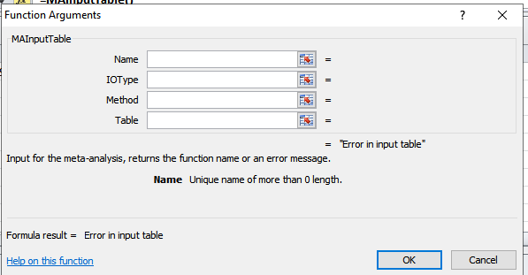

You can either type the input or use a cell (or range of cells to tell excel in which cell the input is)

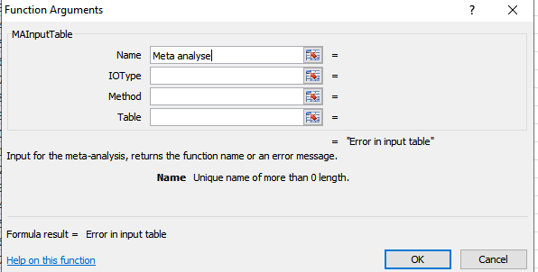

Gives for example

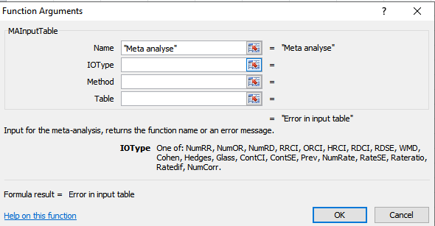

Here we have hazard ratios, so

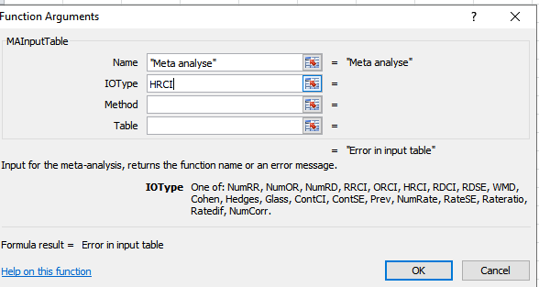

And we choose a random effects analysis so

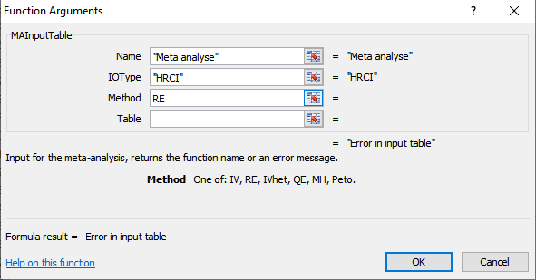

As last input, we need to specify the cells in which the input is:

That can be done by typing or by pressing 

and selecting the range of cells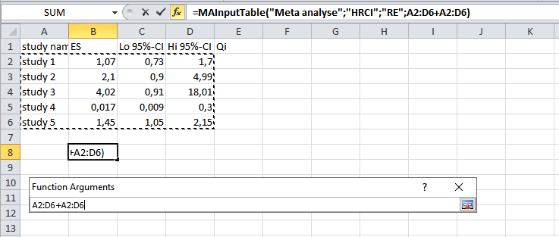And press

And then “OK”

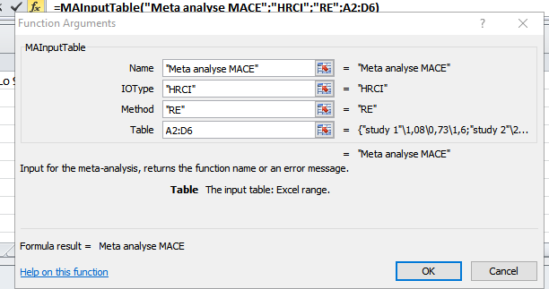

If all went well, the select cell shows the name you have chosen

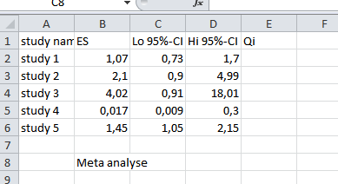

Note:

* More information on the choice of parameters for this function and other available functions can be found in the user guide

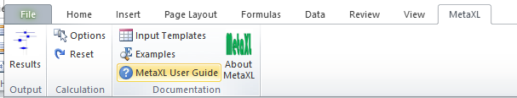

To get results, press the results option in the MetaXL menu.

This gives a forest plot, the weights of the studies, the overall meta-analysis average/estimate, and measure for how heterogeneous the studies are:

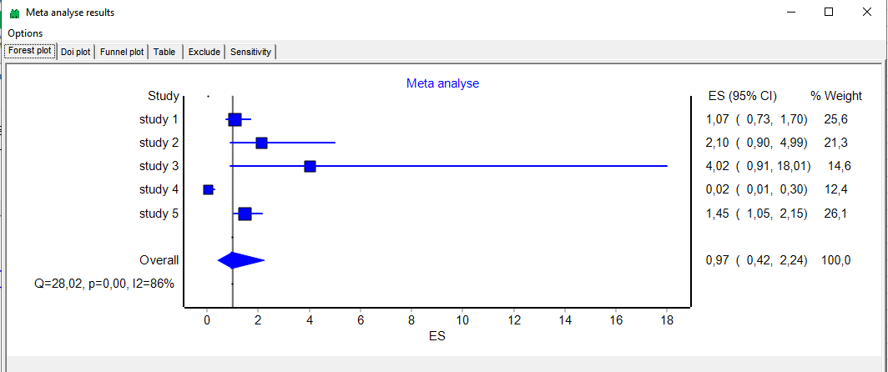

Nice options are to change “ES” in the x-axis:

Right click on the plot and choose “plot options”

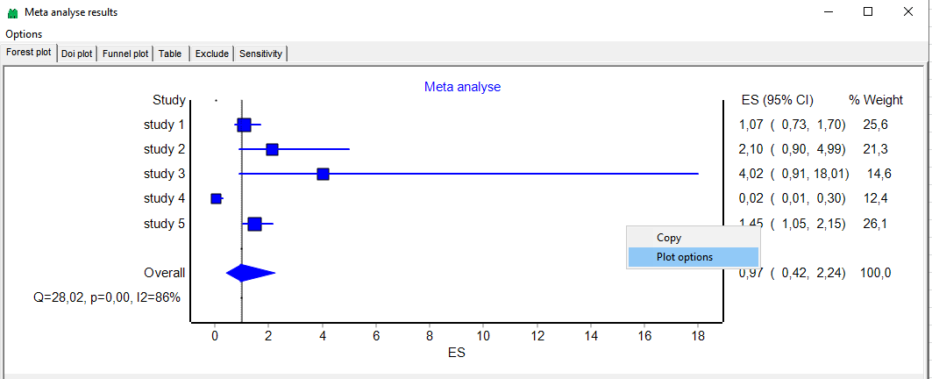

Here you can choose e.g. Hazard ratio:

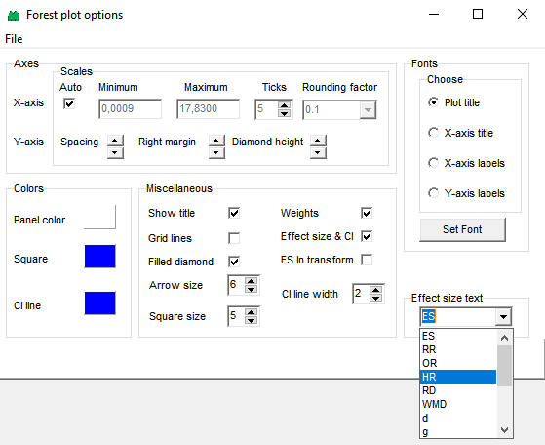

Note:

* The name of the plot is the name you give the meta-analyis (in MAInputTable)
* The name of studies are in the excel cells where the table input is.

There are more options that are useful, for example leaving out one or more studies (to see how sensitive the results are to the particular studies included).

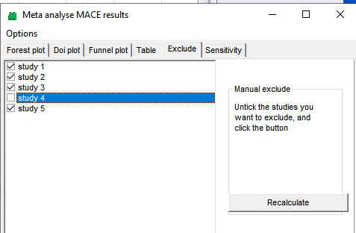

Click “Recalculate” and go back to the forest plot tab.

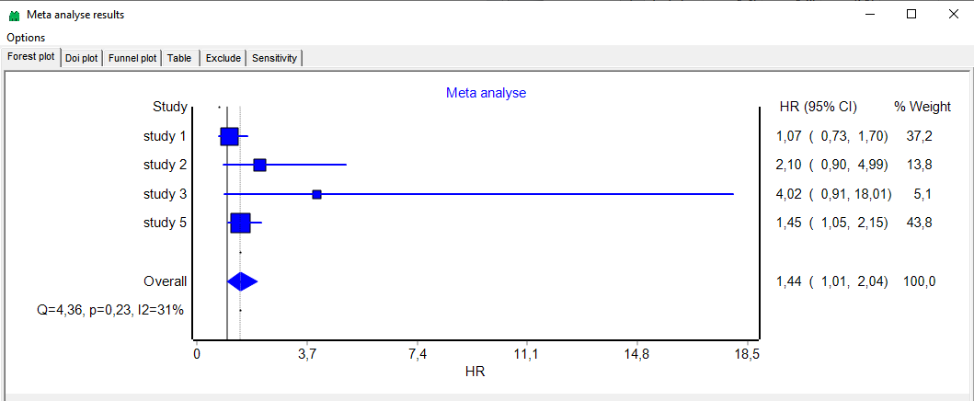

Other topics:

* How to do a subgroup analysis in MetaXL:

[(PDF) How to do subgroup meta-analysis using MetaXL (researchgate.net)](https://www.researchgate.net/publication/342196525_How_to_do_subgroup_meta-analysis_using_MetaXL)