See [Tukey's range test - Wikipedia](https://en.wikipedia.org/wiki/Tukey%27s_range_test)

Tukey’s post hoc test is based on (group A the larger mean, group B the smaller mean)



This has to be compared to tables for critical values q of a studentized range distribution (note that S*sqrt(2/n) is again the SE for the difference of the means:

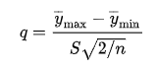

Tables of critical values are tabled for either for the above q (including the factor sqrt(2) )or for that without the factor sqrt(2),

i.e. for q= (y_max –y_min )/( S/sqrt(n) ) .

This can be checked by confirming that for k=nmeans=2 groups, the critical value of the t-test, so 1.96 for df-> infty should be obtained. The r-function qtukey does it without the factor sqrt(2), see below.

Example: if the value difference/SE(differerence) is given in a regression equation, such as below for ffp2 – chir (zonder scherm)= 2.19 in the context of 4 groups being compared.

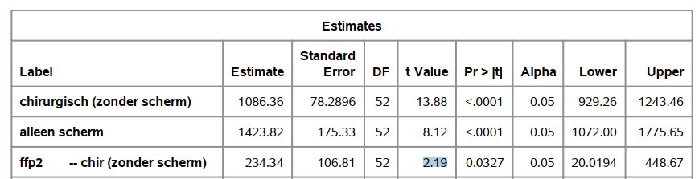

Then we can compare this to the critical q value coming from:



So this is not statistically significant.

(not even if we would consider 3 groups:



**Table below can be reproduced in R with   
(**[Tukey's Test for Post-Hoc Analysis | R-bloggers (r-bloggers.com)](https://www.r-bloggers.com/2018/09/tukeys-test-for-post-hoc-analysis/))

qTukey(p, nmeans, df) where

p= probability to the left,

nmeans=number of groups (of which the means are compared),

df=total sample size (all groups pooled) – number of groups

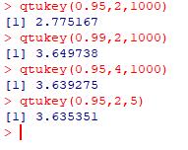

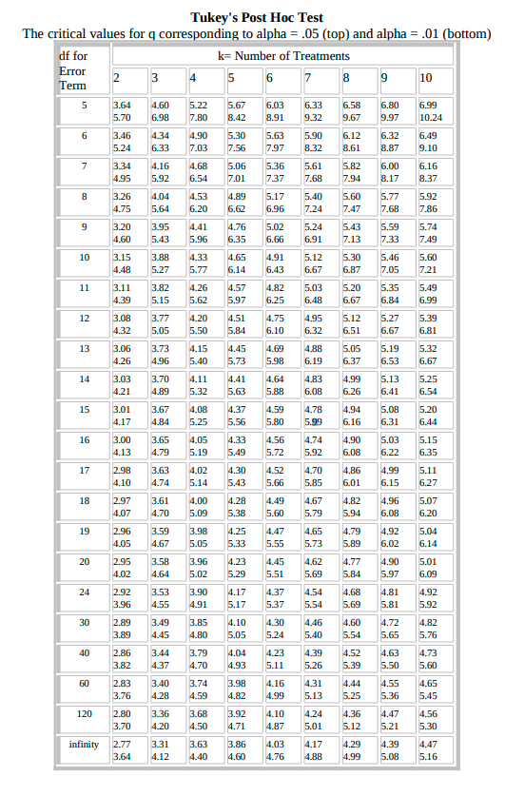

<http://www.de.ufpb.br/~ulisses/disciplinas/tabela_tukey.pdf>