Open the program; choose Balanced ANOVA

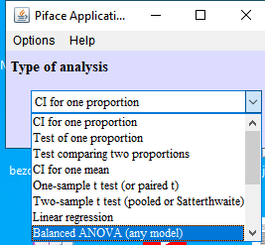

Choose “Differences/Contrasts”

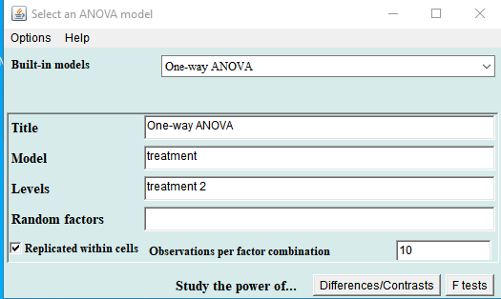

Fill in the SD (here 35) and the number of treatments (including the control group: here 3 i.e. one control group and two experimental groups) and the sample size in each group (here 10)

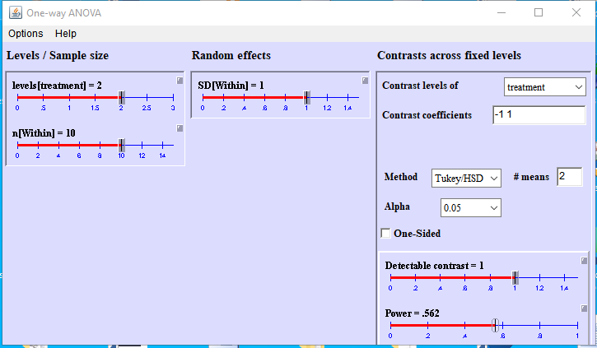

Not that one can click open to fill in any number

Like this:

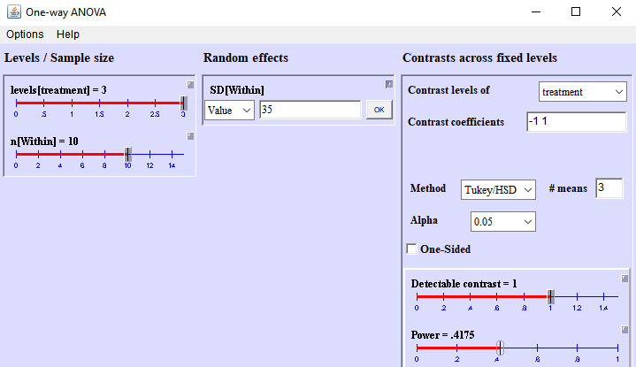

and choose Tukey or Dunnett (whichever you want) from the “methods” option list

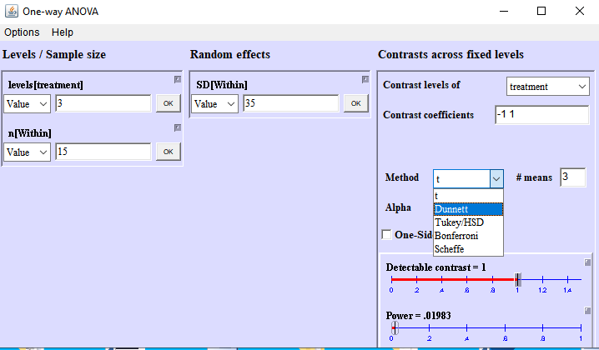

For example, for a difference of 100,000 vs 30,000, so 70,000 and SD=35,000, we can fill in (as multiples of 1,000): 