## Model building

Open “Mixed Models > Linear:

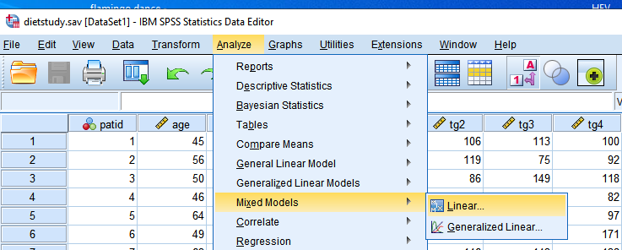

Choose “continue”:

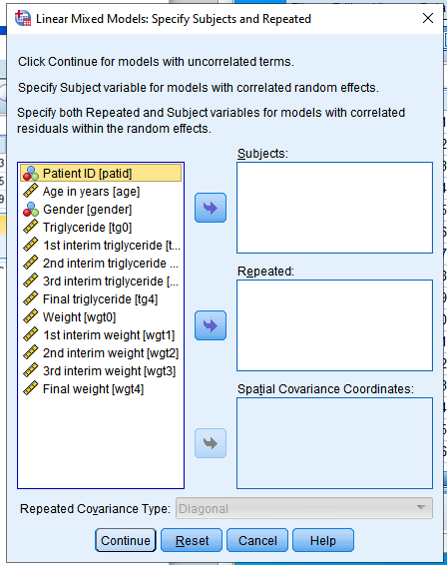

Fill in the dependent variable, and the independent variables: the categorical variables in “factor(s)” and continuous variables in “covariate(s)”

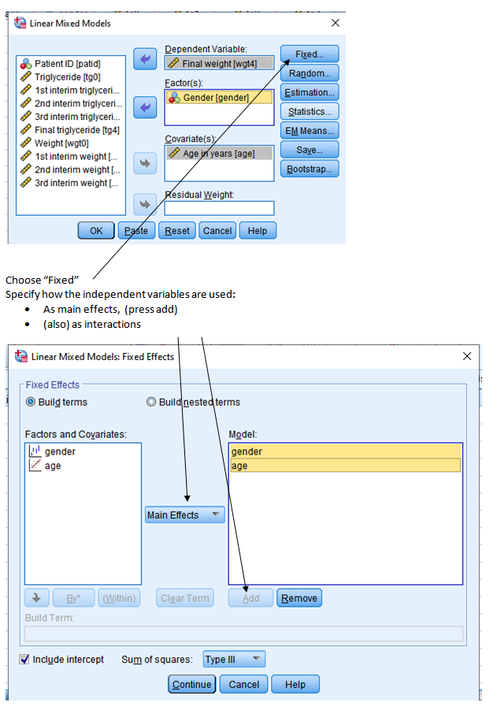

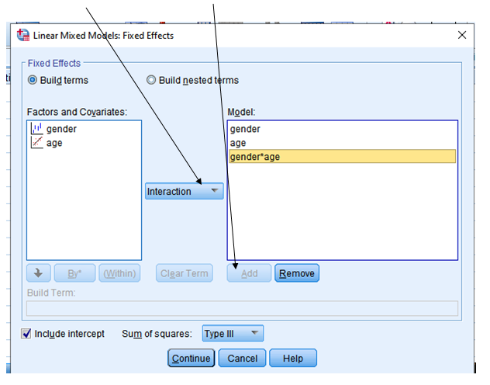

And press “continue” to close.

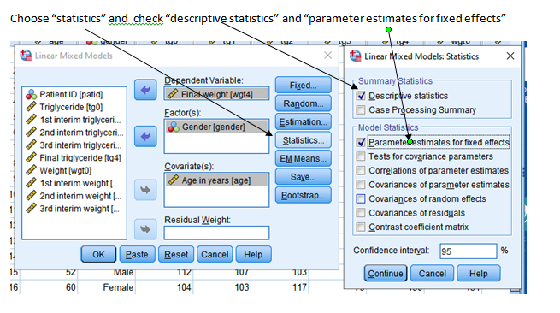

And press “continue”

Choose “Save” and check “predictive values” and “residuals”

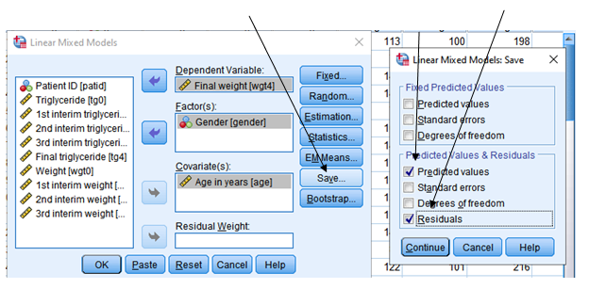

Then press “OK”

## Model checking

The idea is to look at the residuals (difference between observed and model-predicted values) to see whether the model does not systematically overestimates or underestimates.

Step 1: Assess normality of residuals overall:

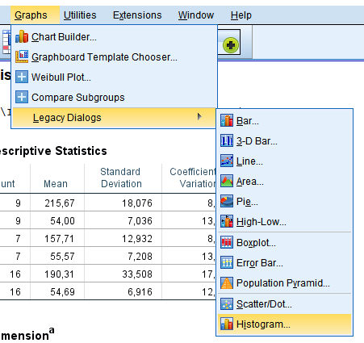

And choose the variable “Residuals”.

**Note that if you do several of these analyses the residuals (and predicted values) are numbered. So for the first analysis it is RESID_1, for the second RESID_2, etc. So keep track which residual you take. For the last analysis that you run it is the residual with the highest number.**

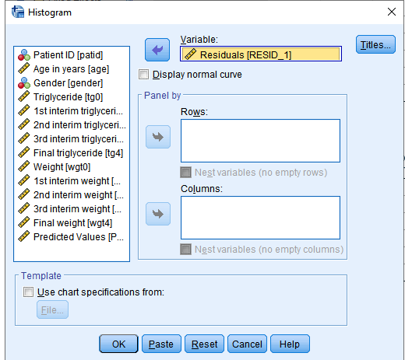

Check whether residuals are centered/symmetric around 0: (in this case it is not too bad, not to good either).

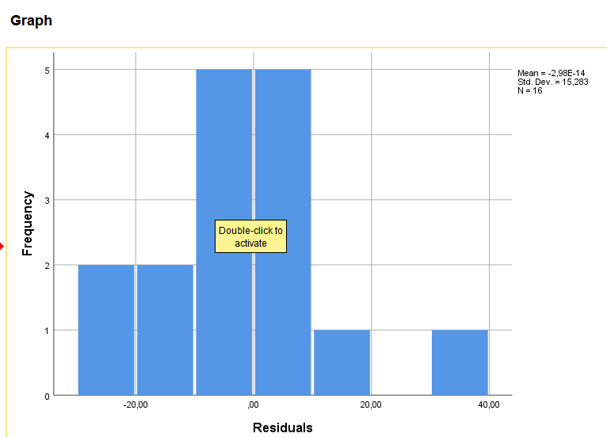

Step 2: assess whether residuals are symmetric around 0 over the range of predicted values

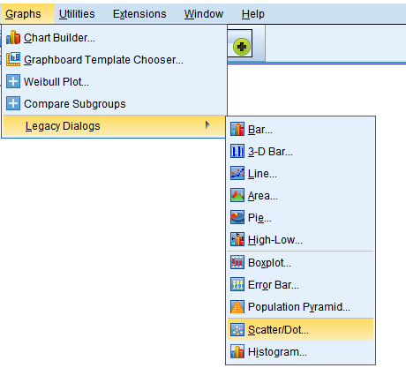

Choose “simple scatter” and “define”:

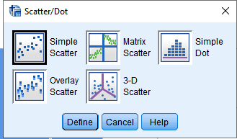

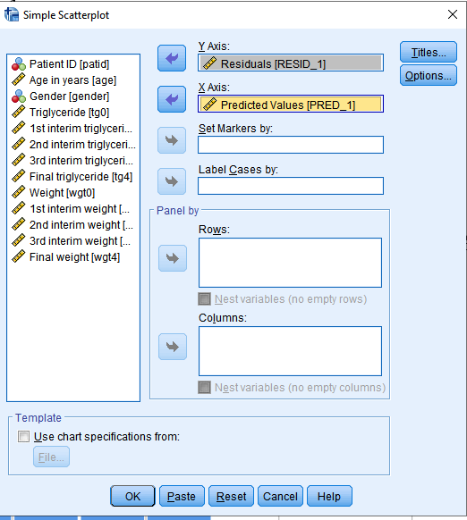

And press “OK”

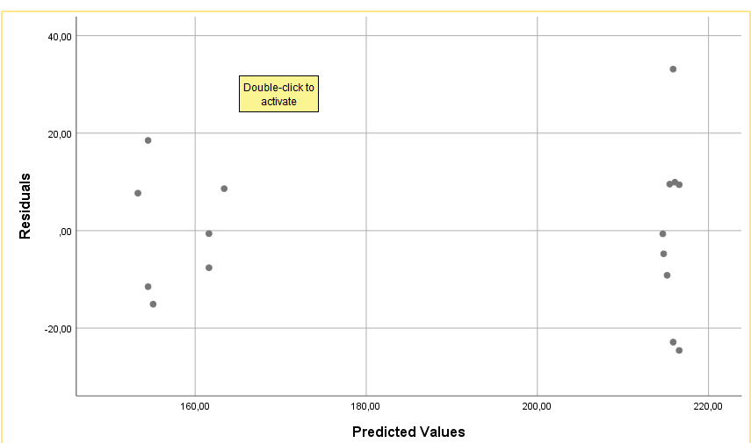

(Here we see that across the range (of predicted values) the residuals seems to spread vertically around 0. Some outlier at 40 at 210. This seems not too bad a fit).

## Model interpretation

If the fit of the model is reasonable, we can interpret the coefficients.

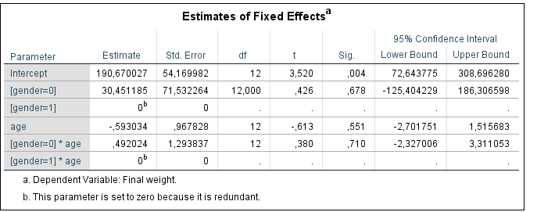

## Some comments

For categorical variables, SPSS standard chooses the highest value as reference. For binary variables, this may be counter intuitive. This can be bypassed as follows:

* code the binary variable as 0 and 1, with 0 the category that one wishes to be the reference.
* Specify the binary variable as a covariate