Steven Fisher
HW1
TTH 3:00 PM – 4:15 PM

1. Run “jps” command and show running tasks:
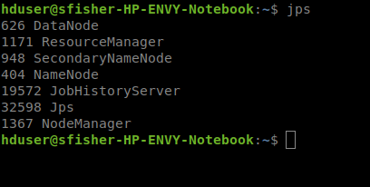

2. Show how many blocks created in HDFS for “tweets” file:
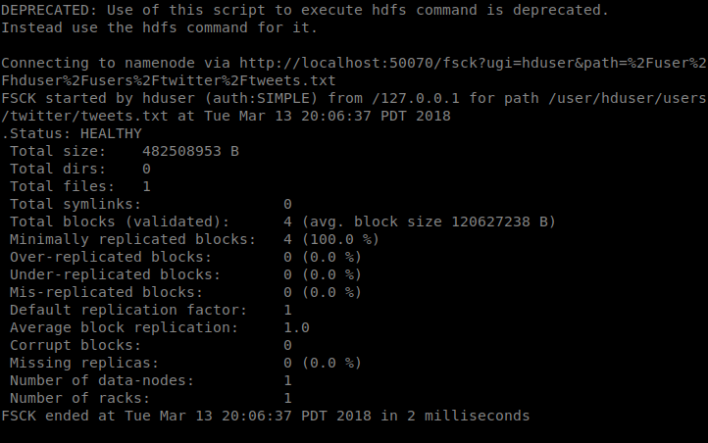

3. Show how many map tasks are created when you try to process “tweets” file in HDFS
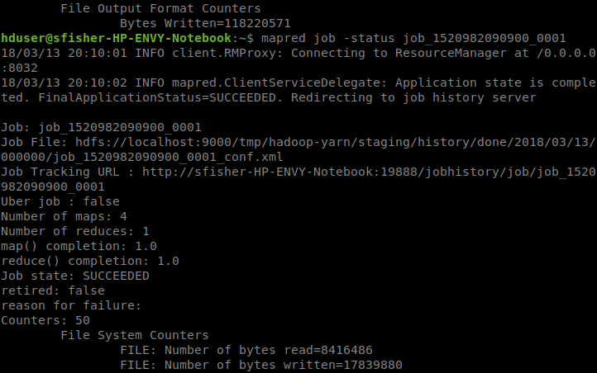
4. Set the number of reduce tasks to 3 and show that Hadoop created 3 reduce tasks:
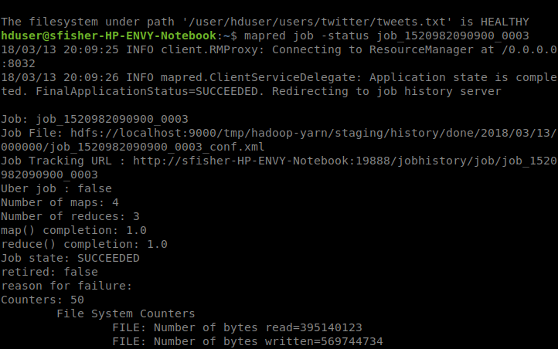

5. Write a MapReduce code to count the occurrences of hashtags and find the most repeated 100 hashtags.

In our program when utilized the ideas at the following website, to help with the sorting by value.
https://dzenanhamzic.com/2016/09/21/java-mapreduce-for-top-n-twitter-hashtags/

Command used for hashtag count:
hadoop jar HashCount.jar HashCount <INPUT FILE> <OUTPUT FILE>

Example: hadoop jar HashCount.jar HashCount /user/hduser/users/twitter/tweets.txt /user/hduser/users/twitter/HashOut

6. Write a MapReduce code find the most tweeted 5 days. (Tweets are associated with time stamps so you need to count all the tweets posted in same days)

In our program when utilized the ideas at the following website.
https://dzenanhamzic.com/2016/09/21/java-mapreduce-for-top-n-twitter-hashtags/

Command used to count top 5 most tweeted days:

hadoop jar TweetCount.jar TweetCount <INPUT FILE> <OUTPUT FILE>

Example: hadoop jar TweetCount.jar TweetCount /user/hduser/users/twitter/tweets.txt /user/hduser/users/twitter/TweetOut

7. Write a MapReduce code to find the most tweeted 10 cities along with the number of tweets (“training_set_users.txt” file has user_id → city relation to extract city information)

In our code we utilized the ideas at the following websites:
https://www.edureka.co/blog/mapreduce-example-reduce-side-join/
https://stackoverflow.com/questions/2499585/chaining-multiple-mapreduce-jobs-in-hadoop

Command used for city count:

hadoop jar MostTweetedCities.jar MostTweetedCities <USERS INPUT FILE> <TWEETS INPUT FILE> <TEMP OUTPUT> <OUTPUT FILE>

Example: hadoop jar CityCount.jar CityCount /user/hduser/users/twitter/users.txt /user/hduser/users/twitter/tweets.txt /user/hduser/users/twitter/CityTmp1 /user/hduser/users/twitter/CityOut1

