Steven Fisher
HW2
TTH 3:00 PM – 4:15 PM

1.) Launch the Spark shell. (2pt)
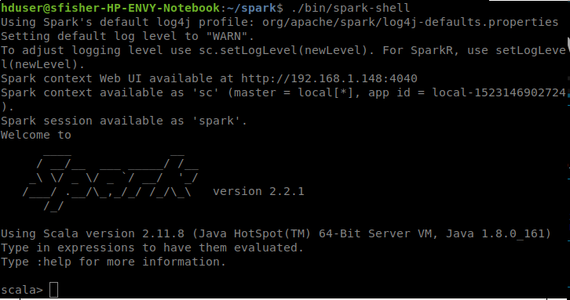
2.) Make a parallel collection of Array(1, 2, 3, 4, 5) and sum up all its
elements. (2pt)
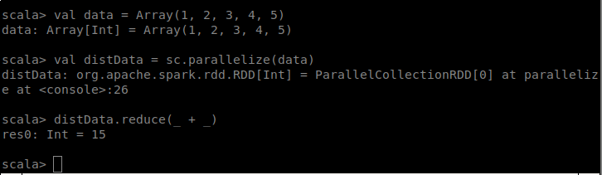

3). Create an RDD named pagecounts from the input file hamlet (3pt)
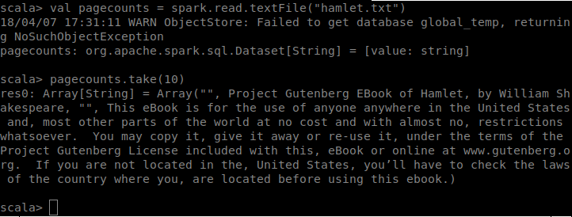
4). Get the first 10 lines of hamlet (i.e., first 10 records of pagecounts). (3pt)
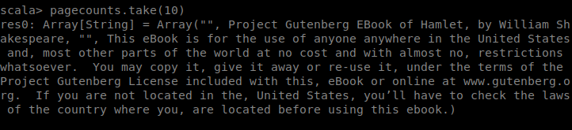
5.) Make a more readable print of the step 4. (3pt)
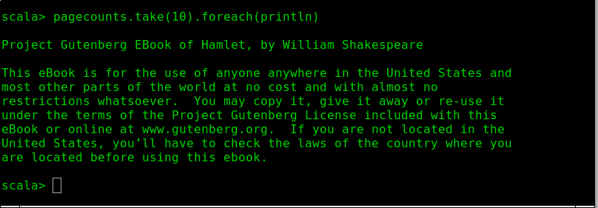
6.) Count the total records in the data set pagecounts, and confirm its correctness by comparing the result with the Bash wc command: wc -l hamlet . (3pt)
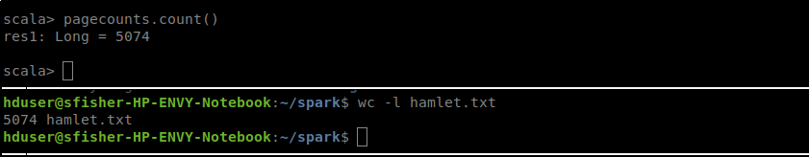
7.) Filter the data set pagecounts and return the items that have the word
“this”. (5pt)
8.) Cache the new data set in memory, to avoid reading from disks. Show cached RDD in web
interface (5pt)
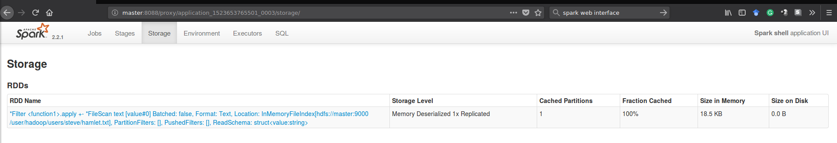
9.) Find 5 lines with the most number of words. Print lines and the number of words(6pt)
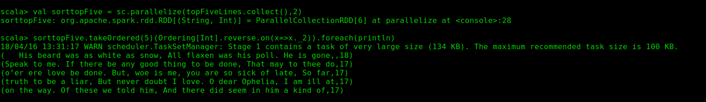
10.) Count the total number words. (3pt)

11.) Count the number of unique words. (5pt)
12.) Count the number of each word. (10pt)
13.) Show the jobs for Q12 in web interface (3pt)
14.) Save the data set in a text file. (3pt)
15.) Collect the word counts in the shell. (4pt)
16.) Write a standalone application in Spark to find 20 the most mentions in “training_set_tweets.txt”
file (20pt)
a.) Mentions starts with “@”.
b.) Multiple mentions in a tweet counts one. For example, “I love UNR @unr @unr @unr @cse
@cse”. You need to count one “@unr” and one “@cse” from this tweet
c.) You need to strip punctuations from mentions. For example, @unr! = !@unr = @unr
17.) Write a standalone application in Spark to find 10 retweeted users (aka twitter handle) (20pt)
a.) Example twitter handle is “@unr”
b.) Retweets can be identified by “RT @” filters. Simply searching for RT will lead incorrect results

Graduate Students only

18.) Write a standalone application in Spark to find 10 most tweeted users (ids of users) from Los Angeles for dates 09/16/2009 - 09/20/2009 (30pt)

