Smart Mirror

Release Plan

 | Document identifier: | SmartMirror-v1.0
 | Instructor: | Ms. V. Hsu
 | Course: | CS596-030-Internet of Things
 | Members: | Vo Doan Quoc Sy #150201133
Ji Li
Fey Wong #150101006
sen ZHENG
Yulun Hu #140301021
Hanjing Peng
Jizhou Wu #140301122
 | Deliverable identifier: | M1.0

Document Log
Issue | Date | Comment | Author
 | 12/4/2015 | First draft

Abstract
A highly functional mirror is a smart mirror. Smart mirror is embedded with various electronics features and technology such as sensor, display, bluetooth connectivity and cameras. Smart mirror is also equipped with wireless communication with enable voice recognition and hands-free calling.
This document presents the smart mirror product releases proposed by the IOT project. The overall smart mirror project schedule has several steps which are use case design, product design, hardware design, software design, and test.

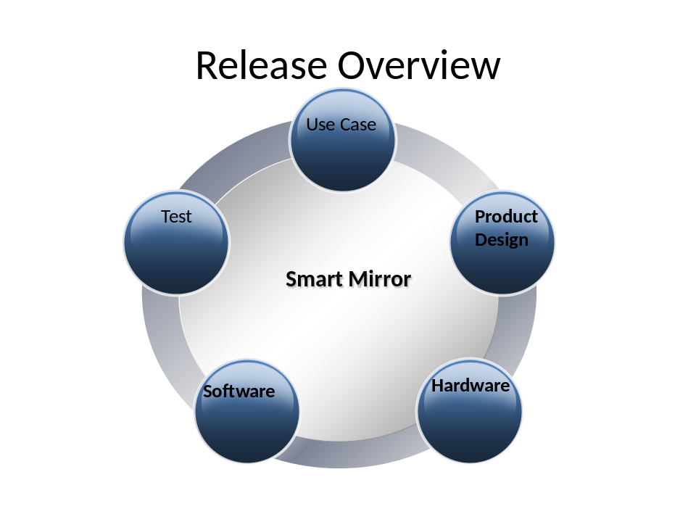

Functions Release

Use case
A representation of a user's interaction with smart mirror that shows the relationship between the user and the different use cases in which the user is involved.

System model
Describes and represents whole system's requirement,implementation,input data, and output data views.

Hardware
The physicalcomponents of a smart mirror, including sensors, LED, Speaker, mic etc.

Software
The software functions release procedure is composed of the followings:
- Function-1
Check News
- Function-2
Check Weather
- Function-3
Try Out Outfit
- Function-4
Check Skin Conditions : Give customers skin treatment suggestions
- Function-5
Measure Body : Measure and compare body shape

Release schedule
This release schedule diagram gives the time line for the partitions.
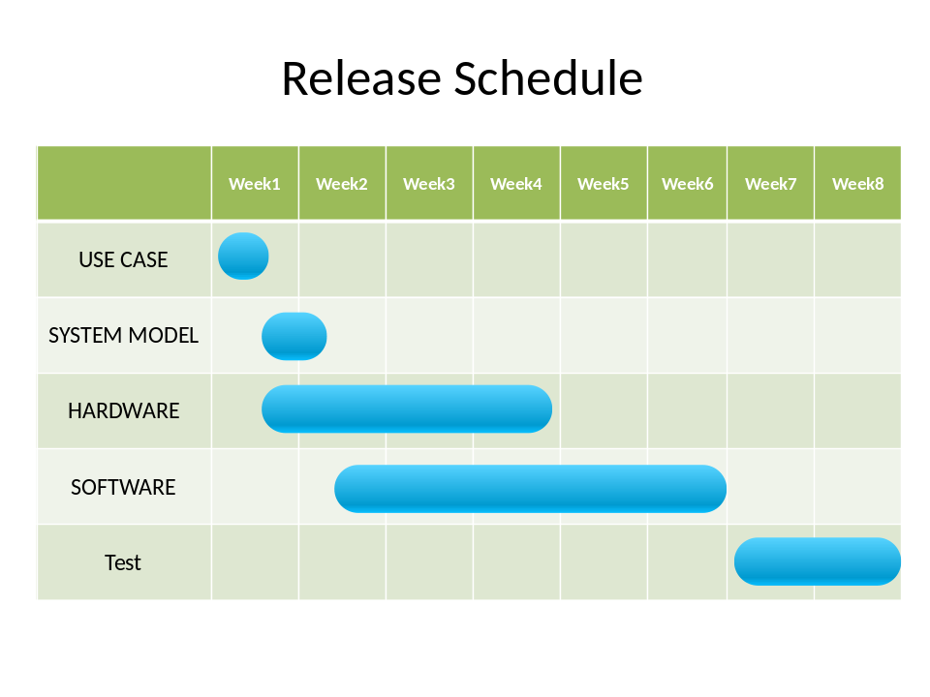

Testing
This section outlines the testing procedures foreseen within the project. The basic approach is to address testing in a bottom-up manner via two distinct phases:
- Unit tests
Performed on individual hardware modules and software functions to test their basic functionality
- Integration tests
Performed on integrated product to verify their correct inter-operation

Unit Tests
Unit tests address the basic functionality. They are to be provided and executed by the engineers on their own machines or the development testbed before delivering for integration.
Details of the unit tests should be documented. Sufficient documentation should be provided to allow other people to execute the tests and interpret the results.

Integration Tests
The integration tests verify successful integration of the hardware and software within the project. Integration tests are executed on the development testbed whenever new release version comes out. The basic approach is to test all the components via typical user scenarios based on job submission. The integration tests represent a succession of increasingly complex job submissions.
It is expected that the set of test scenarios should be expanded as the project gains more experience with the product and requirements from the users.

