TAEval  
_______________

Requirements Analysis Document

**Team Romero’s Severed Head**  
Sean Benjamin  
Dylan Kristolaitis  
Justin Kung

Steven Wu

Submitted to:

Dr. Christine Laurendeau

COMP3004 Object-Oriented Software Engineering  
School of Computer Science  
Carleton University

Contents

1. Introduction………………………………………………………#
   1. Purpose of System………………………………………#
   2. Overview of Document………………………………..#
2. Proposed System……………………………………………….#

2.1. Overview…………………………………………………….#

2.2. Functional Requirements……………………………..#

2.3. Non-functional Requirements………………………#

2.4. System Models……………………………………………..#

2.4.1. Use Case Models…………………………………#

2.4.2. Object Model……………………………………...#

2.4.3. Dynamic Model………………………………….#

1. Glossary…………………………………………………………….#

Figures

tbd

Tables

tbd

1. Introduction

1.1 Purpose of System

In a university setting, the main purpose of attending is for increasing knowledge in a directed, focused manner. One may learn a field of study through books borrowed from the local library, but that structure is a stark contrast to a term filled with lectures from a distinguished PhD accompanied by tests, assignments, and exams that direct the student from point A to point B. Analogously, the current structure of the TA-Instructor relationship is unfocused. In communication of duties, task obligations are set at the start of the semester; but for communication of statuses and feedback for dynamically changing tasks, we still resort to e-mail. In assessing the qualities of a candidate, TA applications still rely on providing references of faculty that need to be manually contacted to receive feedback for performance that is dated or not directly applicable to the job at hand.  
  
To allow the TAs to be successful in their job they need to have clear expectations about the tasks assigned to them for each of the courses that they TA. The instructors need to provide clear tasks and timely feedback to the TAs, to allow the TAs to complete their stated tasks at an appropriate level of satisfaction. Given that many TAs end up TA’ing repeatedly, it is invaluable for the future students in his or her section to benefit from the learning of the TAs previous errs and mistakes.

A unified system which would:

* allow the TA to know his exit criteria set by the Instructor for tasks
* allow the Instructor to know exactly if and when the task is completed from the TA
* allow the TA to receive feedback on previously completed tasks to improve upon the next instance of the same task
* allow the Administrator to be able to run reports on demand for TAs’ evaluation data to judge their eligibility for future positions

could solve the underlying problems with the current infrastructure.

The TAEval system is the proposed system to be used by TAs, Instructors, and Administrators that will allow Instructors to assign tasks to TAs of the course they are instructing and to provide feedback to the TAs about how they are doing on their tasks.

The scope of the TAEval system is for tasks and evaluation to be assigned, completed and evaluated over the course of the term.

The TAEval system will be comprised of the following main features for the Instructor:

1. Instructor can create, modify and deleted tasks.
2. Instructors will assign tasks to an associated TA.
3. Instructors will provide feedback and an evaluation rating for each task assigned to a TA.

The TAEval system will be comprised of the following main features for the Administrators:

1. Administrator will be to manage system data such as to courses, instructors, and TAs.
2. Administrators will be able to execute reports on the TAEval persistent data.

The TAEval system will be comprised of the following main features for the TAs:

1. TAs can view the tasks that have been assigned to them.
2. TAs can view evaluation on their tasks once the have been entered by the instructor.

For further details with regards to detailed system features, technical specifications, graphic user interface (GUI), data storage and inter-process communications refer to the TAEval system description.

1.2 Overview of Document

The purpose of this requirements analysis document is to provide an agreement with the client with respect to the functional and non-functional requirements of the TAEval system.

The document contains the following documentation with regards to the TAEval system:

1. List of functional requirements in a traceability matrix
2. List of non-functional requirements in a traceability matrix
3. Use case diagrams for the Instructor and TA actors
4. Detailed use case descriptions
5. Object model that is comprised of a data dictionary, which describes the TAEval entity, boundary and control objects, and a UML class diagram.
6. Dynamic model that is comprised of sequence diagrams, that map the instructors user cases, and state machine diagrams that map only the entity objects.
7. Proposed System
   1. Overview

In this section we outline the technical details of our proposed system, TAEval, by clearly defining functional requirements, non-functional requirements, and outlining unambiguous and complete system models.  
  
TAEval is a client-server application that is designed to optimize the line of communication between an instructor and his or her teaching assistants by automating the issuing and tracking of tasks, task evaluations, and metrics that can quantify the TA’s body of work.

* 1. Functional Requirements

Functional requirements are the concise, explicit details of what the system will be able to do with respect to functionality. For TAEval, for example, there is a distinct difference between the system allowing   
  
Table 1 – Functional Requirements

|  |  |
| --- | --- |
| Traceability Code | Functional Requirement |
| FR-00 | TAs must be able to view their assigned tasks assigned by the course instructor. |
| FR-01 | TAs must be able to view their tasks’ respective evaluation evaluated by the course instructor. |
| FR-02 | TAs must only be assigned to a maximum of one course at any given time. |
| FR-03 | Instructors must be able to create a task at the beginning of the term for each TA for each class they are instructing. |
| FR-04 | Instructors must be able to edit their existing delegated tasks. |
| FR-05 | Instructors must be able to delete their existing delegated tasks. |
| FR-06 | Instructors must be able to enter evaluation data for each existing delegated task. The evaluation scheme is 1-> ‘poor’, 2-> ‘fair’, 3-> ’good’, 4-> ’very good’, 5-> ’excellent’ |
| FR-07 | Instructors must be able to view a list of courses they are instructing in a specific term. |
| FR-08 | Instructors must be able to view the list of TAs that are assigned to a specific course they are instructing. |
| FR-09 | Instructors must be able to view a list of tasks they have created per course they are instructing. |
| FR-10 | A course must have an existing instructor associated with it upon its creation. |
| FR-11 | Administrators must be able to run reports on TA evaluation data, such as: TA evaluation ratings for one TA spanning all terms, TA evaluation ratings for all TAs spanning one term, TA evaluation ratings for all TAs for a particular course offering, specific TA evaluation ratings (such as only ‘poor’, or only ‘excellent’) for all TAs spanning all terms. |
| FR-12 | Administrators must be able to view a list of courses offered in a given term. |
| FR-13 | Administrators must be able to view a complete list of all instructors. |
| FR-14 | Administrators must be able to view a complete list of all TAs. |
| FR-15 | Administrators must be able to add course offerings. |
| FR-16 | Administrators must be able to edit course offerings. |
| FR-17 | Administrators must be able to delete course offerings. |
| FR-18 | Administrators must be able to add instructors. |
| FR-19 | Administrators must be able to edit instructors. |
| FR-20 | Administrators must be able to delete instructors. |
| FR-21 | Administrators must be able to add TAs. |
| FR-22 | Administrators must be able to edit TAs. |
| FR-23 | Administrators must be able to delete TAs. |
| FR-24 | Administrators must be able to assign existing TAs to any existing course at any time. |
|  |  |

* 1. Non-functional Requirements

Table 2 – Non-functional Requirements

|  |  |  |
| --- | --- | --- |
| Traceability Code | Type of NFR | Non-functional Requirement |
| NFR-01 | Usability | TAEval user interface must be graphical in nature. |
| NFR-02 | Usability | TAEval system must be easy to navigate via menu items and dialog boxes. |
| NFR-03 | Usability | TAEval user interface must have a professional look and feel that is consistent with other commercial UI. |
| NFR-04 | Usability | TAEval generated reports must be concise, consisting of summarized evaluation data, formatted as a single line per record. |
| NFR-05 | Usability | Each client process must execute on a different machine and support a single user. |
| NFR-06 | Usability | Data requested by user must be handled by the TAEval client which queries the central server, accessible at a configurable IP address, to populate the user’s client UI. |
| NFR-07 | Usability | All fields for user text input must have an upper limit that cannot be exceeded. |
| NFR-08 | Usability | All save operations must be confirmed by the user. |
| NFR-09 | Usability | All delete operations must be confirmed by the user. |
| NFR-10 | Usability | TAEval user interface must have the same color scheme that Carleton University uses. |
| NFR-11 | Usability | Explicit documentation on how to install and configure TAEval should be provided |
| NFR-12 | Reliability | All exceptions should be handled gracefully with appropriately detailed error messages |
| NFR-13 | Reliability | If TAEval crashes while an operation leading to a change in the database is occurring, the change must be halted and removed and the system should offer to restore itself to the last safe state. |
| NFR-14 | Performance | User must be able to view up to date information on the client UI instantly. |
| NFR-15 | Performance | There should be no duplication of data anywhere in the system. |
| NFR-16 | Supportability | TAEval must be built to run on a lightweight client such as a mobile device in a future phase. |
| NFR-17 | Supportability | TAEval must be able to support a minimum of four concurrent processes, each on a different host. |
| NFR-18 | Supportability | The system should be extensible to any GUI platform with minimal work required to port over to another. |
| NFR-19 | Implementation | All processes must work on the Linux Ubuntu 12.04 platform. |
| NFR-20 | Implementation | Source code must be written in C++. |
| NFR-21 | Implementation | Data storage organization must be designed for ease of retrieval and efficient use of storage space. |
| NFR-22 | Implementation | Data must be stored in SQLite. |
| NFR-23 | Implementation | Client processes must communicate with the central server using TCP/IP sockets. |
| NFR-24 | Interface | Every user must be running a separate client process which provides the TAEval UI. |
| NFR-25 | Operations | Client must be designed to use very little memory and must have no persistent storage. |
| NFR-26 | Operations | All data must be stored centrally on a single host. |
| NFR-27 | Operations | Server process must execute on central host and must manage updates and retrievals of the data. |
| NFR-28 | Operations | Queries to the server must return only the minimum amount of necessary data. |
| NFR-29 | Operations | Almost no data should be stored on the client when the user moves between UI screens. |
| NFR-30 | Operations | No client processes will run on the central server host. |
| NFR-31 | Packaging | The product must be delivered in a CD-ROM/DVD with everything necessary to install the program. |
| NFR-32 | Legal | All administrators must agree for all sensitive information to be kept confidential. |

* 1. System Models

The system models describe the use cases, object models, and dynamic models for the TAEval system.  They function as an iterative way of defining requirements that need to be satisfied by the system, identifying missing requirements, and refining the existing ones.

We are providing a use case model, object model and dynamic model.  The use case model is composed of use case diagrams, use case descriptions, and a traceability matrix.  The scope of the use case model is for all TA and Instructor actors use cases.  The object model identifies the entities, boundary entities and controls of the system. The object model is composed of a data dictionary and a class diagram.  The scope of the object model is limited to only the entity objects.  The dynamic models illustrate the behaviour of the system.  The dynamic model is composed of state machine diagrams for the entity objects and sequence diagrams for the instructor use cases.

2.4.1 Use Case Model

Use case models are used to model high-level functionality, at a level that is relevant to the user. For our system, we have created use cases to model actions that the Instructor and TA users would perform in conjunction with the TAEval system. Below we begin by giving an overview of all of the high-level use cases, followed by the detailed use cases with their assigned traceability codes and given names. Following the overview, we present tables containing use case descriptions that outline the how we define each use case with respect to traceability code, name, flow of events, entry and exit conditions, quality requirements, and traceability to functional or non-functional requirements that we have previously defined.

Use Case Overview

Limiting our scope to only the TA and Instructor actors, we have two high level use cases: BrowseOwnTasks and ManageTasks.  
  
<insert high level use case diagram>

Table 3 – High-level Use Case Descriptions

|  |  |  |
| --- | --- | --- |
| Traceability Code | Use Case Name | Use Case Description |
| UC-01 | BrowseOwnTasks | The TA browses the tasks assigned to him or her by course |
| UC-02 | ManageTasks | The Instructor manages selected properties for all tasks |

<insert detailed use case diagram for BrowseOwnTasks>

<insert detailed use case diagram for ManageTasks>

Table 4 – Detailed Use Case Descriptions

|  |  |  |
| --- | --- | --- |
| Traceability Code | Use Case Name | Use Case Description |
| UC-03 | ViewTask | The TA views a particular instance of a task |
| UC-04 | ViewTaskEvaluation | The TA views the evaluation for a particular task |
| UC-05 | ViewCourseList | The Instructor or TA views a list of courses they are registered to by a term that he or she chooses |
| UC-06 | ViewTaskList | The Instructor or TA views a list of tasks relating to them for a course that he or she chooses |
| UC-07 | ViewTaList | The Instructor views a list of all TAs for a particular course he or she is instructing |
| UC-08 | CreateTask | The Instructor creates a task |
| UC-09 | EditTask | The Instructor edits a selected task |
| UC-10 | DeleteTask | The Instructor deletes a selected task |
| UC-11 | EvaluateTask | The Instructor evaluates a particular existing task |
| UC-12 | NetworkError | The system reports that the submitted form could not be received |
| UC-13 | ExceedCharLimit | The system prompts the user that the text input given exceeds the limit |
| UC-14 | RepositoryModificationError | The system prompts the user that the request could not be completed because the system was modified |
| UC-15 | NoTaskAvailable | The system prompts the user that there are no associated tasks to be found |
| UC-16 | NoCoursesAvailable | The system prompts the user that there are no associated courses to be found |
| UC-17 | NoEvaluationAvailable | The system prompts the user that there are no evaluations associated with the TA |

Use Case Flow of Events

The following tables organize the layout for a detailed description of each use case. Each table will list the actors that participate in the use case followed by a flow of events that illustrate how the use case proceeds through each step, from being invoked to ending. The entry condition is defined as the condition(s) that must be met for the use case to be invoked. The exit condition is defined as the condition(s) that the system must be left in once the use case terminates. Finally, we list quality requirements pertaining to each use case and the functional or non-functional requirements that are fulfilled.

|  |  |
| --- | --- |
| *Use Case Identifier* | UC-01 |
| *Name* | BrowseOwnTasks |
| *Participating Actors* | Initiated by TA |
| *Flow of Events* | 1. The system displays the list of all courses the TA is or has been involved in with a selectable option to filter by a specific semester and a menu with the following options: view a list of courses, view a list of tasks.  2. If the TA opts to view a list of courses the system displays a list of courses optionally filtered by semester (initiate use case ViewCourseList).  3. The TA selects a course from the course list.  4. If the TA opts to view a list of tasks the system displays a list of tasks associated with the TA's selected course (initiate use case ViewTaskList). |
| *Entry Conditions* | User logged in to TAEval as a TA |
| *Exit Conditions* |  |
| *Quality Requirements* | * TAEval will take no longer than 5 seconds to return list of available courses to the TA. |
| *Traceability* | FR-00 and FR-01 |

|  |  |
| --- | --- |
| *Use Case Identifier* | UC-02 |
| *Name* | ManageTasks |
| *Participating Actors* | Initiated by Instructor Participated by TA |
| *Flow of Events* | 1. The system displays the list of all courses the Instructor is teaching and has taught with a selectable option to filter by a specific semester and a menu with the following options: create a new task, view a list of courses, view a list of TAs, view a list of tasks.  2. If the Instructor opts to create a new task a task creation form is displayed (include use case CreateTask).  3. If the Instructor opts to view a list of courses the system displays a list of courses the Instructor is teaching optionally filtered by a specific semester (include use case ViewCourseList).  4. The Instructor selects a course from the list of courses.  5. If the Instructor opts to view a list of TAs the system displays a list of TAs assigned to the Instructor of the Instructor's selected course (include use case ViewTAList).  6. If the Instructor opts to view a list of tasks the system displays a list of all tasks the Instructor has created for the selected course (include use case ViewTaskList). |
| *Entry Conditions* | User logged in to TAEval as an Instructor |
| *Exit Conditions* |  |
| *Quality Requirements* | * The system should respond to requests in no more than 10 seconds. |
| *Traceability* | FR-03, FR-04, FR-05, FR-06, FR-07, FR-08, FR-09 |

|  |  |
| --- | --- |
| *Use Case Identifier* | UC-03 |
| *Name* | ViewTask |
| *Participating Actors* | Initiated by TA |
| *Flow of Events* | 1. TA selects a single task they want to view. 2. TAEval will return the requested task. 3. TA reviews task. |
| *Entry Conditions* | TA has received list of tasks for a specified course from BrowseOwnTasks |
| *Exit Conditions* | TA has received and reviewed their task |
| *Quality Requirements* | TAEval will take no longer than 5 seconds to return requested task to the TA. |
| *Traceability* | FR-00 |

|  |  |
| --- | --- |
| *Use Case Identifier* | UC-04 |
| *Name* | ViewTaskEvaluation |
| *Participating Actors* | Initiated by TA |
| *Flow of Events* | 1. TA selects a single task they want to view that has been evaluated 2. TAEval will return the evaluated requested task. 3. TA reviews evaluated task. |
| *Entry Conditions* | TA has received list of tasks for a specified course from BrowseOwnTasks |
| *Exit Conditions* | TA has received and reviewed their evaluation |
| *Quality Requirements* | TAEval will take no longer than 5 seconds to return requested evaluation to the TA. |
| *Traceability* | FR-01 |

|  |  |
| --- | --- |
| *Use Case Identifier* | UC-05 |
| *Name* | ViewCourseList |
| *Participating Actors* | Initiated by Instructor or TA |
| *Flow of Events* | 1. The user requests to view the course list that they currently instruct or have previously instructed, for the instructor, or have tasks currently or previously assigned, for the TA. 2. TAEval will return the list of courses for the specific user. The TA will receive the list of courses that they have tasks currently or previously assigned. The instructor will receive the course that they have currently or previously instructed. 3. The Instructor or TA reviews listed courses. |
| *Entry Conditions* | User is logged in as Instructor (or TA?) to the TAEval system |
| *Exit Conditions* | User has received and reviewed their listed courses |
| *Quality Requirements* | * TAEval will take no longer than 5 seconds to return requested course list to the user. * The list of all courses displayed should be sorted alphanumerically by course code and shown grouped in descending order by term. |
| *Traceability* | FR-07 |

|  |  |
| --- | --- |
| *Use Case Identifier* | UC-06 |
| *Name* | ViewTaskList |
| *Participating Actors* | Initiated by Instructor or TA |
| *Flow of Events* | 1. The user requests to view the list of tasks that they have created, for the instructor, or list of tasks that are assigned, for the TA. 2. TAEval will return the list of tasks for the specific user. The TA will receive the list of task they have been assigned. The instructor will receive the list of tasks that they have created. 3. The Instructor or TA reviews listed tasks. |
| *Entry Conditions* | User is logged in as an Instructor or TA to TAEval |
| *Exit Conditions* | User has received and reviewed their list of tasks |
| *Quality Requirements* | * TAEval will take no longer than 5 seconds to return the requested task list * The list of tasks should be sorted alphabetically by task name. |
| *Traceability* | FR-00, FR-09 |

|  |  |
| --- | --- |
| *Use Case Identifier* | UC-07 |
| *Name* | ViewTAList |
| *Participating Actors* | Initiated by Instructor |
| *Flow of Events* | 1. The user requests to view the TA list 2. The TA list is returned and displayed to the user |
| *Entry Conditions* | User is logged in as an Instructor and a course for which to view the TA list has been selected |
| *Exit Conditions* | The list of TAs for the specific course is displayed to the user |
| *Quality Requirements* | * The TA list is displayed within 5 seconds of the request * The list of TAs should be sorted alphabetically by their last names. |
| *Traceability* | FR-08 |

|  |  |
| --- | --- |
| *Use Case Identifier* | UC-08 |
| *Name* | CreateTask |
| *Participating Actors* | Initiated by Instructor |
| *Flow of Events* | 1. Instructor selects the create task option. 2. If one or more TA's are selected from TA List, then their names are added to the assigned TA's. 3. Instructor is prompted to input task name, task description, and assign additional TA's 4. Instructor submits the form. Instructor waits for confirmation. 5. TAEval receives form submission and notifies instructor. |
| *Entry Conditions* | User is logged into TAEval as an Instructor |
| *Exit Conditions* | * Instructor receives notification of task creation success. * Task list updated with the created task name. --OR-- * Instructor cancels form submission and nothing is updated. |
| *Quality Requirements* | Instructor's form submission is received and the Instructor is taken to the previous menu after no longer than 5 seconds. |
| *Traceability* | FR-03 |

|  |  |
| --- | --- |
| *Use Case Identifier* | UC-09 |
| *Name* | EditTask |
| *Participating Actors* | Initiated by Instructor |
| *Flow of Events* | 1. Instructor requests the editing of a task. 2. The system presents the Instructor with a form for the task, with all of the current attributes of the task in place. 3. The instructor changes one or more of the task name, task description, or task assignee. 4. Instructor submits the form and waits for a response. 5. If a task name or task description is entered, the system checks that they have not both crossed their respective upper limit for number of characters. If the input is verified as acceptable, the system edits the task as the Instructor requested and notifies the instructor. |
| *Entry Conditions* | User is logged into TAEval as an Instructor  User has selected a task from the task list |
| *Exit Conditions* | * Instructor receives notification of task editing success. * Task list updated with the edited task name. --OR-- * Instructor cancels form submission and nothing is updated. |
| *Quality Requirements* | * Instructor's form submission is receive * Instructor is taken to the previous menu after no longer than 5 seconds. |
| *Traceability* | FR-04 |

|  |  |
| --- | --- |
| *Use Case Identifier* | UC-10 |
| *Name* | DeleteTask |
| *Participating Actors* | Initiated by Instructor |
| *Flow of Events* | 1. Instructor requests the deletion of a task. 2. The system prompts the Instructor with a confirmation box, asking if the Instructor is sure they want to delete the task and that the changes cannot be reverted. 3. If the Instructor selects 'OK', then the system removes the entire task and any associations to it from the database and notifies the Instructor that the deletion was successful. 4. If the Instructor selects 'Cancel', then the system doesn't act further. |
| *Entry Conditions* | User is logged in to TAEval as an Instructor.  User has selected a task from the task list |
| *Exit Conditions* | * Instructor receives notification of task deletion success. * Task list updated with the deleted task removed from the list.   --OR--   * Instructor cancels upon prompt and nothing is updated. |
| *Quality Requirements* | Instructor's form submission is received and the Instructor is taken to the previous menu after no longer than 5 seconds. |
| *Traceability* | FR-05 |

|  |  |
| --- | --- |
| *Use Case Identifier* | UC-11 |
| *Name* | EvaluateTask |
| *Participating Actors* | Initiated by Instructor |
| *Flow of Events* | 1. The Instructor selects the evaluate task option.  2. The system displays a task evaluation form to the Instructor.  3. The Instructor specifies a rating from 1-5 -- with 1 being the worst and 5 being the best -- then leaves textual feedback and submits the form.  4. The system updates the task with the Instructor's evaluation, sends a notification of success, and returns the Instructor to the previous menu. |
| *Entry Conditions* | The Instructor has selected a task to evaluate from a list of tasks. |
| *Exit Conditions* | * The selected task has its evaluation data updated to reflect the Instructor's evaluation OR * The Instructor has cancelled the evaluation and the task's evaluation data is left unchanged. |
| *Quality Requirements* | The system should respond to requests in no more than 5 seconds. |
| *Traceability* | FR-06 |

|  |  |
| --- | --- |
| *Use Case Identifier* | UC-12 |
| *Name* | NetworkError |
| *Participating Actors* | Communicates with Instructor and TA |
| *Flow of Events* | 1. The TAEval system encounters a network error (timeout, no connection, etc.).  2. The TAEval client will notify user about network error and will allow user to try their request again. |
| *Entry Conditions* | * This use case extends the BrowseOwnTasks, ManageTasks, ViewTaskList, ViewTaskEvaluation, ViewCourseList, and ViewTAList, CreateTask, EditTask, DeleteTask and EvaluateTask use cases. * It is initiated whenever a network error is encountered between the client and server. |
| *Exit Conditions* | * User receives a notification about network error |
| *Quality Requirements* | The user receives a notification in no more than 5 seconds after the network error has affected the system. |
| *Traceability* | TBD |

|  |  |
| --- | --- |
| *Use Case Identifier* | UC-13 |
| *Name* | ExceedCharLimit |
| *Participating Actors* | Communicates with Instructor and TA |
| *Flow of Events* | 1. The user tries to input more characters into a text field than the maximum allowed amount for that particular field.  2. The TAEval system prevents the user from inputting any more characters into the field unless the number of characters exceeding the upper limit is removed. |
| *Entry Conditions* | * This use case extends the CreateTask, EditTask, EvaluateTask use cases. * It is initiated whenever the user attempts to input more than the maximum number of characters allowed into a text field |
| *Exit Conditions* | * The TAEval system prevents the user from inputting any more characters |
| *Quality Requirements* | The user will not be interrupted by this exception |
| *Traceability* | TBD |

|  |  |
| --- | --- |
| *Use Case Identifier* | UC-14 |
| *Name* | RepositoryModificationError |
| *Participating Actors* | Communicates with Instructor and TA |
| *Flow of Events* | 1. The user is performing a task involving some data they have received from the TAEval repository on their last request.  2. The user performs a new request dependent on the data they received from their last request.  3. The new request tries to access the repository referencing the dependent data after it has already been modified by another user.  4. The TAEval system alerts the user that their request could not be completed because of a recent modification to the repository that left it in a state different to what they are expecting. |
| *Entry Conditions* | * This use case extends the ViewTask, ViewTaskEvaluation, ViewCourseList, ViewTaskList, ViewTAList, CreateTask, EditTask, DeleteTask and EvaluateTask use cases. * It is initiated whenever the repository no longer exists in the state that the user is expecting. |
| *Exit Conditions* | * User receives notification that their request could not be completed because the system was modified |
| *Quality Requirements* | * The user receives the notification in no more than 5 seconds * The user will not lose any client-side changes they have made |
| *Traceability* | TBD |

|  |  |
| --- | --- |
| *Use Case Identifier* | UC-15 |
| *Name* | NoTaskAvailable |
| *Participating Actors* | Communicates with TA |
| *Flow of Events* | 1. The TAEval system searches repository to find tasks associated with logged in TA.  2. The TAEval server notifies TAEval client about zero tasks being associated with the TA.  3. The TAEval client receives notification that no tasks are associated with the TA. |
| *Entry Conditions* | * This use case extends the ViewTask. * It is initiated whenever no tasks are found for a particular TA |
| *Exit Conditions* | * TA receives a notification that they do not have any tasks associated with them. |
| *Quality Requirements* | * The user receives the notification in no more than 5 seconds |
| *Traceability* | TBD |

|  |  |
| --- | --- |
| *Use Case Identifier* | UC-16 |
| *Name* | NoCoursesAvailable |
| *Participating Actors* | Communicates with Instructor and TA |
| *Flow of Events* | 1. The TAEval system searches repository to find courses associated with logged in user.  2. The TAEval server notifies TAEval client about zero courses being associated with the user.  3. The TAEval client receives notification that no courses are associated with the user. |
| *Entry Conditions* | * This use case extends the ViewCourseList. * It is initiated whenever no courses are found for a particular user |
| *Exit Conditions* | * User receives a notification that they do not have any tasks associated with them. |
| *Quality Requirements* | * The user receives the notification in no more than 5 seconds |
| *Traceability* | TBD |

|  |  |
| --- | --- |
| *Use Case Identifier* | UC-17 |
| *Name* | NoEvaluationAvailable |
| *Participating Actors* | Communicates with TA |
| *Flow of Events* | 1. The TAEval system searches repository to find evaluations associated with logged in TA.  2. The TAEval server notifies TAEval client about zero evaluations being associated with the TA.  3. The TAEval client receives notification that no tasks are associated with the TA. |
| *Entry Conditions* | * This use case extends the ViewEvaluation. * It is initiated whenever no evaluations are found for a particular TA |
| *Exit Conditions* | * TA receives a notification that they do not have any evaluations associated with them. |
| *Quality Requirements* | * The user receives the notification in no more than 5 seconds |
| *Traceability* | TBD |

2.4.2 Object Model

The object model details the tangible things from the real world that are modeled by the system and how they are associated with either each other or intangible things from the system. The distinction is made here between which objects are:

* + - based on the application domain -- known as entity objects
    - which are necessary for user-system interaction -- boundary objects, and
    - which are used to manipulate them -- control objects.

Data Dictionary

The data dictionary is a table that contains a formal name of the object, its respective attributes that define it.

|  |  |  |  |
| --- | --- | --- | --- |
| Entity Object | Attributes and Associations | Definition | Traceability |
| Admin | - name | The highest level of user supported by the TAEval system. Administrators are responsible for adding, removing and editing courses, instructors and TAs in the system. |  |
| Course | - name  - term  - code  - tasks  - TAs  - instructor | A course is an instructional period for students in a given term. A course is taught by an instructor and may also have TAs assigned to it. |  |
| Evaluation | - rating  - feedback | An evaluation is the communication between an instructor and a TA for a completed task. An evaluation is created by the instructor for a completed task and consists of a numerical rating and written feedback. |  |
| Instructor | - name  - department  - courses | An instructor is responsible for teaching one or more courses. |  |
| TA | - name  - year  - degree  - major  - course  - studentId | A TA (Teaching Assistant) is assigned to a course and performs duties to help the instructor. TAs may be responsible for grading assignments, administering tests and meeting with students to offer help pertaining to course material. |  |
| TAEval | - admins  - instructors  - TAs  - courses | TAEval is a system that facilitates and improves upon Instructor-TA communication by tracking tasks assigned and courses taught, administered by Administrators. |  |
| Task | - name  - description  - TA  - evaluation | A task is an assigned piece of work for a Course, given by an Instructor to a TA. |  |
| User | - name | A user is someone who has credentials in the TAEval system to log in and use its functionality. |  |

Class Diagram

Objects associated with each other will appear listed as an attribute in the data dictionary and have their directionality and multiplicity detailed in a class diagram.

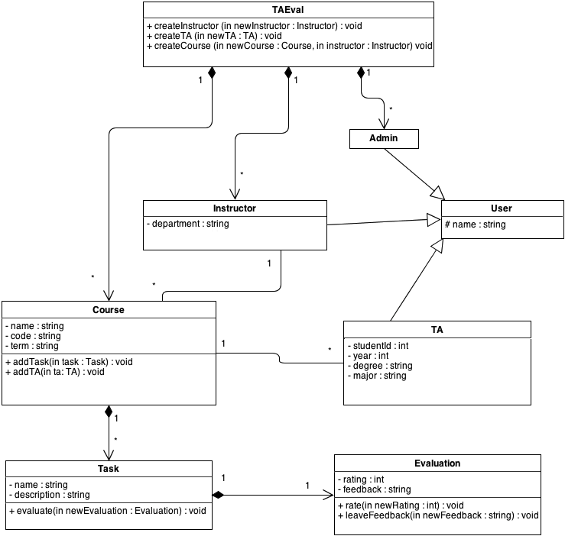

2.4.3 Dynamic Model

The dynamic model clarifies system behavior from an external point of view. The purpose of these models is to show the dynamic, as in ever-changing, behavior of our classes of objects (entity, boundary, control) within the system from a non-developers’ perspective.

State Machines

State machine diagrams specifically show all possibly distinct states that a single object can go through, from its beginning state to its end state, where the end state is defined as the state at which, upon arriving, the object will never re-enter another state. They allow us to formally and visually map out the distinct states of an object while also allowing us to identify new behavior. A state is defined as a unique set of attributes the object maintains with respect to the system. For example, two distinct states that an Instructor may have is that, given he or she is defined with a name and department, he or she is either teaching or not teaching. The scope of our state machine diagrams is limited to the entity objects only, which were declared and defined in the data dictionary.   
  
Below are the state machine diagrams for the following entities: Course, TA, Instructor, Task, Evaluation.

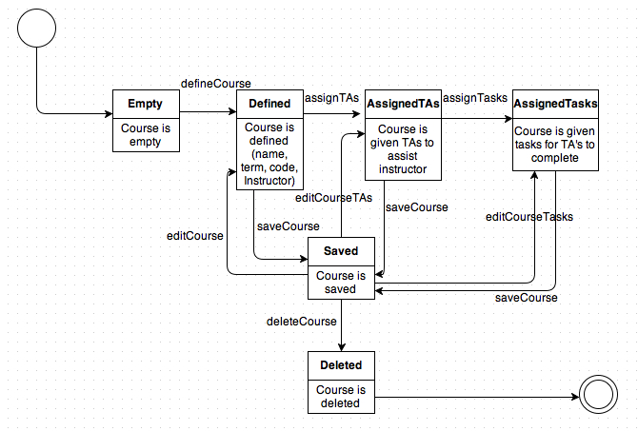  
  
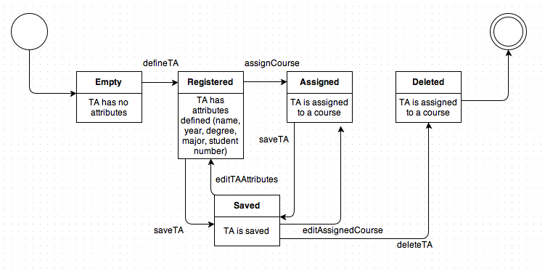

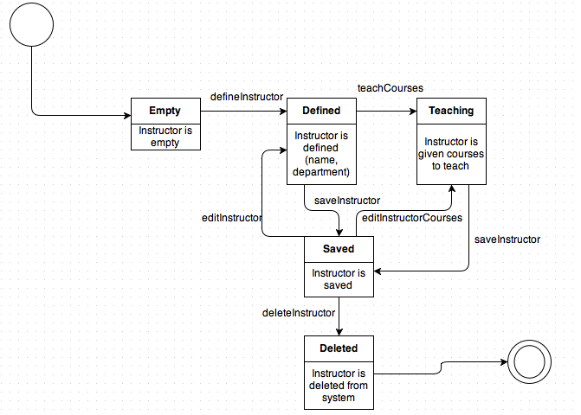

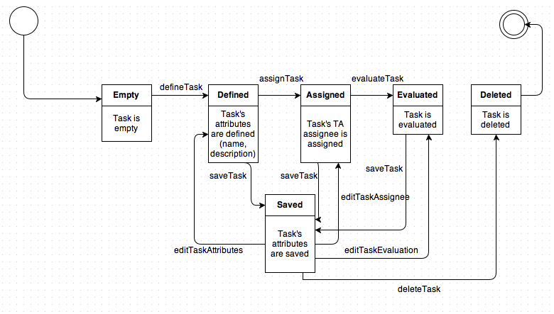

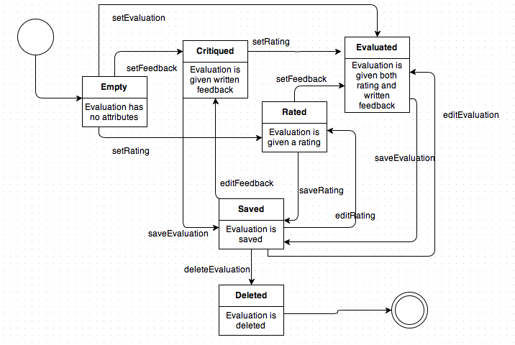

Sequence Diagrams

Sequence diagrams also assist with capturing the system behavior by analyzing and visually diagramming how a particular use case sparks interaction between one or many objects within the system. This is accomplished by having the y-axis representing time elapsed as you descend from the top-down, showing the introductions and interactions of objects with the initial initiating actor in order of appearance. It allows us to see which objects create other objects, and when or whether certain objects terminate before the use case ends or not.