# Pub/Sub Systems Integration

We have designed and been developing pub/sub systems for different kinds of environments such as WSN, WMN and the pervasive computing environment. This document proposes a design to integrate the pub/sub systems from different environments.

## Overview

We have been developing pub/sub systems for different environments. For each of the pub/sub system, we are developing applications which can make use of it. The overall system architecture can be shown in the following figure:



On the top level, users can subscribe events or contexts through applications. The subscription will then be decomposed before disseminated into the network. The network may consist of different parts such as WSN or WMN and different network may need to interact with each other in order to detect the subscribed events.

## Architecture

The software architecture has the following layers:



### Application Layer

On the top, users can interact with the systems through different applications such as traffic systems, SHM or video surveillance systems. The role of the applications mainly includes providing high-level user-friendly interfaces. An example of a traffic management application is given as follows:

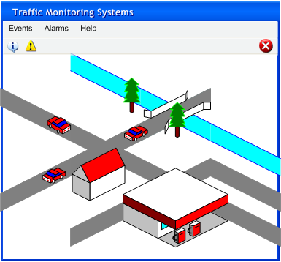

Each type of application will have a set of commonly used context/event templates as libraries. For example, a traffic system may have the event templates such as the number of cars in an area, potential collision events.

### Event Definition

The applications will eventually translate the user requirements into event definitions which are expressed by event definition language (EDL). An event which counts the number of cars in an area may look like follows:

Event CarCount {

Int count=count(car)

} on {

CarEvent car;

} where {

Car.locationX==1 && car.locationY==3

}

### Event Decomposition

Event decomposition involves dividing complicated events into simpler events and then further converts them into certain kind of format (such as byte codes) which can be easier to process by the network.

### The Network Layer

At the bottom, we have the network layer which may consist of more than one type of network such as WSN or WMN. The event subscriptions will be disseminated into the network. Some events may need information from more than one network. In that case, the network can connect with each other through some kind of gateways.