Distributed User Authentication for Sensor Network Applications

Kirk H.M. Wong, Yi Lai, Yang Zou, Yuan Zheng, and Jiannong Cao

Internet & Mobile Computing Lab., Dept. of Computing
The Hong Kong Polytechnic University, Hong Kong SAR China
{cshmwong, csylai, csyzou, csyuazheng, csjcao}@comp.polyu.edu.hk

Abstract

Sensors may provide users with different services for facilitating data enquiry and resource access within a deployed sensor network environment. In this paper, we are addressing User Authentication (UA) issue such that a service provider can deploy sensor network applications and make use of the UA concept to allow authorized or registered users to access the networks. We propose a distributed UA protocol based on Merkle hash tree mechanism and users need to be verified by nearby login node before they can submit a query into a sensor network. We implement our protocols by experiments and make it practical for use in sensor networks. Some preliminary experimental results will also be presented.

Index Terms – Wireless Sensor Network (WSN), User Authentication, Merkle Hash Tree, Security, Access Control.

1. Introduction

Many sensor network applications have been developed for various practical research areas, such as patient monitoring, environmental surveillance, traffic monitoring, and the like [xx]. Traditionally, a gateway or base-station computer is able to submit queries into a deployed sensor network. One of the examples includes submitting a query for showing which areas with traffic volume over 70 percent of the capacity. However it could be foreseen that many users would like to access sensor networks inside the network rather than at the gateway only. They may prefer to access the network from some of deployed sensor nodes for efficient status update or data processing.
User authentication within the area of access control therefore comes to an attention for researchers that we want to secure the access and safeguard the protection of the entire network by at least pre-screening some attacks from beginning. To achieve user authentication, it is essential for local sensor nodes to authenticate the identities of the users, who are going to submit queries into the sensor network afterward.
This paper aims to propose an efficient, practical and secure user authentication scheme for sensor nodes. A first solution for user authentication is to use a centralized mechanism in our previous work [8]. After receiving an authentication request from a user, the sensor node (i.e. login node) sends the user information in one-way hashed values back to the base station computer. Then the base station decides if the access is granted or not and replies the result to the login node. This solution yields a good security result because of the fact that the base station is assumed secure, and the communication channels between login sensor nodes and the base station are also assumed secure based on a group key or pairwise keys’ existence. However, this scheme may suffer the scalability problem when the network size increases. The authentication traffic may possibly cause network congestion, as well as slower response time between the login node and the user.
Therefore, we extend our previous work and consider a distributed approach on user authentication based on Merkle hash tree [3]. We consider a data access application that a user can access in-network stored data at some fixed areas from anywhere in the network, which includes local data access from user’s nearby sensor and remote data access by means of submitting a query through a login sensor node. We also consider from node operation perspective that the authentication scheme should minimize clumsy node operations, i.e. intensive calculation, to make it more practical.
Our work is considered to have the following main contribution. First we propose a scalable local authentication based on Merkle hash tree. It makes use the idea of a pair of public and private keys; such that the public key value (the root value) can be calculated by providing a series of one-way hashed function of partial private keys (the leaf node values) and some intermediate node values. The detail will be shown in the protocol Section 3. Second, it is very practical to apply the proposed authentication scheme to the existing resource-limited sensor motes.
The rest of this paper is organized as follows. Related work on generic access control in sensor network environment is described in Section 2. The details of our Merkle hash tree based user authentication protocol are described in Section 3. Some security analyses and experimental results are presented in Sections 4 and 5 respectively. Finally, a concluding remark for the paper is included in Section 6. An appendix with a simplified example is also included in the end to illustrate the workflow of the authentication protocol.

2. Related Work

Two most recent papers have started to address the access control issue for sensor network applications. One addresses user authentication (UA) by a local sensor when a user needs data access within the WSN [7]. Another one focuses on new sensor node authentication when it is being dispatched into an existing sensor network [9]. This belongs to an access control issue for new nodes’ redeployment.
The work [7] in fact is similar to our work that both propose a solution for user authentication before accessing the WSN, but in different algorithmic approach. Wang et al. [7] uses Elliptic Curve Cryptography (ECC) technique, which is a public key cryptography scheme, to perform a local user authentication. For ECC, a public key Q can be defined as Q = x * P; where P is a given base point on a given elliptic curve, and x is the private key or a session key. Given points P and Q with the property of ECC, it is computationally infeasible to obtain x. The workflow is briefly discussed in the following for later comparison.
A user gets a user certificate during a registration from a Certificate Authority (CA), where normally the sensor gateway or base station computer acts this role. The user certificate contains a plaintext of user’s public key and her access list. The user’s access list is composed of user identity (user_ID), access privilege mask, and timestamp. A user sends her certificate to a local sensor, where it computes a temporary public key (Y), a session key (r), and a nonce (N). The local sensor sends back the user with Y, encrypted r, and the Message Authentication Code (MAC) of a nonce, i.e. MAC(r, N). With user’s own private key, the user retrieves the session key r, uses r to decrypt MAC(r, N), and generates MAC for nonce N concatenated with her access list, i.e. MAC(r, N||Access_list), and sends this to the local sensor. Then the local sensor decrypts the MAC message, verifies N and the access list. The local sensor will grant the access to the user if the nonce and the access list are correct. In summary, the local sensor has operations of at least:
- 2-Hash, 2-MAC, 3-ECC point multiplication,
- 1-XOR, and 2-Compare.
Likewise, the user has operations of at least:
- 1-Hash, 1-MAC, 3-ECC point multiplication,
- 1-XOR.
Although ECC approach is considered to be the most potentially used in WSN due to its less computation when compared to the other public key cryptography schemes like RSA [1]. If in case the local sensor nodes are often required for doing the UA process, the lifetime of the whole sensor network might be doubtful in that it is not able to sustain for a longer time.
In Zhou et al. [9], it considers new node deployment is necessary for an existing WSN. To prevent malicious nodes from joining the sensor network at the very beginning, access control is required. New node authentication involves its node identity (node_ID) and node bootstrapping time. These two parameters are specified in user’s certificate that prevents the content change from attackers. A new node can only be accepted when its node-id has proved correctly and bootstrapping time is within a tolerance period of current time; since there are different bootstrapping times between an old node and a new node. Again public key certificate is used to include the encrypted node-id and bootstrapping time. Access control protocol is based on ECC technique also. Every node needs operations of at least 3-ECC point multiplication, where 2 for node authentication, and 1 for pairwise key establishment between the new node and its old neighboring node.
At predeployment phase, define Q = kG; where Q is CA’s public key, k is CA’s private key, and G is the base point of a given EC. For a handshake between a new node and an old node, it is described briefly in the following. A new node (N_{i}) starts to broadcast its information to neighboring nodes including its node-id, bootstrapping time, the length of bootstrapping period, its public key and digital signature. An old node (N_{j}) will first check the validity of N_{i}’s bootstrapping time and then verify the new node’s identity. The old node will calculate a shared pairwise key (k_{ij}) derived from its private key and N_{i}’s public key, and then selects a nonce (n_{j}). Node N_{j} now encrypts the nonce n_{j} with the key k_{ij} and sends it to the new node N_{i} as a challenge-response procedure. And node N_{i} simply verifies N_{j}’s node-id and decrypts the nonce n_{j} and returns it to the old node N_{j} to show that it is a legitimate new valid node. In summary, this access control scheme tries to protect against the Sybil attack, the node replication attack, and the wormhole attack. Furthermore, the node bootstrapping phase is usually very short, such that it is shorter than the time required to compromise a new node during this phase.
Regarding the performance evaluation, this scheme uses 163-bit point multiplication of ECC on Mica2 motes that requires 34 seconds for one ECC operation. While it compares with 1024-bit RSA modular exponentiation, RSA needs at least 50 seconds. The authors even improve the ECC implementation by using assembly language and reducing the point multiplication down to 0.81 second. Obviously ECC is claimed to be more computationally efficient than RSA in this manner and achieves more energy savings. However, from the mote operational standpoint, is it practical enough to implement both the user and new node authentication with these protocols, which are still considered very complicated handshakes? This also motivates us to propose a simpler but still practical method for implementing the user authentication by use of Merkle hash tree.
In-network programming update over to sensor motes in an entire sensor network is also considered to be another access control issue. In Krontiris et al. [2], they propose a source node authentication scheme with the use of Merkle hash tree as well. Therefore a sensor mote is able to verify that a programming update is originated from a trusted source.

3. User Authentication Protocol

3.1 System Model

We consider a large-scale wireless sensor network deployed in a confined area, e.g. in an ocean park, in an airport site. The service provider of the park or the airport can provide a service such that public users are able to access in-network data stored on sensor nodes. A user is required to login to a login_node which is closer to that user. Once the user has been logged into the login_node with successful user authentication, then the user is able to issue some queries into the networked system, results of queries are supposed routing back to that login_node, which will direct the results back to the user. However, our scope of work for this paper is only to consider the way of how to perform user authentication between a user and a login node; not the way of how to issue queries and route data packets.
A registered user equipped with a handheld device (e.g. a PDA with an embedded sensor mote) interacts with the sensor network for data query and retrieval. This device with sensor mote is referred as a user_node. A user can query data at a location of the network where there is a dedicated sensor mote acted as a function of a login_node. It is assumed that there are enough login_nodes, which scatter around the sensor network and are able to provide a high coverage for users’ logging in.
The sensor network is administrated by a Key Distribution Centre (KDC), which is responsible for generating the security primitives, such as a pair of secret and public keys for each user identity (user_ID), one-way hash function, and signature. If a user decides to have data query service when he/she enters the park and he/she is required to do a registration with the KDC. KDC will generate the necessary security primitives and some partial primitives will then be stored on the user_node. This node will then be carried by the user, who will use it for doing login and data query inside the sensor network. Normally the KDC is collocated with the gateway sensor mote or a base station, here we name it as a gateway_node, where it collects all sensed data sent by other sensor nodes distributed into the network. Therefore, the KDC will maintain a valid user list and associated user’s security information. The KDC is assumed to have the ability in revoking user’s access privilege by broadcasting an authenticated message to all the login_nodes if necessary. Fig. 1 shows the system model of a deployed sensor network.

3.2 Assumptions

We make the following assumptions for our system model:

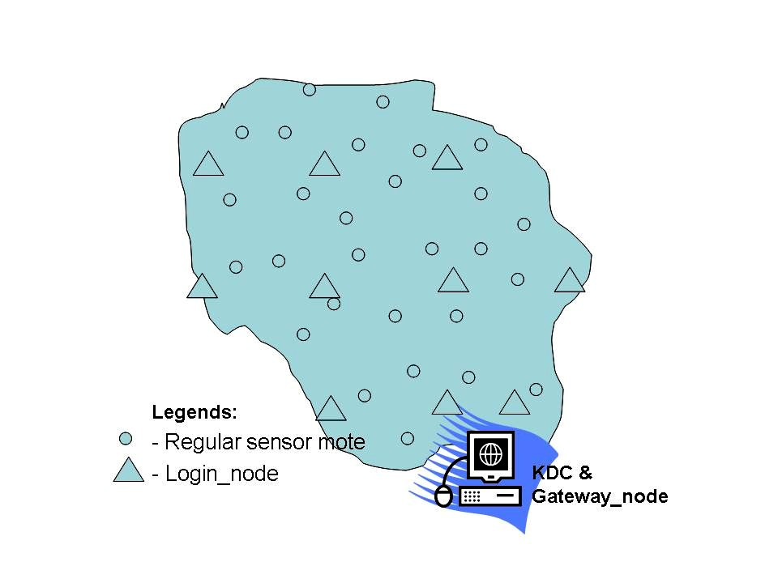
Figure 1: Deployed sensor field with KDC at entrance.

- Our protocols are able to be implemented on either homogeneous or heterogeneous sensor motes.
- Regular and login sensor nodes are assumed to cover sufficiently over an entire sensor network. They may have the same transmission range.
- All sensor nodes are stationary and in static positions.
- User location and her movement tracking have not been considered yet (a good consideration for future work).
- A deployed sensor network is assumed to have a regular maintenance by a service provider that Gateway node is always trusted. Only regular and login nodes may have possibility to be attacked or compromised. However, we assume that there are tools helping to identify any malicious nodes in a short time during some regular system health check-up.
- Our protocol is applicable for any applications that have similar settings with our scenario; i.e. requires in-network access.

3.3 Merkle Hash Tree Based Authentication

Preliminaries. A Merkle hash tree is a complete binary tree where each node is associated with a hashed value, such that the value of each parent node is the hash function on the values of its respective left and right children. That is:

parent = hash (left_child || right_child)

where parent, left_child and right_child are a hashed value; and || is for a bit-string’s concatenation.
Usually, a cryptographic hash function such as SHA-1 or MD5 is used for hashing and its output length is 160 or 128 bits respectively. But a more secure hash algorithm could be used for obtaining a longer hash value, i.e. SHA 256/384/512. Fig. 2 illustrates a sample of constructing a Merkle hash tree.
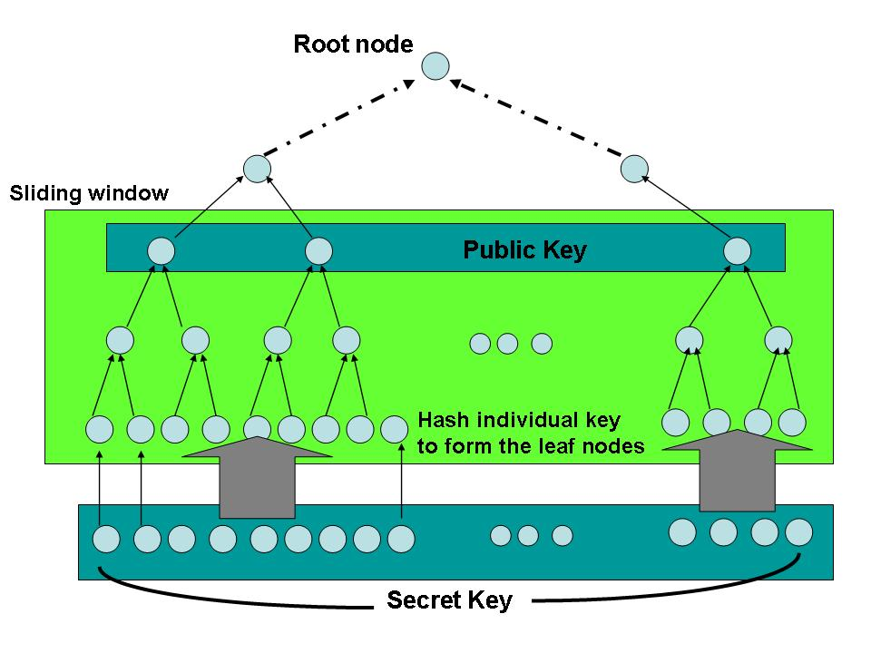
Figure 2: Construct a Merkle hash tree and extract a public key.

In general, a long bit-string of a secret key, i.e. 1024-bit in length or more is randomly generated. A number of chunks could be divided from the secret key, i.e. an oval dot is represented as one chunk in the Fig. 2. Each chunk is firstly hashed into a fixed output value forming a leaf node on the bottom of a Merkle hash tree. The tree is constructed upwardly until a fixed size of root node is obtained. This root node in fact is the public key. One of the functions to employ Merkle hash tree is for one-time signature as well as authentication. Secret key is never to be disclosed, a user only presents one leaf node, the root, and an authentication path (AP, a series of intermediate nodes). Then the verifier is able to compute the final root value based on the construction of a Merkle hash tree. If the computed root value equals to the given root, then the signature or the leaf node value is authentic.
We use this simple idea for user authentication in our scenario for sensor network applications. We also introduce the use of sliding window (shown in Fig. 2) as a system parameter, which governs the height of Merkle hash tree going to be used, i.e. the height equals to level 2 in Fig. 2. As a result, a number of sub-trees are obtained, as well as a number of sub-root values are obtained. We can purposely choose the number of sub-root values such that each sub-root value is for one-time login purpose. For next login, a user needs to use another pair of leaf node and sub-root value for authentication.
To generalize this idea, we can construct many small hash trees (same as sub-trees mentioned before) of height d that contain 2^{d} leaf nodes. The public key would then contain all the root nodes of all small hash trees (also shown in Fig.2 at the top of sliding window). To authenticate each leaf node value during a user’s login process, the user also needs to present the d nodes along the authentication path, which is shown in Fig. 3.
The Scheme. A user is required to do a registration when he/she enters the Ocean Park for example. Then the administrator of the KDC will prepare a PDA with embedded sensor mote for him/her to carry. That mote is referred to as a user_node, which contains all the necessary sub-root values (i.e. the public key) and the signatures generated by KDC.

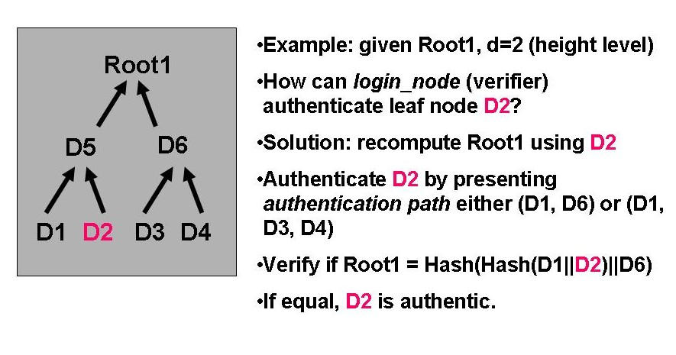
Figure 3: Authentication Path for D2 is AP(D2) = (D1, D6)

Key Generation. For the secret key (SK), generate t random l-bit binary strings, such that SK = (s₁, s₂,…, s_{t}). For the public key (PK), we use the bit-string of the secret key as a basis and follow the construction of Merkle hash trees. That is:
D₁=hash(s₁), … , D_{t}=hash(s_{t}).
Use these values (D₁, D₂, …, D_{t}) as leaf nodes to construct t/2^{d} Merkle hash trees. The roots of the trees are the public keys of our scheme.
Signature Generation. The KDC needs to generate signatures after setting up the PK and SK. The signatures and the PK will be put into the user_node after that. A random nonce (n) is generated or assigned for the user_node. Note that the use of random nonce or assigned nonce is for the purpose of message freshness. The assigned nonce could be made by the combination of valid timestamp, user_ID and KDC’s password (i.e. similar to a network key, which is known by all the login_nodes.) The KDC password could be changed periodically depending on the administration. The effective period of the password could also become one of the system parameters as well. This KDC password could be distributed over to all the login_nodes in a secure way. There are several ways to set up a secure channel. For example, a number of multiple passwords might be pre-installed on the login nodes during the sensor deployment period; another way is to set up a secure channel during system maintenance period by the service provider.
To sign a b-bit nonce n, interpret n as an integer and input it to the hash function. The output hashed value h is then split into k substrings. Here, k is a system parameter such that it determines the number of sub-root values to be included in the signatures, i.e. k-time signatures. Recall that the user will use up one sub-root or one signature for every single login. Interpret each substring in h₁,h₂,…,h_{k} as an integer. Generate one signature per each substring such that each signature will consist of one leaf node value and a set of its inter-mediate node values along the authentication path (AP). Now, the set of signatures and the public key will then be burnt into the user_node and this node will be carried by the user.

Summary 1 – Distributed UA scheme
Key Generation (at KDC centre)
Input: Parameters l,k,t
1. Generate t random l-bit strings (s₁, s₂,…, s_{t})
2. Let D_{i}= hash(s_{i}) for 1 ≤ i ≤ t
3. Group t hash values D_{1,} D_{2, …,} D_{t} into t/2^{d} groups
4. Put each group at the leaves of a Merkle tree,
constructing t/2^{d} Merkle hash trees
5. Let Root₁, Root₂,…, Root_{m} be the roots of the
Merkle hash trees (where m = t/2^{d})

Output: PK = (k, Root₁, Root₂…, Root_{m}) and
SK = (k, D_{1,} D_{2, …,} D_{t} )

Signature Generation (at KDC centre)
Input: Nonce n =(timestamp  user_ID KDC password)
and Secret Key SK = (k, D_{1, …,} D_{t} )
1. Let h = hash(n)
2. Split h into k substrings h₁,h₂,…,h_{k}
3. Interpret each h_{j} as an integer for 1 ≤ j ≤ k
4. we have k number of integers: (int₁, …, int_{k});
such that (int₁ (mod t), …, int_{k} (mod t)),
each integer index falls into range of 0..(t-1),
thus based on the integer index position,
select the D_{ij} and its association of AP nodes.
5. Let μ_{ij} = (D_{ij}, AP(D_{ij})) //a set of leaf nodes, with
its AP nodes specified.
(where  is bitwise XOR operation)
(where mod is a modulus operation)

Output: θ = (μ_{i1}, μ_{i2},…, μ_{ik} ) //signatures

User Authentication (at login_node)
Input: Nonce n, signature θ = (μ₁, μ₂,…, μ_{k} ) and
public key PK = (k, Root₁,…, Root_{m})
1. Let h = hash(n)
2. Split h into k substrings h₁,h₂,…,h_{k}
3. Interpret each h_{j} as an integer for 1 ≤ j ≤ k,
force (integer of h_{j}) (mod t)
4. Compute which Merkle hash tree (M) corresponds
to M_{j} = (integer of h_{j}) Div (2^{d}) for 1 ≤ j ≤ k
(where Div will round up to the nearest quotient
Without remainder)
5. Hash the value in each μ’_{j} to match the
corresponding root Root’M_{j}

Output: “accept” if for each Root’M_{j} = RootM_{j}
for 1 ≤ j ≤ k
Otherwise “reject” the login

Figure 4: Summary of proposed distributed UA scheme.

User Authentication. The final part is that the user is required using the user_node to interact with the nearby login_node inside the WSN when the user has a need to do queries on accessing the in-network data. In fact, this login process is simply to input all the necessary parameters to the login node, say the nonce, the signatures, and the public key. Then the login_node will do a re-computation and accept the user login if the computed root value matches the given public key. Otherwise it will reject the requested login. Fig. 4 shows a summary of our distributed UA scheme, and Fig. 5 shows the exact handshake for the login process. A simplified example is also shown in Appendix A in order to illustrate the overall workflow of this scheme.

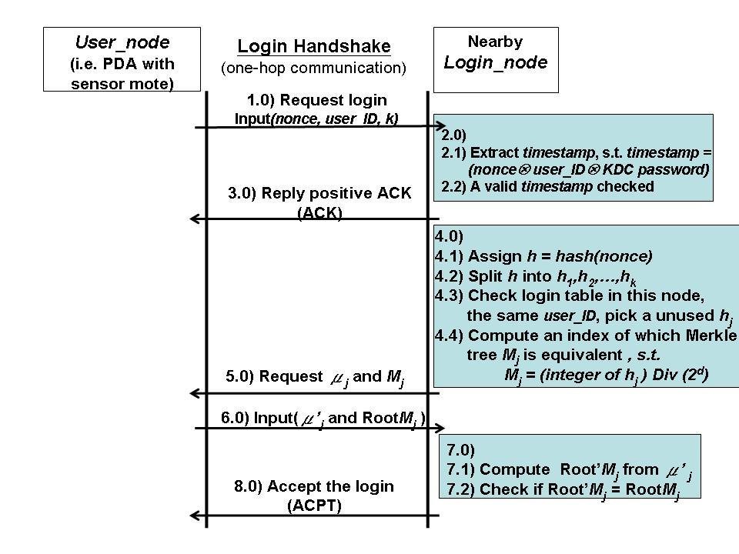
Figure 5: The login handshake between a user_node and a login_node.

4. Evaluation and Security Analysis

In this section, we describe memory requirements for sensor nodes, their performance and some security issues.

4.1 Memory Requirements

Recall that public keys and k-signatures are generated by KDC and stored onto a user sensor mote. During user authentication process, login_node needs to temporarily store the sub-public keys passed by the user_node at the very beginning of the login process. Fig. 6 shows an example of the public key size and various k-signature sizes when SHA-1 and sliding window (d=2) are used.
The numerical example shown in Appendix A is also used here to describe the memory size requirements. The following parameters are used:
- l= 80, k = 16, t = 1024, m = 256 sub-Merkle trees, SHA-1 = 160-bit output, sliding window d=2.
In general, the public key size is affected by two factors. One factor is the number of t, another is the sliding window d. The whole public key size is proportional to the number of t trunks of sub-secret keys. The public key size increases as t increases. However, the smaller of d, the larger of the public key size will be. Therefore, the sliding window that d equals to 2 will be the upper bound to produce the largest public key size; since this produces the largest number of sub-Merkle trees (m). Note, d equaling to 1 is not considered to be a valid parameter in our protocol.

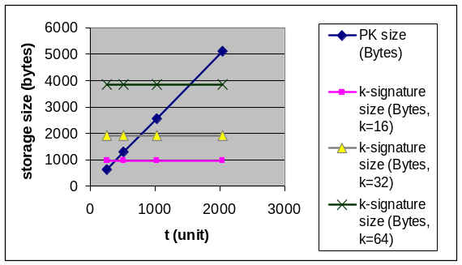
Figure 6: Storage sizes for Public Key (PK) and k-signatures with SHA-1 and d=2 used.

Regarding k signatures, each signature is a fixed size, i.e. (D_{j}, AP(D_{j})), thus they show a horizontal straight line for various k-signatures in Fig. 6. The k signatures will consume the memory size of around 1, 2, or 4-Kbyte for 16, 32, or 64-signature schemes respectively. These memory sizes are acceptable for a user node. Furthermore, if t is picked as 1024, the whole public key size per user is about 2.5 Kbytes. Thus, a login_node with a 128-Kbyte of Micaz sensor mote [10] is able enough to support multiple users logging in simultaneously.

4.2 Security Analysis

Replay Login Attack. The proposed UA scheme can effectively defend against the replay attack. The to-be-verified leaf node and its authentication path are disclosed from eavesdropping during the login communication, but they are only used one-time. The next login will use another set of leaf node and its authentication path. Second, the timestamp embedded into the nonce also serves to safeguard the freshness of the signatures that might be possibly reused at later time on another day.
Denial of Service Attack (DoS). An attacker might masquerade multiple fake identities pretending multiple users for logging in simultaneously. She keeps sending many login requests to a login_node. By examining the nonce, which is protected by KDC’s password, the login_node might have a chance to differentiate the invalid timestamps from the fake login requests. However, there is no guarantee to discover under this scenario. The login service will definitely be degraded; and the login_node should be smartly programmed to send an alert message to the KDC and ignore the login service for a short while.
Login Node Compromise. Node compromise cannot be prevented in unattended mote operations after deployment of a sensor network. There is no exception for our protocol to be prevented from this attack in the meantime. However we try to minimize this effect by two reactions. One is performed by frequent health checks on login nodes periodically. The health check could be done by software tool, since it is assumed that login_nodes should be protected physically with stronger tamper resistance. Second, it is to use a number of KDC pseudo-passwords on a sensor mote that the attacker may need a longer time to find out the current KDC password. Nevertheless, we need to consider more security options to address this issue in our future work.

5. Implementation

We have implemented the UA protocol on MICAZ [10] motes with TinyOS [11]. In order to evaluate our protocol, we set up a testbed and perform some experiments with different key length. The testbed is composed of a gateway, which acts as a KDC, a few login nodes and some user nodes. In this section, we describe the design, implementation and experimentation details of the testbed.

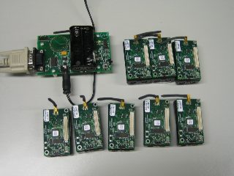
Figure 7: The testbed

5.1 Testbed Components

Gateway. The gateway acts as a KDC and is responsible for accepting registration requests from user nodes and delivering public keys to login node for verifying the users. In the testbed, a Java program is written to perform these operations. The architecture of the program is shown in Figure 8.

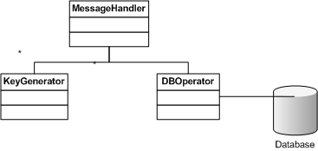
Figure 8: Gateway program architecture

The KeyGenerator uses a Java implementation of MD5 algorithm as the hash function to construct the Merkle Tree. The MessageHandler module is used to accept incoming requests and distribute the keys. The module is capable of packet fragmentation since the generated key pair can sometimes be very large. The gateway is connected to a backend database for storing and retrieving public keys.
Login Node. Login nodes are entrances of the system to which user nodes may submit their login requests. Both login nodes and user nodes are programmed in NesC [12] and their architecture is shown in Figure 9.

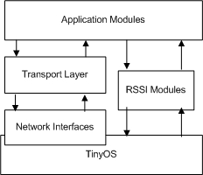
Figure 9: Sensor node program architecture

We develop a couple of RSSI modules for initiating the handshake process. The login nodes listen to the beacon messages sent by the user nodes. When a user node is detected closer than a threshold, the login node will initiate the handshake process by sending out a hello message.
The transport layer is used to recover fragmented data sent by the gateway. It makes use of the interface provided by the underlying routing modules [13] and can be easily ‘wired’ to different routing protocols.
The application modules for login nodes include the handshake protocol and a ported MD5 module from C [14]. The MD5 module is used to verify the user node based on the authentication path provided.
User Node. The user nodes must perform registration with the gateway before they can log into the system. Similar to login nodes user nodes make use of the transport layer modules to receive the keys from gateway. They have RSSI beacon module in order to send beacon messages to the login nodes.
The application modules for user nodes implement the handshake protocol and the sliding window user authentication scheme discussed in section 3.

5.2 Experiments

We have run a couple of experiments on the testbed to show the effectiveness and efficiency of the system. The experiments focus on the two most important operations the system, registration and login.
Registration Time. We measure the average registration time by letting one login node register with the gateway at the highest possible speed. We run the experiments with different Merkle tree levels ranging from 4 (64-bit secret key) to 32 (512-bit secret key). The results are shown in Figure 10.

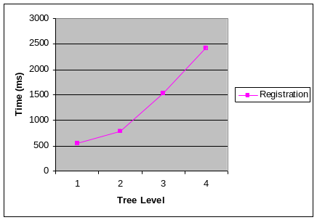
Figure 10: Average registration time

As shown n the figure, the registration time increases quickly when the tree level increases. This is because the number of nodes in a tree increases exponentially when the tree level increases so it takes longer time to transmit the keys to the login sensor node. Fortunately, with larger tree levels, users may log into the system for more times after a single registration. It is also more secure by using larger tree levels.
Login Time. The login time is measured by letting one login node log into the system at the highest rate. The login time is dependent on the underlying routing protocols because public keys need to be delivered from KDC to the log in nodes. In our experiments, we only consider the single hop scenario which measures the time directly related to our UA protocols. The results are shown in Figure 11.

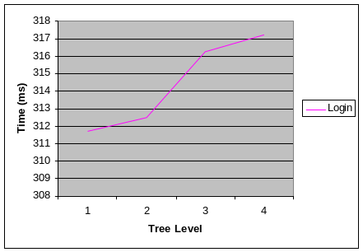
Figure 11: Average login time

Compared with the registration time, the login time increases very little when the tree level increases because the number of calls to the hash function is linear to the tree level and the execution time of the hash function is small compared with the network delay for delivering the public keys. In our experiments, the login time is around 0.3 second for all cases.

6. Conclusion

7. Acknowledgment

8. References

- N. Gura, A. Patel, A. Wander, H. Eberle, S.C. Shantz. “Comparing Elliptic Curve Cryptography and RSA on 8-bit CPUs,” In 6th International Workshop Cryptographic Hardware and Embedded Systems (CHES 2004), Cambridge, MA, USA, August 2004.

- I. Krontiris and T. Dimitriou. “Authenticated In-Network Programming for Wireless Sensor Networks”, In 5th International Conference on AD-HOC Networks & Wireless (Adhoc-Now 2006), Ottawa, Canada, August 2006

- R.C. Merkle. “A certified digital signature.” In Proceeding on Advances in Cryptology (CRYPTO 1989), Springer-Verlag, New York, 1989, pp. 218–238.

- Adrian Perrig. “The BiBa One-Time Signature and Broadcast Authentication Protocol.” In Eighth ACM Conference on Computer and Communication Security, ACM, November 2001, pp. 28–37.

- L. Reyzin and N. Reyzin. “Better than BiBa: Short One-Time Signatures with Fast Signing and Verifying.” In Seventh Australasian Conference on Information Security and Privacy (ACISP 2002), September 2002.

- Douglas Stebila. “Slightly Improved Merkle Tree Traversal for User Authentication Using Pseudorandomly-Generated Leaves”. Research Note, Online, 2006.

- Haodong Wang and Qun Li. “Distributed User Access Control in Sensor Networks,” IEEE International Conference Distributed Computing in Sensor Systems (DCOSS 2006), San Francisco, CA, USA, June 2006, LNCS 4026, Springer-Verlag, pp. 305–320.

- Kirk Wong, Y. Zheng, J. Cao, and S. Wang. “A Dynamic User Authentication Scheme for Wireless Sensor Networks,” IEEE International Conference Sensor Networks, Ubiquitous and Trustworthy Computing (SUTC 2006), Taichung, Taiwan, June 2006.

- Yun Zhou, Yanchao Zhang, and Yuguang Fang. “Access Control in Wireless Sensor Networks,” Ad Hoc Networks, Volume 5, Issue 1, January 2007, pp. 3–13

- Micaz sensor mote datasheet, Crossbow Technologies. http://www.xbow.com/

- TinyOS website: http://www.tinyos.net/

- David Gay, Philip Levis, Robert von Behren, Matt Welsh, Eric Brewer, and David Culler. The nesC Language: A Holistic Approach to Network Embedded Systems. Proceedings of the ACM SIGPLAN 2003 Conference on Programming Language Design and Implementation (2003)

- Philip Levis et al., "Ad-Hoc Routing Component Architecture", Feb. 2003, http://www.tinyos.net/tinyos-1.x/doc/ad-hoc.pdf

- RFC1321-based (RSA-free) MD5 library: http://sourceforge.net/project/showfiles.php?group_id=42360

9. Appendix A

In this appendix, we make use of a simplified numerical example to illustrate the overall workflow for the distributed UA scheme.

Width of a sub-string: l = 80-bit;
Number of Merkle sub-trees: k = 16;
Number of sub-strings: t = 1024;
Number of leaf nodes
for each Merkle sub-tree: m = 2^{d} = 4;
(height of sliding window, let d=2)
Hash function used: SHA-1 = 160-bit

Key Generation:
Input: (80, 16, 1024)
1. (s₁, s₂,…, s₁₀₂₄)
2. D₁= hash(s₁), …, D₁₀₂₄= hash(s₁₀₂₄)
3.1024 hash values into 1024/4 = 256 groups;
i.e. 256 Merkle sub-trees.
4. Root₁ … … Root₂₅₆
/ \ / \
E₁ E … E₅₁₁ E₅₁₂
/ \ / \ / \ / \
D₁ D₂ D₃ D₄ … D₁₀₂₁ D₁₀₂₂ D₁₀₂₃ D₁₀₂₄

Output:
PK = (16, Root₁, Root₂…, Root₂₅₆) and
SK = (16, D_{1,} D_{2, …,} D₁₀₂₄ )

Signature Generation
Input: Nonce n = (timestamp  user_ID KDC password)
= (200704021400 10005 1231587)
= 200705230183
SK = (16, D_{1,} D_{2, …,} D₁₀₂₄ )
(Note, the timestamp value can be replaced by a random number for a different implementation.)

1. h = hash(200705230183) //output in 160-bit
2. split 160-bit output into k=16 sub-strings,
then each sub-string is 10-bit, (h₁,h₂,…,h₁₆ )
3. 2¹⁰ = 1024;
each h_{j} is a number in between 1..1024;
let say, we have h₁=105, h₂=500,…,h₁₆=1;
4. Equivalently, we choose 16 leaf nodes, each with this integer as an index, i.e. (D₁₀₅, D₅₀₀, …, D₁ )
5. μ_{ij} = (D_{ij}, AP(D_{ij}))
= ((D₁₀₅, AP(D₁₀₅)), (D₅₀₀, AP(D₅₀₀)) , …,
(D₁, AP(D₁)))

Output: θ = (μ_{i1}, μ_{i2},…, μ_{ik} ) //got 16 signatures
= ((D₁₀₅, AP(D₁₀₅)), (D₅₀₀, AP(D₅₀₀)) , …,
(D₁, AP(D₁)))

User Authentication
Input: n = 200705230183;
θ = ((D₁₀₅, AP(D₁₀₅)), (D₅₀₀, AP(D₅₀₀)) , …,
(D₁, AP(D₁)))
PK = (16, Root₁,…, Root₂₅₆)

1. h = hash(200705230183)
2. let (h₁,h₂,…,h₁₆ ) = (105, 500,…,1)
3. check the login table in memory, with the same
User_ID, pick a unused h_{j}, say now we pick h₁₆= 1
4. compute the index of which Merkle tree to be
authenticated;
index = (integer of h₁₆ ) Div 2^{d}
= 1 Div 4
= 0 (have remainder, thus need a round up)
= 0 + 1 = 1;
thus Merkle tree of M₁ is to be authenticated.
5. Request user_node to submit ((D₁, AP(D₁)) , M₁)
6. Then user_node replies:
((D’₁, AP(D’₁)=(D’₂, E’₂)), M₁=Root₁)
7. The login_node computes the M’₁ from
(D’₁, (D’₂, E’₂)) to get Root’₁

Output: if Root’₁ = Root₁ Accept login
otherwise Reject login.

