Top K-leader Election in Mobile Ad Hoc Networks

Vaskar Raychoudhury¹, Jiannong Cao¹, Weigang Wu², Yi Lai¹

¹ Department of Computing, The Hong Kong Polytechnic University, Kowloon, Hong Kong
² Department of Computer Science, Sun Yat-sen University, Guangzhou, 510275, China

Abstract—In this paper, we propose a distributed protocol to elect the top K leaders among the nodes in a wireless ad hoc network. Leader election is a fundamental distributed coordination problem arising from many applications, e.g. token regeneration, directory service. However, there is no deterministic protocol proposed for electing k leaders. In our protocol, election is based on the weight values of the nodes, which can represent any performance related attribute such as the node’s battery power, computational capabilities etc. To achieve message efficiency, coordinator nodes are first selected locally and then the coordinator nodes collect the weight information of other nodes using a diffusing computation approach. The coordinator nodes collaborate with each other to further reduce the message cost. Node failures are also considered in our design. The simulation results show that, compared with a naive solution, our proposed protocol can elect top K leaders with much less message cost.

INTRODUCTION

Mobile wireless networks fundamentally differs from the traditional wired distributed networks on the grounds of frequent and unpredictable topology changes, limited energy supplies and highly variable message delays. These characteristics make the design of distributed algorithms for wireless networks more challenging than the traditional distributed systems. Resource constraint, in terms of, low processing power, insufficient memory size, limited energy supply or low network bandwidth, are prime concerns for mobile computing environments [1], [2]. To minimize the quick dissipation of available resources, one viable solution is to use fewer messages which imply consumption of less bandwidth as well as lower processing overhead. So, reduction in message cost is an important issue while designing distributed algorithms for mobile ad hoc networks.
In this paper, we design efficient protocols to solve the K-leader election problem in the context of mobile wireless environment. Traditionally, the leader election problem arises from many distributed applications that require one or more nodes to act as coordinators (for, mutual exclusion, synchronization, concurrency control, etc.), initiators, or perform some special role, e.g. directory server or token regenerator. Typically, the leader election problem is to elect a unique node to play a particular role [8]. Leader election in traditional distributed environment is a widely researched topic. Due to the dynamic characteristics of wireless ad hoc networks, leader election in ad hoc networks is a challenging problem. Here, we study, the weighted K-leader election problem in wireless ad hoc network environments, which aims to elect a number K of leaders with the top K highest weight values. Considering mobility and resource constraint of nodes in a MANET, we adapt the leader election problem for electing K leaders in MANET. The correctness criteria of the modified K leader election problems are as below:-

- Liveness: every connected component will eventually select K nodes as the leaders.
- Safety: each of the elected leaders should be among the top K nodes according to the weight value.

The modified liveness criteria arise from the need to cope with frequent topology changes during and after the election process. Topology changes are attributed to node mobility and can cause network partitions as well as partition merges. All these dynamicity may lead to situations where there are more or less than K leaders in the environment or different nodes have different set of K leaders. To overcome these problems in a dynamic network, our liveness property requires that every connected component will eventually select K leaders. The modified safety criteria aim to elect a number K of leaders with the top K highest weight values. The weight is an abstract property and can be used to refer to any required attribute of a node, e.g. remaining battery power, memory size, processing capacity, etc. The weight-based election will ensure higher life time and processing capability of the elected leaders making them more reliable and less fault prone.
Although, several solutions have been proposed to solve the leader election problem in traditional distributed environment, existing leader election protocols can not satisfy the requirements of electing leaders in a wireless ad hoc environment. While some of the existing leader election protocols assume a static topology (e.g., [15][16][17][18][19] [20][21][22]), others assume that no topological changes takes place during an election ([13][3]). For the protocol proposed in [10], it is for infrastructure networks where the election is in fact done by the wired part of the network using Garcia Molina’s bully algorithm [6]. Moreover, there are some leader election protocols which adopt communication models unsuitable to a dynamic and ad hoc environment, such as, message-order preserving network, or reliable broadcast support [4].
Talking about the K-leader election protocols for mobile ad hoc networks, so far, there is no protocol designed for such systems. Several leader election protocols [7], [8], [9], [14], [23] have been proposed for ad hoc networks to select a single leader. These protocols are designed to perform random node election and cannot be modified to perform weight-based K-leader election.
Compared with existing work, our proposed protocol has the following two features. First, we do not assume a unique weight value for each node. In our design, nodes can have same or different weight values. Such an assumption is reasonable and necessary for electing nodes with some desirable property, e.g. memory size. Second, except one-hop neighbors, we do not assume a node know other nodes in the network. This is inspired by the observation that an ad hoc network is high dynamic and auto-configured and a node knows all other nodes in the network is infeasible. With the above two features, much more challenges arise in the design of leader election protocol and existing solutions can not work at all.
Following the liveness property, we know that, every connected component in the network, will eventually select K nodes as the leaders. Based on that, we make the following two assumptions for our K-leader election protocol –

- Assumption 1) every node in a connected component will have the same set of K-leaders, and
- Assumption 2) absence of one or more leaders in a connected component will necessitate a re-election of all the K-leaders for that component

Our proposed K-leader election protocol uses a diffusing computation-based approach. When an election is triggered at a node, the node starts executing our algorithm and involves all the nodes in the environment to come up with some coordinator nodes highest among their 2-hop neighbors. Those coordinator nodes then start diffusing computation to collect the weight values of a subset of nodes in the environment. When the diffusing computation is finished, the coordinator nodes exchange their partial results, in such a way, that the highest weight coordinator has the weight information about all the nodes in the network. It then chooses top K weighted leaders. An election can be triggered at a node either because the node lost connection with one or more of its leader or because the weight of one or more leaders fall below some application defined threshold.
The primary contributions of this paper are the following:

- We present a weight based K leader election protocol that operates asynchronously in a mobile ad hoc network and can adapt to dynamic and frequent topological changes. To the best of our knowledge, this is the first protocol of this kind. We also provide theoretical proof that the protocol satisfies the required correctness criteria.
- To evaluate the performance of our proposed protocol, we have carried out extensive simulations and present our results with in-depth analysis.
- We also developed a testbed system using wireless sensor nodes and implemented our protocol on the testbed. The experiment results are in congruence to our simulation results which goes to prove that our protocol works efficiently in the real scenarios.

The rest of this paper is organized as follows. Section II reviews existing leader election protocols, including both the election of one leader and K leaders. Our proposed top K leader election protocol is presented in Section III, including data structures and operations. We also discuss some modified fault tolerant version of our protocol along with some optimization procedures. The correctness proof of our protocol has been presented in Section IV. Section V reports our performance metrics and simulation settings along with the simulation results. We have reported our testbed structure and testing results in Section VI. Finally, Section VII concludes that paper and points the directions of our future works.

RELATED WORK
Although leader election is a well-known research problem in distributed computing, very little work has been carried out for leader election in mobile ad hoc networks.
Many leader election protocols have been proposed for static networks, e.g., [17], [18]. These protocols work by constructing several spanning trees with a prospective leader at the root of the spanning tree and recursively reducing the number of spanning trees to one. However, these protocols work only for the static topology and hence cannot be used in a mobile setting.
There have been several protocols for clustering and hierarchy- construction ([15][16][19][20][21][22]) that can be adapted to perform leader election. However, these protocols either assume static networks or assume a synchronous system and therefore cannot be used in an asynchronous, mobile system.
Several leader election protocols ([3][4][13]) proposed for wired networks assume process crashes and link failures and are therefore close to our considerations. However, while [3] and [13] assumes process failures occur before election starts, election protocol described in [4] requires that every message be reliably broadcast to all other nodes and that the network be message order-preserving i.e., a message m sent by a node i at time t is received by all nodes before another message m’ sent by node j at some instant t’>t. Such assumptions are very strong for dynamic and ad hoc mobile environments.
There has been some work on spanning tree construction in the domain of self-stabilizing systems [24] that is related to our work. Informally, a self-stabilizing system is one that can recover from any arbitrary global state and reach a desired stable global state within finite time. Self-stabilizing spanning tree algorithms have been proposed in [25], [27], and [28]. However, these algorithms assume a shared-memory model and are not suitable for a message passing system such as an ad hoc network. In particular, in a message-passing system these algorithms cannot be terminating [26], i.e., they do not reach a state in which all program actions are disabled; instead nodes have to exchange infinitely many messages to detect that a stable state has been reached.
Leader election protocols for ad hoc networks are proposed in [7][8][9][12][14]. Based on the routing protocol named TORA [11], Malpani et al developed an election protocol [8]. As stated earlier, we are interested in a weight-based K leader election protocol, because of the applications discussed in Section 1. The protocols presented in [8] are not weight-based leader election and cannot be extended to perform weight-based election. In the protocols in [8], a node that detects a partition in the network gets elected as the leader and a partition can be detected by any “random” node. Also, no proof of correctness of their algorithms has been provided for the case of concurrent topological changes. Although, weight-based leader election algorithms for mobile ad hoc networks have been proposed in [7], these algorithms are unrealistic as they require nodes to meet and exchange information in order to elect a leader and are not well-suited to the applications discussed earlier. Two randomized protocols for single-hop and two-hop single channel MANETs are presented in [9]. In these protocols, the leader is elected by the collision state of the channel in which the MHs emitting signals randomly and synchronously. Sundramoorthy et al. [12] design a leader election protocol to solve the dynamic directory election problem in service discovery environment. Several clustering algorithms have been proposed for mobile networks ([29][30]), but these algorithms elect cluster heads only within their single hop neighborhood.
There is also a weight-based leader election protocol proposed [14] for mobile ad hoc networks which considers concurrent topological changes and adopts the well-known diffusing computation approach proposed by Dijkstra and Scholten [5]. The protocol works by constructing a spanning tree of the network nodes, and then gradually shrinking the tree, by allowing every node to report their highest weight downstream node to their parent in the tree, so that, eventually, the root of the tree will know the highest weight node in the environment and select it as the leader. The authors have proposed an extension of their protocol for electing K leaders, by which nodes in each level select K highest weight nodes among their downstream nodes and report to the parent. If K is a fixed number, this method can not guarantee exactly K leaders for all the connected components, in case the network gets partitioned. We, on the other hand, employ a ratio based approach where N/K equals to a fixed number greater than 1, where N is the total number of nodes in a connected network component. Moreover, in their protocol, several nodes can start diffusing computation in response to the departure of a leader and hence, multiple diffusing computations can be in progress concurrently. Our protocol stalls multiple diffusing computations by selecting a handful of coordinator nodes, only which will carry out diffusing computations. This approach proves economical in terms of message cost.
The main contributions of this paper are thus the design of an efficient asynchronous protocol for weight-based K-leader election in mobile ad hoc networks which can adapt to arbitrary topological changes.

THE K-LEADER ELECTION PROTOCOL

System Model and Assumptions
The K leader election problem is considered in a MANET that consists of a set of n (n>1) mobile nodes, each of which has a unique ID. The nodes communicate by sending and receiving messages through wireless channels. A node only knows the IDs of its neighboring nodes. Whether two nodes are neighbors, i.e. they are directly connected, is determined by the signal coverage range and the distance between the nodes. Each node is a router and the communication between two nodes can be multiple hops. A node may fail by crashing, i.e. prematurely halting, but it acts correctly until it possibly crashes. A mobile node that crashes in a run is called a faulty node; otherwise, it is correct. Each node has a weight associated with it. The weight of a node indicates its ability as a leader of the network and can be any performance related attribute such as the node’s battery power, computational capabilities etc. Two nodes may have the same weight value. We assume random message delay and no message order preservation.

Data Structures and Message Types
When executing our protocol, each node i maintains necessary information about its state, which is stored in the following data structures.

Table 1: Data Structures
Variable | Meaning
id | Identifier of node i
wt | Weight of node i
color | Color of node i = {WHITE, RED}
visitor | Identifier of RED node which visits node i
nbr | Set of immediate (1-hop) neighbors of node i
pred | Predecessor of i in the diffusion tree
succ | Successors of i in the diffusion tree
in_electn | A binary variable indicating if node i is currently in an election or not
lid | A binary variable indicating if node i is leader or not
ResultQ | List of nodes visited by node i during diffusing computation
RedQ | List of RED nodes known to node i during diffusing computation
LDR | List of K leaders of node i and their weights

The following types of messages are exchanged between nodes in our protocol.

Table II: Message Types
Message | Purpose
ELECT(i,wt_{i}) | node i sends to its neighbors to exchange weights
VOTE(i) | a node votes its highest weight neighbor i
SEARCH(i, v) | for growing the diffusion tree initiated by RED node i. When a node forwards SEARCH to its neighbors it includes the node v to whom it sent vote.
ACK() | exchanged between nodes visited by same RED node to acknowledge SEARCH sent by each other
NACK(i, wt_{i}) | exchanged between nodes visited by different RED nodes, to acknowledge SEARCH sent by each other, by informing their respective visitor’s id and weight
SIGNAL(RedQ_{i}, ResultQ_{i}) | node i sends to its predecessor in response of the SEARCH message received
DIRECT(i, wt_{i}) | a RED node directs all but the highest weight RED node in it’s RedQ to send their RESULT to it’s highest weight RED node i. This message is used for exchanging the RED node information
RESULT(P, ResultQ_{i}) | a RED node sends ResultQ to it’s highest weight RED node. P is the set of RED nodes to which DIRECT was sent. This message is used for converging the network-wide node information in a single RED node
LEADER (LDR) | the highest weight RED node sends to all other nodes to announce the new set of K leaders

K Leader Election in Static Networks
We first describe the basic operations of our protocol in a static network without considering node mobility. Later we shall elaborate the operations of the protocol in mobile ad hoc environment considering node mobility and concurrent topological changes.
Our proposed protocol adopts the approach of diffusing computations [3] to perform K-leader election. The protocol operates in three phases. In phase I, one or more nodes having highest weight among their 2-hop neighbors are voted as RED nodes. Other nodes are called WHITE nodes. Then, in phase II, the RED nodes start the diffusing computation procedure asynchronously and build individual diffusion trees. The diffusing computation is aimed at collecting weight values of all the nodes in the network. To save message cost, a WHITE node is allowed to be included in the diffusion tree of only one RED node. Finally, in Phase III, all the RED nodes coordinate among themselves, and the results collected by different RED nodes are merged, in such a way, that, eventually the highest weight RED node receives the complete weight information of all the nodes in the network. It then chooses K highest weight nodes and designates them as leaders.
Phases in our protocol are completely asynchronous. Different nodes can be in different phases at the same time without any global knowledge. When a node receives messages from some lower phase than the current phase it belongs, it simply ignores the message. E.g., when a node is in phase II and it receives an ELECT message exchanged in phase I, it discards the ELECT message. But when nodes receive messages from higher phases, there must be some way to handle it. We have developed certain policies to deal with messages received from higher phases which we will describe after briefing the operations of the three different phases.

Phase I
Initially every node in the network sets its color to WHITE. When a new election starts, nodes will set in_electn to 1. Every node then sends an ELECT message containing its weight to all its 1-hop neighbors. After a node receives the ELECT messages from all its neighbors, it votes for the highest weight neighbor by sending a VOTE message to that node and then it enters phase II. A node must send ELECT to all its neighbors and received ELECT from all its neighbors before deciding on whom to VOTE as well as before entering phase II. If a node receives a VOTE message from each of its neighbors that means the node is highest among its 2-hop neighbors. It then changes its color to RED and enters phase II. We call such a node as a RED node. Rest of the nodes are WHITE nodes.
Some nodes are higher in weight than their 1 hop neighbors, but not the highest among 2-hop neighbors. Such nodes can not enter phase II as they do not send VOTE to a neighbor or receive VOTE(s) from all the neighbors. These nodes will enter phase II when they receive a SEARCH message sent by a RED node in phase II.
Some nodes may receive VOTE from one or more neighbors before they receive all ELECT messages from all their neighbors. They will collect those VOTE messages until the final decision is made.
Nodes in phase I may also receive SEARCH message from phase II. Consider such a node i which has not received all ELECT messages from its neighbors but receives a SEARCH message from one of it neighbors. Node i will ignore the SEARCH message. This is because, the SEARCH message must have been sent from one of its neighbors which has sent all its ELECT messages and has entered phase II. If one or more other nodes have not sent ELECT yet, that means, they have not entered phase II. So, node i will receive further SEARCH messages from them in future. In this case, node i will wait till the last neighbor has sent the SEARCH message to it before joining to a diffusing computation tree. If still all ELECT do not arrive, then simply the messages are delayed, and node I will join the neighbor who sent the last SEARCH message.
If a node i has received all ELECT messages and is waiting for VOTE messages, and in the mean time, it received a SEARCH message from its neighbor j, then it will check whom j voted. If j did not VOTE i, then i will enter phase II, attach to j and forward the SEARCH message to others.
Since we consider that two or more nodes can have identical weights, in order to create a total ordering among all the nodes, we use the <id, wt> tuple. So, if more than one node has the same weight, then the one with the higher id is selected over the other. E.g., if there are two nodes p and q with <id, wt> tuple, <1, 10> and <2, 8>, respectively, then node p is the higher weight node. But, if p and q has tuples like <1, 10> and <2, 10>, respectively, then node q is selected over p.
At the end of Phase I there are one or more RED nodes in the network, but they do not know each other. It is not necessary that all other WHITE nodes have less weight than the RED nodes. So, a second phase has been designed to collect weights of all the nodes in the network.

Phase II
In Phase II, each RED node r starts a diffusing computation separately and unaware of the others. Each RED node then grows a diffusion tree rooted at it by sending a SEARCH message to all of its 1-hop neighbors. The initiating RED node of a SEARCH message is called the root of the SEARCH message. Each node i, other than a RED node, designates the neighbor from which it first receives a SEARCH message as its predecessor in the diffusion tree and the RED root of the SEARCH message as the visitor. Node i then propagates the received SEARCH message to all of its neighboring nodes except its predecessor. Node i, does not, however, immediately return a SIGNAL message to its predecessor. Instead, it waits until it receives ACK, NACK or, SIGNAL messages from all the nodes to which it has sent SEARCH message. In our protocol, SIGNAL message sent by node i to its predecessor contains node weight information received by i from its children.
When node i receives a SEARCH message from a neighbor j that is not its predecessor, it will check the root of the SEARCH message. If the root is same as the visitor of node i, then i will send an ACK to node j, otherwise, i will send a NACK to j embedding its visitor id and weight. Upon receiving a NACK message, from a neighbor node i, node j will include the information of visitor of i, in its RedQ_{j}.
After the diffusion trees of different RED nodes meet each other they stop propagating any further. The tree shrinking starts from the boundary nodes of adjacent trees which are parent of no other nodes. Eventually, the boundary nodes receive either ACK or NACK messages for the all the SEARCH messages sent by them.
There are also some leaf nodes which are at the periphery of the network and have no other neighbor nodes to send SEARCH message. These nodes eventually send their pending SIGNAL message to their predecessors, who in turn, send their pending SIGNAL messages to their own predecessors, and so on, until the root of the diffusion tree receives all of its pending SIGNAL messages. In its pending SIGNAL message a node incorporates its own weight to the set of weight values (ResultQ) received from all its child nodes through their SIGNAL messages. Each node also includes the id and weight of all the RED nodes (RedQ) known to it through the NACK messages. Hence, the root RED node will eventually have the weight information of all the nodes in its diffusion tree and also the knowledge of the RED nodes in the adjacent diffusion trees. At the end of phase II, every RED node knows one or more other RED nodes and has visited a subset of nodes in the network. In case, there is only one RED node in the environment, the node can select the top K highest weight nodes and declare them leaders. Phase III will only be carried out if there are multiple RED nodes in a single connected network component.
During phase II, a node may receive message(s) from phase III. Suppose a RED node i, which is still ongoing diffusing computation, received a RESULT or DIRECT message from another RED node in phase III. It will handle the received message(s) (as described in the description of phase III) but will not send any RESULT or DIRECT until it enters phase III.

Phase III
In phase III, the RED nodes exchange their partial knowledge of the weight values of nodes visited in such a way that, at the end, only the highest weight RED node receives the global knowledge about all the nodes in the environment. This RED node then selects the K highest weight nodes in the environment.
In phase III, there are mainly two types of messages – DIRECT and RESULT exchanged between the RED nodes. When a RED node enters phase III, it will check the weights of all nodes in its RedQ, and will clearly identify the lower weight and higher weight nodes than itself. Among all higher weight nodes, all but the highest weight node are called intermediate nodes.
Every RED node waits for all the lower weight nodes to send either RESULT or DIRECT messages. RED nodes having no lower weight RED nodes will send their ResultQ to their highest weight RED node via a RESULT message. Upon receiving a RESULT from node i, node j will insert the ResultQ_{i} into its own ResultQ_{j}, and will delete i from its RedQ_{j}.

/********************PHASE 1***********************/

//The code executed by each node, i
(0) color_{i} ← WHITE, pred_{i} ←NULL, visitor_{i} ←NULL,
out_{i} ← 0, RedQ_{i} ←NULL, ResultQ_{i} ← NULL;
(1) send ELECT (i, wt_{i}) to all the neighbors in nbr_{i};
(2) wait until an ELECT message is received from each neighbor;
(3) send VOTE(i) to j, where j is the the highest weight node in nbr_{i};
(4) wait until a VOTE received from each node in nbr_{i} or
a SEARCH message is received;
(5) if (a VOTE received from each node in nbr_{i}) color_{i} ←RED;

/********************PHASE 2***********************/

//This part is executed by each node i
(6) if (color_{i} = RED)
send SEARCH(i, v) to each node j in nbr_{i};
(7) when SEARCH(i, v) is received from node j
(8) if (visitor_{i} = NULL) {
visitor_{i} ← l; pred_{i} ← j; insert i into the ResultQ_{i};
succ_{i} ←nbr_{i} \{pred_{i}}; send SEARCH(i, v) to nbr_{k};}
(9) else {//assuming visitor_{i} =k
if (k= l) send ACK() to j;
else{
send NACK(k, wt_{k}) to i; put (k, wt_{k}) into RedQ_{i};
send SIGNAL(RedQ_{i}, ResultQ_{i}) to pred_{i};
}}
(10) wait until an ACK or NACK or SIGNAL received from
each node j in succ_{i}{
if (pred_{i} =0) GoTo Phase III;//this is the starting RED node
else{
merge RedQ_{j} into RedQ_{i}; merge ResultQ_{j} into ResultQ_{i};
send SIGNAL(RedQ_{i}, ResultQ_{i}) to pred_{i};}

/********************PHASE 3**********************/

//This part is executed by each RED node i
(11) if (wt_{i} =min(RedQ_{i}) ){
k← max(RedQ_{i}); P← RedQ_{i}\{k};
send DIRECT(k, wt_{k}) to each node in P;
send RESULT(|P|, ResultQ_{i}) to k;}
(12) else{
P← RedQ_{i}\{k|wt_{k}≥wt_{i}};
wait until a RESULT or DIRECT received from each j in P;
for (a RESULT(Q, ResultQ_{j}) from j) {
merge ResultQ_{j} into ResultQ_{i}; merge Q into RedQ_{i};
delete j from RedQ_{i};}
for (a DIRECT(k, wt_{k}) from j){
put k into RedQ_{i}; delete j from RedQ_{i};}
if(|RedQ_{i}|>1){
m←max(RedQ_{i});
send DIRECT(m, wt_{m}) to nodes in RedQ_{i}\{m};
send RESULT(ResultQ_{i}) to m;}
else{
sort the nodes in ResultQ_{i} based on their weights;
LDR ← top K of ResultQ_{i};
send a LEADER(LDR) message to nodes in LDR;
}
}

Figure 1. Pseudo-code of the Protocol

After all the lower weight RED nodes have sent their RESULT or DIRECT message, node j will send its own highest weight RED node information to each of the intermediate RED nodes in its RedQ_{j}, via a DIRECT message, asking them to directly send their RESULT(s), without waiting for RESULT from itself. After that, node j will send its own RESULT to the highest weight node in its RedQ_{j}. Upon receiving a DIRECT message from node j, node i will insert the highest weight RED node of j in its RedQ_{i}, unless it is already there, and will delete j from its RedQ_{i}.
After a RED node has received RESULT or DIRECT messages from all lower weight RED nodes and have no other RED node in its RedQ except itself, then it is the highest weight RED node and is known as elector. The elector then sorts its ResultQ and selects the top K nodes according to the weight values, as K leaders. It then sends a LEADER message containing the list of K leaders (LDR) to all the other RED nodes, who, in turn, will forward the message to their diffusion tree members. Any node receiving the LEADER message will set in_electn to 0 and will check whether its own id appears in the list of K-leaders, or not. In case, it does, the node will set lid to 1.

K-leader Election in Dynamic Networks
In this section we consider K leader election in mobile ad hoc network considering concurrent topological changes. Nodes can freely move across the terrain which may result into network partitions as well as partition merges.

- Handling Network Partition

During an ongoing election, network partition may occur. This may cause a node to wait forever to receive ACK, NACK or SIGNAL message from child nodes which have been partitioned.

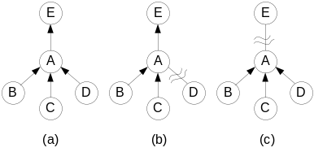

Figure 2(a) – An Example Diffusing Computation Tree,
Figure 2(b) Partition of Child Node D of Node A,
Figure 2(c) Partition of Parent E of Node A

For e.g., in Fig. 2(a), node D is a child of node A and node A waits to receive SIGNAL from D. In Fig 2(b), node D got partitioned and it can no longer send its SIGNAL to node A. If node A can not detect this incident, it may keep on waiting forever. To resolve this issue, we use the well-known probe-reply mechanism between the parent and child nodes. Node A will start a timer for each neighboring node after sending the SEARCH message to its neighbors and wait for receiving ACK, NACK or SIGNAL message. In case, the timer expires before the message arrives, node A will probe the neighbor node which failed to send a reply. If consecutive probing can not fetch any reply, the child node will be deleted from the set of successors (succ).
Similar incident has been illustrated in Fig. 2(c) where node A receives SIGNAL from child nodes B, C, D, but can not reach its own parent node E. In this case also, node A needs to detect that E has been partitioned and should terminate diffusing computation.

- Handling Partition Merges
Node mobility may cause network partitions to merge at times. When two partitions come closer, they form a link to inter-connect. We need to address following cases while handling partition merges:
Case I) If two components each with K leaders merge: In this case, meeting nodes of two adjacent partitions exchange their K leader information over the newly formed link. After they receive the set of 2*K leaders obtained from both the components, they sort them by weight, and select the top K leaders and then broadcasts the information to the other nodes.
Case II) If one or both the merging partitions are without leaders and undergoing election process to elect K leaders: In this case, we choose to wait until one or both of the partitions finish their election and then they will exchange their leader information over the newly formed linked as discussed for the case I.

Handling Node Failures and Recoveries
We consider node failure by crashing, i.e. permanent halting. To handle failures, we use our probing mechanism to enable a node to detect the failure of its neighbors. We consider that there can be node failure during an election as well as after an election is over. We address these cases separately:-
Case I) Node failure during K leader election: node failure during an election can be caused by failure of either a RED or a WHITE node. First, we consider the failure of RED nodes. We adopt the backup approach to handle such failures. After a node is elected as a RED node in Phase I, it will select the highest weight node among its neighbors as a backup node, called a GREEN node. The GREEN node will take over the role of RED node in case the later crashes. Such a mechanism is suitable and efficient considering that only few nodes are RED nodes and they are more reliable than other nodes.
Now, let us discuss the failure of a WHITE node. In phase I and II, a node will detect a crashed WHITE neighbor node using probe-reply and delete it from its neighbor list. In phase III, only RED nodes need to send and receive messages. Therefore, WHITE node failures during Phase III will not affect the protocol performance. Of course, the node failures may change the network topology and affect the routing protocol, but we handle it differently. Moreover, one or more failed WHITE nodes can be the potential leaders and failure of them will necessitate the elector to pick up some more nodes as leaders to replace the failed candidates.
Case II) Node failure after K leader election: After the election is over, all the nodes have equal priority and there is no specific node color. This case can be handled in the same way as the partitions are handled (described in Section III.D).
Our protocol handles node recovery new node joining in the similar way. When a failed node recovers or a new node joins the environment, they first initialize the data structures described in Table I. After that the recovered node is without a leader and it will initiate a new K leader election.

Following our protocol, after the K-leaders are elected, all nodes in the network will be designated either as leaders or as followers. Every follower node in a connected component will have the same set of K leaders and every follower will know all the K leaders. Each leader will send periodic heartbeat messages to the followers. When any one of the leaders fails, one or more nodes can detect the failure and they will start a new election starting from phase I.

Optimized K-leader Election Protocol
In order to reduce the number of messages per elections, we use a message optimization policy (Election-Opt) which aims to reduce the number of ACK and NACK messages. With the increase in node density in the network, every node has many neighbors and they need to send many ACK/NACK messages for all the ELECT messages received from the neighbors. In order to reduce the number of ACK/NACK messages, we notice that, a child node needs to send an ACK only to its parent node, and can ignore all other ELECT messages received from other nodes. To illustrate the benefit of this method we use the following example:
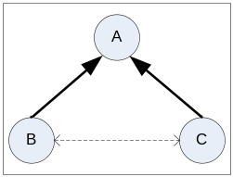
Fig. 3 – An Example of Diffusing Computation Tree

In figure 4, upon receiving an ELECT message from node A, node B and C sends an ATTACH message requesting A to accept them as children. Node A starts a timer after sending the ELECT message and accepts all nodes as its children which sends an ATTACH message before the timer times out. Nodes B and C also propagate ELECT message received from A to each other. Since, both of them already has node A as their parent, none sends ACK/NACK to the other. Eventually, node B and C sends their SIGNAL to node A. In this way, nodes B and C just send 2 messages (1 ATTACH + 1 SIGNAL) each and therefore the total number of messages reduce from 6 to 4.

CORRECTNESS OF THE PROTOCOL

The proof of correctness of our K-leader election protocol requires establishing the safety property and liveness property as described below:

- Safety: There should never be more or less than K leaders in a connected component.
- Liveness: The election protocol eventually terminates electing a set of K leaders. The elected leaders should be the K highest weight nodes among all the nodes within that connected component.

Lemma 1. After Phase I finishes, there is at least one RED node for any connected component C (V, E).

Proof. We assume that every node has a unique id and a weight. Two or more nodes can have identical weight values. The <node id, node weight> tuple is used to provide a total ordering among all the nodes. If more than one node has the same weight, then the one with the lower node id is selected over the other. E.g., if there are two nodes p and q with <node id, node weight> tuple, <1, 8> and <2, 10>, respectively, then node q is the higher weight node. But, if p and q has tuples like <1, 10> and <2, 10> then the node with the lower node id, i.e., p is selected over q. In this way, we can find out one node in an environment of N nodes which is considered to be of highest weight based on the above logic.
Initially, every node issues an ELECTION message containing its <node id, node weight> tuple, which will be received by all the nodes in its transmission range as the links are reliable. When a node receives an ELECTION message from all its immediate neighbors, it finds out the highest weight neighbor and sends a VOTE message to that.
Now for a node to become a RED node, it must receive a VOTE from all its immediate neighbors. So, we have to establish that there will definitely be at least one such node which receives VOTE(s) from all its neighbors. As stated previously, there is at least one node in the environment which is highest weight compared to the others. The highest weight node must receive VOTE message(s) from all its immediate neighbors. So, at least one node in a connected component will receive VOTE from all its neighbors. That node will be chosen as the RED node. So, the lemma holds. □

Lemma 2. The diffusing computation started by a RED node in Phase II eventually terminates.

Proof. The diffusing computation assumes that, initially, all processes other than the initiator are idle. The initiator is active. All channels are empty. The termination condition for the diffusing computation is that the computation terminates when all processes are idle and all channels are empty.
In our protocol, after a node is elected as a RED node, it starts a diffusing computation and grows a tree of visited nodes rooted at it. So, the RED node is called the root of the tree it creates. We can have one or more RED nodes in the environment, so all of them will start a diffusing computation at different times. Any non-RED node is called an intermediate node. In our protocol, any intermediate node will participate in a single diffusing computation. So, if an intermediate node has joined a diffusing computation tree of one RED node, it will not accept any other request from a different RED node.
We propose that, a RED node starts the diffusing computation by sending a SEARCH message to all its immediate neighbors. When an intermediate node receives a SEARCH message directly from an initiating RED node through the incoming channel, it forwards the message through all its outgoing links. This phase of the diffusing computation is about the “growing” of a diffusion tree. A SEARCH message may be delivered in the following three cases:
Case 1) An unvisited intermediate node n receives a SEARCH message directly from an initiating RED node or via some other intermediate node. – n sets node from which it receives the message as its parent and forwards the message to all the successors. Node n does not send any immediate reply to the parent for the time being and keeps it blocked.
Case 2) A visited intermediate node n receives a SEARCH message from its root of the tree via some other intermediate node – n acknowledges the SEARCH immediately by sending an ACK message. As the ACK message will eventually reach the receiver so the sender will not remain blocked for ever.
Case 3) A visited intermediate node receives a SEARCH message from a RED node which is NOT its root of the tree, either directly, or via some other intermediate node – n acknowledges the SEARCH immediately by sending an NACK message. As the NACK message will eventually reach the receiver so the sender will not remain blocked forever.
For Case 1, the parent of node of n remains blocked until it receives either an ACK, or a NACK or a SIGNAL from every node to which has sent a SEARCH message. This is called the “shrinking” phase of the diffusion computation tree. When a node receives replies corresponding to all the SEARCH sent, it sends a SIGNAL to the parent node. In this way, every blocked node ultimately unblocks after receiving one or more message it is waiting for. At the end, the initiating RED node eventually receives replies from all its immediate neighbors in finite time, which ensure that no node in the current diffusion computation tree remains blocked waiting for unreceived messages. So, all the nodes can be considered idle as all of them finished diffusing computation and the channels are also idle as there are no messages being passed through them. So, the termination conditions for diffusing computation as specified before is reached and the diffusing computation terminates in finite time. So Lemma 2 holds. □
Lemma 3. After Phase II finishes, the highest weight RED node for any connected component C (V, E) eventually receives information regarding all the nodes in the component.
Proof. After the Phase II ends, one or more RED nodes present in the environment have partial information regarding the nodes visited by the diffusing computation initiated by it. There can be two cases,
Case I) There is only one RED node in the connected network component – the RED node must be the highest weight RED node as there are no other RED nodes. So, the RED node chooses K leaders by weight, notifies them and terminates the election protocol. For this case, there will be no need to carry out phase III.
Case II) There is more than one RED node in the connected network component – each RED node have to choose the highest weight RED node and send its result to that node. But since, in a large network, all the RED nodes do not know every other RED node, and they have limited information, we have to use the limited knowledge available in the RedQ, through a distributed process, to converge the result to the highest weight RED node.
To prove the proposed lemma we need to prove that, the highest weight RED node Ŕ for any connected component C (V, E) eventually receives RESULT message from all the nodes in its RedQ. Based on the weight of a RED node r, and the weights of all other RED nodes in the RedQ of r, there can be three possible categories of RED nodes:

Weight(r) is lowest in RedQ_{r}: This case has 2 sub-cases:

RedQ of r has only one RED node except r: r will only send a single RESULT message and receive no message.
  - RedQ of r has more than one RED node except r: r will send a single RESULT message to its highest weight RED node and multiple DIRECT messages to other RED nodes.

Weight(r) is highest in RedQ_{r}: This case has 2 sub-cases:

RED node r is highest weight in the whole connected component and waiting for RESULT(s): RED node r will receive only RESULT(s) from lower weight RED nodes

RED node r is highest weight in the whole connected component and finished waiting for RESULT(s): This is the termination condition

RED node r is highest weight among its neighboring RED nodes: RED node r will receive DIRECT(s) or RESULT(s) from lower weight RED nodes

Weight(r) is intermediate in RedQ_{r}: RED node r will receive DIRECT(s) or RESULT(s) from lower weight RED nodes.

Initially, nodes in category (1a) will send their RESULT message to the highest weight RED node in their RedQ. Similarly, nodes in category (1b) will send DIRECT message to all the RED nodes in its RedQ except the highest weight RED node and then send the RESULT to the highest weight RED node.
Nodes in category (2a), (2c) and (3) will wait for the RESULT messages from nodes in category (1a) and (1b), which they will eventually receive as we assume a reliable message delivery system with no message loss. Similarly, nodes in category 2(c) and (3) will receive DIRECT messages. After receiving a DIRECT, a RED node knows about other RED nodes which they did not know before. So, when a node receives a DIRECT message, it updates its RedQ with the new RED node information.
When nodes in category (2c) and (3) have received all RESULT messages from all the lower weight nodes in their RedQ, they can be considered either as category (1a) or (1b) nodes and they act accordingly.
In the same way, following the recursive procedure described above, there will be one stage at which the condition 2(b) will be reached when a RED node will have no other RED nodes to send either DIRECT or RESULT. This RED node should be the highest weight RED node and the protocol will terminate there. In this way, eventually the highest weight RED node receives the RESULT messages from all the RED nodes it knows in finite time. So, lemma 3 holds. □

Theorem 1. The election algorithm eventually terminates electing a set of K leaders. The elected leaders should be the K highest weight nodes among all the nodes within that connected component. (liveness)

Proof. Following lemmas 1, 2 and 3 consecutively, the highest weight RED node i for any connected component C (V, E) eventually receives information regarding all the nodes in the component. After i has the complete knowledge regarding all the nodes in the environment, it sorts the nodes using the total order and selects the top K highest weight nodes. So, Theorem 1 holds. □
Theorem 2. There should never be more or less than K leaders in a connected component. (safety)

Proof. Following Theorem 1, as the highest weight RED node selects the top K nodes in the environment, it will elect exactly K leaders, not more or less than K. As we do not consider node crash or migration, there is no possibility that a leader crashes or migrates out of the environment. So, the number of leader in a static network component is always the same. So, Theorem 2 holds. □

PERFORMANCE EVALUATION
We have carried out extensive simulations to evaluate the performance of our protocol. Both versions of our protocol have been simulated. Moreover, to show the advantage of our protocol, we have also extended the single leader election protocol proposed in [14] to a K-leader election protocol and have compared their results with ours. We generally follow the simulation settings from [14] for ease of comparison.

Simulation Setup and Metrics
The simulation system consists of two modules: the network and the leader election protocol. The main parameters of the simulations are shown in Table 3. The values within parentheses indicate default values. Unless otherwise specified, these default values will be used for our experiment. The network nodes are randomly scattered in a square territory. Total number of nodes is varied to examine the effect of system scale on the performance. To make the performance results in different scenarios comparable, we also scale the territory size according to the total number of nodes. For message routing, we have implemented a simple protocol based on the “least hops” policy, which is adopted in many classical routing protocols in ad hoc networks. A routing table is proactively maintained at each node.
The leader election protocols are implemented as applications running on top of the network. The weight values of the nodes are assigned randomly. In case of node failures, the faulty nodes are randomly selected and a faulty node crashes in a randomly chosen time. The failure detection part is simulated based on the heartbeat-like approach.

Table III: Simulation Parameters
Parameters | Values
Number of nodes, (N) | 50 | (100) | 150 | 200
Territory scale (m²) | 700 | (1000) | 1200 | 1400
K/n | 25%
Mean Link Delay | 5 ms
Max Link Delay | 100 ms
Transmission radius | 150m, (250m)
Routing-protocol | Least hops
Node failure rate (F_{R}) | 10%, (20%), 30%, 40%, 50%
Mobility Model | Random Waypoint
Max. node speed (V_{max}) | 10m/s, (20m/s), 30m/s
Min. node speed (V_{min}) | 5 m/s
Pause time (seconds) | 10

In the simulations, we measure the performance of all the protocols using the following metrics:

Fraction of Time without K-Leaders (F) is the fraction of simulation time that a node is involved in an election (as indicated by in_electn = 1). This metric is a measure of the time a node lacks K leaders. The lower the value of F is, the higher is the efficiency of the protocol to ensure availability of K leaders to a node.
Election-Rate (ER) is defined as the average number of elections that a node participates in per unit time (i.e. the average rate at which node i goes from in_electn_{i} = 0 to in_electn_{i} = 1). Higher is the election rate, lower is the time without K leaders, because a node participates in a new election only when it lacks K leaders. If our protocol can ensure that a node retains K leaders for longer duration, then the election rate will decrease and the message overhead will also decrease which can contribute towards saving more resources for a node following; the objective of our research.
Election-Time (ET) is defined as the mean time elapsed between the instant at which a node begins participating in an election process (corresponds to in_electn_{i} = 1 in our protocol) and the instant at which it knows the identity of its K leaders (in_electn_{i} = 0). It is a measure of how efficient the protocol is. Less election time can ensure longer time a node has K leaders.
Message-Overhead (M) is defined as the average number of messages sent by a node per election. Message overhead for a node is calculated dividing total number of messages sent by a node over the entire simulation period with the total number of elections the node participates in. Less is the message overhead, more is the saving in resource for a wireless mobile node.

Simulation Results and Analysis
Below we present our simulation results with analysis. We have simulated our protocol (Election-Main) and the optimized version (Election-Opt). We also have simulated the K-leader election version of protocol presented in [14]. For the sake of the convenience we name it “Vasu” for the rest of the paper. We run each simulation for 100 simulation minutes and each point is obtained by averaging over 10 different runs.

Performance of F: In the following figure, we plot the fraction of time a node is without K leaders (F) with respect to N for “Election-Main”, “Election-Opt” and “Vasu”. The Fraction of Time Without K Leaders (F) of a node increases with increase in N. We choose K as one quarter of the total number of nodes in a connected component. So for a single connected component there will be more leaders with the increase in N. With more leaders, and a failure rate of 20%, and V_{max} of 20m/s, the leaders will frequently fail or get partitioned. This will raise the need of higher election rate (Figure 4) and renders the nodes without K leaders for longer time. Figure 3 shows that “Election-Opt” ensures higher leader availability than “Vasu” and “Election-Main”. “Vasu” induces multiple concurrent diffusing computations by different nodes when they detect failure or departure of a leader. High node density and a high node failure rate only increases the number of diffusing computations, which delays the election of new set of leaders ultimately increasing the fraction of time without K leaders. “Election-Main”, on the other hand, decreases multiple diffusing computations by picking up few RED nodes to carry out the same, so, it can finish K leader elections quicker than “Vasu”. But, still, in “Election-Main” nodes has lower leader availability as each node needs to wait for all its neighbors to send ACK, NACK or SIGNAL messages. Failure of one or more neighbors will necessitate probing the neighbor which increases the election time as well as the fraction of time without K leaders. We in “Election-Opt” decrease the ACK and NACK messages and hence the election finishes faster than “Election-Main” resulting in higher time of availability for K-leaders.

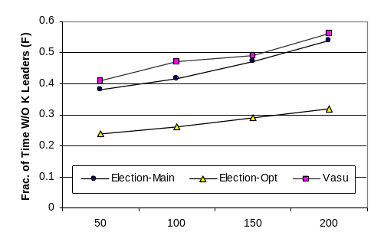
Figure 3. Performance of F versus N

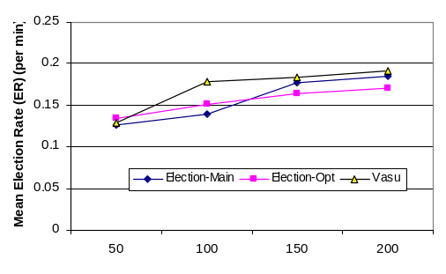
Figure 4. Performance of ER versus N

Performance of ER: In the following figure, we show the mean election rate (ER) of a node for electing K leaders with respect to increasing N, for “Election-Main”, “Election-Opt” and “Vasu”.
As explained for Figure 3, election rate increases with increasing number of nodes (N). In Figure 4, election rate of all three protocols increase with increasing N. This is because with more nodes at a high speed, the network topology changes frequently giving rise to partition with leaders. If all the K leaders are not available, a new election triggers.
Performance of ET: Figure 5 shows the required election time of K leaders for “Vasu” and “Election-Opt” at failure rate of 20%, and V_{max} of 20m/s. We can observe that the election time increases slightly with increase in N for both the protocols. This is because elections can be expected to be longer when there are more nodes.
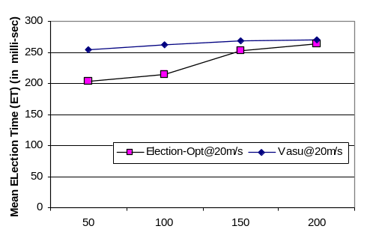
Figure 5. Performance of ET versus N (for Election-Opt & Vasu)

Performance of M: Figure 6 shows the message overhead of each node for “Vasu” and “Election-Opt” at failure rate of 20%, and V_{max} of 20m/s. We can see that “Election-Opt” is far more message efficient than “Vasu”. This is contributed to the concurrent multiple diffusing computations which starts on the detection of a leader failure in “Vasu”. We on the other hand, restrict the number of diffusing computations. Moreover, our message optimization technique using ATTACH messages and discarding ACK and NACK messages saves lot of message overhead which is actually the purpose of our research.
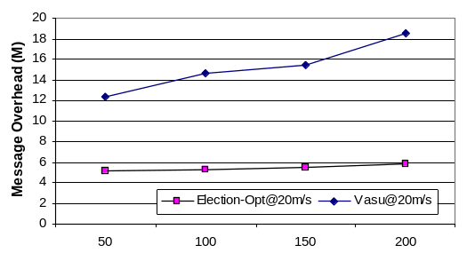
Figure 6. Performance of M versus N (for Election-Opt & Vasu)

In general, from the above results we can realize that all the four metrics, F, ER, ET and M increases with the increase in the total number of nodes taking part in simulations. Comparing our protocol with “Vasu”, our protocol consistently performs better than “Vasu”. To establish our claim more firmly, we produce more simulation results (Figure 7-10) varying node speeds from 10 m/s to 30 m/s.

Effect of Mobility on F: Figure 7 (a) and (b) compares “Election-Opt” with “Vasu” with node speeds 10m/s and 30m/s respectively. We can observe in Figure 7(a) that F increases with N at V_{max} = 10m/s. This observation is similar to that observed in Figure 3 and can be explained similarly. An interesting fact is revealed by Figure 7(b) where F decreases with increase in N for both the curves plotted. This can be explained in the light of high node speed. With node speed as high as 30m/s, nodes get disconnected from their leaders, but they get reconnected within the probing period which results in higher time of availability of K leaders for nodes and lower election rates (Figure 8(b)).
We also show the variation of F with N for different values of V_{max} for “Election-Opt” (Figure 7(c)) and “Vasu” (Figure 7(d)), separately. For both the cases, F increases at lower speeds, but decreases at higher speed.

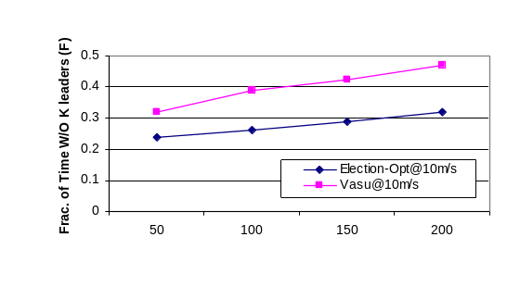 | 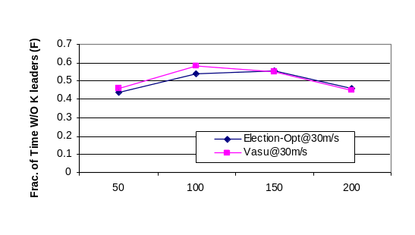
Figure 7(a): Effect of Mobility on F (V_{max} = 10m/s) | Figure 7(b): Effect of Mobility on F (V_{max} = 30m/s)
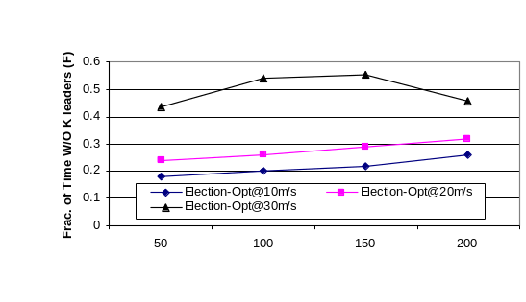 | 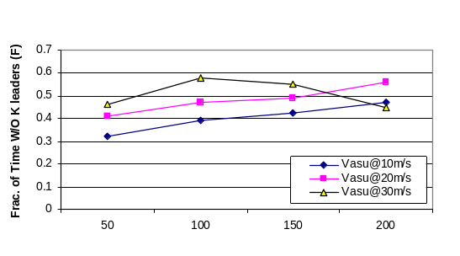
Figure 7(c): Effect of Mobility on F for “Election-Opt” | Figure 7(d): Effect of Mobility on F for “Vasu”
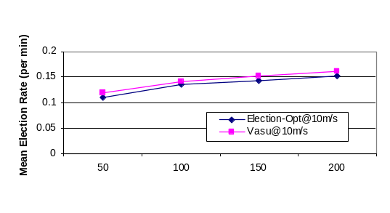 | 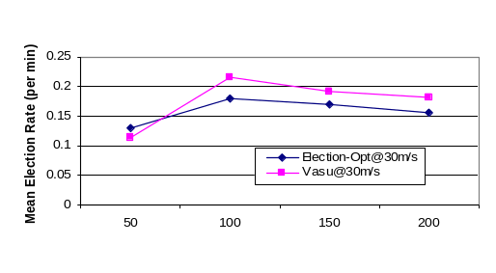
Figure 8(a): Effect of Mobility on ER (V_{max} = 10m/s) | Figure 8(b): Effect of Mobility on ER (V_{max} = 30m/s)
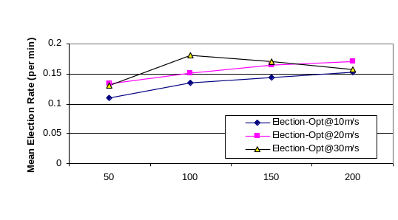 | 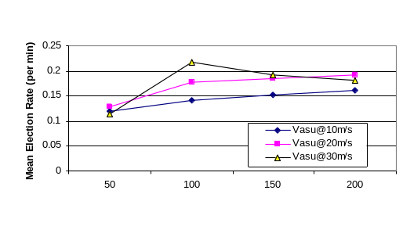
Figure 8(c): Effect of Mobility on ER for “Election-Opt” | Figure 8(d): Effect of Mobility on ER for “Vasu”
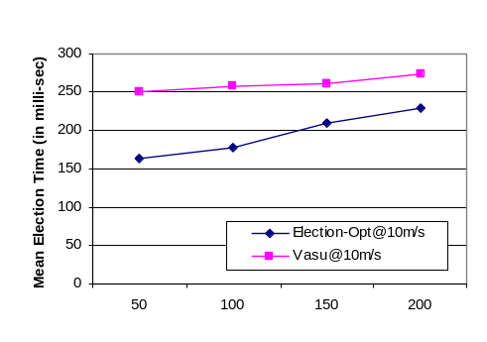 | 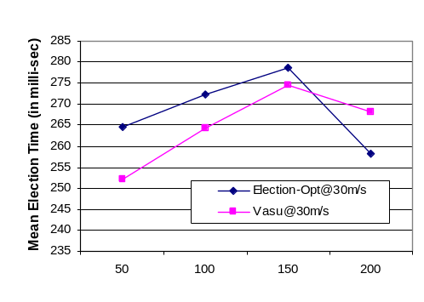
Figure 9(a): Effect of Mobility on ET (V_{max} = 10m/s) | Figure 9(b): Effect of Mobility on ET (V_{max} = 30m/s)
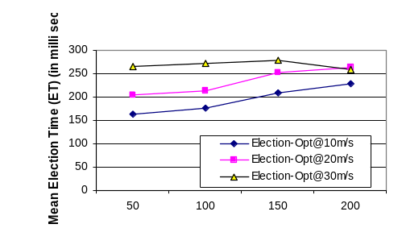 | 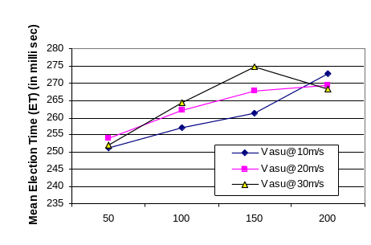
Figure 9(c): Effect of Mobility on ET for “Election-Opt” | Figure 9(d): Effect of Mobility on ET for “Vasu”
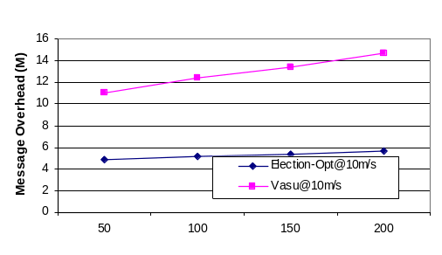 | 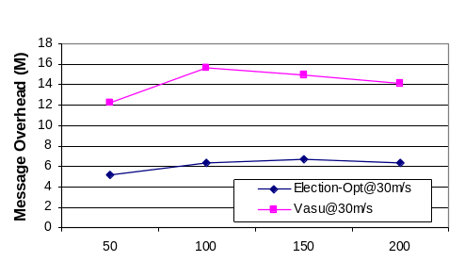
Figure 10(a): Effect of Mobility on M (V_{max} = 10m/s) | Figure 10(b): Effect of Mobility on M (V_{max} = 30m/s)
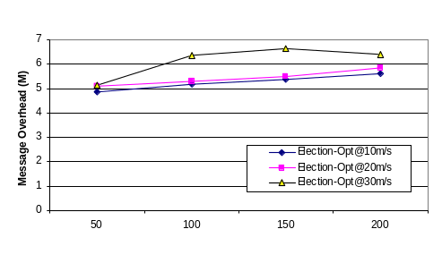 | 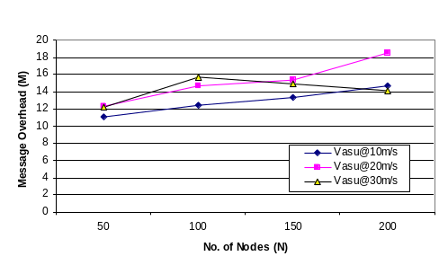
Figure 10(c): Effect of Mobility on M for “Election-Opt” | Figure 10(d): Effect of Mobility on M for “Vasu”

Effect of Mobility on ER: Figure 8 (a) and (b) compares “Election-Opt” with “Vasu” with node speeds 10m/s and 30m/s respectively. We can observe in Figure 8(a) that ER increases with N at V_{max} = 10m/s. This observation can be explained similarly as done for Figure 4 that ER increases with node speed as leader nodes frequently get disconnected from others necessitating a new election. An interesting fact shown in Figure 8(b) is that ER decreases with increase in N for both the protocols. This can be explained in the light of high node speed. With node speed as high as 30m/s, nodes get disconnected from their leaders, but they get reconnected within the probing period without restarting a new election which lowers the ER.
We also show the variation of ER with N for different values of V_{max} for “Election-Opt” (Figure 8(c)) and “Vasu” (Figure 8(d)), separately. For both the cases, ER increases at lower speeds, but decreases at higher speed.

Effect of Mobility on ET: Figure 9 (a) and (b) depicts the change of ET with N by varying node speeds from 10m/s to 30m/s, for “Election-Opt” and “Vasu”. Observation from Figure 9(a) is similar to that in Figure 5, that the ET increases with N. This is because, with more nodes in a dynamic environment, the topology frequently changes which requires probing some nodes which increases the overall election time.
ET, on the other hand, decreases with any further increase in node speed (Figure 9(b)). At higher node speed, such as, V_{max} = 30m/s, election rate decreases significantly as nodes get disconnected from their leaders but remains so for short duration. This decreases the probing time and ultimately the election time gets decreased.
We also show the variation of ET with N for different values of V_{max} for “Election-Opt” (Figure 9(c)) and “Vasu” (Figure 9(d)), separately. For both the cases, ET increases with increasing node speed. At higher speeds, link breaks occur more frequently, therefore increasing, both the routing overhead (in terms of number of control packets) and message delays. But the ET decreases at higher speed as the nodes remain disconnected only for very short durations. Thus, fresh election can be avoided.

Effect of Mobility on M: Figure 10 (a) and (b) depicts the change of M with N by varying node speeds from 10m/s to 30m/s, for “Election-Opt” and “Vasu”. As the election rate increases with N, message overhead also increases at lower speed (Figure 10(a)) and similarly it decreases with further increase in node speed (Figure 10(b)), as the election rate decreases. But the variation of M for “Election-Opt” is significantly lower than that of “Vasu”. For “Vasu”, with the increase in ER, the number of nodes carrying out diffusing computation also increases which results in many messages being generated concurrently. We, on the other hand, are able to restrict M by allowing only the RED nodes to carry out diffusing computations. The ELECT messages generated in the Phase I of our protocol are also controlled in such a way, that, when a node starts Phase I and sends ELECT message to its neighbors, the receiver of ELECT message will not start a new election even if it detected the departure of a leader. This gives us an edge over “Vasu” in controlling M and conserving energy.
After depicting the effect of mobility on our protocol, we also report the results of varying rate of node failure (F_{R}) on the execution of our protocol. We fail a percentage, p, of the total number of nodes (N), participating in the election process in such a way that throughout the execution time, at least as many as (p*N/100) nodes are always in the list of failed nodes. We release nodes in the head of this list if more than the expected number of nodes has been failed. The released nodes are considered as recovered nodes which takes part in K leader election as described in section III.E. Below we describe our results by varying node failure rates (F_{R}) from 10% to 50%. All the following experiments are executed at default values, i.e., with 100 nodes moving at a speed of 20m/s, the transmission radius being 250 m. The results have been reported at Figure 11 to Figure 14.

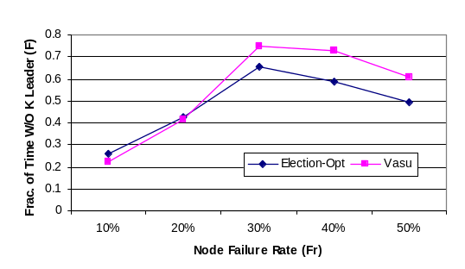 | 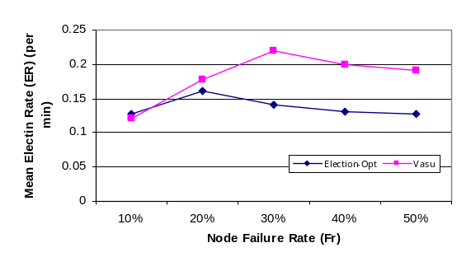
Figure 11: Effect of F_{R} on F (N=100, V_{max}= 20m/s) | Figure 12: Effect of F_{R} on ER (N=100, V_{max}= 20m/s)
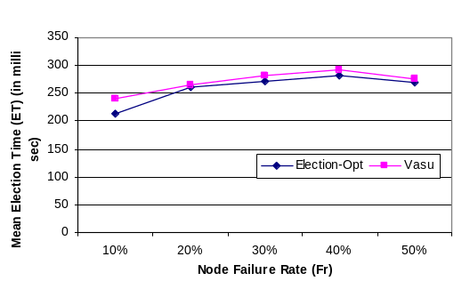 | 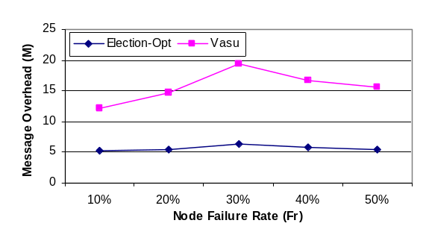
Figure 13: Effect of F_{R} on ET (N=100, V_{max}= 20m/s) | Figure 14: Effect of F_{R} on M (N=100, V_{max}= 20m/s)

Effect of F_{R} on F: Figure 11 depicts the change of F with varying node failure rates for “Election-Opt” and “Vasu”. The results show that F initially increases with increase in F_{R}, but decreases with further increase in F_{R}. This is because, with initial increase in F_{R} will result in increased leader failure and hence high unavailability of K leaders. But, with further increase in F_{R}, the network gets mostly partitioned and K leaders are elected for the individual components which will decrease F by increasing availability of K leaders.

Effect of F_{R} on ER: Figure 12 depicts the change of ER with varying node failure rates for “Election-Opt” and “Vasu”. The election rate increases initially and decreases with further increase in F_{R}. This can be explained similarly as for Figure 11. With increasing F_{R}, elections are higher as leaders get unavailable frequently, but with very high F_{R}, the network is mostly partitioned and leader availability increases within each partition which decreases the election rate.

Effect of F_{R} on ET: Figure 13 plots the change of ET with varying node failure rates for “Election-Opt” and “Vasu”. The election time initially increases with F_{R}, as nodes get frequently partitioned which requires probing to detect failures. With further increase in F_{R}, however, network gets divided in small partitions with few nodes in each partition. This decreases the election time as the election needs to be carried out only within small set of participating nodes.

Effect of F_{R} on M: Figure 14 shows the change of M with varying node failure rates for “Election-Opt” and “Vasu”. Following the trend of election rate change with respect to F_{R}, message overhead also increases with increase in ER and decreases with decreasing ER.

We can argue from the above figures, that our protocol performs better than “Vasu” consistently and significantly.

TESTBED IMPLEMENTATION

CONCLUSIONS AND DISCUSSION

In this paper, we propose a deterministic K-leader election protocol for mobile ad hoc network environment. We have considered a mobile ad hoc network where each node has a weight value that represents some performance property, e.g. processing capability, battery power. Our protocol aims to elect the top K weighted nodes in the network. A diffusing computation approach is adopted to collect the weight information for electing leaders. To reduce message cost, we first locally choose some high weighted nodes, called RED nodes, to act as coordinators. Then, each RED node initiates a diffusing computation procedure to collect the weight information of other nodes collaboratively. Finally, the information collected by different RED nodes is merged together to elect the final leaders. We also design mechanism to handle node failures and network partitions as well as partition merges. The simulation results show that, benefiting from the use of RED nodes, our protocol can elect leaders with much less message cost than other protocols.

ACKNOWLEDGMENT
This research is partially supported by the Hong Kong RGC CERG grant PolyU 5105-05E and China National 973 Program Grant 2007CB307100

REFERENCES

- Badrinath, B.R., Acharya, A. and Imielinski, T., Designing distributed algorithms for mobile computing networks. Journal of Computer Communications. v19. , no. 4, Apr. 1996.
- G. Forman and J. Zahorjan, “The Challenges of Mobile Computing,” Computer, vol. 27, no. 4, Apr. 1994.
- M. Aguilera, C. Gallet, H. Fauconnier, S. Toueg. Stable leader election, LNCS 2180, p. 108 ff.
- J. Brunekreef, J. Katoen, R. Koymans and S. Mauw. Design and Analysis of Leader Election Protocols in Broadcast Networks, Distributed Computing, vol. 9 no. 4, pages 157-171, 1996.
- E.W. Dijkstra and C.S. Scholten. Termination Detection for Diffusing Computations, Information Processing Letters, vol. 11, no. 1, 1980.
- H. Garcia-Molian, Elections in a Distributed Computing System, IEEE Transactions on Computers, vol. C-31, no. 1, 1982.
- Kostas P. Hatzis, George P. Pentaris, Paul G. Spirakis, Vasilis T. Tampakas and Richard B. Tan, Fundamental Control Algorithms in Mobile Networks, Proc. 11th Annual ACM Symposium on Parallel Algorithms and Architectures, 1999.
- N. Malpani, J. L. Welch, and N. vaidya, Leader Election Algorithms for Mobile Ad Hoc Networks, Proc. of the 4th int’l workshop on Discrete algorithms and methods for mobile comp. and comm., Aug. 2000.
- K. Nakano and S. Olariu, Randomized Leader election protocols for ad hoc networks, Proc. of SIROCCO, 2000.
- Sung-Hoon Park, An Election Protocol in a Mobile Environment, Proc. of PDPTA2000, pp. 200-210, June 2000.
- V. D. Park, and M. S. Corson. A Highly Adaptive Distributed Routing Algorithm for Mobile Wireless Networks, Proc. IEEE INFOCOM, Apr 1997.
- V. Sundramoorthy, and J. Scholten, Ir. and P.G.Jansen, Ir. and P.H. Hartel, Service discovery at home, Proc. of Joint Conf. of the 4th Int’l Conf. on Info., Comm. and Signal Processing, and the 4th Pacific Rim Conf. on Multimedia, 2003.
- G. Taubenfeld. Leader Election in presence of n-1 initial failures, Information Processing Letters, vol.33, no.1, pages 25-28, October 1989.
- S. Vasudevan, J. Kurose and D. Towsley, Design and Analysis of a Leader Election Algorithms for Mobile Ad Hoc Networks, Proc. of ICNP04, pp. 350–360.
- A. Amis, R. Prakash, T. Vuong, and D.T. Huynh. MaxMin D-Cluster Formation in Wireless Ad Hoc Networks. In Proceedings of IEEE Conference on Computer Communications (INFOCOM), March 1999.
- S. Banerjee and S. Khuller. A Clsutering Scheme for Hierarchichal Control in Multi-HopWireless networks. In Proceedings of IEEE Conference on Computer Communications (INFOCOM), Anchorage, Alaska, Apr. 2001.
- R. Gallager, P. Humblet and P. Spira. A Distributed Algorithm for Minimum Weight Spanning Trees. In ACM Transactions on Programming Languages and Systems, vol.4, no.1, pages 66-77, January 1983.
- D. Peleg. Time Optimal Leader Election in General Networks. In Journal of Parallel and Distributed Computing, vol.8, no.1, pages 96-99, January 1990.
- D. Estrin,R. Govindan,J. Heidemann and S. Kumar. Next Century Challenges : Scalable Coordination in Sensor Networks. In Proceedings of ACM MobiComm,August 1999.
- D. Coore, R. Nagpal and R. Weiss. Paradigms for Structure in an Amorphous Computer. Technical Report 1614, Massachussetts Institute of Technology Artificial Intelligence Laboratory, October 1997.
- W. Heinzelman,A. Chandrakasan and H. Balakrishnan. Energy-Efficient Communication Protocol forWireless Microsensor Networks. In Proceedings of Hawaiian International Conference on Systems Science, January 2000.
- S. Vasudevan, B. DeCleene, N. Immerman, J. Kurose and D. Towsley. Leader Election Algorithms for Wireless Ad Hoc Networks. In Proceedings of IEEE DISCEX III, April 22-24, 2003.
- N. Malpani, J. Welch and N. Vaidya. Leader Election Algorithms for Mobile Ad Hoc Networks. In Fourth International Workshop on Discrete Algorithms and Methods for Mobile Computing and Communications, Boston, MA, August 2000.
- E.W. Dijkstra. Self-stabilizing systems in spite of distributed control. In Communications of the ACM, 17:634-644,1974.
- A. Arora and M. Gouda. Distributed Reset. In IEEE Transactions on Computers, 43(9), 1026–1038, 1994.
- A. Arora and M. Nesterenko. Unifying stabilization and termination in message-passing systems. 21st International Conference on Distributed Computer Systems (ICDCS’01), Phoenix, 2001.
- Y. Afek, S. Kutten and M. Yung. Local Detection for Global Self Stabilization. In Theoretical Computer Science, Vol 186, No. 1-2, 339 pp. 199-230, October 1997.
- S. Dolev, A. Israeli and S. Moran. Uniform dynamic self-stabilizing leader election part 1: Complete graph protocols. Preliminary version appeared in Proceedings of 6th International Workshop on Distributed Algorithms, (S. Toueg et. al., eds.), LNCS 579, 167-180, 1992), 1993.
- C. Lin and M. Gerla. Adaptive Clustering for Mobile Wireless Networks. In IEEE Journal on Selected Areas in Communications, 15(7):1265-75, Sep 1997.
- P. Basu, N. Khan and T. Little. A Mobility based metric for clustering in mobile ad hoc networks. In International Workshop on Wireless Networks and Mobile Computing, Apr. 2001.

