MIMO for Wireless MAN
Xiaopeng Fan, Steven Y. Lai, Yuan Zheng, Jiannong Cao
Internet and Mobile Computing Lab
Department of Computing, Hong Kong Polytechnic University
Hung Hom, KLW
Hong Kong

1. Introduction
As the possible next development in wireless IP offering a possible solution to the last mile access problem, Wireless Metropolitan Area Networks (WMANs) based on the 802.16 standards-based technology [6] have recently captured lots of interest from vendors and ISPs. With a theoretical speed of up to 75 Mbps and a range of several miles, 802.16 broadband is expected to be an alternative to cable modem and DSL in the near future. Promoters of 802.16 have elected to form an organization called the WiMAX (Worldwide Interoperability for Microwave Access) Forum [7] to test and certify products for interoperability and standards compliance.
WiMAX specifies a technology devoted to making broadband wireless commercially available to the mass market. WiMAX is an IEEE 802.16 standards-based technology, which supports point to multi-point (PMP) broadband wireless access. The IEEE 802.16 specification includes IEEE 802.16-2004 [31] and 802.16e amendment [6] as the physical (PHY) layer specifications. The IEEE 802.16-2004 standard is primarily intended for stationary transmission while IEEE 802.16e amendment is primarily intended for both stationary and mobile deployments. Based on the IEEE 802.16-2004 Air Interface Standard, fixed WiMAX has proven to be a cost-effective fixed wireless alternative to cable and DSL services. Furthermore, the IEEE ratified the 802.16e amendment [6] to the 802.16 standard in December 2005 to add the features and attributes to the standard necessary for supporting mobility. The WiMAX Forum is now defining system performance and certification profiles based on the IEEE 802.16e Mobile Amendment.
WiMAX is a wireless metropolitan area network technology that will connect IEEE 802.11 (Wi-Fi) hotspots to the Internet and provide a wireless extension to cable and DSL for last mile broadband access, so it faces a lot of challenges in terms of coverage, data rate, and mobility. For coverage, WiMAX is designed to provide up to 50 km of linear service area and allow users connectivity without a direct line of sight to a base station. For data rate, WiMAX should provide enough bandwidth to simultaneously support more than 60 businesses with T1-type connectivity and well over a thousand homes at the 1Mbit/s DSL-level connectivity. For mobility, WiMAX needs to support a system of combined fixed and mobile broadband wireless access, with subscriber stations moving at vehicular speeds and support. To meet these new requirements, WiMAX adopts Multiple-Input Multiple-Output (MIMO) and other new technologies. In this chapter, we will focus on MIMO and its related technologies, including Orthogonal Frequency Division Multiplexing (OFDM), Space-time Coding, and diversity.
MIMO systems are a natural extension of developments in antenna array communication [1] [2]. Sometimes referred to as “volume-to-volume” wireless links, MIMO systems are important because they have the potential to play a significant role in resolving traffic capacity bottlenecks in future wireless networks. Communication theory suggests that they can provide a potentially very high capacity that, in many cases, would grow approximately linearly with the number of antennas. Recently, MIMO systems have attracted more and more attention because of their implementation in wireless communication systems, especially in wireless MANs, and because of the proposal of a number of different MIMO system structures by industrial organizations in the Third Generation Partnership Project (3GPP) standardizations.
MIMO systems can be simply defined as systems that contain multiple transmitter antennas and multiple receiver antennas. As an example, we might consider an arbitrary wireless communication system in which the links on both the transmitting and receiving ends are equipped with multiple antenna elements. The idea behind MIMO is that the signals on the transmit (TX) antennas at one end and the receive (RX) antennas at the other end are “combined” in such a way as to improve the quality (Bit Error Rate) or the data rate (bits/sec) of the communication for each MIMO user. This has significant advantages in terms of both the network’s quality of service and the operator’s revenues.
When we analyze the capacity of MIMO, it is important to note that OFDM is particularly well suited to MIMO technology. OFDM is a multiplexing technique that subdivides bandwidth into multiple frequency sub-carriers [8]. In an OFDM system, the input data stream is divided into several parallel sub-streams of reduced data rate (thus increased symbol duration) and each sub-stream is modulated and transmitted on a separate orthogonal sub-carrier. Because the narrowband subcarriers in the OFDM signal experience flat fading, MIMO reception does not require complex channel equalization schemes. So when we discuss the capacity of the multi-user MIMO-OFDM system in Section 2 , the basic ideas of OFDM will be introduced.
Space-time signal processing [29] is one of the core ideas in MIMO. This involves complementing the use of time, the natural dimension of digital communication data, with the use of the spatial dimension inherent in the use of multiple spatially distributed antennas. Space-Time Codes (STCs) [5] is used for coding signals in both the temporal and spatial domains. MIMO systems can also be viewed as an extension of the so-called smart antennas, a popular technology using antenna arrays for improving wireless transmission dating back several decades.
Multi-path fading is a significant problem in MIMO communications [10]. In a fading channel, signal strength will decrease significantly, leading to a failure to receive signals. One way to combat fading is to make use of diversity [11], which can take full advantage of the redundancy of the signals over time, frequency, or space on the transmitting and receiving terminals. In general, the effectiveness of any diversity technique is guaranteed by the fact that the receiver can provide independent samples of the basic signal that was transmitted. Based on this, we can assume that two or more relevant parts of a signal will not fade significantly at the same time. To achieve great improvements in the quality of signals, diversity techniques need to optimally fuse the received diversified samples. Thus, depending on the signal domain which was the source of the redundancy, diversity techniques are classified as either time, frequency, or space diversity.
This chapter is organized as follows. In Section 2, we analyze the capacity of MIMO systems to understand how much MIMO improves the capacity when used in WiMAX. We begin this work with a single user MIMO system model and highlight the capacity analysis under two different physical specifications in WiMAX. In Section 3, we discuss various kinds of space-time block codes (STBCs) used in MIMO and how they are applied in WiMAX. In Section 4, we discuss the diversity technique to know how much MIMO improves the reliability in WiMAX. In the last section, we conclude our chapter with a brief summary.
2. Multiple-Input Multiple-Output Wireless Communication
In this section, we begin with a single user MIMO system model. Based on the model, we generalize the discussion on capacity to cases that encompass transmitters having some prior knowledge of a channel [9]. Then we consider a single MIMO user communicating over a fading channel with additive white Gaussian noise (AWGN). Finally we discuss the capacity of MIMO systems in WiMAX, including a multi-user model.
2.1 MIMO System Model
A single user MIMO system consists of 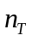transmitter antennas (Tx) and 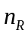receiver antennas (Rx). During each Symbol Time Slot (STS), the transmitted signals are presented as an 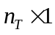column vector, whose entry,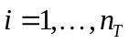, is the transmitted signal at the 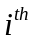Tx antenna during the considered STS.
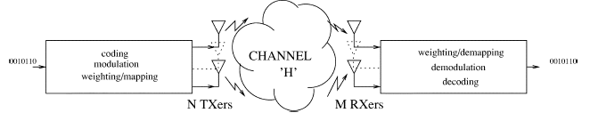
Figure 1: Diagram of a wireless MIMO communication system
We consider here an additive Gaussian MIMO channel for which the optimal distribution of the transmitted signals inis also Gaussian, i.e., the transmitted signals , for , are zero-mean, identically independently distributed (i.i.d.) complex random variables. The covariance matrix of is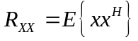, where 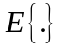denotes the expectation, and 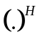 denotes the Hermitian transposition operation, i.e. the transpose-conjugate operation. The total power of transmitted signals (during each STS) is constrained to, regardless of the number of transmitter antennas. This implies that 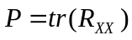 where 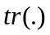denotes the trace operation on the argument matrix.
In all following sections, we assume that channel coefficients (or transmission coefficients) are perfectly known at the receiver, but may or may not be known at the transmitter.
When channel coefficients are unknown at the transmitter (but known at the receiver), we assume that the transmitted power at each Tx antenna is the same and equal to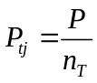, for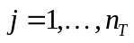. When the channel coefficients are known at the transmitter, the transmitted power is unequally assigned to the Tx antennas following the water-filling rule [13]. The scenario where channel coefficients are unknown at both transmitter and receiver is mentioned in [12]. Most of the results in this section can be found in [30].
The channel is represented by an 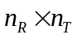complex matrix, whose elements 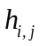are the channel coefficients between the 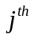Tx antenna () and the Rx antenna 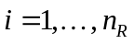. Channel coefficients are assumed to be zero-mean, i.i.d. complex Gaussian random variables with a distribution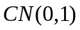. Noise at the receiver is represented by an 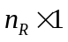column vector whose elements are zero-mean, i.i.d. complex Gaussian random variables with identical variances.
Let denote the column vector of signals received at 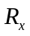antennas during each STS, the transmission model is represented as follows.
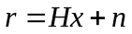.
If we assume that the average total power 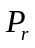received by each Rx antenna (regardless of noise) is equal to the average total transmitted powerfrom Tx antennas, the Signal-to-Noise (SNR) at each Rx antenna is given by the following equation
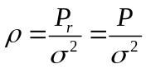.
To guarantee the assumption that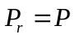, for a channel with fixed channel coefficients and the equal transmitted power per Tx antenna 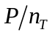(i.e., channel coefficients are known at the receiver, but unknown at the transmitter), we have the following constraint:
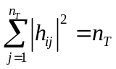 (2.1)
for. For a channel with random channel coefficients and equal transmitted power per Tx antenna, Formula (2.1) is calculated with the expected value.
The system capacity 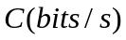 is defined as the maximum possible transmission rate such that the error probability is arbitrarily small. In this chapter, we also consider the normalized capacity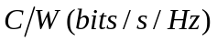, which is the system capacity normalized to the channel bandwidth.
2.2 Capacity of MIMO
In this section, we consider the Additive Gaussian Noise Channels with fixed channel coefficients. We derive the most general formula to calculate the channel capacity for both cases where channel coefficients are known as well as unknown at the transmitters.
The general formula for calculating the channel capacity in the case where channel coefficients are either known or unknown at the transmitter is give by the Shannon capacity:
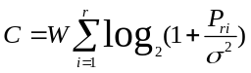 (2.2)
where is the bandwidth of each sub-channel, is the rank of the channel coefficient matrix (is equal to the number of non-zero eigenvalues of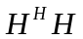), 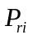is the received power at each Rx antenna from the sub-channel, for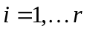, during the symbol time slot under consideration . The rank is less than or equal to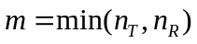.
Then, we calculate the channel capacity where there are unknown channel coefficients at the transmitter. Let  be the Wishart matrix defined as
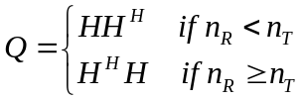.
From Eq. (2.2), it has been proved in [13] that the channel capacity for such a scenario is
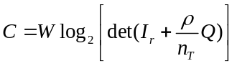 (2.3)
where det(.) denotes the determinant of the argument matrix.
The channel capacity can be increased if channel coefficients are known at the transmitter. In that case, the transmitted power is assigned unequally to the Tx antennas, according to the “water-filling” rule, i.e., a larger power is assigned to a better sub-channel and visa versa (see Appendix 1.1 in [13]). The power assigned to the sub-channel is
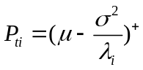, 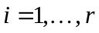
where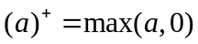, 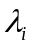is the non-zero eigenvalues of the matrix (also 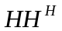) and is determined to satisfy the power constraint
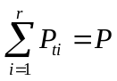 (2.4)
For the sub-channel, the received power at the receiver antenna is calculated as (see Eq. (1.20) in [13]):
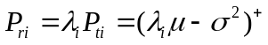
Then, the channel capacity is given below:
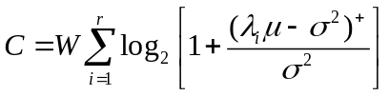 (2.5)
2.3 Capacity of MIMO in WiMAX
As mentioned before, WiMAX technology is based on the IEEE 802.16 specification, which includes IEEE 802.16-2004 [31] and 802.16e amendment as the Physical (PHY) layer specifications. The IEEE 802.16-2004 standard is primarily intended for stationary transmission while 802.16e amendment is primarily intended for both stationary and mobile deployments. In this section, we will examine the PHY layer in WiMAX in detail. We discuss two different physical layer specifications in [6].
The 10-66 GHz bands provide a physical environment where, due to the short wavelength, line-of-sight (LOS) is required and multipath is negligible. In the 10-66 GHz band, channel bandwidths of 25 MHz or 28 MHz are typical. With raw data rates in excess of 120 Mb/s, this environment is well suited for PMP (Point to Multipoint) access serving applications from small office/home (SOHO) through medium to large office applications.
In the design of the physical layer for 10–66 GHz, line-of-sight propagation was deemed a practical necessity. With this condition assumed, single-carrier modulation was easily selected; the air interface is designated as “WirelessMAN-SC.” However, many fundamental design challenges remained. Because of the point-to-multipoint architecture, the BS basically transmits a TDM signal, with individual subscriber stations allocated time slots serially. Access in the uplink direction is by Time-Division Multiple Access (TDMA). Following extensive discussions regarding duplexing, a burst design was selected that allows simultaneously both time-division duplexing (TDD), in which the uplink and downlink share a channel but do not transmit simultaneously, and frequency-division duplexing (FDD), in which the uplink and downlink operate on separate channels, sometimes simultaneously. This burst design allows both TDD and FDD to be handled in a similar fashion. Support for half-duplex FDD subscriber stations, which may be less expensive since they do not simultaneously transmit and receive, was added at the expense of some slight complexity. Both TDD and FDD alternatives support adaptive burst profiles in which modulation and coding options may be dynamically assigned on a burst-by-burst basis.
In the above scenario, the channel model can be modeled as the flat Rayleigh Fading channel. We assume that channel coefficients are zero-mean, i.i.d. complex Gaussian random variable with variance of 1/2 per dimension (real and imaginary). Hence, each channel coefficient has a Rayleigh distributed magnitude, uniformly distributed phase and the expected value of the squared magnitude equal to one, i.e., 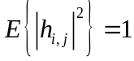. In all following sections, channel coefficients are assumed to be known at the receiver, but unknown at the transmitter. Thus, the transmitted power per Tx antenna is assumed to be identical and equal to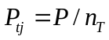, for.
If the channel coefficient matrix is random and its entries change randomly during every symbol time slot (STS), then the channel is referred to as the fast flat Rayleigh fading channel. The capacity of MIMO systems in fast and block Rayleigh fading channels is calculated as follows (see Eq. (1.56) in [13] or Theorem 1 in [19 Telatar, 1999])
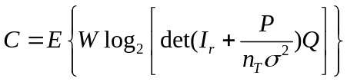 (2.6)
where is the rank of matrix and the matrix is the Wishart matrix defined above.
If is random and its entries change randomly after each block containing a fixed number of STSs, then the channel is referred to as the block flat Rayleigh fading channel. If is random but is selected at the beginning of transmission and its entries keep constant during the whole transmission, the channel is referred to as the slow flat Rayleigh fading channel. These results were originally derived by Foschini and Gans [9]. Considering a MIMO system where the channel coefficient matrixis chosen randomly at the start of transmission and says constant during the whole transmission. The entries offollow the Rayleigh distribution. Examples of this scenario include Wireless Local Area Networks (LANs) with high data rates and low fade and 802.16 for fix broadband access systems in Wireless Metropolitan Areas Networks (WMANs).
Now, we consider the transmit and receive diversity. We first assume that 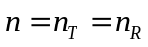and is large. As shown by Eq. (20) in [9] or by Eq. (1.82) in [13], the lower bound on the capacity is given by
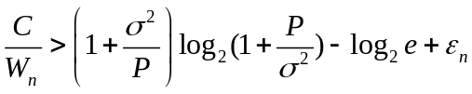 (2.7)
Where 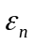is a Gaussian random variable with the mean and variance as given below:
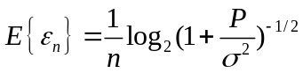
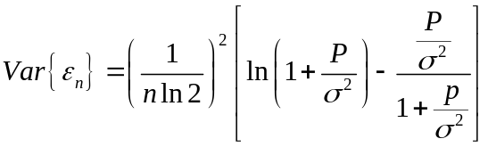
The other bands, frequencies below 11 GHz, provide a physical environment where, due to the longer wavelength, LOS is not necessary and multipath may be significant. The ability to support near-LOS and non-LOS (NLOS) scenarios requires additional PHY functionality, such as the support of advance power management techniques, interference mitigation/coexistence, and multiple antennas.
The original WiMAX standard (IEEE 802.16) specified WiMAX in the 10 to 66 GHz range. 802.16a, updated in 2004 to 802.16-2004 (also known as 802.16d), added support for the 2 to 11 GHz range. 802.16d was updated to 802.16e in 2005. Revision 802.16e uses scalable OFDM as opposed to the non-scalable version used in revision 802.16d. This brings potential benefits in terms of coverage, self installation, power consumption, frequency re-use and bandwidth efficiency. Revision 802.16e also adds a capability for full mobility support. Design of the 2–11 GHz physical layer is driven by the need for non-line-of-sight (NLOS) operation. Because residential applications are expected, rooftops may be too low for a clear sight line to a BS antenna, possibly due to obstruction by trees. Therefore, significant multipath propagation must be expected.
IEEE 802.16-2005 (formerly named, but still best known as, 802.16e or Mobile WiMAX) provides an improvement on the modulation schemes stipulated in the original (fixed) WiMAX standard. It allows for fixed wireless and mobile NLOS applications primarily by enhancing the Orthogonal Frequency Division Multiple Access (OFDMA). Furthermore, outdoor-mounted antennas are expensive due to both hardware and installation costs. The three 2–11 GHz air interface specifications [15] are:
- WirelessMAN-SCa: It uses a single-carrier modulation format.
- WirelessMAN-OFDM: It uses orthogonal frequency-division multiplexing with a 256-point transform. Access is by TDMA. This air interface is mandatory for license exempt bands.
- WirelessMAN-OFDMA: It uses orthogonal frequency-division multiple access with a 2048-point transform. In this system, multiple access is provided by addressing a subset of the multiple carriers to individual receivers.
OFDM has become a popular technique for transmission of signals over wireless channels. It converts a frequency-selective channel into a parallel collection of frequency flat subchannels, which makes the receiver simpler. The time domain waveforms of the subcarriers are orthogonal, yet the signal spectra corresponding to different subcarriers overlap in frequency. Hence, the available bandwidth is used very efficiently. Using adaptive bit loading techniques based on the estimated dynamic properties of the channel, the OFDM transmitter can adapt its signaling to match channel conditions, and approach the ideal water pouring capacity of a frequency-selective channel. The increased symbol duration improves the robustness of OFDM to delay spread. Furthermore, the introduction of the cyclic prefix (CP) can completely eliminate Inter-Symbol Interference (ISI) as long as the CP duration is longer than the channel delay spread. The CP is typically a repetition of the last samples of data portion of the block that is appended to the beginning of the data payload.
MIMO is known to boost capacity. For high-data-rate transmission, the multipath characteristic of the environment causes the MIMO channel to be frequency-selective. OFDM can transform such a frequency-selective MIMO channel into a set of parallel frequency-flat MIMO channels, and therefore decrease receiver complexity. The combination of the two powerful techniques, MIMO and OFDM, is very attractive and has become one of the most promising broadband wireless access schemes. In the following, we will consider the capacity of MIMO-OFDM.
In the scheme proposed in [14], at transmitter, the bit streams for each of antennas are coded separately and then mapped to their corresponding symbols. These symbols are then grouped into 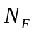symbols with a serial to parallel (S/P) converter and spread with a size 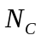Walsh spreading codes, where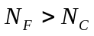. Next, point IFFT is performed and time domain symbols are parallel to serial (P/S) converted and transmitted. At receiver, antennas receive signals from user and pass them through a complex channel matrix whose characteristic is described by the independent identically distributed (i.i.d.) complex Gaussian random matrix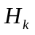. In all the following cases, we assume that the realization of is known to the receiver perfectly but unknown to the transmitter. is defined as the maximum number of interfered symbols corresponding with maximum delay spread. Thus, the channel matrix of user,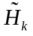, is written as
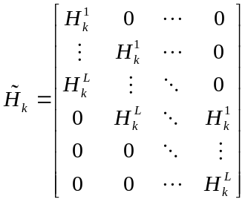
For a single user channel in MIMO-OFDM, we can calculate the capacity of the considered system as
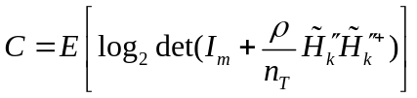 (2.8)
where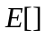denotes expectation, is 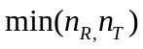and is an average signal to noise ratio (SNR) at each receive antenna. 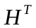denotes transpose of matrix , 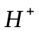denotes conjugate and transpose of matrix .
For a multi-user channel in MIMO-OFDM, we can calculate the capacity considered system as
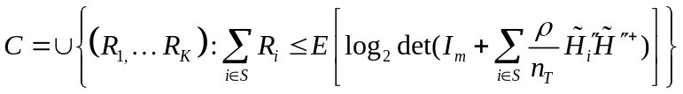 (2.9)
whereis the number of users, 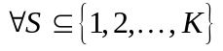. We assume that the receiver knows the realization of every user matrix channel. Also we assume that all the transmitting devices generate equal power and use the same number of antennas.
3. Space-Time Block Codes
A space-time block code (STBC) is a channel coding method used in multiple-antenna wireless communications. The objective of STBC is to improve the reliability of high data rate transmission in wireless communication systems by transmitting multiple, redundant copies of a data stream in the hope that some of them may arrive at the receiver in a better state than others.
Most of the earlier works on wireless communications had focused on having an antenna array at only one end of the wireless link – usually at the receiver. Then, some works extended the scope of wireless communication possibilities by showing that substantial capacity gains are enabled when antenna arrays are used at both ends of a link. Examples are D-BLAST [15] and V-BLAST [16]. Later, space-time code [5] (STC) was proposed as an alternative approach which relies on having multiple transmit antennas and only optionally multiple receive antennas. It has been shown that STC achieves significant error rate improvements over single-antenna systems. Its original scheme was based on trellis codes. However, the cost for this scheme is additional processing, which increases exponentially as a function of bandwidth efficiency (bits/s/Hz) and the required diversity order. A simpler approach called block codes was proposed by Siavash Alamouti [11], and later extended to develop space–time block-codes (STBCs) [17].
3.1 Different Kinds of Space-Time Block Codes
An STBC is usually represented by a matrix. Each row represents a time slot and each column represents one antenna's transmissions over time.

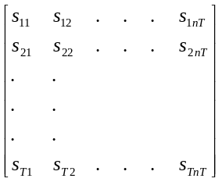
Here, s_{ij} is the modulated symbol to be transmitted in time slot i from antenna j. There are T time slots and nT transmit antennas as well as nR receive antennas.
The code rate of an STBC measures how many symbols per time slot it transmits on average over the course of one block [17]. If a block encodes k symbols, the code-rate is
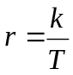
- Alamouti’s Code: Alamouti invented the simplest of all the STBCs [11]. It was designed for a two transmit antenna system and has the coding matrix:
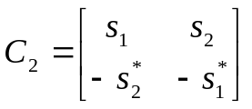
where * denotes complex conjugate.
It is readily apparent that this is a full-rate code. It takes two time-slots to transmit two symbols and the bit-error rate (BER) of this STBC is equivalent to 2nR-branch maximal ratio combining (MRC). This is a result of the perfect orthogonality between the symbols after the receive processing — there are two copies of each symbol transmitted and nR copies received.
- Higher order STBCs: Tarokh et al. discovered a set of higher order STBCs [17] [18]. They also proved that no code for more than two transmit antennas could achieve full-rate. Their codes have since been improved upon (both by the original authors and by many others). Nevertheless, they serve as clear examples of why the rate cannot reach one, and what other problems must be solved to produce 'good' STBCs. They also demonstrated the simple, linear decoding scheme that goes with their codes under the perfect channel state information assumption.
Two STBCs for 3 transmit antennas are:
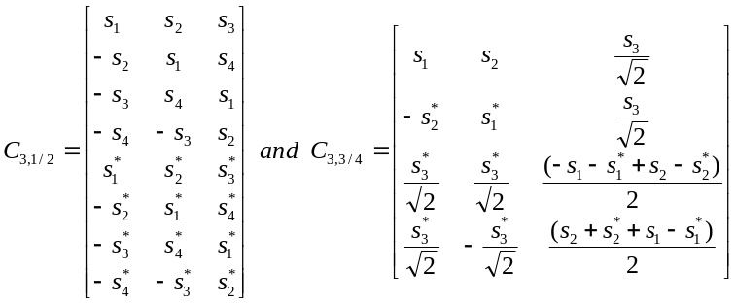
These codes achieve the rates of 1/2 and 3/4 respectively. The two matrices give examples of why codes for more than two antennas must sacrifice rate — it is the only way to achieve orthogonality. One particular problem with 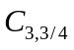 is that it has uneven power among the symbols it transmits. This means that the signal does not have a constant envelope and the power that each antenna must transmit has to vary, both of which are undesirable. Modified versions of this code that overcome this problem have since been designed.
Two STBCs for four transmit antennas are:
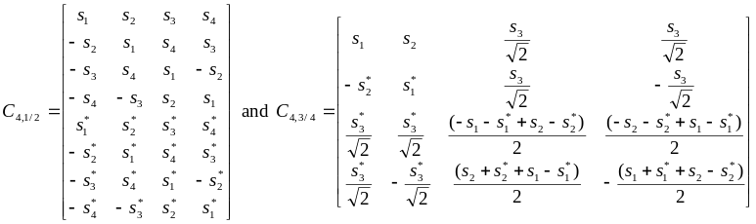

These codes achieve the rates of 1/2 and 3/4 respectively, as for their 3-antenna counterparts. 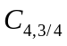 exhibits the same uneven power problems as . An improved version of is [19]:
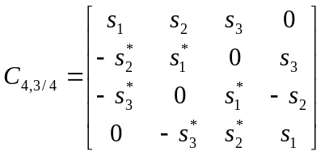
which has equal power from all antennas in all time-slots.
3.2 Orthogonal Space-Time Block Codes
STBCs, as originally introduced are orthogonal , meaning that the STBC is designed in such a way that the vectors representing any pair of columns taken from the coding matrix are orthogonal. The result of this is simple, linear, optimal decoding at the receiver. Its most serious disadvantage is that all but one of the codes that satisfy this criterion must sacrifice some proportion of their data rate.
There are also 'quasi-orthogonal STBCs' that allow some inter-symbol interference but can achieve a higher data rate, and even a better error-rate performance, in harsh conditions. Quasi-orthogonal STBCs exhibit partial orthogonality and provide only part of the diversity gain. An example given by Hamid Jafarkhani in [20] is:
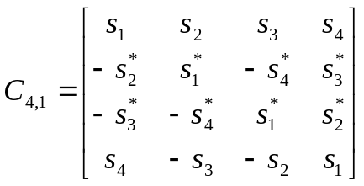
The orthogonality criterion only holds for columns (1 and 2), (1 and 3), (2 and 4) and (3 and 4). Crucially, however, the code is full-rate and still only requires linear processing at the receiver, although decoding is slightly more complex than for orthogonal STBCs. Results show that this Q-STBC outperforms (in a bit-error rate sense) the fully-orthogonal 4-antenna STBC over a good range of signal-to-noise ratios (SNRs). At high SNRs, though (above about 22dB in this particular case), the increased diversity offered by orthogonal STBCs yields a better BER. Beyond this point, the relative merits of the schemes have to be considered in terms of useful data throughput. More Q-STBCs have also been developed considerably from the basic example shown.
3.3 Space-Time Codes for WiMAX
In IEEE 802.16-2004 OFDM-256, the Alamouti code is applied to a specific subcarrier index k. For instance, suppose that in the uncoded system S1[k] and S2[k] are sent in the first and second OFDM symbol transmissions. The Alamouti encoded symbols send S1[k] and S2[k] off the first and second antennas in the first transmission and -S2*[k] and S1*[k] off the first and second antennas in the next transmission.
There are a number of features of IEEE 802.16-2004 OFDM-256 Alamouti transmission that are of interest. The first is that the preamble for Alamouti transmission is transmitted from both antennas with the even subcarriers used for antenna 1 and the odd subcarriers used for subcarrier 2. This means that each set of data needs to be appropriately smoothed, which is done in these simulations. The second feature is that the pilots have certain degenerate situations: for the first Alamouti transmitted symbol, the pilots destructively add and for the second Alamouti transmitted symbol, the pilots constructively add. Hence, the pilots are not always useful. The pilot symbols must be processed properly.
Figure 1 shows the detailed flow of an Alamouti implementation [21]. This implementation has two parts. The first calculates the parameters that are necessary for data demodulation such as channel estimates. The second part is the actual data demodulation and tracking.
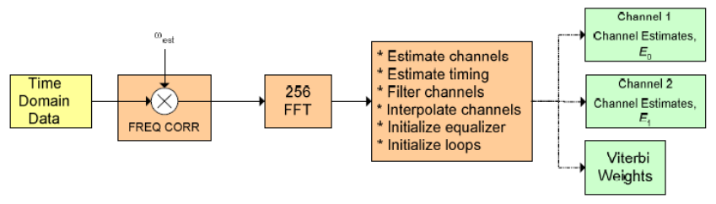
Figure 2: Alamouti implementation in WiMAX
It has been shown that under various conditions, the error rates can be greatly reduced when the Alamouti Code is used.
4. Transmission Diversity Techniques
A key feature of MIMO systems is their ability to turn multipath propagation, traditionally a pitfall of wireless transmission, into a user benefit [3]. MIMO effectively multiplies transfer rates by taking advantage of random fading and, when available, multipath delay spread. This prospect of an improvement in wireless communication performance of many orders of magnitude at no extra spectrum cost (adding only hardware and complexity) largely accounts for the success of MIMO as a new technology. It and has prompted progress in areas as diverse as channel modeling, information theory and coding, signal processing, antenna design, and fixed and mobile multiantenna-aware cellular design.
4.1 Time Diversity
Time diversity is a diversity technique where identical signals are transmitted during different time slots. Because the channel must provide sufficient variations in time, the time slots can be uncorrelated, i.e. the temporal separation between those slots is greater than the coherence time of the wireless channel [22]. Thus, the interleaving symbol duration is independent of the previous symbol and then, the completely new replica of the original signal can be obtained.
However, this technique will incur considerable redundancy in the time domain, which will cause a negative consequence of a loss in bandwidth efficiency. The loss in bandwidth is due to the guarantee of time duration being larger than coherence time between the time slots.
In practice, interleavers and error control coding, such as Forward Error Correction (FEC) codes, are applied to provide time diversity for the receiver. In addition, RAKE receiver in CDMA (Code Division Multiple Access) system is also an example of the modern implementation of time diversity is the RAKE receiver in CDMA (Code Division Multiple Access) systems [10].
4.2 Frequency Diversity
The frequency diversity technique uses several carriers with different frequencies to transmit the same signals. The frequency separation between these carrier frequencies is an order of several times of the coherence bandwidth of the channel to achieve uncorrelated carriers, which do not experience the same fades.
As in time diversity, in frequency diversity, the redundancy in the frequency domain will lead to a loss in spectral efficiency. The loss in spectral efficiency is aiming to guarantee the enough spectral bands existing among the carrier frequencies without coherence [23]. Additionally, the receivers need to employ complicated receiving devices which can work with a number of frequencies.
In practice, frequency diversity is often used in Line-Of-Sight (LOS) microwave channels. Some examples of systems employing frequency diversity include spread spectrum systems, such as Direct Sequence Spread Spectrum (DS-SS), Frequency Hop Spread Spectrum (FH-SS) or Multi-Carrier Spread Spectrum (MC-SS) systems [10].
4.3 Space Diversity
Space diversity techniques, also named antenna diversity techniques, use multiple transmitting and receiving antennas to transmit and/or receive signals [3]. These antennas are installed with at least coherent distance among each other, where a coherent distance is a half of wavelength of a signal. The requirement of spatial distance allows every involved antenna to be regarded as an independent sampling channel [26].
Different from time diversity and frequency diversity, the redundancy incurred by spatial diversity is provided for the receiver in the spatial domain. Therefore, these techniques will not cause a loss in spectral or bandwidth efficiency. However, space diversity needs a larger space to install multiple interference-free antennas at the transmitters and receivers compared with the time and frequency techniques.
In practical wireless communication systems, space diversity techniques are often combined with other diversity techniques to achieve multi-dimensional diversity. For instance, in MIMO systems [3], a combination between multiple antennas at the base station (space diversity) and time coding (time diversity) is utilized to provide the 2-dimensional diversity for receivers (mobile users) [10].
The spatial diversity techniques can be further classified according to different criteria. Depending on how the redundant signals are combined at the receivers, space diversity techniques are classified into selection combining technique [24], maximum ratio combining (MRC) technique [11], scanning combining technique [25], equal-gain combining technique[25]. Depending on whether a technique is applied to the transmitter or to the receiver, it can be classified as using either transmit diversity or receive diversity [29]. Depending on how the replicas of the transmitted signals are combined at the receiver. In additional, there are also three other techniques, including polarization diversity [27], angle diversity [28]. In following part of this section, we will give a description of them in detail.
4.3.1Combination Techniques for Space Diversity
In this part, we will introduce four important space diversity combination techniques: selection combining, switch combining, equal-gain combining, and maximum ratio combining. All of them are designed to achieve a high diversity gain, which means that the combination replicas of signals can effectively improve the signal transmission in channels. In order to achieve diversity gains, three important conditions have to be satisfied, as listed below:
- Redundancy: the identical signal should be transmitted at different communication channels.
- Distinction: the signals transmitted in the different channels can be distinct at a receiver without significant distortion.
- Independence: the channels carrying the identical signal should have statistically different fading parameters.
Selection combining is the simplest spatial diversity combining method. It requires only an SNR monitoring action and an antenna switch at the receiver. In this technique, the receiver needs M antennas and demodulators to provide M branches of signal samplings. The receiver selects the incoming signal sampling with the highest SNR to demodulate at every sampling instant. In practice, because the instantaneous SNR is difficult to measure, as a substitution, it measures the signals with the highest strength (including the strength of both the signal and the noise).
Obviously, the SNR of the received signals is larger than the average SNR of all signals provided by all pairs of antennas and demodulators, since the signal with the highest SNR will be selected in every sampling instant. However, this technique has not taken full advantage of the total diversified signals simultaneously to provide the best received signals. Thus, this technique is not the optimal method for combining signals.
Maximum ratio combining can use samples of all incoming signals by assigning different weight to different incoming signal branches and then summing them together to obtain the final incoming signal. Generally speaking, the weighting factor of a signal branch is proportional to the strength ratio of the incoming signal (including both signal and noise) to the noise. In addition, before summing, the signals must carry out phase alignment to provide the coherence voltage addition. The average SNR of the output signal is simply the sum of individual SNRs of all branches.
This technique can provide a satisfying output signal with the expected SNR even when there is no acceptable incoming signal branch. However, the cost of the MRC devices is higher than any other combining technique, because there is an independent radio frequency channel for every signal branch. MRC has been widely accepted by MIMO systems to improve transmission bandwidth.
In scanning combining, the receivers employ multiple antennas but just one antenna switch and one demodulator. A receiver scans all antennas following a certain order to obtain the SNR of every branch and selects a specific branch with SNR above the pre-determined SNR threshold. The receiver then uses the signal of this branch as the output signal. Once the SNR of the selected signal becomes lower than the predetermined threshold, the receiver will start the searching process, again, and select a new branch as the output signal.
Obviously, the receiver using this technique need not continuously monitor the SNRs of all branches at every sampling instant. In addition, the receiver needs just one set of devices for demodulation and switch. The cost of devices can be lowered. However, this method, obviously, will not always select the signal with the highest SNR. Similar to selection combining, scanning combining will not use all the branches to obtain the output signals. Therefore, the SNR of the output signal is smaller than MRC.
Equal gain combining assigns the same weight to every input signal branch, where the weight is 1. However, since the technique considers all the input branches, its performance is a little lower than the maximum ratio combining method.
4.3.2 Receiver Diversity and Transmit Diversity
Depending on the terminals where the diversity techniques are employed, transmission diversity techniques make use of either transmitter diversity or receiver diversity.
When using receiver diversity, it is assumed that the receivers have complete knowledge of the channels. According to the fading properties, a receiver can benefit from the combining gains of the Signal-Noise Ratio from channel-coding and diversity simultaneously. The most popular method used in receiver diversity is maximum ratio combining (MRC). In general, as for terminals in cellular networks, the receiver diversity is thought to be highly costly and impractical, because it is impossible to install several independent antennas in a cell phone. However, with the development of personal communication systems, the dual antennas are expected to be widely used in personal wireless communication devices, for example, PDA phones and laptop computers.
When using transmitter diversity, transmitters are assumed to have complete knowledge of channels. According to the fading properties of a channel, transmitters can be elaborately controlled to provide signals’ redundancy, which can be then exploited by receivers to improve the efficiency of signal collection. With the advent of MIMO systems, using time-space codings like Alamouti’s scheme, the transmitters can combine the channel coding techniques with diversity techniques and can effectively use the diversity techniques even without any knowledge of channels.
4.3.3 Polarization diversity and Angle diversity
Space diversity includes two more types of diversity techniques: polarization diversity and angle diversity.
When using polarization diversity, a transmitter employs horizontal and vertical antennas to transmit horizontal and vertical signals and then the receiver also need horizontal and vertical antennas to receive the polarized signals. There is no correlation between the different polarized signals, and thus there is no need to be concerned about the coherent distance for separating the same signals.
Angle diversity is based on the widely accepted fact that signals can be highly spatially scattered when the frequencies of their carriers is higher than 10 GHz. Using such a carrier, a transmitter can transmit the signals via two highly directional antennas which are facing in totally different directions. The receiver can use two antennas facing in the corresponding two directions respectively and then collect samples of the same signal, which will not be coherent with each other.
5. Summary
MIMO is an important technology for WiMAX-based WMAN. In this chapter, we have briefly introduced the WiMAX and IEEE 802.16 standard. For MIMO, we have focused on the system capacity, which is approximately proportional to the number of antennas. We generalize the discussion on capacity to cases that encompass transmitters having some prior knowledge of a channel. Our discussion covers a fading channel with additive white Gaussian noise and a low flat Rayleigh fading channel. When discussing MIMO in WiMAX, we analyze the capacity of a multi-user system model. Space-time coding is one of the schemes for the transmission of signals via MIMO systems. We have introduced the Alamouti transmission because the Alamouti code is applied in WiMAX for IEEE 802.16-2004 OFDM-256. We also described various diversity schemes for enhancing the performance of wireless channels. Space diversity is an effective scheme for combating multipath fading.

References
[1] W. C. Jakes, “Microwave Mobile Communications,” Wiley Press, New York, 1974.
[2] V. Weerackody, “Diversity for Direct-Sequence Spread Spectrum Using Multiple Transmit Antennas,” Proc. IEEE Int. Communications Conf. 3, Geneva, 23–26 May, 1993, pp. 1775–1779.
[3] D. Gesbert, M. Shafi, D.-S. Shiu, P. J. Smith, and A. Naguib, “From theory to practice: An overview of MIMO space–time coded wireless systems,” IEEE J. Sel. Areas Commun., vol. 21, no. 3, pp. 281–302, Apr. 2003.
[4] D. Bliss, K. Forsythe, and A. Chan, “MIMO Wireless Communication”, LINCOLN LABORATORY JOURNAL, vol. 1and Wireless Access Systems
[5] Vahid Tarokh, Nambi Seshadri and A. R. Calderbank, "Space–time codes for high data rate wireless communication: Performance analysis and code construction". IEEE Transactions on Information Theory 44 (2): 744–765.
[6] IEEE 802.16e-2005, IEEE Standard for Local and metropolitan area networks Part 16: Air Interface for Fixed and Mobile Broadband Wireless Access Systems Amendment for Physical and Medium Access Control Layers for Combined Fixed and Mobile Operation in Licensed Bands.
[7] WiMAX Forum, http://www.wimaxforum.org.
[8] Van Nee, R., and R. Prasad, “OFDM for Wireless Multimedia Communications,” Norwood, MA: Artech House, 2000.
[9] G. J. Foschini and M. J. Gans, “On limits of wireless communications in a fading environment when using multiple antennas,” Wireless Pers. Commun., vol. 6, pp. 311-335, Mar. 1998.
[10] T. S. Rappaport. Wireless Communications: Principles and Practice. Upper Saddle River, NJ: Prentice Hall, 2002.
[11] S.M. Alamouti. "A simple transmit diversity technique for wireless communications". IEEE Journal on Selected Areas in Communications 16 (8): 1451–1458.
[12] Marzetta TL, Hochwald B M., “Capacity of a mobile multiple-antenna communication link in Rayleigh flat fading,” IEEE Trans Inform Theory, 1999, 45(1):139-157.
[13] B. Vucetic and J. Yuan, “Space-time Coding,” John Wiely & Sons, Hoboken, NJ, 2003
[14] Uthansakul, P. and Bialkowksi, M. E., "Multipath signal effect on the capacity of MIMO, MIMO-OFDM and spread MIMO-OFDM," in proc. MIKON2004, vol. 3, May 204, Poland, pp. 989-992.
[15] Gerard J. Foschini. "Layered Space-time Architecture for Wireless Communications in a Fading Environment when Using Multi-element Antennas," Bell Labs Technical Journal 1: 41–59. (D-BLAST)
[16] G.D. Golden, G.J. Foschini, R.A. Valenzuela, and P.W. Wolniansky, “V-BLAST: an Architecture for Realizing very High Data Rates over the Rich-scattering Wireless Channel”. 1998 URSI International Symposium on signals, Systems, and Electronics, 1998. ISSSE 98. (V-BLAST)
[17] Vahid Tarokh, Hamid Jafarkhani, and A. R. Calderbank, "Space–time Block Codes from Orthogonal designs," IEEE Transactions on Information Theory 45 (5): 744–765.
[18] Vahid Tarokh, Hamid Jafarkhani, and A. Robert Calderbank, "Space–time Block Coding for Wireless Communications: Performance Results," IEEE Journal on Selected Areas in Communications 17 (3): 451–460.
[19] G. Ganesan and P. Stoica, "Space–time block Codes: A maximum SNR approach," IEEE Transactions on Information Theory 47 (4): 1650–1656.
[20] Hamid Jafarkhani. "A Quasi-Orthogonal Space–time Block Code," IEEE Transactions on Communications 49 (1): 1–4.
[21] A Salvekar, S Sandhu, Q Li, M Vuong, X Qian, "Multiple-Antenna Technology in WiMAX Systems," Intel Technology Journal, 2004.
[22] A. M. D. Turkmani, A.F. de Toledo, “Time Diversity for Digital Mobile Radio,” IEEE Vehicular Technology Conference, 1990.
[23] J.G. Proakis, “Digital Communications,” 4th ed. McGraw-Hill, Boston.
[24] L. Yue, “Analysis of Generalized Selection Combining Techniques,” In IEEE Vehicular Technology Conference (VTC), 2000.
[25] D.G. Brennan, “Linear Diversity Combining Techniques,” In Proceedings of the IEEE,91(2):331 - 356, 2003.
[26] J. Salz, J. H. Winters, “Effect of Fading Correlation on Adaptive Arrays in Digital Mobile Radio,” In IEEE transaction on Vehicular Technology, 43(4): 1049-1057.
[27] B. Lindmark, M. Nilsson, “Polarization Diversity Gain and Base Station Antenna Characteristics,” IEEE Vehicular Technology Conference, 1999.
[28] J.B. Carruther, J.M. Kahn, “Angle Diversity for Nondirected Wireless Infrared Communication,” IEEE Transactions on Communications, 48(6):960-969, 2000.
[29] M. Jankiranman, “Space-time Codes and MIMO Systems,” Artech House, Norwood, MA.
[30] L. Tran, T. A. Wysochi, A. Metrins, and J. Seberry, “Complex Orthogonal Space-time Processing in Wireless Communications,” Springer, New York, 2006.
[31] IEEE 802.16-2004, IEEE Standard for Local and metropolitan area networks Part 16: Air Interface for Fixed Broadband Wireless Access Systems.

