Protocols for Traffic Safety Using Wireless Sensor Network
Yi Lai, Yuan Zheng, Jiannong Cao1

1 Internet and Mobile Computing Lab, Department of Computing, the Hong Kong Polytechnic University, Hung Hom, Kowloon, Hong Kong
{csylai, csyuazheng, csjcao}@comp.polyu.edu.hk
Abstract. Wireless Sensor Networks (WSNs) have attracted a wide interest from academic and industrial communities due to their diversity of applications. In this paper, we describe the design and implementation of power-efficient WSN protocols that can be used to improve traffic safety. Based on these protocols, we implement an intelligent traffic management system. In this system, low-cost wireless sensor nodes are deployed on the roadbed. With the help of the protocols, sensor nodes work collaboratively and detect potential collisions on the road. Experiments have been performed based on this system and the results demonstrate the effectiveness of our protocols.
Keywords: Wireless Sensor Networks (WSNs), WSN protocols, Intelligent Transportation System (ITS), WSN based ITS, Pervasive Computing.
1 Introduction
Recent development in wireless communication and electronics has made it possible to create low-cost, low-power sensor nodes. Each sensor node usually contains a wireless transceiver, a micro processing unit and a number of sensors. The sensor nodes can communicate with each other in short distances and they together can form ad hoc wireless sensor networks (WSN) [1]. Such kind of networks is usually self-organized and self-maintained without any human intervention.
Taking advantage of the low cost and self-organization capabilities, wireless sensor networks are usually deployed in large scales. Each node can collect data and do some simple processing locally. Wireless sensor networks represent a significant improvement over traditional sensors and they have been used in various application areas such as smart building [2], wild environment monitoring [3], battle surveillance [1] and healthcare [4].
With the rapid world-wide increase of motorization, the need for intelligent traffic management service is expected to grow quickly in the near future. There are quite a lot of studies on sensing technologies in the field of ITS. For example, a lot of commercial traffic management systems use ultrasonic sensor [5, 6] or inductive loops [5]. More recently, there are growing interests in using automated vision-based approaches such as [6] and [7]. All of these technologies have their own disadvantages. For example, the ultrasonic sensor is very sensitive to the weather; inductive loop are typically quite large and affects the traffic during installation and are prone to breakage as a result of other construction; automated vision-based approaches could be easily affected by weather conditions and shadows. Furthermore, most of the existing approaches rely on wired communication and power supply so it is difficult to deploy those wired technologies.
In this paper, we describe the design and implementation of WSN protocols that can be used to improve traffic safety. Taking advantage of the small, robust, easily manageable and inexpensive wireless sensor nodes [8], our system is able to overcome the above mentioned disadvantages that come with existing approaches and improve safety and efficiency upon the current transportation system. All the sensor nodes are deployed on the road and the distance between two consecutive sensor nodes is fixed. In order to save energy, most of the sensor nodes are in sleep mode whenever possible. When a vehicle passes over a sensor node, the first sensor node on the road will detect it. That sensor node will then wake up some neighboring sensor nodes so that they will be able to work collaboratively to find out the speed and safety of a particular vehicle. By using Berkeley MicaZ [9] sensor nodes, we implement a prototype of such a system and perform some experiments on it.
The remaining part of this paper is organized as follows. Section 2 reviews the related works. Section 3 describes our system model and overview the system components. Section 4 describes the logic positioning protocol. Section 5 describes the traffic safety protocol which is able to let the sensor nodes work collaboratively in order to detect potential collision on the road. Section 6 shows the experiment and simulation results. Finally, Section 7 concludes the paper and discusses our future work.
2 Related Works
Sensing technologies have been widely studied and used in ITS. In this section, we will review some of the related works to our project.
Inductive loop has been used in many countries to detect traffic flow [5]. However, inductive loop is usually quite large and the road needs to be torn up during installation so the traffic flow is usually disrupted. Therefore, it may not be convenient during deployment.
Most commercial traffic management systems are made using video cameras: Human operators sitting in a control room watch images from the cameras, identify incidents, and assign speed rankings to various roads. This technology does not require any hardware to be placed in the road. However, the need for human operators makes it cost-effective only for the most-traveled roads [4].
Some systems are using automated machine vision to detect vehicles and possible collisions [6]. However, automated machine vision is still an active research topic and it is still faced to a lot of challenges such as shadows and reflection of light.
There are already some works that try to make use of WSN such as [8] and [10]. However, these works have different focuses: [8] is mainly concerned with hardware design while [10] is mainly concerned with high level algorithms about how to control the traffic lights based on the information collected from sensors. These works are either too high-level or too low-level so their contributions have been limited.
In this paper, we describe a WSN-based intelligent traffic management system. By taking advantage of the small, robust, easily manageable and inexpensive wireless sensor nodes [8], our system is able to solve the above-mentioned problems which exist in other approaches. We develop some protocols and system models to fulfill these objectives. We have performed theoretic analysis and have run some experiments and simulations in order to evaluate the effectiveness of the system.
3 System Model
The system model of our protocols is formally defined as follows:
There are S = {s₁, s₂, ... s_{n}}sensors and R = {r₁, r₂, ... r_{m}} roads in the system where n≥m. Each road is a straight, unidirectional path that and one-lane road that can allow one single car to pass at one time. In reality, more complex roads can be built up from this kind of simple road.
Each sensor has two modes, sleep or active. During the sleep mode, sensor nodes only have their radio transceivers turned on so that they can receive wake-up messages. When a sensor node receives a wake-up message, it switches to active mode and tries to sample the data in a very high frequency so as to detect a high speed vehicle. Energy consumption in active mode is much higher than in sleep mode [16]. Once a sensor node is woken up, it will stay active for a time period t. In order to measure the power consumption more easily, we define a time unit to be T where T=Nt. We also define an addition parameter m which is the number of vehicles that pass through a particular sensor node during T.
All of the sensor nodes are deployed in such a way that the distance between each of the two consecutive sensors is fixed. There are a small number of special sensor nodes called landmarks. Each landmark sensor node is located at the beginning of a road. The responsibility of the landmark sensor nodes is to let other sensor nodes automatically find their logic positions based on our protocol. Compared with ordinary sensor nodes, landmark sensor nodes are more powerful in terms of energy. Some of the landmarks stay active at all the time so that they can be the first one to detect an incoming vehicle on their roads.
Each sensor node s_{i} belongs to a road r_{j} and their relationship can be uniquely expressed as s_{i} = (r_{j}, k) where k denotes that s_{i} is the k_{th} sensor on the road r_{j}.
The sensor nodes are not deployed very densely. In real world, we think the distance between 2 closest sensors on the same road is at least 10 meters. In order to achieve more reliable communication, on the same road, each sensor node only communicates with its closest neighbor. Contact with other sensor nodes is achieved by multi-hop. Packet loss rate for each one-hop communication is ρ.
Based on the system model, we design an intelligent traffic management. The system mainly consists of two components. The first component is called TrafficDetect which includes the wireless sensors and some protocols that run on each sensor node. The second component is called TrafficView which is the visualization and data management application. TrafficView is installed at the sink and it is responsible for managing and displaying the data collected by the WSN. Figure 1 shows a high level view of the traffic management system.
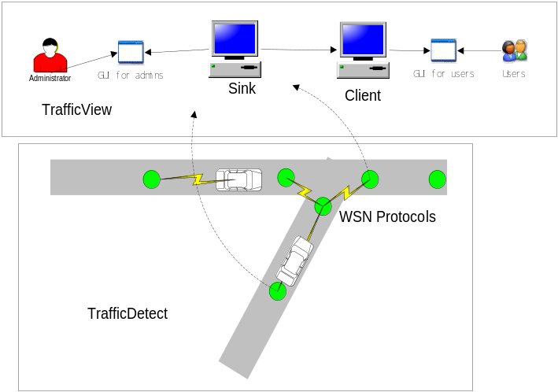
Fig. 1: Traffic management system overview
The essential WSN protocols, which are going to be discussed in details in this paper, are included in the TrafficDetect component. The architecture of TrafficDetect and its relationship with TrafficView is shown in figure 2.
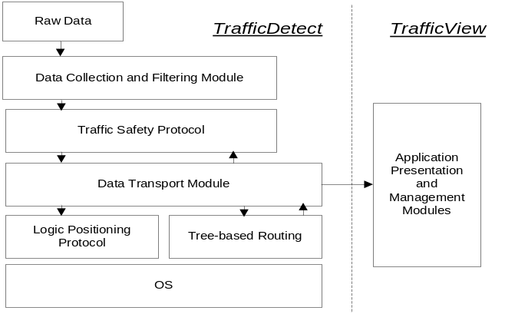
Fig. 2: Software architecture of TrafficDetect
The data collection and filtering module is mainly responsible for collecting raw data and transform them into useful information. The processed information will be fed to the traffic safety protocol which will make necessary decision if there is any potential collision. The data transport module is responsible for transport some data with certain success rate. The two routing modules are used by the transport module to determine how to send the information. In particular, the logic positioning protocol is used to transmit data between sensor nodes on the same road. The tree-based routing protocol collects some of the interesting data and transmits to the sink where the TrafficView application will visualize the data.
4 Logic Positioning Protocol
The most important modules to this project are the two WSN protocols which will be discussed in details in this paper. This section discusses the logic positioning protocol.
4.1 Problem Definition
The major responsibility for the logic positioning protocol is to help each sensor node find its logic position on the road. More specifically, each sensor need to find out its own ‘k’ value in the relationship s_{i} = (r_{j}, k) which has been defined in our system model. In addition to its own ‘k’, each sensor node needs to find out the ‘k’ values for some other sensor nodes with which it will cooperate. The reason why such information is necessary is because the traffic safety protocol needs this information in order to forward wake-up messages to the correct sensor so that the speed of the vehicles can be measured and collisions can be detected. Figure 3 shows a very simple example of how the traffic safety protocol works.
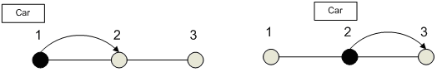
Fig. 3: Basic idea of the traffic safety protocol
When a car has reached sensor node 1, that sensor node will record the time stamp and transmit it to the sensor node 2. Upon receiving the time stamp, sensor node 2 will become active. When the car passes by, it will record another time stamp. With these 2 time stamps, the sensor nodes can estimate the speed of the car and detect potential collisions. Therefore, in order to make this system work, each sensor node needs to know its logic position and who its neighbors are. The logic positioning protocol makes use of a small number of landmarks and let the sensor nodes find their logic positions in a distributed fashion.
4.2 Mechanism
In this protocol, each sensor node will be finally assigned a unique coordinate which can be used to identify its logic position. The coordinate is composed of 2 parts: ‘block number’ and ‘position’. ‘Block number’ is the minimum number of hops for the sensor node to reach the landmark. ‘Position’ is the relative position for a sensor node within a block. As shown in figure 4, the coordinate has the following properties:
- The smaller the ‘block number’, the closer to the landmark.
- If two coordinate have the same ‘block number’, then the larger the ‘position’, the closer to the landmark.
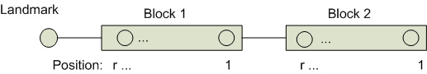
Fig. 4: Coordinates for the sensors
The logic positioning protocol is composed of 2 phases. In the first phase, each sensor is assigned a unique coordinate. The protocol can be most clearly illustrated by dividing it into 3 steps:
- Landmark broadcasts a message, all of the receiver will be assigned block number 1 automatically:
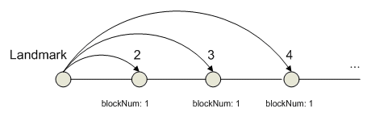
Fig. 5: Logic positioning protocol - step 1

- Each of the sensors in block 1 will broadcast a message. The receivers of those messages will be assigned block number 2 if it hasn’t been assigned any block number yet. Because of the different distances from block 1, each sensor in block 2 will receive different number of messages. The number of messages received can be used to determine the ‘position’ for each of the sensor in this block.
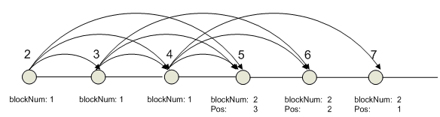
Fig. 6: Logic positioning protocol - step 2
- Repeat step 2 until each of the sensors is assigned a coordinate. The sensors in block 2 will broadcast a message. Sensors in block 1 and block 3 will also receive the broadcast messages and they will be able to determine their position by counting how many messages they have received:
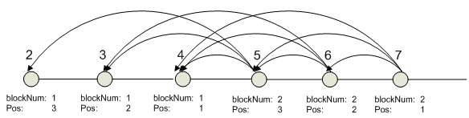
Fig. 7: Logic positioning protocol - step 3
In the second phase, after each sensor is assigned a unique coordinate in order, sensors simply need to exchange their coordinates with their neighbors and the logic position can be easily determined based on the neighbors’ coordinates.
5 Traffic Safety Protocol
The traffic safety protocol is used to detect potential collision on the road and send warning messages. Since all sensor nodes are battery-powered and usually it is very difficult to re-charge the network, energy should be taken into consideration when designing such a protocol. Here, we propose a couple of schemes that can be combined to achieve both good accuracy and energy efficiency.
5.1 Objective
The primary objective of this protocol is to improve traffic safety by detecting potential traffic collisions and save as much energy as possible. In order to achieve this objective, each sensor should be active when any kind of collision may occur. During the rest of the time, sensors should be kept in sleep mode. Basically, there are three types of collisions. The first type occurs on the same lane where the vehicles hit with each other on the tail or head as shown in figure 4.
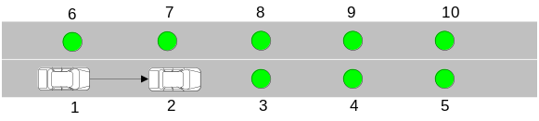
Fig. 4: Collision on the same lane
This type of collision could be detected if each sensor keeps a record of the last passed vehicle. The speed of the newly arrived vehicle can then be compared with the last passed vehicle so as to find potential collisions. The second type of collision occurs when the vehicles are trying to switch lane as shown in figure 5.
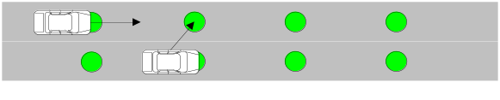
Fig. 5: Collision during lane switching
This type of collision can be viewed as an extension to the first application scenario. Now the sensor nodes on different roads will need to work together. In order to detect such kind of collision, when a vehicle passes by a sensor node, that sensor node will need to send wake-up messages not only to the sensor nodes on the same road, but also sensor nodes on the neighboring road. The third type of collision occurs in the intersections when vehicles are driving too fast near the intersection, as shown in figure 6.
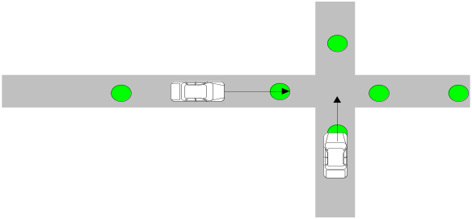
Fig. 6: Collision in the intersection
This kind of collision can also be viewed as an extension to the first scenario because when the sensor node near the intersection detects a vehicle, it simply wakes up other sensor nodes near the intersection in order to detect collision.
The objective of the system is to detect all the 3 types of possible collisions and alert the driver when there is one. In order to detect potential collisions, the sensor nodes first need to measure the speed of the vehicles. For the first collision case above, assume there are two vehicles with speed v₁ and v₂. The time interval between the arrivals of these two vehicles is t. The distance between two consecutive sensors is d. As a result, in order to avoid collision within distance d, which is the coverage of each sensor, we should have: v₂<d/t+v₁
Potential collision in the second case above can also be estimated by speed v₁ and v₂, time interval t and distance d. In order to avoid collision, a vehicle can be allowed to switch lane only when v₂<d/t+v₁ is satisfied.
Collision in the intersection can be estimated in a similar manner. Suppose the speeds of the 2 vehicles are v₁ and v₂. The distance between the sensor at the road end and the intersection is d. Then, the formula |v₁/d-v₂/d| should be smaller than a threshold which ensures the safety of both vehicles.
5.2 Wakeup Schemes and Analysis
Based on the system model and objective, we propose a couple of wakeup schemes in order to compare the performance and find out the best schemes under different conditions.
- Always-on: This is the simplest scheme where all of the sensor nodes are active at all the time.
- Random wake-up: all the sensor nodes just wake up randomly.
- Normal wake-up: When a sensor node detects a vehicle, it will wake up the next sensor that is going to be reached by the vehicle.
- Normal wake-up + random wake-up: in addition to the previous scheme, each sensor node will also wake up randomly in case some of the wake-up messages are lost.
- Selective wake-up: this scheme is similar to normal wake-up. Sensors are woken up in turns depending on the safety of the vehicles and the energy of the sensors. For instance, as shown in the figure 7, when a vehicle reaches sensor 2, sensor 2 will forward the wake-up message either directly to sensor 3 or through 2 hops to sensor 4. In this way, only one sensor needs to be woken up at a time.
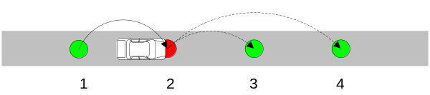
Fig. 7: Selective wake-up scheme
We have compared all of the above schemes in terms of accuracy and energy consumption. First, the analysis of accuracy is shown below. Here, A denotes the average accuracy for each scheme and accuracy means the probability of a sensor being in active mode when a vehicle passes it. ρ is the transmission error rate. n is a parameter which denotes the number of sensors on a road. P_{w} is the wake-up probability.
Always-on: in this scheme, since the sensors are turned on at all the time, the accuracy is nearly 100% for every collision scenario described above.
Random wake-up: in this scheme, the accuracy equals the wake-up probability: A=P_{w}
Normal wake-up: in this scheme, since each sensor will not be active until it receives a wake-up message from the previous sensor. Therefore, the sensors that are farther away from the beginning of the road tend to have poorer accuracy because once the wake-up message fails to be delivered, all the following sensors will not be able to wake up and detect the vehicle.
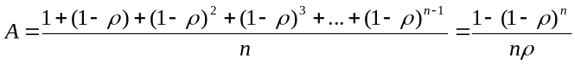
Normal wake-up + random wake-up: this scheme is the combination of normal wake-up and random wake-up. We may analyze its accuracy from the first sensor node on the road. The accuracy of the first sensor node is:
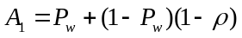
With the same approach, we can get accuracy for other sensor nodes as well. Finally, we can get:
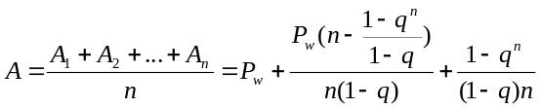,
Here, 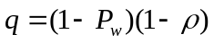
Selective wake-up has the similar results as normal wake-up here because this scheme simply let some of the sensor nodes work in terms.
In addition to accuracy, we also analyze the average energy consumption, E, for each scheme. Here energy consumption is defined as the ratio between the amount of time spent in active mode and total amount of time.
Always-on: in this scheme, the sensors are always in active mode so the energy consumption is 100%.
Random wake-up: in this scheme, the energy consumption is simply the wake-up probability: P_{w}
Normal wake-up: First, let e be the average energy consumption for a sensor in T time unit where there are m cars passing by. Therefore, the average energy consumption for this scheme is:
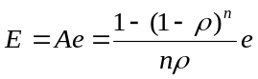
Normal wakeup with self-wakeup: this scheme can be regarded as a combination of both normal wakeup and random wake-up:
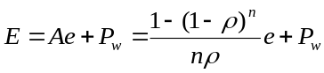
Selective wakeup: this scheme consumes only half the energy as the normal wake-up scheme because sensors are working in turns.
As we can see from the analysis above, the average accuracy for normal wake-up scheme is largely related to the total number of sensor nodes on the road. The sensor nodes that are far away from the beginning of the road will have poor accuracy so they’d better use random wake-up to make up for the poor accuracy. Currently, we set P_{w} to be k*ρ with a max value of 0.5. Selective wake-up is a good scheme for highway because sensor nodes don’t need to wake up so often due to the high speed of the vehicles.
5.3 Pseudo Code
Based on the analysis in the previous section, we have the following pseudo code for scheme selection:
Set scheme=normal wake-up; random=0
If (k>3)
Random=k* ρ>0.5?k* ρ:0.5;
If (getAverageSpeed ()>80)
Scheme=selective wake-up;
6. Performance Evaluation
The protocols have been implemented by NesC [12] programming language on MicaZ [9] platform equipped with TinyOS [11] operating system. All the sensor nodes are clock-synchronized with the ETA protocol [15]. We have completed the first round of real experiment in our campus car park. In our experiment, we used light sensor. As shown in figure 9, the raw data obtained by the sensor contains a lot of noises. Therefore, we develop a simple data filtering algorithm that can be used to filter the raw data. The basic idea of the filtering algorithm is that a change in the sensory data is identified only when the newly changed value has lasted for a while.
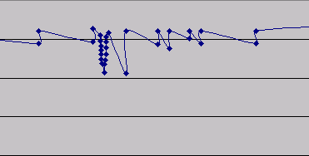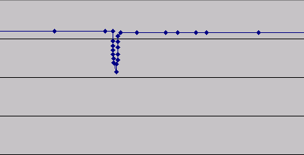
Fig. 9: Raw data (left) and filtered data (right).
Based on the data filtering algorithm, we were able to measure the speed of the vehicle. In the campus car park, the speed cannot go very high and the deployment of sensor nodes is rather dense (around 7 meters between 2 consecutive sensors). The normal wake-up scheme is already good enough to measure the approximate speed.
In addition to the field experiment, we have also conducted some simulations. The ‘logic positioning protocol’ in has been simulated in TOSSIM [13]. In the simulation environment, the sensors are able to correctly find their correct coordinates with our protocol.
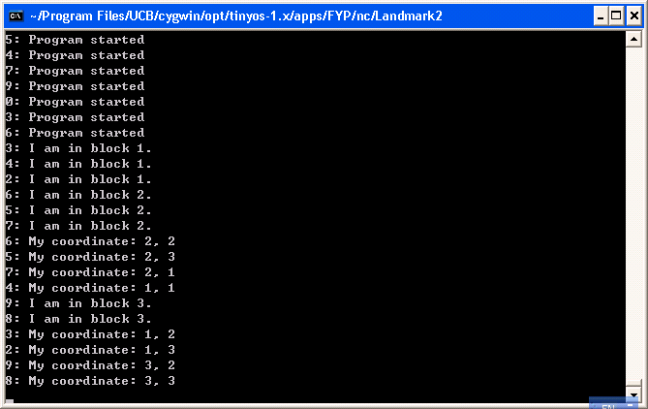
Fig. 10: Logic positioning protocol in TOSSIM
7. Conclusion and Future Works
In this paper, we have described how to design and implementation of WSN protocols which can be used to improve safety and efficiency upon the existing transportation system. Based on the protocols, we implement and test an intelligent traffic management system. We believe that WSN can be a very promising technology to be used in future ITS. We will improve our existing work in the following aspects:
- We will continue to test our system in outdoor environment.
- Combine the work with on-going projects like intelligent parking system [14] to provide better services.
References
1. I. Akyildiz, W. Su, Y. Sankarasubramaniam, E. Cayirci. “A survey on sensor networks” In IEEE Communication Magazine, 40(8): 102-114, 2002.
2. J. P. Lynch, K. Loh. “A Summary Review of Wireless Sensors and Sensor Networks for Structural Health Monitoring” Shock and Vibration Digest, Sage Publications, 38(2):91-128, 2005.
3. A. Mainwaring, D. Culler, J. Polastre, R. Szewczyk, J.Anderson. Wireless sensor networks for habitat monitoring. In ACM international workshop on Wireless sensor networks and applications，September 2002
4. B Lo, S Thiemjarus, R King, G Yang. “Body Sensor Network–A Wireless Sensor Platform for Pervasive Healthcare Monitoring” The 3rd International Conference on Pervasive Computing, 2005
5. L.A. Klein, “Traffic parameter measurement technology evaluation”. Proceedings of the IEEE-IEE Vehicle Navigation and Information Systems Conference, 1993, pp.529-533
6. Atev, S.; Arumugam, H.; Masoud, O.; Janardan, R.; Papanikolopoulos, N.P. “A vision-based approach to collision prediction at traffic intersections” IEEE Transactions on Intelligent Transportation Systems. Vol. 6, Issue 4. 2005
7. Kumar, P.; Ranganath, S.; Huang Weimin; Sengupta, K. “Framework for real-time behavior interpretation from traffic video” IEEE Transactions on Intelligent Transportation Systems. Vol. 6, Issue 4. 2005
8. http://www.media.mit.edu/resenv/vehicles.html
9. http://www.xbow.com/
10. Chen Wenjie, Chen Lifeng, Chen Zhanglong, Tu Shiliang. "A realtime dynamic traffic control system based on wireless sensor network". International Conference Workshops on Parallel Processing, June 2005 Page(s): 258 - 264.
11. TinyOS website: http://www.tinyos.net/
12. David Gay, Philip Levis, Robert von Behren, Matt Welsh, Eric Brewer, and David Culler. The nesC Language: A Holistic Approach to Network Embedded Systems. Proceedings of the ACM SIGPLAN 2003 Conference on Programming Language Design and Implementation (2003)
13. Philip Levis, Nelson Lee, Matt Welsh, and David Culler “TOSSIM: Accurate and Scalable Simulation of Entire TinyOS Applications” In Proceedings of the First ACM Conference on Embedded Networked Sensor Systems (SenSys 2003)
14. Vanessa W.S. Tang, Yuan Zheng, Jiannong Cao, "An Intelligent Car Park Management System based on Wireless Sensor Networks", Proc. 1st International Symposium on Pervasive Computing and Applications (SPCA-2006), Aug. 3 – 5, 2006. Urumchi, Xinjiang, China.
15. Branislav Kusy, Prabal Dutta, Philip Levis, Miklos Maroti, Akos Ledeczi, David Culler, "Elapsed time on arrival: a simple and versatile primitive for canonical time synchronisation services", International Journal of Ad Hoc and Ubiquitous Computing, Volume 1, Number 4, 2006
16. Tian He, Sudha Krishnamurthy, John A. Stankovic, Tarek Abdelzaher, Liqian Luo, Radu Stoleru, Ting Yan, Lin Gu, Jonathan Hui, Bruce Krogh "Energy-efficient surveillance system using wireless sensor networks", Proceedings of the 2nd international conference on Mobile systems, applications, and services, 2004

