Introduction to SQLTags:
Lab 1—Installing Tools

Installing MySQL Version 4.0
Goal: To install a local MySQL database server with main user named “root” with no password on Windows 2000 or XP operation system. Assumption: winzip installed on local computer.

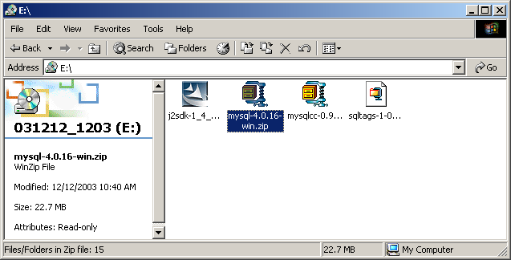
Download the 4.0 Windows version of MySQL from http://www.mysql.com/downloads/ and double-click on the mysql-4.0.16-win.zip file, from the WinZip program, double-click on the “setup.exe” file to execute the install. (Screen shots are from MySQL version 4.0.16.)

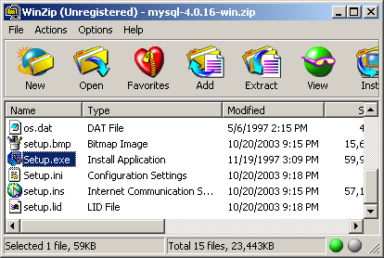
Install MySQL into the C:\MYSQL directory and do a “typical” install.

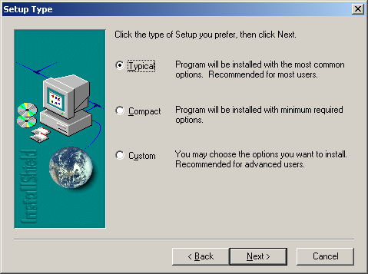
Click “Next” to begin the installation. Click “Finish” when it is complete. Don’t forget to close the WinZip window now that the installation is complete.

Launch “Windows Explorer” and navigate to the “C:\MYSQL\BIN” directory and double-click on the “winmysqladmin.exe” file to complete the setup of your database. Create the “root” user and assign it a dummy password.

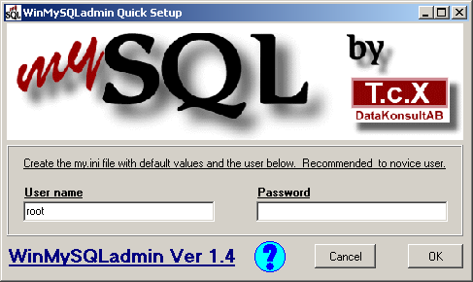
Click on “OK” to complete the database setup. Verify that the traffic light icon is in the “System Tray” with a green light. This indicates that your MySQL database is up and running.

The next step is to eliminate the root user’s password. (Sorry, but this caused problems in the installation, so we will be deleting the password for the lab). Right-click on the MySQL “traffic light” icon in the “System Tray” and select “Show me” to launch the MySQL admin tool. Click on the “my.ini Setup” tab and delete the password value as shown below.

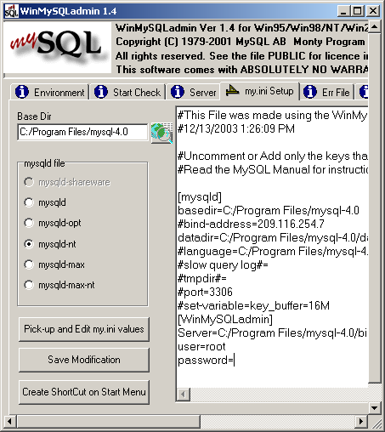
Next, click on the main “Environment” tab and finally Right-click on the “mySQL” logo in the top left and select “Hide me” to send the administration window back to the “System Tray.”

Done! You have successfully installed the MySQL database engine.

Installing MySQL Control Center
Goal: To install MySQL Control Center application and to use it to create a database named: “scott.”

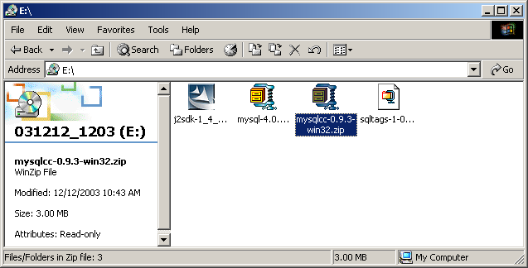
Download the MySQL Control Center softwarae from http://www.mysql.com/downloads/mysqlcc.html and double click on the mysqlcc-0-9-3-win32.zip file, from the WinZip program, double-click on the “setup.exe” file to execute the install. (Screen shots are from version 0.9.3.)

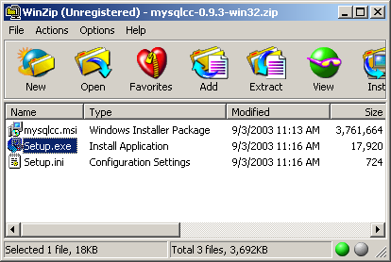
Follow the instructions for the MySQL Control Center installation:

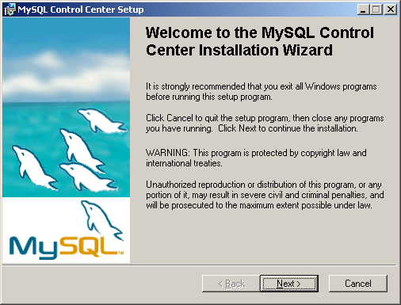
Accept the defaults for the Features and languages and click “Next” to continue, finally, click “Next” on the “Ready to Install the Application” screen to start the installation. Once the application has been installed, click “Finish” to complete the process. Don’t forget to close the WinZip window now that the installation is complete.

You can now double-click on the “MySQL Control Center” icon that has been added to the desktop.

The fist time you run the Control Center, you must identify the database you want to manage:
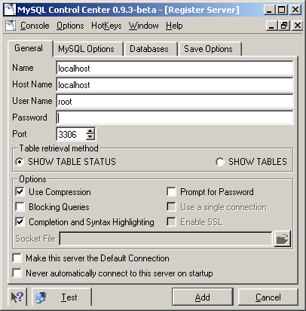
Enter “localhost” for the “Name” and “Host Name” fields and “root” for the “User Name” field. Leave the “Password” field blank and click on “Add.”

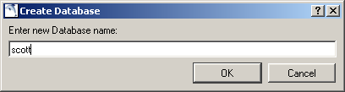
Next, we will add the “scott” database. From the “Console Manager” click on “Action->New Database” and enter “scott” into the pop-up window.

Upon completion your screen should look like this:
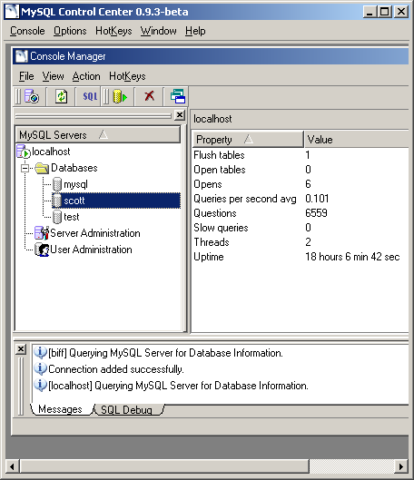
Done! This completes the MySQL database setup. You may now exit the MySQL Control Center program.

Installing The Java 1.4.2/NetBeans COBOUNDLE
Goal: To install the Java 1.4.2/NetBeans COBOUNDLE.

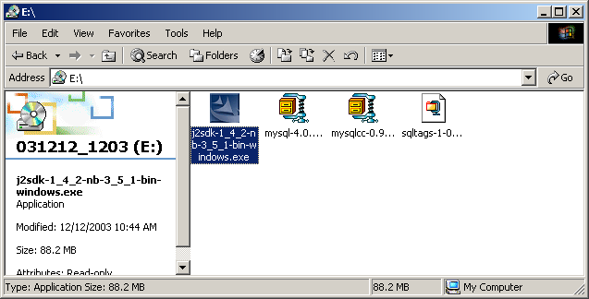
Download the “NetBeans IDE version 3.5.1 with J2SE verson 1.4.x COBUNDLE” from http://java.sun.com/j2se/1.4.2/download.html and double-click on the j2sdk-1_4_2-nb-3_5_1-bin-windows.exe file to begin the installation. (Screen shots are from J2se verson 1.4.2_02; be sure to download the windows version.)

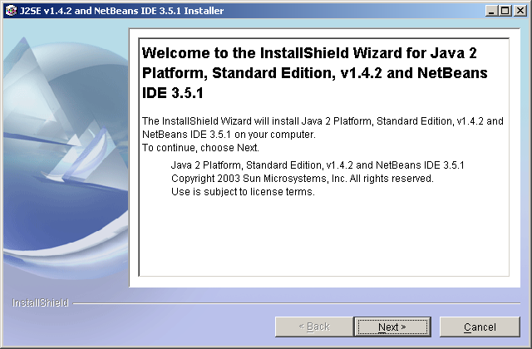
Accept the License Agreement and click “Next,” accept the default directory location and click “Next,” associate “.java” and “.nbm” files with NetBeans and click “Next,” do not use a proxy and click “Next,” confirm options and click “Next.”

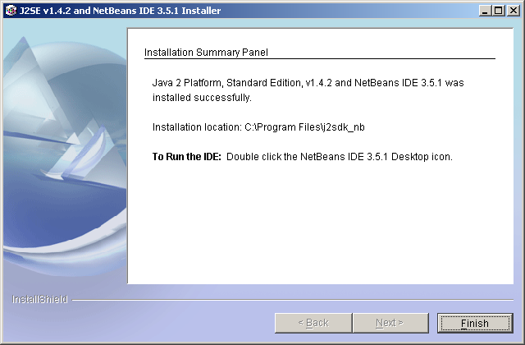

Once the installation process is complete, click on the “Finish” button to complete the Java 1.4.2/NetBeans COBOUNDLE Installation.


The NetBeans shortcut should now be available on the Windows desktop.

Done!

