Introduction to SQLTags:
Lab 2—Installing sqltags-1-0-6.war
Goal: To install the sqltags-1-0-6 web application for use with NetBeans.
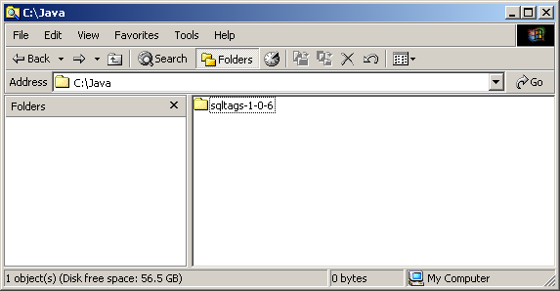
Create the directory c:\java\sqltags-1-0-6 using “Windows Explorer.”

Download the latest SQLTags web application file from: http://www.sqltags.org/downloads.jsp, double-click on the sqltags-1-0-6.war file, then from the WinZip program, extract all files from “sqltags-1-0-6.war” file into the “C:\java\sqltags-1-0-6” directory. Be sure to check the “Use folder names” and “All files” options on the Extract window. (See example screen shot below.)

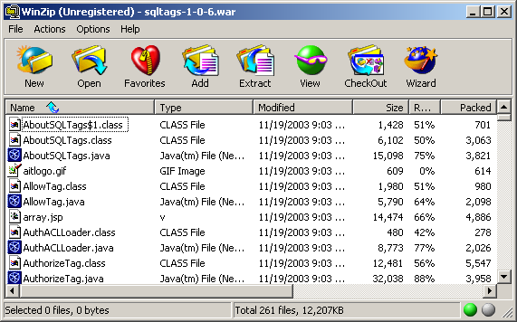
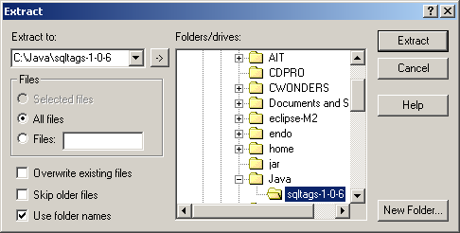
Launch NetBeans by double-clicking on the NetBeans icon on the Windows desktop.

In the “Editing” workspace, within “Explorer” window, right-click on “Filesystems” and select “Mount->Local Directory.”
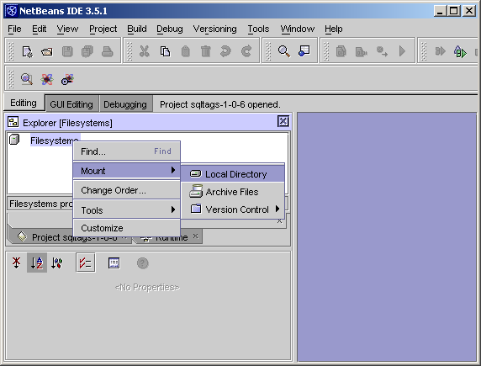
Select the “sqltags-1-0-6” directory from the “C:\Java” folder and click on “Finish” to mount the local directory.

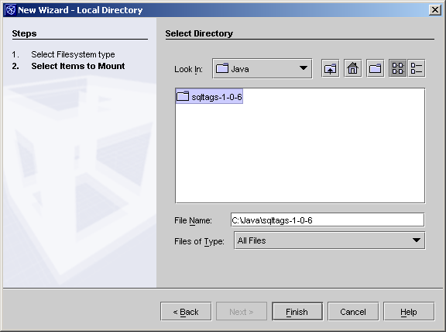
NetBeans will recognize the “Web Module” and issue the following prompt:

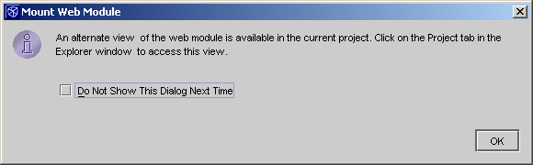
The sqltags-1-0-6 project is now available for use.

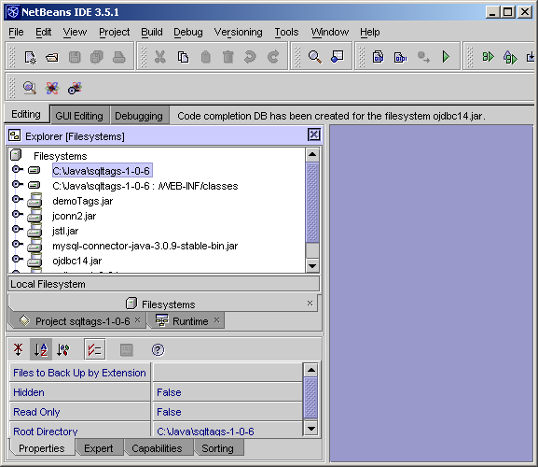
Note: since the sqltags-1-0-6 directory represents a “Web Module,” NetBeans will automatically mount the WEB-INF, WEB-INF/classes, and all “JAR” files contained within the WEB-INF/lib directory. Opening the “sqltags-1-0-6” directory in the Explorer view provides access to all of the files within the application.

Done! The sqltags-1-0-6 project is now ready for use.

