Introduction to SQLTags:
Lab 3—Using the SQLTags Generator

Goal: To run the SQLTags Generator and create a SQLTags JSP tag library.

Prerequisites: Labs 1 and 2.
- Running MySQL database with a “scott” database.
- Java 1.4.2/NetBeans COBOUNDLE installed.

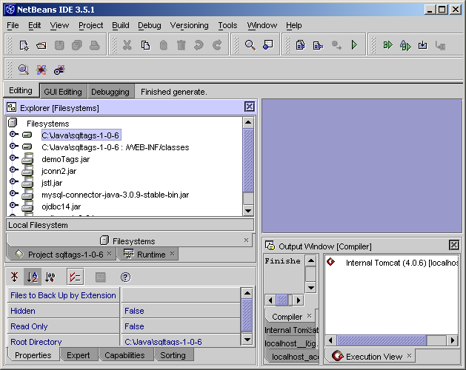
Launch NetBeans and open the “sqltags-1-0-6” project.

Verify the SQLTags “Deployment Descriptor.” Note: no changes to the web.xml file will be required. Edit the “sqltags-1-0-6/WEB-INF/web.xml” file by double-clicking on the file from the explorer view and verify the following “context-params”:

param-name | param-value
SQLTags.databaseDriver | org.gjt.mm.mysql.Driver
SQLTags.connectionUrl | jdbc:mysql://localhost/scott?user=root
SQLTags.userName | root
SQLTags.password

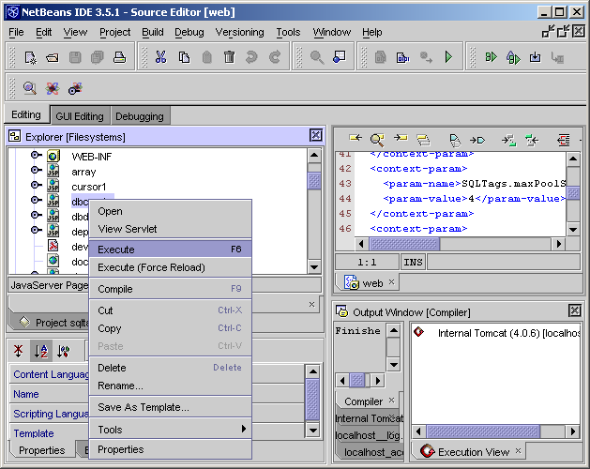
To setup the “scott” database, right-clicking on the dbcreate file and select “execute.”

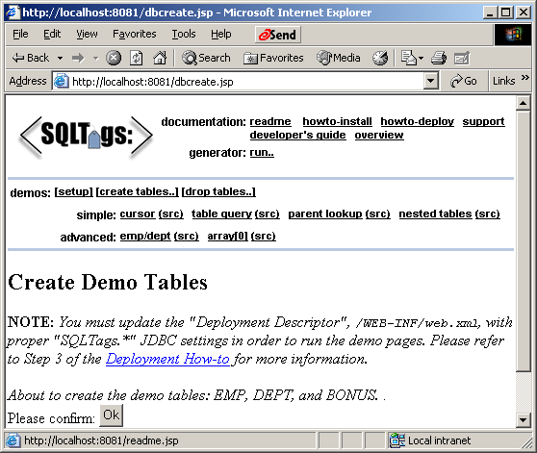
NetBeans will compile a few pages, launch tomcat server, and launch a browser window as shown below:

Click on “Ok” just after the “Please confirm:” prompt in the browser to create and load the demo tables.

At this point, verify that the demo pages are working properly by clicking on any of the “simple” demo pages: cursor, table query, parent lookup, etc.

Now that the data source is setup with tables and data, we can run the SQLTags Generator by clicking on the “run …” link next to the “generator:” prompt.

Fill in the fields according to the table below the screen shot.
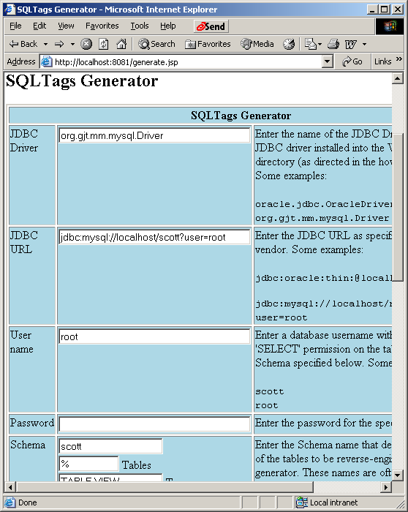

Generator Inputs:

Input Field | Value
JDBC Driver | org.gjt.mm.mysql.Driver
JDBC URL | jdbc:mysql://localhost/scott?user=root
User name | root
Password
Schema | scott
Tables | %
Types | TABLE, VIEW
Target Package Name | gov.loc.crs.samples.db
JAR Filename | scottTags.jar
Include built-in Tags | True
Include Source Code | True

Click the “Generate!” button. The SQLTags Generator will connect to the MySQL database as defined by the input fields and the SQLTags tag library based on the database schema.
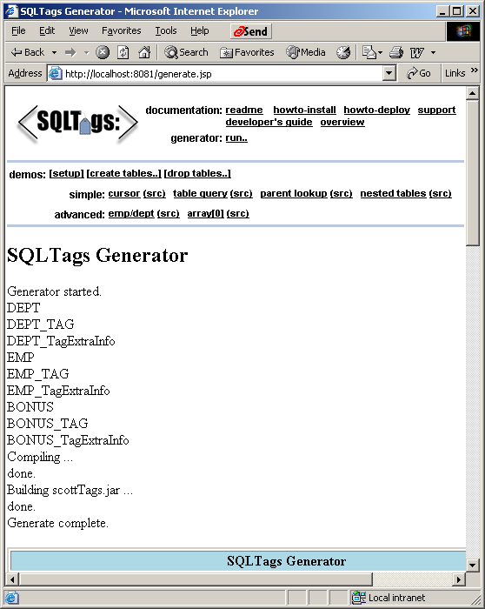

Well Done! You’ve generated a SQLTags tag library.
Navigate to the “C:\java\sqltags-1-0-6\WEB-INF\tmp” directory using “Windows Explorer” to see the generated files:

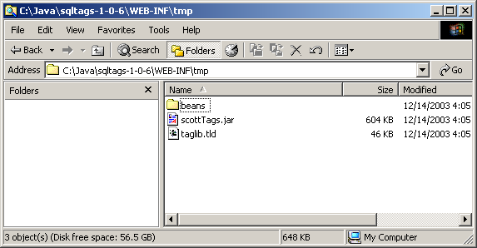
The contents of the generated Jar file, scottTags.jar, can be viewed with WinZIP or from the NetBeans IDE. Additionally, the generated Java source code is contained below the “tmp” directory based on the package name provided to the generator.

The scottTags.jar file can now be dropped into any web application by simply coping it into the WEB-INF/lib directory of the target application.

Note: NetBeans will lock all JAR files mounted from WEB-INF/lib so you must copy the generated JAR file into the WEB-INF/lib directory only when NetBeans is not running.

This completes the Generator Lab.

