**Index Page (temporary just for me)**

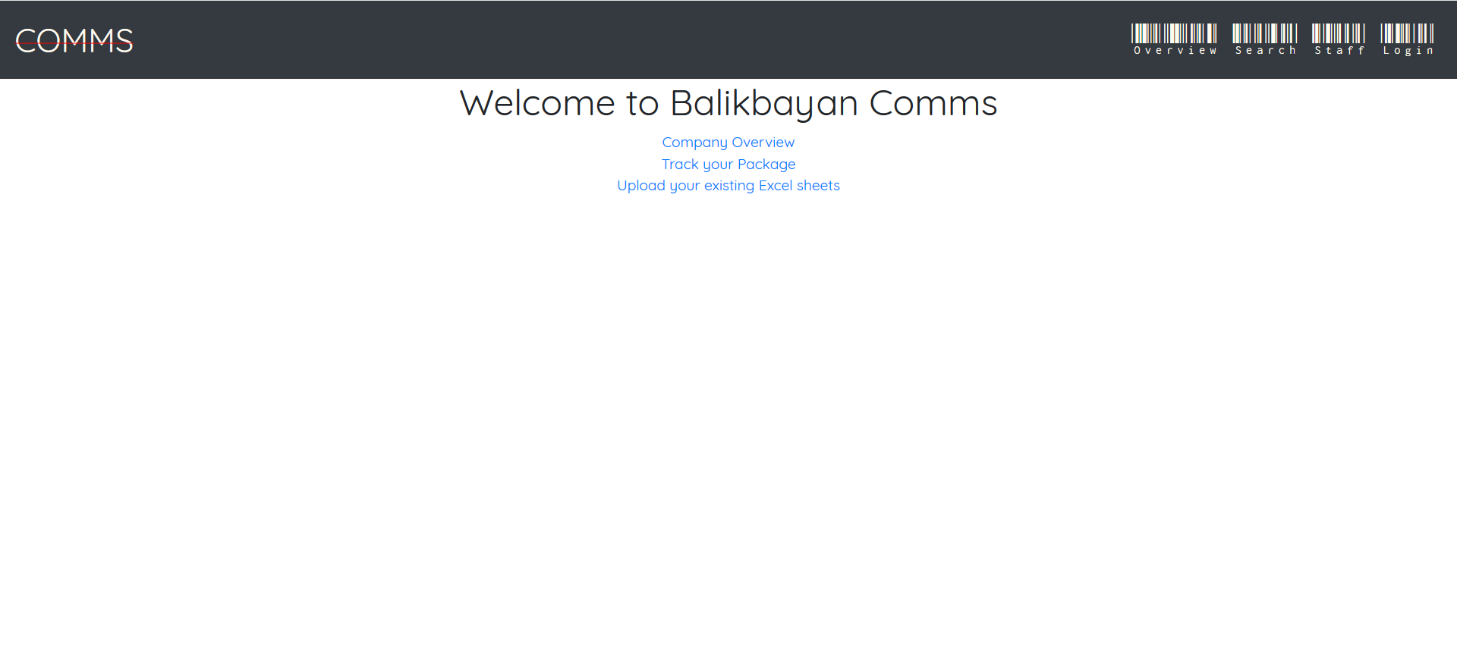

**Tracking page for customers (UI update TBD)**

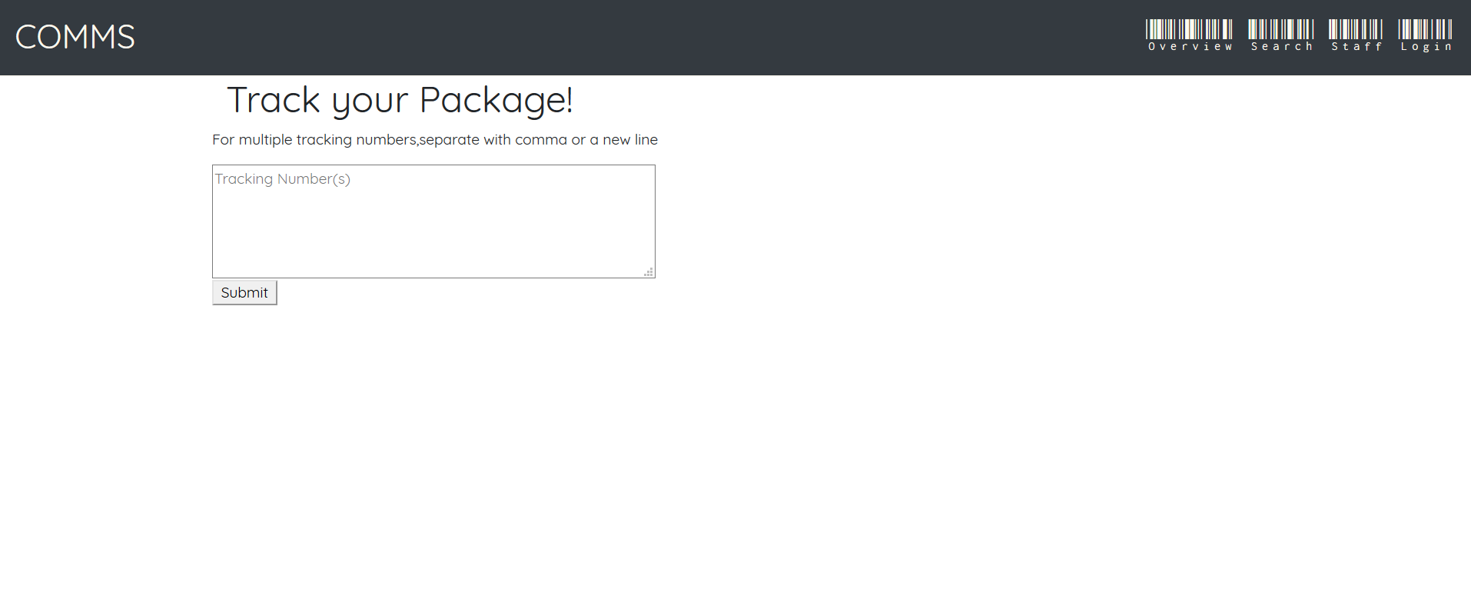

**Tracking results for the customer (UI update TBD)**

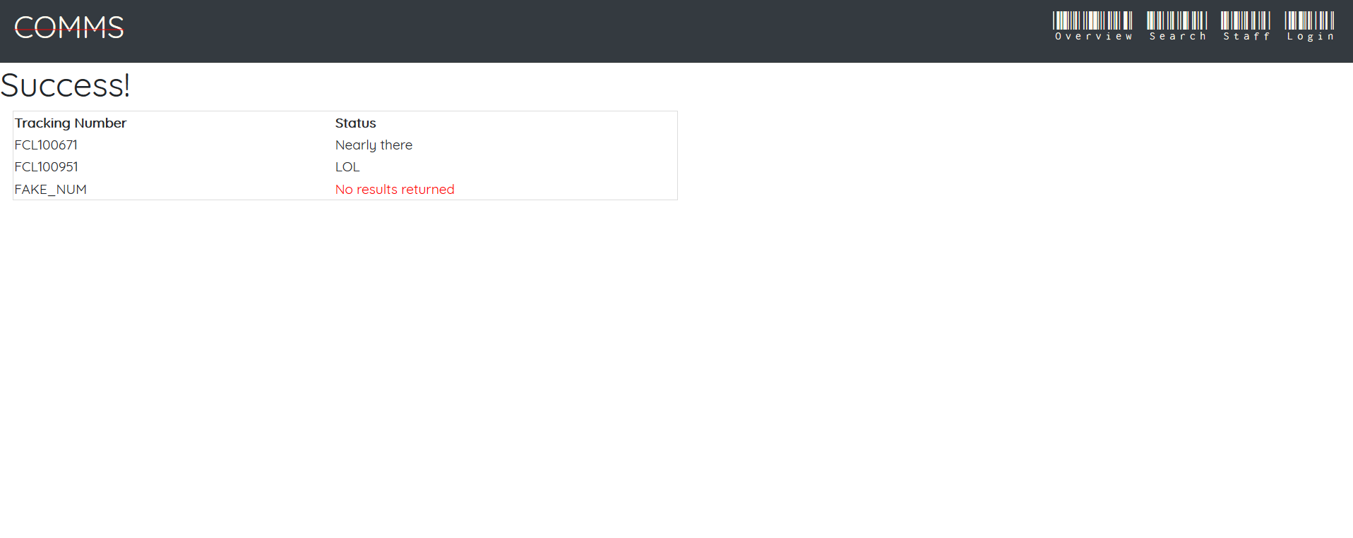

**Phillipines Company side**

**Page showing all of the countries the company is associated with**

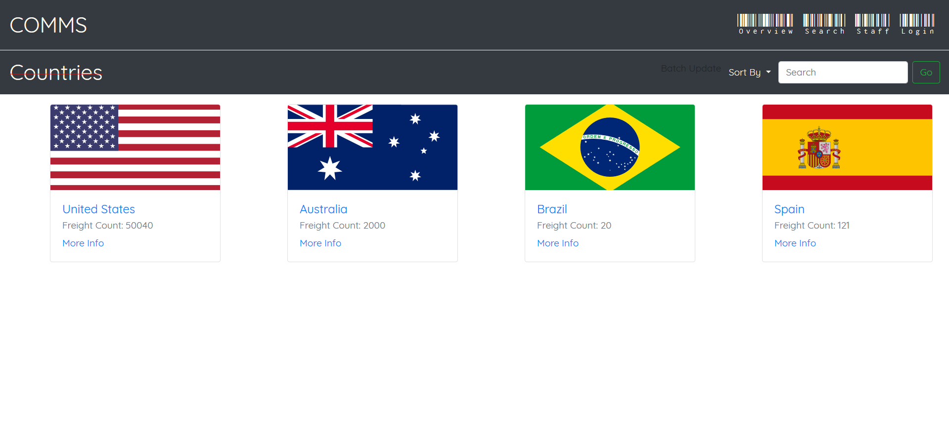

**Page showing all of the companies associated with belonging to the selected country (US in this case) (format to be fixed soon)**

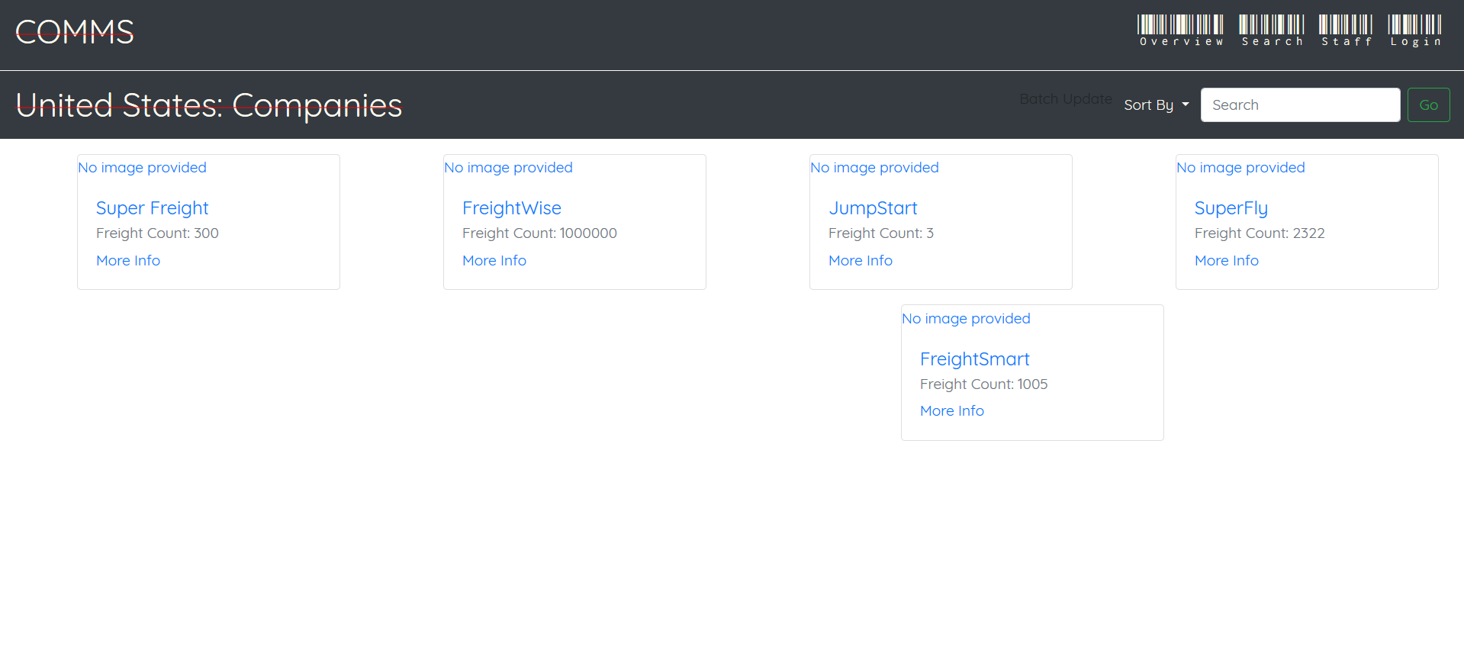

**Page showing all of the transactions for the selected company (FreightWise in this case)**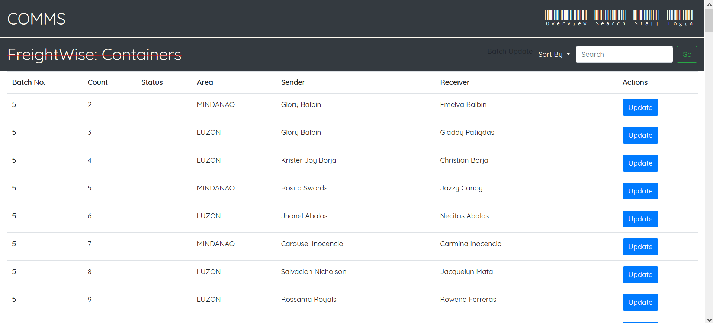

**Overseas Company**

**Page to allow uploading of Excel sheets to be uploaded into the database (UI update TBD)**

