CoffCo
System Architecture
COFFCO-ARCH-001 | Issue 2.1
Safety Engineering Update — Safety-Updated Architecture with High-Resolution Diagrams
Field | Detail
Document Reference | COFFCO-ARCH-001
Issue | 2.1
Date | 26 June 2026
Project | CoffCo — Next-Generation In-Room Hotel Coffee Machine
Customer | Vacation Stables Hotel Group
Prepared by | CoffCo Systems Team / School of Systems Engineering Secondment
Approved by | Pending — Systems Design Authority (SDA)
Classification | Commercial in Confidence
SRS Baseline | COFFCO-SRS-001 — 42 requirements (38 + SRS 1.10 + SRS 3.10, 3.11, 3.12, 3.13 (safety provisions embedded in SRS))
HAZID Baseline | COFFCO-HAZID-001 — 19 hazards (H-01 to H-19)
Related Documents | COFFCO-SAFECASE-001 | COFFCO-VVP-001 | COFFCO-SDD-001 | COFFCO-ICD-001 | CN-001 | CN-002

Document History
This table records all issues of COFFCO-ARCH-001. Changes are not highlighted within the document body. Each issue is complete and self-contained.

Issue | Date | Author | Description of Change | CN Ref
1.0 | June 2026 | CoffCo / SSE | Initial issue. Two-level logical and physical architecture, five MBSE views per INCOSE Z8/Z9. Six subsystems SS-1 to SS-6. | —
2.0 | June 2026 | CoffCo / SSE | Architecture update following V&V Plan and detailed design phase. Added SS-5 Monitoring & Comms as distinct subsystem. Requirements traceability matrix extended. Activity diagram (Figure 9) added. Physical BDD revised. | —
2.1 | June 2026 | CoffCo / SSE | Safety Engineering update. Nineteen hazards identified (COFFCO-HAZID-001 H-01 to H-19). Seventeen safety requirements added (SRS 3.10, 3.11, 3.12, 3.13 (safety provisions embedded in SRS)). Architecture changes per CN-001 and CN-002: TCO, hardware watchdog, PRV, mains fuse, IPX2 enclosure, drip tray sensor, descale firmware, consumable interlock, chassis thermistor, anti-tip bracket. State machine extended to 10 states (SAFE-SHUTDOWN, FLUID-EMPTY added). Requirements allocation table updated with full SAF series. Diagrams redrawn at high resolution. | CN-001, CN-002

1. Introduction and Scope
This document is version 2.2 of COFFCO-ARCH-001, the System Architecture for the CoffCo next-generation in-room hotel coffee machine. It has been updated following the Safety Engineering review to incorporate 19 identified hazards, 17 new safety requirements (SRS 3.10, 3.11, 3.12, 3.13 (safety provisions embedded in SRS)), and the associated architectural changes mandated by Change Notices CN-001 and CN-002.

The architecture provides five formally connected MBSE views per INCOSE Z8 (System Architecture) and Z9 (MBSE): logical, physical, behavioural (state model), requirements traceability, and safety requirements allocation. All six subsystems (SS-1 through SS-6) are defined. No new subsystems have been added; all safety changes are accommodated within the existing subsystem structure.

Applicable Standard / Document | Purpose
INCOSE Z8 | System Architecture — view types and completeness criteria
INCOSE Z9 | MBSE — ontology, viewpoints, concerns
MIL-STD-882E | Qualitative risk matrix used in COFFCO-HAZID-001
IEC 60335-1 | Household and similar electrical appliances — Safety — applied to all SAF requirements
IEC 60529 | Enclosure ingress protection — IPX2 requirement (SAF-14)
IEC 61000-4-5 | Surge immunity test (SAF-05)

2. System Context
The context diagram defines the system boundary and all external actors. Labelled flows show the interfaces between the CoffCo machine and each actor. This view establishes what is inside and outside the system, and what crosses the boundary.

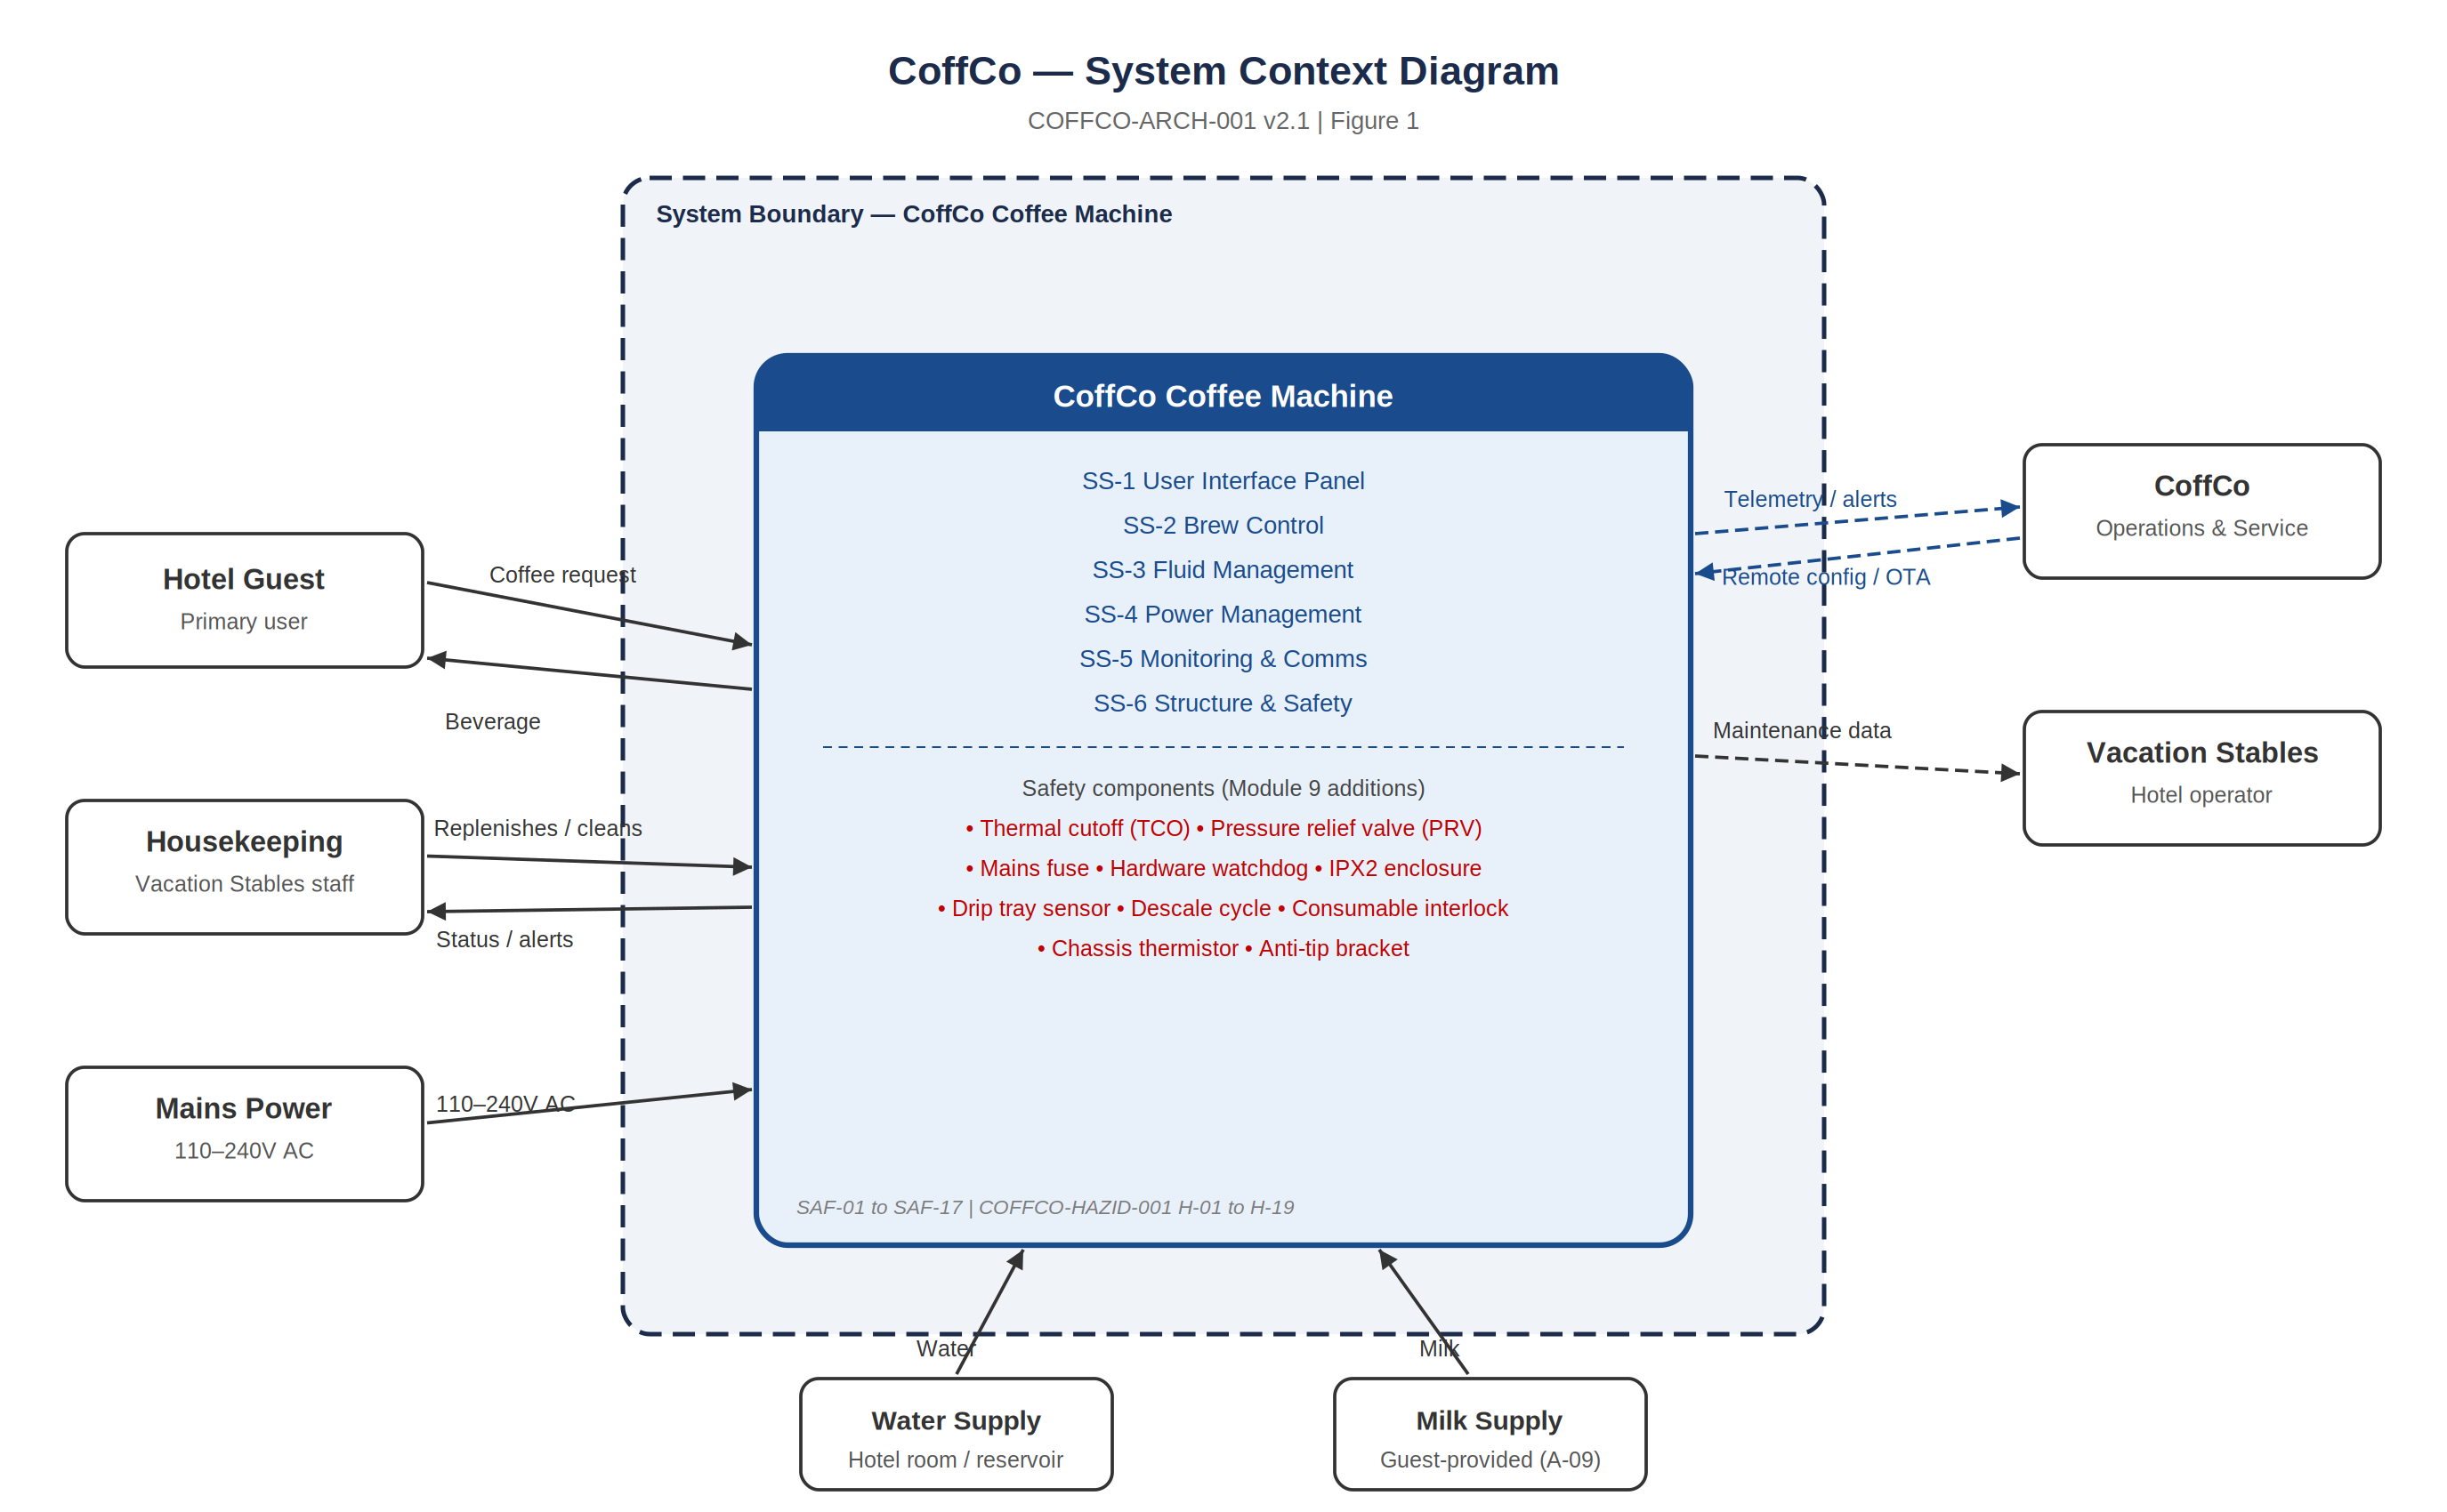
Figure 1 | System context diagram. All external actors and labelled interface flows. System boundary encloses all six subsystems (SS-1 to SS-6). Red text indicates safety additions from Safety Engineering Review.

3. Logical Architecture
The logical architecture decomposes the CoffCo system into six functional subsystems, each grouping a set of related functions from COFFCO-SRS-001. This view is entirely technology-agnostic — it defines what the system does and how those functions interact, without specifying how they are realised. Flows represent logical exchanges of data, material, or energy.

Issue 2.1 additions (shown in red in Figure 2): fluid level interlock and pressure monitoring added to SS-2; pressure relief valve, drip tray sensor, and consumable interlock added to SS-3; mains fuse and surge protection added to SS-4; IPX2 rating, anti-tip bracket, surface temperature constraint, and chassis thermistor added to SS-6. Three new safety telemetry events added to SS-5.

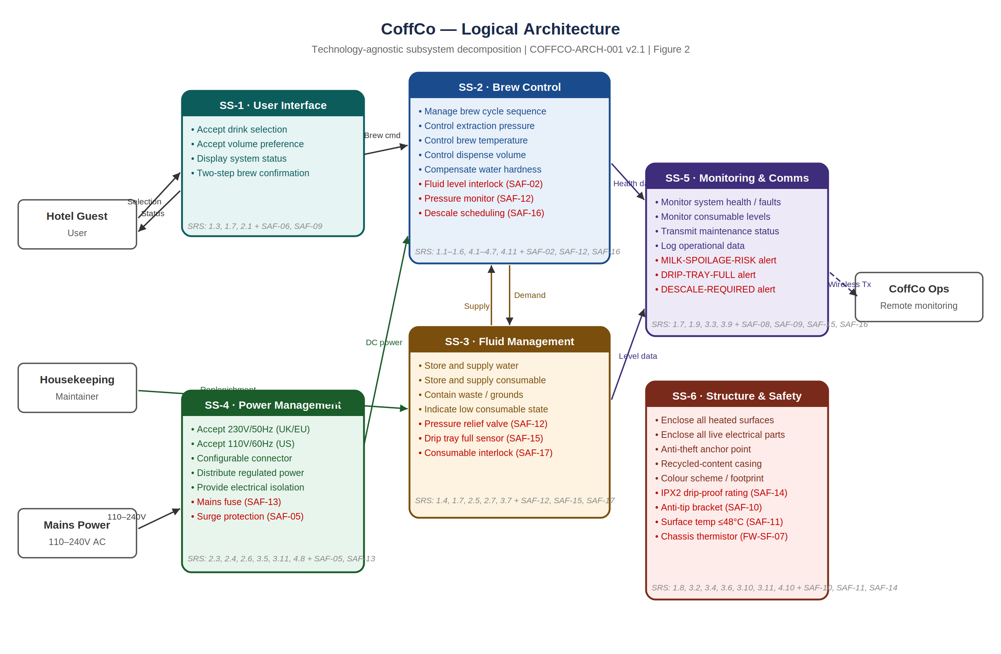
Figure 2 | Logical architecture — six functional subsystems (SS-1 to SS-6). Technology-agnostic. Flows show logical exchanges. Red text indicates Issue 2.1 safety additions.

3.1 Subsystem Function Summary
Subsystem | Name | Primary Functions (v2.2) | SRS Refs
SS-1 | User Interface | Accept drink and volume selection; display system status; two-step brew confirmation (H-19 child misuse mitigation) | 1.3, 1.7, 2.1
SS-2 | Brew Control | Manage brew cycle; control extraction pressure, temperature, and volume; fluid level interlock (SAF-02); pressure monitoring / PRV backstop (SAF-12); descale cycle scheduling (SAF-16); hardware watchdog (SAF-07) | 1.1–1.6, 4.1–4.7 + SAF-02, SAF-07, SAF-12, SAF-16
SS-3 | Fluid Management | Store water and consumables; contain waste; drip tray (SAF-15 sensor); pressure relief valve (SAF-12); consumable loading interlock (SAF-17); milk refrigeration (NR-05) | 1.4, 1.7, 2.5, 2.7, 3.7 + SAF-12, SAF-15, SAF-17
SS-4 | Power Management | Universal AC input; regional connector; regulated DC output; Class II isolation (SAF-04); mains fuse (SAF-13); surge protection (SAF-05) | 2.3, 2.4, 2.6, 3.5, 3.11, 4.8 + SAF-04, SAF-05, SAF-13
SS-5 | Monitoring & Comms | Monitor system health and faults; transmit maintenance status; MILK-SPOILAGE-RISK (SAF-08); DRIP-TRAY-FULL (SAF-15); DESCALE-REQUIRED (SAF-16); COMMS-FAULT watchdog (SAF-09) | 1.7, 1.9, 3.3, 3.9 + SAF-08, SAF-09, SAF-15, SAF-16
SS-6 | Structure & Safety | Enclose heated and live surfaces; anti-theft anchor; recycled-content casing; IPX2 drip-proof rating (SAF-14); anti-tip bracket (SAF-10); surface temperature ≤48°C (SAF-11); chassis thermistor for FW-SF-07 | 1.8, 3.2, 3.4, 3.6, 3.10, 3.11, 4.10 + SAF-10, SAF-11, SAF-14

4. Physical Architecture
The physical architecture allocates the six logical subsystems to seven physical elements. This level introduces technology-selection decisions and physical design constraints, without descending to component-level specification.

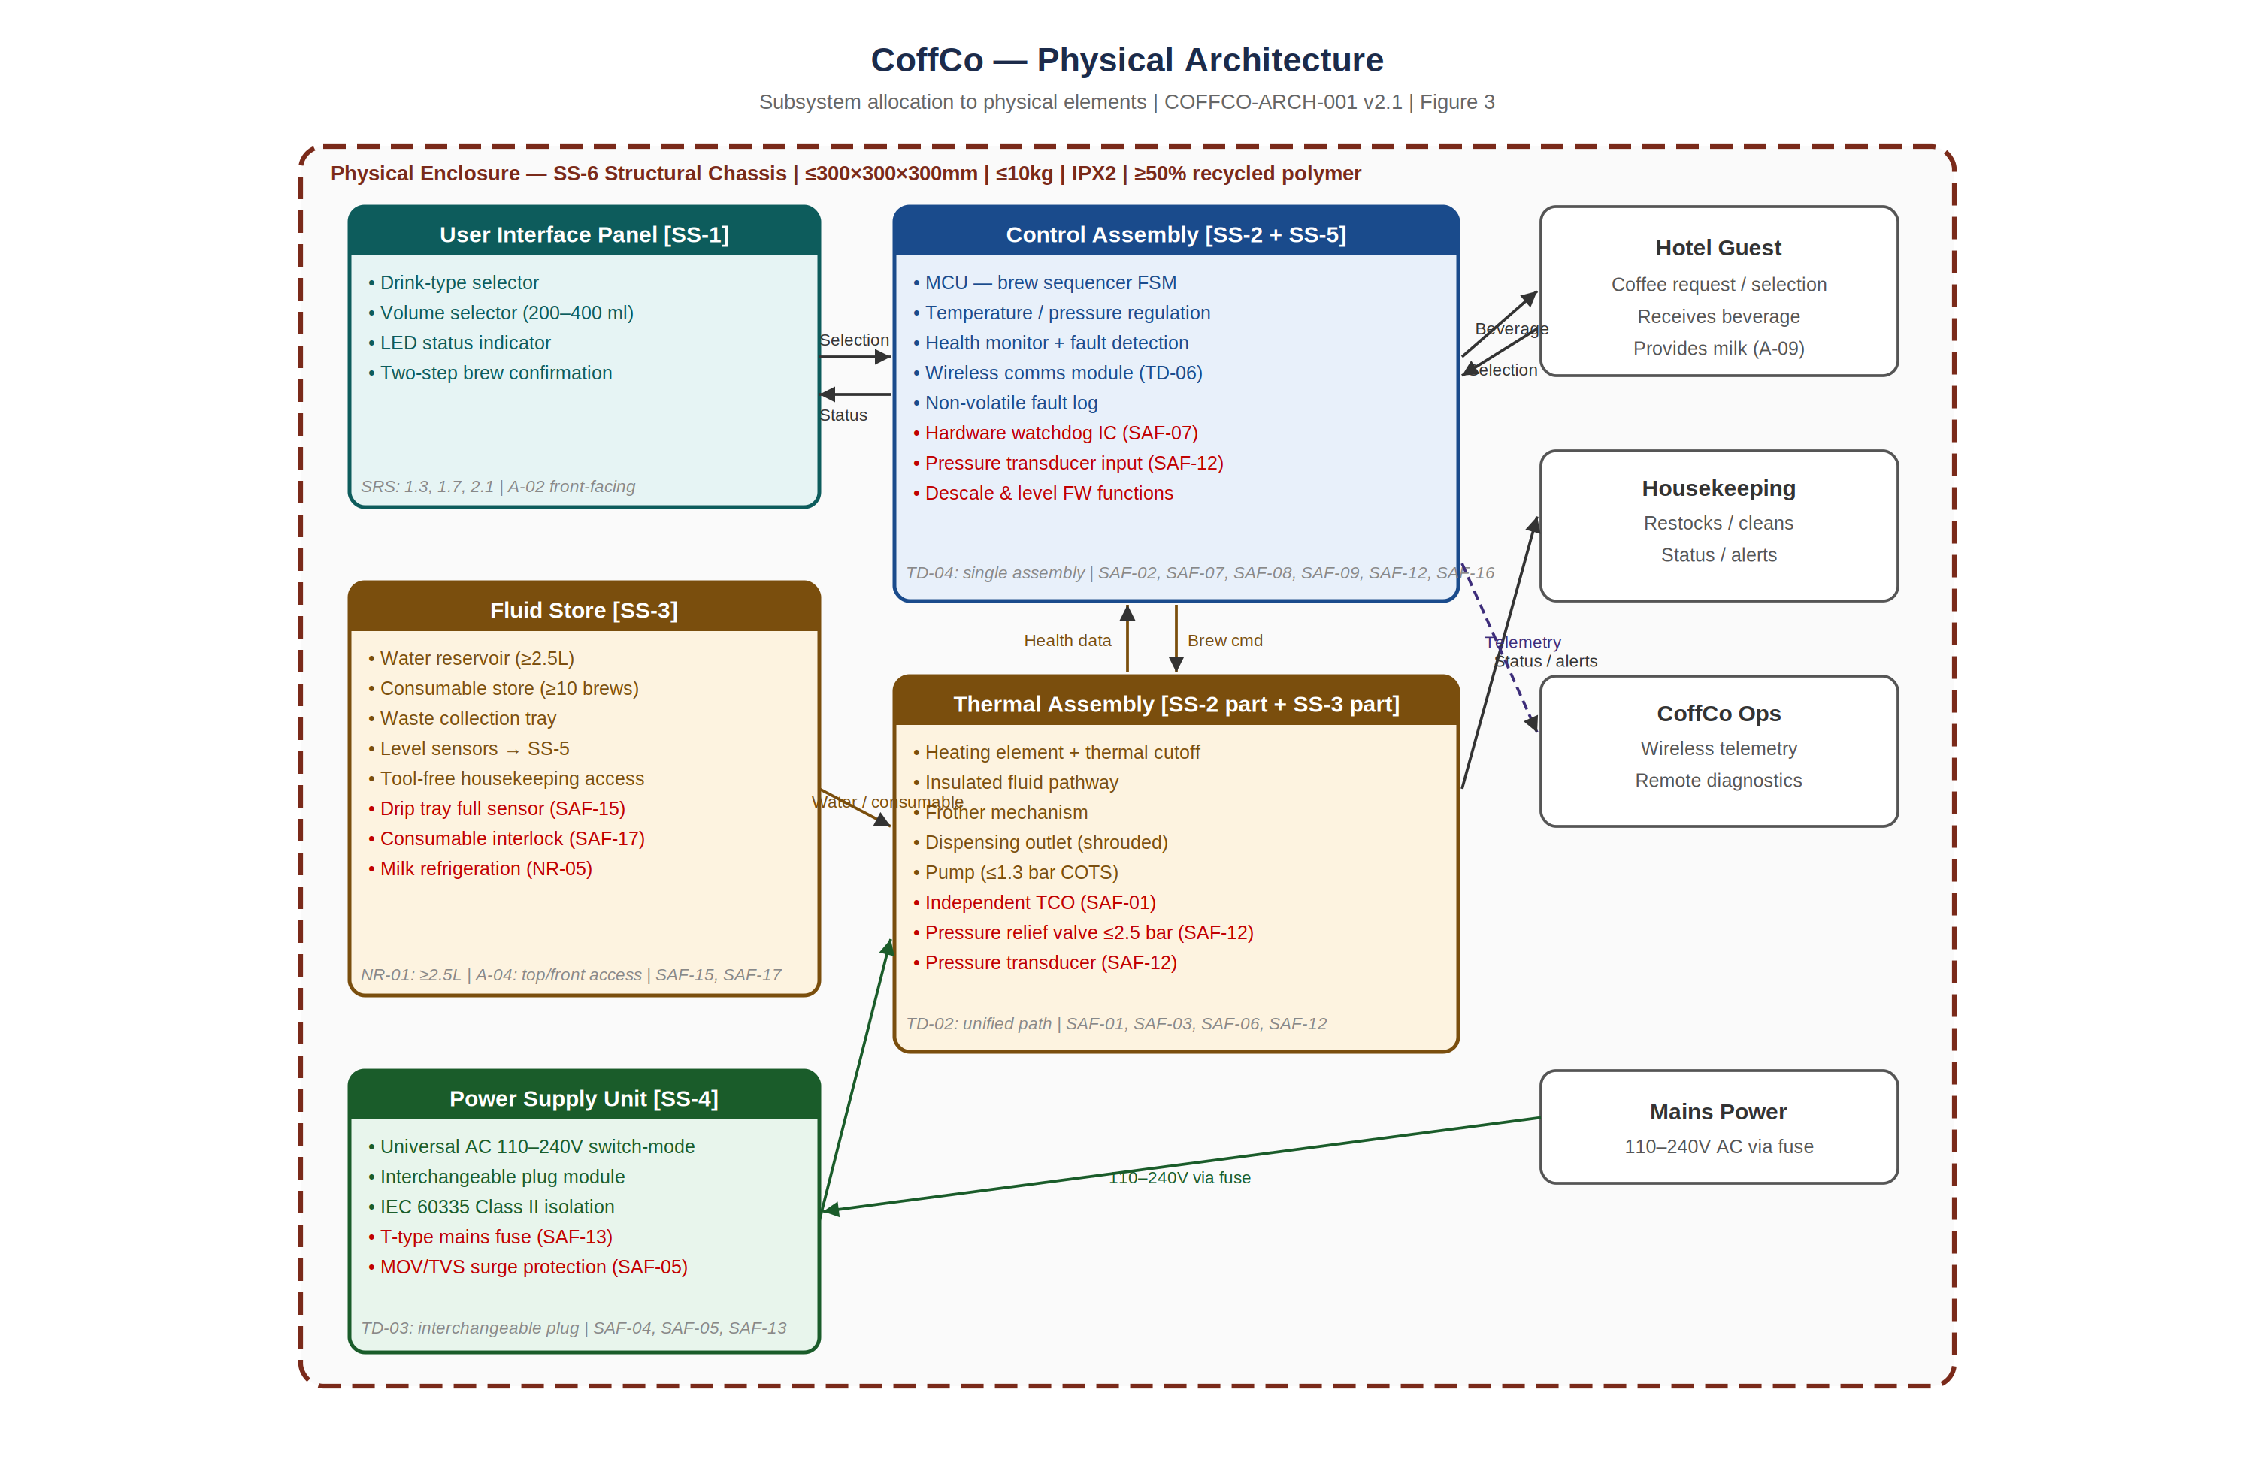
Figure 3 | Physical architecture — logical subsystems allocated to seven physical elements within the SS-6 structural chassis enclosure. Red text indicates Issue 2.1 safety additions.

4.1 Physical Element Summary
Physical Element | Subsystem(s) | Issue 2.1 Safety Additions | Key Standards
User Interface Panel | SS-1 | Two-step brew confirmation (H-19 child misuse mitigation) | —
Control Assembly | SS-2 + SS-5 | Hardware watchdog IC (SAF-07); pressure transducer input (SAF-12); descale and level firmware functions (SAF-16, SAF-02); all safety telemetry events | IEC 60335 / EMC EN 55014
Thermal Assembly | SS-2 part + SS-3 part | Independent TCO (SAF-01); pressure relief valve ≤2.5 bar (SAF-12); pressure transducer (SAF-12); shrouded dispensing outlet (SAF-06) | IEC 60335-2-15
Fluid Store | SS-3 | Drip tray full sensor (SAF-15); consumable loading interlock (SAF-17); milk refrigeration (NR-05) | HACCP / food grade
Power Supply Unit | SS-4 | T-type mains fuse (SAF-13); MOV/TVS surge protection (SAF-05) | IEC 60335, IEC 61000-4-5
Structural Chassis | SS-6 | IPX2 enclosure rating (SAF-14); anti-tip bracket (SAF-10); surface temp constraint ≤48°C (SAF-11); chassis thermistor (FW-SF-07) | IEC 60529 IPX2, IEC 60335
External Interfaces | — | No change at v2.2 | —

5. Behavioural View — System State Model
The state model defines how the CoffCo machine moves through operational states over time. Issue 2.1 extends the original eight states with two mandatory safety-priority states (SAFE-SHUTDOWN and FLUID-EMPTY) that supersede all other state transitions when triggered. The state model directly supports the firmware design (COFFCO-SAFECASE-001 Section 5 firmware safety functions FW-SF-01 to FW-SF-08).

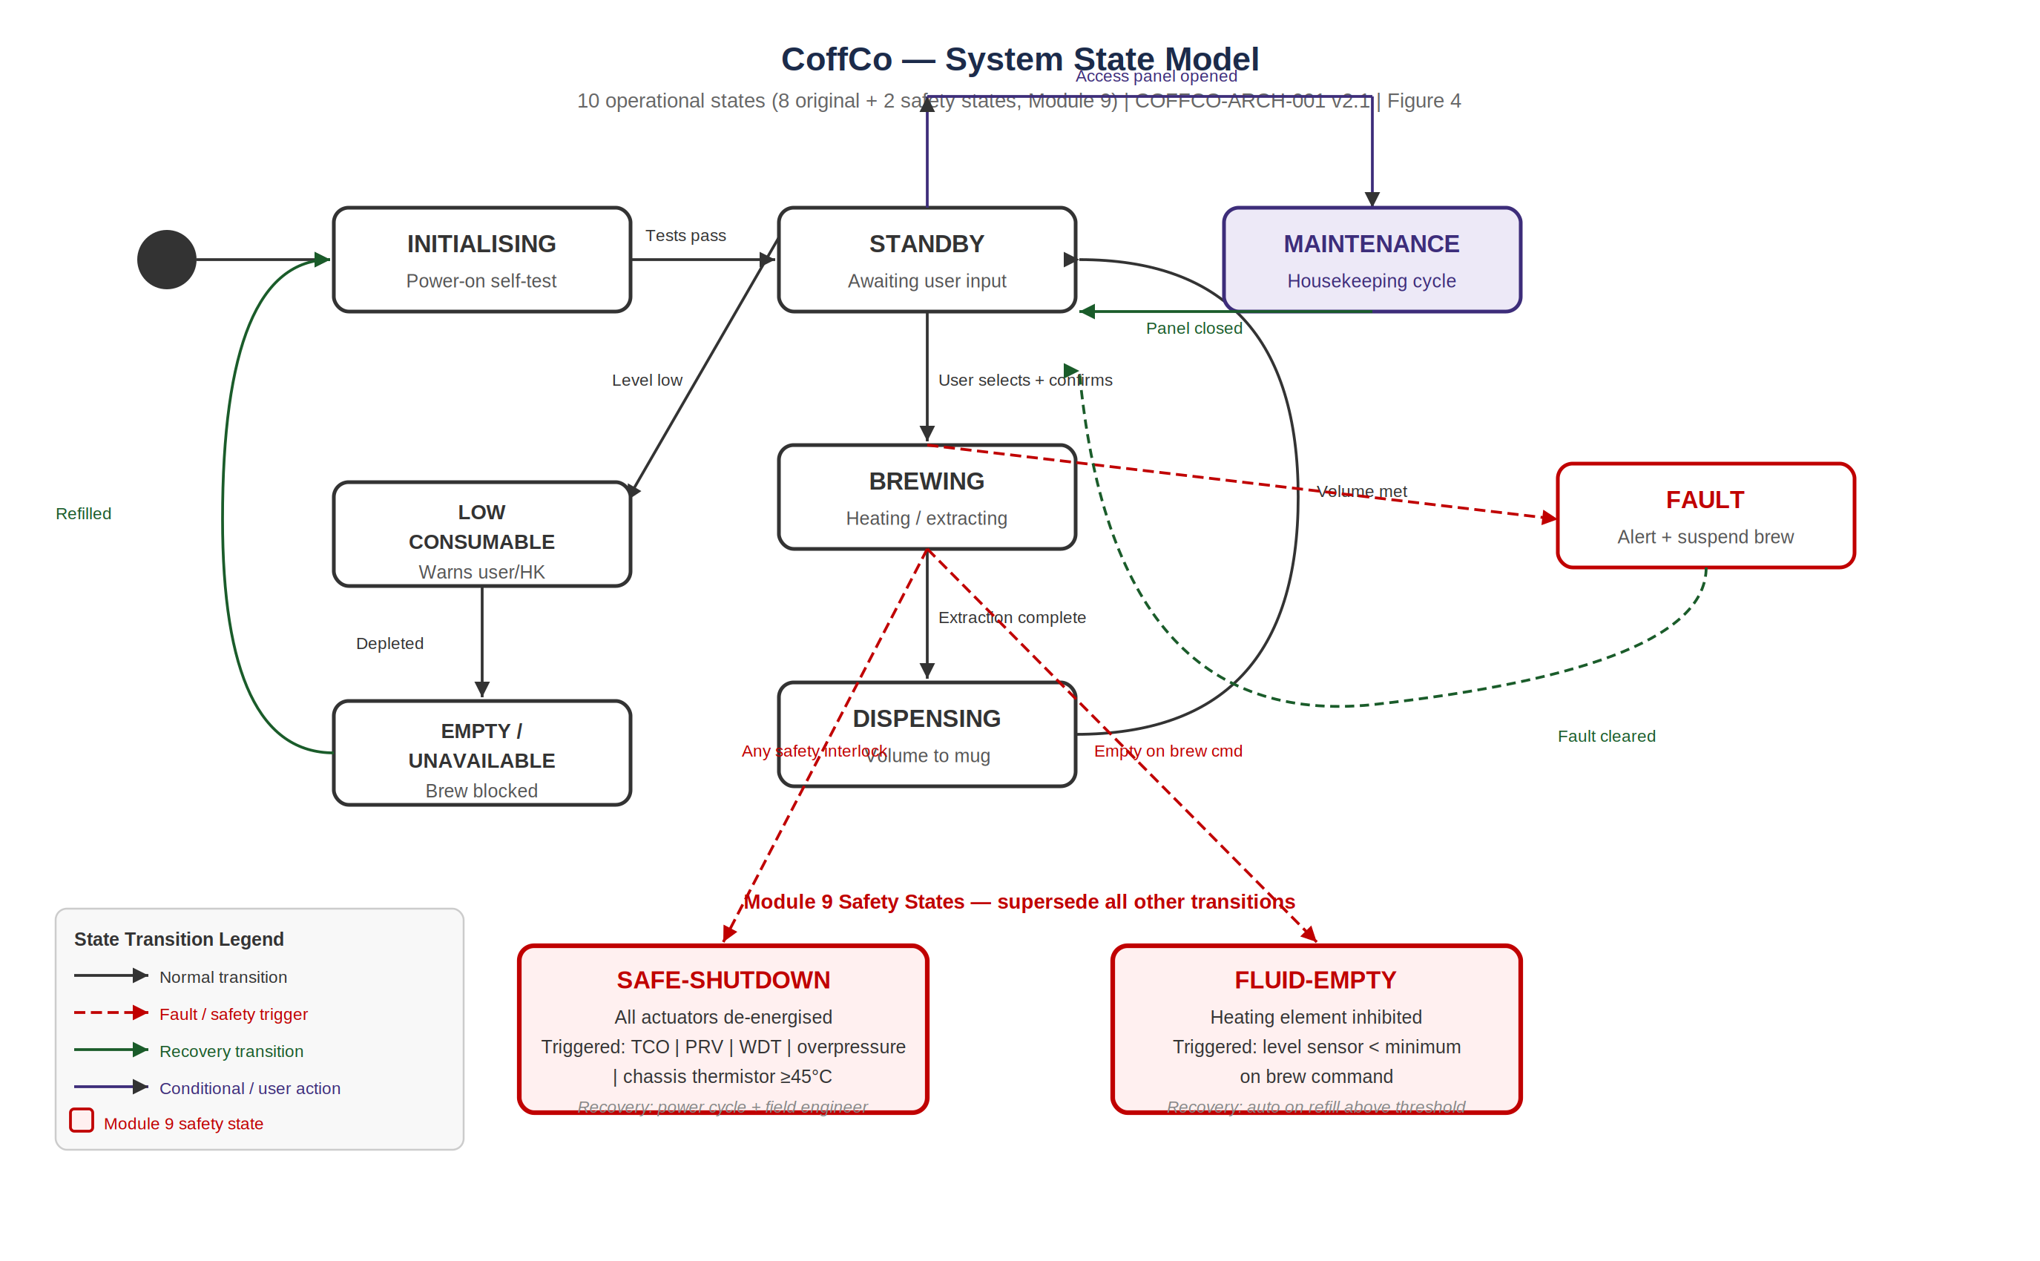
Figure 4 | System state model — 10 states. SAFE-SHUTDOWN and FLUID-EMPTY (red boxes) are Safety Engineering additions that override all other transitions. Recovery from SAFE-SHUTDOWN requires power cycle and field engineer intervention.

5.1 Safety States — Trigger and Recovery
State | Trigger Conditions | Actuator Behaviour | Recovery
SAFE-SHUTDOWN | TCO trip (SAF-01); pressure transducer >1.5 bar (SAF-12); hardware watchdog reset (SAF-07); chassis thermistor ≥45°C (SAF-11); PRV activation signal | All actuators de-energised immediately. FAULT indicator asserted. Telemetry event SAFE-SHUTDOWN transmitted. UI displays FAULT. | Power cycle only. Field engineer notified via cloud dashboard.
FLUID-EMPTY | Level sensor < minimum threshold on brew command. SRS 1.10, SAF-02. | Heating element relay inhibited. FAULT/EMPTY UI state asserted. EMPTY telemetry event transmitted. Brew cycle aborted. | Automatic on refill above minimum threshold.

6. Safety Requirements Allocation (SRS 3.10, 3.11, 3.12, 3.13 (safety provisions embedded in SRS))
The following diagram and table map all 17 safety requirements to the subsystems responsible for implementing them. Primary responsibility indicates the subsystem that provides the physical or firmware function. Secondary responsibility indicates a contributing element (e.g. a sensor providing input to another subsystem's control function).

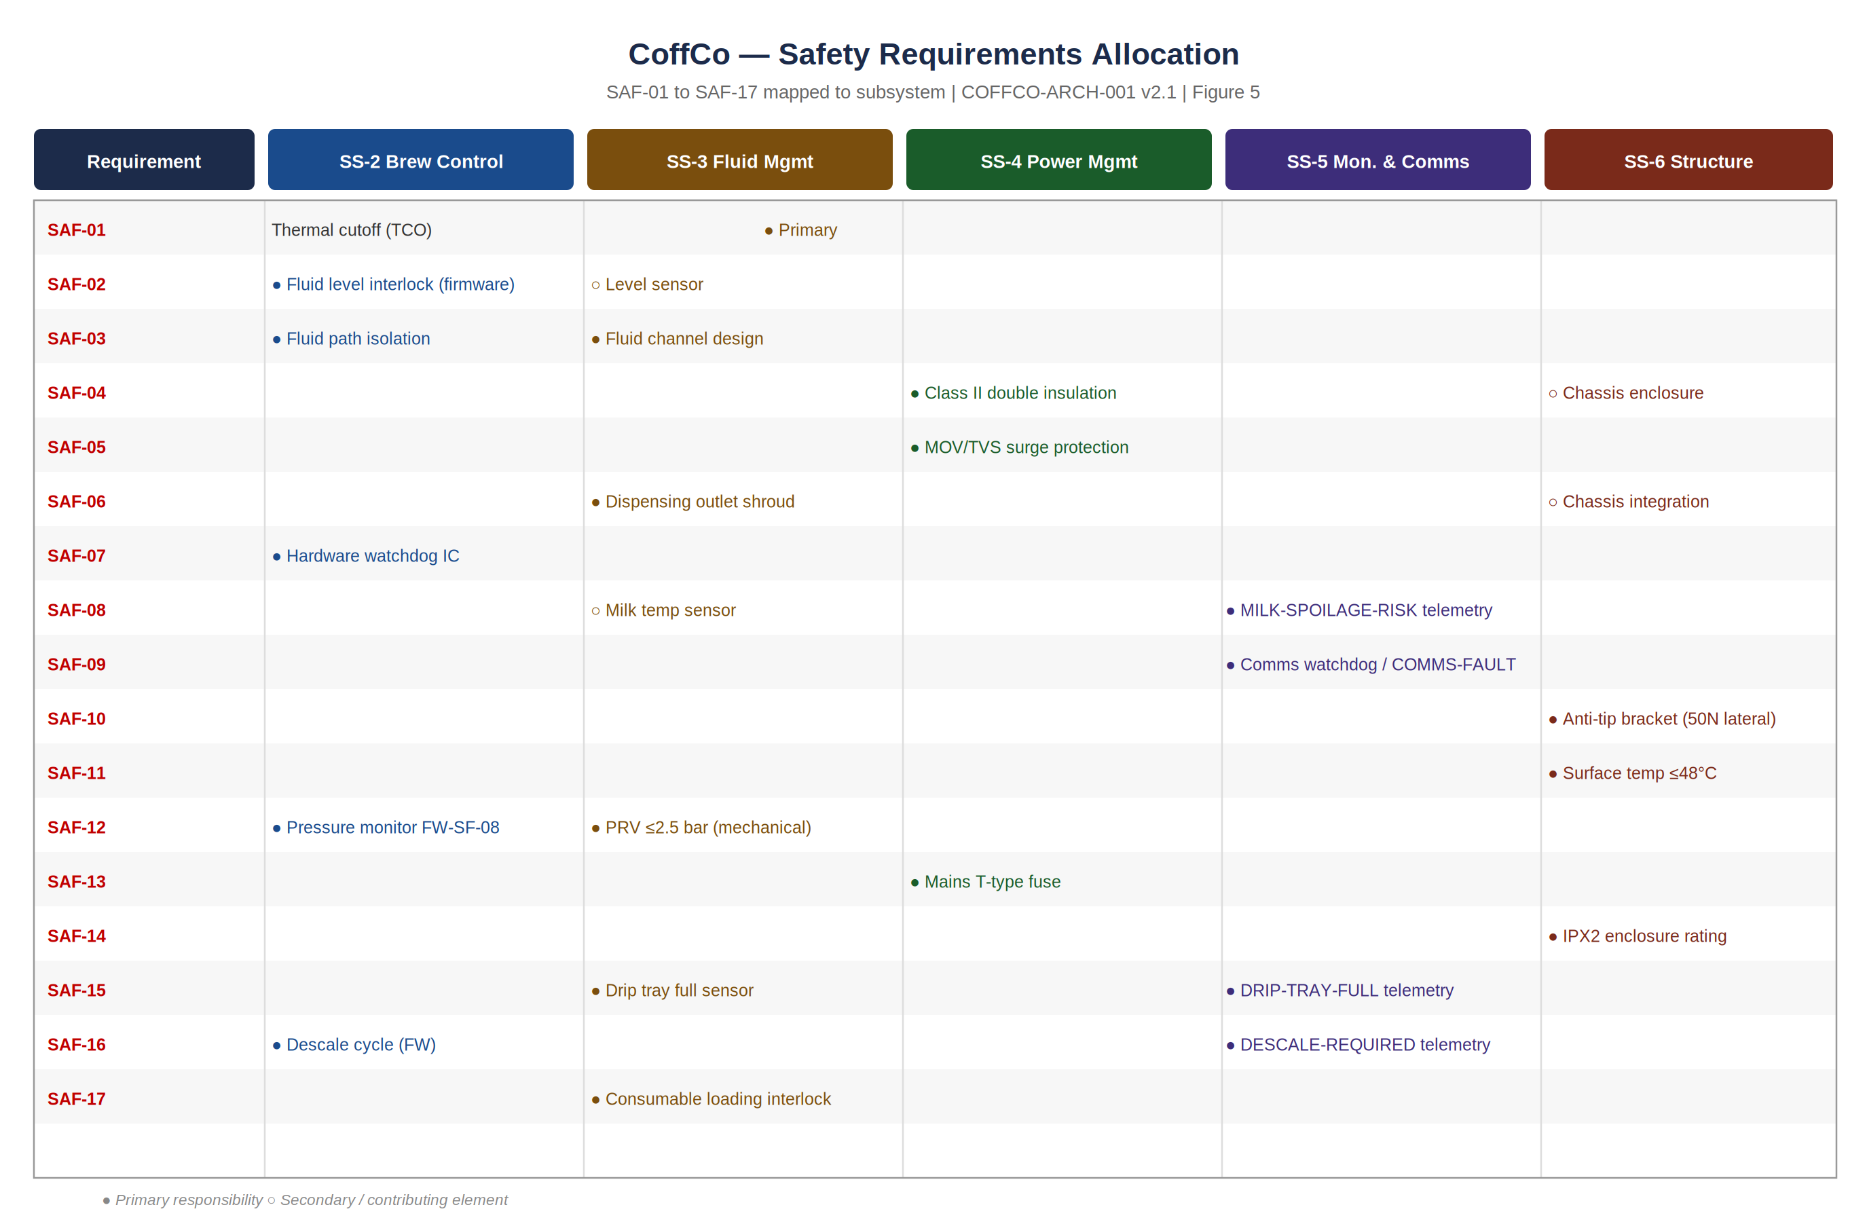
Figure 5 | Safety requirements allocation — SRS 3.10, 3.11, 3.12, 3.13 (safety provisions embedded in SRS) mapped to responsible subsystems. Primary and secondary responsibilities shown. Derived from COFFCO-HAZID-001 H-01 to H-19.

Req ID | Name | Requirement (abbreviated) | HAZID Ref | Arch. Element
SAF-01 | Independent thermal cutoff | Bi-metallic TCO disconnects heating element ≥100°C regardless of firmware | H-01 | SS-2 Thermal
SAF-02 | Fluid level brew interlock | Heating element inhibited; FAULT/EMPTY within 5 s when level < minimum | H-02 | SS-2 Control
SAF-03 | Fluid path isolation | ≥6 mm isolation between all fluid paths and electrical conductors | H-03 | SS-2/SS-3
SAF-04 | No live surface — single fault | IEC 60335-1 Class II; no accessible surface live under single fault | H-04 | SS-4 + SS-6
SAF-05 | Surge immunity | IEC 61000-4-5 Level 2 (2 kV) surge test; MOV/TVS in PSU primary | H-05 | SS-4 PSU
SAF-06 | Dispensing outlet shroud | Shroud prevents hand contact with beverage stream at outlet | H-06 | SS-2/SS-6
SAF-07 | Hardware watchdog timer | External WDT IC de-energises actuators if heartbeat absent >500 ms | H-07 | SS-2 Control
SAF-08 | Milk spoilage telemetry | MILK-SPOILAGE-RISK alert if milk store >4°C for >30 min | H-08 | SS-3 + SS-5
SAF-09 | Telemetry comms watchdog | COMMS-FAULT logged; MAINTENANCE REQUIRED on UI if link down >60 min | H-10 | SS-5 + SS-1
SAF-10 | Anti-tip stability | Stable under 50 N lateral; anti-tip bracket supplied | H-11 | SS-6
SAF-11 | Surface temperature ≤48°C | All accessible surfaces ≤48°C at steady state and 30 min post power-off | H-12 | SS-6
SAF-12 | Pressure relief valve | Mechanical PRV ≤2.5 bar; firmware pressure guard at 1.5 bar | H-13 | SS-2/SS-3
SAF-13 | Mains input fuse | T-type fuse at mains inlet; field-engineer accessible only | H-14 | SS-4 PSU
SAF-14 | IPX2 enclosure rating | IEC 60529 IPX2 drip-proof; no ingress to live parts during cleaning | H-15 | SS-6
SAF-15 | Drip tray full alert | DRIP-TRAY-FULL telemetry and UI alert before overflow | H-16 | SS-3 + SS-5
SAF-16 | Automated descale cycle | Firmware descale at calculated interval; DESCALE-REQUIRED alert ≥10 brews prior | H-17 | SS-2 + SS-5
SAF-17 | Consumable loading interlock | Keyed geometry + mechanical interlock; brew inhibited with unseated consumable | H-18 | SS-3

7. Architectural Structuring Principles
Nine structuring principles govern all architectural decisions in COFFCO-ARCH-001. Issue 2.1 adds SP-10 (Defence in Depth) derived from the Safety Engineering review.

ID | Principle | Statement and Safety Relevance
SP-01 | Safety Isolation | Safety shall be a system-level property. All thermal and electrical hazards shall be physically isolated from user-accessible surfaces by dedicated structural elements. No single subsystem is solely responsible for safety.
SP-02 | Modularity | Each physical element shall be independently replaceable without redesigning adjacent elements. Supports DfR and SAF requirements that mandate field-replaceable safety devices (e.g. TCO, fuse).
SP-03 | Loose Coupling | Interfaces between subsystems shall be defined at the logical level before physical connections are specified. Changes to one subsystem shall not propagate to others unless the interface changes.
SP-04 | Single Responsibility | Each subsystem shall have one primary function. Safety functions that cut across subsystems (e.g. TCO, PRV) are allocated to the subsystem that owns the hazard source.
SP-05 | Technology Neutrality | Logical subsystem definitions shall remain technology-agnostic. Technology selection occurs at the physical level only. Implementation-neutral requirement language maintained throughout (no references to specific consumable formats).
SP-06 | Minimalism | The simplest architecture that meets all requirements is preferred. No architectural element is included without a traceable SRS requirement or documented assumption.
SP-07 | Traceability | Every architectural element traces to at least one SRS requirement. Every SAF requirement traces to a HAZID entry. Gaps trigger new requirements, not silent design decisions.
SP-08 | COTS Priority | Prefer commercially proven, multi-sourced, pre-certified components for safety-critical functions (TCO, fuse, WDT IC, PSU). Bespoke design only where COTS cannot meet the functional or interface requirement.
SP-09 | Fail-Safe Default | All actuators shall default to de-energised on loss of control signal, power interruption, or watchdog reset. No actuator shall remain energised in any undefined system state.
SP-10 | Defence in Depth | Critical safety functions shall have at least two independent layers of protection: a firmware-layer guard (software) and a hardware-layer device (physical). Examples: firmware temp watchdog + TCO; firmware pressure guard at 1.5 bar + PRV at 2.5 bar. Added at Issue 2.1.

8. Architecture Trade Decisions
Six trade decisions (TD-01 to TD-06) were recorded at Issue 1.0 and remain unchanged at Issue 2.1. No new trade decisions have been required by the safety update — all safety design choices are mandated by SAF requirements rather than selected as options.

TD | Decision | Selected | Rejected | Rationale
TD-01 | Water supply method | Removable user-filled reservoir | Plumbed connection; single-use cartridge | No room modification; guest-refillable; lowest lifecycle waste
TD-02 | Thermal path | Unified thermal assembly with switching | Separate dedicated paths | Lower mass/footprint/cost; cross-contamination managed by NR-04 flush
TD-03 | Regional connectors | Universal PSU + interchangeable plug module | Market-specific PSUs; fixed cable | Minimises SKU complexity; no loose adaptors in hotel rooms
TD-04 | Control integration | Single integrated control assembly | Separate assemblies | Fewer interfaces; higher MTBF; supports SRS 3.9
TD-05 | Anti-theft | Cable anchor lug (Kensington-style) | Mechanical lock; weight-only | No key management burden; effective deterrent
TD-06 | Wireless comms | DEFERRED — Wi-Fi / BLE / Zigbee all feasible | N/A | Pending Vacation Stables IT infrastructure confirmation; EMC (SRS 3.8) is discriminator

9. Requirements Traceability Matrix
Every SRS requirement (including SRS 3.10, 3.11, 3.12, 3.13 (safety provisions embedded in SRS)) is traced to its primary physical element and satisfying function. The SAF requirements are grouped as Category 5 at the end of the matrix. This table satisfies the Z9 MBSE requirement for a traceability view.

Req | Name | Primary Physical Element | Satisfying Function
Category 1 — Functional Requirements (SRS 1.1 to 1.10)
1.1 | Brew coffee | Control Assembly + Thermal Assembly | Extract americano at 0.9–1.3 bar, 60–90°C
1.2 | Froth milk | Thermal Assembly | Froth milk to 60–90°C; supply to cup
1.3 | Volume selection | User Interface Panel + Control Assembly | User selects 200–400 ml; control assembly executes
1.4 | Consumable capacity | Fluid Store | Consumable and water store for ≥10 brews
1.5 | Extraction pressure | Thermal Assembly + Control Assembly | Maintain 0.9–1.3 bar at extraction point
1.6 | Water hardness | Control Assembly | Hardness compensation; scale management; descale scheduling
1.7 | Status indication | User Interface Panel | Ready / Brewing / Low / Empty / Fault without instruction
1.9 | Maintenance comms | Control Assembly (SS-5) | Wireless maintenance status transmission
1.10 | Dry-fire prevention | Control Assembly + Fluid Store | Inhibit heating element when level < minimum
Category 2–4 — Interface, Non-Functional, Performance Requirements (SRS 2.x, 3.x, 4.x)
2.1 | Unaided operation | User Interface Panel | Intuitive UI; no instruction required
2.3/2.4 | Power supply | Power Supply Unit | Universal AC 110–240 V; regulated DC output
2.6 | Regional connectors | Power Supply Unit | Interchangeable plug module (TD-03)
3.1 | Dispense time ≤3 min | Control Assembly + Thermal Assembly | Brew cycle completes within 180 s (SRS 4.11)
3.5 | Energy efficiency | Power Supply Unit + Thermal Assembly | EU rating A; standby power ≤0.5 W (NR-02)
3.7 | Waste recyclable | Fluid Store | Recyclable waste route; no landfill (SRS 3.7)
3.8 | EMC compliance | PSU + Control Assembly | EN 55014 Class B; EMC filtering in PSU
3.9 | MTBF ≥26,280 h | All elements | System-level reliability target; COTS components specified
4.4/4.5 | Extraction pressure | Thermal Assembly | 0.9–1.3 bar at coffee outlet
4.8 | IEC 60335 | PSU + Structural Chassis | Full domestic appliance safety compliance
4.9 | Food safety | Thermal Assembly + Fluid Store | Food-grade wetted parts; HACCP plan
4.10 | Mass ≤10 kg | Structural Chassis | All elements packed within 300×300×300 mm at ≤10 kg
Category 5 — Safety Requirements (SRS 3.10, 3.11, 3.12, 3.13 (safety provisions embedded in SRS)) | All mandatory | Derived from COFFCO-HAZID-001
SAF-01 | Independent TCO | Thermal Assembly (SS-2) | Non-resettable bi-metallic cutoff at ≥100°C, hardware-only
SAF-02 | Fluid level interlock | Control Assembly (SS-2) | Firmware inhibits heating element if level < minimum
SAF-03 | Fluid path isolation | Thermal Assembly + Fluid Store | ≥6 mm isolation — fluid paths from all electrical conductors
SAF-04 | No live surface | PSU + Structural Chassis | IEC 60335-1 Class II; no surface live under single fault
SAF-05 | Surge immunity | Power Supply Unit | MOV/TVS; IEC 61000-4-5 Level 2 (2 kV) surge test
SAF-06 | Outlet shroud | Thermal Assembly + Chassis | Physical shroud prevents hand contact with beverage stream
SAF-07 | Hardware watchdog | Control Assembly | External WDT IC; all actuators de-energised on watchdog reset
SAF-08 | Milk spoilage alert | Fluid Store + Monitoring | MILK-SPOILAGE-RISK telemetry if milk >4°C >30 min
SAF-09 | Comms watchdog | Monitoring & Comms | COMMS-FAULT logged; MAINTENANCE REQUIRED on UI after 60 min outage
SAF-10 | Anti-tip bracket | Structural Chassis | Stable under 50 N lateral; M6-compatible bracket supplied
SAF-11 | Surface temp ≤48°C | Structural Chassis | All accessible surfaces ≤48°C steady state + 30 min post power-off
SAF-12 | Pressure relief valve | Thermal Assembly + Fluid Store | Mechanical PRV ≤2.5 bar; firmware pressure guard at 1.5 bar
SAF-13 | Mains fuse | Power Supply Unit | T-type fuse at mains inlet; field-engineer accessible only
SAF-14 | IPX2 enclosure | Structural Chassis | IEC 60529 IPX2 drip-proof — protects live parts from cleaning water
SAF-15 | Drip tray full alert | Fluid Store + Monitoring | DRIP-TRAY-FULL telemetry and UI alert before overflow
SAF-16 | Descale cycle | Control Assembly + Monitoring | Firmware descale at calculated interval; DESCALE-REQUIRED alert ≥10 brews prior
SAF-17 | Consumable interlock | Fluid Store | Keyed geometry + interlock; brew inhibited with unseated consumable

10. INCOSE Z8 / Z9 MBSE Compliance
The following table maps each view type required by the INCOSE Z8 and Z9 guides to its realisation in this document, confirming architectural completeness.

View Type | Z8 / Z9 Requirement | Figure / Section | Scope
Context | System boundary and external actors | Figure 1 / Section 2 | All external actors; labelled interface flows across system boundary
Logical | Functional decomposition | Figure 2 / Section 3 | Six subsystems; technology-agnostic flows; requirements allocation
Physical | Element allocation | Figure 3 / Section 4 | Seven physical elements; interfaces; architectural assumptions
Behavioural — State | Operational state model | Figure 4 / Section 5 | 10 states including SAFE-SHUTDOWN and FLUID-EMPTY (Issue 2.1)
Behavioural — Activity | Brew cycle sequence | COFFCO-ARCH-001 v2.0 Figure 9 | Swimlane: Hotel Guest, Coffee Dispenser, Milk Frother, Water Store, Drip Collector
Operational | Actor interactions | COFFCO-ARCH-001 v2.0 Figure 5 | Five actor types and system interactions across operational lifecycle
Requirements Traceability | Req → Element → Function | Section 9 | All 53 SRS requirements including SRS 3.10, 3.11, 3.12, 3.13 (safety provisions embedded in SRS)
Safety Allocation | Safety req → Subsystem | Figure 5 / Section 6 | SRS 3.10, 3.11, 3.12, 3.13 (safety provisions embedded in SRS) mapped with primary and secondary responsibilities

