http://www.cs.tut.fi/~tabus/course/ASP/LectureNew10.pdf

Filter Summary

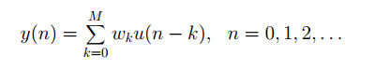

Computing the RLS update parameters:

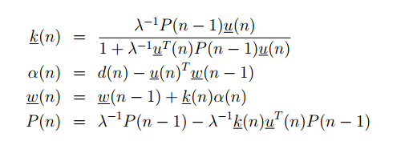

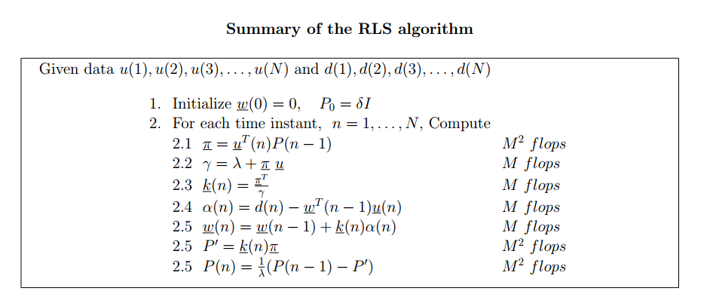

https://pdfs.semanticscholar.org/80eb/236ec16f66e4ce167b2bb0c9804385b03c7f.pdf

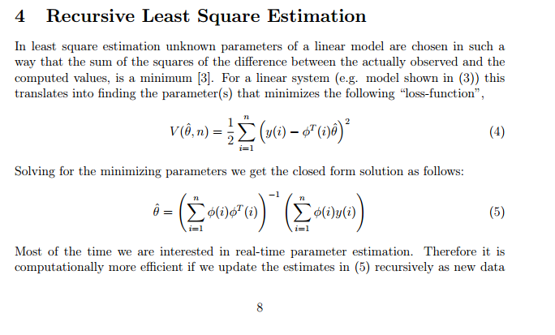

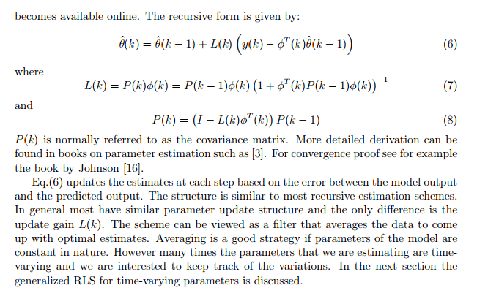

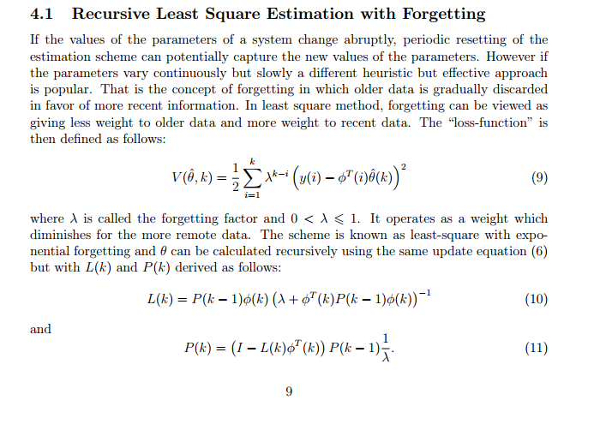

Wikipedia

<https://en.wikipedia.org/wiki/Recursive_least_squares_filter>

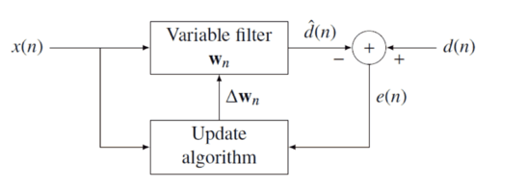

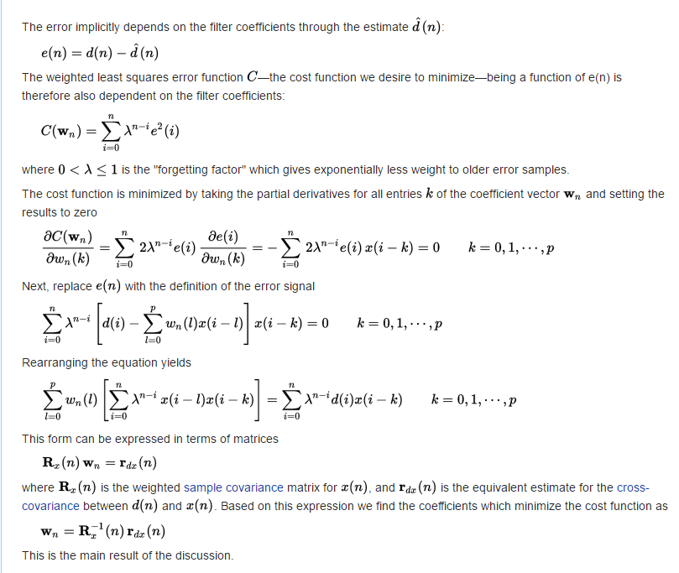

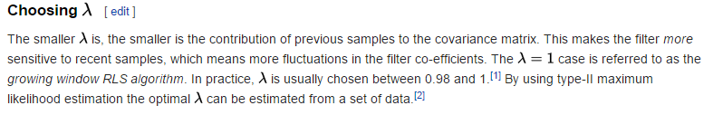

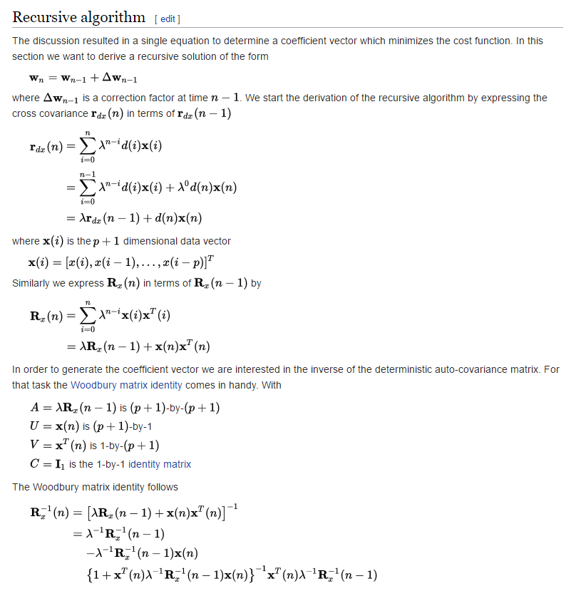

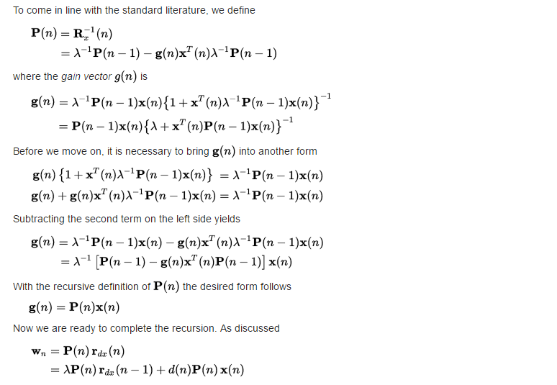

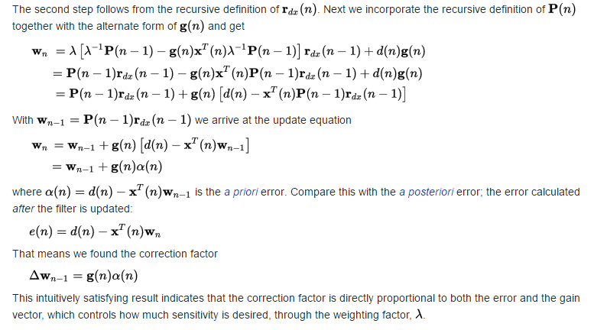

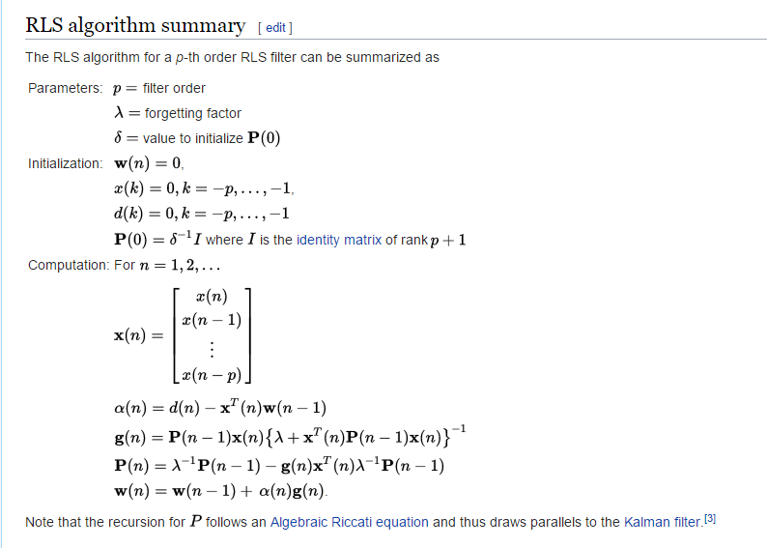

OTHER References (Need to read/buy/library)

<https://link.springer.com/article/10.1007/s12541-011-0077-9>

Test and error parameter estimation for MEMS — based low cost IMU calibration

* [uthors](https://link.springer.com/article/10.1007/s12541-011-0077-9#authors)
* [Authors and affiliations](https://link.springer.com/article/10.1007/s12541-011-0077-9#authorsandaffiliations)
* Dongkyu Lee
* Sangchul Lee[Email author](mailto:slee@kau.ac.kr)
* Sanghyuk Park
* Sangho Ko

<http://ieeexplore.ieee.org/document/7039912/>

# IMU-based vehicle load estimation under normal driving conditions

[Maryam Sadeghi Reineh](http://ieeexplore.ieee.org/search/searchresult.jsp?searchWithin=%22Authors%22:.QT.Maryam%20Sadeghi%20Reineh.QT.&newsearch=true)

Division of Automatic Control, Department of Electrical Engineering, Linköping University, SE-581 83, Sweden

[Martin Enqvist](http://ieeexplore.ieee.org/search/searchresult.jsp?searchWithin=%22Authors%22:.QT.Martin%20Enqvist.QT.&newsearch=true)

Division of Automatic Control, Department of Electrical Engineering, Linköping University, SE-581 83, Sweden

Linearized Recursive Least Square Methods for Real-Time Identification of Tire-Road Friction Coefficient

<https://ai2-s2-pdfs.s3.amazonaws.com/67f3/bf0bb97a07e37074c8c891e165bc56d8b0cb.pdf>

