# Trie data structure

In computer science, a trie, also called digital tree or prefix tree, is a type of k-ary search tree, a tree data structure used for locating specific keys from within a set. These keys are most often strings, with links between nodes defined not by the entire key, but by individual characters.

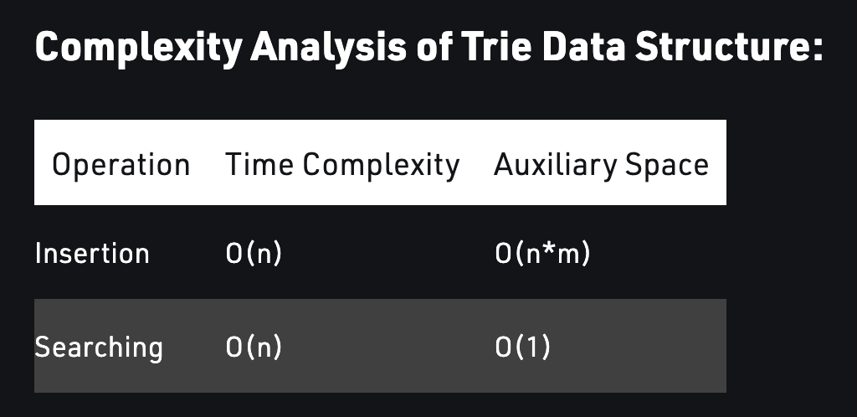

# Vector amortised time:

Amortized time is the way to express the time complexity **when an algorithm has the very bad time complexity only once in a while besides the time complexity that happens most of time.**

**The insertion takes O(n) w**hen the capacity has been reached, **and the amortized time for each insertion is O(1).**

# Bit Manipulation

Bit add, bit multiple, ^ is XOR, >> logical right shift ,>>> arithmetic right shift.

# Singleton Design Pattern

Class has one instance and ensure access to the instance through the project.

# Factory Design pattern

Offers the interface to create an instance of class.

# Union-Find datastructure

Union unions two groups containing x and y.

Find get the representative of the node which is the top parent root.

Time complexity is O(logN)

# Quick select

Get the kth of the array in O(n)

Worst is O(n^2)

# Binary search tree

# Red black tree:

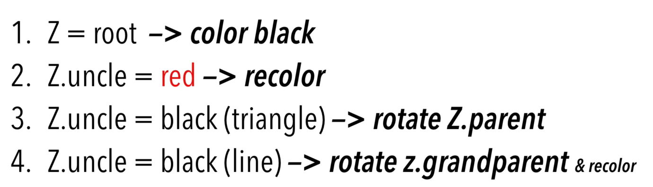

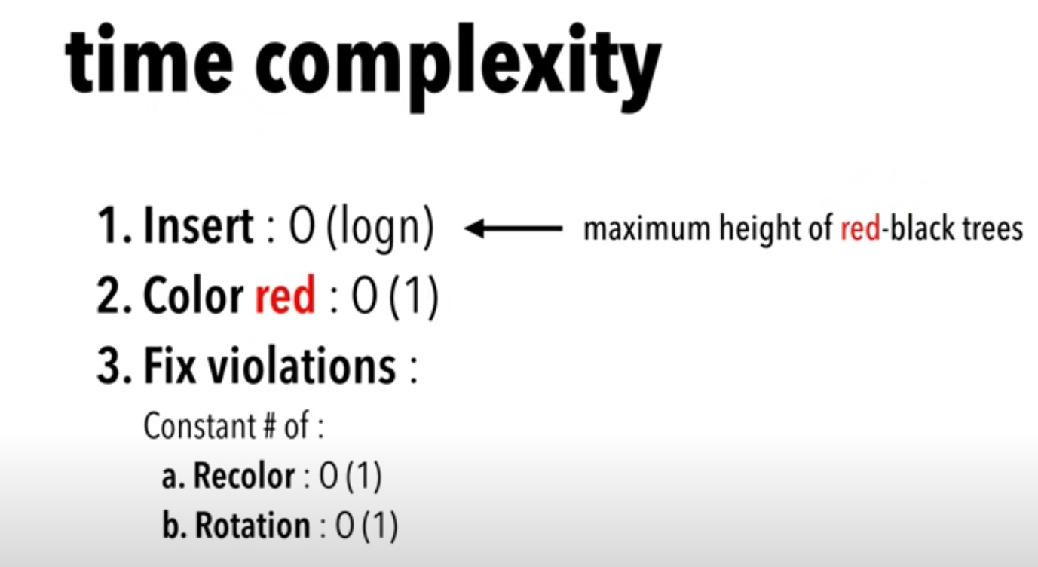

Djs algorithm:

