1. STUDENT NAME: Steve Tolvaj

2. **URL to STUDENT WEB SITE:** [**http://cis-linux2.temple.edu:8080/FA22_3308_tuo21314/index.html**](http://cis-linux2.temple.edu:8080/FA22_3308_tuo21314/index.html)

**3. user_role TABLE DESIGN:**

**4. web_user TABLE DESIGN and FOREIGN KEY:**

1. 5. **“OTHER” TABLE DESIGN and FOREIGN KEY :** Used for web users logging what plants they have identified.
   1. Graphical user interface, text, application, email

      Description automatically generated
   2. Graphical user interface, text, application, email

      Description automatically generated
   3. **6. DATA ENTRY ERRORS a) Error: Duplicate user_role PK:**
   4. Text

      Description automatically generated
   5. **b) Error: Invalid user_role FK in web_user record** 
      * + 1. Text, letter

             Description automatically generated
   6. **c) Error: Cannot delete a user_role record that’s referenced by a web _user record**
   7. 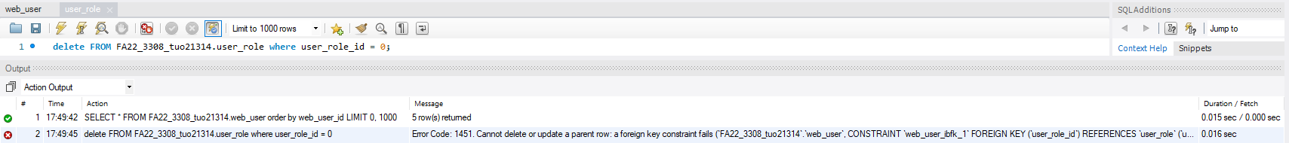
   8. **d) Invalid web_user FK in “other” record**

* 1. **e) Error trying to delete a web_user record that’s referenced by an “other” record**

* 1. **7. SELECT STATEMENTS**
  2. **a) USER_ROLE:** all rows, all columns, **sorted by user_role_id.**
  3. Graphical user interface, text, application

     Description automatically generated
  4. **b) WEB_USER: all rows, all columns, sorted by web_user_id.**
  5. Graphical user interface, application

     Description automatically generated
  6. c) **WEB_USER JOINED WITH USER_ROLE: all rows, certain** columns, sorted.

* 1. **f) “OTHER”: all rows, all columns, sorted by the id of your “other” table.**
  2. Graphical user interface

     Description automatically generated with low confidence
  3. **g) “OTHER” JOINED WITH WEB_USER all rows, certain columns, sorted.**
  4. Graphical user interface, text, application, email

     Description automatically generated
  5. **h) “OTHER” JOINED WITH WEB_USER some rows, certain columns, sorted.**
  6. Graphical user interface, text, application, email

     Description automatically generated