Practice for CAP Empirical Methods – Day #1

1. Explain these concepts in your own words, ideally to a real person who might have follow-up questions. If you have no friends, welcome to GME. Ask an LLM to role-play.

i. counterfactual notion of causation
ii. why confounding / selection bias is almost always a problem in observational studies of humans
iii. prognostic balance
iv. intent to treat and per protocol analysis
v. external validity

2. The table below is from a trial of risperidone for agitation in children with autism. Explain why most trials have this type of “Table 1,” what it is supposed to show, and if this “Table 1” achieves that objective.
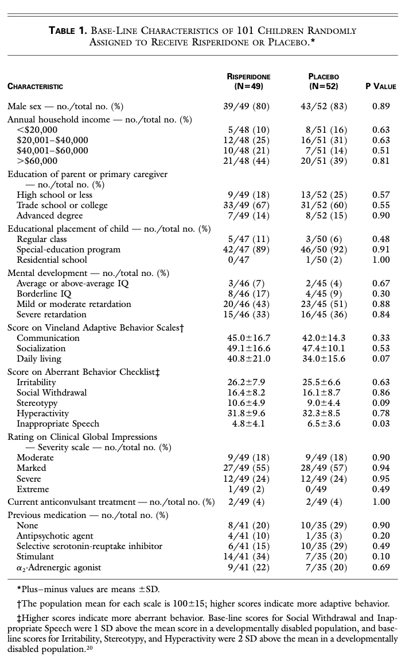

3. Download this paper. (Also available from JAMA.)
i. Answer the PICOT questions for this trial.
ii. This trial was NOT done in your patients. List some salient ways your patients are different. For each note whether it is likely an innocuous difference or might be a reason the treatment works differently (for better or worse) in your population. For this part think of the treatment as schema therapy vs a default alternative of DBT.
iii. If you listed any difference as a reason the treatment would work better/worse, which is it?

4. A peer sent me this article which criticized Open Evidence for citing “a trial of 57 children randomized . . . [that] doesn’t appear the researchers accounted for potential confounders like age, weight, gender” and describing it is “strong[] clinical evidence.”

Do you need to control for confounders in a randomized trial in order to get an unbiased estimate of the treatment effect?

5. “Antidepressant Use During Pregnancy and Childhood Autism Spectrum Disorders” was published by JAMA Psych, has 747 citations, and spawned a literature investigating this topic. The authors found an association between taking exposure to antidepressants in utero and autism. You can find the paper here.
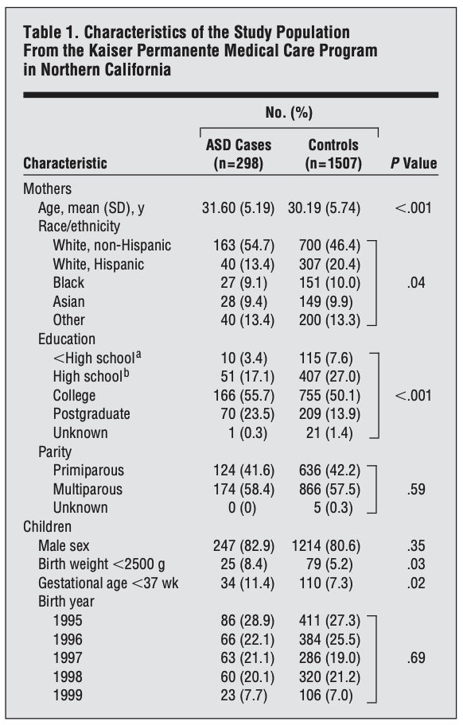

i. Can you think of a simple explanation or two for why mom’s with autistic children would be more likely to take SSRIs during pregnancy?

ii. Observational studies often have a Table 1 that parallels the ones seen in RCTs. Does this table show balance?

iii. A patient on an SSRI is concerned that autistic kids are much more likely to have moms with a postgrad degree. She plans to stop the SSRI but isn’t sure about dropping out of law school and giving up on a dream she held since she saw Legally Blonde when she was eight years old. Should you urge her to drop out?

