S.H.I.T.S
SHEFFIELD HOCKEY IN THE SUN

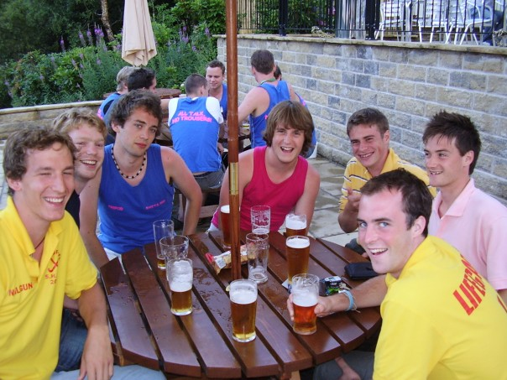
Friday 20th July – Sunday 22nd July 2007

A fantastic weekend of hockey, beer and partying hosted by the one and only Sheffield University! Not to be missed!

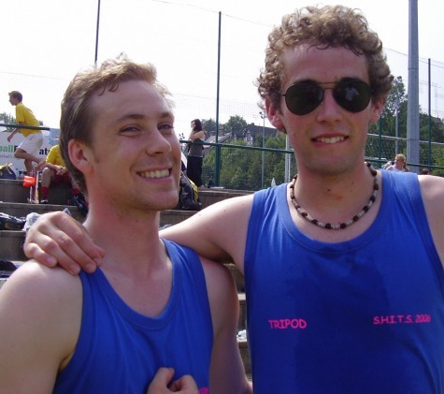
S.H.I.T.S kick starts on Friday night with a BBQ giving you the perfect chance to check out the competition and get the banter going with the option of a few cheeky ones at the South Seas in Broomhill and partying at Frouk afterwards.

Games begin at Goodwin a sport pitches 11am on Saturday morning and will finish at 5 so you can hit the South Seas pub before an awesome night at Pop Tarts!

Meet at the Goodwin pitches again at 10:30am on Sunday for another day of hockey mayhem, finals and presentations until 3pm when sadly the weekend has to end.
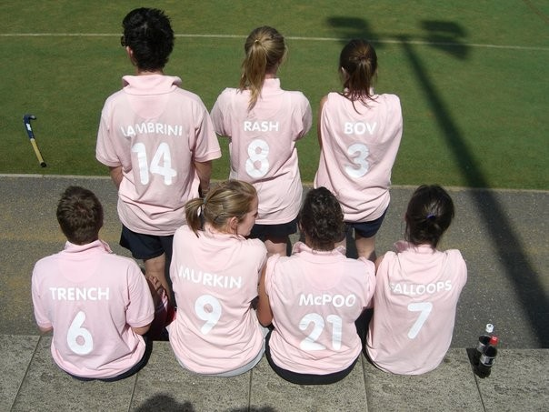

This fabulous weekend of hockey madness is yours for just £25 per person which includes all your hockey and your ticket for the fabulous Pop Tarts. So get your team sorted, come up with a winning team name, chose the colour of your kit and get your application forms in a.s.a.p!

Teams for S.H.I.T.S must have between 11 and 15 players of mixed ability and include a minimum of 5 girls and a goalie. Deposits must be in by the 30th June and final payments made on Fri 20th July. If you do not have accommodation we can arrange this for you, just let us know on your registration form.

Team name: _________________________

Name of Captain: _____________________

No. of players: ___

Colour of playing shirts: _______

E-mail address:_________________________

Contact phone number: __________________

Number of people needing accommodation: ___

Please send a deposit of £150 per team by 30th June to:

Matthew “ASBO” Harrison:
10 Moorgate Avenue
Crookesmore Road
Sheffield
S10 1EQ

Cheques need to be made payable to ‘The Union’ with Sheffield Women’s Hockey club and your team name written clearly on the back.

Thank you for registering to play S.H.I.T.S 2007, we look forward to seeing you in July!

