# Using GitHub

## Overview

Any professional developer needs to keep their code up to date. To do this, they turn to cloud systems that will help them maintain versions of their code, so that if they have to make changes it is easily done from their IDE or editor. In addition, storing code in this type of system allows for easier collaboration between developers and the possibility to roll back changes to previous versions. There are three main cloud services today for this purpose: GitHub, GitLab, and BitBucket. In this course, we recommend using GitHub, where you will find many other open-source developers with whom to collaborate and from whom you can learn. In this article, we'll walk through an ideal installation path for the tooling you need to set up your computer for version-controlled software development. Note, all of these tools are free to use.

Installations

To use GitHub, you need to have:

1. An account on GitHub

Go to GitHub.com and create an account for yourself. Once done, you'll be able to create 'repos', or folders of code, for your own purposes as a storage system.

2. Git installed locally

GitHub uses 'Git', a distributed version control system. You need to have it installed locally on your own computer. To do this, visit <https://git-scm.com/downloads> and download the proper version for your OS. Note, on a Mac, you might need to use Homebrew to do this installation, so visit <https://brew.sh/> to install Homebrew. Once it is installed you can then install Git following the instructions on git-scm.

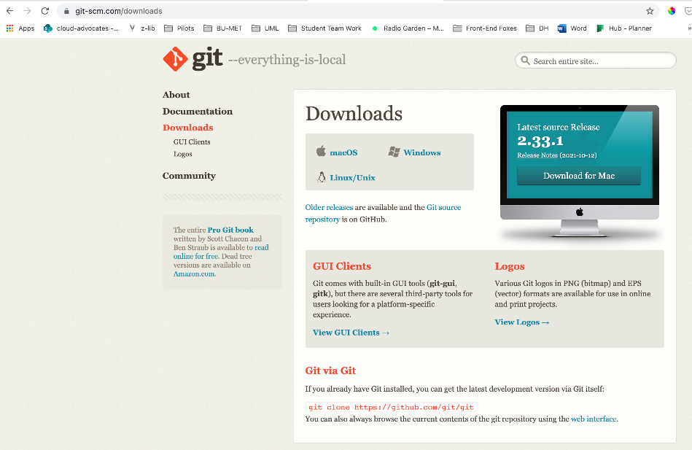

3. Connect your codebase

Once Git is installed on your local computer, open your codebase in Visual Studio Code, which you can install from here: <https://code.visualstudio.com/Download>. Click the 'Source Control' icon on the left:

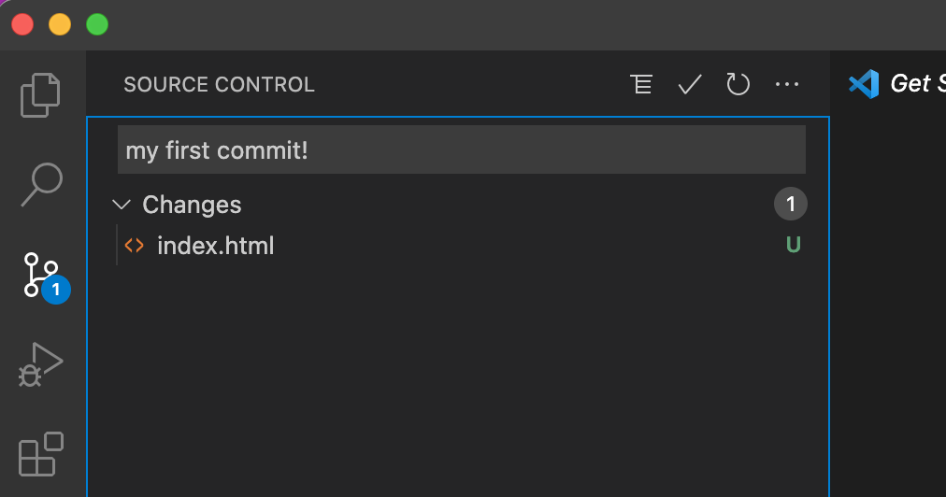

Click 'initialize Repository'. It is best practice to add a README.md file in the root of your code so that people visiting your codebase on GitHub will understand your project's purpose.

Once the repository is initialized, click 'yes' when prompted to 'stage' all changes. Staging changes means that you are ready to push your code to GitHub.

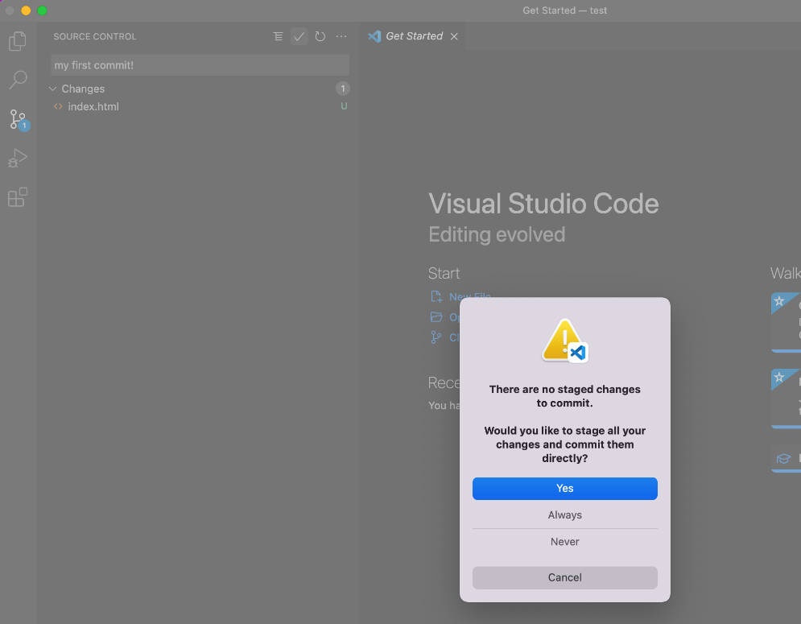

Add a message in the Message input box to explain your change and Publish your change to GitHub by pressing the Publish button. The editor may ask you to allow it to sign into GitHub:

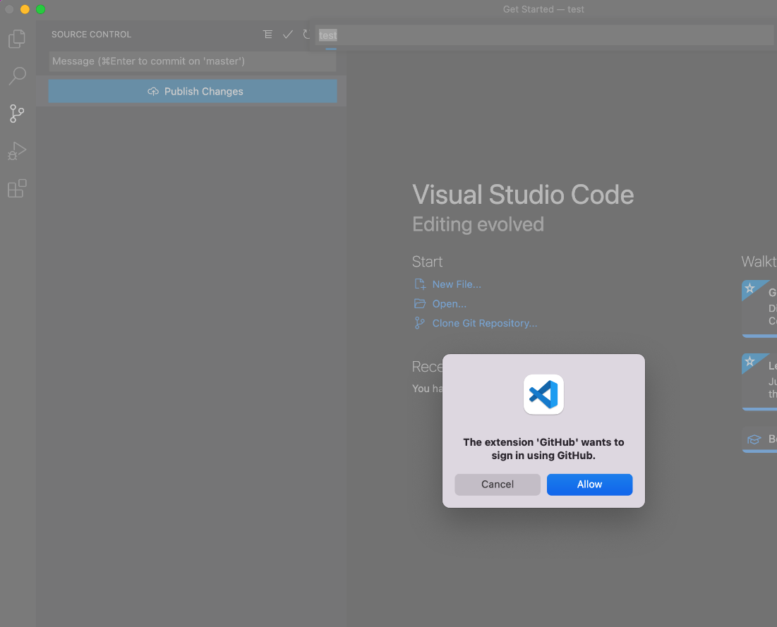

At this point your editor needs to make a 'handshake' with GitHub, and it will do that in a browser which will appear once you allow the window to open:

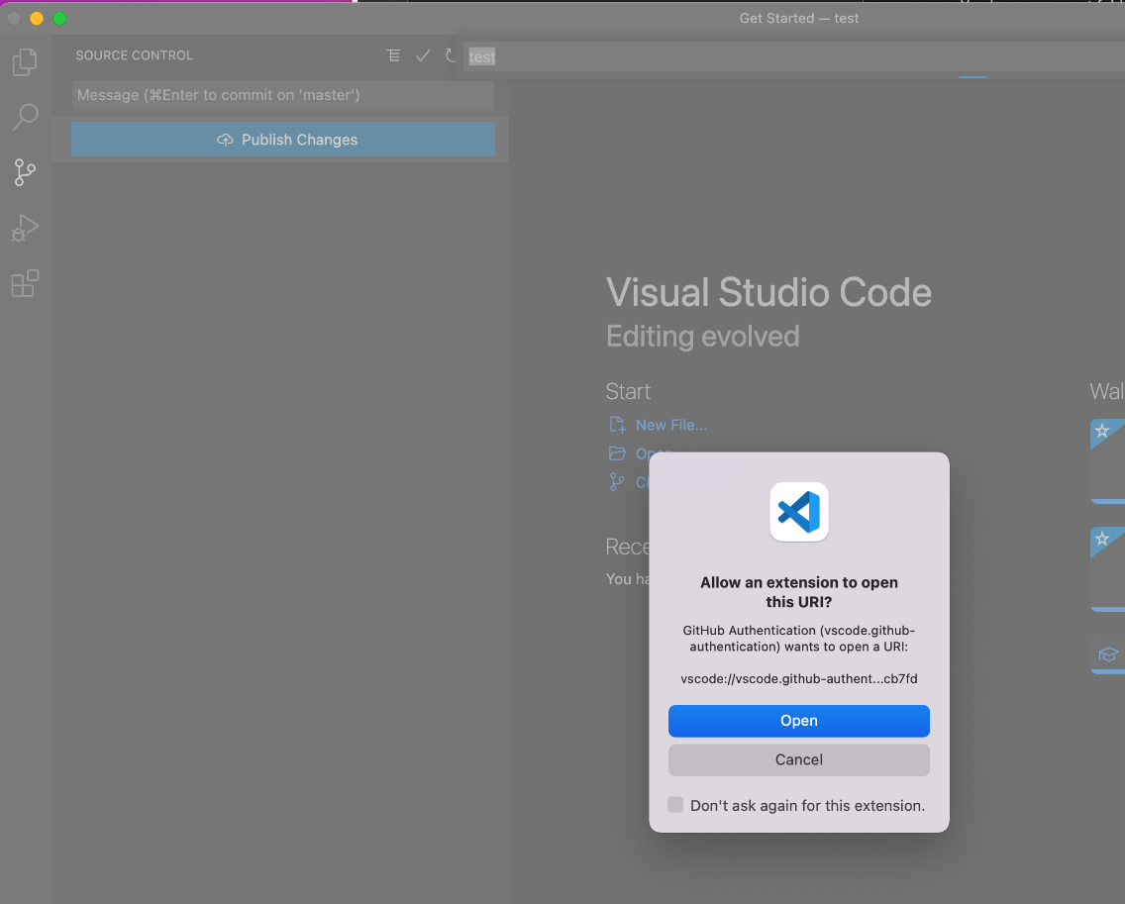

Once the handshake is made, VS Code will prompt you to publish your repo to a public or private repository. You can give it a name in the box above, and select 'Publish to GitHub public repository:

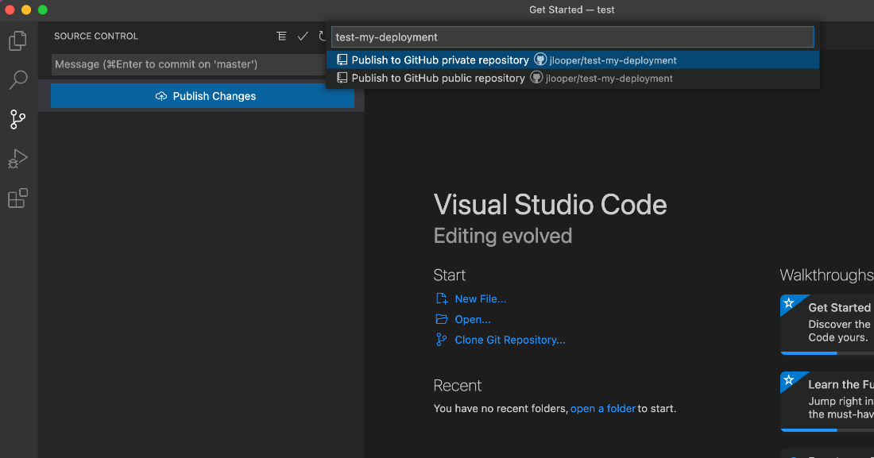  
  
Once the publication process is complete, you can visit your repo in GitHub! Don't forget to add a README.md file, which you can do in the browser or on your local machine and then push it to GitHub.

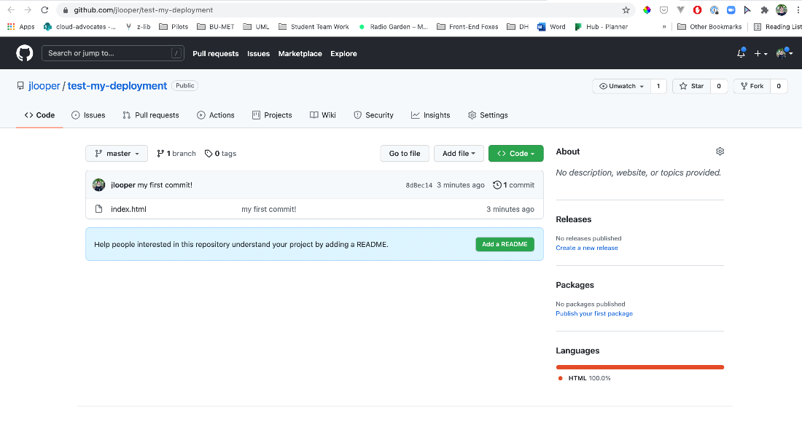

Now that your code is safely stored in the cloud, you can develop locally and push your changes to GitHub. Remember, if you make changes to your code in GitHub, you need to 'pull' those changes back to your local computer, which you can do in VS Code in the Source Control pane - click the three dots at the top right of the pane and choose 'pull' to sync changes. You can also use the sync icon at the bottom left of the editor. VS Code can also automatically sync changes, but it's better to do frequent pulls and pushes to make sure your content is in sync with the versions on GitHub.

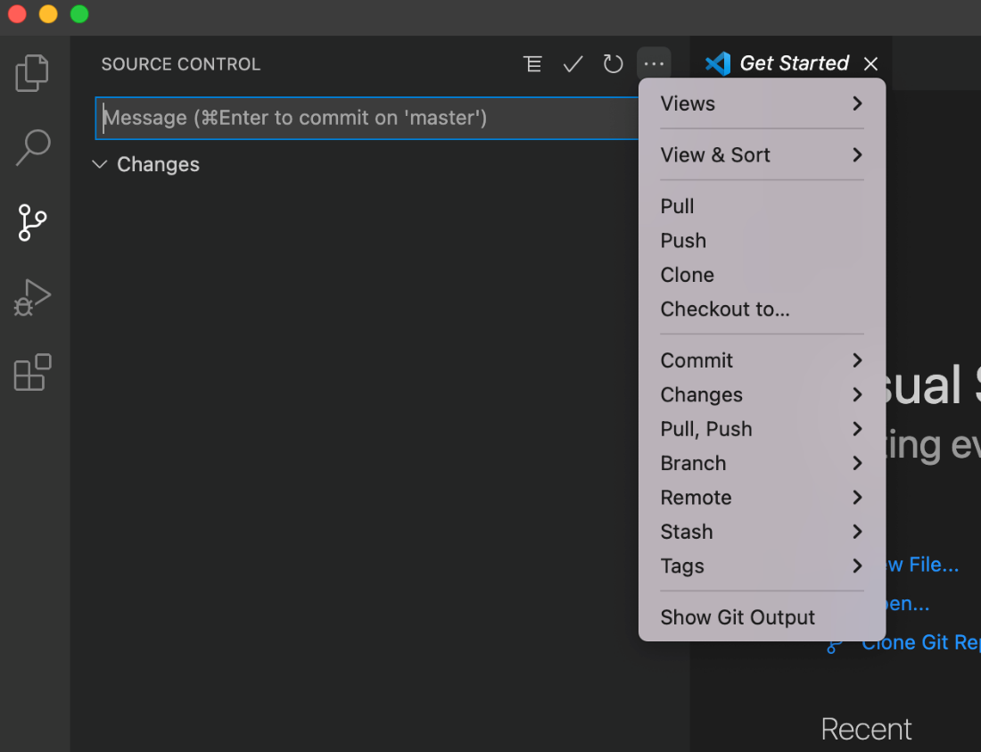

For a good tutorial on how to use GitHub, please follow this Quickstart: <https://docs.github.com/en/get-started/quickstart>