**Program environment**

Visual Studio 2022

.net 6.0 and MSTest

**Unit Test**

Open Project PalindromesTest and run test

Test Method 1: test if the input string is palindromes

Test Method 2: test if the input string is palindromes with case insensitive

**How to use**

Palindromes\bin\Debug\net6.0\Palindromes.exe WordsFile.txt ResultFile.txt

**Work flow**

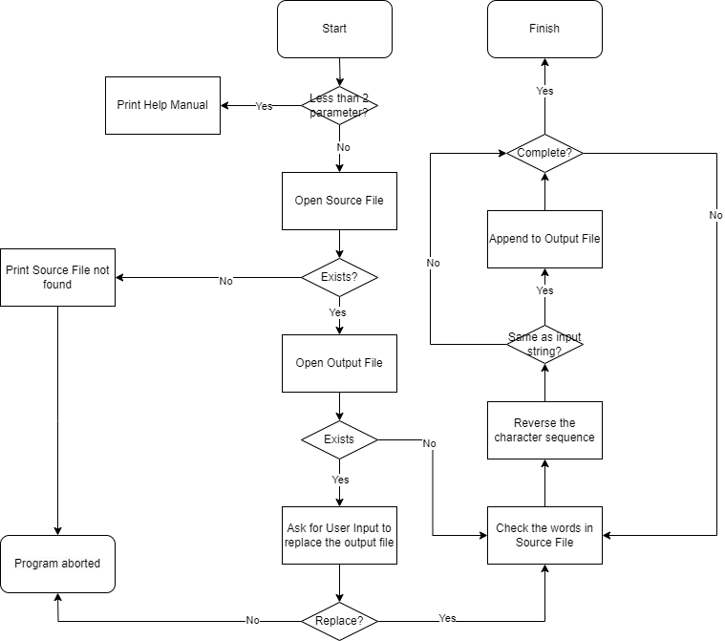

**Description**

1. Open the source file and get all the words in the file
2. Use while loop to test all the words in the source file
3. Append the palindromes to output file
4. Completed