Stephen Bailey

COP4365C

Final Project

1. Program startup

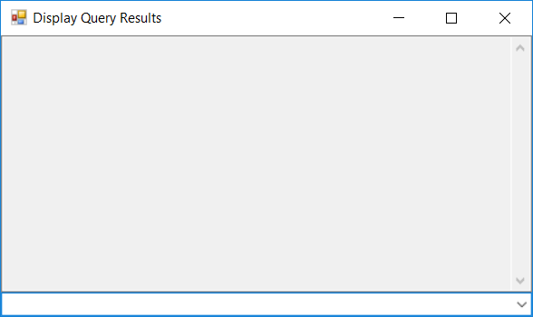

1. Choose first option in combo box

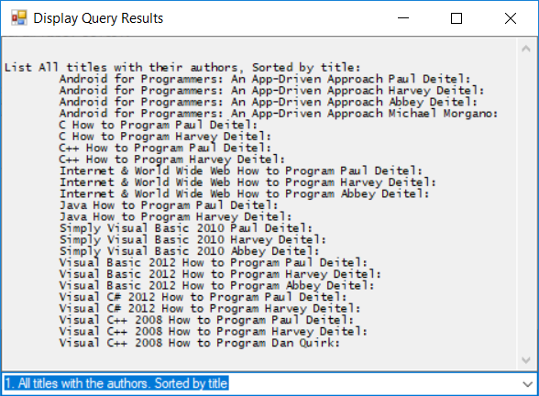

1. Choose second option in combo box

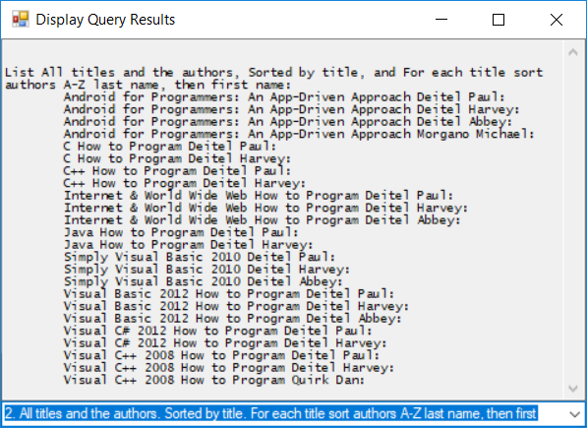

1. Choose third option in combo box

