Raspberry Pi Arcade Game Development Demo

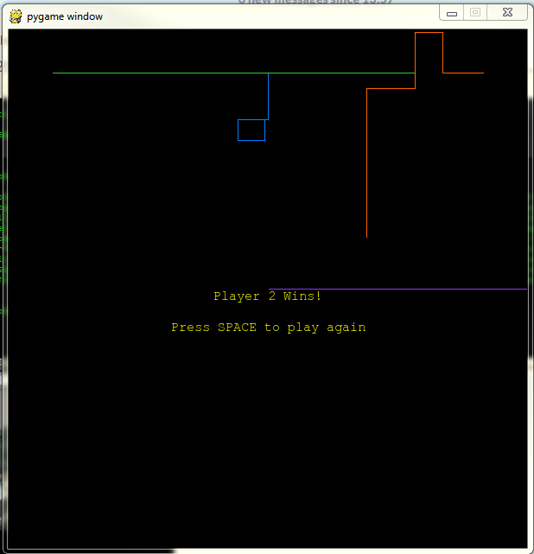The Raspberry Pi comes with the Python programming language already on it as well as the PyGame library which offers functionality useful for building games, such as, helpers for drawing graphics on the screen. This means that we just need to create a text file with the code for our game in it and the Raspberry Pi already has everything it needs to run it.

To demo this we have built a version of the old Tron arcade game which runs on the Raspberry Pi and allows up to five players to compete with each other. Players drive around the screen, leaving a trail behind them. If you crash into the side or another player then you die. Whoever survives longest wins!

Useful Links

There are lots of resources on the internet to learn about PyGame. This tutorial describes step-by-step how to write a 2D version of Minecraft:

* <http://usingpython.com/pygame-intro/>

The PyGame website provides documentation and links to more tutorials and ebooks:

* <http://pygame.org/wiki/about>
* <http://www.pygame.org/wiki/tutorials>
* <http://www.pygame.org/docs/>

If you have specific programming questions, such as, how to draw text on the screen using Python then StackOverflow is often a good place to search. There is usually a good chance someone has asked your question before others have provided answers:

* <http://stackoverflow.com/>

You can check out the code for our Tron demo game and see how it evolved from a simple blue square into a fully playable game here:

* <https://github.com/steviehailey-skyscanner/raspberry-pi-tron>